DharaAI
An AI-Powered Indian Legal Intelligence Platform
MASTER DOCUMENT
Architecture, technology stack, roadmap, and business framing — in one place

Document | 5 of 5 — Master Document
Version | 1.0
Date | 26 July 2026
Status | Draft for team review
Companion documents | SRS · SDD · Project Workflow · Role Division

Table of Contents

(If this outline looks empty, right-click it and choose “Update Field” — Word/LibreOffice recalculate it from the headings automatically.)

1. Executive Summary
DharaAI is an AI-powered legal intelligence platform for Indian law: a hybrid-retrieval, citation-grounded question-answering system that starts with the Constitution and the new BNS/BNSS/BSA criminal codes and is architected to extend — as a data-ingestion task, not a rebuild — through central Acts, court judgments, state law, and regulatory material. It answers a legal question the way a careful researcher would: find the exact provision, quote it precisely, cite it, and say clearly when it doesn't know.
The core bet is architectural rigor applied to an underserved segment. India's legal-tech market already has strong editorial databases (Indian Kanoon, SCC Online, Manupatra) and a growing wave of citizen-facing legal chatbots — but, from available public information, none of them publish retrieval-precision metrics, treat the IPC→BNS legal transition as a first-class feature, or offer a genuinely extensible architecture. DharaAI's MVP targets law students and judiciary/bar-exam aspirants specifically — a segment that is both differentiated from the crowded citizen-chatbot space and objectively benchmarkable against BhashaBench-Legal, a real Indian legal-exam question set.
Aspect | Summary
Problem | Legal information in India is fragmented across editorial databases built for keyword search, not natural-language questions — and the citizen-facing AI alternatives that do exist don't publish evidence of retrieval quality or handle the 2024 criminal-law code transition explicitly.
Solution | A hybrid-retrieval (keyword + semantic), citation-grounded, faithfulness-checked answer engine, built on a generic legal-document data model that scales across law types without architectural rework.
Initial wedge | Law students & judiciary/bar-exam aspirants — benchmarkable, underserved by rigorous tooling, naturally extends to general citizens without extra engineering.
Differentiator | Measured retrieval quality (published recall/faithfulness numbers), the IPC→BNS repealed-mapping feature, and a platform architecture (developer API path from Phase 6) rather than a single-purpose chatbot.
Team | 3 people — AI/ML/MLOps, Frontend, Backend/Data (full split in the Role Division document).
Stack | Next.js · FastAPI · PostgreSQL · Qdrant · BGE-M3 · Vertex AI (Gemini) · Google Cloud Platform.

2. Market & Competitive Landscape
Three distinct tiers of existing product shape where DharaAI needs to differentiate.

2.1 Editorial / Static Legal Databases
Product | Position
Indian Kanoon | Free, comprehensive full-text search across courts and tribunals since 2008; recently added a paid “Prism AI” tier for AI-assisted search on top of its existing search engine.
SCC Online | Editorial gold standard with strong headnotes; introduced neural-network-based case categorization by legal principle in its 2026 “Digest 3.0” update. Premium/subscription-priced, aimed at practicing lawyers.
Manupatra | Strong citator features (flags overruled cases) and “decision heatmap” analytics showing how courts have ruled on a topic; broad state-enactment coverage.
e-SCR (Supreme Court's own portal) | Free, official, digitized Supreme Court judgments back to 1950; reached what the Court has described as full maturity in 2026 — strong on authority and completeness, not built for natural-language Q&A.

2.2 Citizen-Facing Legal AI Chatbots
This niche is more crowded than it might first appear: Nyaaya (operating since 2016), Nyaya Setu, NyayaSathi, Nyaya Saathi, Nyaay AI, NyayaDarpanAI, and BharatNyay.ai are all currently active citizen-facing Indian legal-AI products, several explicitly using “Nyaya”-prefixed names. At least one (Nyaya Saathi) explicitly advertises a RAG pipeline over Indian Kanoon content.
FIX APPLIED — Why this matters for positioning
This is why DharaAI's working name deliberately avoids the Nyaya-prefixed pattern (“Dhara” — the Hindi legal term for “Section” — was chosen instead), and why the MVP persona targets law students/exam-prep rather than general citizens: that specific niche already has multiple funded and unfunded entrants, none of which, from public information, publish retrieval-quality evidence or address the IPC→BNS transition as a named feature.

2.3 Global Legal-AI Comparables (Architecture Reference, Not Direct Competitors)
Harvey AI — built for large law firms (60%+ of the AmLaw 100, reportedly valued in the $3–5B range) — is architected around sentence-level citations and a three-pronged “lawyer-in-the-loop” evaluation methodology rather than a single benchmark score. That citation-precision-first, evaluation-rigorous philosophy is directly relevant to DharaAI's design even though Harvey targets BigLaw practice, not the Indian citizen/student segment.

2.4 Competitive Positioning Map
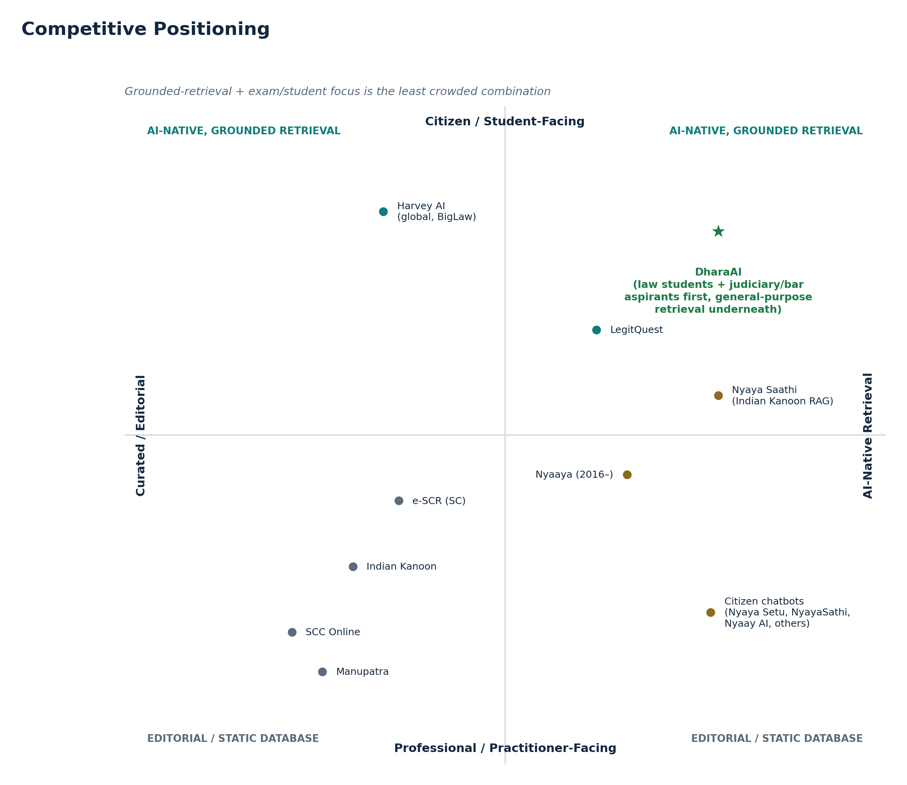
Figure 2.1 — Grounded-retrieval + exam/student focus is the least crowded combination on the map.

3. Product Overview

3.1 Vision
A trusted AI layer over Indian law — accurate, explainable, and source-grounded — usable by everyone from a first-year law student to, eventually, a compliance team at a fintech startup, all served by the same underlying retrieval engine and generic document model.

3.2 Personas
Persona | Phase | Core need
Law students & exam aspirants | 1 (MVP) | Precise, citation-backed answers; benchmarkable accuracy
Informed citizens | 1 (secondary) | Plain-language explanation of their rights and obligations
Lawyers & researchers | 4+ | Case-law depth, version history, higher trust bar
Businesses / govtech / fintech (via API) | 6+ | Programmatic, compliance-grounded legal Q&A

3.3 What Makes This Defensible, Not Just Different
- Hybrid retrieval (keyword + semantic + rerank) instead of vector-search-only — legal text's exact identifiers (“Section 144”) are precisely what pure embeddings under-retrieve.
- Faithfulness-checked citations — a second-pass check before an answer ships, not just a citation shown for appearance.
- The IPC→BNS repealed-mapping feature — a concrete, demonstrable answer to a real, high-volume legal-transition question that generic tools handle poorly.
- A generic data model — the platform's growth path (new laws, new jurisdictions) is a data task, evidenced in the architecture itself, not a roadmap promise.

4. System Architecture
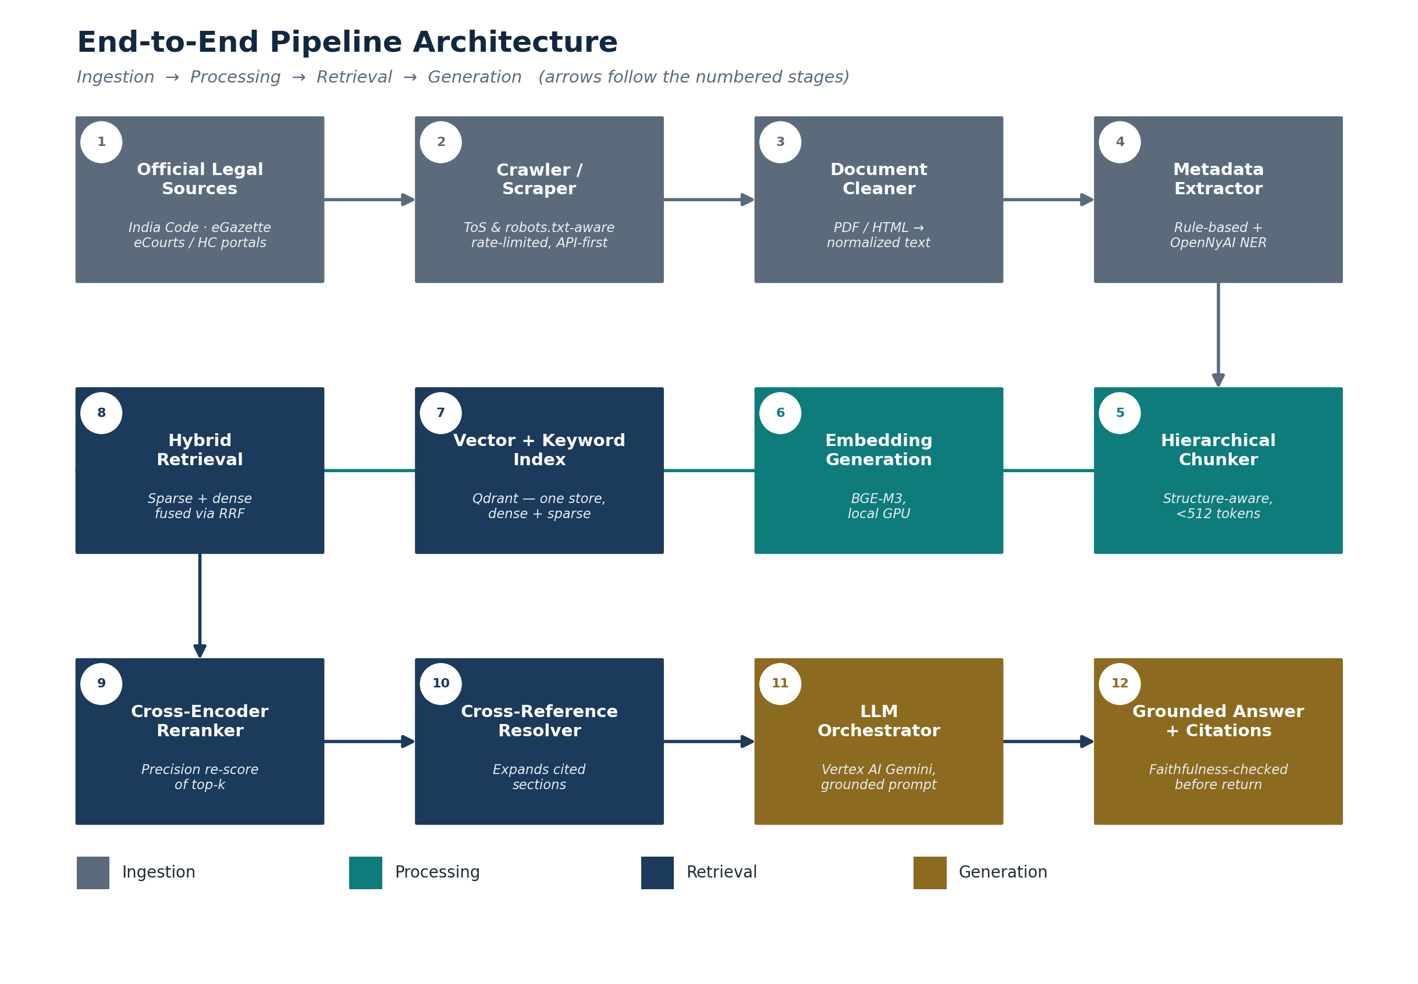
Figure 4.1 — End-to-end pipeline (full detail in the SDD).
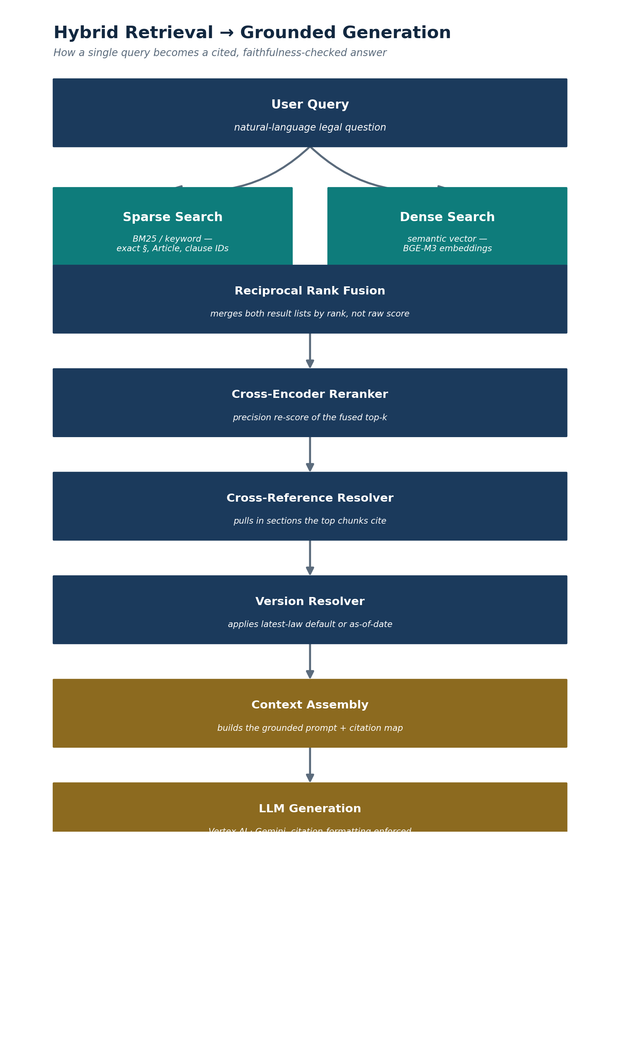
Figure 4.2 — Query to grounded answer.
Full architectural detail — component-by-component design, database schema, API surface, algorithms, security threat model, and the reasoned Architecture Decision Record log — lives in the companion Software Design Document. This section is the map; the SDD is the territory.

5. Technology Stack
Every choice below is sized to what a 3-person team can actually operate, and cross-checked against what comparable production systems use — not selected from a generic “modern AI stack” checklist.
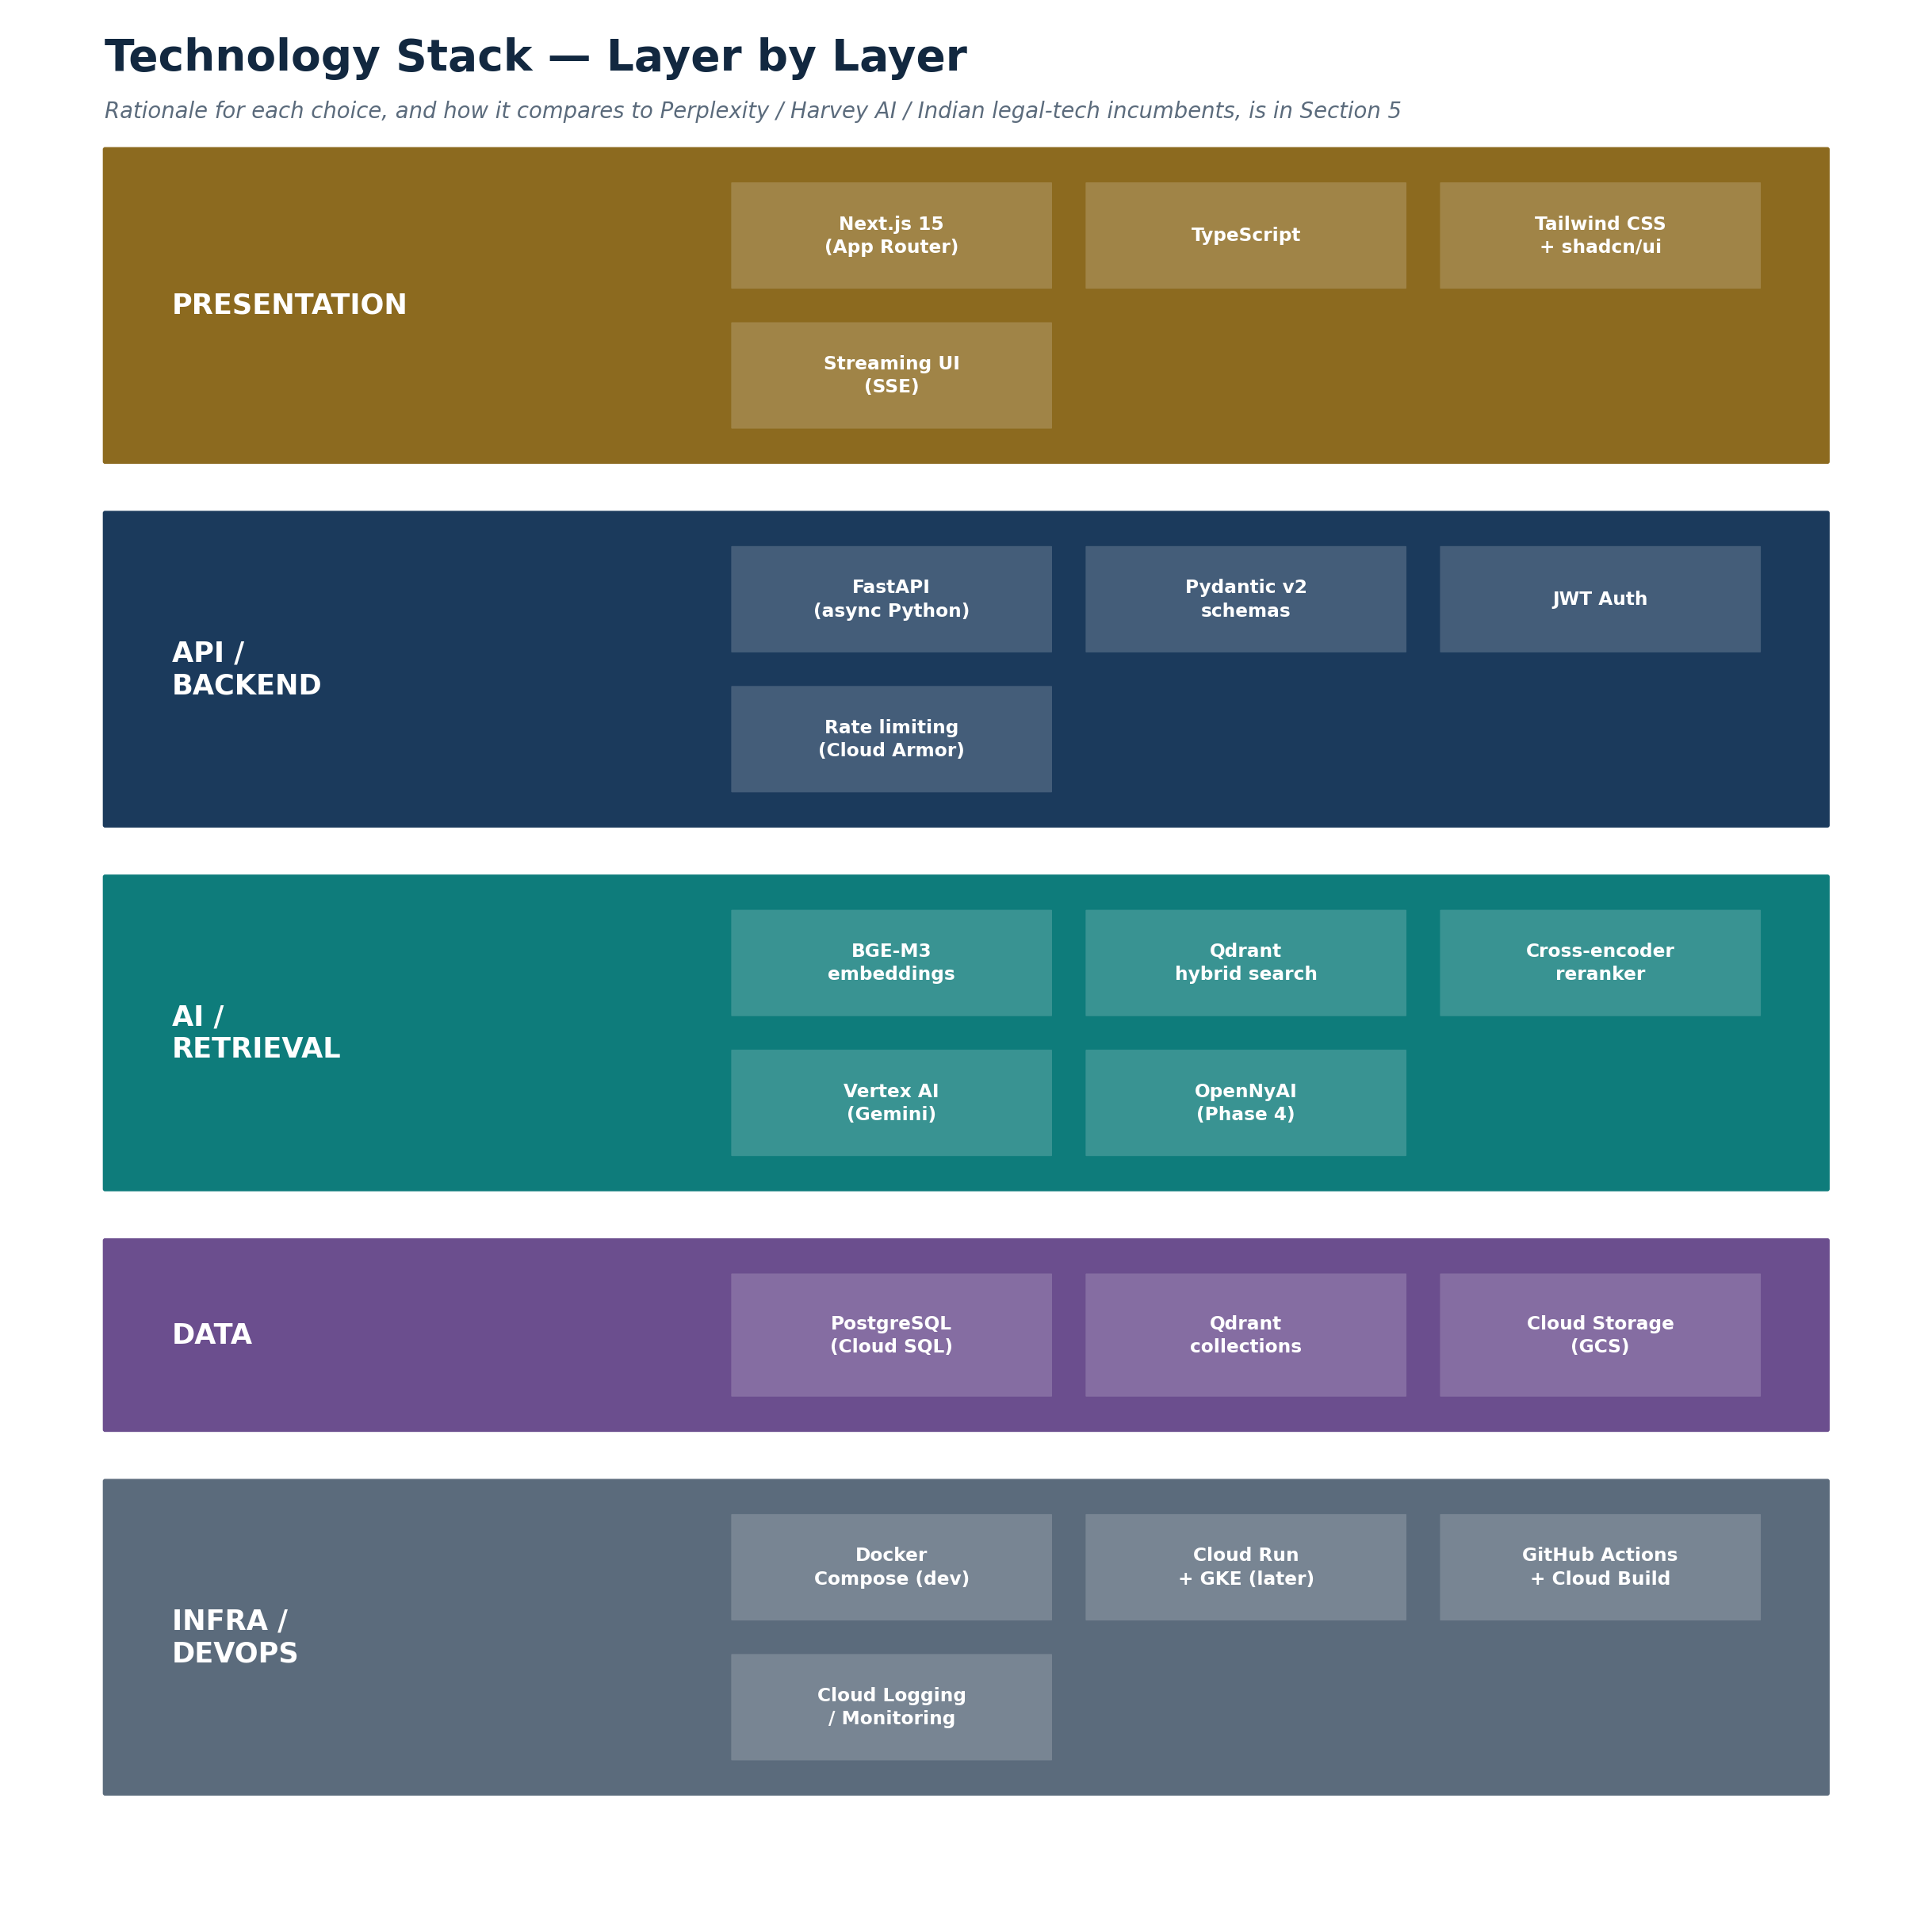
Figure 5.1 — The stack, layer by layer.

5.1 Layer-by-Layer Rationale, With Comparables
Layer | DharaAI choice | How it compares
Retrieval | Qdrant native hybrid (dense + sparse) search, RRF fusion, cross-encoder rerank | Perplexity's production search stack similarly retrieves at sub-document (chunk) granularity and fuses multiple signals before generation, rather than relying on a single embedding pass — the same principle, applied here to legal text's identifier-heavy structure.
Citations | Section-level, faithfulness-checked before the answer ships | Harvey AI's stated design emphasis on sentence-level citations and lawyer-in-the-loop evaluation validates citation-precision as a first-order design goal, not a UI nicety, in serious legal-AI products.
Generation | Vertex AI (Gemini), no self-hosted LLM | Consistent with the broader industry pattern of separating a specialized retrieval layer from a general-purpose hosted LLM for generation, rather than fine-tuning or self-hosting a generation model before there's a proven need to.
Data layer | PostgreSQL + Qdrant, no separate Elasticsearch/OpenSearch at MVP | Qdrant's native hybrid support removes a service that many earlier RAG architectures needed only because their vector database lacked built-in sparse-vector support.
Infra | Cloud Run first, GKE deferred until justified | Mirrors the just-in-time infrastructure principle used throughout the design (SDD ADR log) — provision for the load that exists, not the load that might exist.

5.2 What's Deliberately Not in the Stack (Yet)
Not (yet) used | Why, and when it would be reconsidered
Elasticsearch / OpenSearch | Qdrant's native hybrid search covers Phase 1–3 needs; reconsidered only if faceted-search requirements at Phase 6+ scale specifically need it.
Celery / Redis | Ingestion at Phase 1–2 volume runs fine as synchronous, resumable jobs; reconsidered when ingestion genuinely needs to be asynchronous at scale.
Prometheus / Grafana | Cloud Logging/Monitoring (already part of the GCP deployment) covers Phase 1–2 observability; reconsidered once there's enough in production to justify dedicated dashboards.
A dedicated graph database | The cross-reference graph is one-hop at Phase 1–3 scope — a Postgres adjacency array and a reverse-lookup query cover it without a seventh service to operate.
Self-hosted / fine-tuned LLM | The local dev hardware's GPU/VRAM budget can't host a capable LLM alongside embeddings and reranking; Vertex AI is used for inference only, with no fine-tuning until Phase 1–2 prove the concept.

6. Roadmap Summary
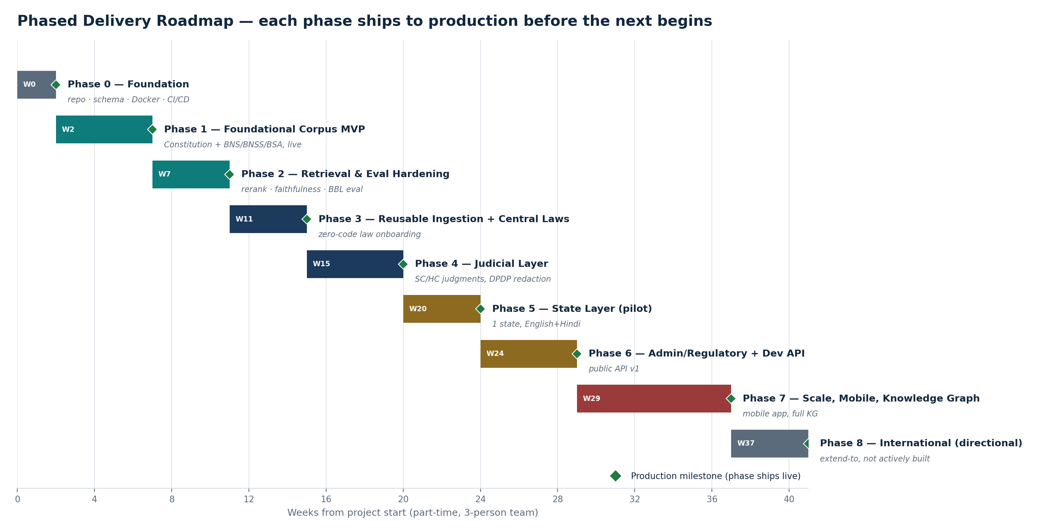
Figure 6.1 — Full roadmap; per-phase task breakdown and Definition of Done in the Project Workflow document.
Phase 0–2 (roughly the first 11 weeks) is the complete, demonstrable core: a live, publicly reachable product answering Constitution and BNS/BNSS/BSA questions with measured retrieval quality and a working IPC→BNS mapping feature. Everything from Phase 3 onward is genuine platform growth, not padding — but it is sequenced so each phase is a real, shippable increment rather than a promise bundled into a single “full vision” release.

7. Team Summary
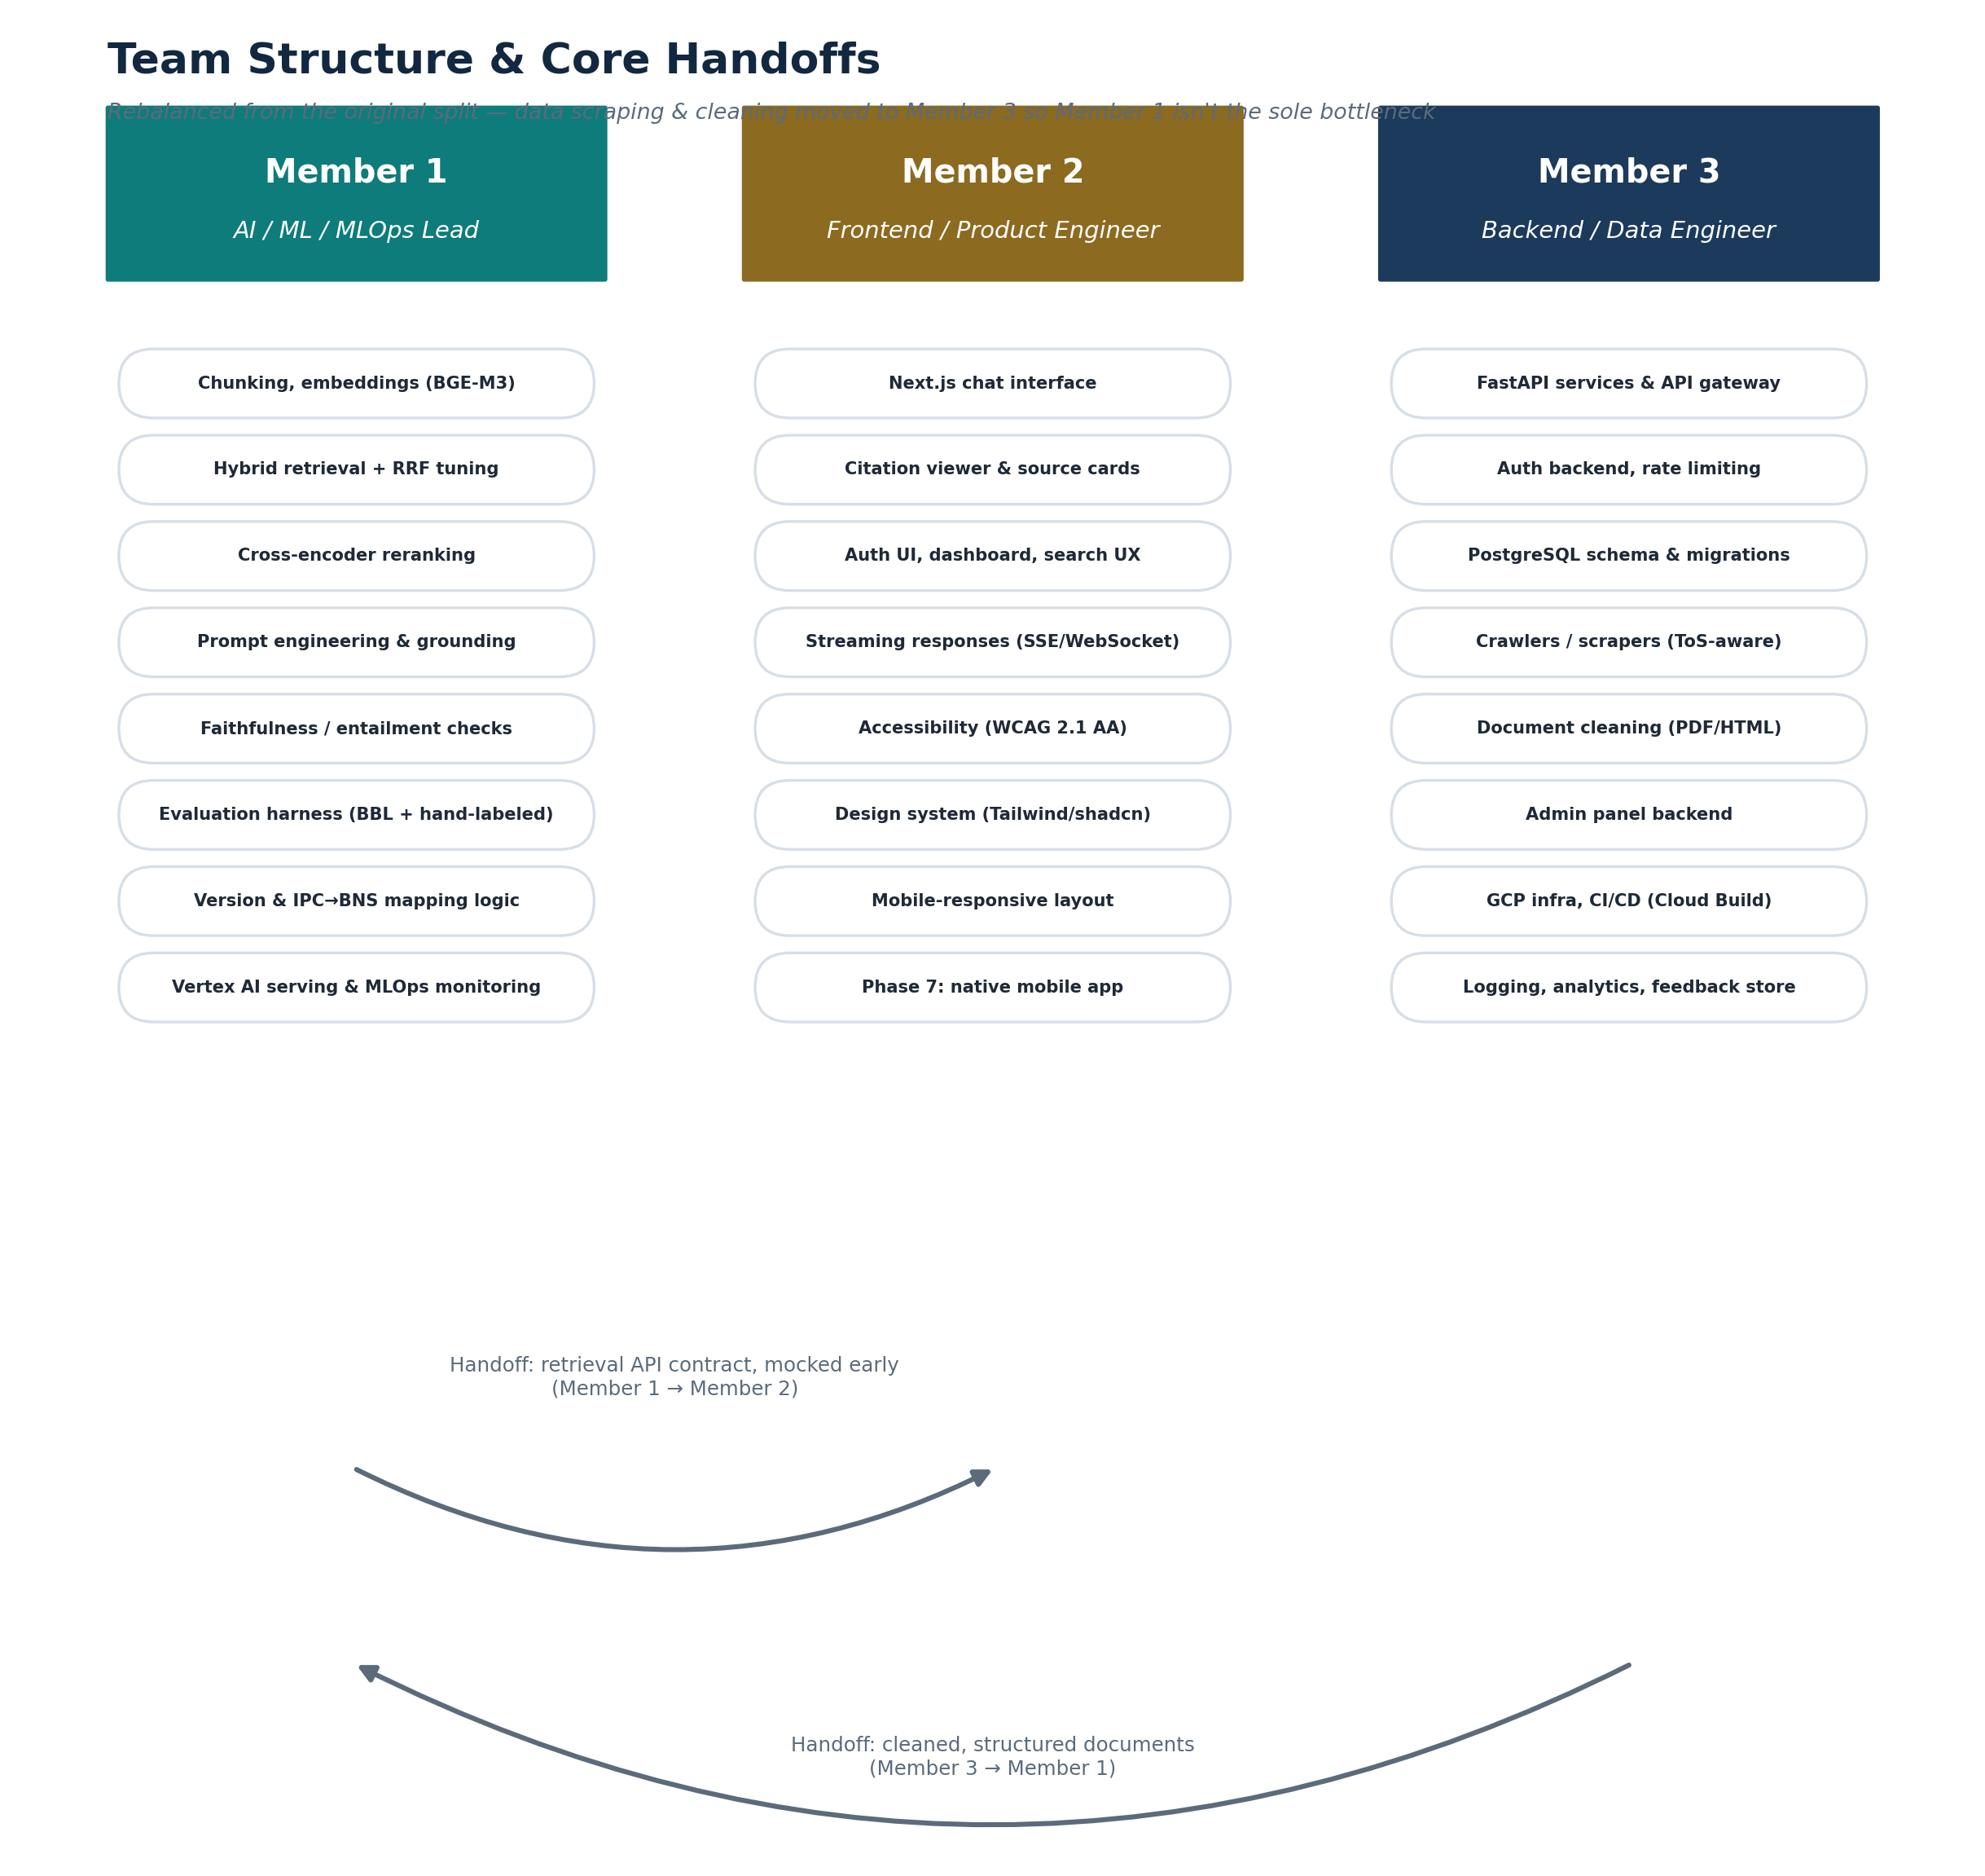
Figure 7.1 — Full responsibilities, handoffs, and ramp-up plan in the Role Division document.

8. Business Model & Monetization
Not part of the original technical planning conversation, but a necessary companion to “treat this as a startup” — laid out here as a directional model to validate, not a committed plan.
Tier | Who | Model
Free | Citizens, students (rate-limited) | Ad-free, rate-limited access; the growth and trust-building layer.
Pro | Serious students/exam aspirants, individual lawyers | Subscription: unlimited queries, deeper case-law access (post-Phase 4), version-comparison tools (Phase 7).
API / B2B | Legaltech, fintech, govtech platforms needing compliance-grounded legal Q&A | Usage-based pricing on the Phase 6+ developer API.
B2G (directional) | State legal-aid or digital-governance integrations | Explored only after Pro/API tiers show real traction — government sales cycles are long and shouldn't gate early validation.
ASSUMPTION — Treated as hypotheses, not commitments
None of these tiers should be built out before the Phase 1–2 product proves retrieval quality and real usage. The point of naming them now is so Phase 3+ product decisions (e.g. what goes behind a paywall) aren't made ad hoc later.

9. Risk Register
Risk | Category | Mitigation
Answer treated as legal advice; user relies on a wrong high-stakes answer | Legal/liability | UPL-safe disclaimer-and-scope-limiting design is a MUST requirement (SRS FR-SEC-004), not launch polish.
Source portal ToS violation during crawling | Legal/compliance | Source registry compliance gate (FR-ING-001) blocks ingestion from any source without a logged ToS review.
Personal data in judgments mishandled under DPDP Act | Legal/compliance | Dedicated redaction/exclusion pipeline (FR-ING-006) is a Phase 4 production-milestone blocker, not an add-later item.
Retrieval quality doesn't hold up outside hand-picked demo questions | Product/technical | Numeric, pre-committed evaluation targets (SRS Section 6) with CI-gated regression testing from Phase 2.
Team bandwidth (3-person, part-time-realistic team) vs. roadmap ambition | Execution | Phase durations are explicitly framed as revisable planning inputs (Project Workflow, Section 1.2); Phase 8 is explicitly directional rather than scheduled.
Competitive response from an existing citizen-chatbot entrant | Market | Differentiation is architectural (measured quality, IPC→BNS mapping, extensibility) rather than a feature an incumbent could trivially copy without similar retrieval-engineering investment.
Hosting/inference cost at Phase 6+ scale not yet budgeted in ₹ terms | Financial | Explicitly flagged as an open issue (SRS Appendix C) rather than assumed away; to be modeled once Phase 1–2 usage gives real per-query cost data.

10. Success Metrics

10.1 Product Quality
Metric | Target
Recall@5 (hand-labeled evaluation set) | > 85%
Citation faithfulness | > 90%
Out-of-scope refusal accuracy | > 95%
Retrieval latency, p95 | < 500 ms

10.2 Usage & Business (Directional, Post-Launch)
- Monthly active users and query volume, tracked from the Phase 1 production milestone.
- Free-to-Pro conversion rate, once the Pro tier exists (Section 8).
- Developer API adoption (registered API keys, call volume), once the API ships (Phase 6).

10.3 Technical Health
- CI-gated evaluation regression rate (target: zero unreviewed regressions reach production, from Phase 2 onward).
- Uptime against the 99.5% target (SRS NFR-REL, Section 5.3).

Appendix — Document Set Overview
This Master Document is the fifth of a five-document set. For implementation-level detail, see:
Document | Contains
Software Requirements Specification (SRS) | Full functional and non-functional requirements, each with a stable ID, priority, and acceptance criterion.
Software Design Document (SDD) | Architecture, data schemas, component design, API design, algorithms, security threat model, and the ADR log.
Project Workflow | Phase-by-phase task breakdown, Definition of Done, and production milestones.
Role Division | Full responsibilities, handoffs, ramp-up plans, and shared practices for the 3-person team.

