Temp Title

Objective
2 players must team-up to create a beautiful artwork only one of the player, the client, knows. The client, however, can only use body gestures to communicate to their partner, the artist, what to draw.

Requirements
- Even number of players (minimum: 2). Each pair of players will act as a team.
- A deck of diagrams (can be printed from diagrams.pdf)
- 1 pen and 1 sheet of paper for each team.
- A timer (smartphones recommended).
- A table is recommended

How to Play
Each game is split between 3 phases: planning, drawing, and judging phase.

Planning Phase
- All the players should agree on the amount of time they should set the timer to during the Drawing Phase. The recommended times are between 5 to 10 minutes. Do not start the timer yet!
- For each team, designate one player as the client, and the other as the artist.
- Each client will draw a random card from the deck of diagrams.
  - This card cannot be revealed to any artists until the Judging Phase.
  - The client must hold onto the card until the Judging Phase.
  - So long as the card remains hidden from all the artists, the client may check it for reference at any time during the game.
- The client may spend any time planning on how to convey their card’s diagram amongst themselves—see Gestures section for context—before moving into the Drawing Phase below.
  - The artists, however, may not eavesdrop on what the clients are discussing, let alone listen or join in the conversation.

Drawing Phase
- Each artists prepares their own sheet of paper, and places their pen’s tip at the center of the paper.
  - Make sure all the artists are informed that the artwork the clients have in mind can be drawn without lifting their pen from the paper.
- The client needs to stand up in front of their artist, and face their direction.
  - Make sure each client is provided enough space to swing their arms freely without hitting anyone while communicating to their artist.
- When everyone is ready, start the timer.
- Each client must use only the body gesture language described under the section, Gestures, to instruct their artist what to draw.
  - With exactly 1 exception—described in step 5 below—the client may not speak while instructing their artist.
- The client can say either “close” or “done” to end their drawing session if the following conditions are met:
  - If the last step in completing the artwork involves drawing a straight line from where the artist’s pen is at, back to the starting point (the center of the paper), the client can say, “close” to indicate the artist only needs to draw one more line, effectively finishing the artwork and ending their drawing session.
  - Otherwise, the client can say, “done” whenever they feel like to end their drawing session.
  - Finishing early does not affect the timer in any way.
- While in the Drawing Phase, the artist must ask their client exactly 3 yes-or-no questions—no more, no less—that the client can answer, lest they risk losing during the Judging Phase. The client must respond to each of them by nodding (yes) or shaking their head (no).
  - Artists are not allowed to ask their client what the card’s diagram is, or anything hinting what the diagram could be.
    - Not allowed: “is the diagram a heart?”
    - Not allowed: “is the diagram similar to a vital organ?”
  - Otherwise, artists are allowed to ask their client any yes-or-no questions.
    - Allowed: “do you want me to curve this line more downwards?”
    - Allowed: “is my drawing close to what you’re envisioning?”
    - Allowed: “are you feeling good today?”
- Drawing phase ends when either the timer goes off, or all teams are finished drawing. When it does, all artists must put their pens down, and move on to the judging phase.

Judging Phase
- Each team reveals the client’s card and the artist’s artwork to everyone.
- If 4 or more players are playing, points are rewarded to each team to determine the winners.
- First, every individual votes on the artwork that most closely resembles the client’s card. Each vote counts as 1 point for that team.
- The teams who asked and answered to each other exactly 3 yes-or-no questions—no more, no less—are rewarded additional points: one-half the number of teams in the game, rounded down.
  - Example: if there are 2 teams, the team who fulfilled the 3-questions rule gets 1 extra point; 3 teams, 1 extra point; and 4 teams, 2 extra points.
- The team with the most points wins. If there are ties, the tying teams are all considered winners.

Gestures

Direction Gesture
A client provides a direction to draw by simply pointing to a direction perpendicular to the direction they’re facing. This gesture is meant to be used with the other gestures listed below to create a sentence. Note that the indicated direction is relative to the artist.
The rest of the document will refer to this gesture as, “Direction Gesture.”

Examples
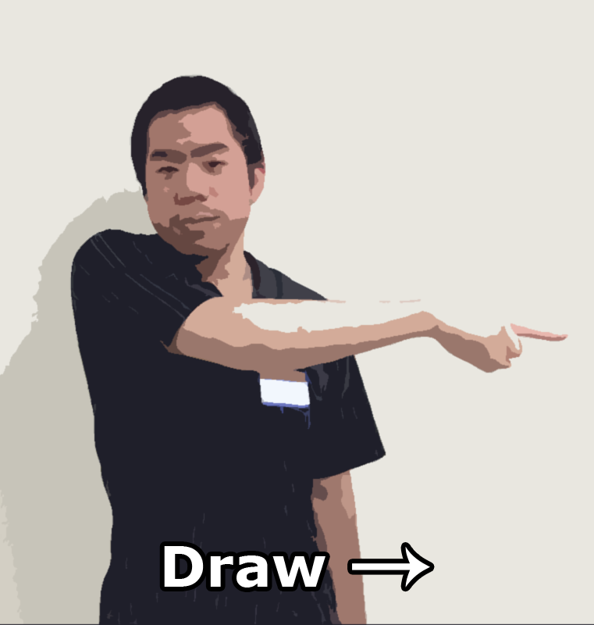
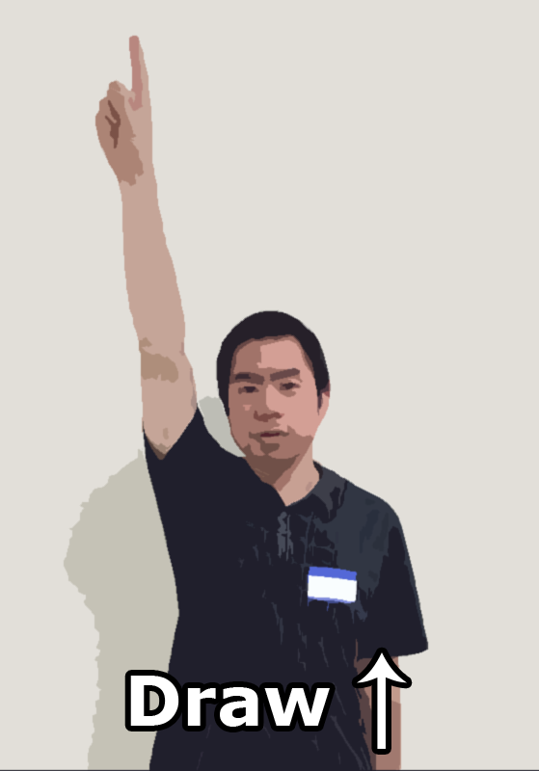
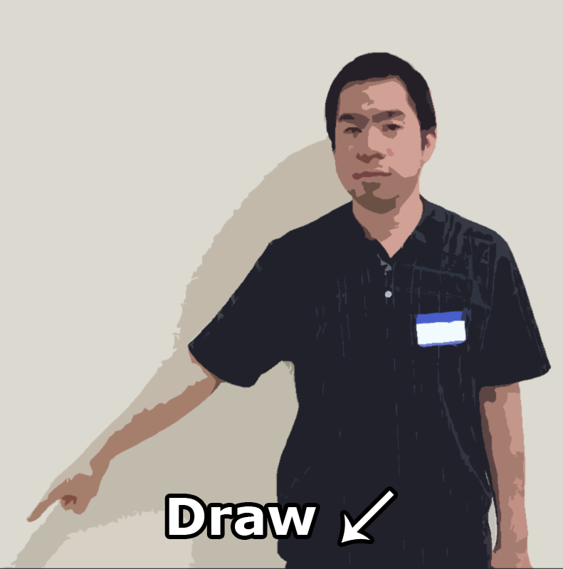
- Pointing up stands for, “draw up”
- Pointing right relative to the artist stands for, “draw right”
- Pointing down-left relative to the artist stands for, “draw down-left”

Straight Line Gesture
When the client swings their arms up-and-down twice, followed by a Direction Gesture, this informs their artist to draw a straight line from their pen’s current position to the indicated direction.

Example
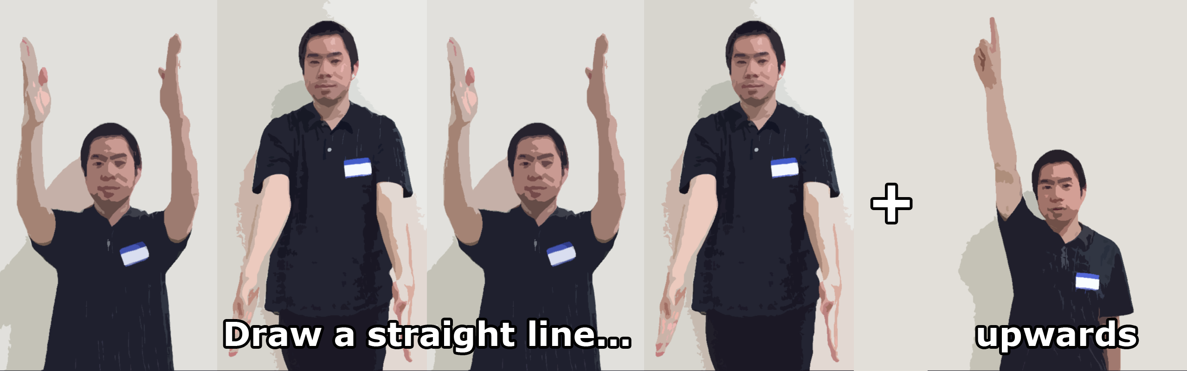
- When the client
  - swings their arms up-and-down twice,
  - then points up,
  - that stands for, “draw a straight line upwards.”

Curved Line Gesture
When the client waves their arms into an L-formation, then to a mirrored L-formation twice, this indicates to the artists to start drawing a curved line from their pen’s current position. This gesture is followed by a Direction Gesture, then crossing the arms into an X, and finally a second Direction Gesture to indicate the starting direction of the curve, followed by an ending direction.

Example
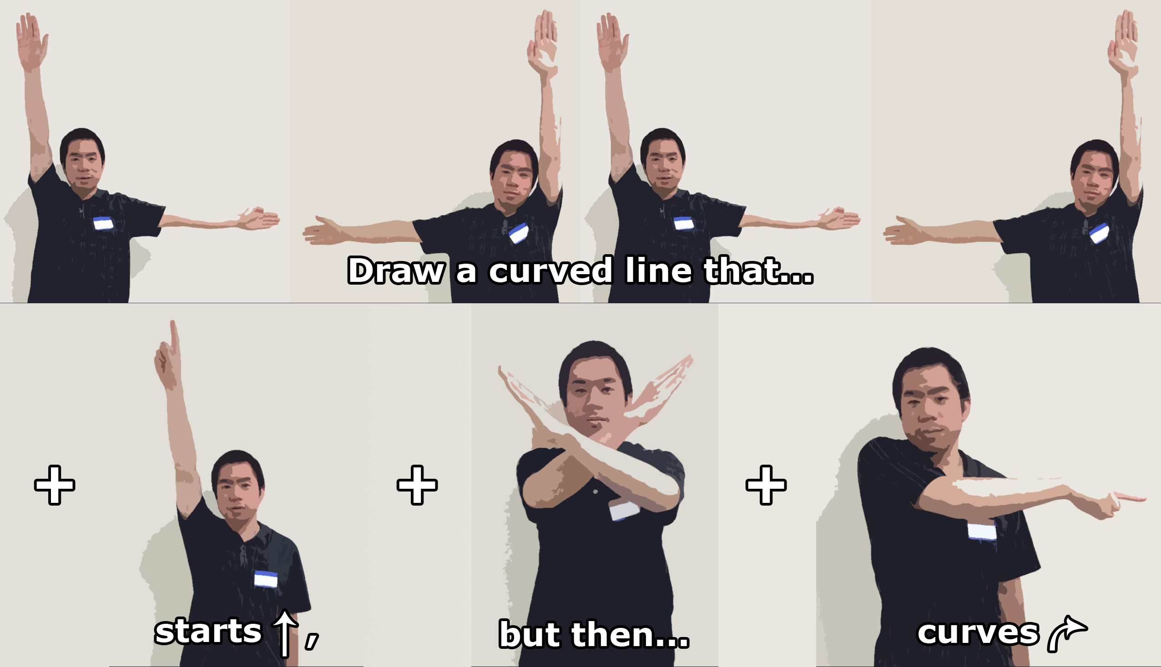
- When the client
  - waves their arms into an L, then mirrored twice,
  - then points up,
  - crosses their arm into an X,
  - then points right relative to the artist,
  - that stands for, “draw a curved line that starts going upwards, then gradually curves to the right.”

Stop Gesture
When the client claps, the artists should stop moving their pen and wait for the next instruction.

Example
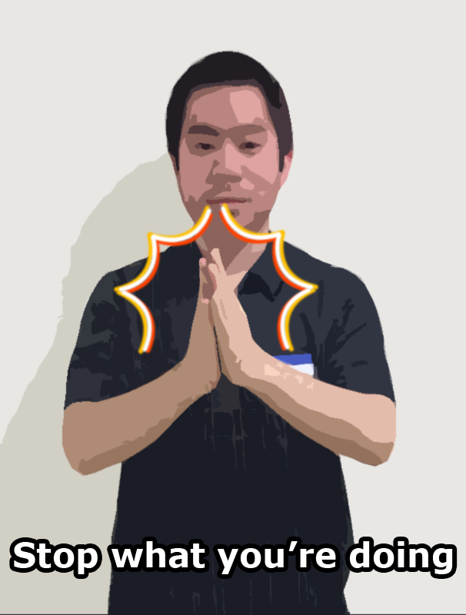
- When the artists
  - keeps drawing a straight line to the right,
  - and the client claps,
  - that stands for, “stop drawing the straight line in that direction.”

Keep Going Gesture
If the client needs to indicate to the artists that they need to continue drawing the line they’ve started, the client can squat up-and-down. This gesture can be combined with a Direction Gesture for clarity.

Example
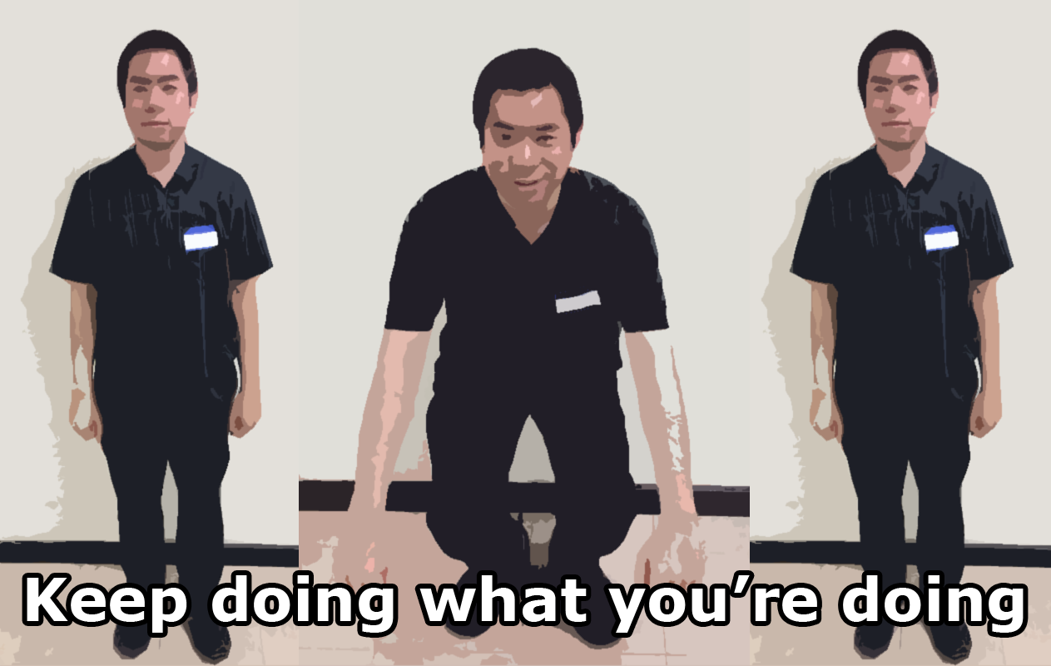
- When the artists
- stops drawing a straight line to the right,
- but the client is squatting up-and-down (possibly while still pointing to the right),
- that stands for, “keep drawing that straight line to the right.”

Sharper Curve Gesture
If the client needs to indicate to the artists either…
- a start of a curve that turns more sharply in one direction than the other, or,
- indicate to the artists that the trajectory of their curved line needs modification,
the client can use two arms to point to the direction the artists needs to curve their line more sharply.

Examples
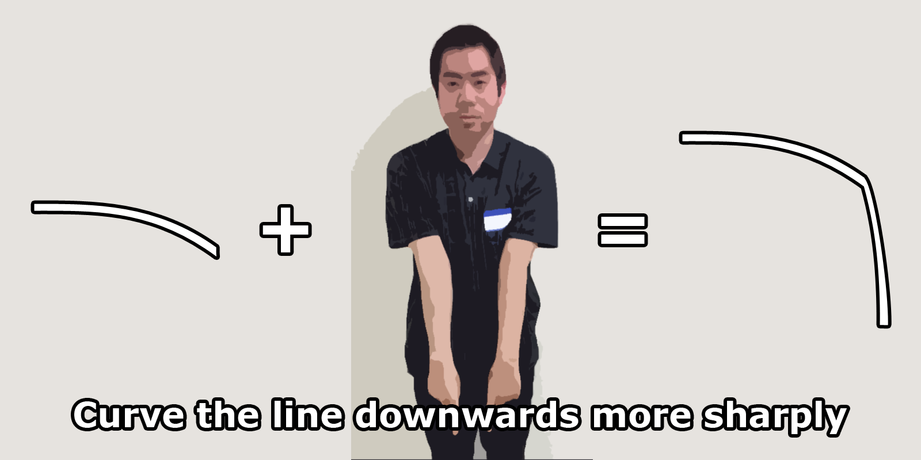
- When the artists
  - draws a curve going from right to down, but needs to curve downwards more sharply,
  - and the client points their 2 arms down,
  - that stands for, “curve the line more downwards.”
- When the client
  - does the “Start Curved Line” gesture,
  - then points up with 2 arms,
  - crosses their arm into an X,
  - then points right with 1 arm relative to the artist,
  - that stands for, “draw a curved line that starts going upwards, then barely curves to the right.”
- When the client
  - does the “Start Curved Line” gesture,
  - then points up with 1 arm,
  - crosses their arm into an X,
  - then points right with 2 arms relative to the artist,
  - that stands for, “draw a curved line that starts going upwards, then sharply curves to the right.”

