DEPARTMENT OF INFORMATION TECHNOLOGY


Synopsis of Major Project On

Intelligent AI - Assisted Trading Simulation

Prepared By:
Nandan Khatod (Roll No. 40)
Bhumi Khona (Roll No. 41)
Omkar Kulkarni (Roll No. 44)

Under the guidance of:
Dr. Seema Yadav

Department of Information Technology
Academic Year: 2025-2026
Autonomy Syllabus Scheme-III (2025-26) - SEMESTER VII (LY - IT)

CERTIFICATE

This is to certify that following students:

Nandan Khatod (Roll no. 40)
Bhumi Khona (Roll no. 41)
Omkar Kulkarni (Roll no. 44)
have submitted Major Project-A Report on “Intelligent AI-Assisted Trading Simulation System” as the partial fulfillment for the requirement of Final Year of Engineering (7th Semester) in L.Y. - Information Technology under my guidance during the academic year 2025-2026.

Dr. Seema Yadav | Dr. Radhika Kotecha
Project Guide | Head of Department
Assistant Professor | Associate Professor
Department of Information Technology | Department of Information Technology

Date of Examination: _________________

Signature of Internal Examiner Signature of External Examiner

Table of Contents

Acknowledgement | i
Abstract | ii
Introduction | 1
Literature Review | 3
Functionalities of Proposed System | 5
Implementation Details and Results | 10
References | 15

Acknowledgement
We would like to express our heartfelt gratitude to the individuals whose support and guidance have been instrumental in the successful completion of this project. Firstly, we extend our sincere thanks to Dr. Seema Yadav, our Project Guide, for her invaluable mentorship throughout this journey. Her vast knowledge and constant encouragement played a key role in shaping the project’s direction and ensuring its success.
We would also like to thank Mrs. Nasim Shah, our Major-Project Coordinator, for her diligent oversight and organizational support. Her meticulous planning and commitment to maintaining high standards were essential in the smooth execution of the project.
Our deep appreciation goes to Dr. Radhika Kotecha, our esteemed Head of Department, for fostering an environment of academic excellence and innovation. Her constant support and belief in our capabilities have motivated us to strive for greater heights.
Finally, we extend our gratitude to Dr. Vivek Sunnapwar, our respected Principal, for providing an academic environment that promotes growth and exploration. His leadership and vision have greatly contributed to the success of this project.
We are immensely grateful to these educators for their guidance and encouragement. Their contributions have not only supported the completion of this project but have also significantly influenced our academic and personal growth.

Abstract
The Intelligent AI-Assisted Trading Simulation System is a modern financial technology platform designed to bridge the gap between theoretical trading knowledge and real-world market experience. Its primary objective is to provide users with a realistic, risk-free environment where they can learn, experiment, and refine trading strategies using advanced technological tools. By combining a high-performance trading engine with intelligent analytics and an interactive user interface, the system enables users to understand complex market dynamics and make informed decisions.
The platform integrates a low-latency C++-based order matching engine that simulates real-world exchange behaviour using a Limit Order Book and price-time priority execution. This ensures accurate trade processing and realistic order handling. The user interface is developed using modern web technologies including React.js, providing a responsive dashboard for market visualization, portfolio tracking, and order management.
The backend system, built using Node.js and Express.js, is integrated with MongoDB to store user data, orders, trades, and portfolio information persistently. The system supports dynamic data fetching for Indian stock markets (NSE), where stock symbols follow the NSE format (e.g., RELIANCE.NS) and prices are displayed in Indian Rupees (₹).
Additionally, the platform includes a Python-based AI module using machine learning models such as LSTM to provide basic prediction insights. The AI module is partially implemented and can be extended further. Additionally, the platform is designed with scalability and extensibility in mind. It ultimately empowers users to develop confidence and competence in trading while eliminating financial risk, making it a comprehensive solution for learning and innovation in financial markets.

Chapter 1
Introduction
The Intelligent AI-Assisted Trading Simulation System is a modern financial technology platform designed to provide a realistic and interactive environment for learning and experimenting with stock trading. In recent research on algorithmic trading and financial simulations, it has been highlighted that realistic market modelling and AI-driven insights significantly improve decision-making efficiency and learning outcomes [1][3]. In today’s fast-paced financial markets, traders rely heavily on real-time data, accurate execution, and intelligent insights to make informed decisions. However, most traditional paper trading platforms fail to replicate real market behaviour and lack advanced analytical support. To overcome these limitations, this project focuses on building a system that combines realistic trading simulation with artificial intelligence and modern web technologies.
The system integrates a high-performance trading engine developed in C++ that simulates real-world exchange mechanisms using a Limit Order Book and price-time priority, concepts widely studied in order book modelling research [1][2][7]. This ensures accurate execution of buy and sell orders similar to actual stock markets. To enhance user interaction, a web-based interface built using the MERN stack provides real-time dashboards, portfolio tracking, and data visualization. Users can monitor their trading activities, analyse market trends, and evaluate their strategies in a risk-free environment, supported by efficient real-time communication techniques [10].
Additionally, the system incorporates a Python-based AI module that uses machine learning models such as LSTM to predict short-term price movements, as demonstrated in financial time-series forecasting studies [4][5][9]. Technical indicators like RSI, MACD, and Moving Averages are used to generate actionable insights, supporting hybrid approaches combining statistical indicators with deep learning [6][8]. By integrating simulation, analytics, and visualization into a single platform, the system bridges the gap between theoretical learning and practical market experience.
Overall, the project aims to create a scalable, secure, and user-friendly platform that serves as both an educational tool and a research environment for trading strategies, aligning with current trends in AI-driven financial systems [6][9].

  - Motivation
The motivation behind this project arises from the need to provide a realistic and risk-free environment for learning stock trading. Many beginners find it difficult to understand how real markets function due to lack of practical exposure. Existing simulators often fail to represent key aspects such as order matching, market depth, and execution delays. This project aims to bridge this gap by creating a system that closely mimics real-world trading while also providing intelligent insights through AI, enabling users to learn and experiment without financial risk.
  - Problem Analysis
Current trading simulators face several limitations that reduce their effectiveness as learning tools. Most platforms execute trades instantly without maintaining a real order book, which does not reflect actual market behaviour. They lack simulation of important factors such as bid-ask spread, order queues, and latency. Additionally, there is minimal integration of artificial intelligence, forcing users to rely on external tools for analysis. These limitations prevent users from gaining a complete understanding of trading dynamics and reduce the accuracy of strategy testing.
  - Objectives
● To develop a real-time trading platform for interactive user experience.
● To design and implement a high-performance order matching engine .
● To integrate machine learning models for short-term price prediction.
● To provide AI-based trading suggestions using technical indicators.
● To enable users to simulate trading strategies in a risk-free environment.
  - Scope
The scope of this project includes the development of a complete trading simulation platform that enables users to place buy and sell orders, view real-time market data, and analyze their trading performance through interactive dashboards. The system incorporates a realistic order matching mechanism, portfolio tracking, and AI-based predictions using machine learning models to assist users in decision-making. It is designed as an educational and experimental tool that allows users to understand market behaviour and test trading strategies in a risk-free environment.
The system includes integration with real-time or near real-time market data for Indian stock markets, enabling users to visualize live price movements and perform realistic trading simulations. It supports stock symbols in NSE format and displays prices in Indian Rupees (INR).
However, the system does not involve real-money transactions or direct integration with live stock exchanges. It is designed purely as a simulation and educational tool and does not guarantee financial accuracy or investment outcomes.

Chapter 2
Literature Review
  - Related Work
The development of intelligent trading systems has been significantly influenced by advancements in financial data analysis, machine learning, and market microstructure modeling. Several research works have focused on improving the prediction of stock price movements using limit order book (LOB) data and deep learning techniques.
One of the most influential works in this domain is by Zhang et al. (2019), titled “DeepLOB: Deep Convolutional Neural Networks for Limit Order Books,” published in IEEE Transactions. This study proposes a hybrid deep learning architecture combining Convolutional Neural Networks (CNNs) and Long Short-Term Memory (LSTM) networks to analyze spatial and temporal features of the limit order book. The model captures both price-level relationships and time dependencies, achieving superior prediction accuracy compared to traditional machine learning methods. The study demonstrates that deep learning models can effectively extract meaningful patterns from high-frequency financial data and generalize well across different stocks [1].
Another important contribution is the work on benchmark datasets for limit order book forecasting by Ntakaris et al., which highlights the importance of structured financial datasets in improving prediction accuracy. The study provides a standardized dataset for evaluating different machine learning models and emphasizes the role of high-quality data in financial forecasting systems [2].
Further research by Tsantekidis et al. explores the use of convolutional neural networks for predicting stock prices using limit order book data. Their work shows that CNN-based models can efficiently capture local patterns in order book data and outperform traditional statistical methods in high-frequency trading scenarios [3].
Recent advancements focus on deep learning models such as LSTM networks for financial time-series forecasting. These models are capable of capturing temporal dependencies and trends in stock price movements. Studies available on IEEE Xplore demonstrate that LSTM-based approaches significantly improve prediction accuracy compared to classical models, making them suitable for real-time trading applications [4], [5].
Additionally, emerging models such as transformer-based architectures and hybrid CNN-LSTM approaches have been proposed to further enhance prediction capabilities. These models focus on improving robustness and adaptability across different market conditions, addressing the limitations of earlier approaches [6].
Overall, the literature highlights the effectiveness of combining deep learning techniques with financial data analysis. However, most existing research focuses primarily on prediction accuracy and lacks integration with realistic trading simulation systems. This gap motivates the proposed system, which aims to combine real-time order matching with AI-based analytics in a unified platform.
  - Existing System
The existing systems related to trading simulation and financial analysis can be broadly categorized into manual systems, basic simulation platforms, and advanced trading tools. Each of these systems provides certain functionalities but also suffers from limitations that reduce their effectiveness for learning and experimentation [1][3].
Traditional or manual trading systems rely on spreadsheets, historical data analysis, and delayed market information. These systems lack automation and real-time interaction, making them inefficient for understanding dynamic market behaviour. Users must manually analyse data and make decisions without any system-generated insights, which increases complexity and reduces learning efficiency.
Advanced trading platforms and brokerage systems offer real-time data and sophisticated analytical tools. These systems include features like technical indicators, charting tools, and algorithmic trading capabilities. However, they are often complex, require financial investment, and are not suitable for beginners. Additionally, most of these platforms do not integrate AI-based prediction models directly into the trading interface, forcing users to rely on external tools for analysis [4][5][9].
Another major limitation of existing systems is the lack of integration between simulation, analytics, and visualization. Most platforms focus either on trading execution or data analysis but do not provide a unified environment where users can simultaneously simulate trades, analyse data, and receive intelligent recommendations [2][6][8].
Security and scalability are also important concerns in existing systems. Some platforms do not provide adequate protection for user data or lack proper authentication mechanisms. Additionally, handling large volumes of financial data in real time requires efficient system design, which is often missing in simpler platforms [10].
The proposed system addresses these limitations by integrating a realistic order matching engine, AI-based analytics, and a modern web interface into a single platform. By combining simulation accuracy with intelligent decision support and real-time visualization, the system provides a more comprehensive and effective solution for learning and experimenting with financial trading [1][6][9].
Chapter 3
Proposed System
The proposed Intelligent AI-Assisted Trading Simulation System consists of the following modules and functionalities:
● User Authentication Module
- User registration and login functionality
- Secure authentication using JWT
- Password encryption and session management
● Trading Engine Module
- Placement of buy and sell orders
- Execution of trades using price-time priority
- Support for limit and market orders
- Order cancellation and modification
● Market Data Module
- Real-time display of stock prices
- Visualization of order book (bids and asks)
- Live updates using WebSockets
● Portfolio Management Module
- Tracking of user holdings
- Profit and Loss (P&L) calculation
- Display of transaction history
● AI Analytics Module
- Prediction of stock prices using LSTM model
- Generation of Buy / Sell / Hold recommendations
● Visualization Module
- Interactive candlestick charts
- Graphical representation of market trends
- Dashboard for user insights
● Notification Module
- Alerts for order execution
● Data Management Module
- Storage of user data and trading records
- Database management using MongoDB
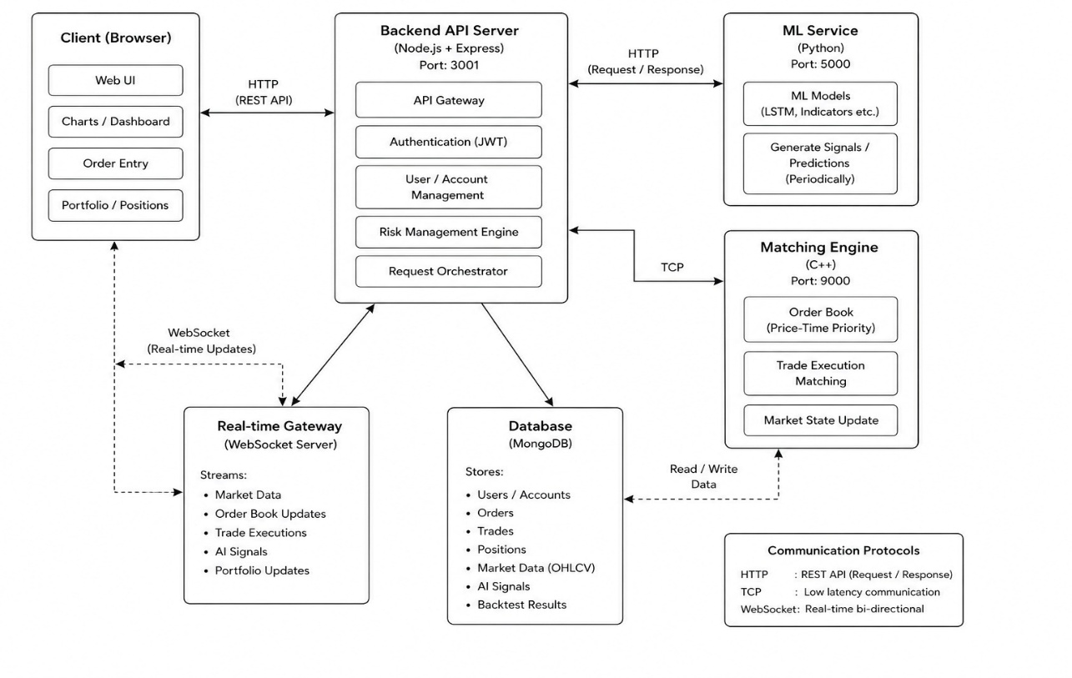
3.1 Proposed Approach and Details
(Fig 3.1 System Architecture)
This figure illustrates the overall architecture of the system showing interaction between frontend, backend.

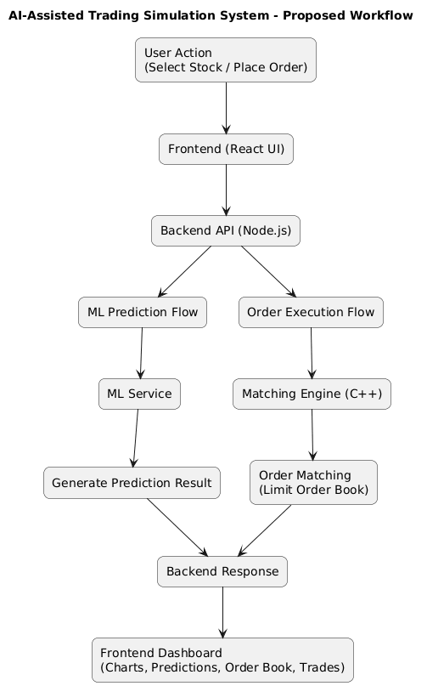
(Fig 3.2 Proposed Workflow)
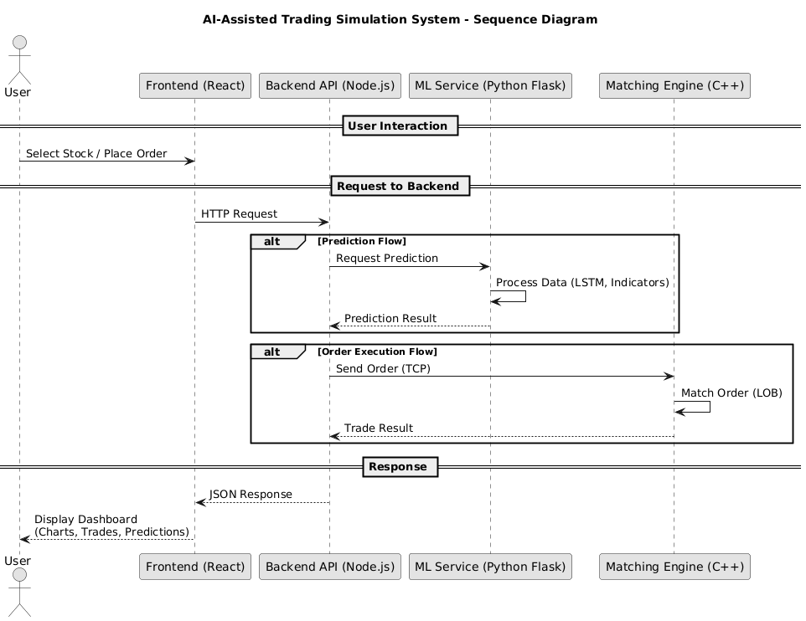
This figure illustrates the workflow of the system showing the flow of data for prediction and order execution.
(Fig. 3.3 Sequence Diagram)
This figure illustrates the interaction between system components showing the sequence of requests.
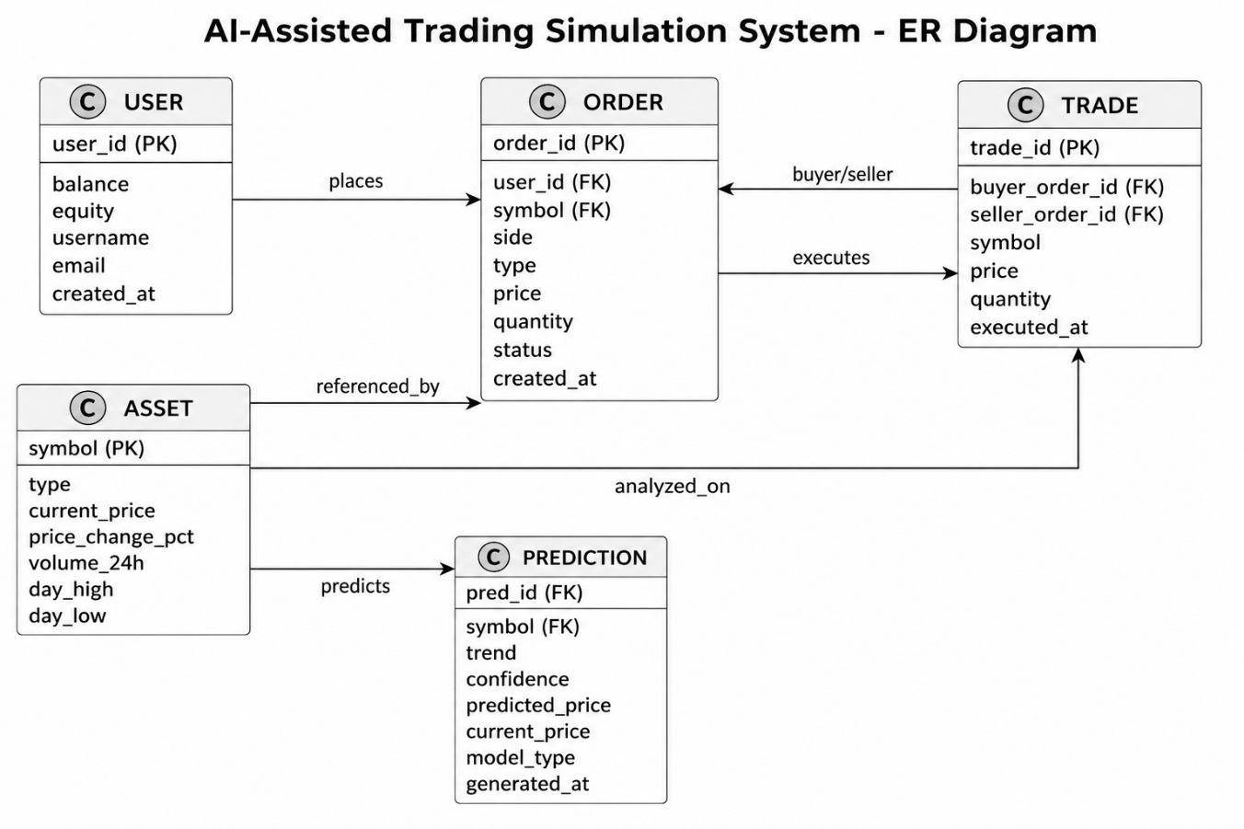
(Fig. 3.4 Entity Relationship Diagram)
This figure illustrates the relationships between entities such as user, asset, order, trade, and prediction in the system.

3.2 Innovation in Idea
The proposed system introduces several innovative features compared to traditional trading simulators:
- Realistic Order Matching Engine: Simulates real stock exchange behaviour using price-time priority instead of instant execution.
- AI-Based Decision Support: Integrates machine learning models to provide predictive insights and trading recommendations.
- Unified Platform: Combines trading simulation, analytics, and visualization in a single system.
- Real-Time Data Processing: Uses Web Sockets to ensure live updates and fast response time.
- Educational Simulation Environment: Provides a risk-free platform for users to learn and test trading strategies.
- Scalable Architecture: Designed using modular and microservice-based approach for future expansion.

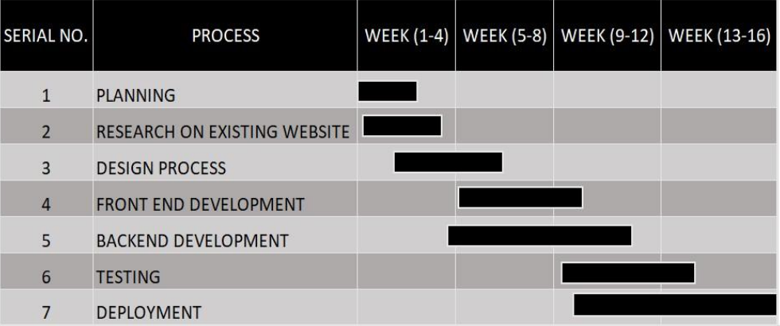
3.3 Timeline
(Fig. 3.1 Timeline in Gantt Chart)
This figure illustrates the project schedule and progress over time.

3.4 Roles and Responsibilities
The development of the Intelligent AI-Assisted Trading Simulation System is a collaborative effort where all team members contributed to frontend development, backend implementation, system design, testing, and documentation, ensuring equal participation across different technologies.
- Omkar Kulkarni – Backend, Research, and Testing
• Assisted in backend development and API design.
• Contributed to database planning and system architecture.
• Conducted research on AI models (LSTM/GRU) for future implementation.
• Participated in testing, debugging, and system integration.
- Bhumi Khona – Frontend, UI/UX Design, and Documentation
• Designed responsive UI and improved user experience.
• Prepared project documentation including synopsis and UML diagrams.
• Assisted in frontend-backend integration and testing.
- Nandan Khatod – Frontend, Backend, and Documentation
• Developed user interface components using React.js.
• Worked on backend structure and API development using Node.js and Express.js.
• Assisted in integrating frontend and backend modules.
At the current stage, the frontend interface and core backend structure are developed, while authentication, database integration, and AI modules are under development.

Chapter 4
Implementation Details and Results
4.1 Technology Stack
The system is developed using modern technologies to ensure scalability and performance. The frontend is built using React.js, providing an interactive and responsive user interface. The backend is developed using Node.js and Express.js to handle API requests and system logic.
MongoDB is implemented as the database for storing user data, orders, trades, and portfolio information. The system integrates a C++-based matching engine to simulate real-world trading using a Limit Order Book and price-time priority mechanism.
A Python-based machine learning module using LSTM is partially implemented to provide prediction insights. The system also supports real-time or near real-time data fetching for Indian stock markets.
The backend is developed using Node.js and Express.js, which handle API requests, system logic, and communication between different modules. MongoDB is planned as the database for storing user data, trading records, and system information.
Additionally, a C++-based trading engine is planned to simulate real-world order matching using a Limit Order Book and price-time priority mechanism. A Python-based AI module using machine learning techniques such as LSTM is also proposed for future implementation to provide predictive insights.
The system architecture is designed to support real-time communication using WebSockets, enabling live updates of market data and user activities. Overall, the technology stack ensures a modular, scalable, and efficient system design.

4.2 Implementation Parameters
The system is designed based on several important implementation parameters to ensure efficiency and realistic behaviour. The trading system is planned to follow price-time priority for order execution, which ensures fairness and consistency similar to real-world stock exchanges.
Performance is considered by designing a modular architecture where frontend, backend, and future AI components can operate independently. Real-time updates are intended to be handled using Web Sockets to reduce latency and improve responsiveness.
For the AI module, parameters such as prediction accuracy, training data quality, and model performance (LSTM/GRU) are considered for future implementation. Additionally, system reliability, scalability, and secure data handling are important factors taken into account during development.

4.3 Preliminary Results

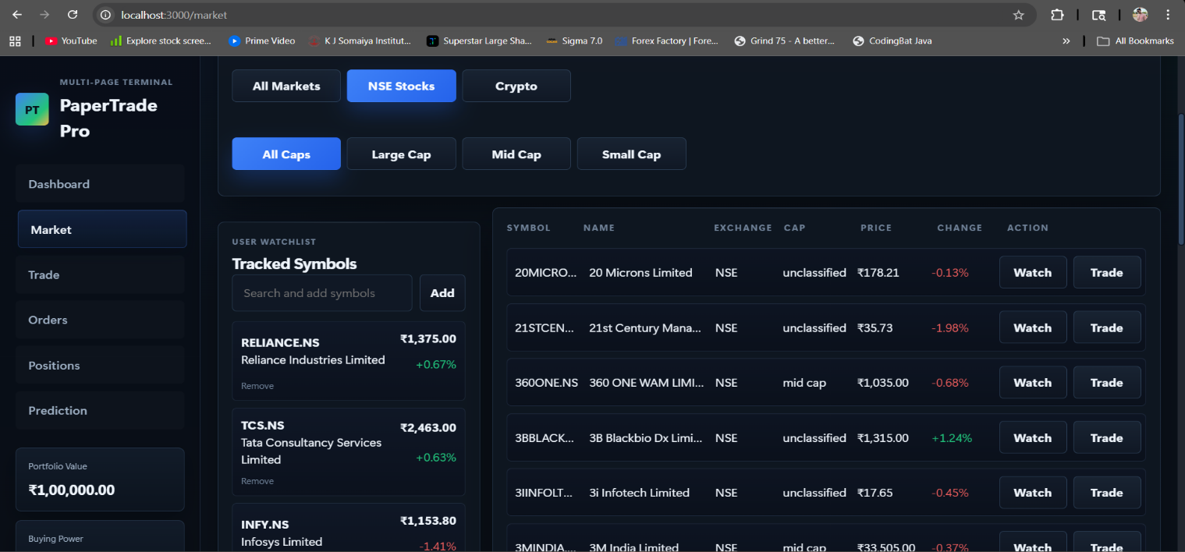
(Fig. 4.1 Market Watchlist and Listings)
This figure displays the list of stocks along with real-time price updates and user-selected watchlist items.
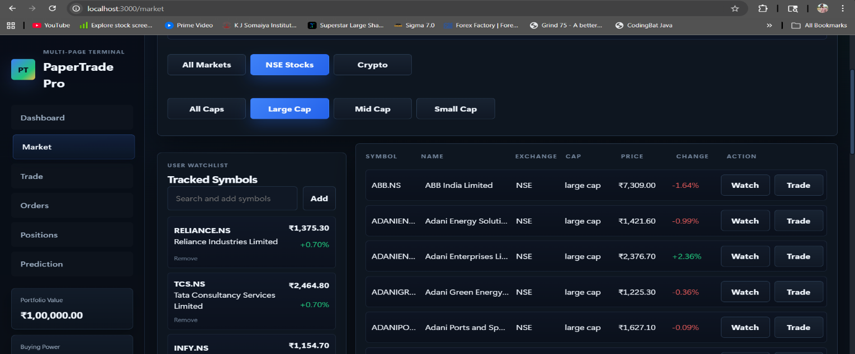
(Fig. 4.2 Filtered Large Cap Market View)
This figure displays the filtered list of large-cap stocks based on selected criteria for analysis.
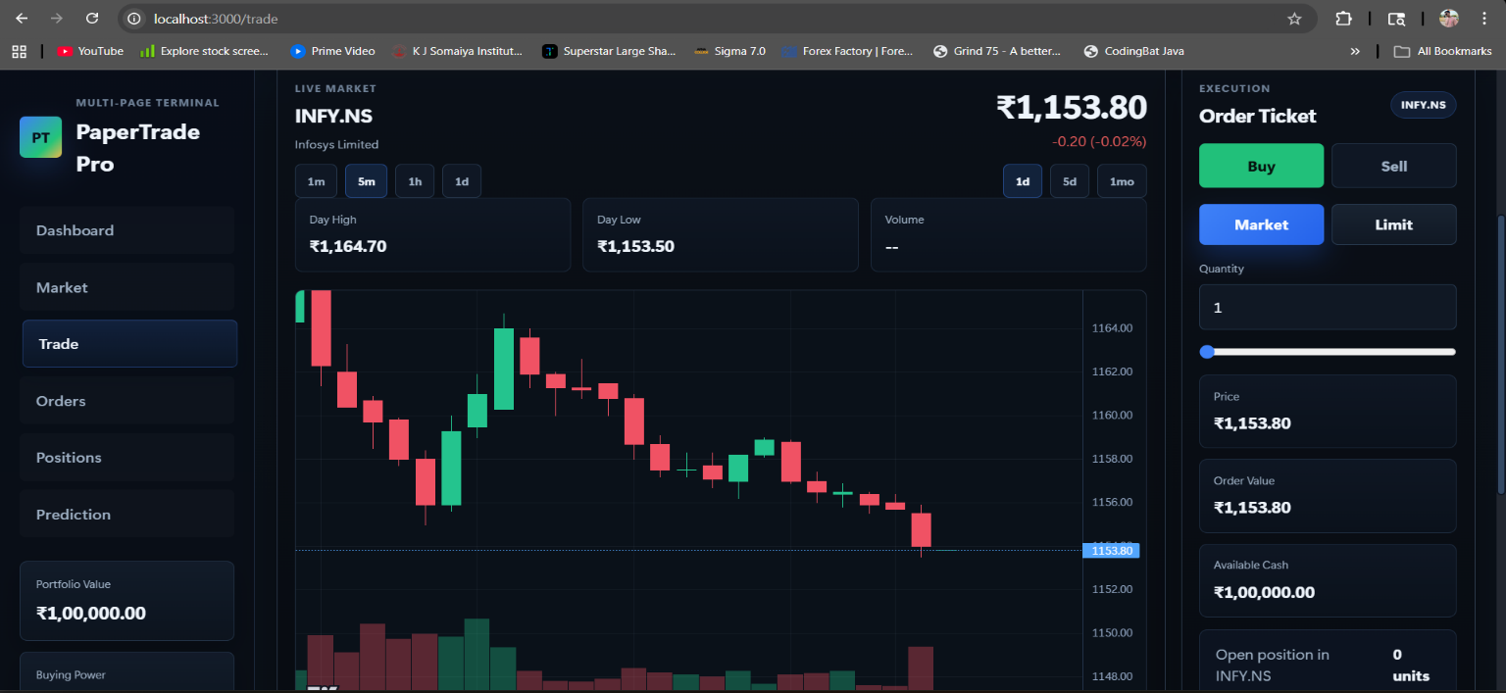
(Fig. 4.3 Live Trading Execution Dashboard)
This figure displays the real-time trading interface showing order execution, price updates, and transaction details.
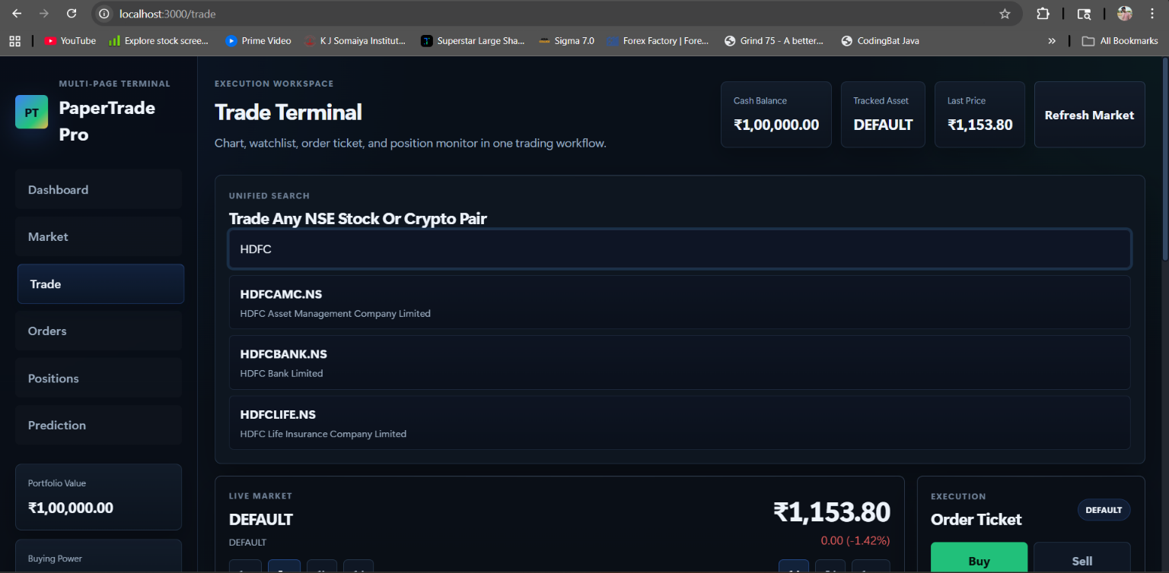
(Fig. 4.4 Trading Workspace Interface)
This figure displays the integrated trading environment including order panel, and tickets.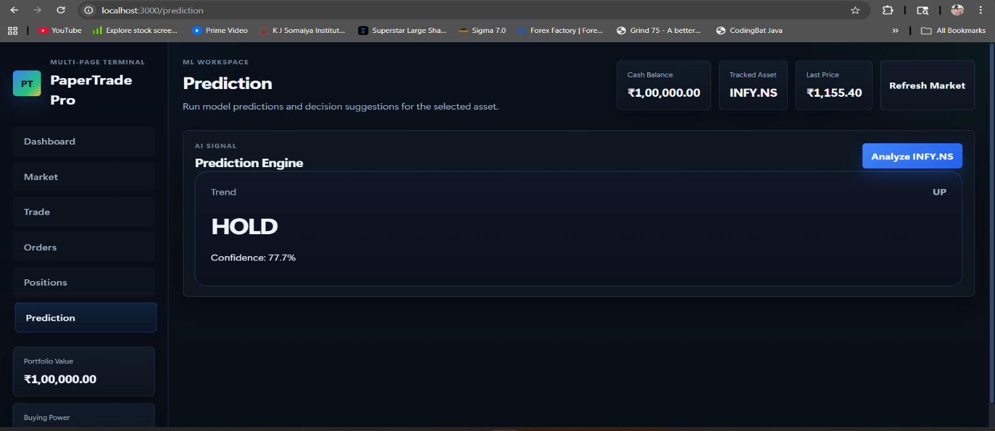
(Fig. 4.5 AI-Based Trading Prediction Panel)
This figure displays the AI-driven prediction interface showing prediction and confidence.

4.4 Conclusion
The system has been partially implemented with a working frontend interface, backend APIs, and database integration. MongoDB is successfully connected and used to store user data, orders, and trades. The C++ matching engine is operational and handles order execution using price-time priority.
The platform supports dynamic data fetching for Indian stocks, enabling candlestick chart visualization. The user interface has been enhanced to resemble modern trading platforms, with proper page separation and improved user experience. Although some components such as authentication, database integration, and prediction models are yet to be completed, the current progress validates the overall design and feasibility of the system. The project is expected to evolve into a fully functional platform that provides a realistic and intelligent trading simulation environment for users.

References

[1] Z. Zhang, S. Zohren, and S. J. Roberts, “DeepLOB: Deep Convolutional Neural Networks for Limit Order Books,” IEEE Transactions on Signal Processing, vol. 67, no. 11, pp. 3001–3012, Nov. 2019.
[2] A. Ntakaris, G. Iosifidis, S. Zohren, and M. Kanniainen, “Benchmark Dataset for Mid-Price Forecasting of Limit Order Book Data with Machine Learning Methods,” International Journal of Forecasting, vol. 37, no. 8, pp. 852–866, Dec. 2018.
[3] A. Tsantekidis, G. Passalis, D. Tzelepis, et al., “Forecasting Stock Prices from the Limit Order Book Using Convolutional Neural Networks,” in Proc. IEEE 19th Int. Conf. on Business Informatics, 2017, pp. 125–132.
[4] “Predicting Stock Market Trends Using Long Short-Term Memory (LSTM) Networks: A Deep Learning Approach for Financial Time-Series Forecasting,” IEEE Xplore, 2025.
[5] “Time Series Forecasting in Financial Market: Long Short-Term Memory (LSTM) Approach for Stock Price Prediction,” IEEE Xplore, 2025.
[6] Y. Xiao, M. Chen, H. Li, et al., “LiT: Limit Order Book Transformer for Short-Term Market Predictions,” Frontiers in Artificial Intelligence, 2025.
[7] Y. Wu, M. Mahfouz, D. Magazzeni, and M. Veloso, “Towards Robust Representation of Limit Order Books for Deep Learning Models,” arXiv preprint, 2021.
[8] A. Ntakaris, A. Tefas, J. Kanniainen, et al., “Feature Engineering for Mid-Price Prediction with Deep Learning,” arXiv preprint, 2019.
[9] “Forecasting and Prediction Using Deep Learning in Financial Markets – CNN-LSTM Approach,” IEEE Xplore, 2025.
[10] K. Brown and A. Johnson, “Optimization Techniques for WebSocket-Based Real-Time Communication Systems,” IEEE Transactions on Network and Service Management, 2024.

