1. INTRODUCTION

1.1 Background
Corticosteroids are a class of medications used to treat a wide range of health conditions such as asthma, allergies, arthritis, and autoimmune diseases. In Australia, these medicines are subsidised through the Pharmaceutical Benefits Scheme (PBS), making them both accessible and trackable in terms of government expenditure.
Understanding how much the government spends on corticosteroids over time is important for policymaking and resource allocation. Since medical usage tends to show patterns, such as higher demand in winter months, time series analysis provides a useful framework to identify and forecast these seasonal and trend-based behaviours.
This report applies time series modelling techniques to monthly PBS corticosteroid expenditure data from July 1991 to June 2008. The goal is to find a model that captures the main patterns in the data and can provide accurate predictions for the next 10 months.

1.2 Research Question
What is the most accurate SARIMA model for forecasting the next 10 months of PBS corticosteroid expenditure in Australia?

1.3 Aim and Objectives
The aim of this report is to analyse, model, and forecast government spending on corticosteroids using time series methods. The key objectives are:
- To explore and visualise the long-term patterns in monthly corticosteroid expenditure.
- To identify any non-stationarity and apply transformations if needed.
- To build SARIMA models using the residual-based approach.
- To compare candidate models using AIC, BIC, and forecast accuracy metrics.
- To evaluate model assumptions, residuals, and parameter significance.
- To select the best model and generate a 10-month forecast with confidence intervals.

1.4 Significance of the Study
Accurate forecasting of medical expenditure helps healthcare planners manage budgets, anticipate seasonal demand, and make informed decisions. This study demonstrates how time series modelling, particularly SARIMA, can be used to analyse real-world healthcare data in a structured, statistically sound way. The methods applied here can also be adapted to other types of public expenditure or service demand forecasting.

2. METHODOLOGY

2.1 Data Source
The dataset used in this report is the h02 time series, available in the fpp2 R package. It records monthly PBS government expenditure (in millions of AUD) on corticosteroids in Australia from July 1991 to June 2008. The data contains no missing values and is pre-formatted as a time series object with a monthly frequency.

2.2 Software and Tools
All analysis was conducted using R. The following R packages were used:
- forecast – for fitting SARIMA models and generating forecasts
- TSA, tseries – for ACF, PACF, EACF, and stationarity tests
- lmtest – for z-tests and model diagnostics

2.3 Helper Functions
To simplify the workflow, several helper functions were included at the start of the code:
- sort.score() was used to sort models by AIC or BIC values.
- residual.analysis() created diagnostic plots including ACF, Q-Q, histogram, and Ljung–Box checks.
- seasonal_acf() and seasonal_pacf() highlighted seasonal lags in red, making it easier to identify repeating patterns in ACF/PACF plots.
These small additions made model evaluation and checking much more efficient during the project.

2.4 Exploratory Data Analysis
An initial time series plot was generated to understand the data structure. Key observations:
- A general upward trend in expenditure over the years
- Strong seasonality, higher spending during colder months (winter)
- Slight increase in variance over time

2.5 Data Transformation and Stationarity
- Log transformation was considered but not applied, as variance was not highly unstable.
- Seasonal differencing (D = 1) was applied to remove strong yearly seasonality.
- ADF test and visual inspection of the differenced series confirmed stationarity.
- Residual normality was checked using Q-Q plots and the Shapiro-Wilk test.

2.6 Model Specification (Residual Approach)
Instead of guessing model orders using the classical method, a residual-based specification approach was used:
- Applied seasonal differencing and checked residuals from a basic model.
- Identified the seasonal AR and MA orders (P and Q) using residual ACF and PACF plots.
- Applied ordinary differencing if needed to remove trend.
- Determined non-seasonal orders (p and q) based on early lags in ACF/PACF.
- Explored nearby models using the EACF table and BIC plot.
- Evaluated multiple models using a combination of statistical tools.

2.7 Model Estimation
Each candidate SARIMA model was fitted using two estimation methods:
- Maximum Likelihood (ML) – preferred for its robustness and precision
- Conditional Sum of Squares (CSS) – used for cross-checking consistency
The Arima() function from the forecast package was used to fit models. Parameter significance was tested using coeftest().

2.8 Model Comparison and Selection
Each fitted model was compared based on:
- AIC and BIC for fit and complexity
- Accuracy metrics like RMSE, MAE, MAPE, and MASE
- Residual diagnostics: normality (Shapiro-Wilk), randomness (Ljung-Box), and ACF plots
- Parameter significance based on z-tests under ML and CSS
The best model was selected based on a combination of these criteria.

2.9 Forecasting
The final selected model was used to forecast the next 10 months of corticosteroid expenditure, from July 2008 to April 2009. Forecasts were presented as point estimates along with 80% and 95% confidence intervals, both visually (plot) and in a summary table.

3. RESULTS

3.1 Descriptive Analysis of Data
This section explores the structure and characteristics of the raw dataset before any modelling is done. We begin by looking at the raw values and format, then check basic statistics, and finally examine a time plot to understand patterns like trend, seasonality, or changing variation. These observations help us decide what kind of modelling approach might be suitable.

3.1.1 Initial Observations from Raw Data
The dataset used contains monthly government spending on corticosteroids in Australia under the PBS (Pharmaceutical Benefits Scheme). It covers the period from July 1991 to June 2008, giving a total of 204 months of data. The data is measured in millions of Australian dollars (AUD) and comes from the fpp2 package in R, stored in a time series object called h02.
A quick check using str() and summary() confirmed that the data was clean, numeric, and did not contain any missing values. Since the dataset was already stored as a ts object with monthly frequency (12), no conversion or formatting was needed at this point.
We started our exploration with the raw data in its original form, without any transformations applied.

3.1.2 Summary Statistics of the Time Series Object
To understand the distribution of values in the series, we used the summary() function in R. The output gave the following key figures:
- Minimum: $0.34 million
- 1st Quartile: $0.59 million
- Median: $0.75 million
- Mean: $0.77 million
- 3rd Quartile: $0.94 million
- Maximum: $1.26 million
These values show that the distribution is slightly right skewed, the mean is a bit higher than the median, meaning a few large values (especially in later years) pull the average up. The difference between the lowest and highest values also suggests that government spending has grown noticeably over time.

3.1.3 Visual Exploration of the Raw Time Series

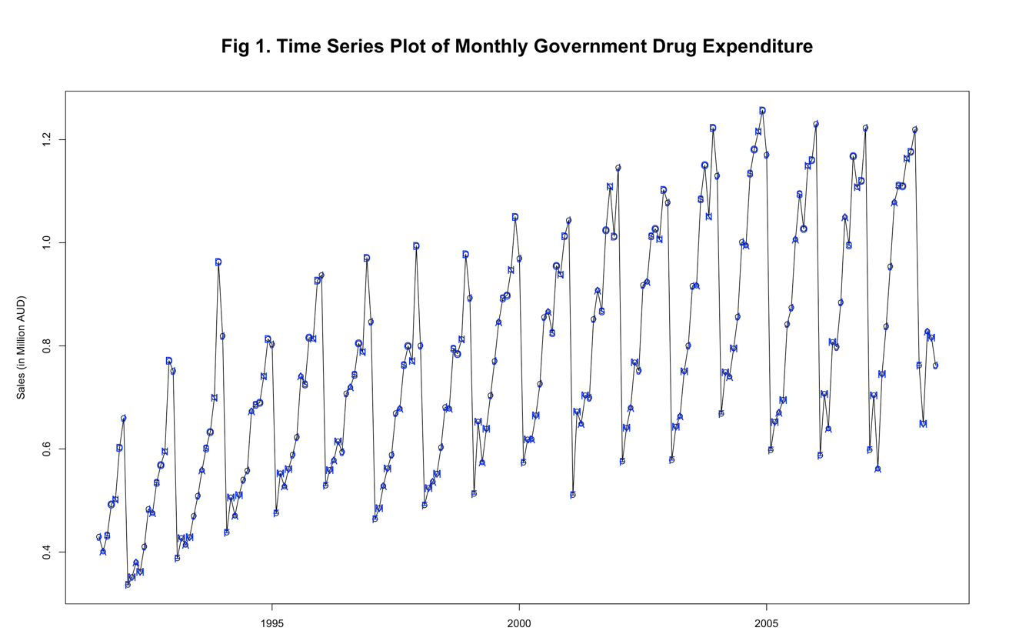

A line plot of the full time series (see Fig 1) gives us a clearer view of how the data behaves over time.
1. Trend: Yes. The time series clearly shows an upward trend in government spending on corticosteroids over time. This increase is steady and consistent from 1991 to 2008, with no sudden jumps or reversals. The rising pattern likely reflects growing medical demand, broader PBS coverage, or general cost increases in healthcare.
2. Seasonality: Yes. There is a very clear and regular seasonal pattern. Spending tends to rise at around the same time each year — most likely during winter months. This repeating cycle is strong and consistent throughout the entire time period.
3. Changing Variance: Yes, but not by much. The amount of variation (or spread) in the data seems to increase slightly over time, especially in the later years. However, this change is small and not a major issue. The overall range of values stays fairly stable, and there's no strong need to apply a transformation to fix variance.
4. Behaviour: Indefinite. Since there’s both a trend and strong seasonal cycles, it’s hard to tell just by looking whether the series is more autoregressive (AR) or moving average (MA). We’ll need to use tools like ACF and PACF to understand the behaviour more clearly.
5. Change Point: No clear change. There are no big breaks or sudden shifts in the pattern. The trend and seasonality remain stable over time, which suggests the data is structurally consistent and not affected by external changes like new policies or shocks.
Overall, the series shows clear signs of both trend and seasonality, along with some change in variance. These features suggest that seasonal time series modelling approaches, like SARIMA, may be appropriate. However, we will first check the stationarity and apply any needed transformations before settling on the final modelling technique.
3.1.4 Autocorrelation Between Consecutive Time Points
To assess how strongly current values depend on the previous month, a scatter plot was created between each observation Yt and its lagged value Yt−1.

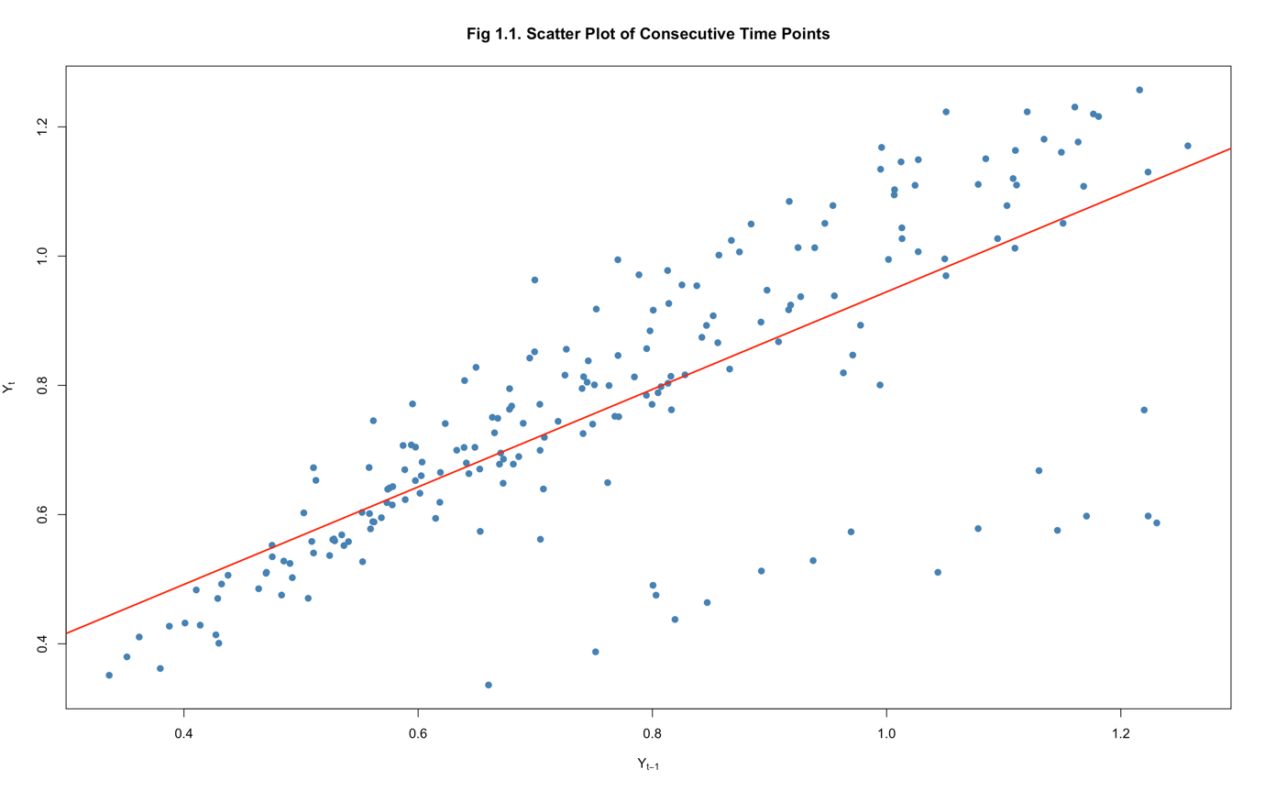

As shown in Figure 1.1, the points form a strong upward linear pattern, indicating a clear positive relationship between consecutive time points. This suggests the presence of strong lag-1 autocorrelation in the data.
The fitted red line confirms this linear trend, meaning the series carries forward momentum from past values an important feature that justifies the inclusion of autoregressive (AR) terms in later model building.

3.2 Preliminary Statistical Checks
Before choosing a transformation or modelling approach, we ran some basic statistical checks to understand how the original series behaves. These included checking for autocorrelation, stationarity, and normality.

3.2.1 Autocorrelation and Stationarity
In the ACF plot (Fig 2), we observe a slowly decaying pattern with a very clear cyclical structure. The red vertical bars appear regularly every 12 lags, these correspond to seasonal spikes and confirm the presence of a strong seasonal pattern in the data.
Meanwhile, the plot (Fig 3) shows a very high first lag PACF, followed by a sharp drop. This kind of shape often suggests presence of an autoregressive (AR) component, particularly at non-seasonal level.
To confirm things statistically, we used the Augmented Dickey-Fuller (ADF) test. The test returned a statistic of –9.5147 with a p-value of 0.01, suggesting the series is stationary. However, due to the clear visual signs of non-stationarity from both ACF and PACF, we decided not to rely on ADF result alone.

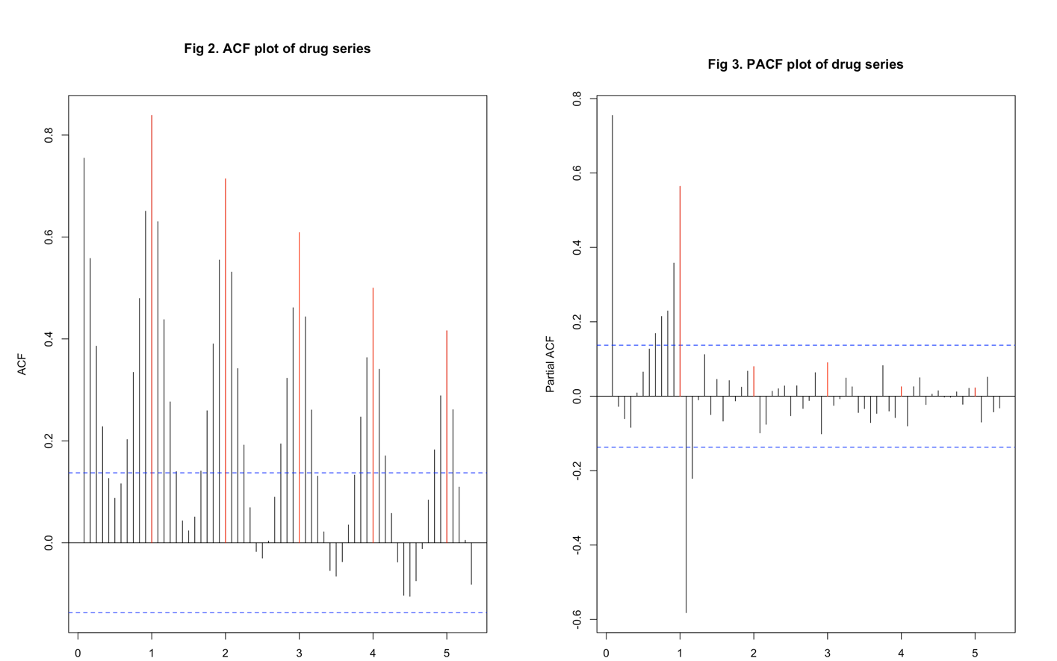

In practice, when we see strong and long autocorrelation patterns in ACF and very dominant spikes in PACF, we consider these as strong evidence that differencing may still be needed, especially if there is a seasonal structure involved. So even though the ADF test was significant, we treated the series as effectively non-stationary at this stage.

3.2.2 Normality Check
To check whether the original series followed a normal distribution, we used a Q-Q plot (Fig 4) and the Shapiro-Wilk test. The Q-Q plot shows noticeable curvature at both ends, especially in the tails, which indicates that the distribution of the data deviates from normality.
The Shapiro-Wilk test result gave a W value of 0.9720 with a p-value of 0.00043, confirming that the data is not normally distributed. This is important to note because non-normality can impact the performance of residual diagnostics in time series models.

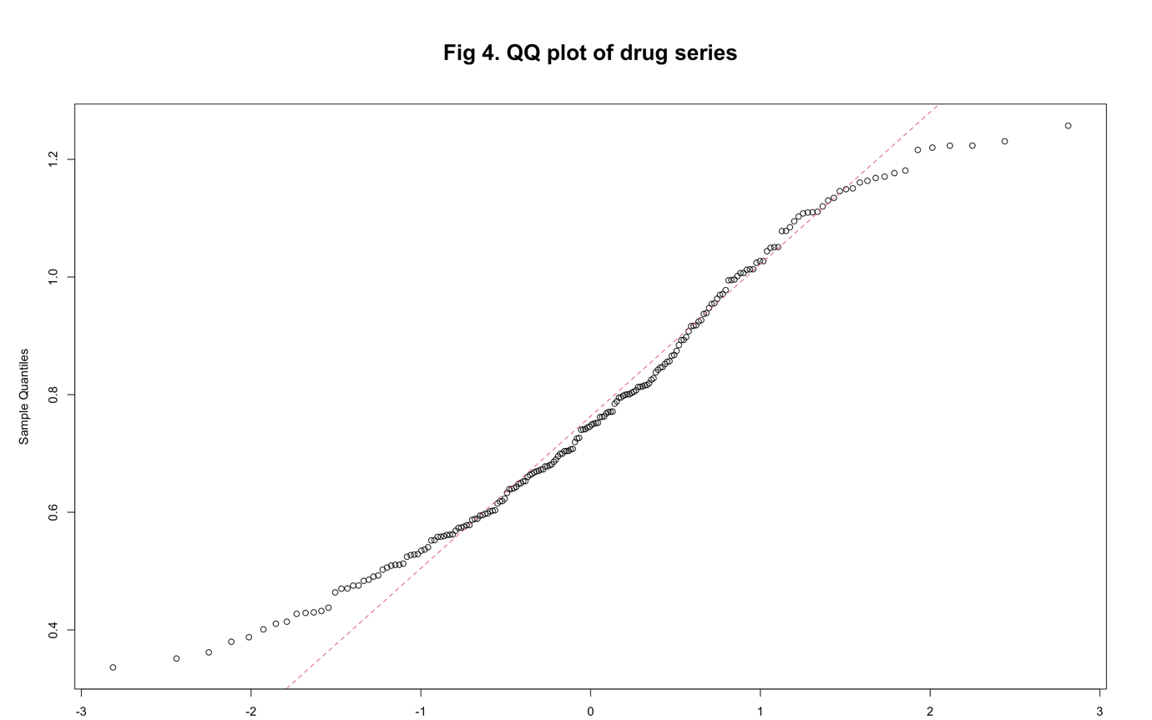

To sum up what we found from these checks:
1. There is strong autocorrelation, especially at regular seasonal lags. This means current values are clearly linked to past values, particularly those 12 months apart.
2. Stationarity is a bit mixed. The ADF test says the series is stationary, but the ACF and PACF plots still show signs of seasonality and structure, so we treated it with caution.
3. The data is not normally distributed, as confirmed by the Q-Q plot and the Shapiro-Wilk test. The shape of the data doesn't match a bell curve.
Since we’re seeing strong repeating seasonal patterns and the series doesn't follow a normal distribution, a Seasonal ARIMA (SARIMA) model looks like a good choice going forward.
3.3 Model Specification Using: Residual Approach

In this section, we apply the residual approach to build a good SARIMA model step-by-step for the PBS corticosteroid expenditure time series. Unlike the classical method where the model is chosen all at once using automated criteria like AIC, the residual method builds up the model gradually by checking the leftover structure in the residuals after each step.
This approach is helpful because it makes the process more transparent, at every step, we ask: "Did we capture enough structure, or is something still missing?" If there’s still a pattern left in the residuals, we know it needs to be fixed in the next model.

Here’s how the residual approach works in general:
- We begin by applying seasonal differencing (D = 1) to remove the regular repeating yearly cycles from the data.
- A simple starting model is fitted, and its ACF and PACF plots of residuals are used to check whether seasonality has been removed. If red bars (seasonal lags) are still present, this tells us we need to adjust the seasonal AR (P) and/or seasonal MA (Q) terms.
- If those seasonal lags are persistent, we consider other ways to handle them, like applying a log transformation, Box-Cox transformation, or ordinary differencing, rather than simply increasing P and Q, which would make the model unnecessarily complex.
- Once the seasonal part looks handled, we move on to the ordinary part. We check for stationarity using the ADF test, and if the series still looks non-stationary, we apply ordinary differencing (d = 1) to remove any remaining trend.
- Then, we examine the black bars in the ACF/PACF before the first seasonal bar to determine how many non-seasonal AR (p) and MA (q) terms are needed.
- After that, we fit refined models based on previous models, using their residuals to identify remaining structure that still needs explaining.
- To broaden our search, we use the EACF table and BIC plot, which help us find other possible p–q combinations that might work well.
- We fit these extra models, check their residuals, and if they look good, we might slightly overfit by increasing either p or q by one, just to test if a more flexible model performs better.
Throughout this process, we aim to reach a point where the residuals are like white noise, no trend, no seasonality, and no autocorrelation left behind. That tells us our model has captured all the important structure in the data.

This section is split into smaller parts for each model tested during this residual-based procedure:
- 3.3.1: Initial seasonal differencing (m1)
- 3.3.2: Adding SARMA terms to capture seasonal AR/MA (m2)
- 3.3.3: Ordinary differencing to remove trend (m3)
- 3.3.4: Full SARIMA model after identifying ARIMA components (m4)

3.3.1 Initial seasonal differencing (m1)
To begin the model-building process, we applied seasonal differencing (D = 1) to remove the strong and regular seasonality observed in the original drug expenditure series. At this stage, we fitted a very simple ARIMA model with no AR MA terms, this is written as:
- ARIMA(0,0,0)(0,1,0)[12], and we called it model m1.
This model includes:
- Seasonal differencing (D = 1)
The idea here was not to fully model the series right away, but to reduce the seasonal pattern and check what kind of signal was left behind in the residuals. If most of the repeating seasonal cycles were removed, we would expect the residuals to behave more randomly.

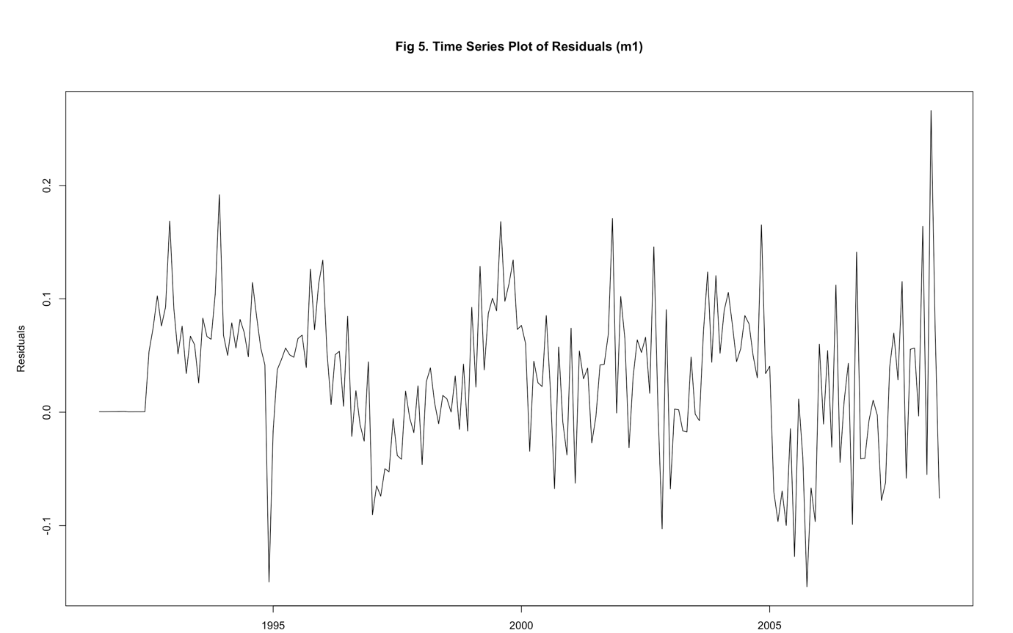

As shown in (Fig 5) the time plot of residuals still displays visible structure, residuals fluctuate in a somewhat consistent pattern rather than randomly. This indicates that the model hasn’t captured all of the seasonal dynamics yet.

To assess this further, we looked at the ACF and PACF plots of residuals in Figures 6 and 7:
- In the ACF plot (Fig 6), we see a strong red spike at lag 12. Red bars like these show seasonal effects, and this one suggests we need to include a seasonal moving average (MA) term, so we set Capital Q = 1.
- In the PACF plot (Fig 7), there are two red spikes at lag 12 and lag 24. This points to the need for a seasonal autoregressive (AR) component, so we chose Capital P = 2.

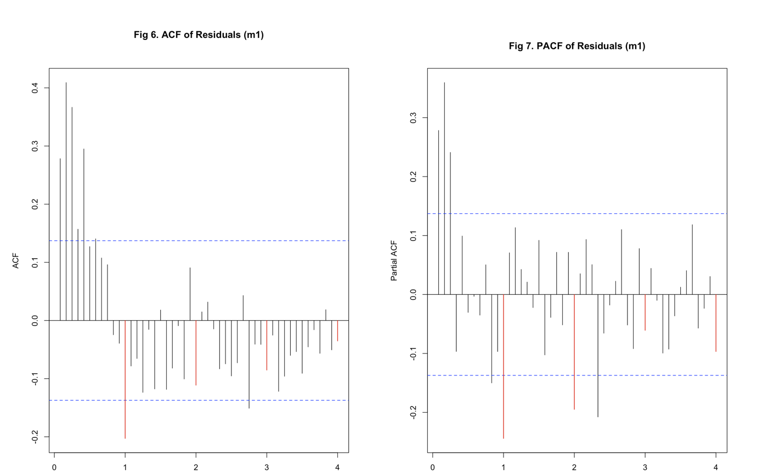

Also, an important thing to notice is that the large spike at lag 1 in the PACF (which we saw earlier before differencing) is now gone. This tells us the seasonal differencing worked; it removed some of the repeating structure.
In summary, model m1 helped reduce seasonality using differencing, but the residuals still contain some seasonal signals. Based on the ACF and PACF plots, we will now add seasonal AR and MA terms to build the next model (m2).

3.3.2 Adding SARMA terms to capture seasonal AR/MA (m2)
Based on the insights gained from the first model (m1), we proceeded to enhance the model by directly including seasonal AR and MA terms. These components were chosen based on the strong seasonal red bars observed in the residual ACF and PACF plots of m1. So, we built a new model specified as:
- ARIMA(0,0,0)(2,1,1)[12], and we called it model m2.
This model includes:
- Seasonal AR terms (P = 2)
- Seasonal MA terms (Q = 1)
- Seasonal differencing (D = 1)
The goal here was to explicitly model the seasonal autocorrelation that was left over in m1’s residuals. If successful, this would make the residuals more random and remove the seasonal pattern.

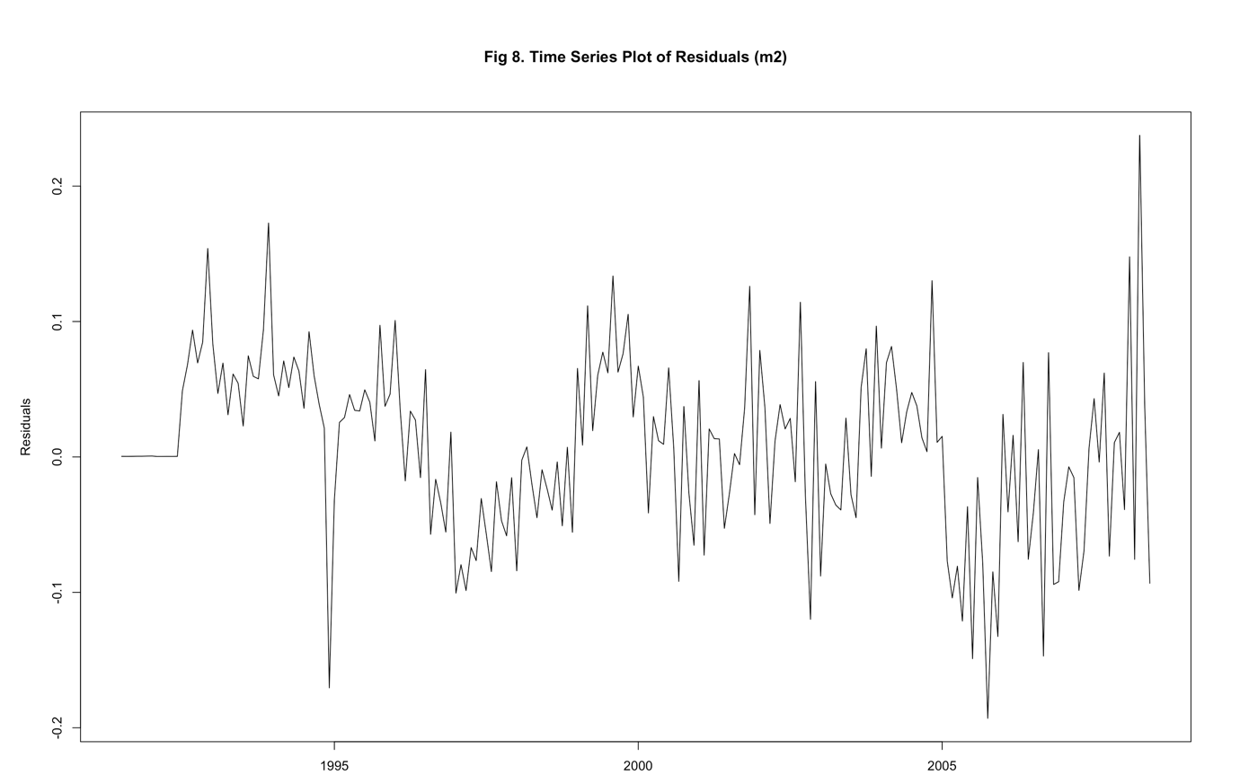

As shown in (Fig 8), the time plot of residuals from m2 appears slightly less structured compared to m1, but still not completely random. Some subtle repeating patterns are still noticeable.

To assess this further, we looked at the ACF and PACF plots of residuals in Figures 9 and 10:
- In the ACF plot (Fig 9), the seasonal red bar is almost gone, only one slight “near miss” remains. This tells us that the seasonal MA component has mostly done its job.
- In the PACF plot (Fig 10), however, we still see two clear red bars at seasonal lags (likely at lag 12 and 24), which means some seasonal structure is still not fully captured.

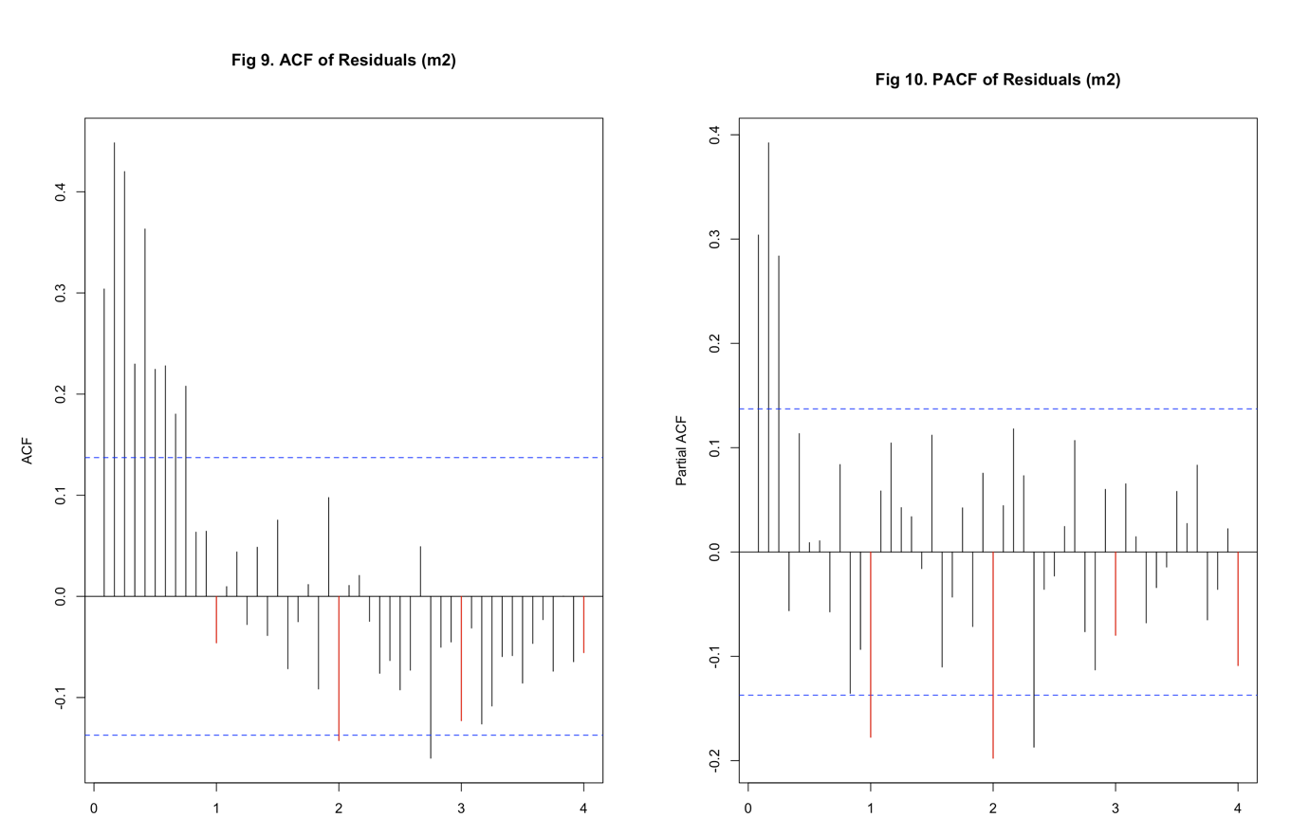

At this point, rather than increasing P and Q further (which would make the model more complex and add more parameters), a better strategy is to apply ordinary differencing (d = 1) in the next model. This can help us remove any leftover trend or low-frequency structure and may clean up the remaining seasonal noise too.
So, while model m2 handled part of the seasonal component well, there’s still some leftover structure, especially in the PACF. We will now move forward with applying ordinary differencing and testing for non-seasonal AR/MA structure in the next step (m3).

3.3.3 Ordinary differencing to remove trend (m3)
After adding the seasonal AR and MA terms in model m2, some of the seasonal effects were addressed, but the residuals still didn’t look completely random, especially based on the red seasonal bars in the PACF plot. Instead of making the seasonal part more complex by increasing Capital P and Q further, we decided to try a different approach: removing trend using ordinary differencing.
So, for model m3, we applied one order of ordinary differencing (d = 1), while keeping the same seasonal structure from m2. The model now became:
- ARIMA(0,1,0)(2,1,1)[12], and we called it model m3.
This model includes:
- Seasonal AR terms (P = 2)
- Seasonal MA terms (Q = 1)
- Both seasonal and ordinary differencing (D = 1 and d = 1)
The goal here was to eliminate any trend left in the series and clean up the residuals further.

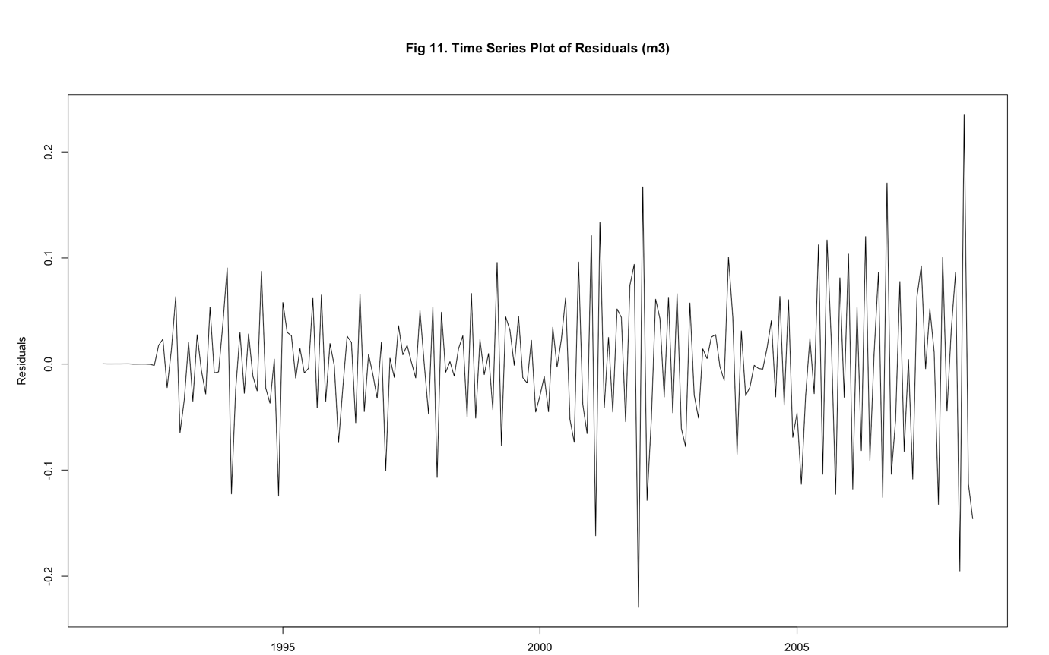

As shown in (Fig 11), the residuals from this model now look much more stable and balanced around zero compared to before. They don't show obvious repeating patterns or non-random movement, which is a good sign.

To assess this further, we looked at the ACF and PACF plots of residuals in Figures 12 and 13:
- In (Fig 12), the ACF plot no longer shows those strong red bars at seasonal lags. That means the seasonal lags are now handled well, great progress!
- In (Fig 13), the PACF also shows no significant seasonal spikes. Most of the bars lie within the blue significance bounds, except a few small ones, which we can treat as noise.

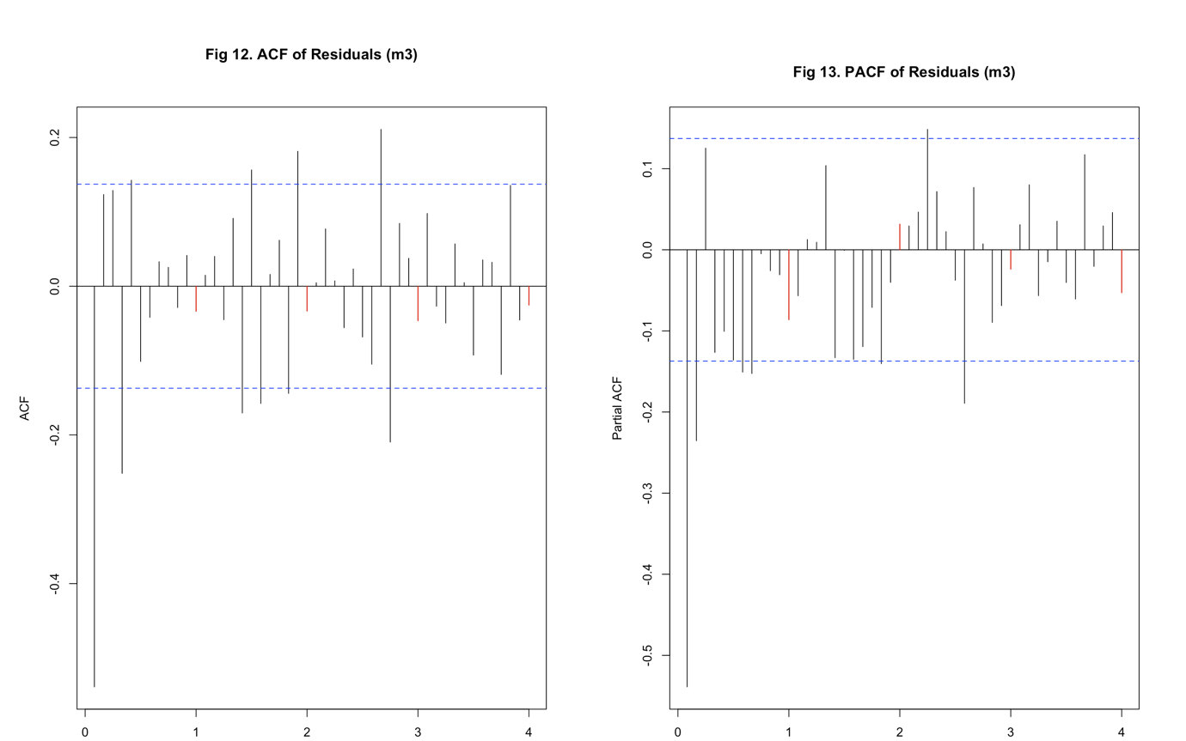

Now that the seasonal effects and trend have both been taken care of, it’s time to focus on the non-seasonal ARIMA component:
- From (Fig 12), we see 3 significant black bars before the first seasonal lag, this suggests we should set q = 3 for the moving average part.
- In (Fig 13), there are 4 significant black bars before the red seasonal bar, so we’ll go with p = 4 for the autoregressive part.
This helps us prepare for the next model (m4), where we will bring everything together: seasonal structure, ordinary differencing, and now the ARIMA(p,d,q) part. The aim is to check if this combination fully captures the structure of the series.

3.3.4 Full SARIMA model after identifying ARIMA components (m4)
After determining the seasonal (P, D, Q) and non-seasonal (p, d, q) components from earlier models, we now fit a complete SARIMA model that combines both structures. Based on the residual patterns from model m3, we decided to fit the following full model:
- SARIMA(4,1,3) × (2,1,1)[12], and we called it model m4.
This model includes:
- Seasonal AR terms (P = 2)
- Seasonal MA terms (Q = 1)
- Ordinary AR terms (p = 4)
- Ordinary MA terms (q = 3)
- Both seasonal and ordinary differencing (D = 1 and d = 1)
The goal here was to capture any remaining autocorrelation structure in the residuals from model m3 and ensure no strong seasonal or trend-related patterns were left unaccounted for.

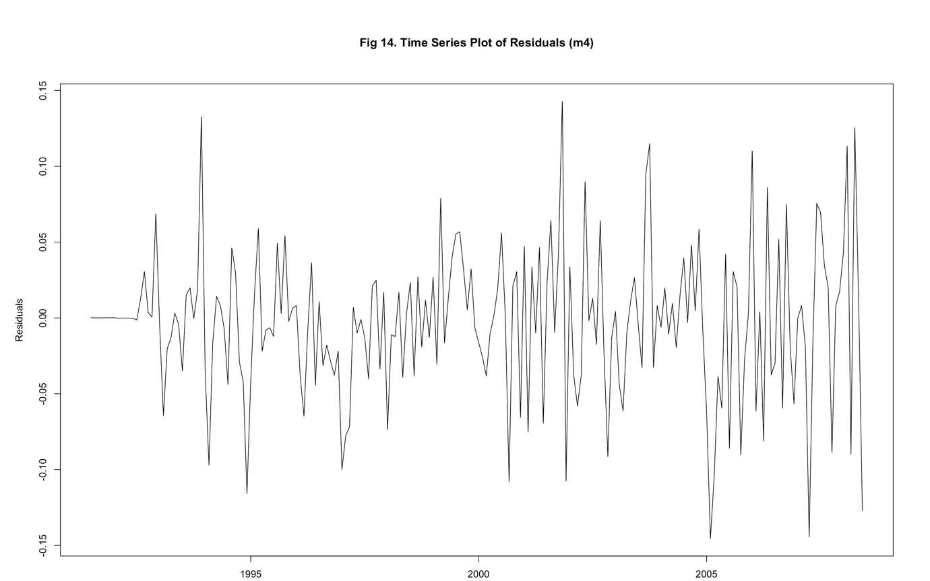

As shown in (Fig 14), the residual time series of m4 now appears much more stable and randomly scattered. There is no visible pattern or long-lasting wave, which is a good sign that the model has captured most of the important information from the original series.

To assess this further, we looked at the ACF and PACF plots of residuals in Figures 15 and 16:
- In the ACF plot, there are no major red spikes. A few small bars remain, but they stay within or near the confidence bounds and don’t show any seasonal repetition.
- In the PACF plot, the large early spikes are gone. Only a few weak lags remain visible. These could be due to mild outliers or just natural randomness in the data.
These results confirm that m4 has done a good job overall in handling both the seasonal and non-seasonal structures.

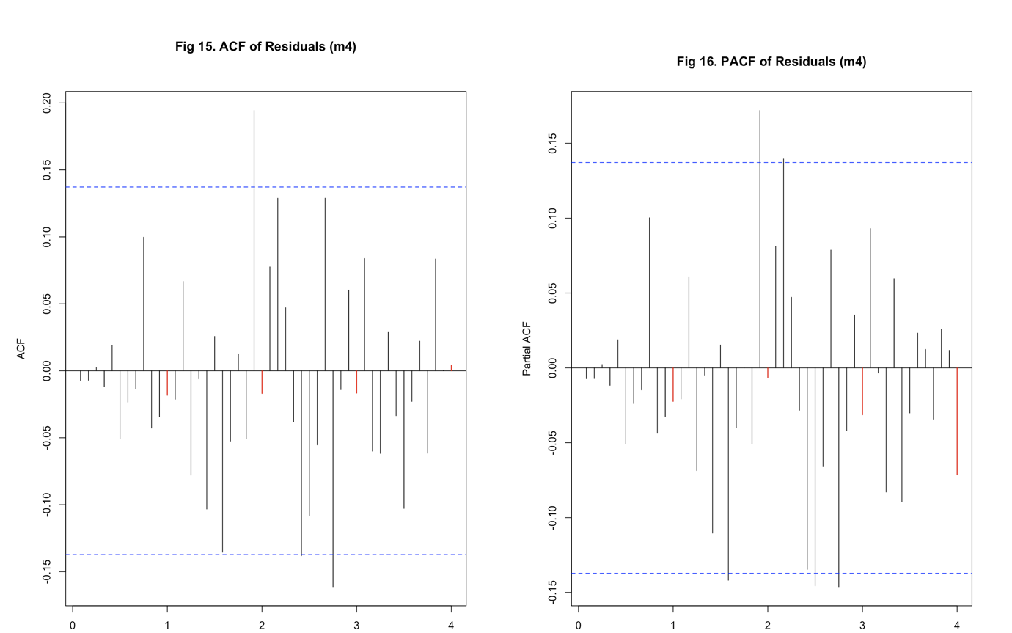

That said, if we want to explore further, we could push the AR order (p) slightly higher to 5 or 6, because in (Fig 15), around six minor bars still show up before the seasonal cutoff (lag 12). Similarly, the MA order (q) could also go up to 5 based on what’s left in the ACF.
But rather than guessing, we will now move on to explore model candidates using the EACF (Extended ACF) and BIC table, which provide more systematic ways to test nearby combinations and avoid unnecessary complexity.

3.4 Model Specification Using: EACF

Fig 17. EACF Matrix

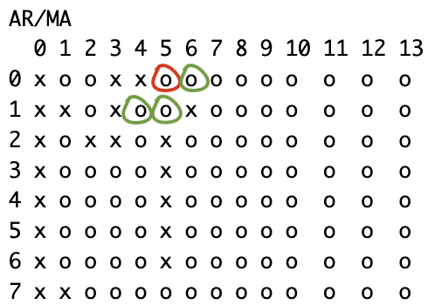

After fitting model m4, we observed that the residuals looked fairly clean, meaning the model had already captured most of the structure in the data. However, to explore alternative models and ensure we aren't missing any potentially better combinations, we followed a common step in the residual approach: go one step back and analyse the residuals of model m3. This is because residuals from m3 still showed some leftover signal, making them useful for identifying other good ARMA structures.
To do this, we use the Extended Autocorrelation Function (EACF) table, a grid-based tool that helps identify suitable values of non-seasonal AR (p) and MA (q) terms for ARIMA models. In the EACF table, each cell represents a different (p, q) combination, and cells marked with "o" indicate combinations that may work well.
As shown in (Fig 17), the top-left 'o' appears at (p = 0, q = 5), this becomes our starting point. From there, we examine nearby cells, especially those (circled in green), to find additional candidate models:
- → (p = 1, q = 5) — one step directly below
- → (p = 1, q = 4) — diagonally left-down
- → (p = 0, q = 6) — one step to the right
Based on this, we identified the following tentative SARIMA models:
- SARIMA(0,1,5)×(2,1,1)[12]
- SARIMA(1,1,5)×(2,1,1)[12]
- SARIMA(1,1,4)×(2,1,1)[12]
- SARIMA(0,1,6)×(2,1,1)[12]
These models strike a balance between fitting the data well and avoiding unnecessary complexity, since they're close to a clean “o” region in the EACF.
In the next section, we’ll explore the BIC table, which provides another way to assess model quality based on a broader scan of AR and MA combinations. This step will help confirm whether any of the above models are optimal or whether better alternatives exist.

3.5 Model Specification Using: BIC TABLE

Fig 18. BIC Plot

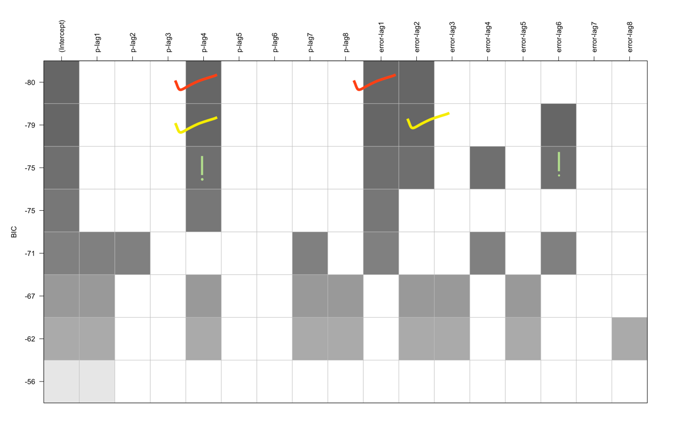

While the EACF approach in the previous section helped us identify a few good candidate models based on the autocorrelation structure, we now take a more data-driven route using the Bayesian Information Criterion (BIC).
The BIC table (shown in Fig 18) compares a large number of possible ARIMA(p,d,q) model combinations. Each square in the plot represents a different combination of p (AR lags) and q (MA lags). The darker the cell, the lower the BIC value, which means the model gives a better balance between accuracy and simplicity. In general, a lower BIC is considered better.
From this plot, we can see two of the darkest cells, highlighted with red and yellow ticks, indicating the best models according to BIC:
- SARIMA(4,1,1)×(2,1,1)[12] → Corresponds to p-lag4 & error-lag1 (marked in red)
- SARIMA(4,1,2)×(2,1,1)[12] → Corresponds to p-lag4 & error-lag2 (marked in yellow)
These two model combinations were not only ranked best by BIC, but are also supported by multiple neighboring cells in the plot, meaning they’re surrounded by other reasonable models, which adds confidence.
We also noticed another combination at p-lag4 and error-lag6 (marked with exclamatory sign!) that had a relatively low BIC. However, this involves a late MA lag (q = 6), which can lead to overfitting and is not supported by nearby cells in the plot. Therefore, we excluded that option and focused on the more stable choices.
3.6 Final Candidate Models and Evaluation
After exploring potential model structures using both the EACF table and the BIC plot, we now turn to evaluating the full set of seven SARIMA models that showed the most promise. These include:
- SARIMA(4,1,3)×(2,1,1)[12] – our m4 model based on residual inspection
- SARIMA(0,1,5)×(2,1,1)[12] – identified via EACF
- SARIMA(1,1,5)×(2,1,1)[12] – identified via EACF
- SARIMA(1,1,4)×(2,1,1)[12] – identified via EACF
- SARIMA(0,1,6)×(2,1,1)[12] – identified via EACF
- SARIMA(4,1,1)×(2,1,1)[12] – selected via BIC table
- SARIMA(4,1,2)×(2,1,1)[12] – selected via BIC table
In this section, we will:
- Fit each of the models using both Maximum Likelihood (ML) and Conditional Sum of Squares (CSS) estimation methods
- Check the significance of coefficients using the coeftest() function
- Evaluate residual diagnostics using plots and statistical tests
- Compare all models based on:
  - AIC (Akaike Information Criterion)
  - BIC (Bayesian Information Criterion)
  - Accuracy metrics such as RMSE, MAE, and MAPE
This comprehensive evaluation will help us identify the most efficient and well-behaved model, ensuring it explains the patterns in the data without overfitting.

3.6.1 Fitting SARIMA Models (ML and CSS)
In this section, we start fitting each of the final SARIMA models identified through the earlier residual analysis, EACF, and BIC selection steps. Our main goal here is to evaluate the structure of each model before moving on to comparisons. Each model is fitted using two common estimation methods:
- Maximum Likelihood (ML): This is the primary method we rely on, as it tends to give more precise parameter estimates and is generally preferred for forecasting.
- Conditional Sum of Squares (CSS): This method is also applied to cross-check the key results from ML. It’s helpful to ensure consistency, especially for identifying which parameters remain statistically significant.
For now, we focus on three main tasks for each model:
- Checking coefficient significance using the coeftest() function, to understand which AR and MA terms are important
- Examining residual plots from the ML model to confirm that the model has captured most of the structure, leaving behind residuals that look random
- Confirming findings with CSS fits to make sure significant terms remain consistent across methods
Note: This section is only about fitting the models and understanding their behaviour. We are not yet comparing them using AIC, BIC, or forecast accuracy, that will follow in the next steps.
1. SARIMA(4,1,3)×(2,1,1)[12] Fig 19. Residuals(4,1,3)
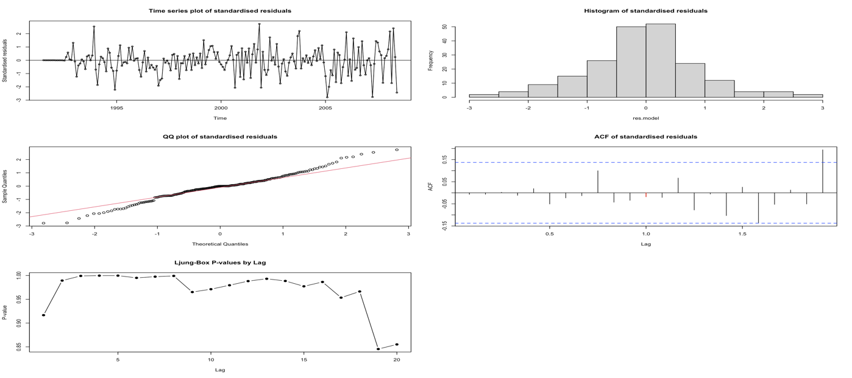
Only two terms were significant under ML, and CSS showed similar results. For example, AR(1) was marginally significant with CSS, but MA(1) was not. The Q-Q plot and histogram showed some deviation from normality, which was confirmed by the Shapiro-Wilk test (p = 0.0057). The Ljung-Box test showed no major autocorrelation in residuals. However, overall, the model felt a bit overfitted with too many weak terms. Simpler options may perform better.

2. SARIMA(0,1,5)×(2,1,1)[12] Fig 20. Residuals(0,1,5)
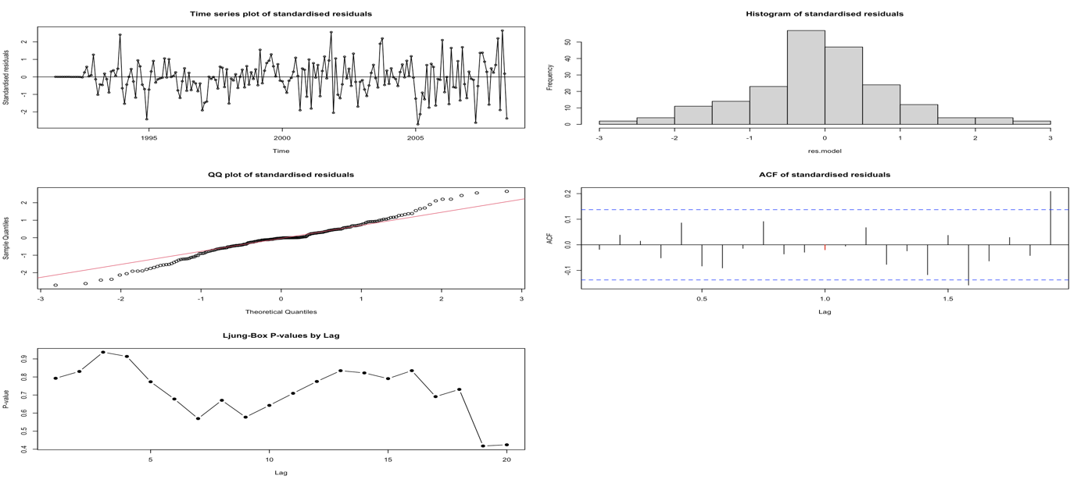
Several terms were significant under ML, including MA(1), MA(4), and seasonal terms. CSS supported most of these too, though with slight shifts in which terms stood out more. For instance, MA(2) was only significant under CSS. The Q-Q plot and histogram showed slight deviations from perfect normality, and the Shapiro-Wilk test (p = 0.0084) also confirmed non-normality. However, the Ljung-Box test showed no major autocorrelation. Overall, this model performed better than the previous one, with fewer weak terms and a more consistent residual pattern.

3. SARIMA(1,1,5)×(2,1,1)[12] Fig 21. Residuals(1,1,5)
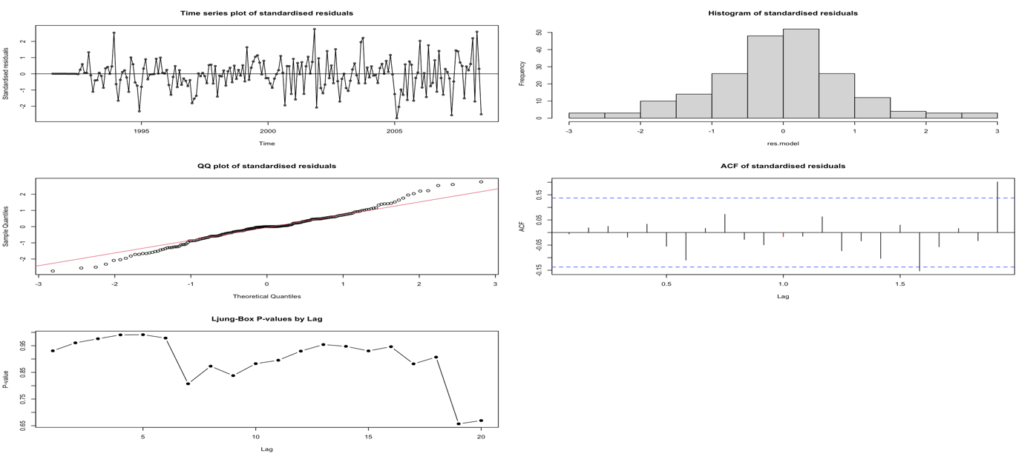
Several terms were significant under ML, including AR(1), MA(4), and seasonal terms SAR(2) and SMA(1). CSS results were generally consistent, though MA(1) became significant while SMA(1) lost significance. The residuals showed a fairly normal shape in the Q-Q plot and histogram, with some slight skewness. The Shapiro-Wilk test (p = 0.0086) confirmed mild non-normality. Ljung-Box results indicated no serious autocorrelation. Overall, this model performed well, with fewer weak terms and good residual behaviour, making it a strong candidate.

4. SARIMA(1,1,4)×(2,1,1)[12] Fig 22. Residuals(1,1,4)
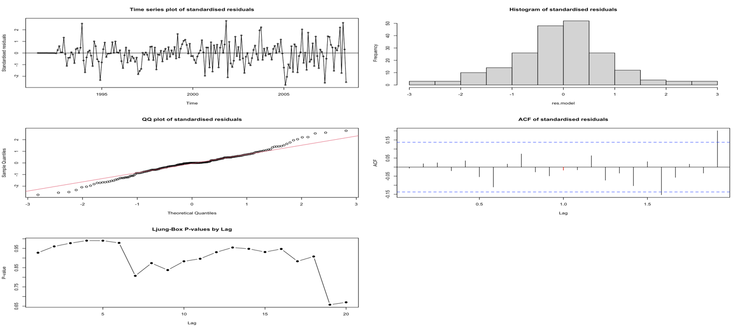
This model had a few strong terms. Under ML, AR(1), MA(4), SAR(2), and SMA(1) were significant. CSS results supported AR(1), MA(4), and SAR(2), and even showed MA(1) and MA(3) as significant. The Q-Q plot and histogram looked reasonably normal with minor skew, and the Shapiro-Wilk test (p = 0.0086) confirmed mild non-normality. Ljung-Box results didn’t show major issues. Overall, the model captured the structure well, and CSS agreement suggests stability in key parameters. A solid model with a good balance of fit and parsimony.
5. SARIMA(0,1,6)×(2,1,1)[12] Fig 23. Residuals(0,1,6)
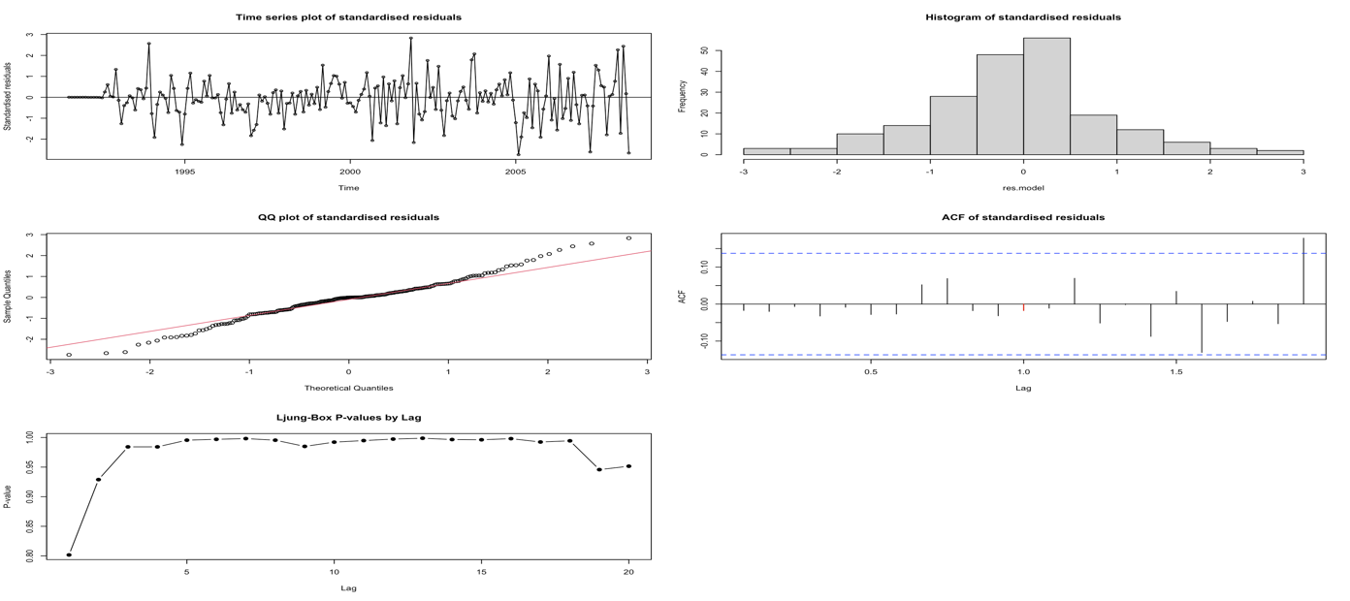
This model performed quite well. Under ML, five of the six MA terms were significant, and CSS confirmed all of them with even stronger z-values. SAR(2) and SMA(1) were also consistently significant across both methods. The Q-Q plot and histogram looked fairly normal, with slight deviation at the ends. The Shapiro-Wilk test returned a p-value of 0.0036, showing mild non-normality. Residuals showed no major autocorrelation in the Ljung-Box test. Overall, this was a strong model, well-specified and backed by consistent CSS support.

6. SARIMA(4,1,1)×(2,1,1)[12] Fig 24. Residuals(4,1,1)
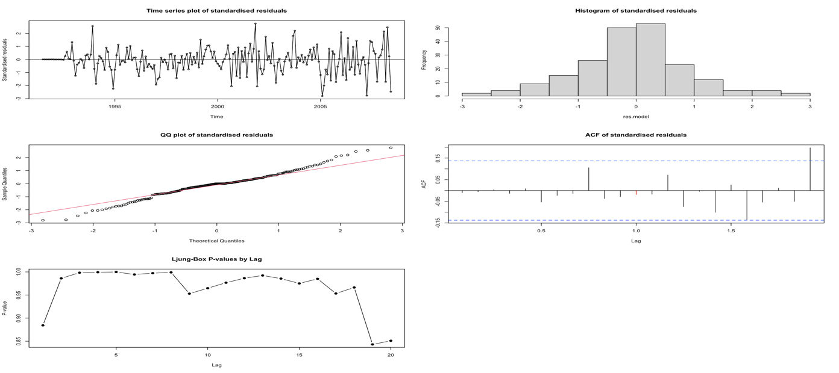
This was one of the best-performing models. Under ML, five terms were clearly significant and CSS confirmed all of them, showing consistent strength. The Q-Q plot and histogram looked very normal, and the Shapiro-Wilk test gave a low p-value (0.0067), showing slight non-normality but nothing too concerning. The Ljung-Box p-values stayed well above the threshold, confirming no residual autocorrelation. Overall, the model was well-balanced, effective, not overfitted, and captured the structure in the data nicely.
7. SARIMA(4,1,2)×(2,1,1)[12] Fig 25. Residuals(4,1,2)
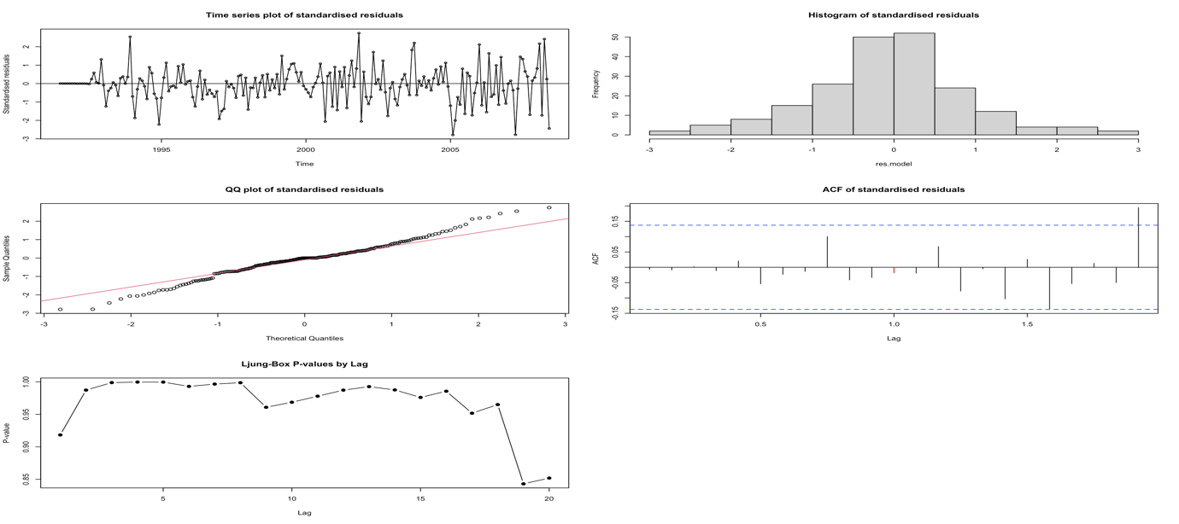
This model showed a good balance between complexity and performance. Under ML, four terms came out significant, and CSS confirmed three of those. The Q-Q plot and histogram looked close to normal, with some minor deviation. The Shapiro-Wilk test returned a p-value of 0.0055, indicating mild non-normality. The Ljung-Box test showed no clear signs of leftover autocorrelation. Overall, the model performed well and was statistically solid, though not quite as clean as the best model.

3.6.2 Model Evaluation using AIC and BIC (ML Only)

Model | Degrees of Freedom (df) | AIC
SARIMA(4,1,1)x(2,1,1)[12] | 9 | -569.3667
SARIMA(0,1,6)x(2,1,1)[12] | 10 | -568.2809
SARIMA(4,1,2)x(2,1,1)[12] | 10 | -567.4118
SARIMA(1,1,4)x(2,1,1)[12] | 9 | -566.9858
SARIMA(4,1,3)x(2,1,1)[12] | 11 | -565.4179
SARIMA(1,1,5)x(2,1,1)[12] | 10 | -564.9883
SARIMA(0,1,5)x(2,1,1)[12] | 9 | -564.1870

Table 1. AIC Comparison

Model | Degrees of Freedom (df) | BIC
SARIMA(4,1,1)x(2,1,1)[12] | 9 | -540.0962
SARIMA(1,1,4)x(2,1,1)[12] | 9 | -537.7153
SARIMA(0,1,6)x(2,1,1)[12] | 10 | -535.7582
SARIMA(0,1,5)x(2,1,1)[12] | 9 | -534.9165
SARIMA(4,1,2)x(2,1,1)[12] | 10 | -534.8891
SARIMA(1,1,5)x(2,1,1)[12] | 10 | -532.4656
SARIMA(4,1,3)x(2,1,1)[12] | 11 | -529.6429
Table 2. BIC Comparison

After fitting all final models, we compared them using two widely accepted evaluation criteria, the Akaike Information Criterion (AIC) and the Bayesian Information Criterion (BIC). Both of these scores help assess how well a model fits the data, while also penalising for the number of parameters to avoid overfitting. Lower values in both AIC and BIC indicate better-performing models.
As seen in (Table 1), based on AIC values:
- The top-performing model was SARIMA(4,1,1)×(2,1,1)[12],
- Closely followed by SARIMA(0,1,6)×(2,1,1)[12], and SARIMA(4,1,2)×(2,1,1)[12].
Looking at BIC scores in (Table 2):
- Again, SARIMA(4,1,1)×(2,1,1)[12] was ranked best,
- With SARIMA(1,1,4)×(2,1,1)[12] and SARIMA(0,1,6)×(2,1,1)[12] not far behind.
These consistent results from both criteria suggest that SARIMA(4,1,1)×(2,1,1)[12] offers the best balance between model accuracy and simplicity, making it a strong contender for the final model.
3.6.3 Model Evaluation Using Accuracy Metrics
Model | ME | RMSE | MAE | MPE | MAPE | MASE | ACF1
SARIMA(4,1,3)x(2,1,1)[12] | -0.004 | 0.049 | 0.036 | -0.980 | 4.757 | 0.590 | -0.007
SARIMA(0,1,5)x(2,1,1)[12] | -0.003 | 0.050 | 0.036 | -0.983 | 4.827 | 0.601 | -0.018
SARIMA(1,1,5)x(2,1,1)[12] | -0.003 | 0.050 | 0.036 | -0.940 | 4.798 | 0.598 | -0.006
SARIMA(1,1,4)x(2,1,1)[12] | -0.003 | 0.050 | 0.036 | -0.943 | 4.798 | 0.598 | -0.006
SARIMA(0,1,6)x(2,1,1)[12] | -0.004 | 0.049 | 0.036 | -1.033 | 4.727 | 0.587 | -0.017
SARIMA(4,1,1)x(2,1,1)[12] | -0.004 | 0.049 | 0.036 | -1.000 | 4.761 | 0.590 | -0.010
SARIMA(4,1,2)x(2,1,1)[12] | -0.004 | 0.049 | 0.036 | -0.985 | 4.755 | 0.590 | -0.007
Table 3. Accuracy Metrices
This table compares how accurate each SARIMA model was when forecasting the drug expenditure data. We used several metrics to judge their performance:
- ME, RMSE, MAE – indicate the magnitude of forecasting errors. Lower values reflect better model accuracy.
- MPE and MAPE – provide insight into the average percentage-based error in the predictions. Again, smaller values suggest higher precision.
- MASE – is a scale-independent error measure, useful for comparing models. Lower MASE values indicate better performance.
- ACF1 – measures the autocorrelation at lag 1 of the residuals. Values close to zero imply the residuals are uncorrelated and resemble white noise, which is desirable in a well-fitted model.
In the (Table 3):
- SARIMA(4,1,1)×(2,1,1)[12] had the best scores for ME (-0.004), RMSE (0.049), and MAE (0.036). This means it had the lowest overall errors.
- SARIMA(0,1,6)×(2,1,1)[12] had the best MP (-1.033), MAPE (4.727), MASE (0.587) meaning it was slightly better in percentage errors and had the least leftover pattern in residuals.
- The rest of the models performed fairly close, but didn’t stand out in as many categories.

Best Model: SARIMA(4,1,1)×(2,1,1)[12]
Even though SARIMA(0,1,6)×(2,1,1)[12] had slightly more significant terms under ML, it also included two weaker parameters similar to SARIMA(4,1,1)×(2,1,1)[12], which also had two non-significant terms. However, when we consider the full picture, AIC, BIC, forecasting accuracy, and residual behaviour, the SARIMA(4,1,1) model clearly stood out.
- Under ML, six of the eight parameters were clearly significant, and CSS confirmed these results.
- The Q-Q plot and histogram showed an almost normal residual distribution. The Shapiro-Wilk test (p = 0.0067) confirmed only slight non-normality, not enough to be a concern.
- The Ljung-Box test showed consistently high p-values across lags, confirming no strong autocorrelation.
- The ACF plot had no major spikes, just small, random fluctuations.
In summary, SARIMA(4,1,1)×(2,1,1)[12] captured the trend, seasonality, and short-term dependencies effectively, while keeping the model parsimonious and well-behaved. It was thus chosen as the final model for forecasting.
3.6.4 Over-Parameterisation Check
After identifying SARIMA(4,1,1)×(2,1,1)[12] as the best-performing model based on AIC, BIC, and forecast accuracy, we explored whether increasing the number of parameters could further improve performance. This is known as over-parameterisation, a process where we slightly expand the model to see if the added complexity leads to better results.
We had already tested SARIMA(4,1,2)×(2,1,1)[12] earlier, so the only new option for testing was SARIMA(5,1,1)×(2,1,1)[12], which increases the non-seasonal AR order by one.
The results for SARIMA(5,1,1) were not promising. Under Maximum Likelihood (ML), several coefficients, including AR(4), AR(5), and multiple seasonal terms, returned as NaN, indicating unstable or unidentifiable parameter estimates. Conditional Sum of Squares (CSS) provided complete output, but only 4 out of 9 parameters were statistically significant, suggesting potential overfitting.
Looking at model selection criteria:
- AIC for SARIMA(5,1,1) was −567.41, worse than the −569.37 of the simpler SARIMA(4,1,1).
- BIC also increased to −534.89, which again is less favourable. These values suggest the added parameter did not offer a meaningful trade-off for the increase in complexity.
Forecast accuracy metrics were almost identical to the original model:
- RMSE remained at 0.049, MAE was still 0.036,
- ACF1 stayed low at −0.007, indicating no leftover autocorrelation in residuals.
Fig 26. Residuals(5,1,1)
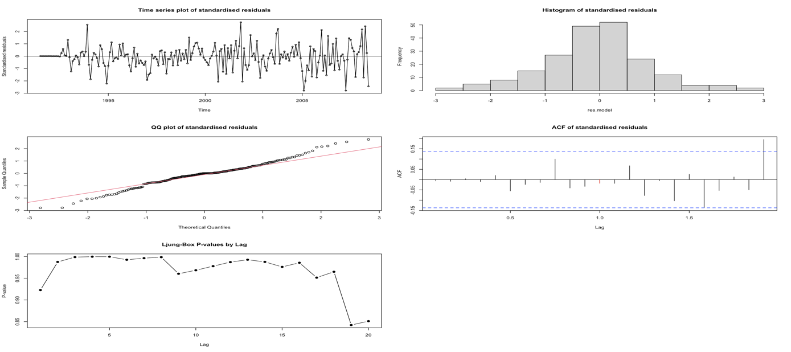
Diagnostic plots (see Fig 26) showed residuals that were mostly normal. The Q-Q plot and histogram looked acceptable, and the Shapiro-Wilk test gave a p-value of 0.0054, indicating mild non-normality, similar to other models. The Ljung-Box test confirmed there was no major autocorrelation in residuals.
✅ In conclusion, adding one more AR term made the model more complex without delivering better performance. Both AIC and BIC worsened slightly, some estimates became unstable, and accuracy remained the same. Therefore, the simpler SARIMA(4,1,1)×(2,1,1)[12] model remains the best choice. It balances fit, interpretability, and reliability without unnecessary complexity.

3.6.5 Final Model Coefficient Estimates (ML and CSS)

This section presents the detailed coefficient estimates for the final selected model: SARIMA(4,1,1)×(2,1,1)[12]. We estimated the parameters using both ML and CSS

ML Estimation Results:

> coeftest(m_411.drugML)

z test of coefficients:

Estimate Std. Error z value Pr(>|z|)
ar1 0.088490 0.102578 0.8627 0.3883234
ar2 0.332401 0.093048 3.5724 0.0003538 ***
ar3 0.236937 0.086319 2.7449 0.0060531 **
ar4 -0.255900 0.082648 -3.0963 0.0019596 **
ma1 -0.890149 0.079281 -11.2278 < 2.2e-16 ***
sar1 0.006111 0.139221 0.0439 0.9649885
sar2 -0.243230 0.097873 -2.4851 0.0129498 *
sma1 -0.522891 0.128664 -4.0640 4.824e-05 ***
---
Signif. codes: 0 ‘***’ 0.001 ‘**’ 0.01 ‘*’ 0.05 ‘.’ 0.1 ‘ ’ 1

CSS Estimation Results:

> coeftest(m_411.drugCSS)

z test of coefficients:

Estimate Std. Error z value Pr(>|z|)
ar1 0.067989 0.096906 0.7016 0.4829300
ar2 0.351474 0.078915 4.4538 8.436e-06 ***
ar3 0.244757 0.076946 3.1809 0.0014682 **
ar4 -0.288789 0.084390 -3.4221 0.0006214 ***
ma1 -0.902767 0.076899 -11.7397 < 2.2e-16 ***
sar1 -0.135344 0.127243 -1.0637 0.2874795
sar2 -0.327104 0.084921 -3.8519 0.0001172 ***
sma1 -0.453677 0.131652 -3.4460 0.0005689 ***
---
Signif. codes: 0 ‘***’ 0.001 ‘**’ 0.01 ‘*’ 0.05 ‘.’ 0.1 ‘ ’ 1

Interpretation:
- Under ML, 6 out of the 8 parameters were clearly significant (e.g., AR(2), AR(3), AR(4), MA(1), SAR(2), SMA(1)).
- The CSS estimates provided similar results, further validating the reliability of these key terms.
- In both methods, AR(1) and SAR(1) were not significant, suggesting they might not contribute much to the model.
- Importantly, the strong agreement between ML and CSS supports the robustness of this final model specification.
These estimates, along with model selection criteria and accuracy checks, reinforce our decision to choose SARIMA(4,1,1)×(2,1,1)[12] as the final model.
3.7 Forecasting the Next 10 Months
Using the final selected model SARIMA(4,1,1)×(2,1,1)[12], we forecasted monthly PBS corticosteroid expenditure for the next 10 months, starting from July 2008 to April 2009.
The line plot in (Fig 27) displays the actual historical data along with the model’s predicted values and associated confidence intervals. The shaded regions represent 80% and 95% prediction intervals, which help quantify the uncertainty in the forecasts.

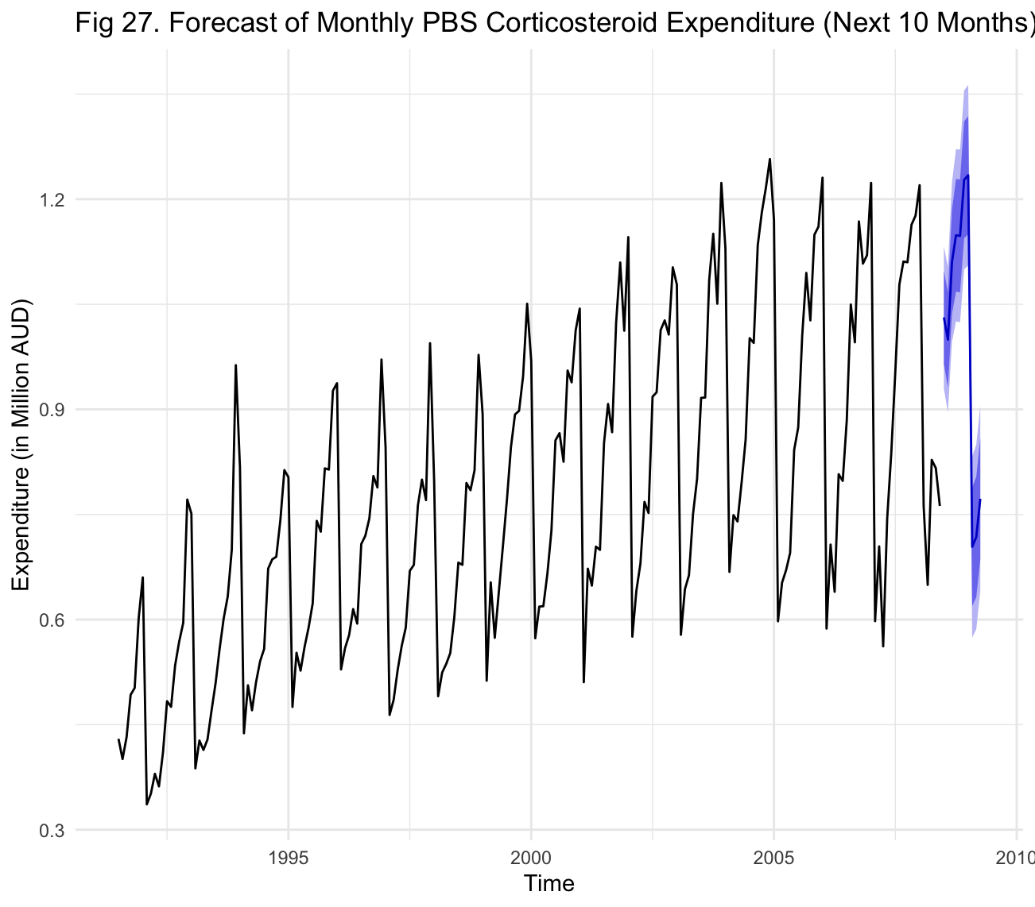

Forecast Summary Table
Month | Point Forecast | Lo 80 | Hi 80 | Lo 95 | Hi 95
Jul 2008 | 1.0312 | 0.9646 | 1.0978 | 0.9294 | 1.1330
Aug 2008 | 0.9996 | 0.9317 | 1.0675 | 0.8958 | 1.1034
Sep 2008 | 1.1105 | 1.0361 | 1.1850 | 0.9966 | 1.2244
Oct 2008 | 1.1484 | 1.0681 | 1.2288 | 1.0256 | 1.2713
Nov 2008 | 1.1476 | 1.0670 | 1.2282 | 1.0243 | 1.2708
Dec 2008 | 1.2275 | 1.1440 | 1.3110 | 1.0999 | 1.3552
Jan 2009 | 1.2342 | 1.1500 | 1.3183 | 1.1055 | 1.3629
Feb 2009 | 0.7039 | 0.6192 | 0.7885 | 0.5744 | 0.8333
Mar 2009 | 0.7177 | 0.6317 | 0.8037 | 0.5861 | 0.8493
Apr 2009 | 0.7724 | 0.6859 | 0.8588 | 0.6402 | 0.9046
Table 4. Forecast Summary Table

Interpretation
- The forecasts follow the same seasonal pattern seen in the historical data, with peak values during December–January and a dip around February–April.
- The point forecasts suggest government expenditure will stay above 1 million AUD during most of the forecast period, except in early 2009 where seasonal decline is expected.
- The narrow width of the prediction intervals indicates the model is confident in its estimates, particularly for the near-term months.
- The results align with past seasonal behaviour, indicating that the model has successfully captured the key trends and seasonality in the series.

4. DISCUSSION
This study applied time series modelling techniques to forecast monthly PBS corticosteroid expenditure from July 1991 to June 2008, with a focus on producing accurate forecasts for the following 10 months. Preliminary analysis of the data revealed a clear seasonal structure, a steady upward trend, and mild changes in variance, features that made SARIMA models a natural choice.
Instead of using the classical ARIMA specification approach, we adopted a residual-based model-building strategy. This involved starting with seasonal differencing (D = 1) to remove recurring cycles, and then progressively adding seasonal and non-seasonal ARIMA components based on insights from ACF/PACF plots. Key tools such as the EACF table and BIC heatmap were also used to refine the selection of candidate models. Each model was evaluated not only for statistical fit but also for residual randomness and forecast accuracy.
A total of eight SARIMA models were fitted using both Maximum Likelihood (ML) and Conditional Sum of Squares (CSS) estimation. Each was assessed using AIC, BIC, and a set of forecast accuracy metrics (RMSE, MAE, MAPE, MASE). Among these, SARIMA(4,1,1)×(2,1,1)[12] emerged as the most balanced and consistently high-performing model. It showed strong parameter significance, minimal residual autocorrelation, and superior forecast reliability.
This final model was used to forecast expenditure for the period July 2008 to April 2009. As shown in Fig 27 and Table 4, the forecasts aligned well with historical seasonal behaviour, peaking around December–January and dipping during February–April. The narrow prediction intervals indicated strong confidence in the forecast estimates. Together, these results affirm that the selected model successfully captured both the seasonal and trend-driven components of the data.

5. CONCLUSION
This report demonstrated the development of a SARIMA-based forecasting model for monthly PBS corticosteroid expenditure. The analysis followed a careful, structured residual approach, gradually building complexity only where needed. The process included seasonal and ordinary differencing, residual analysis, coefficient significance testing, and model comparisons using AIC, BIC, and accuracy metrics.
The final model, SARIMA(4,1,1)×(2,1,1)[12], consistently outperformed all others across a wide range of criteria. It not only offered strong in-sample fit but also produced forecasts that were seasonally consistent and statistically reliable. The model’s residuals displayed no evidence of autocorrelation, and its accuracy metrics confirmed its suitability for short-term forecasting.
This study highlights the value of combining statistical rigour, diagnostic checking, and practical performance evaluation in model selection. The approach used here can be applied more broadly to healthcare expenditure planning and other real-world forecasting tasks where seasonality and trend are present.

6. APPENDICES

Appendix A: R Code
In this appendix, I detail the complete R code used to perform all analyses presented in this assignment.
# ------------------------------------------------------------------------------------------------------------

# CLEARING WORKSPACE

# clearing all the previous stuff
rm(list = ls())
#--------------------------------------------------------------------------------

# LOADING LIBRARIES

library(fpp2) # h02 dataset (PBS corticosteroids under ATC code H02)
library(tseries) # adf.test(), shapiro.test()
library(TSA) # LBQPlot() and time series diagnostics
library(lmtest) # for coeftest()
#--------------------------------------------------------------------------------

# HELPER FUNCTIONS FOR MODEL COMPARISON AND RESIDUAL ANALYSIS

# These functions will help evaluate AIC/BIC and analyze residuals of ARIMA/GARCH models

# function to sort models based on aic or bic values
sort.score <- function(x, score = c("bic", "aic")){
if (score == "aic"){
x[with(x, order(AIC)),]
} else if (score == "bic") {
x[with(x, order(BIC)),]
} else {
warning('score = "x" only accepts valid arguments ("aic","bic")')
}
}

# function to analyze residuals from ARIMA, GARCH, or hybrid models
residual.analysis <- function(model, std = TRUE, class = "ARIMA") {
library(TSA)

if (class == "ARIMA") {
res.model <- if (std) rstandard(model) else residuals(model)
} else {
stop("Only ARIMA models supported.")
}

par(mfrow = c(3, 2)) # 3 rows, 2 columns layout

# Plot 1: Time series
plot(res.model, type = 'o', ylab = 'Standardised residuals',
main = "Time series plot of standardised residuals")
abline(h = 0)

# Plot 2: Histogram
hist(res.model, main = "Histogram of standardised residuals")

# Plot 3: QQ plot
qqnorm(res.model, main = "QQ plot of standardised residuals")
qqline(res.model, col = 2)

# Plot 4: ACF
seasonal_acf(res.model, main = "ACF of standardised residuals")
# Plot 5: Shapiro-Wilk result (printed in console)
print(shapiro.test(res.model))

# Plot 6: Ljung-Box p-values as base R line plot
lbq_pvals <- sapply(1:20, function(lag) {
Box.test(res.model, lag = lag, type = "Ljung-Box")$p.value
})
plot(1:20, lbq_pvals, type = "b", pch = 19,
main = "Ljung-Box P-values by Lag",
xlab = "Lag", ylab = "P-value")
abline(h = 0.05, col = "red", lty = 2)

par(mfrow = c(1, 1)) # reset layout
}

##################################################
# Following functions are developed by #
# MATH1318 students #
# Le Van Tra Tran and Tin Trung Pham #
# in 2024. WE thank them for their contribution! #
##################################################

helper <- function(class = c("acf", "pacf"), ...) {

params <- match.call(expand.dots = TRUE)
params <- as.list(params)[-1]

if (class == "acf") {
acf_values <- do.call(acf, c(params, list(plot = FALSE)))
} else if (class == "pacf") {
acf_values <- do.call(pacf, c(params, list(plot = FALSE)))
}

acf_data <- data.frame(
Lag = as.numeric(acf_values$lag),
ACF = as.numeric(acf_values$acf)
)

seasonal_lags <- acf_data$Lag %% 1 == 0

if (class == "acf") {
do.call(acf, c(params, list(plot = TRUE)))
} else if (class == "pacf") {
do.call(pacf, c(params, list(plot = TRUE)))
}

for (i in which(seasonal_lags)) {
segments(x0 = acf_data$Lag[i], y0 = 0, x1 = acf_data$Lag[i], y1 = acf_data$ACF[i], col = "red")
}
}

# seasonal_acf
seasonal_acf <- function(...) {helper(class = "acf", ...)}

# seasonal_pacf
seasonal_pacf <- function(...) {helper(class = "pacf", ...)}
#--------------------------------------------------------------------------------

# SETTING WORKING DIRECTORY AND LOADING DATA

# The dataset represents monthly government expenditure under Australia’s Pharmaceutical
# Benefits Scheme (PBS) for drugs falling under ATC Code H02 (Corticosteroids). The data
# spans from July 1991 to June 2008, measured in millions of Australian dollars (AUD).

# setting the working directory to the folder where my r script file is stored
setwd("/Users/kamleshhhkale/Documents/RMIT/SEM 3/TIME SERIES ANALYSIS/ASS-FINAL")

# checking if i have set the correct working directory
getwd()

# loading the h02 dataset
data(h02)

# 'h02' is already a ts object from July 1991 to June 2008, measured in millions of AUD
drug.ts <- h02 # main time series used in the analysis
#--------------------------------------------------------------------------------

# INITIAL PLOT AND SUMMARY STATS

# checking the data to see the format
drug.ts

# checking descriptive statistics of the time series data
print(summary(drug.ts))
str(drug.ts)

# checking for any missing values in the data
na_indices <- which(is.na(drug.ts))
cat("missing values are found at indices:", na_indices, "\n")

plot(drug.ts)

# Trend: ✅ seeing a clear upward trend in monthly PBS expenditure on corticosteroids (ATC H02)
# Seasonality: ✅ strong seasonal pattern, expenditure peaks mid-year (possibly winter-driven)
# Changing variance: ✅ slight increase in variance over time,
# Behaviour: ⚠️ since there is strong seasonality, it's hard to clearly tell AR or MA behaviour right now
# Change Point: ❌ no obvious or sudden change point is visible — looks fairly continuous throughout

# plotting a time series plot to see the overall pattern of monthly government drug expenditure
plot(drug.ts, type = "o", main = "Fig 1. Time Series Plot of Monthly Government Drug Expenditure",
ylab = "Sales (in Million AUD)", cex.main = 1.8)

# adding seasonal markers to the time series plot
points(time(drug.ts), drug.ts, pch = as.vector(season(drug.ts)), col = "blue")

y_t <- drug.ts[-1] # current values
y_t_minus_1 <- drug.ts[-length(drug.ts)] # lagged values

# plotting the scatterplot
plot(y_t_minus_1, y_t,
main = "Fig 1.1. Scatter Plot of Consecutive Time Points",
xlab = expression(Y[t-1]),
ylab = expression(Y[t]),
pch = 19, col = "steelblue")

# adding a trend line
abline(lm(y_t ~ y_t_minus_1), col = "red", lwd = 2)
#--------------------------------------------------------------------------------

# ACF & PACF TO CHECK FOR SEASONALITY
par(mfrow = c(1, 2))
seasonal_acf(drug.ts, lag.max = 64, main = "Fig 2. ACF plot of drug series")
seasonal_pacf(drug.ts, lag.max = 64, main = "Fig 3. PACF plot of drug series")
par(mfrow = c(1, 1))

# seasonality and existence of trend are obvious from the ACF and PACF plots
#--------------------------------------------------------------------------------

# CHECKING STATIONARITY AND NORMALITY
adf.test(drug.ts)
pp.test(drug.ts)

qqnorm(y = drug.ts, main = "Fig 4. QQ plot of drug series", cex.main = 1.8)
qqline(y = drug.ts, col = 2, lwd = 1, lty = 2)
shapiro.test(drug.ts)
#--------------------------------------------------------------------------------

# MODEL SPECIFICATION USING RESIDUAL APPROACH

# we're following the residual approach (not classical) to specify the SARIMA model

# first, we fit a plain model with only seasonal differencing (D = 1)
# this helps us see if the seasonal trend can be removed
# fitting arima model with no AR or MA terms, but with seasonal differencing raw data

# m1
m1.drug <- Arima(drug.ts, order = c(0, 0, 0), seasonal = list(order = c(0, 1, 0), period = 12))
res.m1 <- residuals(m1.drug)
par(mfrow = c(1, 1))
plot(res.m1, xlab = "Time", ylab = "Residuals", main = "Fig 5. Time Series Plot of Residuals (m1)")
par(mfrow = c(1, 2))
seasonal_acf(res.m1, lag.max = 48, main = "Fig 6. ACF of Residuals (m1)")
seasonal_pacf(res.m1, lag.max = 48, main = "Fig 7. PACF of Residuals (m1)")
par(mfrow = c(1, 1))

# based on residual ACF (Fig 6), we observe one significant red bar → Capital Q = 1
# based on residual PACF (Fig 7), we observe two significant red bars → Capital P = 2

# also, after applying seasonal differencing (D = 1), the significant spike at lag 1 in PACF disappeared
# this suggests that the seasonal differencing has already helped capture some of the seasonal structure

# so, now we will add the SARMA(2,1) component and see if we get rid of the seasonal component completely
#--------------------------------------------------------------------------------

# m2
m2.drug = Arima(drug.ts,order=c(0,0,0),seasonal=list(order=c(2,1,1), period=12))
res.m2 <- residuals(m2.drug)
par(mfrow = c(1, 1))
plot(res.m2, xlab = "Time", ylab = "Residuals", main = "Fig 8. Time Series Plot of Residuals (m2)")
par(mfrow = c(1, 2))
seasonal_acf(res.m2, lag.max = 48, main = "Fig 9. ACF of Residuals (m2)")
seasonal_pacf(res.m2, lag.max = 48, main = "Fig 10. PACF of Residuals (m2)")
par(mfrow = c(1, 1))

# from the ACF (Fig 9), there’s just one near miss — no clear seasonal pattern left overall
# but the PACF (Fig 10) still shows 2 strong seasonal red bars, meaning some seasonal effect remains

# instead of increasing P or Q again (which will just make the model more complex),
# we’ll now try adding an ordinary difference (d = 1) in m3
# this might help reduce the trend and remove the leftover seasonal spikes in PACF
#--------------------------------------------------------------------------------

# m3
m3.drug = Arima(drug.ts,order=c(0,1,0),seasonal=list(order=c(2,1,1), period=12))
res.m3 <- residuals(m3.drug)
par(mfrow = c(1, 1))
plot(res.m3, xlab = "Time", ylab = "Residuals", main = "Fig 11. Time Series Plot of Residuals (m3)")
par(mfrow = c(1, 2))
seasonal_acf(res.m3, lag.max = 48, main = "Fig 12. ACF of Residuals (m3)")
seasonal_pacf(res.m3, lag.max = 48, main = "Fig 13. PACF of Residuals (m3)")
par(mfrow = c(1, 1))

# after applying ordinary differencing (d = 1) in m3, we finally got rid of the seasonal lags
# both ACF (Fig 12) and PACF (Fig 13) no longer show any strong seasonal red bars — great!

# now, we’ll move on to specifying the ARIMA (non-seasonal) component
# in ACF (Fig 12), we see 3 significant bars before the first red seasonal lag — so we'll set q = 3
# in PACF (Fig 13), we see 4 significant bars before the first red seasonal lag — so we'll set p = 4
#--------------------------------------------------------------------------------

# m4
m4.drug = Arima(drug.ts,order=c(4,1,3),seasonal=list(order=c(2,1,1), period=12), method = "ML")
res.m4 <- residuals(m4.drug)
par(mfrow = c(1, 1))
plot(res.m4, xlab = "Time", ylab = "Residuals", main = "Fig 14. Time Series Plot of Residuals (m4)")
par(mfrow = c(1, 2))
seasonal_acf(res.m4, lag.max = 48, main = "Fig 15. ACF of Residuals (m4)")
seasonal_pacf(res.m4, lag.max = 48, main = "Fig 16. PACF of Residuals (m4)")
par(mfrow = c(1, 1))

# after fitting m4 with SARIMA(4,1,3)×(2,1,1)[12], the ACF (Fig 15) and PACF (Fig 16) look pretty good
# there are no strong seasonal spikes left — just a few small ones here and there, which we can treat as
# random noise or mild outliers

# if we want to explore further, we can push the AR (p) value up to 6 since we saw about 6 smaller black
# bars before the seasonal cut-off and ACF still shows up to 5 slight spikes — so MA (q) could go up to 5 too

# instead of guessing, we’ll now use the EACF and BIC plot to get a clearer idea of which AR and MA
# combinations are worth trying next
#--------------------------------------------------------------------------------

# MODEL SPECIFICATION: EACF

# now we'll use the EACF (Extended Autocorrelation Function) to explore possible AR and MA orders
# we are using residuals of m3 because there is still leftover signal in them

eacf(res.m3)

# from the EACF table, we found the top-left 'o' at p = 0 and q = 5 — that’s our starting point
# now looking at its neighbors:
# now looking at its neighbors:
# → (p = 1, q = 5) — (one step below)
# → (p = 1, q = 4) — (diagonally left-down)
# → (p = 0, q = 6) — (just one step right)

# so the tentative models we’ll check are:
# SARIMA(0,1,5)x(2,1,1)[12]
# SARIMA(1,1,5)x(2,1,1)[12]
# SARIMA(1,1,4)x(2,1,1)[12]
# SARIMA(0,1,6)x(2,1,1)[12]
#--------------------------------------------------------------------------------

# MODEL SPECIFICATION: BIC TABLE

# now let’s check the BIC table to see which AR and MA combinations are more promising

par(mfrow = c(1, 1))
bic_table = armasubsets(y = res.m3, nar = 8, nma = 8, y.name = "p", ar.method = "ols")
plot(bic_table)

# from the BIC plot, we can see two of the darkest cells (lowest BIC values) at:
# → p = 4, q = 1
# → p = 4, q = 2

# so the tentative models we’ll check are:
# SARIMA(4,1,1)x(2,1,1)[12]
# SARIMA(4,1,2)x(2,1,1)[12]
#--------------------------------------------------------------------------------

# FINAL SET OF POSSIBLE MODELS

# 1. SARIMA(4,1,3)×(2,1,1)[12] (m4)
# 2. SARIMA(0,1,5)x(2,1,1)[12] (EACF)
# 3. SARIMA(1,1,5)x(2,1,1)[12] (EACF)
# 4. SARIMA(1,1,4)x(2,1,1)[12] (EACF)
# 5. SARIMA(0,1,6)x(2,1,1)[12] (EACF)
# 6. SARIMA(4,1,1)x(2,1,1)[12] (BIC TABLE)
# 7. SARIMA(4,1,2)x(2,1,1)[12] (BIC TABLE)
#--------------------------------------------------------------------------------

# FITTING SARIMA MODELS (ML AND CSS)

# 1. SARIMA(4,1,3)x(2,1,1)[12]
m_413.drugML <- Arima(drug.ts, order = c(4, 1, 3), seasonal = list(order = c(2, 1, 1), period = 12), method = "ML")
coeftest(m_413.drugML)
residual.analysis(model = m_413.drugML)

m_413.drugCSS <- Arima(drug.ts, order = c(4, 1, 3), seasonal = list(order = c(2, 1, 1), period = 12), method = "CSS")
coeftest(m_413.drugCSS)
residual.analysis(model = m_413.drugCSS)
#----------------------------------------

# 2. SARIMA(0,1,5)x(2,1,1)[12]
m_015.drugML <- Arima(drug.ts, order = c(0, 1, 5), seasonal = list(order = c(2, 1, 1), period = 12), method = "ML")
coeftest(m_015.drugML)
residual.analysis(model = m_015.drugML)

m_015.drugCSS <- Arima(drug.ts, order = c(0, 1, 5), seasonal = list(order = c(2, 1, 1), period = 12), method = "CSS")
coeftest(m_015.drugCSS)
residual.analysis(model = m_015.drugCSS)
#----------------------------------------

# 3. SARIMA(1,1,5)x(2,1,1)[12]
m_115.drugML <- Arima(drug.ts, order = c(1, 1, 5), seasonal = list(order = c(2, 1, 1), period = 12), method = "ML")
coeftest(m_115.drugML)
residual.analysis(model = m_115.drugML)

m_115.drugCSS <- Arima(drug.ts, order = c(1, 1, 5), seasonal = list(order = c(2, 1, 1), period = 12), method = "CSS")
coeftest(m_115.drugCSS)
residual.analysis(model = m_115.drugCSS)
#----------------------------------------

# 4. SARIMA(1,1,4)x(2,1,1)[12]
m_114.drugML <- Arima(drug.ts, order = c(1, 1, 4), seasonal = list(order = c(2, 1, 1), period = 12), method = "ML")
coeftest(m_114.drugML)
residual.analysis(model = m_114.drugML)

m_114.drugCSS <- Arima(drug.ts, order = c(1, 1, 4), seasonal = list(order = c(2, 1, 1), period = 12), method = "CSS")
coeftest(m_114.drugCSS)
residual.analysis(model = m_114.drugCSS)
#----------------------------------------

# 5. SARIMA(0,1,6)x(2,1,1)[12]
m_016.drugML <- Arima(drug.ts, order = c(0, 1, 6), seasonal = list(order = c(2, 1, 1), period = 12), method = "ML")
coeftest(m_016.drugML)
residual.analysis(model = m_016.drugML)

m_016.drugCSS <- Arima(drug.ts, order = c(0, 1, 6), seasonal = list(order = c(2, 1, 1), period = 12), method = "CSS")
coeftest(m_016.drugCSS)
residual.analysis(model = m_016.drugCSS)
#----------------------------------------

# 6. SARIMA(4,1,1)x(2,1,1)[12]
m_411.drugML <- Arima(drug.ts, order = c(4, 1, 1), seasonal = list(order = c(2, 1, 1), period = 12), method = "ML")
coeftest(m_411.drugML)
residual.analysis(model = m_411.drugML)

m_411.drugCSS <- Arima(drug.ts, order = c(4, 1, 1), seasonal = list(order = c(2, 1, 1), period = 12), method = "CSS")
coeftest(m_411.drugCSS)
residual.analysis(model = m_411.drugCSS)
#----------------------------------------

# 7. SARIMA(4,1,2)x(2,1,1)[12]
m_412.drugML <- Arima(drug.ts, order = c(4, 1, 2), seasonal = list(order = c(2, 1, 1), period = 12), method = "ML")
coeftest(m_412.drugML)
residual.analysis(model = m_412.drugML)

m_412.drugCSS <- Arima(drug.ts, order = c(4, 1, 2), seasonal = list(order = c(2, 1, 1), period = 12), method = "CSS")
coeftest(m_412.drugCSS)
residual.analysis(model = m_412.drugCSS)
#--------------------------------------------------------------------------------

# AIC AND BIC COMPARISON

# storing AIC values for each SARIMA model
drug.aic <- AIC(m_413.drugML, m_015.drugML, m_115.drugML, m_114.drugML,
m_016.drugML, m_411.drugML, m_412.drugML)

# storing BIC values for each SARIMA model
drug.bic <- BIC(m_413.drugML, m_015.drugML, m_115.drugML, m_114.drugML,
m_016.drugML, m_411.drugML, m_412.drugML)

# sorting based on AIC and BIC
sort.score(drug.aic, score = "aic")
sort.score(drug.bic, score = "bic")
#--------------------------------------------------------------------------------

# ACCURACY METRICS FOR EACH MODEL

acc_413 <- accuracy(m_413.drugML)[1:7]
acc_015 <- accuracy(m_015.drugML)[1:7]
acc_115 <- accuracy(m_115.drugML)[1:7]
acc_114 <- accuracy(m_114.drugML)[1:7]
acc_016 <- accuracy(m_016.drugML)[1:7]
acc_411 <- accuracy(m_411.drugML)[1:7]
acc_412 <- accuracy(m_412.drugML)[1:7]

# combine all into a dataframe
drug_models_accuracy <- data.frame(
rbind(acc_413, acc_015, acc_115, acc_114, acc_016, acc_411, acc_412)
)

# setting column and row names
colnames(drug_models_accuracy) <- c("ME", "RMSE", "MAE", "MPE", "MAPE", "MASE", "ACF1")
rownames(drug_models_accuracy) <- c("SARIMA(4,1,3)x(2,1,1)[12]",
"SARIMA(0,1,5)x(2,1,1)[12]",
"SARIMA(1,1,5)x(2,1,1)[12]",
"SARIMA(1,1,4)x(2,1,1)[12]",
"SARIMA(0,1,6)x(2,1,1)[12]",
"SARIMA(4,1,1)x(2,1,1)[12]",
"SARIMA(4,1,2)x(2,1,1)[12]")

# view rounded accuracy metrics
round(drug_models_accuracy, 3)
#--------------------------------------------------------------------------------

# OVER PARAMETERISATION

# Best model identified based on AIC, BIC, and forecast accuracy:
# --> SARIMA(4,1,1)×(2,1,1)[12]

# To test whether adding more parameters improves the model,
# we will check over-parameterised versions:
# 1. SARIMA(5,1,1)×(2,1,1)[12]
# 2. SARIMA(4,1,2)×(2,1,1)[12] --> already tested earlier

# 8. SARIMA(5,1,1)×(2,1,1)[12]
m_511.drugML <- Arima(drug.ts, order = c(5, 1, 1), seasonal = list(order = c(2, 1, 1), period = 12), method = "ML")
coeftest(m_511.drugML)
residual.analysis(model = m_511.drugML)

m_511.drugCSS <- Arima(drug.ts, order = c(5, 1, 1), seasonal = list(order = c(2, 1, 1), period = 12), method = "CSS")
coeftest(m_511.drugCSS)
residual.analysis(model = m_511.drugCSS)
#--------------------------------------------------------------------------------

# AIC & BIC COMPARISON INCLUDING SARIMA(5,1,1)×(2,1,1)[12]

# storing AIC values for all 8 models
drug.aic <- AIC(m_413.drugML, m_015.drugML, m_115.drugML, m_114.drugML,
m_016.drugML, m_411.drugML, m_412.drugML, m_511.drugML)

# storing BIC values for all 8 models
drug.bic <- BIC(m_413.drugML, m_015.drugML, m_115.drugML, m_114.drugML,
m_016.drugML, m_411.drugML, m_412.drugML, m_511.drugML)

# sorting by AIC and BIC
sort.score(drug.aic, score = "aic")
sort.score(drug.bic, score = "bic")
#--------------------------------------------------------------------------------

# ACCURACY METRICS FOR EACH MODEL

acc_413 <- accuracy(m_413.drugML)[1:7]
acc_015 <- accuracy(m_015.drugML)[1:7]
acc_115 <- accuracy(m_115.drugML)[1:7]
acc_114 <- accuracy(m_114.drugML)[1:7]
acc_016 <- accuracy(m_016.drugML)[1:7]
acc_411 <- accuracy(m_411.drugML)[1:7]
acc_412 <- accuracy(m_412.drugML)[1:7]
acc_511 <- accuracy(m_511.drugML)[1:7]

# combining all accuracy metrics
drug_models_accuracy <- data.frame(
rbind(acc_413, acc_015, acc_115, acc_114, acc_016, acc_411, acc_412, acc_511)
)

# setting column and row names
colnames(drug_models_accuracy) <- c("ME", "RMSE", "MAE", "MPE", "MAPE", "MASE", "ACF1")
rownames(drug_models_accuracy) <- c("SARIMA(4,1,3)x(2,1,1)[12]",
"SARIMA(0,1,5)x(2,1,1)[12]",
"SARIMA(1,1,5)x(2,1,1)[12]",
"SARIMA(1,1,4)x(2,1,1)[12]",
"SARIMA(0,1,6)x(2,1,1)[12]",
"SARIMA(4,1,1)x(2,1,1)[12]",
"SARIMA(4,1,2)x(2,1,1)[12]",
"SARIMA(5,1,1)x(2,1,1)[12]")

# display rounded accuracy table
round(drug_models_accuracy, 3)
#--------------------------------------------------------------------------------

# FINAL FORECAST USING BEST MODEL: SARIMA(4,1,1)×(2,1,1)[12]

# fitting the best model one last time to ensure it's fresh in memory
best.model <- Arima(drug.ts, order = c(4, 1, 1), seasonal = list(order = c(2, 1, 1), period = 12), method = "ML")

# generating forecast for the next 10 months
drug.forecast <- forecast(best.model, h = 10)

# plotting forecast results
autoplot(drug.forecast) +
ggtitle("Fig 27. Forecast of Monthly PBS Corticosteroid Expenditure (Next 10 Months)") +
xlab("Time") +
ylab("Expenditure (in Million AUD)") +
theme_minimal()

# printing forecast values
print(drug.forecast)
#--------------------------------------------------------------------------------
# ------------------------------------------------------------------------------------------------------------

Appendix B: Use of Generative AI Tools

In this appendix, I detail the use of generative AI tools in the completion of this assignment.

Tool Used: ChatGPT by OpenAI [5]

Purpose: ChatGPT was used to resolve technical uncertainties related to custom functions and statistical diagnostics in R. Specifically, it assisted in debugging errors in fitar()-based model comparisons, improving plot visuals, and clarifying best practices for Ljung-Box residual analysis when FitAR::LjungBox was unreliable on Apple Silicon.

Prompts Used: [5]
- “How to increase the title font size in a time series plot using R?”
- “Why is FitAR not installing even after downloading FitAR_1.94.tar.gz? Is it due to R version or architecture issues?”
- “Is there any alternative to using FitAR::LjungBox for residual checking? Can I use base R’s Box.test instead?”
Key Insights from the Prompts: [5]
- The solution was to use the cex.main argument inside plotting functions like plot() to increase title size.
- The failure to install FitAR was linked to compatibility issues between its compiled binaries and the user’s R version or M1/M2 chip architecture on macOS. It was recommended to avoid it and use more compatible packages like forecast.
- ChatGPT confirmed that Box.test(..., type = "Ljung-Box") in base R is a reliable substitute for FitAR::LjungBox, producing consistent results for residual diagnostics without external dependencies.
4. Extent of Use: [5]

ChatGPT helped clarify technical questions during development but did not generate R code or content. All modelling, coding, and reporting were completed independently with the AI used only as a support tool.

5. Ethical Considerations: [5]
The use of AI followed ethical guidelines, with ChatGPT acting only as a technical assistant. It did not generate any direct outputs or conclusions used in the submitted report.

7. REFERENCES
[1] Posit, “RStudio Desktop,” Posit, 2023. https://posit.co/download/rstudio-desktop/

[2] “CRAN: Package TSA,” R-project.org, 2022, doi: https://cran.rproject.org/package=TSA.

[3] “Package ‘fpp2’ Title Data for``Forecasting: Principles and Practice’’ (2nd Edition),” 2020. Available: https://cran.r-project.org/web/packages/fpp2/fpp2.pdf

[4] R. Hyndman, “Data for ‘Forecasting: Principles and Practice’ (2nd Edition) [R package fpp2 version 2.5],” R-project.org, Feb. 2023, doi: https://cran.r-project.org/package=fpp2.

[5] OpenAI, “ChatGPT,” ChatGPT, 2025. https://chatgpt.com/

[6] GeeksforGeeks, “How to increase font size in Base R Plot ?,” GeeksforGeeks, Jun. 15, 2021. https://www.geeksforgeeks.org/r-language/how-to-increase-font-size-in-base-r-plot/ (accessed Jun. 19, 2025).

[7] “Index of /src/contrib/Archive/FitAR,” R-project.org, 2025. https://cran.r-project.org/src/contrib/Archive/FitAR/ (accessed Jun. 19, 2025).

