**Problem Statement = Deploy index.html from three different branches of a Git repo on httpd servers in three different docker containers with three different port numbers (80, 90,8001) on Jenkins slave using Jenkins pipeline.**

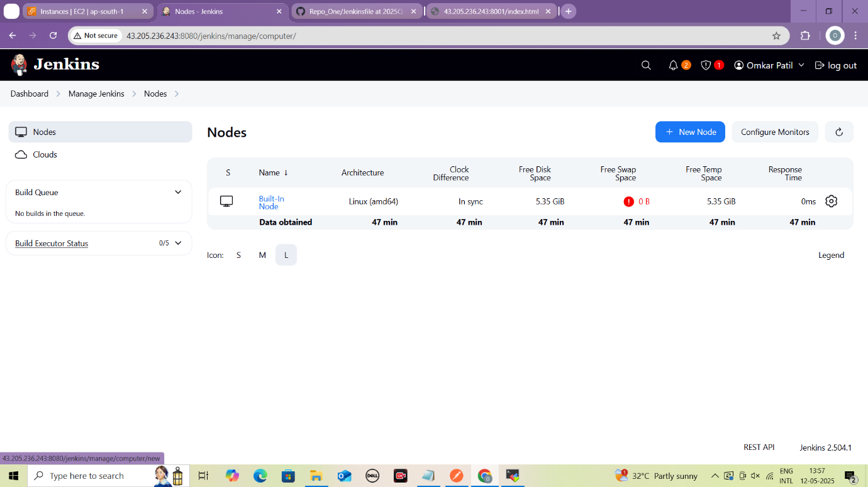

**Create new node**

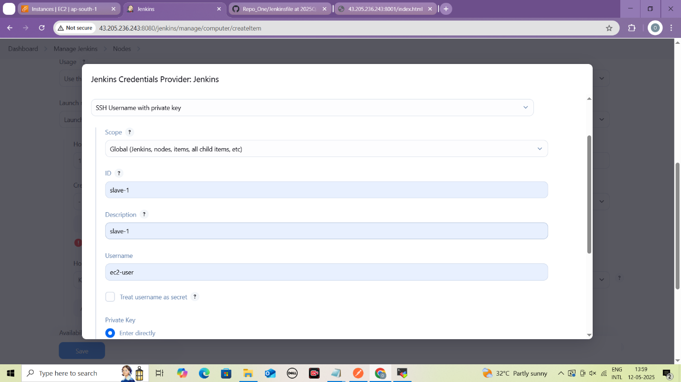

**Configure Credentials of slave-1**

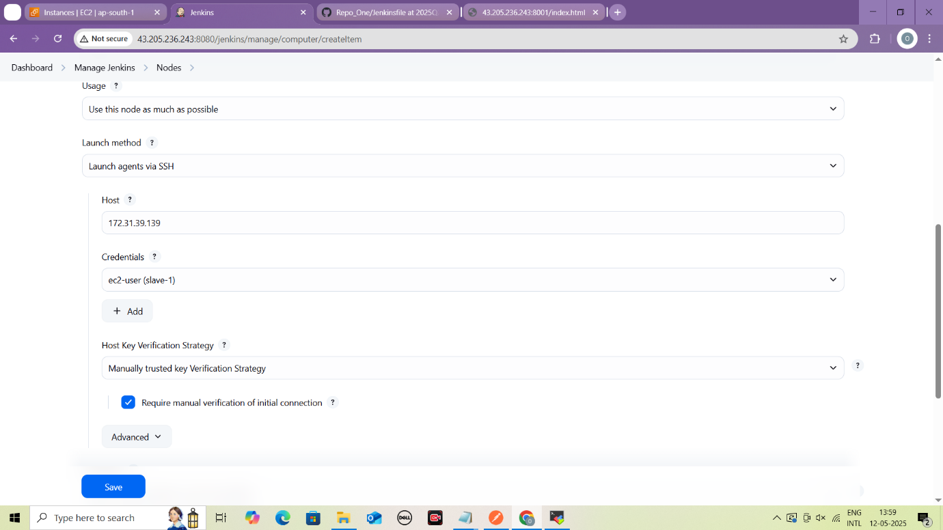

**Configure Launch Method for Slave-1**

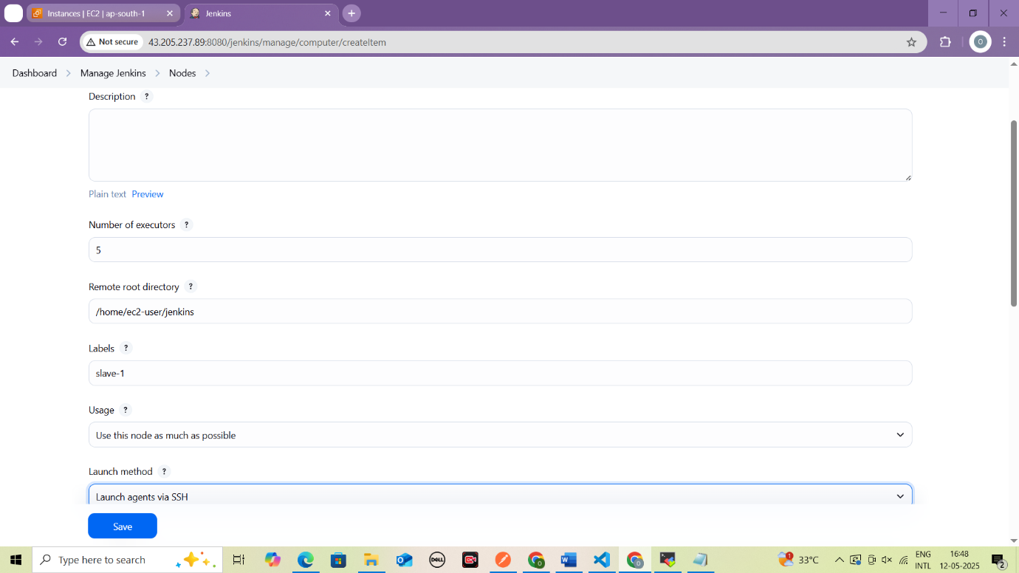

**Configure label, remote root directory, etc for slave-1**

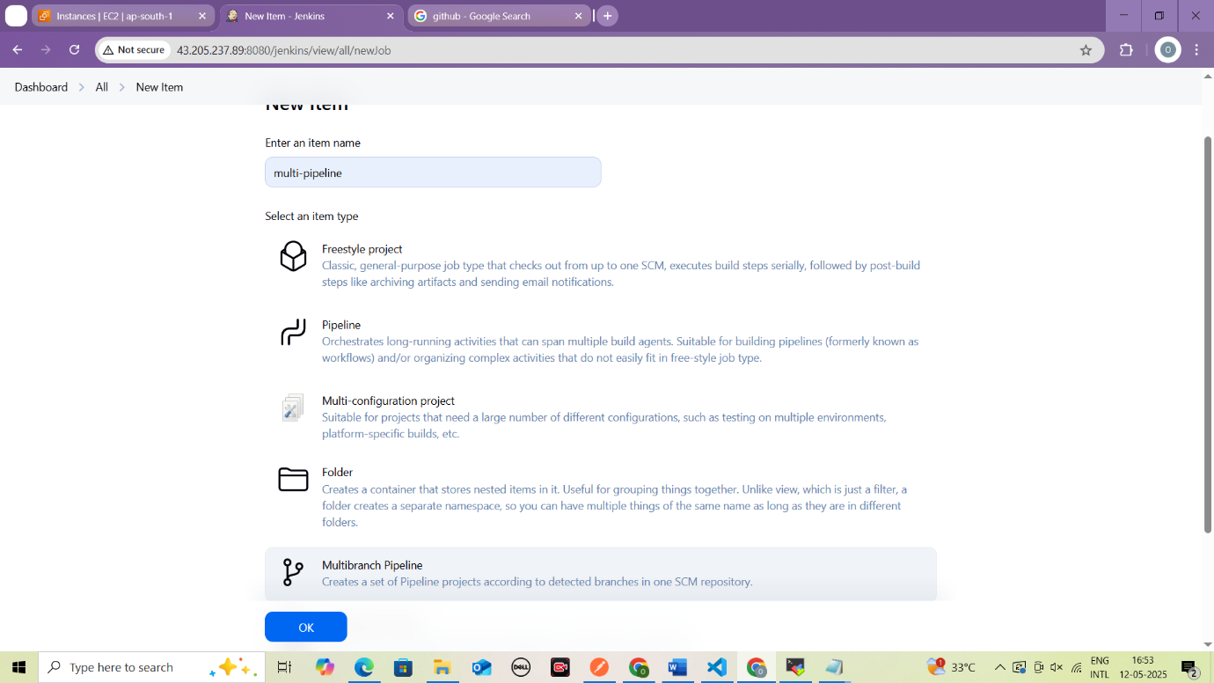

**Create Multibranch Pipeline**

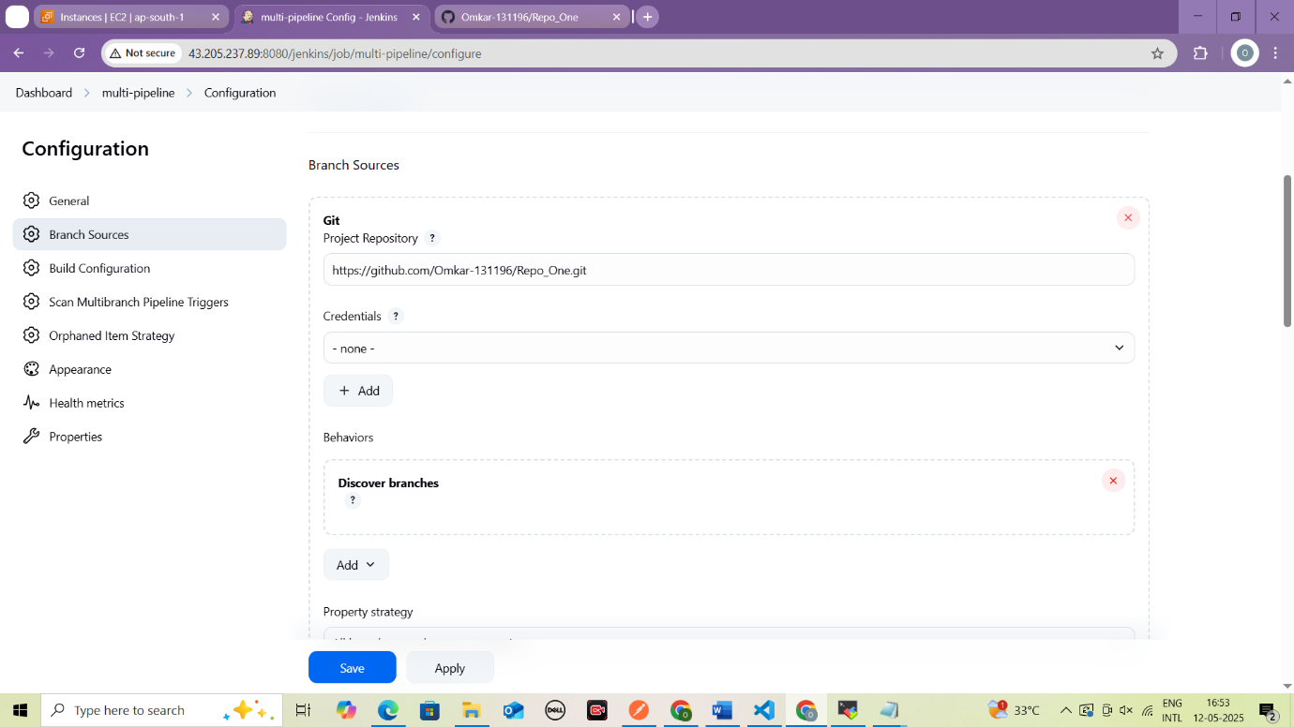

**Give Github Repo URL to clone inde.html**

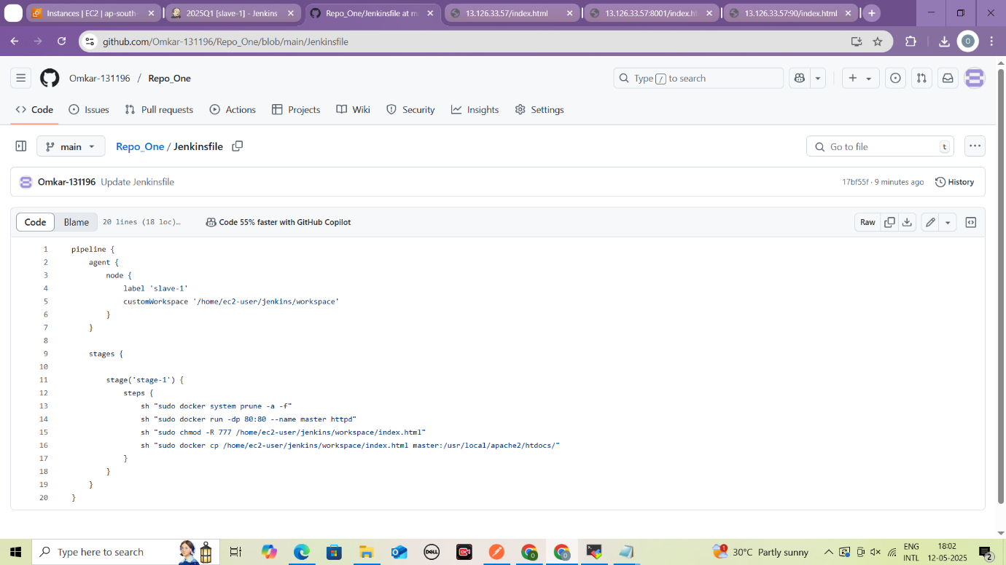

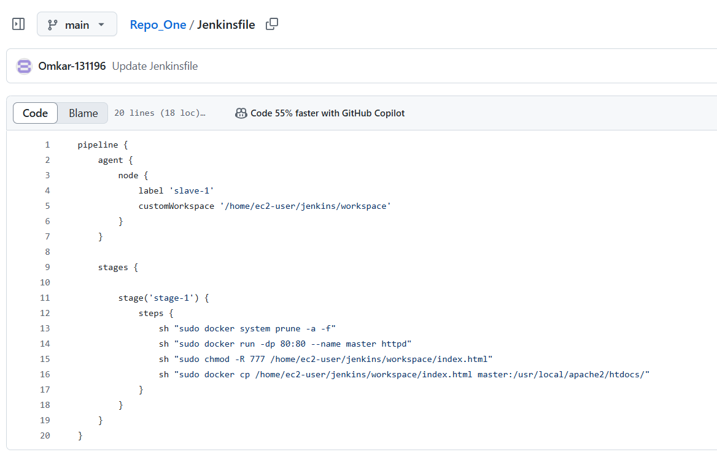

**Write Jenkinsfile keeping label as slave-1**

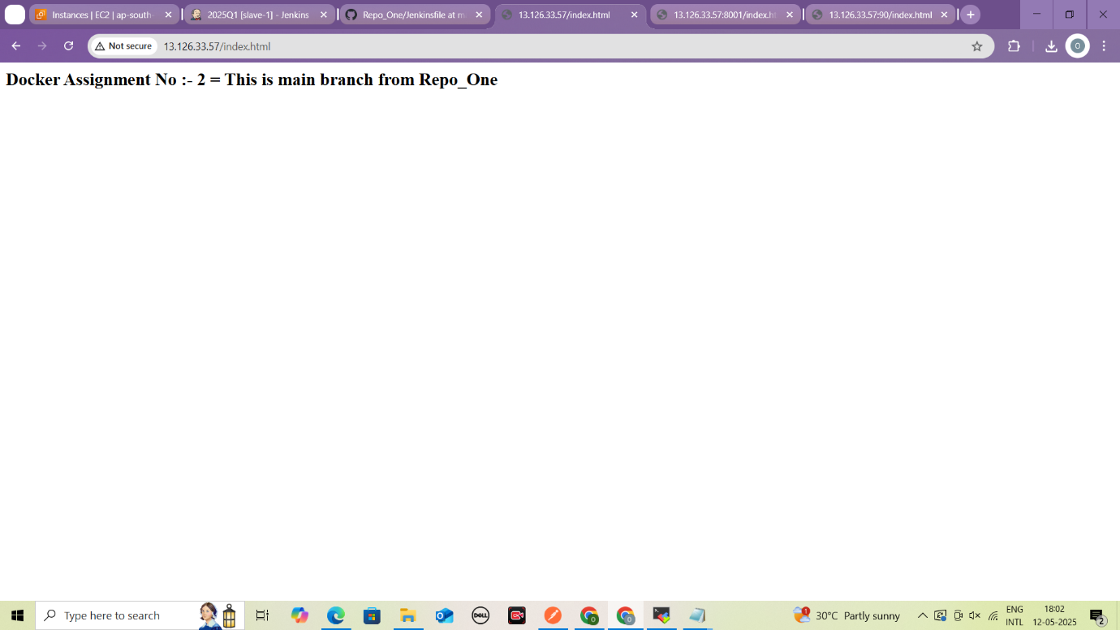

**Content of index.html of main branch**

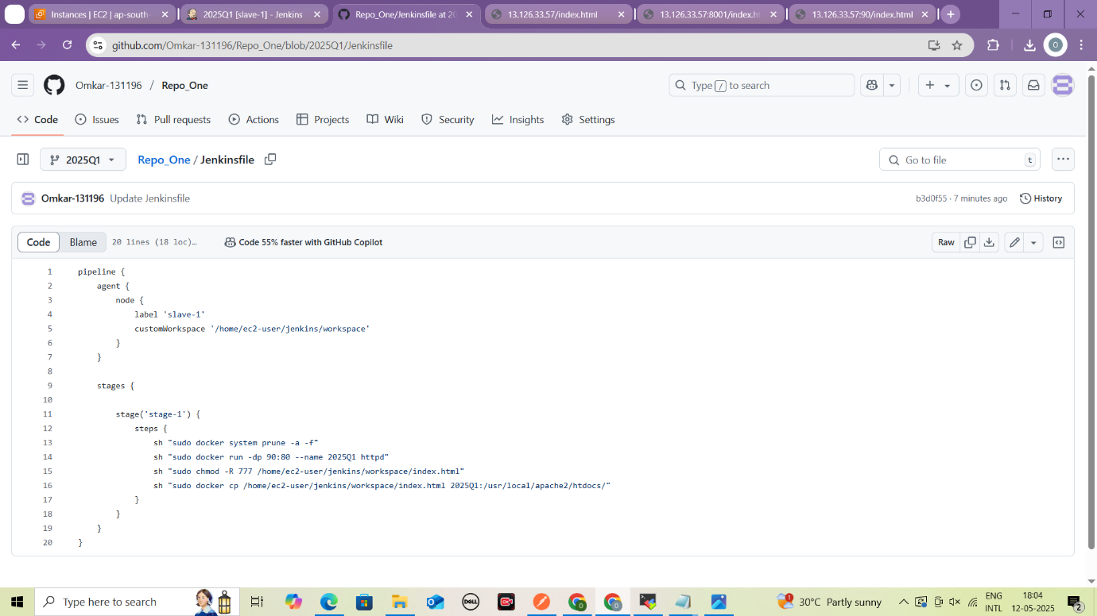

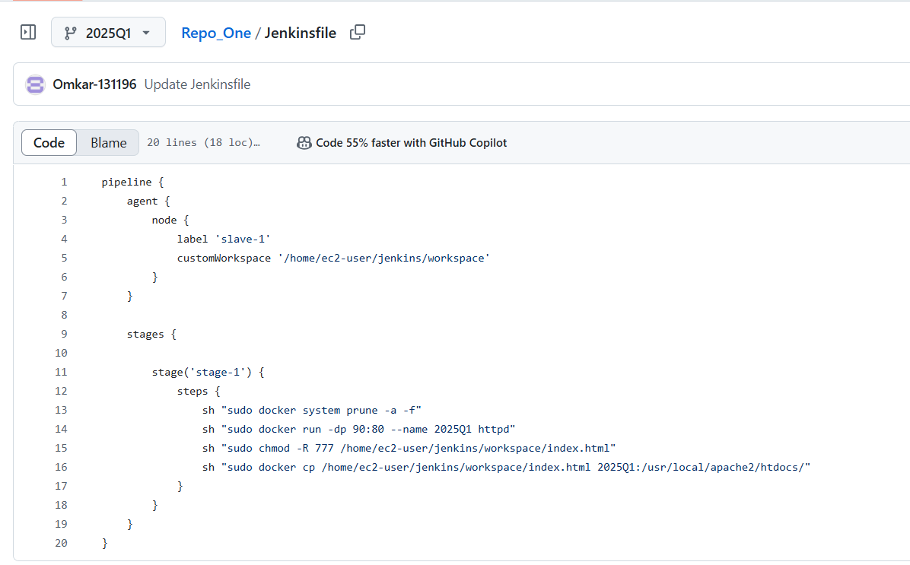

**Create Jenkinsfile in 2025Q1 branch**

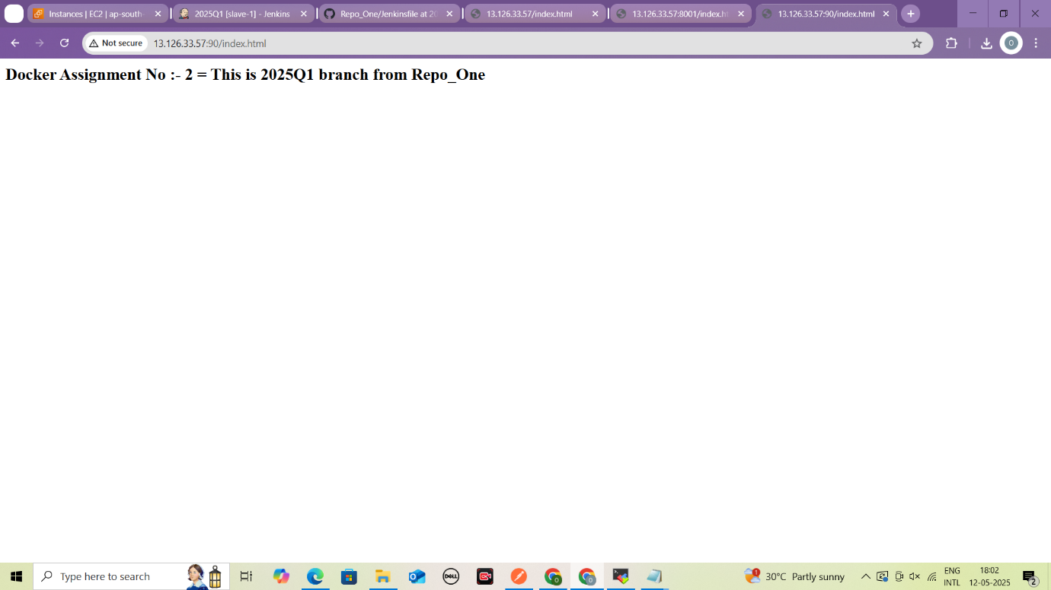

**Content of index.html file from 2025Q1 branch**

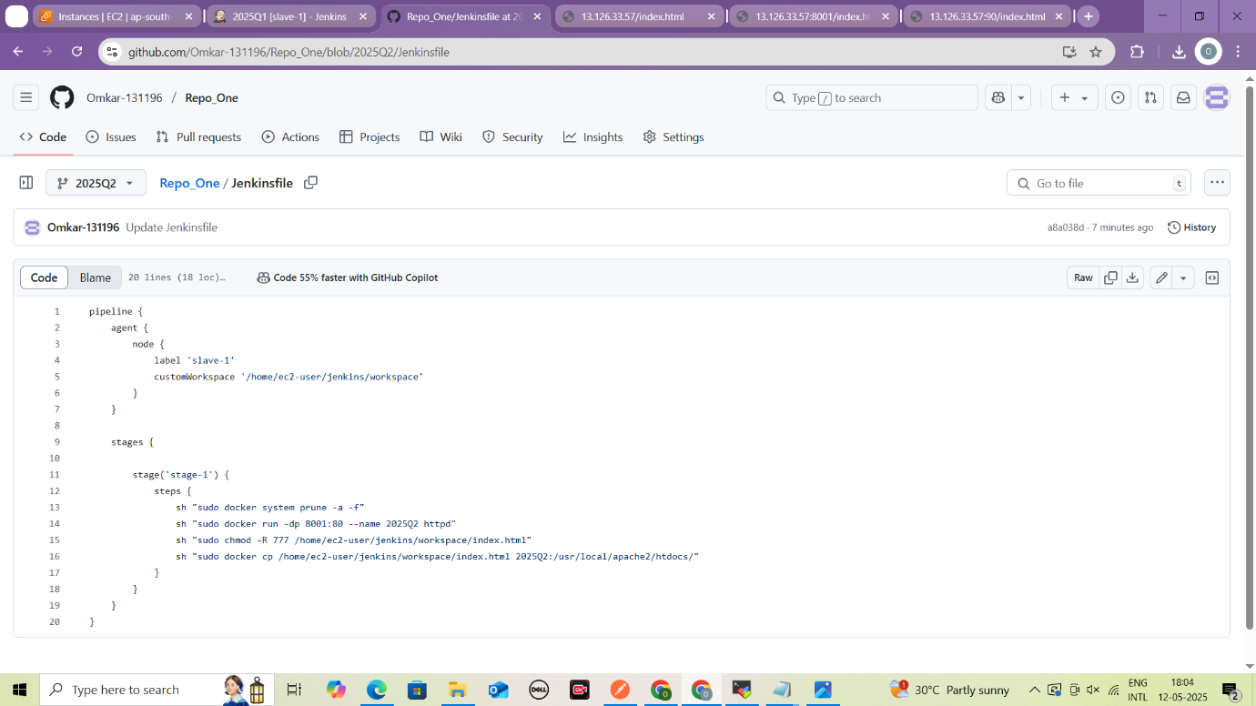

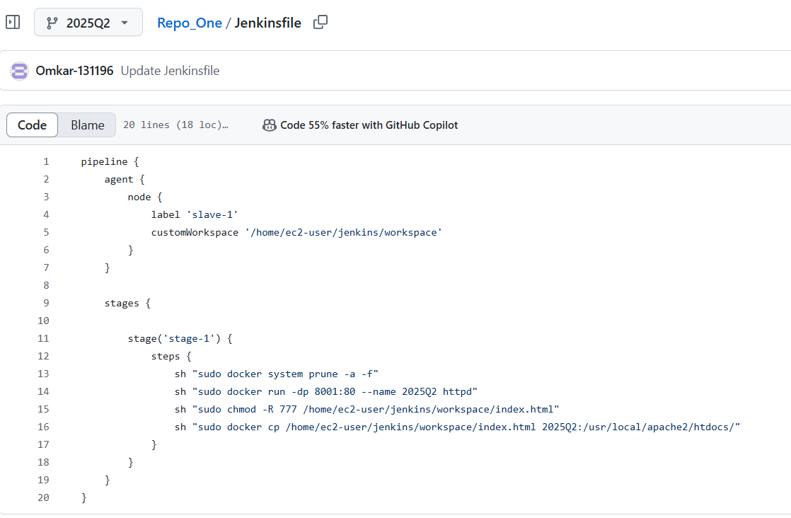

**Create Jenkinsfile in 2025Q2 branch**

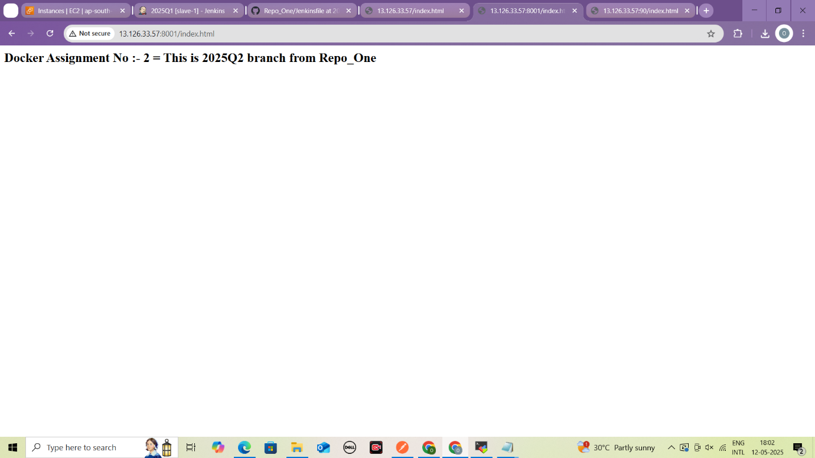

**Content of index.html file from 2025Q2**