**Problem Statement = Deploy index.html from three different branches of a Git repo on httpd servers in three different docker containers with three different port numbers (80, 90,8001) on Jenkins slave using docker volume and using Jenkins pipeline.**

**Submitted by = Omkar Patil (AWS DevOps Batch :- 04 Jan 2025)**

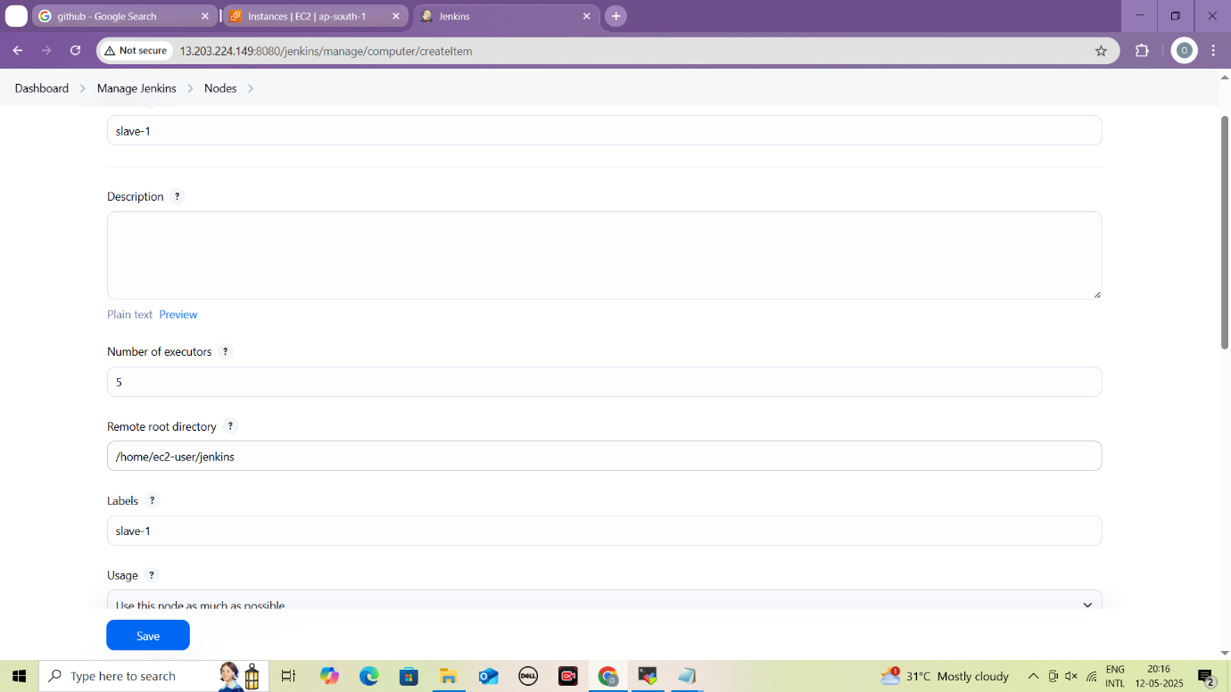

**Configure Node settings for slave**

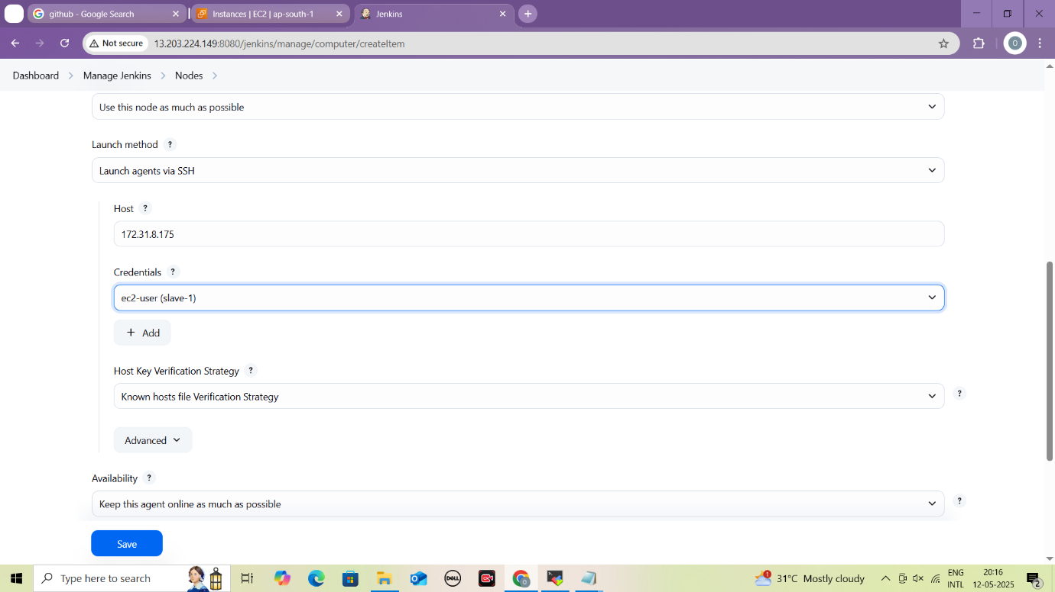 **Configure Node settings for slave**

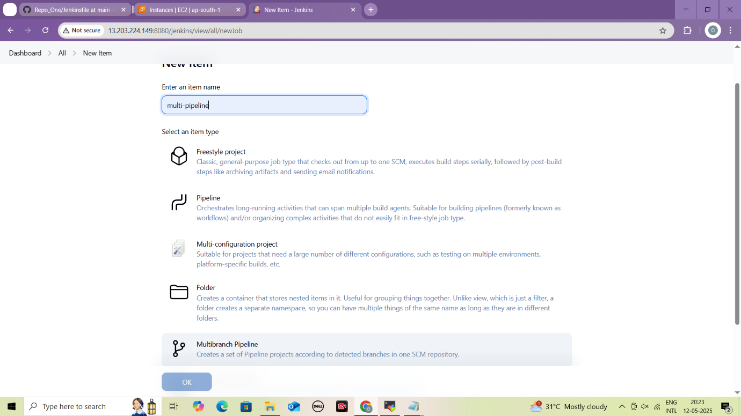

**Create new Jenkins job using multibranch pipeline**

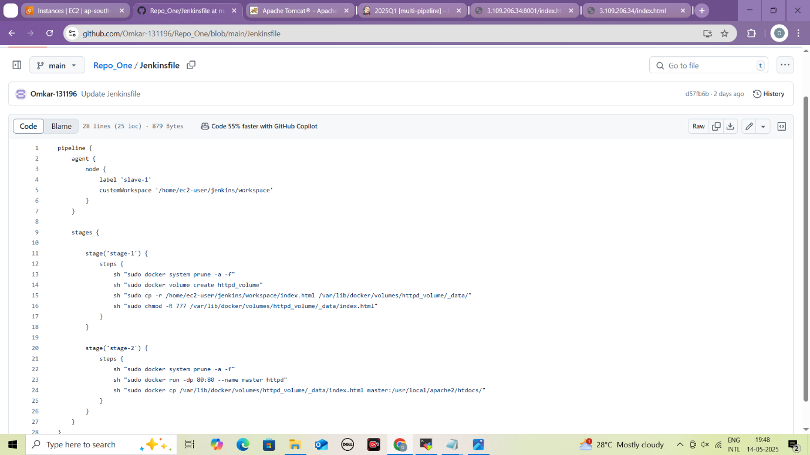

**Create Jenkinsfile in main branch**

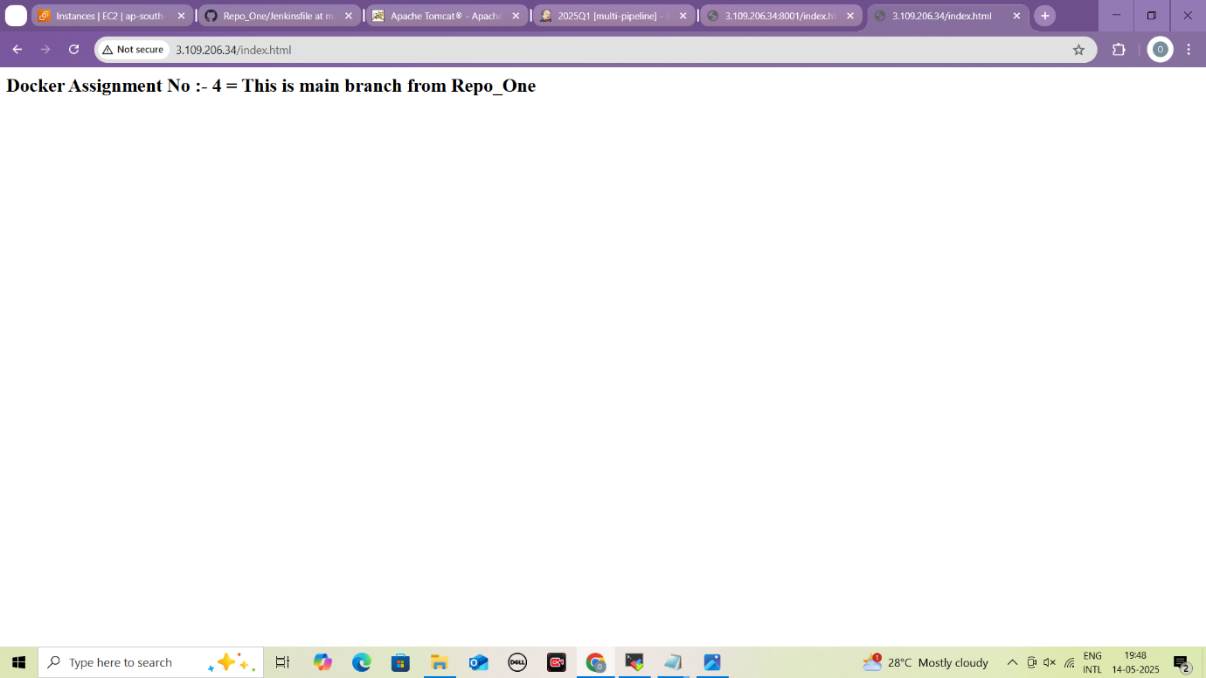

**Content of index.html file from main branch**

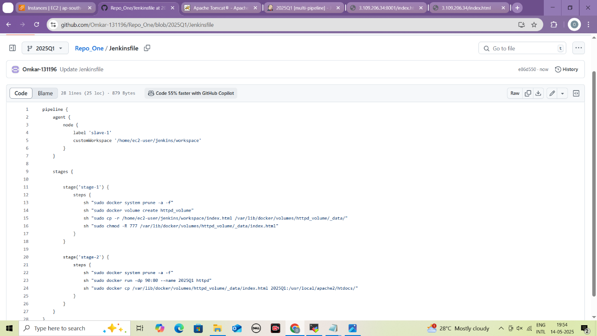

**Create Jenkinsfile in 2025Q1 branch**

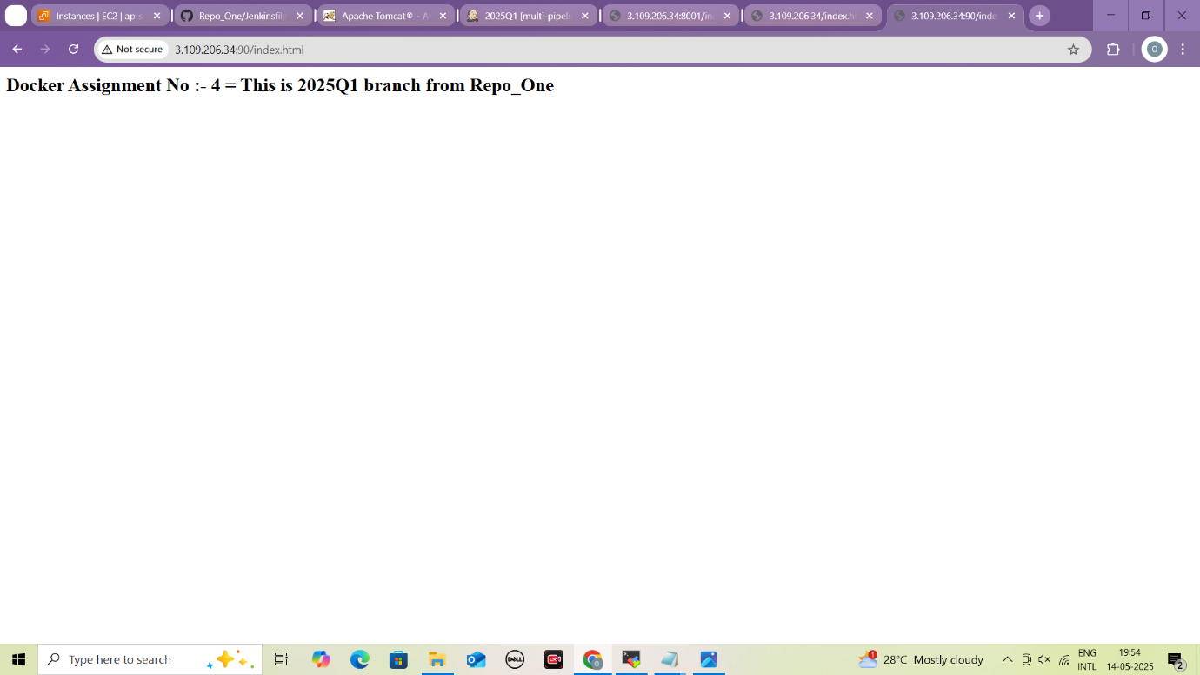

**Content of index.html file from 2025Q1**

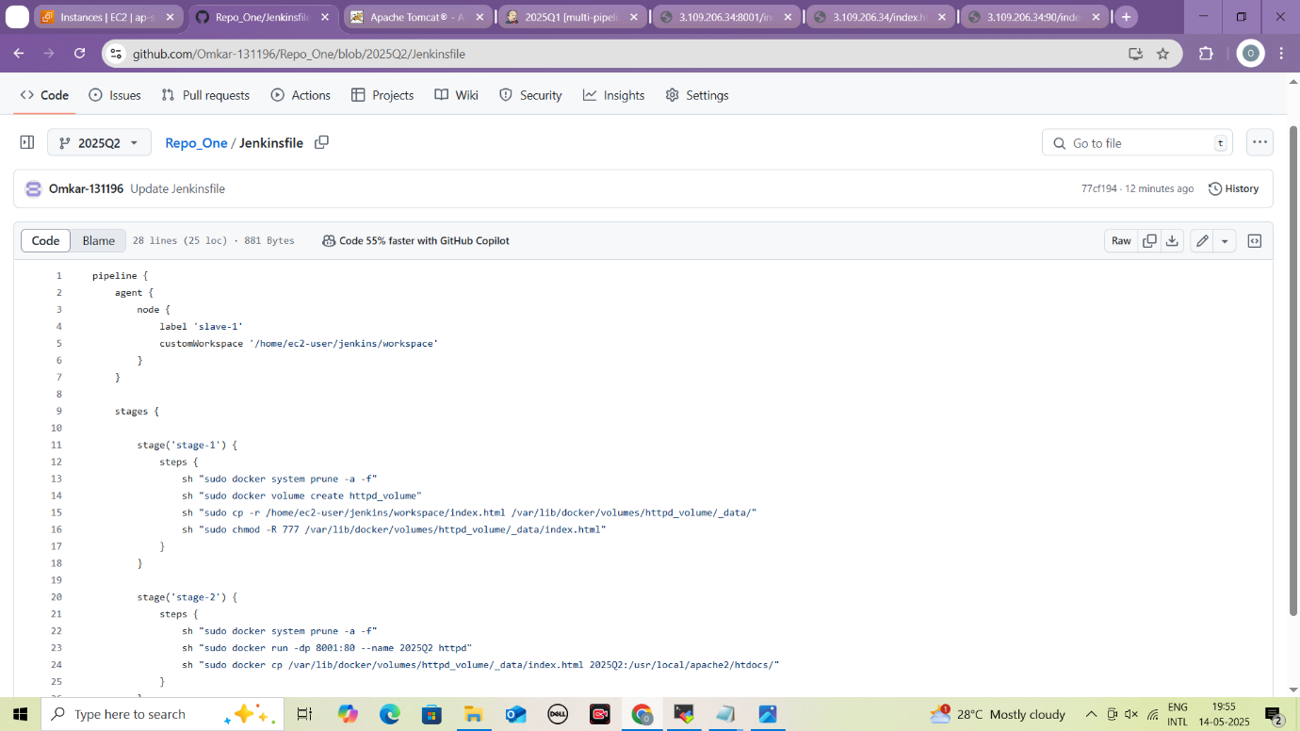

**Write Jenkinsfile in 2025Q2 branch**

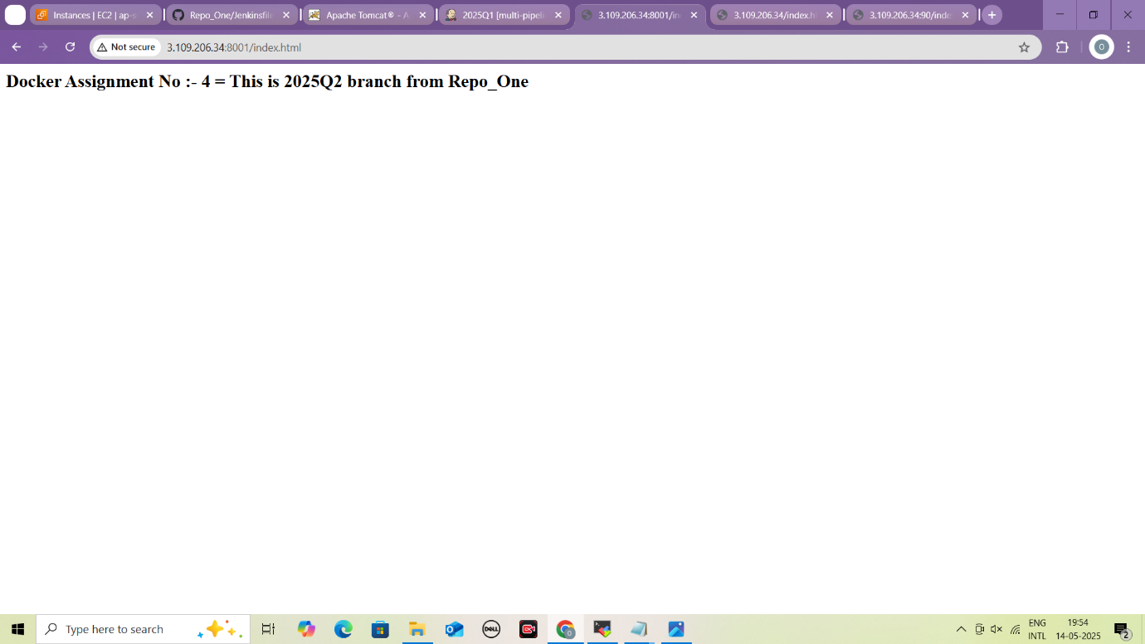

**Content of index.html file in 2025Q2 branch**