**Problem Statement = Create two different containers in two different custom bridge networks and connect them.**

**Submitted by = Omkar Patil (AWS DevOps Batch :- 04 Jan 2025)**

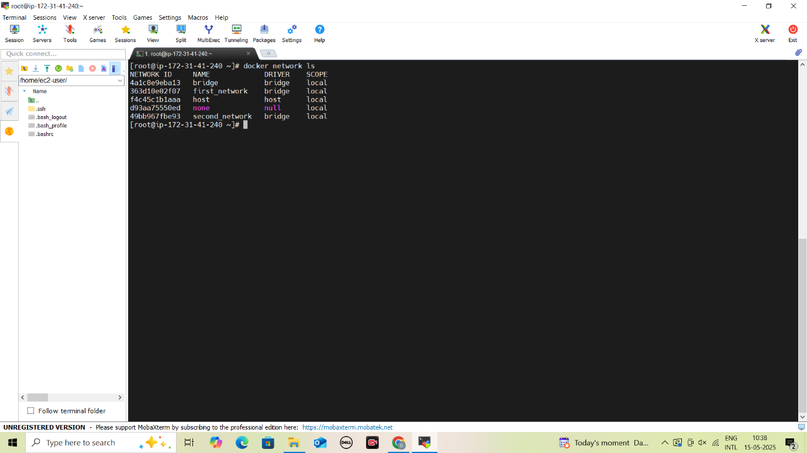

**Create two custom bridge networks**

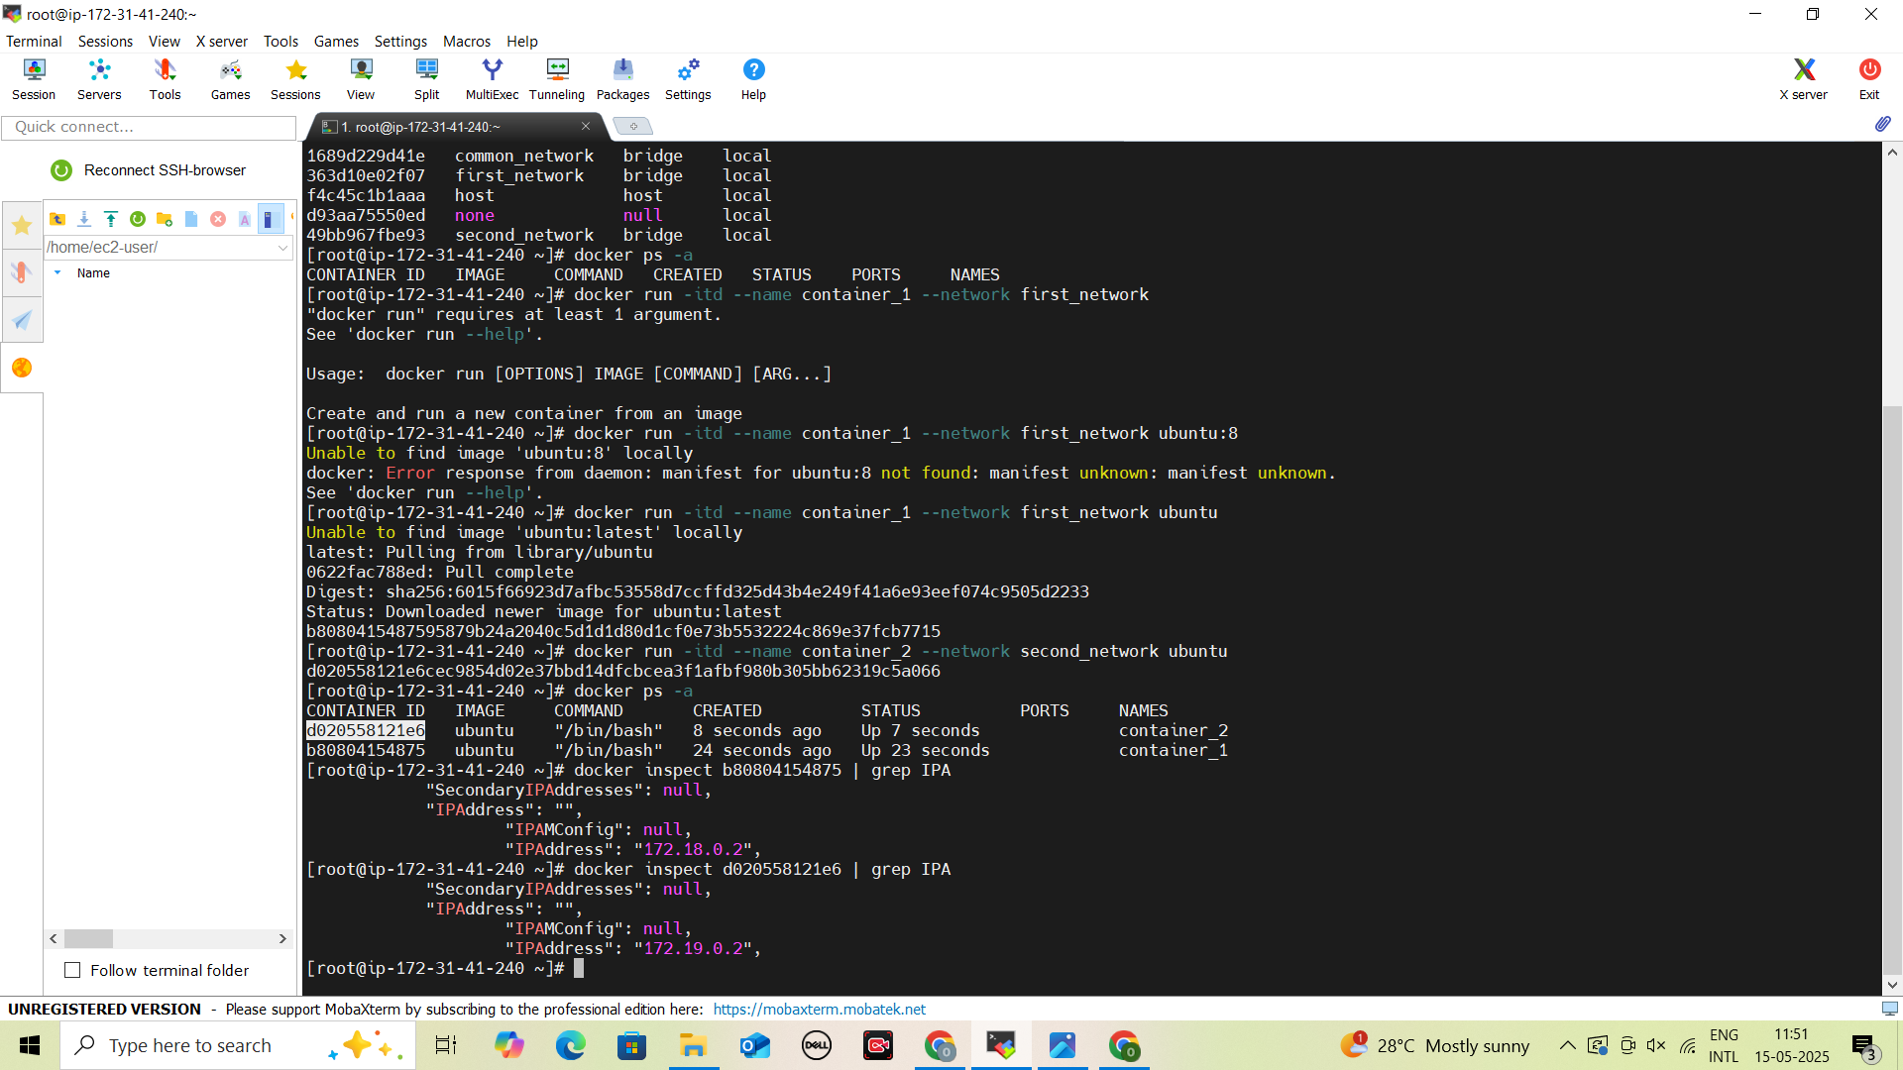

**Create one container on each network**

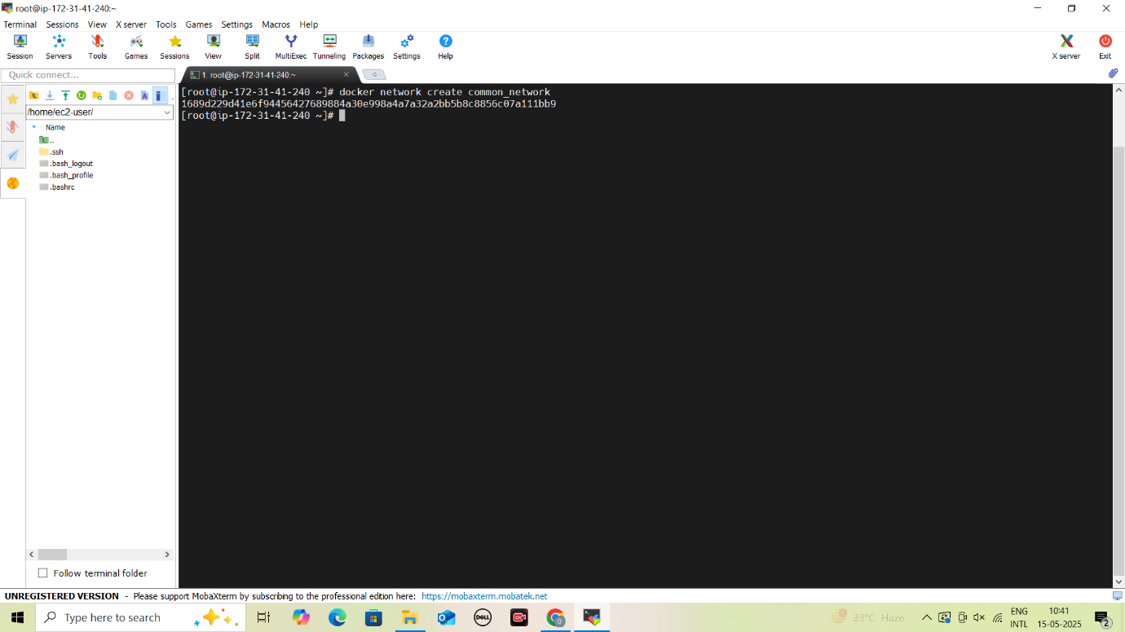

**Create custom common network**

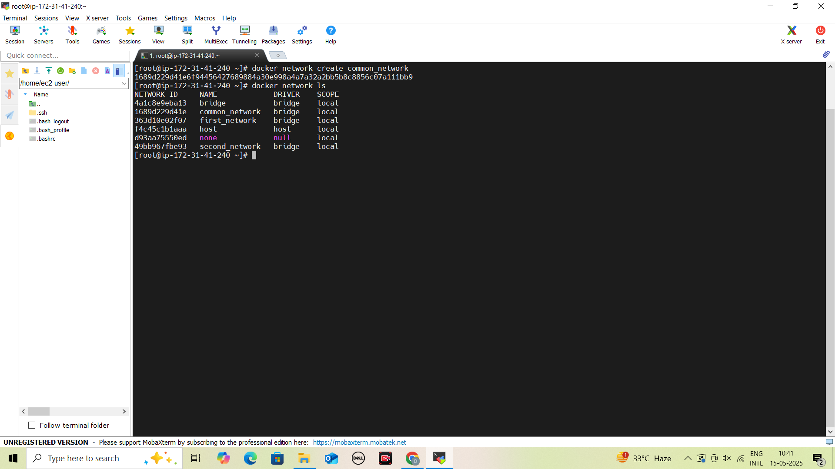

**View All Networks**

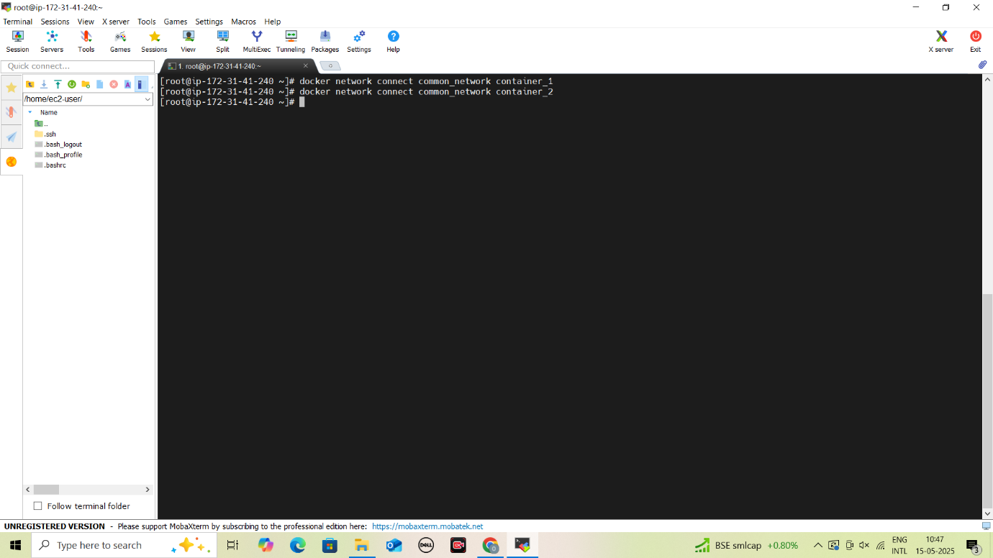

**Connect two containers to common network**

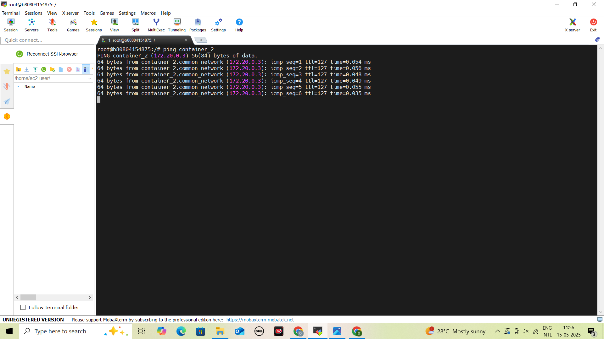

**Ping Container_2 from Container_1**

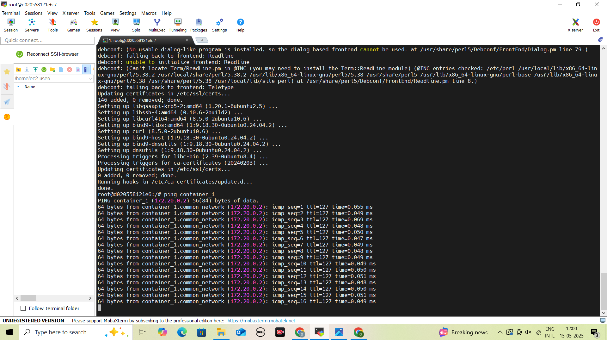

**Ping Container_1 from Container_2**