**Problem Statement = Deploy index.html from three different branches of a Git repo on httpd servers in three different docker containers with three different port numbers (80, 90,8001) using Jenkins pipeline.**

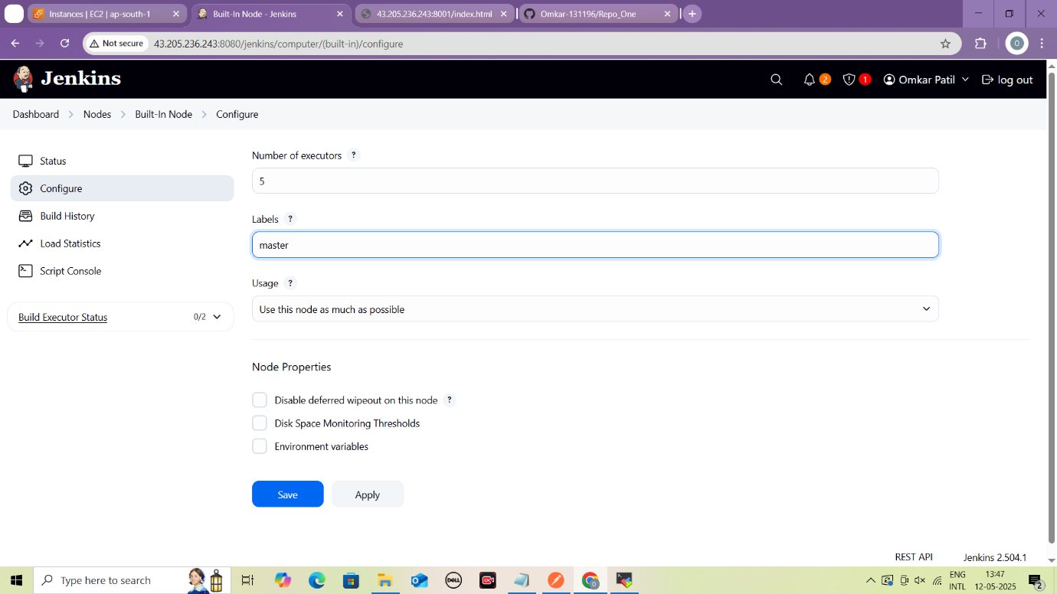

**Configure Label of Build in node as ‘master’**

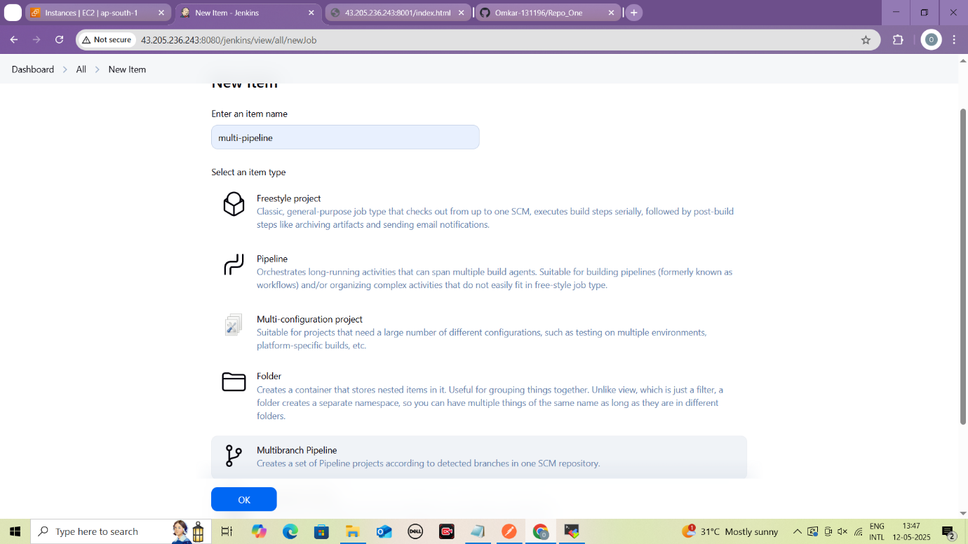

**Create multibranch pipeline Jenkins job**

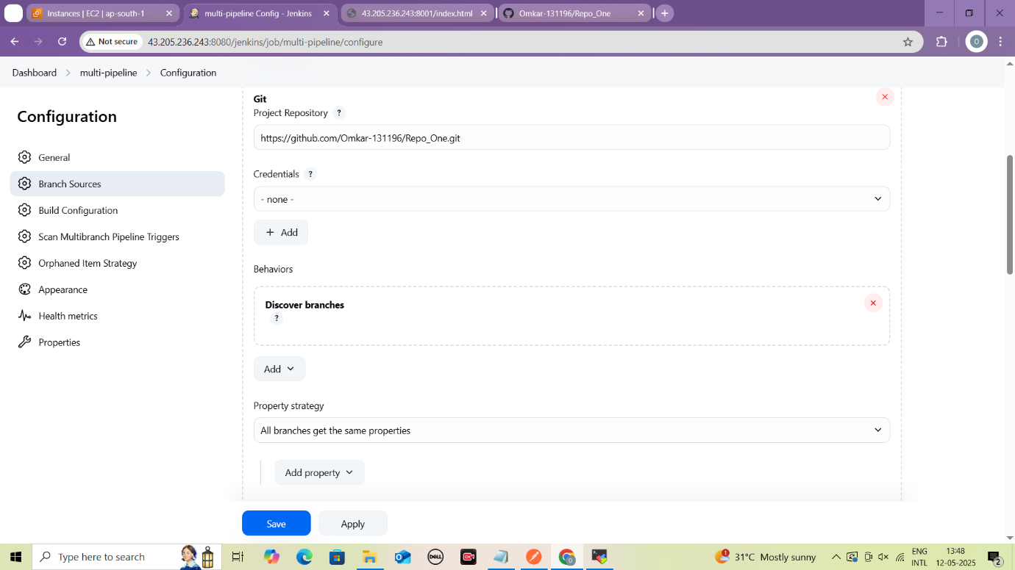

**Set up the repository in job**

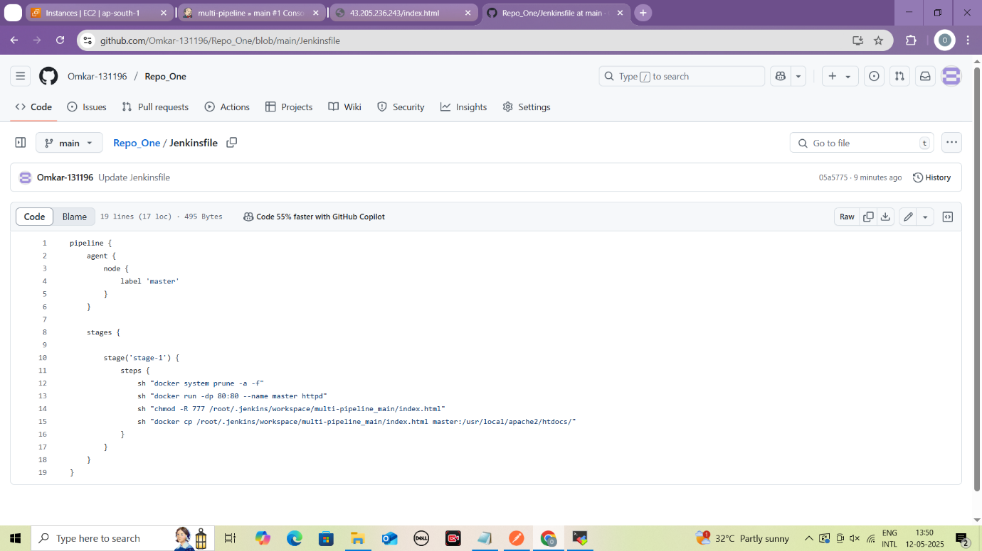

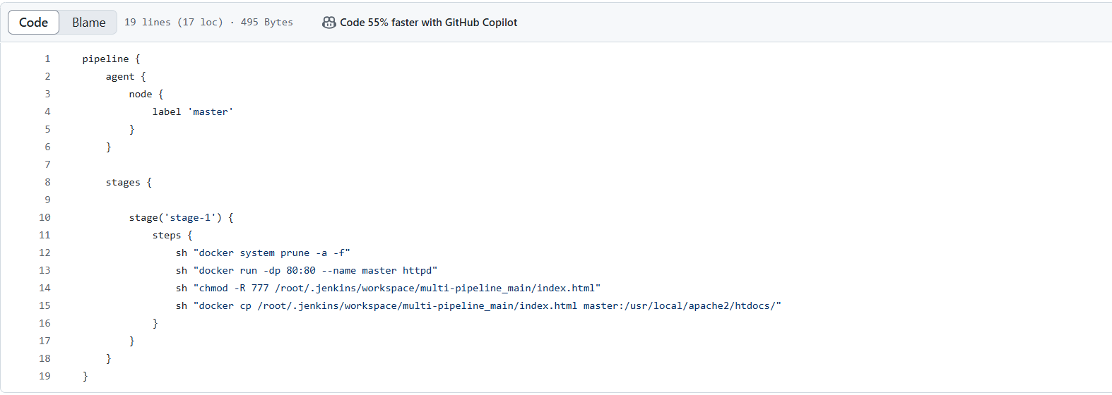

**Write Jenkinsfile pipeline in main branch**

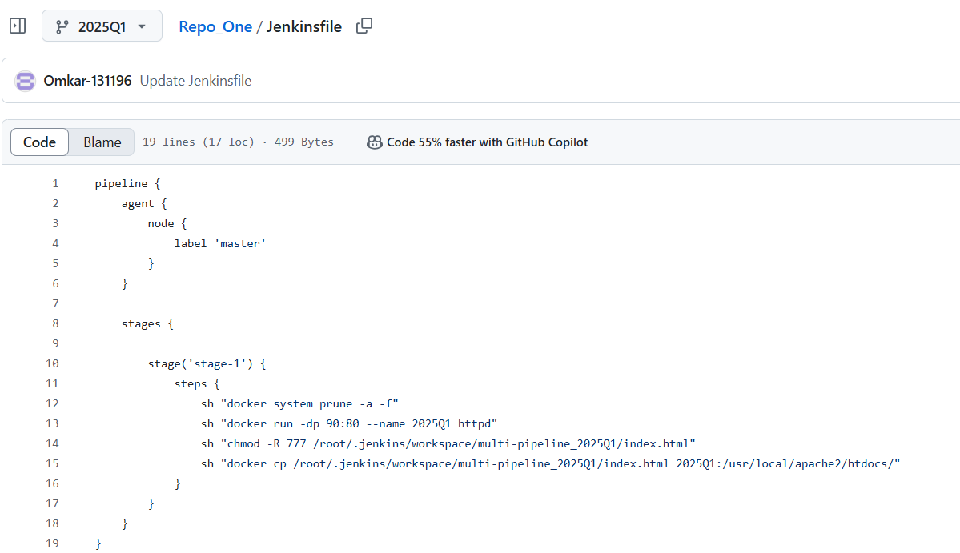

**Do the same for 2025Q1 branch**

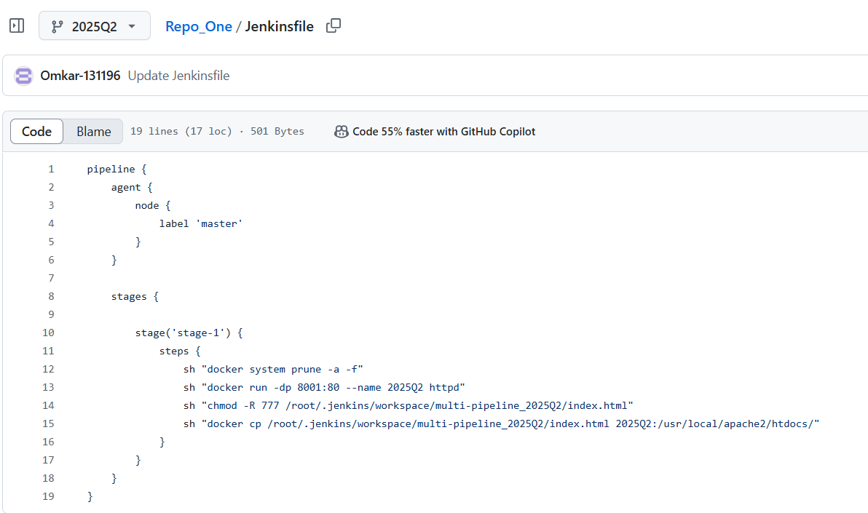

**Do the same for 2025Q2 branch**

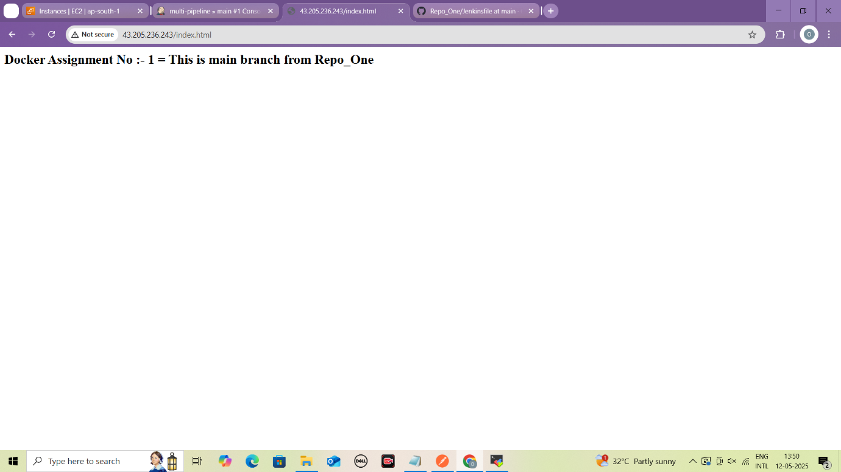

**Content of Index.html of main branch**

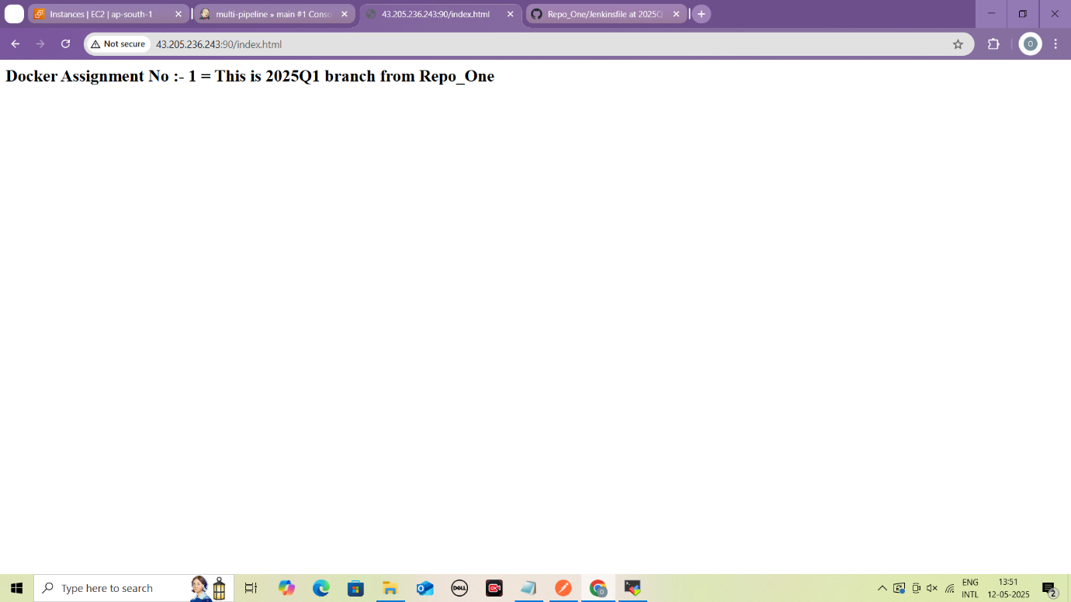

**Content of index.html of 2025Q1 branch**

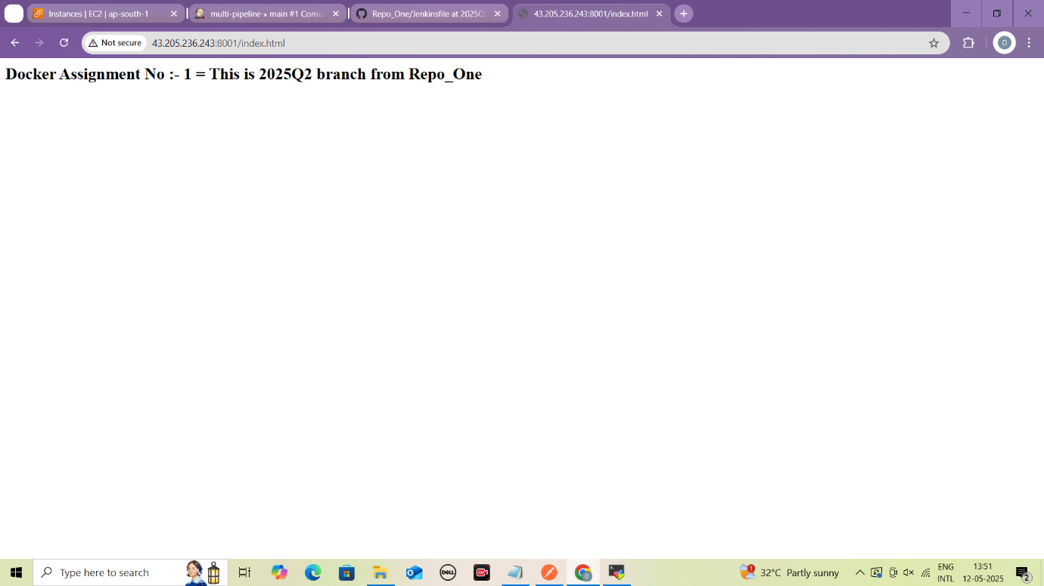

**Content of index.html of 2025Q2 branch**