Employee Management System - Test Cases
Employee Operations :-
Test Scenario | Input | Expected Output | Actual Output
Employee Registration | Valid employee registration details | Successful registration | Successful registration
Employee Login | Valid login credentials | Successful employee login | Successful employee login
Invalid Login | Invalid login credentials | Login failed with error message | Login failed with error message
Timer Functionality | Starts login timer | Timer starts successfully | Timer starts successfully
Chat Functionality | Employee sends message to other employees | Message send successfully to other users | Message send successfully to other users
Projects | Employee create new project | Project created successfully message | Project created successfully message
Leave Approval Request | Employee applies leave request | Request submitted successfully message | Request submitted successfully message
View Profile | Logged-in employee accesses profile | Employee profile details displayed | Employee profile details displayed
Update Profile | Edit name or contact info | Profile updated successfully | Profile updated successfully
Access Restriction | Regular employee tries accessing admin UI | Access denied / unauthorized message | Access denied / unauthorized message
Admin Role Access | Admin logs in | Admin dashboard visible | Admin dashboard visible
Logout Functionality | Click logout button | Employee session ended | Employee session ended

Admin Operations :-

Test Scenario | Input | Expected Output | Actual Output
Admin  Registration | Valid admin registration details | Successful registration | Successful registration
Admin Login | Valid login credentials | Admin dashboard rendered | Admin dashboard rendered
Invalid Login | Invalid login credentials | Login failed with error message | Login failed with error message
Feed Message Functionality | Sending message to particular employees | Message are only visible to assigned employees | Message are only visible to assigned employees
Feed Task Functionality | Assigning a task to particular employees | Tasks are only visible to assigned employees | Tasks are only visible to assigned employees
Feed Event Functionality | Assigning a event to particular employees | Events are only visible to assigned employees | Events are only visible to assigned employees
Manage Users | Admin can give permission to any employees to access the admin dashboard | Selected employees can access the admin dashboard | Selected employees can access the admin dashboard
Reports | Click on report | Employee summary displayed | Employee summary displayed
Admin Approvals | Admin approves /reject pending leave request | Leave marked as approved / rejected | Leave marked as approved / rejected
Logout Functionality | Click logout button | Admins session ended | Admins session ended

Test Report :-

Test Case ID | Test Objective | Pre-Condition | Status
1 | Employee Management | Employee Registration | Pass
2 | Employee Management | Employee Authentication | Pass
3 | Employee Management | Employee Profile | Pass
4 | Employee Management | Timer Functionality | Pass
5 | Employee Management | Chat | Pass
6 | Employee Management | Projects | Pass
7 | Employee Management | Task | Pass
8 | Employee Management | Event | Pass
9 | Employee Management | Approval Request | Pass
10 | Employee Management | Attendance | Pass

Test Case ID | Test Objective | Pre-Condition | Status
11 | Admin Management | Feed Message Functionality | Pass
12 | Admin Management | Feed Task Functionality | Pass
13 | Admin Management | Feed Event Functionality | Pass
14 | Admin Management | Projects | Pass
15 | Admin Management | Drive | Pass
16 | Admin Management | Calendar | Pass
17 | Admin Management | Chat | Pass
18 | Admin Management | Manage Users | Pass
19 | Admin Management | Reports | Pass
20 | Admin Management | Admin Approvals | Pass

User Dashboard :
Working Timer
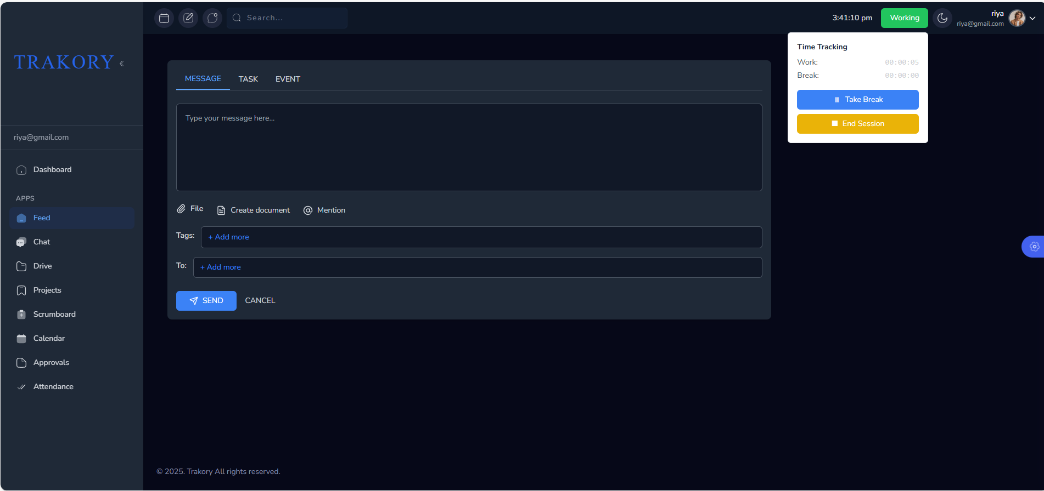

Break timer 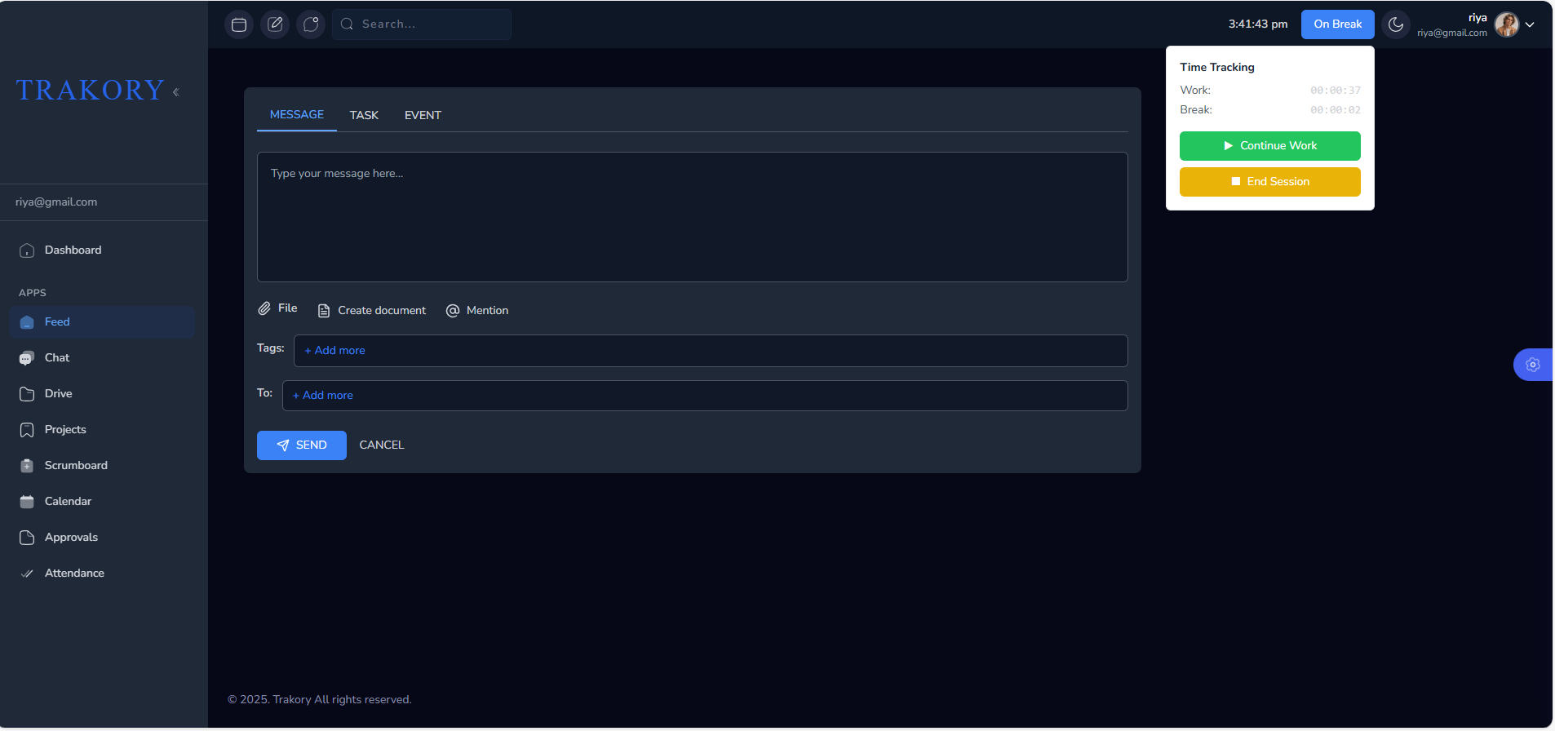
User Feed Message
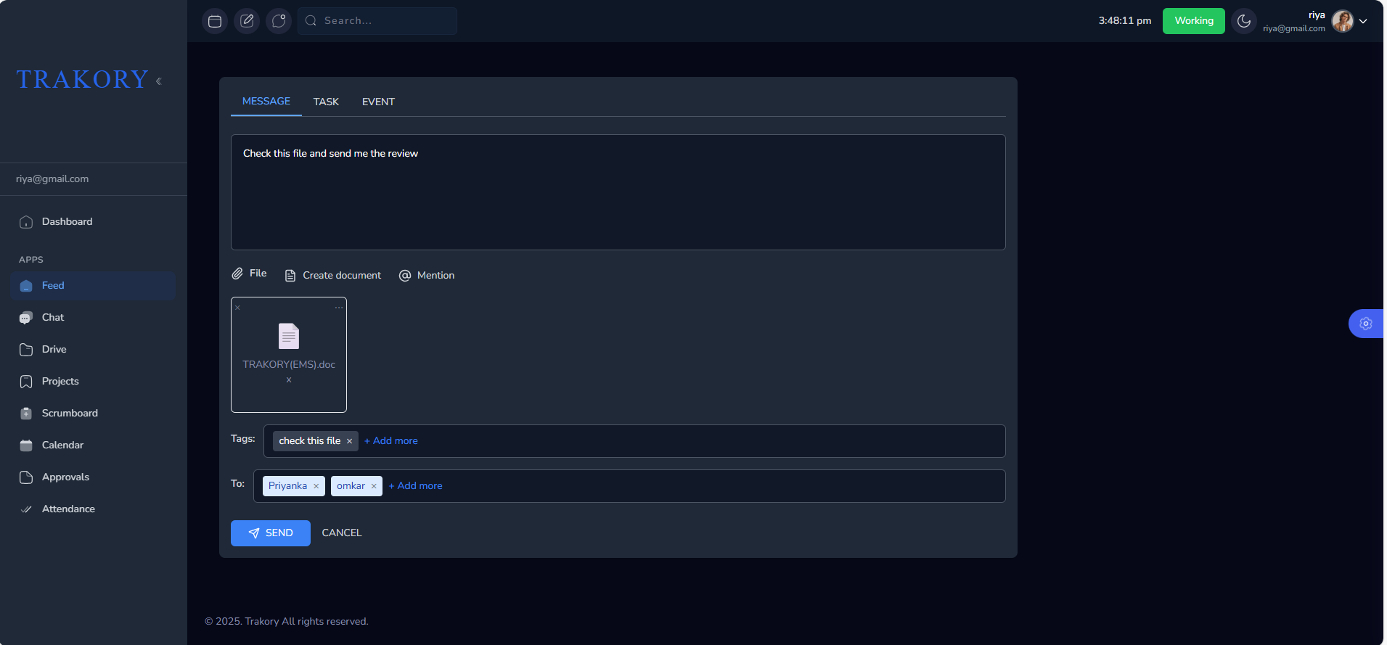
Message send successfully to the selected users
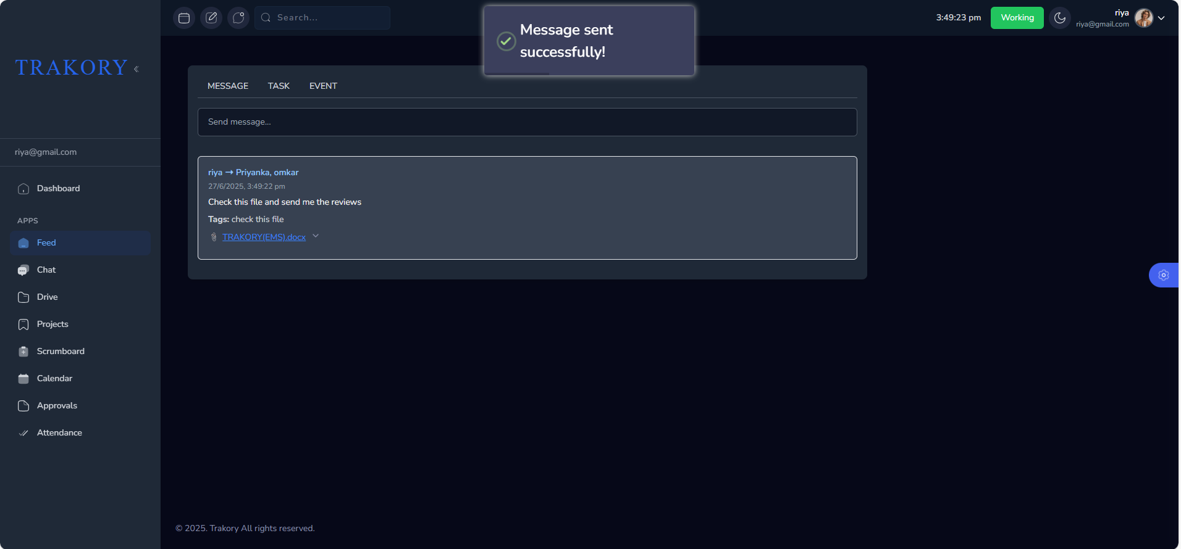

Feed task
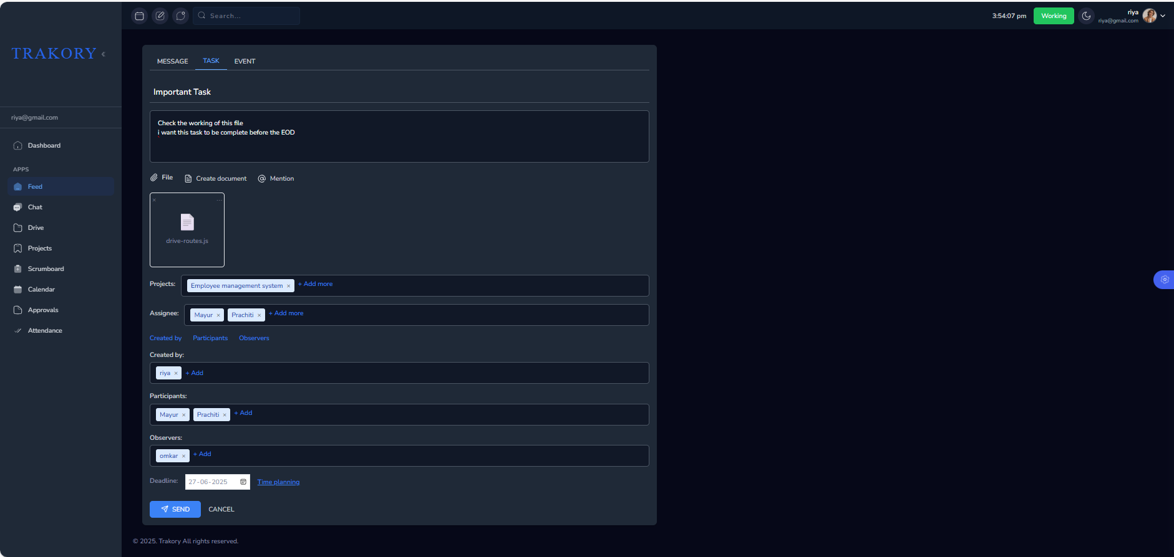
Task send successfully to the selected users
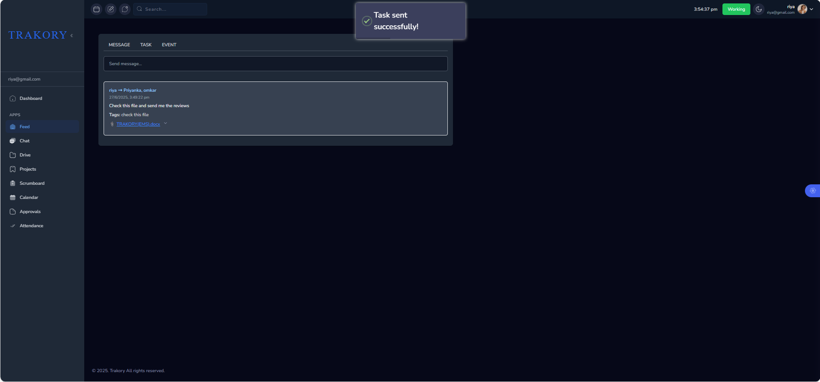
Feed Event
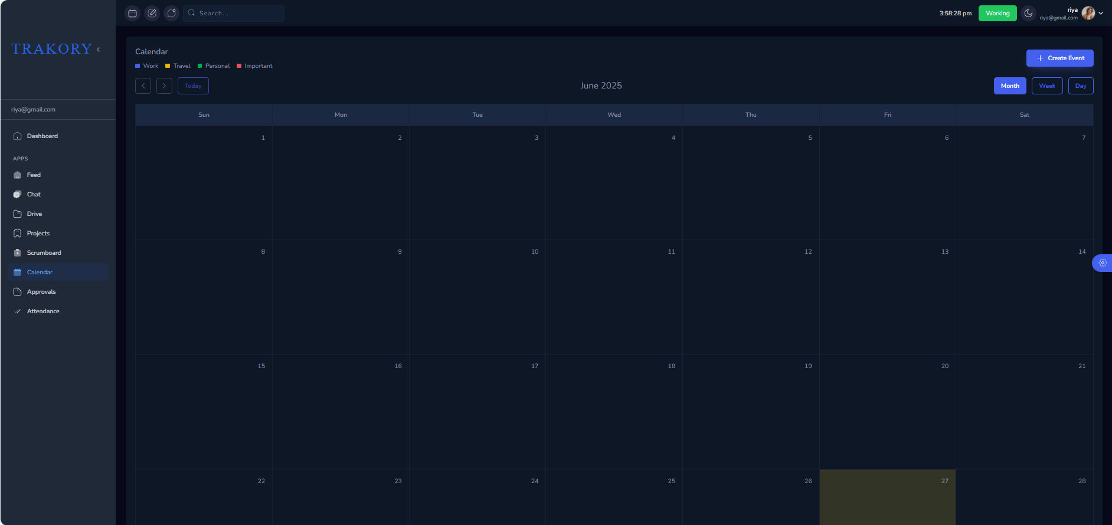
creating the event
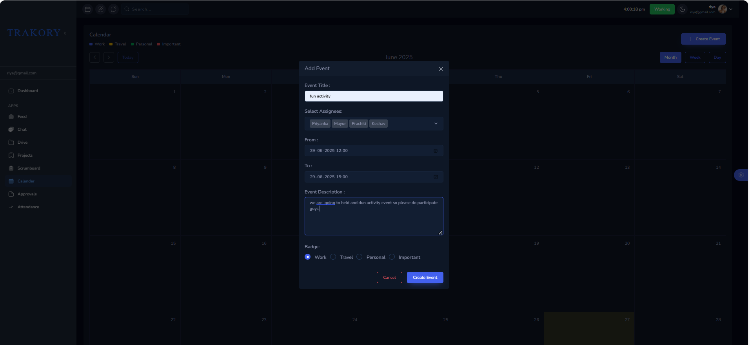
event created successfully
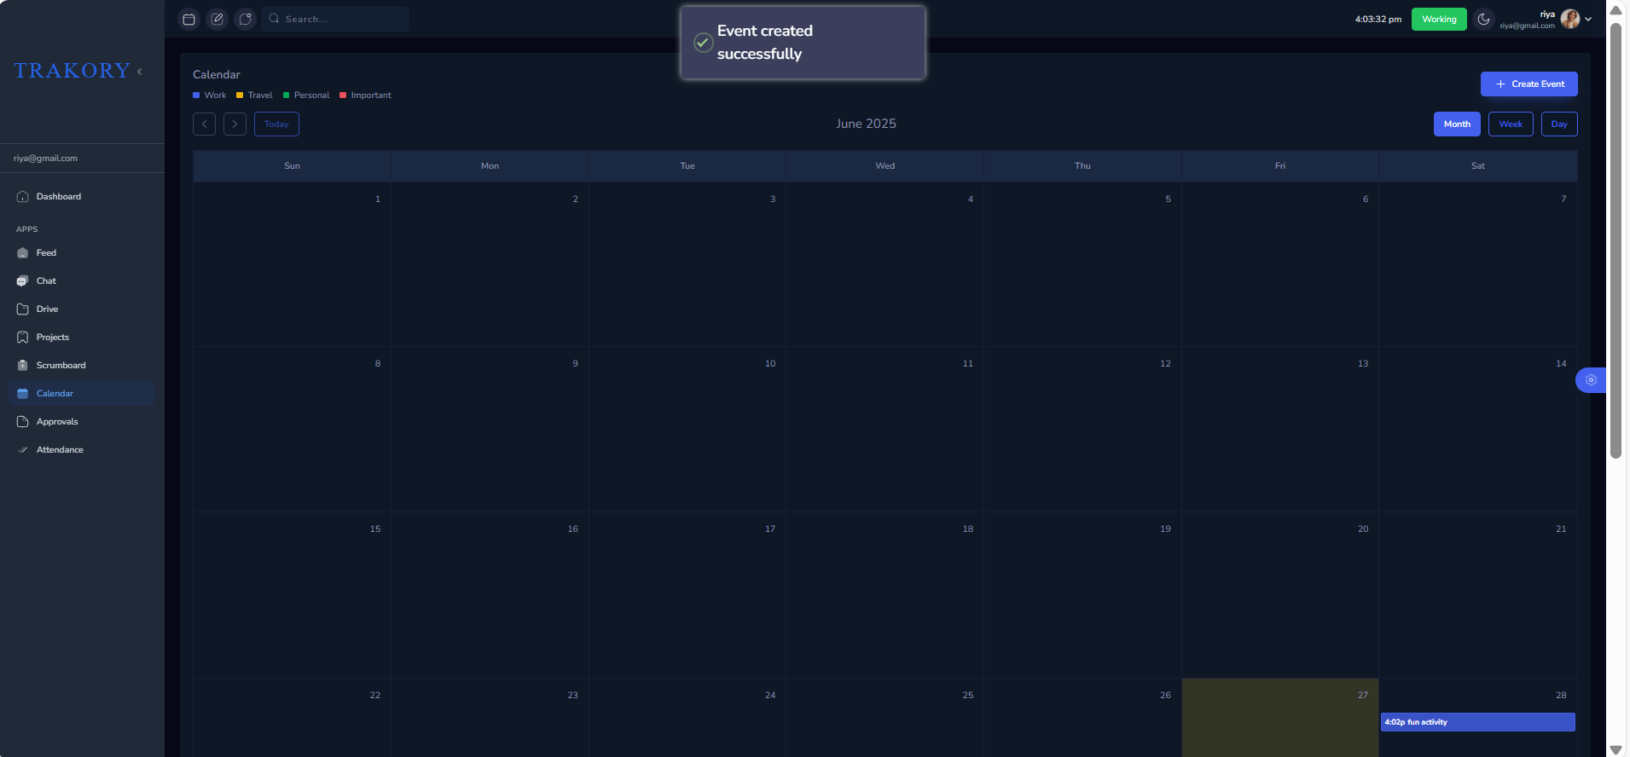

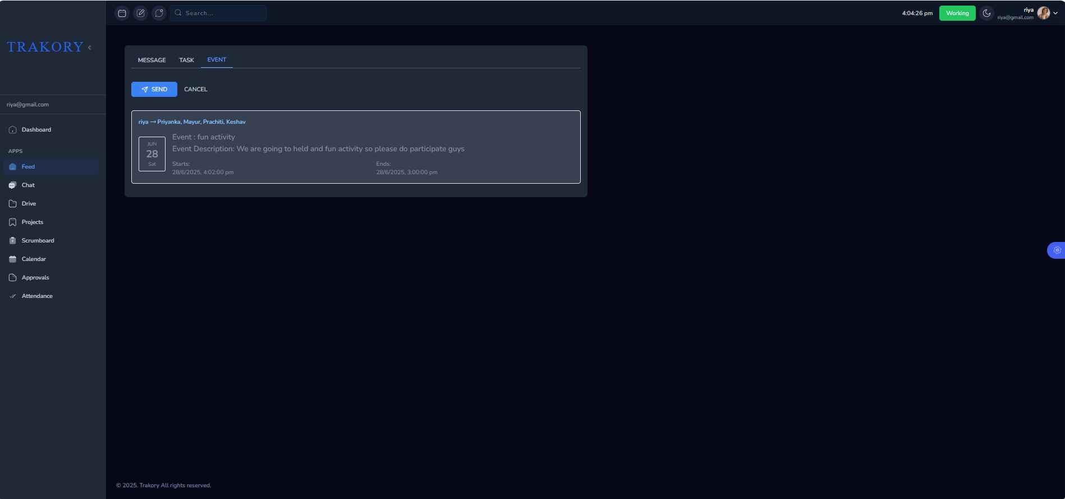

Chat
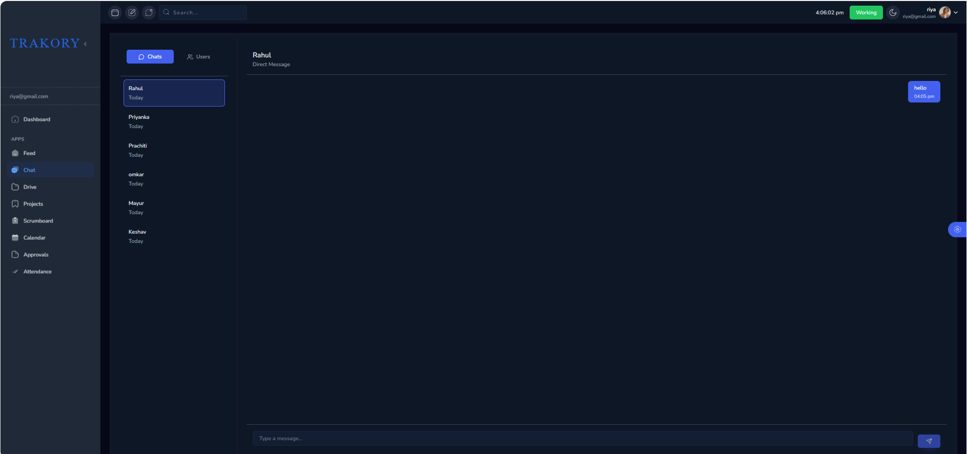

Drive
file created
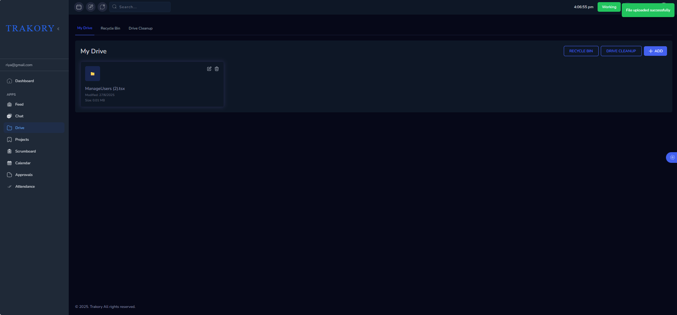
file moved to the recycle bin
