Name: Ghodake Omkar Atul

Roll No: 30

PRN No: 72036196G

BE IT

**Assignment 1**

# Hello.java

import java.rmi.Remote;

import java.rmi.RemoteException; public interface Hello extends Remote

{

default void message() throws RemoteException{}

}

InterfaceImplementation.java

public class ImplExample implements Hello{ public void message() { System.out.println("This is at server");

}

}

# Server.java

import java.rmi.registry.Registry; import java.rmi.registry.LocateRegistry; import java.rmi.RemoteException;

import java.rmi.server.UnicastRemoteObject; public class Server extends ImplExample { public Server() {}

public static void main(String args[]) { try {

// Instantiating the implementation class ImplExample obj = new ImplExample();

// Exporting the object of implementation class

// (here we are exporting the remote object to the stub)

Hello stub = (Hello) UnicastRemoteObject.exportObject(obj, 0);

// Binding the remote object (stub) in the registry Registry registry = LocateRegistry.getRegistry(); registry.bind("Hello", stub); System.err.println("Server ready");

} catch (Exception e) {

System.err.println("Server exception: " + e.toString()); e.printStackTrace();

}

}

}

Client.java

import java.rmi.registry.LocateRegistry; import java.rmi.registry.Registry; public class Client {

private Client() {}

public static void main(String[] args) { try {

// Getting the registry

Registry registry = LocateRegistry.getRegistry(null);

// Looking up the registry for the remote object Hello stub = (Hello) registry.lookup("Hello");

// Calling the remote method using the obtained object stub.message();

// System.out.println("Remote method invoked");

} catch (Exception e) {

System.err.println("Client exception: " + e.toString()); e.printStackTrace();

}

}

}

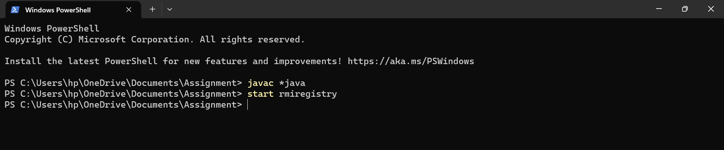

## Here we have started the RMI

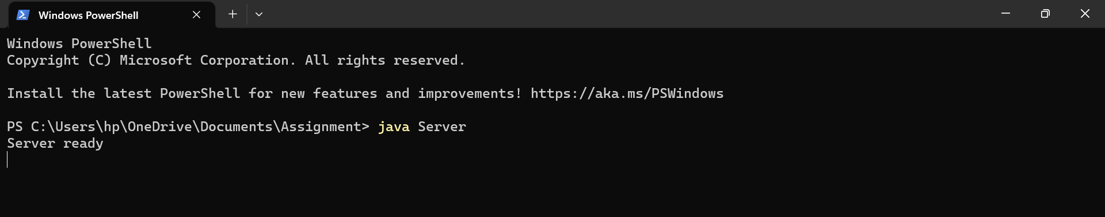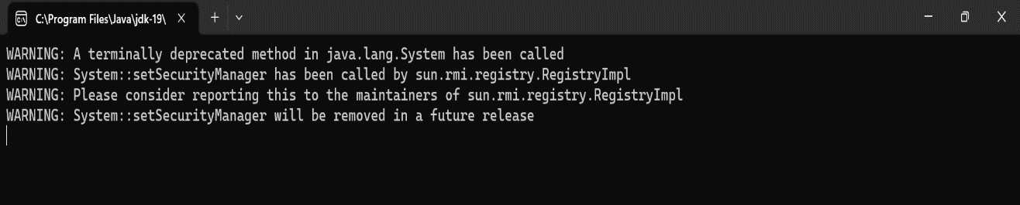

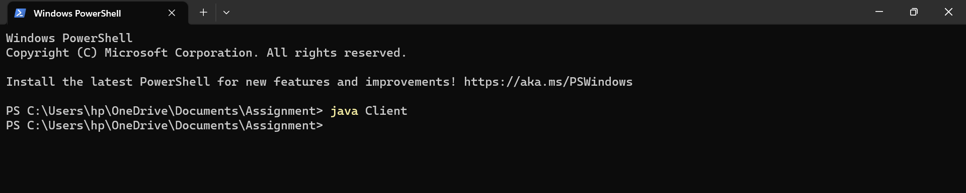Then we have started the server

## Finally, the output of the implemented code.