NO LIFE BELONGS

2032, 7th  August a deadly virus got all the population down. I am Aiden J. locky a scientist who saved the humans. And here’s how it go’s

## **At 2028, A scientist jonnie was trying to make a antibodies for** Bubonic Plague and smallpox . The Bubonic plague most of world from 2020 until 2040. Over 50 million people died, more than 60% of world entire population at the time and Smallpox is caused by the variola virus. Humans are the only natural hosts of smallpox and transmission depends upon direct contact with an infected person or infected bodily fluids, contaminated bedding or clothing. Airborne transmission is rare, although is more likely in enclosed settings such as buildings, buses, and trains. But it would be a great discovery, actually he made a deadly virus. That mutates every 20 days. The first host of Ash who took this risk for

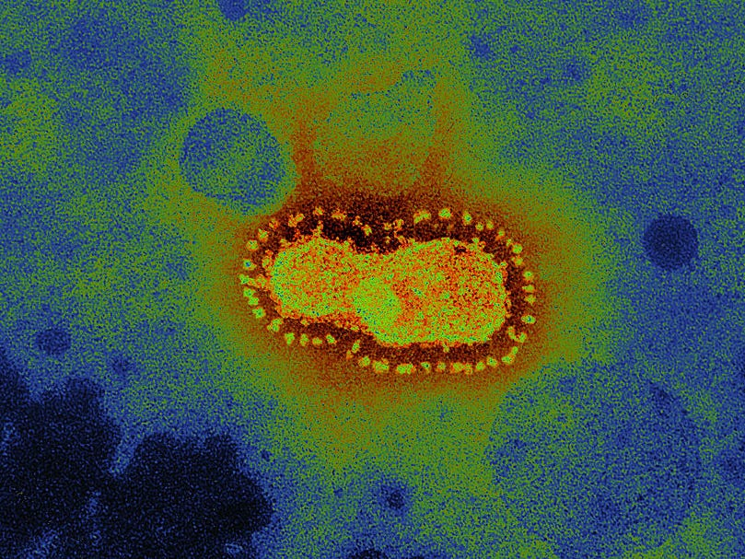

: the virus in microscope

**$10,000. There was no change in the hosts body but the host was carrying smallpox. Reason be hide no change in suspects body as the virus didn’t mutated since. The host was left free in 10 days isolation. The smallpox was cured ( no reason found). The antitude was declared to take to all of those who have smallpox. When a host of bubonic plague was given this antitude his oxygen rate and blood pressure dropped down and unfortunately he died. The rate of bubonic plague was more. That was nice that antitude didn’t work, I mean if it worked whole world would have the virus inside them mutating. Day 20 of the host the virus mutated.**

* Marburg virus
* Hair fall
* Death chances 05%

the hosts was sent in ICU immediately. Jonnie was asked about the diagnosis of the antibodies the told all antibodies that where present. But he took antibodies of Yersinia pestis which was more in the antibody which made it a virus. Many doctors where called from all over the world to California. I was asked to look over the virus he made. Me being scared by looking it in microscope. As all the virus where mutating inside. I asked to send all vaccines of :

## Marburg virus

## Ebola virus

## HIV

## Hantavirus

## Rotavirus

## SARS-CoV

### Which I got that were mutating. At 35th day over 15% of the world was infected. Day 40 virus mutates. Death chances up to 15% , heart attacks 01% , Slow heartbeat (bradycardia), cardiomyopathy symptoms. Many cardiologist were called all over world. We were in a lockdown where nobody can leave there house. Many vaccine tests failed. It was a hard month. After 2 years means in 2031 the mutation was :

* Blood vessel disease, such as coronary artery disease.
* Heart rhythm problems (arrhythmias)
* Heart defects you're born with (congenital heart defects)
* Heart valve disease.
* Disease of the heart muscle.
* Heart infection.
* Common Contagions. Contagious diseases like Ebola and bird flu frequently make headlines. ...
* Norovirus (“Stomach Flu”) ...
* Influenza. ...
* Meningitis. ...
* Hand, Foot and Mouth Disease (HFMD) ...
* Pertussis. ...
* A. Asbestosis. Asthma.
* B. Bronchiectasis. Bronchitis.
* C. Chronic Cough. Chronic Obstructive Pulmonary Disease (COPD) Common Cold.
* H. Hantavirus.
* L. Lung Cancer.
* P. Pandemic Flu. Pertussis. Pleurisy. Pneumonia. Pulmonary Embolism. ...
* R. Respiratory Syncytial Virus (RSV)
* Chronic kidney disease. The most common form of kidney disease is chronic kidney disease. ...
* Kidney stones. Kidney stones are another common kidney problem. ...
* Glomerulonephritis. ...
* Polycystic kidney disease. ...
* Urinary tract infections.
* Alzheimer's Disease.
* Dementias.
* Brain Cancer.
* Epilepsy and Other Seizure Disorders.
* Death chances upto 78%

The world population before this disease was **7.9 Billion but now it is just 2.4 billion. After a lot research I made a chart of the deaths.** Every body with this disease where gave all the vaccine found but when heart disease where found no body could save them . hunger of the patient would increase in only 10 mins they needed food. It was a problem! I made a chemical compound C6HY64CO20 (IMAGINARY COMPOUND) which would kill the hunger for 6 days. But then the patients would get weaker. It also failed ! the humanity was about to end but when I got the main biological compound of the disease in a patients blood. I took it in surveillance. About a year means 2032 I made the hyvigioxide named vaccine. The antibodies were of the main biological compound of the disease. But only 2.2 billion people were alive. This pandemic was named as horious pandemic. I was awarded to find the vaccine and the world was happy enjoying the life. But still we don’t know when a virus will mutate and will get us again.

That’s what happened

To be continued

( the disease name took in this story are real, but this is a frictional story)

* + ISHAN S.MALI