NPC – UNIT 3 ASSIGNMENT
Configure DNS and Web Server Using Cisco Packet Tracer
Student Name | Omkar Sunil Londhe
PRN | 2125UCSM1074
Subject / Module | Network Protocols and Communication (NPC) - Unit 3
Project Title | Configure DNS and Web Server Using Cisco Packet Tracer
Software / Tools | Cisco Packet Tracer 9.0.1 (Windows/Kali)
GitHub Repository | Unit-3
GitHub Link | https://github.com/Omkar-Sunil-Londhe/Unit-3.git

1. Aim and Objectives
Aim: To configure a DNS Server and a Web Server using Cisco Packet Tracer and to access a hosted website through its domain name (www.npcunit3.com) instead of its IP address.
Objectives:
1. Design and construct a local area network in Cisco Packet Tracer containing client PCs, a switch, a DNS server, and a web server.
2. Configure static IPv4 addressing across all devices on the 192.168.1.0/24 subnet.
3. Enable and configure the HTTP service on the Web Server to host a custom webpage.
4. Enable and configure the DNS service on the DNS Server with an A record resolving www.npcunit3.com to the web server IP.
5. Verify ICMP end-to-end connectivity using ping commands.
6. Verify DNS resolution and HTTP web page retrieval from client PCs.
2. Hardware & Software Requirements
• Simulation Tool: Cisco Packet Tracer (v9.0.1 or compatible)
• Central Switch: Cisco Catalyst 2960-24TT Layer-2 Switch
• DNS Server: Generic Server-PT (configured as DNS Server at 192.168.1.2)
• Web Server: Generic Server-PT (configured as HTTP Web Server at 192.168.1.3)
• End User PCs: PC0 (192.168.1.10) and PC1 (192.168.1.11)
• Media: Copper Straight-Through Ethernet Cables
3. Network Topology & IP Addressing
The topology connects all devices to a central Cisco 2960 switch within a single broadcast domain (192.168.1.0/24).
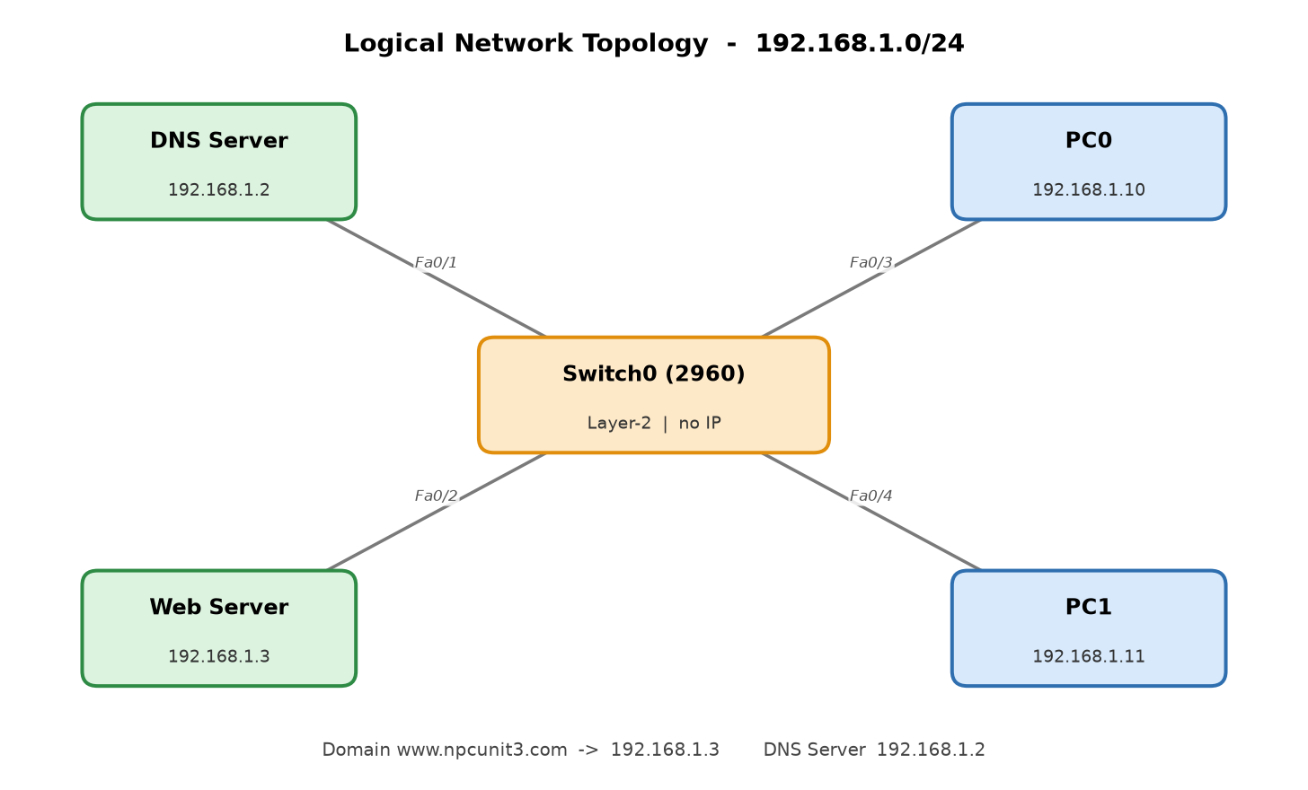
Figure 1: Logical Network Topology (192.168.1.0/24)
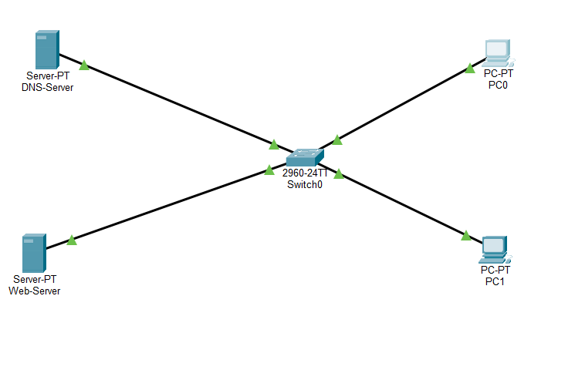
Figure 2: Cisco Packet Tracer Workspace Simulation Topology
Device | IP Address | Subnet Mask | Switch Port | Role / Notes
DNS Server | 192.168.1.2 | 255.255.255.0 | Fa0/1 | DNS Service (Port 53)
Web Server | 192.168.1.3 | 255.255.255.0 | Fa0/2 | HTTP Service (Port 80)
PC0 | 192.168.1.10 | 255.255.255.0 | Fa0/3 | DNS: 192.168.1.2
PC1 | 192.168.1.11 | 255.255.255.0 | Fa0/4 | DNS: 192.168.1.2
4. Server Configurations
DNS Server Configuration: On the DNS Server, static IP 192.168.1.2 was configured. In Services > DNS, DNS Service was toggled ON. An A-Record was added mapping domain www.npcunit3.com to IPv4 address 192.168.1.3.
Web Server Configuration: On the Web Server, static IP 192.168.1.3 was configured. In Services > HTTP, HTTP service was switched ON. The index.html file was edited with custom HTML heading "Welcome to My Web Server!" and confirmation text.
5. Connectivity Testing & Results
Connectivity was validated from PC0 by executing ICMP ping commands in Command Prompt to both servers. Both tests succeeded with 0% packet loss and round-trip times < 1ms.
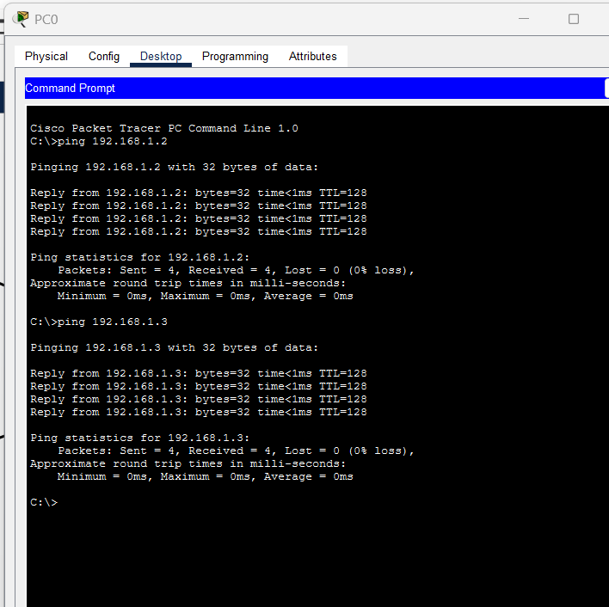
Figure 3: Ping verification from PC0 to DNS Server (192.168.1.2) and Web Server (192.168.1.3)
6. Website Access via Domain Name
To verify DNS resolution and Web Server hosting, PC0 opened Desktop > Web Browser and entered http://www.npcunit3.com. The DNS server resolved the domain to 192.168.1.3, and the HTTP page rendered successfully.
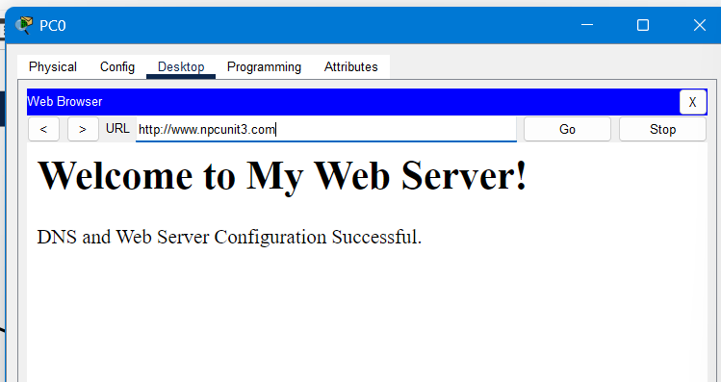
Figure 4: Web Browser rendering www.npcunit3.com successfully on PC0
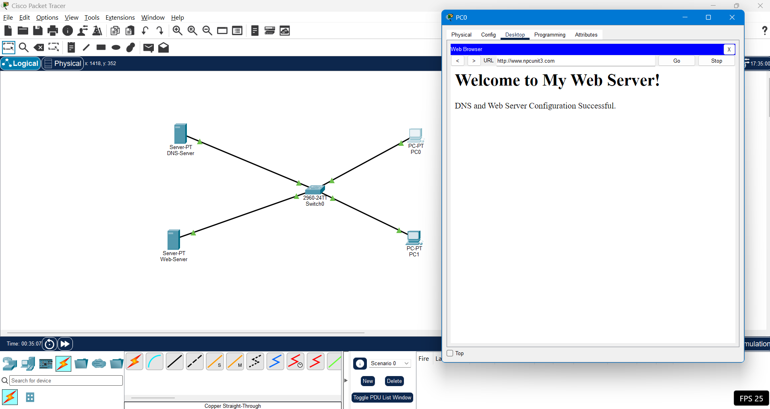
Figure 5: Complete Cisco Packet Tracer simulation environment
7. Conclusion
In this practical, a complete Local Area Network was designed and implemented in Cisco Packet Tracer. The DNS and Web services were successfully deployed, static addressing was verified, and client access using the domain name www.npcunit3.com was demonstrated with 100% operational success.
8. Submission Evidence Checklist
✓ Cisco Packet Tracer Project File: NPC_Unit_3_DNS_Web_Server.pkt
✓ Project Documentation Report: NPC_Unit_3_Omkar_Londhe.pdf & NPC_Unit_3_DNS_Web_Server_Report.docx
✓ Complete Topology & Configuration Screenshots in screenshots/ folder
✓ Logical Topology Diagram: logical_topology.png
✓ GitHub Repository: https://github.com/Omkar-Sunil-Londhe/Unit-3.git

