VISVESVARAYA TECHNOLOGICAL UNIVERSITY

“Jnana Sangama”, Belagavi 590014,
KARNATAKA, INDIA

Project Phase I -BCS685
On
“Asset Tokenization: Decentralized Platform for Real-World Asset Tokenization Using Blockchain”

Submitted in Partially fulfillment of the requirement for the award of degree Of

Bachelor of Engineering In
Computer Science & Engineering
Of Visvesvaraya Technological University, Belgaum.
Submitted by:
Omkar Bharath Pukale: 1AM23CS127 Sahil kumar Mishra: 1AM23CS176 Sandesh G C: 1AM23CS183
Sanjitha A: 1AM23CS186

Under the Guidance of:
Prof. Premkumar M K
Asst Professor, Dept. of CSE



DEPARTMENT OF COMPUTER SCIENCE AND ENGINEERING AMC ENGINEERING COLLEGE
18th K.M. Bannerghatta Main Road, Bengaluru – 560083 Year 2025-26

AMC Engineering College
Belagavi 560083
Department of Computer Science & Engineering


CERTIFICATE
Certified that the Project work entitled “Asset Tokenization: Decentralized Platform for Real-World Asset Tokenization Using Blockchain” carried out by bonafide students Omkar Bharath Pukale (1AM23CS127), Sahil Kumar Mishra (1AM23CS176), Sandesh G C (1AM23CS183), Sanjitha A (1AM23CS186) of
AMC Engineering College, in partial fulfillment for the award of Bachelor of Engineering in Computer Science & Engineering of Visvesvaraya Technological University, Belagavi during the year 2025–2026.It is certified that all corrections/ suggestions indicated for internal assessment have been incorporated in the report. The project report has been approved as it satisfies the academic requirements in respect of Project Work prescribed for the said Bachelor of Engineering degree.

Project Guide HOD Principal
Mr. Premkumar M K Dr.V.Mareeswari Dr. Yuvaraju B N

Assistant Professor Dept. of CSE
Prof. & Head Dept. of CSE
Principal, AMCEC

External Viva

External Name 1.
2.
Signature with Date

DECLARATION

We, the undersigned students of 6th semester, Department of Computer Science & Engineering, AMC Engineering College, declare that our project work entitled “Asset Tokenization: Decentralized Platform for Real-World Asset Tokenization Using Blockchain” is a bonafide work carried out by us. This project is neither a copy nor a modification of any other engineering project. We further declare that this work has not been submitted to any other university for the award of any degree in the past and shall not be submitted in the future.

Name | USN | Signature
OMKAR BHARATH | 1AM23CS127
PUKALE
SAHIL KUMAR MISHRA | 1AM23CS176
SANDESH G C | 1AM23CS183
SANJITHA A | 1AM23CS186

ACKNOWLEDGEMENT

We express our sincere gratitude to the Almighty for His blessings in successfully completing this project.
We take this opportunity to express our deep sense of gratitude to the management of AMC Engineering College for providing excellent infrastructure and a supportive environment for carrying out this project work.
We express our heartfelt thanks to our Principal, Dr. Yuvaraju B N, for his constant encouragement and support.
We would like to extend our sincere gratitude to Dr. V. Mareeswari, Professor and Head, Department of Computer Science & Engineering, for her valuable guidance and encouragement throughout the course of this project.
We are extremely thankful to our project guide, Prof. Premkumar M K, Assistant Professor, Department of CSE, for his continuous support, motivation, and valuable suggestions which helped us successfully complete this project.
We also thank all the teaching and non-teaching staff of the Department of Computer Science & Engineering for their support and cooperation.
Finally, we would like to thank our parents and friends for their constant encouragement and support throughout the development of this project.

OMKAR BHARATH PUKALE 1AM23CS127 SAHIL KUMAR MISHRA 1AM23CS176 SANDESH G C 1AM23CS183
SANJITHA A 1AM23CS186

ABSTRACT

Asset tokenization is an emerging technological innovation that enables the digital representation of real-world assets on a blockchain or distributed ledger system. Traditional asset markets such as real estate, commodities, and financial instruments often suffer from issues like high investment barriers, lack of liquidity, and dependency on intermediaries. Tokenization addresses these challenges by converting ownership rights into digital tokens, enabling fractional ownership, improved accessibility, and enhanced transparency.
This project presents the design and development of a decentralized platform for tokenizing real- world assets using blockchain technology. The system leverages smart contracts to manage asset ownership, token issuance, and secure transactions without relying on centralized authorities. By integrating modern web technologies with blockchain networks, the platform provides a user- friendly interface for asset listing, investment, and transaction tracking.
Tokenization also improves operational efficiency by reducing transaction costs, enabling faster settlement, and minimizing counterparty risks. However, challenges such as regulatory uncertainty, security risks, and infrastructure limitations still exist. This project demonstrates the feasibility of asset tokenization as a scalable and efficient solution for modern investment systems, promoting inclusivity and transforming traditional financial markets.

CONTENTS

CERTIFICATE i
DECLARATION ii
ACKNOWLEDGEMENT iii
ABSTRACT iv
CHAPTER - 1 INTRODUCTION 1 - 4
1.1 Overview 1
1.2 Objectives 3
1.3 Purpose, Scope, Applicability 3
1.3.1 Purpose 3
1.3.2 Scope 4
1.3.3 Applicability 4
1.4 Organization of Report 4
CHAPTER – 2 LITERATURE SURVEY 5 – 13
2.1 Introduction 5
2.2 Summary of papers 6
2.3 Drawbacks of existing system 12
2.4 Problem statement 13
2.5 Proposed solution 13
CHAPTER - 3 REQUIREMENT ENGINEERING 14 - 19
3.1 Software and Hardware Tools Used 14
3.1.1 Software Requirements 14
3.1.2 Hardware Requirements 15

3.2 Conceptual/Analysis Modeling 15
3.2.1 Use case diagram 15
3.2.2 Sequence diagram 16
3.2.3 Activity diagram 17
3.3 Software Requirement Specification 18
3.3.1 Functional Requirements 18
3.3.2 Non-Functional Requirements 19
CHAPTER - 4 PROJECT PLANNING 20
4.1 Project Planning and Scheduling 20
CHAPTER - 5 SYSTEM DESIGN 21 - 25
5.1 System Architecture 21
5.2 Component Design/Module Decomposition 22
5.3 Interface Design 23
5.4 Data Structure Design 24
5.5 Algorithm Design 24
5.5.1 Asset Tokenization Algorithm 24
5.5.2 Token Purchase Algorithm 25
5.5.3 Transaction Validation Algorithm 25
5.5.4 User Authentication Algorithm 25
CHAPTER - 6 IMPLEMENTATION 26 - 29
6.1 Implementation Approaches 26
6.2 Code Snippets 27
CHAPTER - 7 TESTING 30 - 31
7.1 User Login Test 30

7.2 Asset Listing Test 31
7.3 Token Purchase Test 31
CHAPTER - 8 RESULT DISCUSSION AND 32 - 36
PERFORMANCE ANALYSIS
8.1 Test Reports 32
8.2 User Documentation 33
8.3 Snapshots 34
CHAPTER - 9 CONCLUSION, APPLICATIONS 37
AND FUTURE WORK
9.1 Conclusion 37
9.2 Applications 37
9.3 Limitations of the System 37
9.4 Future Scope of the Project 37
REFERENCES 42
ANNEXURE 44
LIST OF FIGURES

Fig. No. | Figure Name | Page No.
3.1 | Use case diagram | 15
3.2 | Sequence diagram | 16
3.3 | Activity diagram | 17
5.1 | Architecture Diagram | 21
5.2 | Component Design | 22
5.3 | Interface Design | 23
6.1 | Specifications of available tools | 26
6.2 | User Schema(Database Model) | 27
6.3 | Asset Schema | 27
6.4 | Ownership Schema | 28
6.5 | Transaction Schema | 28
6.6 | Token Purchase Logic (Backend) | 29
6.7 | Frontend Interaction (React) | 29

LIST OF TABLES

Table No. | Title | Page No.
3.1 | Software Requirements | 14
3.2 | Hardware Requirements | 15
5.1 | Few data structures used in project | 24
6.1 | Specifications of available tools | 26
7.1 | User Login Test | 30

CHAPTER 1
INTRODUCTION
1.1 Overview
In today’s rapidly evolving digital landscape, the financial sector is undergoing a major transformation driven by advancements in information technology, blockchain systems, and decentralized computing. Traditional financial markets and asset ownership models have long been associated with several inefficiencies such as high transaction costs, lack of transparency, dependency on intermediaries, and limited accessibility for small and medium investors. These limitations have created barriers that restrict participation in high- value asset markets such as real estate, commodities, and financial securities.
One of the major challenges in traditional asset management is the issue of illiquidity. Many real-world assets, particularly real estate and commodities, require significant capital investment and involve complex legal and administrative procedures. These factors make it difficult for investors to buy, sell, or transfer ownership quickly. Additionally, the presence of multiple intermediaries such as brokers, banks, and legal authorities increases the cost and time required for transactions, while also introducing risks related to trust, fraud, and inefficiency.
With the emergence of blockchain technology and distributed ledger systems, new possibilities have been introduced to overcome these challenges. Blockchain provides a decentralized, secure, and transparent platform where transactions can be recorded in an immutable manner. It eliminates the need for centralized control and enables peer-to-peer transactions with high levels of security and trust. One of the most significant applications of blockchain technology in recent years is asset tokenization.
Asset tokenization refers to the process of converting ownership rights of real-world assets into digital tokens that are stored and managed on a blockchain network. These tokens represent fractional ownership of assets, allowing investors to purchase smaller portions instead of investing in the entire asset. This concept of fractional ownership significantly lowers the barrier to entry for investors and increases participation in asset markets.Tokenization enhances liquidity by enabling assets to be easily traded on digital

platforms. Unlike traditional systems where transferring ownership can take days or weeks, blockchain-based transactions can be completed in a matter of seconds or minutes.
Furthermore, the use of smart contracts automates processes such as asset issuance, ownership transfer, and compliance verification, thereby reducing human intervention and operational errors.
Another important advantage of asset tokenization is transparency. All transactions recorded on a blockchain are visible to authorized participants, ensuring that there is a clear and tamper-proof record of ownership and transaction history. This reduces the risk of fraud and increases trust among investors and stakeholders. Additionally, blockchain systems provide improved security through cryptographic mechanisms, making it extremely difficult for unauthorized entities to manipulate data.
Despite its numerous advantages, asset tokenization also faces several challenges. Regulatory uncertainty is one of the major concerns, as different countries have different legal frameworks for digital assets and blockchain-based systems. Issues related to data privacy, cybersecurity, and standardization of platforms also need to be addressed for large- scale adoption. Moreover, the integration of blockchain technology with existing financial systems requires significant infrastructure development and technological expertise.
This project focuses on the design and development of a decentralized platform for tokenizing real-world assets using blockchain technology. The proposed system aims to provide a secure, transparent, and efficient solution for asset management and investment. By leveraging smart contracts, distributed ledger technology, and modern web frameworks, the system enables users to list assets, purchase tokens, and track transactions in a user- friendly environment.
The platform is designed to demonstrate the feasibility of asset tokenization as a modern investment model. It highlights how blockchain technology can transform traditional financial systems by improving efficiency, reducing costs, and increasing accessibility. The system also emphasizes the importance of security, transparency, and scalability in the development of decentralized applications.
In conclusion, asset tokenization represents a significant step towards the modernization of financial markets. It has the potential to revolutionize the way assets are owned, managed,

and traded by introducing innovative solutions that address the limitations of traditional systems. As technology continues to evolve, tokenization is expected to play a crucial role in shaping the future of digital finance and investment ecosystems.

Objectives
- To design and develop a decentralized platform for tokenizing real-world assets using blockchain technology.
- To enable fractional ownership of high-value assets, allowing investors to
participate with lower capital investment.

- To implement smart contracts for secure, automated, and transparent asset management and transaction processes.
- To improve liquidity, accessibility, and efficiency in asset trading through digital tokenization.
- To reduce dependency on intermediaries and minimize transaction costs in asset management systems.
- To ensure transparency and security using blockchain-based distributed ledger technology.
- To analyze the feasibility, scalability, and performance of the proposed tokenization system.

Purpose, Scope, Applicability
1.3.1 Purpose
The primary purpose of this project is to develop a blockchain-based platform that enables the conversion of real-world assets into digital tokens. This system aims to simplify asset ownership and investment processes by providing a secure, transparent, and decentralized environment. By automating operations through smart contracts, the system reduces manual intervention, enhances efficiency, and ensures the integrity of transactions.

The project also aims to demonstrate how emerging technologies such as blockchain can be used to modernize traditional financial systems. It provides a practical approach to understanding the implementation of tokenization and its potential impact on real-world applications.

Scope
The scope of this project includes the design and implementation of a decentralized application that supports the tokenization of assets such as real estate, commodities, and financial instruments. The system focuses on creating digital tokens that represent ownership rights and enabling their secure transfer through blockchain technology.
The project also covers the development of a user-friendly interface for asset listing, token purchasing, and transaction tracking. It includes the integration of smart contracts for handling asset issuance, ownership verification, and transaction processing. Additionally, the system evaluates the performance and scalability of the platform under different scenarios. However, the project is limited to a prototype implementation and does not cover real-time deployment in a fully regulated financial environment. Legal and regulatory aspects are considered conceptually but are not implemented in detail.

1.3.3 Applicability
The proposed system can be applied in various domains such as financial services, real estate investment, and digital asset management. It is particularly useful for investors who seek access to high-value assets without the need for large capital investment. Financial institutions and organizations can also utilize this system to improve efficiency and transparency in asset management processes.
Furthermore, the system can be extended to support other applications such as supply chain management, intellectual property rights, and commodity trading. The concept of tokenization can be adapted to various industries, making it a versatile solution for modern digital ecosystems.

1.4 Organization Report
The report is organized into several chapters for a clear understanding of the project. Chapter 2 presents a detailed literature survey of existing systems and research related to

asset tokenization. Chapter 3 discusses the requirement engineering, including software and hardware requirements and system modeling. Chapter 4 explains the project planning and methodology adopted during development. Chapter 5 describes the system design, including architecture and module decomposition. Chapter 6 focuses on the implementation details and tools used..

CHAPTER 2

LITERATURE SURVEY

Introduction

A literature survey is a systematic study and analysis of previously published research papers, articles, and technical reports related to a specific domain. It helps in understanding existing methodologies, technologies, and challenges associated with the chosen topic. In the context of this project, the literature survey focuses on asset tokenization, blockchain technology, and their applications in financial markets.

The rapid advancement of digital technologies has led to the emergence of innovative financial solutions aimed at improving efficiency, transparency, and accessibility. Asset tokenization is one such innovation that has gained significant attention in recent years. It enables the representation of real-world assets in the form of digital tokens on a blockchain network, thereby facilitating fractional ownership and efficient asset management.

The primary objective of this literature survey is to study the existing research on tokenization, understand its benefits and limitations, and identify the gaps in current systems. This analysis helps in formulating a robust solution that overcomes the shortcomings of traditional asset management systems. Through this survey, we aim to gain insights into various aspects such as distributed ledger technology, smart contracts, regulatory challenges, and market adoption of tokenized assets.Summary of Literature Survey

2.2 Summary of papers
Agur et al. (2025) presented a comprehensive study on tokenization and its impact on financial market inefficiencies. The paper highlights that traditional financial systems suffer from issues such as transaction costs, information asymmetry, and counterparty risks. Tokenization, by leveraging distributed ledger technology, improves shared access to data, enhances programmability, and reduces friction in asset lifecycle stages such as issuance, trading, and settlement. The study emphasizes that tokenization can significantly improve liquidity and reduce operational inefficiencies in financial markets.
The consultation paper by the International Financial Services Centres Authority (IFSCA)
(2025) discusses the regulatory approach towards tokenization of real-world assets. It highlights the transformative potential of tokenization in areas such as asset ownership, cross- border payments, and financial services. The paper emphasizes the need for a structured regulatory framework to manage risks related to security, governance, and investor protection. It also identifies the importance of mechanisms for issuance, trading, custody, and settlement of digital tokens.
The report by Nishith Desai Associates (2025) focuses on real estate tokenization and its legal, tax, and regulatory implications. The study explains how fractional ownership allows multiple investors to participate in high-value real estate assets. By using distributed ledger technology, ownership rights can be represented as digital tokens, improving liquidity and accessibility. However, the report also highlights challenges such as regulatory compliance, cross-border legal issues, and infrastructure limitations.
Soni et al. (2025) provide an investment perspective on tokenization and explain the role of distributed ledger technology in transforming financial markets. The study discusses how tokenization enhances transparency, improves settlement efficiency, and enables fractional ownership of assets. It also highlights the limitations of tokenization, including cybersecurity risks, regulatory uncertainties, and the need for standardized infrastructure.
Additionally, various studies indicate that tokenization can reduce operational costs and improve transaction efficiency by eliminating intermediaries. It also enables real-time settlement and enhances market accessibility for retail investors. However, the adoption of tokenization is still in its early stages, and significant challenges remain in terms of scalability, regulation, and security.

2.3 Drawbacks of Existing System
Despite advancements in financial technologies, traditional asset management systems suffer from several limitations:
- Lack of Liquidity: High-value assets such as real estate and commodities are inherently illiquid, making it difficult to buy or sell them quickly.
- High Entry Barriers: Traditional investment systems require large capital, restricting participation to a limited group of investors.
- Dependency on Intermediaries: The involvement of brokers, banks, and legal entities increases transaction costs and processing time.
- Lack of Transparency: Centralized systems may not provide complete visibility into transactions, leading to trust issues and potential fraud.
- Complex Processes: Asset ownership transfer involves complex legal and administrative procedures, making the system inefficient.
- Regulatory Challenges: Lack of standardized regulations for digital assets creates uncertainty in adoption and implementation.

Problem Statement
“Design and develop a decentralized platform that enables the tokenization of real- world assets using blockchain technology. The system should support fractional ownership, secure transactions, and transparent asset management while reducing dependency on intermediaries and improving efficiency in asset trading.”

Proposed Solution
To overcome the limitations of existing systems, a blockchain-based asset tokenization platform is proposed. The system leverages distributed ledger technology to create digital tokens representing ownership of real-world assets. These tokens can be securely stored, transferred, and traded on a decentralized network.
The proposed solution includes the use of smart contracts to automate processes such as token issuance, ownership transfer, and transaction validation. This reduces manual intervention and ensures the integrity of transactions. The platform provides a user-friendly interface for asset listing, investment, and transaction tracking.
By enabling fractional ownership, the system lowers investment barriers and increases market participation. The decentralized nature of blockchain ensures transparency, security, and immutability of records. Additionally, the system improves liquidity by allowing assets to be traded easily on digital platforms. Overall, the proposed solution aims to create an efficient, secure, and scalable system for asset management, addressing the shortcomings of traditional financial systems and paving the way for modern digital investment ecosystems.

CHAPTER 3
REQUIREMENT ENGINEERING

Hardware and Software Requirements
    - Software Requirements
Software Component | Description
Operating System | Windows / Linux / macOS
Programming Languages | JavaScript, Solidity
Frontend Framework | React.js
Backend Framework | Node.js, Express.js
Database | MongoDB
Blockchain Platform | Ethereum (Test Network)
Smart Contract IDE | Remix IDE / Hardhat
Development Tools | Visual Studio Code
Wallet Integration | MetaMask

Table 3.1 Software Requirements
The table 3.1 The frontend is developed using React.js to provide a user-friendly interface for asset listing, token purchasing, and transaction tracking. The backend is implemented using Node.js and Express.js to handle server-side operations and API communication. Smart contracts are developed using Solidity and deployed on the Ethereum blockchain to manage token creation and ownership transfer..

Hardware Requirements
Component | Minimum Requirement | Recommended Requirement
Processor | Intel i3 or equivalent | Intel i5 or higher
RAM | 4 GB | 8 GB or more
Storage | 128 GB | 256 GB SSD or higher
Internet | Stable connection | High-speed broadband

Table 3.2 Hardware Requirements
The table 3.2 summerizes hardware specifications ensure smooth development, testing, and deployment of the application.

Conceptual/Analysis Modeling
System modeling is essential to understand the structure and behavior of the proposed system. It provides a clear representation of how different components interact with each other.

Use case diagram
A use case diagram represents the interaction between users and the system. In this project, the primary actors include:
- User (Investor): Registers, logs in, views assets, and purchases tokens
- Admin: Adds assets, manages platform operations
- Blockchain System: Handles smart contracts and transaction validation The main use cases include:
- User registration and login
- Asset listing and viewing
- Token purchase and ownership tracking
- Transaction validation using blockchain

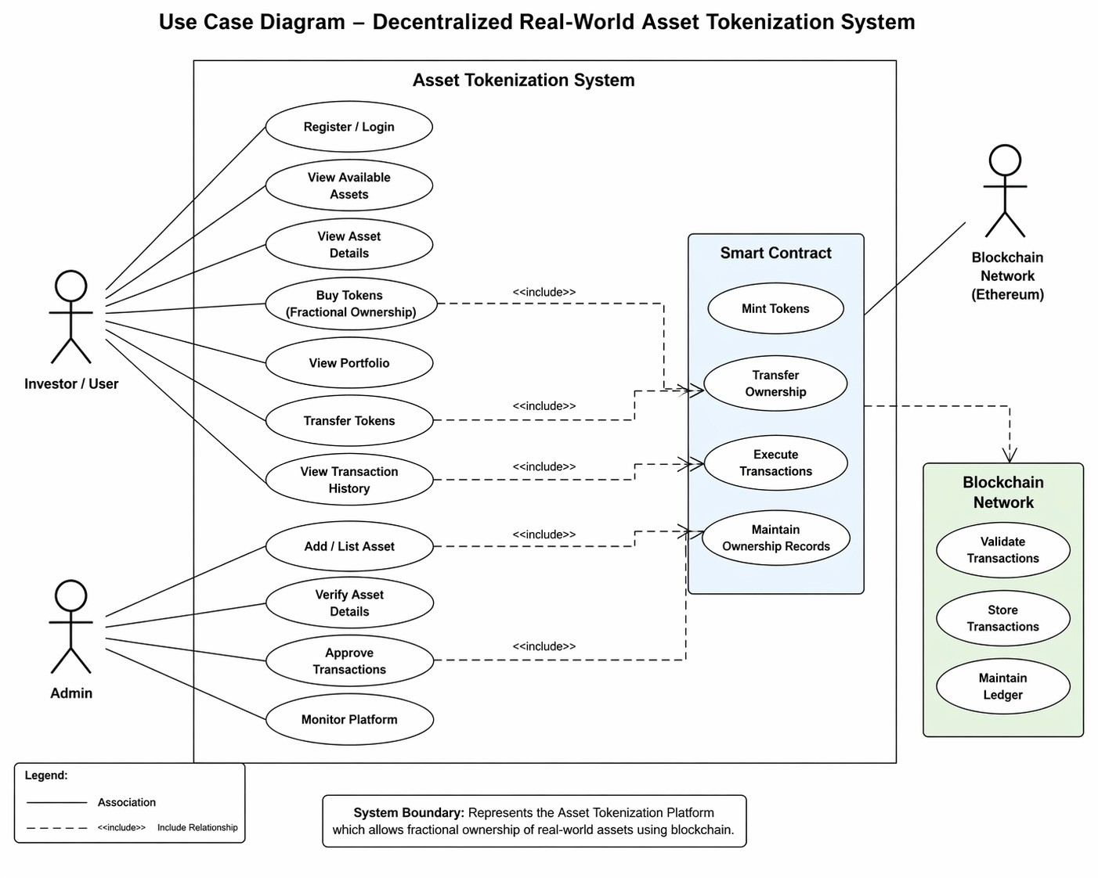
Fig 3.1: Use case diagram

Sequence diagram
A sequence diagram shows object interactions arranged in time sequence. It depicts the objects and classes involved in the scenario and the sequence of messages exchanged between the objects needed to carry out the functionality of the scenario. The figure 3.2 depicts the sequence diagram for our project.

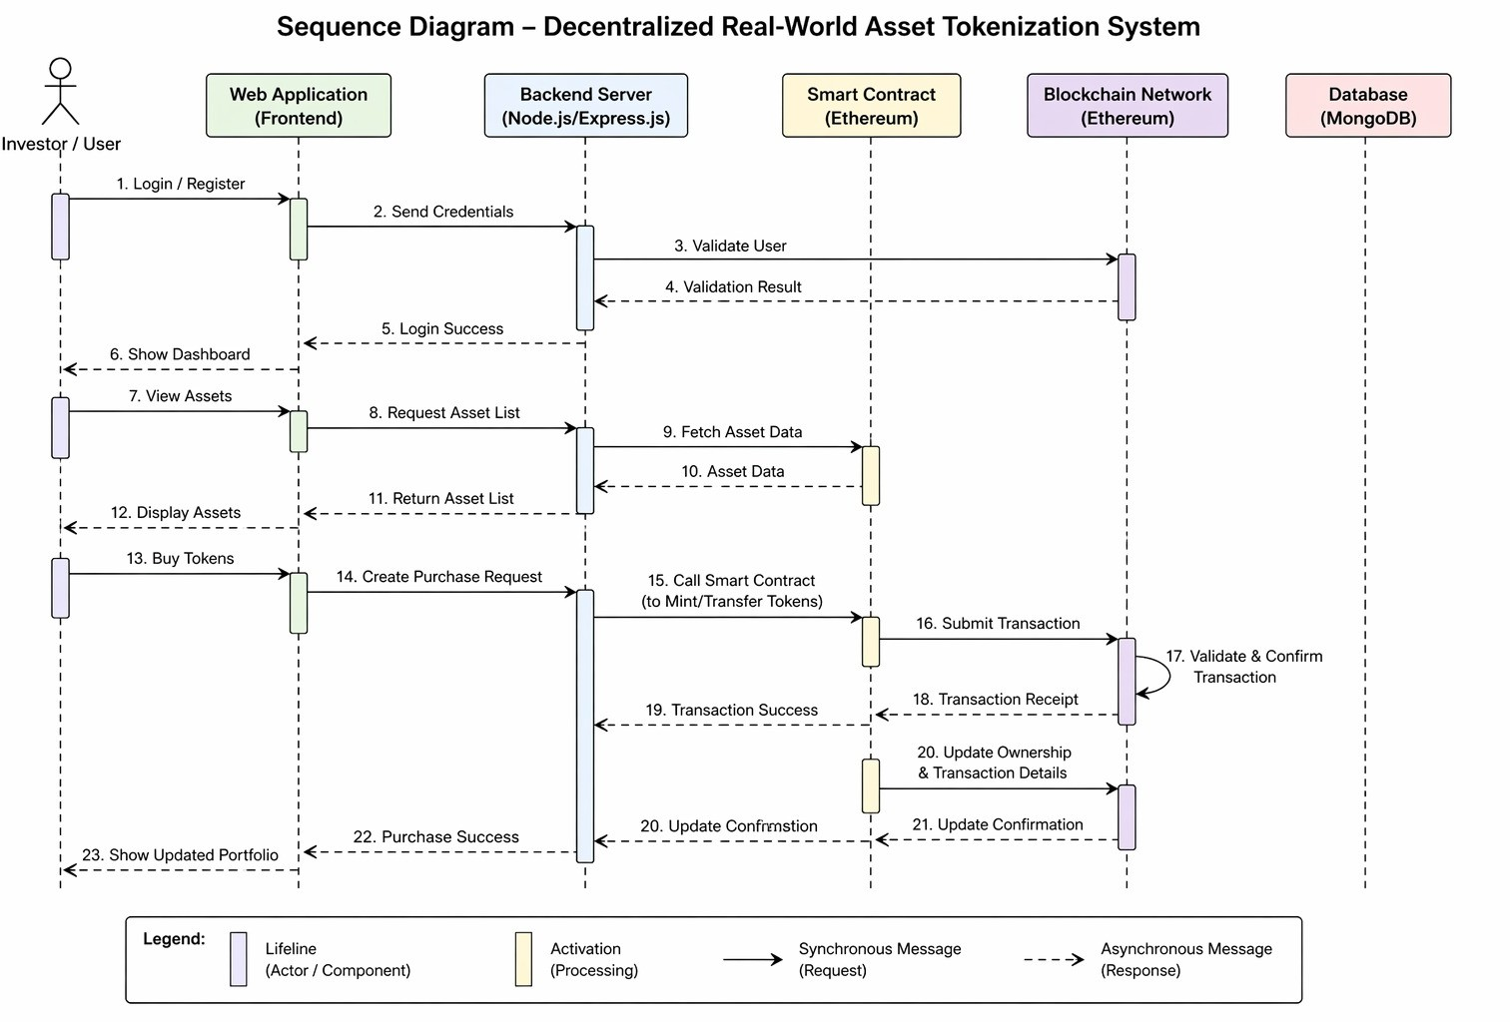
Fig 3.2: Sequence diagram

Activity diagram
An activity diagram is a behavioral diagram i.e. it depicts the behavior of a system. An activity diagram portrays the control flow from a start point to a finish point showing the various decision paths that exist while the activity is being executed. We can depict both sequential processing and concurrent processing of activities using an activity diagram.

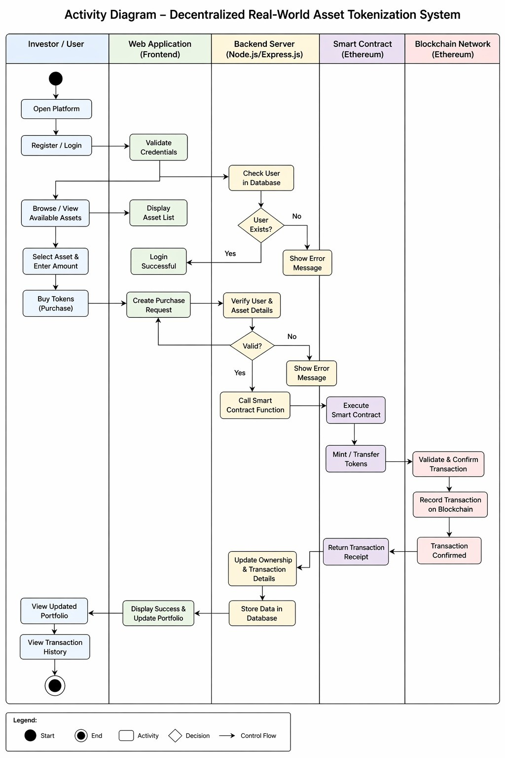
Fig 3.3: Activity diagram

Software Requirements Specification

Functional Requirements:

User Registration and Authentication:
The system should allow users to create accounts and securely log-in

Asset Management:

Admin should be able to add, update, and manage asset listings.

iii. Tokenization Process:
The system should convert asset ownership into digital tokens using smart contracts.

iv. Transaction Handling:

Users should be able to purchase tokens and transfer ownership securely.

v. Blockchain Integration:
All transactions must be recorded on the blockchain for transparency and immutability.

User Dashboard:
Users should be able to view their owned assets and transaction history.
Non-Functional Requirements
- Performance:
The system should process transactions efficiently with minimal delay.
- Security:
The platform must ensure data protection, secure authentication, and safe transactions using encryption and blockchain.
- Scalability:
The system should support a growing number of users and transactions.
iv. Usability:
The interface should be simple, user-friendly, and easy to navigate.
- Reliability:
The system should function consistently without failures.
vi. Maintainability:
The codebase should be structured to allow easy updates and improvements.

CHAPTER 4
PROJECT PLANNING

Project Planning and Scheduling

Selecting Domain:
This project is related to blockchain technology and financial systems. It focuses on asset tokenization, where real-world assets are converted into digital tokens and managed using a decentralized blockchain network.

Prepared Plan of Execution:
After identifying the domain and problem, a plan was prepared to develop a system that enables secure and efficient tokenization of assets.

Gathered Research Papers:
Relevant research papers, consultation reports, and technical documents related to blockchain and asset tokenization were studied. This helped in understanding the existing systems, their methodologies, and their drawbacks.

Designed Architecture:
Based on the study of research papers, a suitable system architecture was designed. The system consists of frontend, backend, and blockchain components, which work together to provide asset tokenization and transaction functionalities.

Determine Model Architecture:
The overall architecture and working model of the system were defined. The system includes modules such as asset listing, tokenization, transaction processing, and user management. These modules are developed and integrated step by step.

Development, Testing and Execution:
The development process includes designing smart contracts, developing frontend and backend components, and integrating them with the blockchain network. Testing is performed at each stage to ensure correct functionality and performance.

Deriving Results:
After completing the implementation, the system is tested and evaluated. The results demonstrate the efficiency, security, and feasibility of the proposed asset tokenization platform.

CHAPTER 5
SYSTEM DESIGN

Architecture Diagram
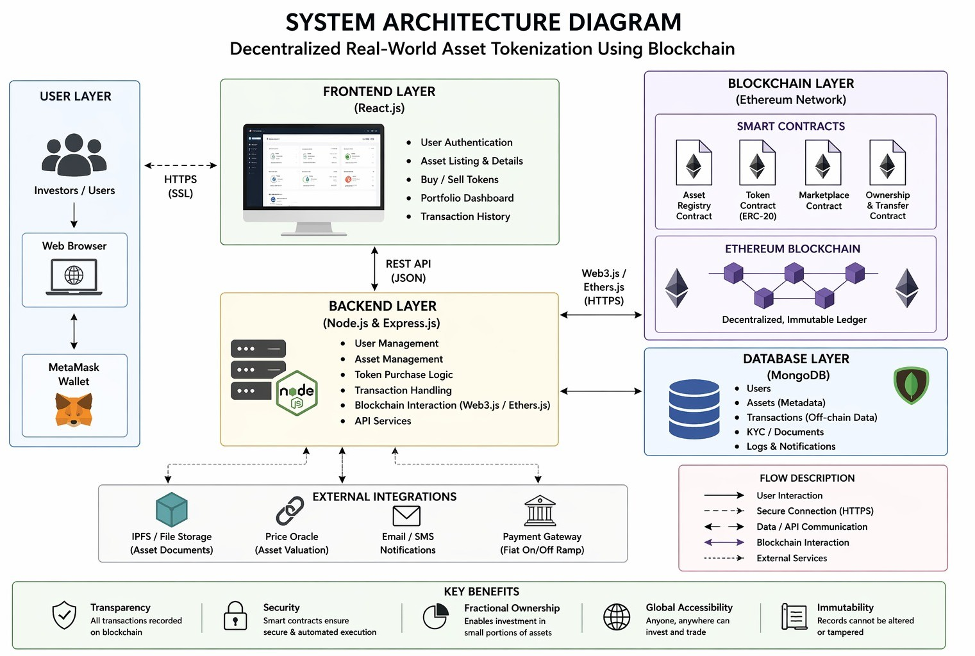
Fig 5.1: Architecture Diagram
The architecture of the system consists of three main components:

- Frontend Application – Provides user interface for asset listing, token purchase, and transaction tracking.
- Backend Server – Handles API requests, user authentication, and communication between frontend and blockchain.
- Blockchain Network – Executes smart contracts and records transactions securely.
The frontend interacts with the backend, which in turn communicates with the blockchain network to perform tokenization and transaction operations.

5.2 Component Design / Module Decomposition
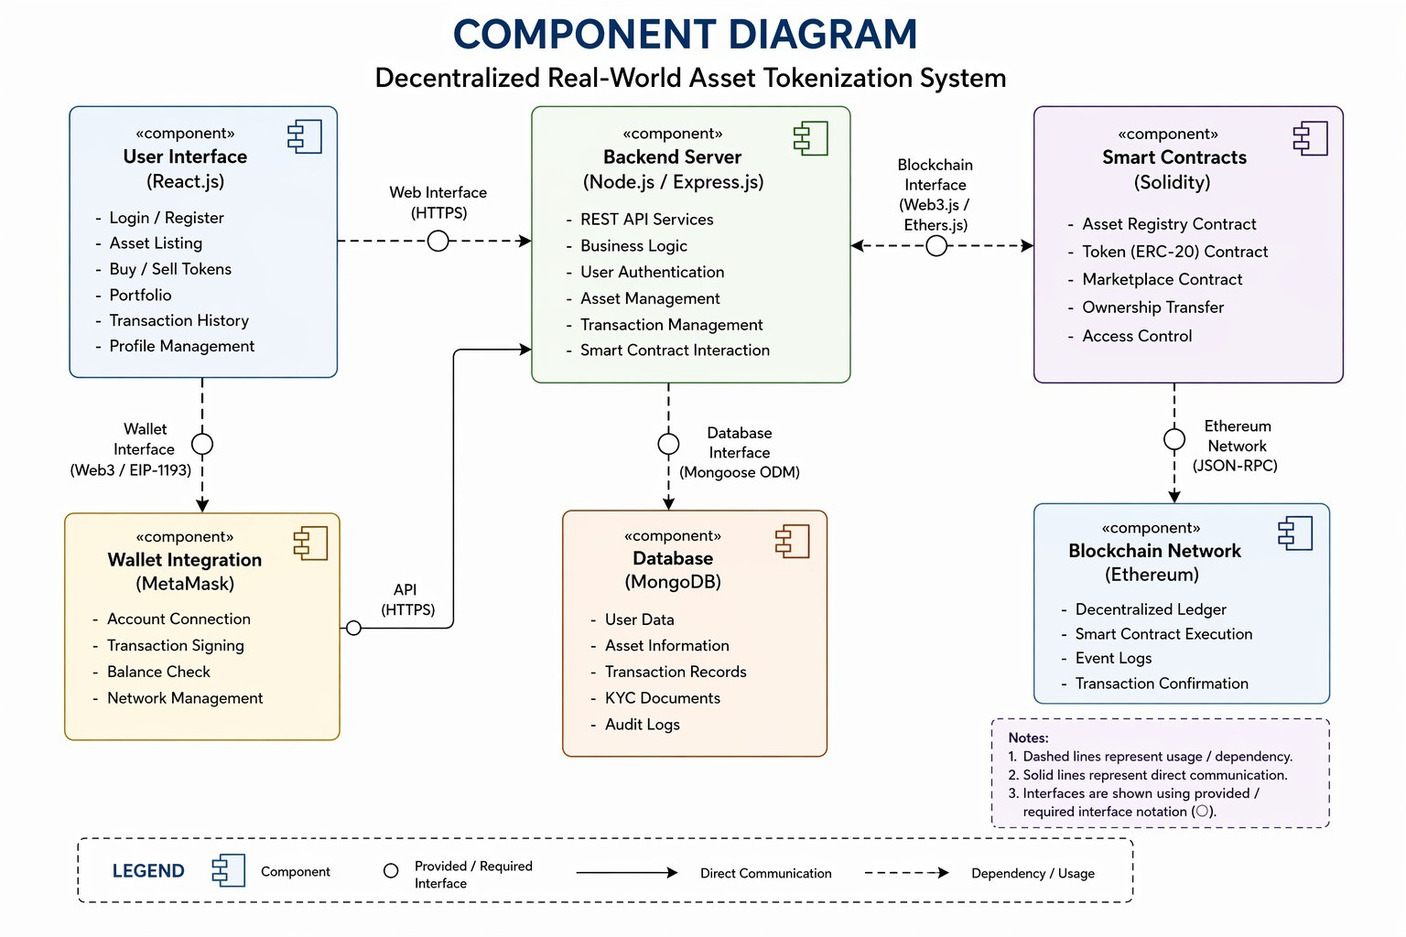
Fig. 5.2: Component Design
The system is divided into the following modules:

User Module:
Handles user registration, login, and authentication.

Asset Management Module:
Allows admin to add and manage asset details.

Tokenization Module:
Converts real-world assets into digital tokens using smart contracts.

Transaction Module:
Manages token purchase, transfer, and transaction validation.

Blockchain Module:
Handles execution of smart contracts and storage of transaction records.
Each module performs a specific function and is integrated to ensure smooth system operation.

5.3 Interface Design
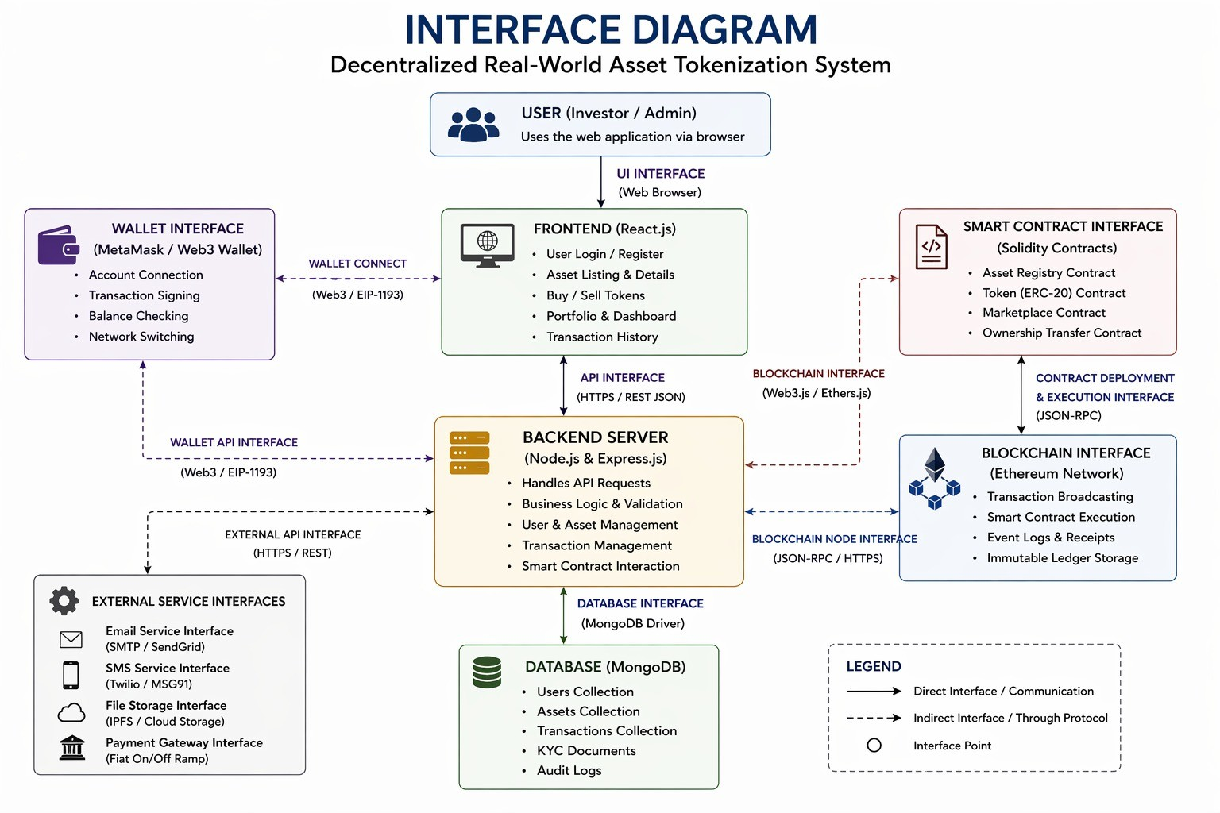
Fig 5.3: Interface Design
Figure 5.3 shows the interface diagram of the project.
The system consists of user-friendly interfaces for interaction:

User Interface:
Allows users to view assets, purchase tokens, and track ownership.

Admin Interface:
Enables admin to manage asset listings and system operations.

Blockchain Interface:
Facilitates communication between backend and blockchain network for executing smart contracts.
The interface is designed to be simple, interactive, and easy to use.

5.3 Data Structure Design
The following data structures are used in the project:

Data Structure | Description
JSON | Used for storing and exchanging data between frontend and backend
Arrays | Used to store lists of assets and transactions
Objects | Used to represent user and asset details
Blockchain Ledger | Stores transaction records in a secure and immutable format
Table 5.1: Few data structures used in project

5.4 Algorithm Design
An algorithm is a sequence of steps used to solve a problem. The system consists of the following algorithms:
The four algorithms are as follows:

5.4.1 Asset Tokenization Algorithm
Step 1: Admin adds asset details into the system. Step 2: Smart contract is created for the asset.
Step 3: Asset value is divided into tokens.
Step 4: Tokens are generated and stored on blockchain.
Step 5: Tokens are made available for purchase.Hash Collection

5.4.2 Token Purchase Algorithm
Step 1: User logs into the system. Step 2: User selects an asset.
Step 3: User enters number of tokens to purchase. Step 4: Request is sent to smart contract.
Step 5: Blockchain validates transaction. Step 6: Tokens are transferred to user wallet

5.4.3 Transaction Validation Algorithm
Step 1: Transaction request is initiated. Step 2: Smart contract verifies user details.
Step 3: Blockchain network validates transaction. Step 4: Transaction is recorded in ledger.
Step 5: Confirmation is sent to user.

User Authentication Algorithm
Step 1: User enters login credentials.
Step 2: Backend verifies credentials from database.
Step 3: If valid, access is granted.
Step 4: If invalid, error message is displayed.
CHAPTER 6
IMPLEMENTATION

6.1 Implementation Approaches

Tool | Advantages | Disadvantages
Traditional Asset Systems | Established infrastructure, widely used | High cost, slow processing, lack of transparency
Centralized | Easy to manage, fast operations | Security risks, single point of
Blockchain | Decentralized, secure, transparent, | Requires technical knowledge, gas
Smart Contracts | Automation of processes, reduces intermediaries | Complexity in development and testing
Table 6.1: Specifications of available tools
A study was conducted on various technologies suitable for implementing the asset tokenization system. Traditional systems were found to be inefficient due to their dependency on intermediaries and lack of transparency. Centralized systems, although faster, suffer from security risks and lack of trust.
After analysis, blockchain technology was selected for implementation due to its decentralized nature, security, and ability to provide transparency. Ethereum blockchain was chosen as the platform because it supports smart contracts and is widely used for decentralized applications.
The system uses smart contracts to automate asset tokenization and transaction processes. These smart contracts are responsible for creating tokens, managing ownership, and validating transactions. The use of blockchain ensures that all transactions are recorded in an immutable ledger, preventing data manipulation.
The frontend of the system is developed using React.js to provide an interactive and user- friendly interface. The backend is implemented using Node.js and Express.js to handle server-side operations and communication with the blockchain. MongoDB is used to store user data and asset details.
The reason for selecting this technology stack is its flexibility, scalability, and compatibility with blockchain integration. This combination allows the system to efficiently handle asset tokenization and provide a seamless user experience.

  - Code Snippets

User Schema(Database Model)

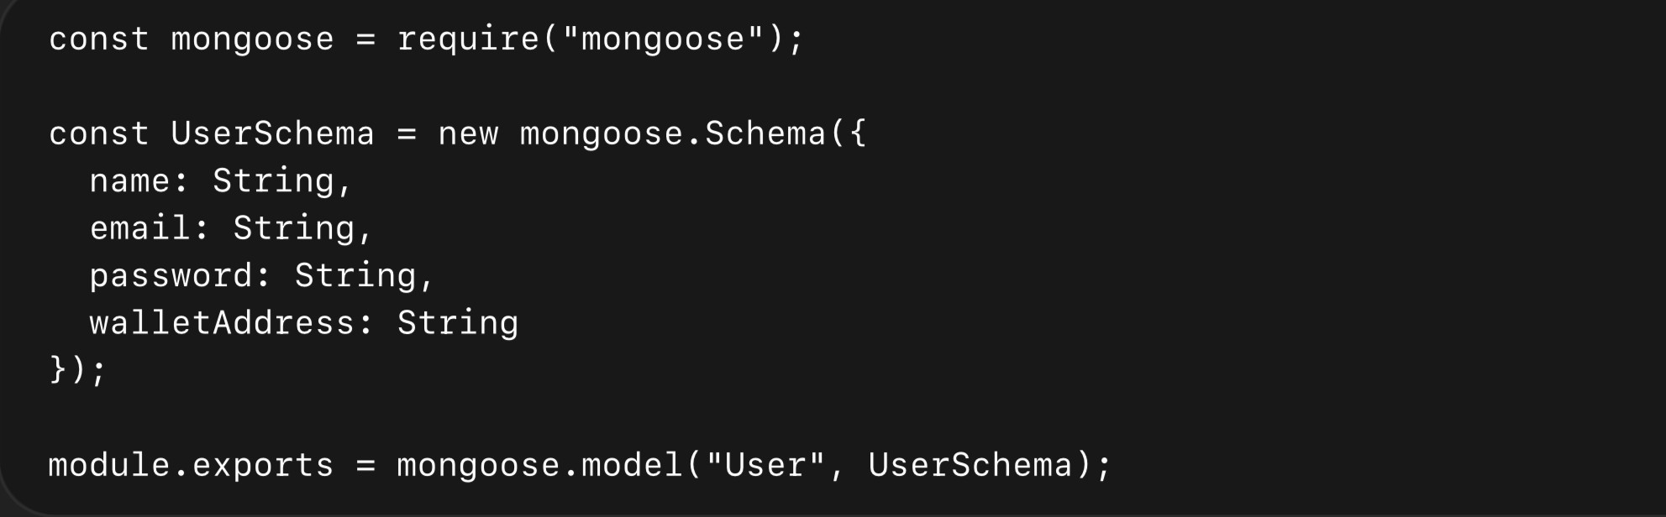

Fig 6.1: User Schema(DatabaseModel)

In figure 5.1, This schema defines the structure of user data stored in MongoDB. It includes user details such as name, email, password, and wallet address used for blockchain transactions.

Asset Schema
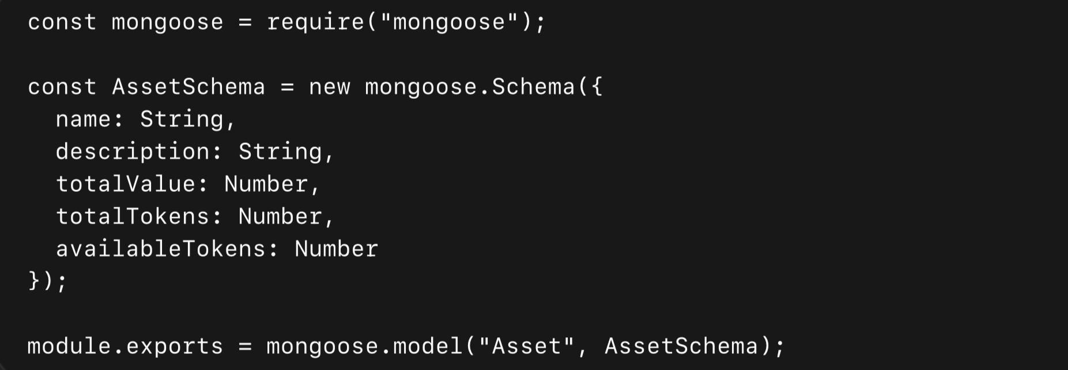

Fig 6.2: Asset Schema

Similarly, in figure 5.2 This schema represents real-world assets. Each asset is divided into tokens, enabling fractional ownership. The availableTokens field tracks remaining tokens.

Ownership Schema

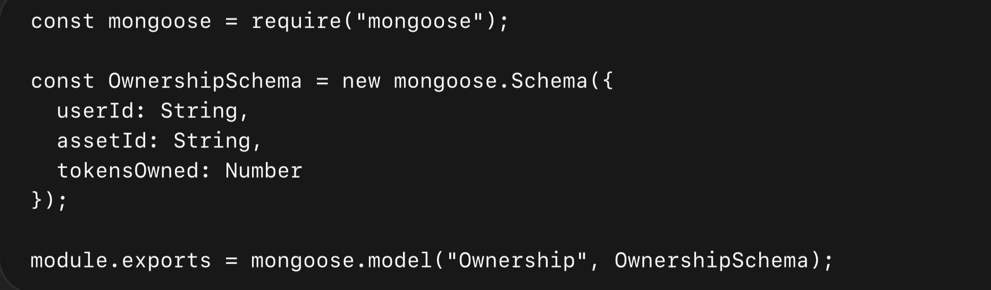

Fig 6.3: Ownership Schema

This schema stores ownership details of tokens. It maps users with assets and tracks how many tokens each user owns.

Transaction Schema
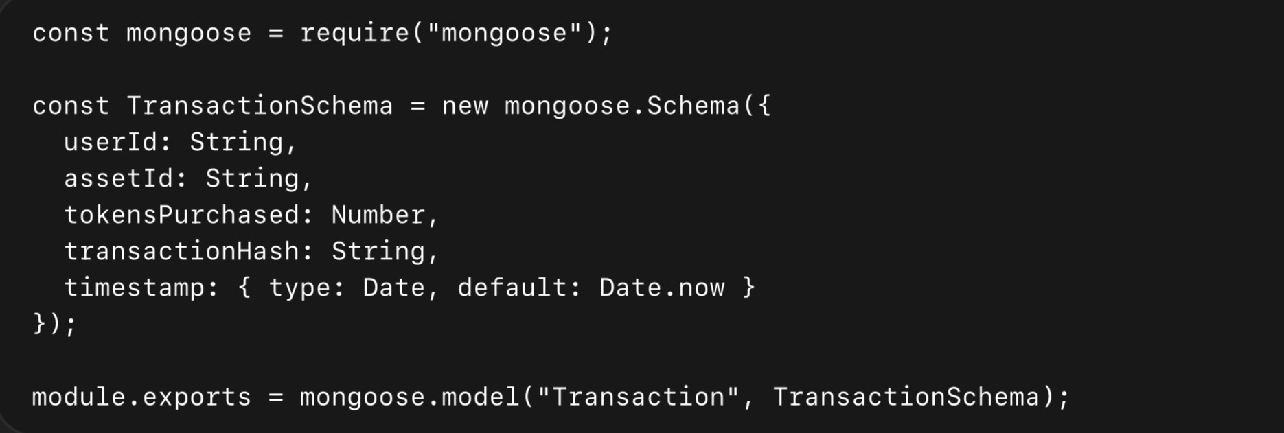

Fig 6.4: Transaction Schema

In figure 5.1, This schema records all token purchase transactions. Each transaction includes user details, asset details, and blockchain transaction hash.

Token Purchase Logic (Backend)
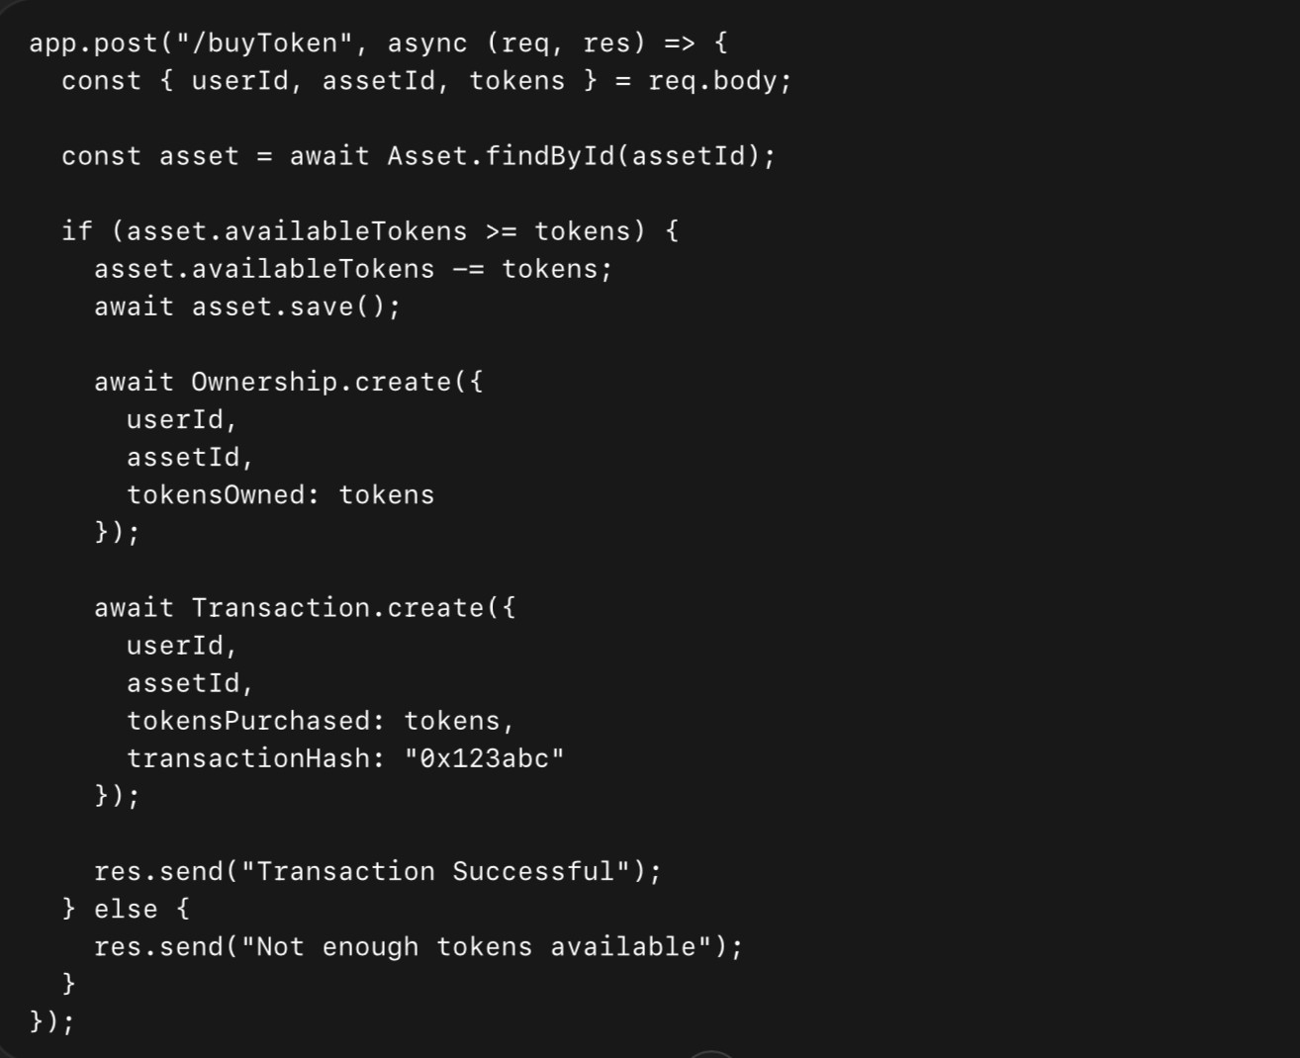
Fig 6.5: Token Purchase Logic (Backend)
This API handles token purchase. It checks token availability, updates asset data, stores ownership details, and records the transaction.

Frontend Interaction (React)
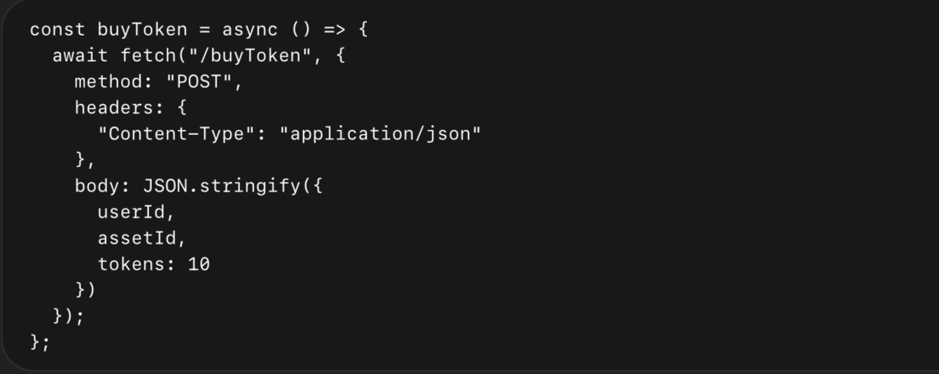
Fig 6.6: Frontend Interaction (React)
This function sends a request from the frontend to purchase tokens. It connects the user interface with backend services.

CHAPTER 7
TESTING

Software testing is an important phase in the development of any system. It ensures that the developed system functions correctly and meets the specified requirements. Testing helps in identifying errors, improving performance, and ensuring reliability of the application.
In this project, different types of testing are performed to verify the functionality of the asset tokenization platform.
Different Types of Software Testing:
1) Unit Testing: Unit Testing is a level of software testing where individual units/ components of a software are tested. The purpose is to validate that each unit of the software performs as designed. A unit is the smallest testable part of any software. It usually has one or a few inputs and usually a single output.
2) Integration Testing: Integration Testing is a level of software testing where individual units are combined and tested as a group. The purpose of this level of testing is to expose faults in the interaction between integrated units. Test drivers and test stubs are used to assist in Integration Testing.
3) System Testing: System Testing is a level of software testing where a complete and integrated software is tested. The purpose of this test is to evaluate the system's compliance with the specified requirements. system testing: The process of testing an integrated system to verify that it meets specified requirements.
4) Interface Testing: Interface Testing is defined as a software testing type which verifies whether the communication between two software systems is done correctly.
A connection that integrates two components is called interface.
5) Regression Testing: Regression Testing is defined as a type of software testing to confirm that a recent program or code change has not adversely affected existing features. Regression Testing is nothing but a full or partial selection of already executed test cases that are executed to ensure existing functionalities work fine.

User Login Test
Our tool currently only supports the Windows operating system for the target system. Therefore, the tool must perform a prior check and only continue with the execution if the target computer is running a Windows operating system. This is illustrated in table 7.1.
Table 7.1: User Login Test

Test No. | Input | Test Description | Output
1 | Valid email & password | Check login functionality | Login successful
2 | Invalid password | Check incorrect credentials | Error message displayed
3 | Empty fields | Validate input fields | Prompt to fill required fields

Test for Asset Listing
The USB should have enough space to accommodate the data that is to be collected from the target system. The system is designed to check the available space on the USB drive each time before attempting to collect RAM image. However, this is not a foolproof method as the size of the memory image depends on the size of the target RAM and there may come a situation where the RAM is larger than the assumed requirement. We can see this in table 7.2
Table 7.2: Check Asset Listing

Test No. | Input | Test Description | Output
1 | Valid asset data | Display available assets | Assets displayed correctly
2 | No assets | Check empty state | “No assets available” message
3 | Large dataset | Load multiple assets | Proper loading without crash

Test for Token Purchase
Our tool handles a lot of files throughout its course of execution. These files include collected RAM image files, system information text files and a JSON file for storing hash values. This was implemented using error handling in Python. This is shown in table 7.3.

Table 7.3: Test For Token Purchase

Test No. | Input | Test Description | Output
1 | Valid token amount | Purchase tokens | Transaction successful
2 | Tokens > available | Check limit condition | Error message displayed
3 | Invalid input | Check validation | Transaction rejected

Similar exception handling for files is performed for the data files as well with appropriate messages.

CHAPTER 8
RESULT DISCUSSION AND PERFORMANCE ANALYSIS
The developed system for asset tokenization was successfully implemented and tested. The application provides a user-friendly interface for viewing assets, purchasing tokens, and tracking investments. The following snapshots represent the execution of different modules of the system.

Home Page/ Landing View
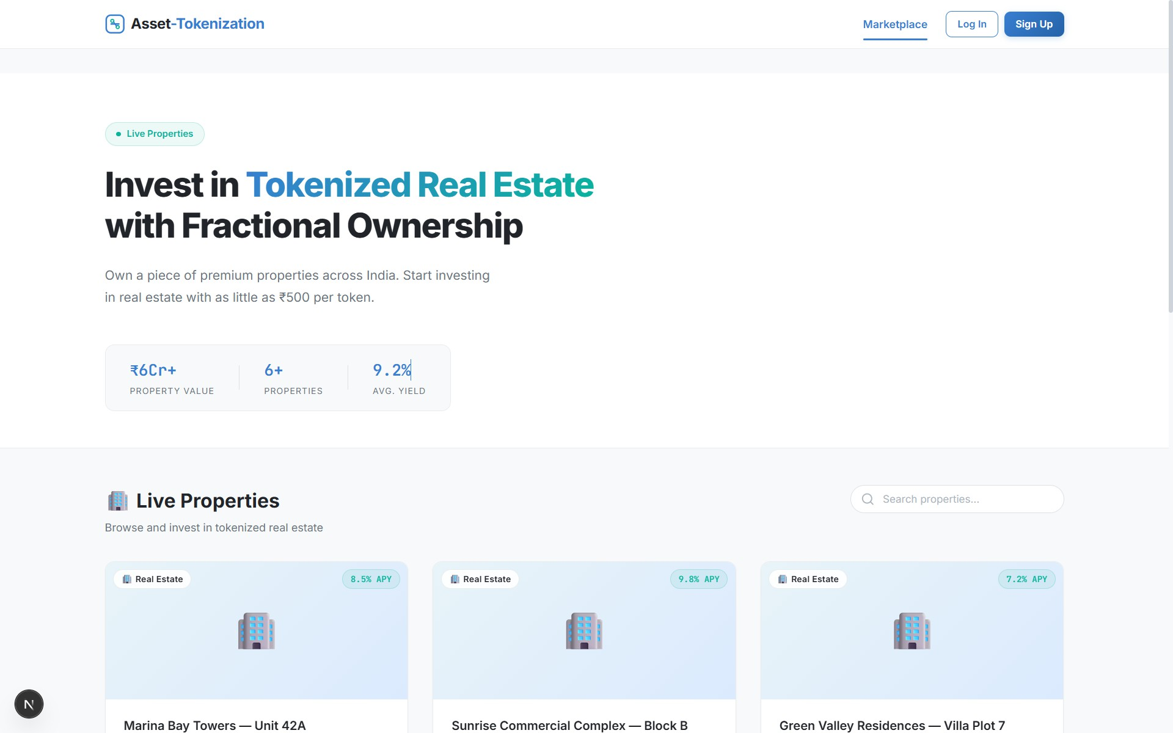

Fig 8.1: Home Page
The home page serves as the entry point of the application and provides an overview of the platform’s purpose and functionality. It introduces users to the concept of tokenized real estate and highlights the advantages of fractional ownership. The page displays important statistics such as total property value, number of listed properties, and average yield, which helps users understand the scale and potential of the platform.
In addition to this, the home page includes navigation options such as marketplace access, login, and signup features. The design is clean and intuitive, ensuring that users can easily

understand the workflow of the system. This page plays a crucial role in attracting users and
guiding them towards investment opportunities available on the platform.

Asset Listing
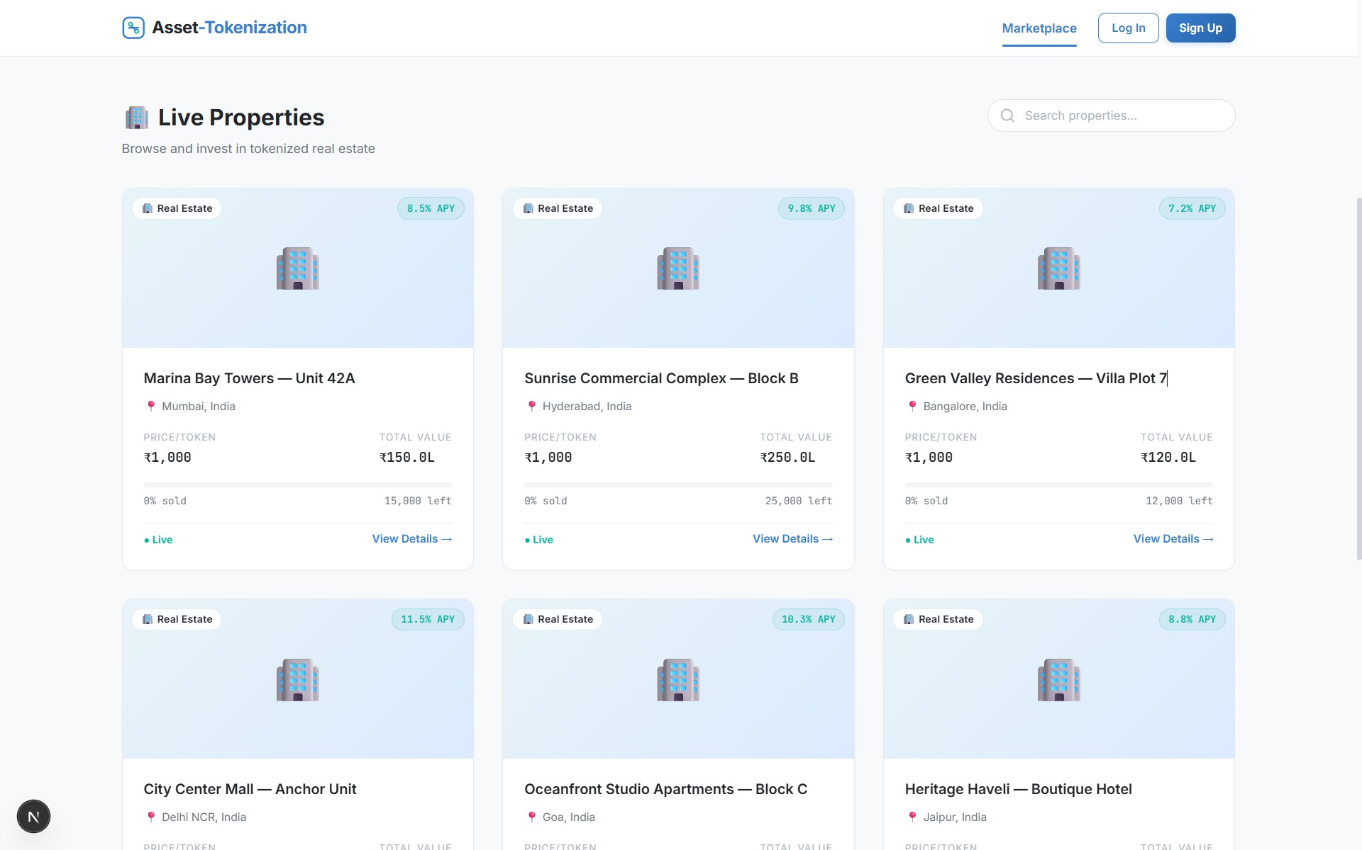

Fig 8.3: Asset Listing
Fig. 8.2 The asset listing page displays all the available properties that can be tokenized and invested in. Each asset is presented in the form of a card containing essential details such as property name, location, price per token, total value, and availability of tokens. Additional information such as expected returns (APY) and status of the asset (live or sold) is also displayed.
This page allows users to browse through multiple investment options and compare different assets based on their value and returns. The structured layout and organized presentation of data improve user experience and help investors make informed decisions. The listing page acts as the core component of the system where users explore and select assets for investment

Token Purchase Page
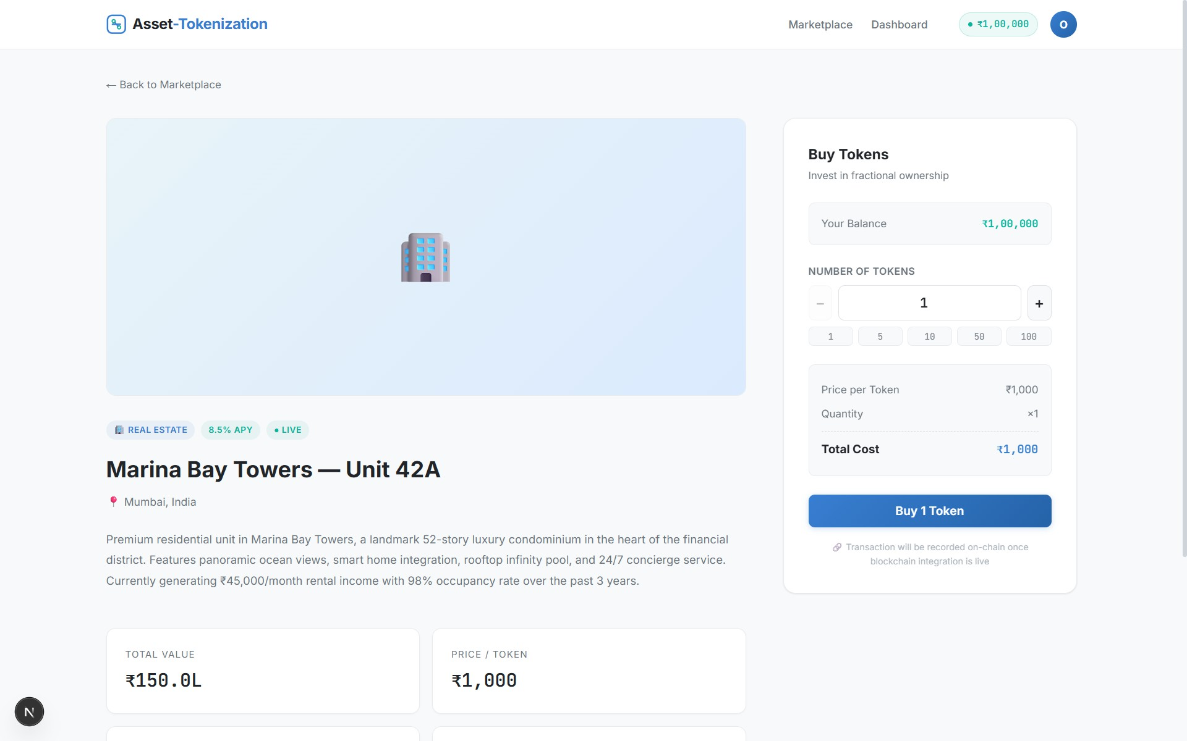

Fig 8.3: GUI Application
The token purchase page provides detailed information about a selected asset and enables users to invest in it. It displays comprehensive details such as asset description, location, total value, price per token, total tokens available, and remaining tokens. This helps users gain a clear understanding of the asset before making an investment decision.
On the right side of the interface, a purchase panel is provided where users can select the number of tokens they wish to buy. The system dynamically calculates the total cost based on the selected quantity. Once the user confirms the purchase, the request is processed through the backend and recorded in the system. This page demonstrates the core functionality of tokenization by allowing fractional ownership of assets.

8.4 Transaction Success / Output
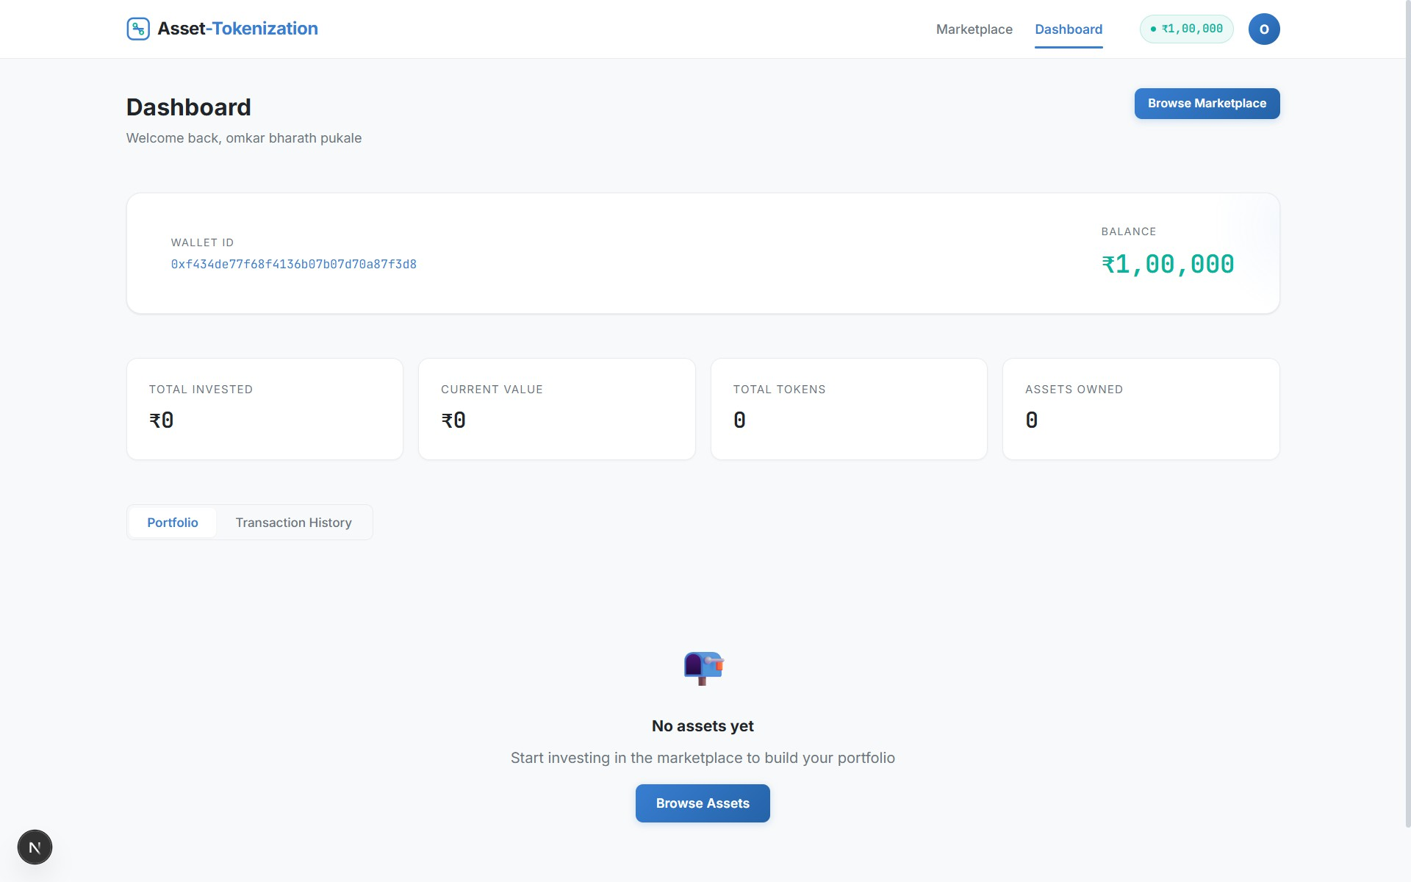

Fig 8.4: Transaction Success
After completing a transaction, the user is redirected to the dashboard where the results are displayed. The dashboard shows important details such as wallet ID, available balance, total investment, number of tokens owned, and assets held by the user. It also provides options to view portfolio details and transaction history.
The successful execution of transactions indicates that the system is functioning correctly and that ownership has been updated accordingly. The dashboard acts as a centralized place for users to monitor their investments and track their financial activities within the platform.

Project Folder
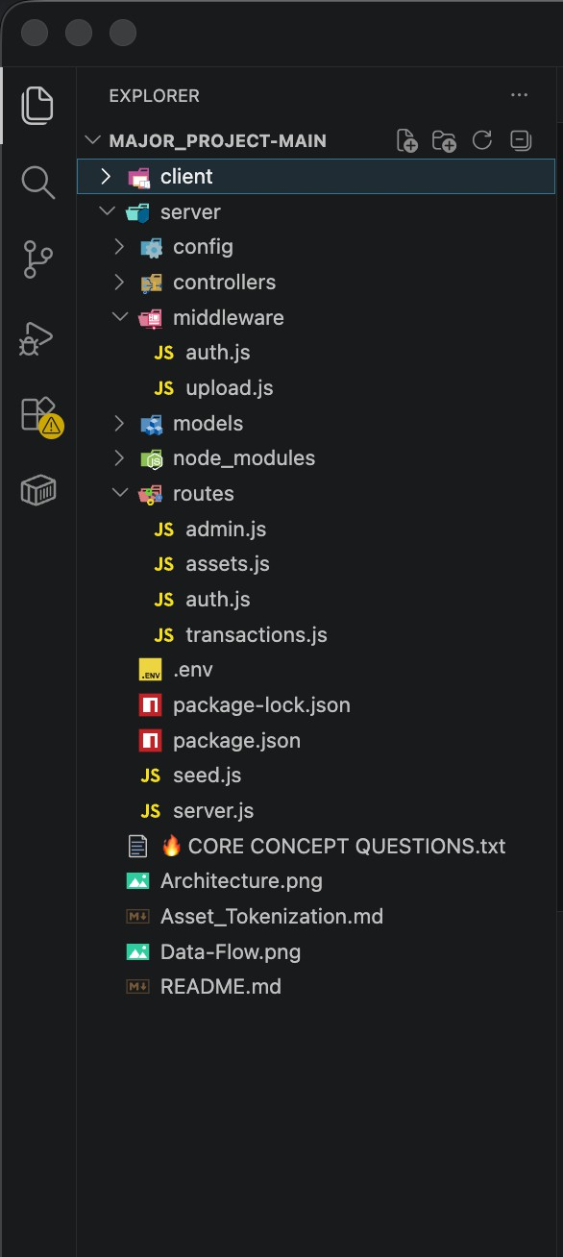

Fig 8.5 Project Folder
The project folder structure represents the organization of files and directories used in the development of the system. It includes separate folders for frontend, backend, database models, and configuration files. The frontend contains user interface components, while the backend handles API requests and business logic. The models folder includes schemas for users, assets, transactions, and ownership.
This structured organization improves code readability, maintainability, and scalability of the project. It ensures that different components of the system are properly separated and can be developed or modified independently. A well-defined folder structure is essential for efficient development and debugging of the application.

User Documentation
User documentation provides a detailed guide for users to understand and effectively use the asset tokenization platform. It explains the step-by-step procedure for accessing the system, performing operations, and interacting with different modules of the application.
Steps to run the project:

Step 1: Accessing the Application
The user must first open the application through a web browser. The home page will be displayed, providing an overview of the platform along with options for login and registration. New users can create an account using the signup option, while existing users can log in using their credentials.

Step 2: User Registration and Login
To access the system functionalities, users are required to register by providing basic details such as name, email, and password. After successful registration, users can log in using their credentials. Upon login, the system generates or links a wallet address, which is used for performing transactions.

Step 3: Exploring the Marketplace
Once logged in, the user can navigate to the marketplace section where all available assets are displayed. Each asset contains details such as property name, location, token price, total value, and availability. Users can browse through different assets and select one based on their interest and investment capacity.

Step 4: Viewing Asset Details
After selecting an asset, the user is redirected to the asset details page. This page provides complete information about the selected asset, including description, pricing, and token distribution. Users can analyze these details before proceeding with the investment.

Step 5: Purchasing Tokens
The user can enter the number of tokens they wish to purchase in the provided input field. The system automatically calculates the total cost based on the selected number of tokens. Once confirmed, the transaction request is processed, and the tokens are allocated to the user.

Step 6: Viewing Dashboard and Portfolio
After completing the transaction, users can view their dashboard. The dashboard displays

wallet balance, total investment, owned assets, and transaction history. This allows users to monitor their investments and track their performance.

CHAPTER 9
CONCLUSION, APPLICATIONS AND FUTURE WORK

Conclusion
The rapid advancement of digital technologies has significantly transformed traditional financial systems, paving the way for innovative solutions such as asset tokenization. This project, titled “Asset Tokenization: Decentralized Platform for Real-World Asset Tokenization Using Blockchain”, successfully demonstrates the feasibility and effectiveness of integrating blockchain technology with modern web-based applications to address the limitations of conventional asset management systems.
The primary objective of this project was to design and develop a decentralized platform that enables the conversion of real-world assets into digital tokens, thereby facilitating fractional ownership, enhancing liquidity, and improving accessibility for investors. The system effectively eliminates the dependency on intermediaries by leveraging smart contracts and distributed ledger technology, ensuring secure, transparent, and tamper-proof transactions.
The implementation of the system using technologies such as React.js, Node.js, MongoDB, and Ethereum blockchain provides a robust and scalable solution. The developed platform offers an intuitive user interface for asset browsing, token purchasing, and portfolio management, thereby enhancing user experience and usability. The successful execution of transactions and proper management of ownership records demonstrate the reliability and correctness of the system.
Furthermore, the project highlights the potential of blockchain technology in revolutionizing financial markets by reducing operational inefficiencies, minimizing transaction costs, and enabling real-time settlement. The concept of tokenization not only democratizes investment opportunities but also introduces a new paradigm for asset ownership and management in the digital era.
Despite its successful implementation, the system also acknowledges certain limitations
such as regulatory constraints, security challenges, and dependency on blockchain infrastructure. However, these limitations can be addressed with further research and technological advancements.

In conclusion, the proposed system serves as a significant step towards modernizing traditional financial ecosystems. It demonstrates how asset tokenization can bridge the gap between physical assets and digital platforms, thereby creating a more inclusive, efficient, and transparent investment environment.

Applications
The asset tokenization platform has wide-ranging applications across various domains due to its ability to digitize and decentralize asset ownership.
  - Real Estate Investment: Enables fractional ownership of high-value properties, allowing multiple investors to participate with lower capital.
  - Financial Markets: Facilitates trading of tokenized securities, bonds, and other financial instruments.
  - Commodity Trading: Allows tokenization of commodities such as gold, silver, and oil for easier trading and investment.
  - Supply Chain Management: Improves transparency and traceability of goods through tokenized assets.
  - Intellectual Property Rights: Enables ownership and trading of digital assets such as patents, copyrights, and media content.
  - Crowdfunding Platforms: Provides a decentralized mechanism for raising funds through tokenized assets.
These applications demonstrate the versatility and adaptability of tokenization across multiple industries.

Limitations of The System
Although the proposed asset tokenization system demonstrates significant advantages over traditional asset management approaches, it is subject to certain limitations that need to be considered.
The current system is developed as a prototype and is deployed on a test environment rather than a live blockchain network. As a result, real-time financial transactions and actual asset ownership validations are not fully implemented. This limits the system’s applicability in real-world scenarios without further enhancements.
Another limitation is related to regulatory and legal compliance. Asset tokenization involves

complex legal frameworks that vary across different countries. The current system does not incorporate comprehensive regulatory compliance mechanisms such as Know Your Customer (KYC), Anti-Money Laundering (AML), and legal ownership verification, which are essential for real-world deployment.
The system also depends on blockchain infrastructure, which may introduce challenges such as network latency, transaction fees (gas fees), and scalability issues. In high-demand scenarios, blockchain networks may experience congestion, leading to delays in transaction processing.
Security is another critical concern. Although blockchain provides a secure environment, vulnerabilities may still exist in smart contracts or application layers. The current implementation does not include advanced security measures such as formal smart contract auditing or multi-signature authentication.
Additionally, the platform currently supports a limited set of asset types, primarily focusing on real estate-based tokenization. It does not yet support a wide range of asset classes such as equities, bonds, or digital collectibles.
Finally, the user interface and experience, although functional, can be further improved to enhance usability and accessibility for non-technical users. Integration with mobile platforms and advanced analytics features is also not included in the current version.

Future Scope of The Project
The future scope of asset tokenization is vast and promising, with significant potential for growth and innovation. Several enhancements and advancements can be incorporated to further improve the system:
    - Integration with Real Blockchain Networks: Deployment on mainnet environments for real-time transactions and practical usage.
    - Enhanced Security Mechanisms: Implementation of advanced cryptographic techniques and multi-factor authentication for improved security.
    - Regulatory Compliance Integration: Incorporation of legal frameworks and compliance mechanisms to ensure adherence to global financial regulations.

    - Multi-Asset Support: Expansion of the platform to support various asset classes such as stocks, bonds, and digital collectibles.
    - AI and Data Analytics Integration: Use of artificial intelligence for predictive analysis and investment recommendations.
    - Cross-Platform Accessibility: Development of mobile applications to enhance accessibility and user engagement.
    - Scalability Improvements: Adoption of advanced blockchain solutions such as Layer-2 scaling for handling large volumes of transactions.
With continuous advancements in blockchain technology and increasing adoption of decentralized systems, asset tokenization is expected to play a crucial role in shaping the future of digital finance.
CO No. | Statement
CO1 | To develop student’s knowledge for solving technical problems
CO2 | To provide an opportunity to learn about new ideas and concepts
CO3 | To improve written and verbal communication skills.
CO4 | To Analyze, Design and Evaluate Engineering System
CO5 | To Develop the working products model or prototypes and applications with ethics
CO6 | To provide an opportunity to work in team
CO and PO Mapping

Strength of CO Mapping to PO/PSOs with Justification:
COs | PO1 | PO2 | PO3 | PO4 | PO5 | PO6 | PO7 | PO8 | PO9 | PO10 | PO11 | PSO1 | PSO2
CO1 | 3 | 2 | - | - | 3 | - | - | - | - | - | - | 3 | 2
CO2 | 2 | 3 | 2 | 2 | - | - | - | - | - | - | - | 2 | 3
CO3 | 2 | 2 | 3 | 2 | 2 | - | - | 1 | - | - | - | 3 | 3
CO4 | 2 | 3 | 2 | 3 | 3 | - | - | 1 | - | - | - | 2 | 3
CO5 | 2 | 2 | 3 | 2 | 2 | - | - | 3 | 1 | - | - | 3 | 2
CO6 | - | - | - | - | - | - | - | 1 | 3 | 3 | 2 | - | -
Average | 1.8 | 2.3 | 2.0 | 1.8 | 1.8 | - | - | 0.8 | 0.7 | 0.5 | 0.3 | 2.1 | 2.5

CO PO/PSO Justification
CO1 PO1, PO5, PSO1 Applies engineering knowledge, blockchain tools, MongoDB, React.js, and Ethereum technologies for
solving asset management problems.
CO2 PO2, PO4,PSO2 Analyzes traditional system inefficiencies and
evaluates blockchain-based decentralized solutions
CO3 PO3, PO5,PSO1, PSO2 Designs and develops a complete blockchain-based
asset tokenization platform using modern software engineering practices.
CO4 PO2, PO4,PSO2 Evaluates security, transaction transparency, scalability, and system performance using
blockchain architecture.
CO5 PO3, PO5, PO8, PSO1 Develops a secure and ethical decentralized application ensuring transparency and proper
handling of user transactions.
CO6 PO9,PO10,PO11 Demonstrates teamwork, communication, project coordination, and management during project
development and documentation.
SDG – Sustainable Development Goals Mapping with Project
SDG No. | Sustainable Development Goal | Mapping with Project
SDG 8 | Decent Work and Economic  Growth | The project promotes digital investment opportunities and improves financial accessibility through asset  tokenization and fractional ownership.
SDG 9 | Industry, Innovation and  Infrastructure | The system utilizes blockchain technology, smart contracts, and decentralized applications to support technological innovation and modern digital  infrastructure.
SDG 10 | Reduced Inequalities | Fractional ownership allows small and medium investors to participate in high-value asset markets, reducing financial inequality.
SDG 11 | Sustainable Cities and  Communities | Real estate tokenization can improve access to property investment and support transparent urban  asset management systems.
SDG 16 | Peace, Justice and Strong  Institutions | Blockchain technology ensures transparency, immutability, and secure transactions, reducing fraud  and improving trust in financial systems.
SDG 17 | Partnerships for the Goals | The project supports integration between blockchain platforms, financial systems, and digital technologies  for collaborative development.

SWOT Analysis

Category | Description
Strengths | - Decentralized and secure blockchain-based platform.  - Enables fractional ownership of assets.  - Improves transparency and reduces fraud.  - Reduces dependency on intermediaries.  - Faster and efficient transactions using smart contracts.
Weaknesses | - Regulatory and legal uncertainty regarding digital assets.  - Requires blockchain knowledge and technical expertise.  - High dependency on internet and network availability.  - Gas fees and scalability issues in blockchain networks.
Opportunities | - Growing adoption of blockchain and Web3 technologies.  - Expansion into real estate, commodities, and financial sectors.  - Increasing interest in decentralized finance (DeFi).  - Potential integration with global digital investment platforms.
Threats | - Cybersecurity threats and smart contract vulnerabilities.  - Rapidly changing government regulations.  - Market volatility in blockchain ecosystems.  - Competition from centralized financial platforms and emerging blockchain projects.

REFERENCES
- Agur, I., Villegas-Bauer, G., Mancini-Griffoli, T., Martinez Peria, M. S., and Tan, B., “Tokenization and Financial Market Inefficiencies”, International Monetary Fund (IMF), Fintech Note 2025/001, January 2025.
- International Financial Services Centres Authority (IFSCA), “Regulatory Approach towards Tokenization of Real-World Assets”, Consultation Paper, February 2025.
- Nishith Desai Associates, “Real Estate Tokenisation: Legal, Tax and Regulatory Considerations”, Research Report, March 2025.
- Soni, U., Fines, O., and Sun, J., “An Investment Perspective on Tokenization: A Primer on the Use of Distributed Ledger Technology”, CFA Institute Research Report, January 2025.
- Nakamoto, S., “Bitcoin: A Peer-to-Peer Electronic Cash System”, 2008.
- Antonopoulos, A. M., “Mastering Ethereum: Building Smart Contracts and DApps”, O’Reilly Media, 2018.
- Buterin, V., “Ethereum Whitepaper: A Next-Generation Smart Contract and Decentralized Application Platform”, 2014.
- Wood, G., “Ethereum: A Secure Decentralised Generalised Transaction Ledger”, Ethereum Project Yellow Paper, 2014.
- Crosby, M., et al., “Blockchain Technology: Beyond Bitcoin”, Applied Innovation Review, 2016.
- Swan, M., “Blockchain: Blueprint for a New Economy”, O’Reilly Media, 2015.

Web Resources
- Ethereum Official Website – https://ethereum.org
- Solidity Programming Language Documentation – https://soliditylang.org
- React.js Official Documentation – https://react.dev
- Node.js Official Documentation – https://nodejs.org
- MongoDB Official Website – https://www.mongodb.com
- MetaMask Wallet Documentation – https://metamask.io
- Hardhat Development Environment – https://hardhat.org
- Remix IDE for Smart Contracts – https://remix.ethereum.org

- Web3.js Library Documentation – https://web3js.readthedocs.io
- Ethers.js Library Documentation – https://docs.ethers.org

Online Tools and AI Assistance
- ChatGPT (OpenAI), used for structuring the report, generating explanations, refining academic content, and assisting in documentation of project modules.
- Claude AI (Anthropic), used for conceptual clarification, technical understanding of blockchain systems, and enhancement of written explanations.
- Gemini AI (Google), used for supplementary research, validation of ideas, and gathering additional insights on tokenization and distributed ledger technology.
- Visual Studio Code, used as the primary development environment for coding, debugging, and project management.
- GitHub, used for version control, code storage, and collaboration during project development.

ANNEXURE

Source Code Structure
The project is organized into multiple directories for better modularity and maintainability:

Frontend Folder:
Contains React.js components, pages, and UI-related files for user interaction.

Backend Folder:
Includes server-side code developed using Node.js and Express.js for handling APIs and business logic.

Models Folder:
Contains database schemas such as User, Asset, Transaction, and Ownership.

Routes Folder:
Defines API endpoints for handling user requests and transactions.

Smart Contract Folder:
Includes Solidity code for token creation and transaction management on the blockchain.

Tools and Technologies Used
The following tools and technologies were used during the development of the project:
  - Frontend: React.js
  - Backend: Node.js, Express.js
  - Database: MongoDB
  - Blockchain Platform: Ethereum
  - Smart Contract Language: Solidity
  - Development Tools: Visual Studio Code
  - Version Control: GitHub
  - Wallet Integration: MetaMask

Sample Input and Output

Input:
  - User registration details (name, email, password)
  - Asset selection
  - Number of tokens to purchase

Output:
  - Successful login confirmation
  - Display of available assets
  - Transaction success message
  - Updated user portfolio

