VISVESVARAYA TECHNOLOGICAL UNIVERSITY

“Jnana Sangama”, Belagavi 590014,
KARNATAKA, INDIA

Project Phase I -BCS685
On
“Asset Tokenization: Decentralized Platform for Real-World Asset Tokenization Using Blockchain”

Submitted in Partially fulfillment of the requirement for the award of degree Of

Bachelor of Engineering In
Computer Science & Engineering
Of Visvesvaraya Technological University, Belgaum.
Submitted by:
OMKAR BHARATH PUKALE | : 1AM23CS127
SAHIL KUMAR MISHRA | : 1AM23CS176
SANDESH G C | : 1AM23CS183
SANJITHA | : 1AM23CS186

Under the Guidance of:
Prof. Premkumar M K
Asst Professor, Dept. of CSE

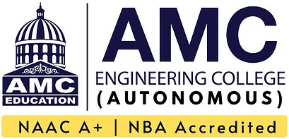

DEPARTMENT OF COMPUTER SCIENCE AND ENGINEERING AMC ENGINEERING COLLEGE
18th K.M. Bannerghatta Main Road, Bengaluru – 560083 Year 2025-26

AMC Engineering College
Belagavi 560083
Department of Computer Science & Engineering


CERTIFICATE
Certified that the Project work entitled “Asset Tokenization: Decentralized Platform for Real-World Asset Tokenization Using Blockchain” carried out by bonafide students Omkar Bharath Pukale (1AM23CS127), Sahil Kumar Mishra (1AM23CS176), Sandesh G C (1AM23CS183), Sanjitha A (1AM23CS186) of AMC Engineering College, in partial fulfillment for the award of Bachelor of Engineering in Computer Science & Engineering of Visvesvaraya Technological University, Belagavi during the year 2025–2026.It is certified that all corrections/ suggestions indicated for internal assessment have been incorporated in the report. The project report has been approved as it satisfies the academic requirements in respect of Project Work prescribed for the said Bachelor of Engineering degree.

Project Guide HOD Principal
Mr. Premkumar M K Dr. V. Mareeswari Dr. Yuvaraju B N
Assistant Professor Prof. & Head Principal,
Dept. of CSE Dept. of CSE AMCEC

External Viva

External Name 1.
2.
Signature with Date

DECLARATION

We, the undersigned students of 6th semester, Department of Computer Science & Engineering, AMC Engineering College, declare that our project work entitled “Asset Tokenization: Decentralized Platform for Real-World Asset Tokenization Using Blockchain” is a bonafide work carried out by us. This project is neither a copy nor a modification of any other engineering project. We further declare that this work has not been submitted to any other university for the award of any degree in the past and shall not be submitted in the future.

Name | USN | Signature
OMKAR BHARATH PUKALE | 1AM23CS127
SAHIL KUMAR MISHRA | 1AM23CS176
SANDESH G C | 1AM23CS183
SANJITHA A | 1AM23CS186

ACKNOWLEDGEMENT
First and fore most we would like to thank GOD, the Almighty for being so merciful on us.
We have a great pleasure in expressing our deep sense of gratitude to founder Chairman Dr. K.R. Paramahamsa and Executive Vice President Mr. Rahul Kalluri for having provided us with a great infrastructure and well-furnished labs for successful completion of our Project.
We express our sincere thanks and gratitude to our Principal Dr. Yuvaraju B N for providing us all the necessary support successful completion of our project.
We express our special thanks and gratitude to our Academic Advisor Dr. R Nagaraja for providing us all the necessary advice for successful completion of our project.
We would like to extend our special thanks to Dr. V Mareeswari, Professor and Head of Department of CSE, for her support and encouragement and suggestions given to us in the course of our project work.
We are grateful to our project phase I coordinators Prof. Velvizhi Ramya and Prof. Snigdha Kesh Assistant Professor, Department of CSE, AMC Engineering College, Bengaluru for their constant motivation & timely help, encouragement and suggestion.
We are extremely thankful to our project guide, Prof. Premkumar M K, Assistant Professor, Department of CSE, for his continuous support, motivation, and valuable suggestions which helped us successfully complete this project.
Last but not the least, we wish to thank all the teaching & non-teaching staffs of department of Computer Science and Engineering, for their support, patience and endurance shown during the preparation of this project report.
OMKAR BHARATH PUKALE 1AM23CS127
SAHIL KUMAR MISHRA 1AM23CS176
SANDESH G C 1AM23CS183
SANJITHA A 1AM23CS186

ABSTRACT
Asset tokenization is an emerging technological innovation that enables digital representation of real-world assets on a blockchain or distributed ledger system. Traditional asset markets such as real estate, commodities, and financial instruments often suffer from high investment barriers, limited liquidity, and reliance on intermediaries. Tokenization addresses these challenges by converting ownership rights into digital tokens, enabling fractional ownership and broader accessibility. By digitizing ownership, tokenization improves transparency through immutable ledger records and audit trails. This project presents the design and development of a decentralized platform for tokenizing real-world assets using blockchain technology. The system leverages smart contracts to automate asset ownership management, token issuance, and secure transactions without centralized authorities. Integrating modern web technologies with blockchain networks, the platform offers a user-friendly interface for asset listing, investment, and transaction tracking. Tokenization also enhances operational efficiency by reducing transaction costs and enabling faster settlement times. Furthermore, it minimizes counterparty risks through trustless, verifiable transactions. The platform aims to promote inclusivity by lowering entry barriers for smaller investors and enabling fractional participation. Despite these advantages, the project acknowledges challenges such as regulatory uncertainty that can affect market adoption. Security risks related to smart contract vulnerabilities and key management remain significant concerns. Infrastructure limitations, including network scalability and interoperability, also pose obstacles to widespread deployment. Overall, this project demonstrates the feasibility of asset tokenization as a scalable and efficient solution for modern investment systems, with the potential to transform traditional financial markets.
CONTENTS
CERTIFICATE i
DECLARATION ii
ACKNOWLEDGEMENT iii
ABSTRACT iv
CHAPTER - 1 INTRODUCTION 1 - 5
1.1 Overview 1
1.2 Objectives 2
1.3 Purpose, Scope, Applicability 3
1.3.1 Purpose 3
1.3.2 Scope 3
1.3.3 Applicability 3
1.4 Organization of Report 4
CHAPTER – 2 LITERATURE SURVEY 5 - 7
2.1 Introduction 5
2.2 Summary of papers 5
2.3 Drawbacks of existing system 6
2.4 Problem statement 6
2.5 Proposed solution 7
CHAPTER - 3 REQUIREMENT ENGINEERING 8 - 13
3.1 Software and Hardware Requirements 8
3.1.1 Software Requirements 8
3.1.2 Hardware Requirements 8
3.2 Conceptual/Analysis Modeling 9
3.2.1 Use case diagram 9
3.2.2 Sequence diagram 10
3.2.3 Activity diagram 11
3.3 Software Requirement Specification 12
3.3.1 Functional Requirements 13
3.3.2 Non-Functional Requirements 13
CHAPTER - 4 PROJECT PLANNING 14 - 15
4.1 Project Planning and Scheduling 14
CHAPTER - 5 SYSTEM DESIGN 16 - 21
5.1 Architecture Diagram 16

5.2 Component Design/Module Decomposition 17
5.3 Interface Design 19
5.4 Data Structure Design 20
5.5 Algorithm Design 21
5.5.1 Asset Tokenization Algorithm 21
5.5.2 Token Purchase Algorithm 21
5.5.3 Transaction Validation Algorithm 21
5.5.4 User Authentication Algorithm 21
CHAPTER - 6 CONCLUSION, APPLICATIONS 22 - 24
AND FUTURE WORK
6.1 Conclusion 22
6.2 Applications 23
6.3 Limitations of the System 23
6.4 Future Scope of the Project 24
COURSE OUTCOMES (CO) AND CO-PO MAPPING 25-27
SDG – SUSTAINABLE DEVELOPMENT GOALS 28
SWOT – STRENGTHS, WEAKNESSES, OPPORTUNITIES, 29
THREATS
ANNEXURE 30-34
REFERENCES 35-36

LIST OF FIGURES
Fig. No. | Figure Name | Page No.
3.1 | Use Case Diagram | 10
3.2 | Sequence Diagram | 11
3.3 | Activity Diagram | 12
5.1 | Architecture Diagram | 16
5.2 | Component Design | 18
5.3 | Interface Design | 19

LIST OF TABLES
Table No. | Table Name | Page No.
3.1 | Software Requirements | 8
3.2 | Hardware Requirements | 8
5.1 | Few Data Structures Used in Project | 20
A1 | Course Outcomes | 25
A2 | CO-PO-PSO Mapping Matrix | 25
A3 | Justification for CO-PO-PSO Mapping | 27
A4 | Mapping with Sustainable Development Goals (SDGs) | 28
A5 | SWOT Matrix | 29

CHAPTER 1
INTRODUCTION
1.1 Overview
In today’s rapidly evolving digital landscape, the financial sector is undergoing a major transformation driven by advancements in information technology, blockchain systems, and decentralized computing. Traditional financial markets and asset ownership models have long been associated with several inefficiencies such as high transaction costs, lack of transparency, dependency on intermediaries, and limited accessibility for small and medium investors. These limitations have created barriers that restrict participation in high- value asset markets such as real estate, commodities, and financial securities.
One of the major challenges in traditional asset management is the issue of illiquidity. Many real-world assets, particularly real estate and commodities, require significant capital investment and involve complex legal and administrative procedures. These factors make it difficult for investors to buy, sell, or transfer ownership quickly. Additionally, the presence of multiple intermediaries such as brokers, banks, and legal authorities increases the cost and time required for transactions, while also introducing risks related to trust, fraud, and inefficiency.
With the emergence of blockchain technology and distributed ledger systems, new possibilities have been introduced to overcome these challenges. Blockchain provides a decentralized, secure, and transparent platform where transactions can be recorded in an immutable manner. It eliminates the need for centralized control and enables peer-to-peer transactions with high levels of security and trust. One of the most significant applications of blockchain technology in recent years is asset tokenization.
Asset tokenization refers to the process of converting ownership rights of real-world assets into digital tokens that are stored and managed on a blockchain network. These tokens represent fractional ownership of assets, allowing investors to purchase smaller portions instead of investing in the entire asset. This concept of fractional ownership significantly lowers the barrier to entry for investors and increases participation in asset markets. Tokenization enhances liquidity by enabling assets to be easily traded on digital platforms. Unlike traditional systems where transferring ownership can take days or weeks, blockchain-based transactions can be completed in a matter of seconds or minutes.
Furthermore, the use of smart contracts automates processes such as asset issuance, ownership transfer, and compliance verification, thereby reducing human intervention and operational errors.
Another important advantage of asset tokenization is transparency. All transactions recorded on a blockchain are visible to authorized participants, ensuring that there is a clear and tamper-proof record of ownership and transaction history. This reduces the risk of fraud and increases trust among investors and stakeholders. Additionally, blockchain systems provide improved security through cryptographic mechanisms, making it extremely difficult for unauthorized entities to manipulate data.
Despite its numerous advantages, asset tokenization also faces several challenges. Regulatory uncertainty is one of the major concerns, as different countries have different legal frameworks for digital assets and blockchain-based systems. Issues related to data privacy, cybersecurity, and standardization of platforms also need to be addressed for large- scale adoption. Moreover, the integration of blockchain technology with existing financial systems requires significant infrastructure development and technological expertise.
This project focuses on the design and development of a decentralized platform for tokenizing real-world assets using blockchain technology. The proposed system aims to provide a secure, transparent, and efficient solution for asset management and investment. By leveraging smart contracts, distributed ledger technology, and modern web frameworks, the system enables users to list assets, purchase tokens, and track transactions in a user- friendly environment.
The platform is designed to demonstrate the feasibility of asset tokenization as a modern investment model. It highlights how blockchain technology can transform traditional financial systems by improving efficiency, reducing costs, and increasing accessibility. The system also emphasizes the importance of security, transparency, and scalability in the development of decentralized applications.
In conclusion, asset tokenization represents a significant step towards the modernization of financial markets. It has the potential to revolutionize the way assets are owned, managed, and traded by introducing innovative solutions that address the limitations of traditional systems. As technology continues to evolve, tokenization is expected to play a crucial role in shaping the future of digital finance and investment ecosystems.

Objectives

To design and develop a decentralized platform for tokenizing real-world assets using blockchain technology.

ii. To enable fractional ownership of high-value assets, allowing investors to participate with lower capital investment.

iii. To implement smart contracts for secure, automated, and transparent asset management and transaction processes.

iv. To improve liquidity, accessibility, and efficiency in asset trading through digital tokenization.

v. To reduce dependency on intermediaries and minimize transaction costs in asset management systems.

vi. To ensure transparency and security using blockchain-based distributed ledger technology.

vii. To analyze the feasibility, scalability, and performance of the proposed tokenization system.

1.3 Purpose, Scope, Applicability

1.3.1 Purpose
The primary purpose of this project is to develop a blockchain-based platform that enables the conversion of real-world assets into digital tokens. This system aims to simplify asset ownership and investment processes by providing a secure, transparent, and decentralized environment. By automating operations through smart contracts, the system reduces manual intervention, enhances efficiency, and ensures the integrity of transactions. The project also aims to demonstrate how emerging technologies such as blockchain can be used to modernize traditional financial systems. It provides a practical approach to understanding the implementation of tokenization and its potential impact on real-world applications.

Scope
The scope of this project includes the design and implementation of a decentralized application that supports the tokenization of assets such as real estate, commodities, and financial instruments. The system focuses on creating digital tokens that represent ownership rights and enabling their secure transfer through blockchain technology.
The project also covers the development of a user-friendly interface for asset listing, token purchasing, and transaction tracking. It includes the integration of smart contracts for handling asset issuance, ownership verification, and transaction processing. Additionally, the system evaluates the performance and scalability of the platform under different scenarios. However, the project is limited to a prototype implementation and does not cover real-time deployment in a fully regulated financial environment. Legal and regulatory aspects are considered conceptually but are not implemented in detail.

1.3.3 Applicability
The proposed system can be applied in various domains such as financial services, real estate investment, and digital asset management. It is particularly useful for investors who seek access to high-value assets without the need for large capital investment. Financial institutions and organizations can also utilize this system to improve efficiency and transparency in asset management processes. Furthermore, the system can be extended to support other applications such as supply chain management, intellectual property rights, and commodity trading. The concept of tokenization can be adapted to various industries, making it a versatile solution for modern digital ecosystems.

1.4 Organization of Report
The report is organized into several chapters for a clear understanding of the project. Chapter 2 presents a detailed literature survey of existing systems and research related to asset tokenization. Chapter 3 discusses the requirement engineering, including software and hardware requirements and system modeling. Chapter 4 explains the project planning and methodology adopted during development. Chapter 5 describes the system design, including architecture and module decomposition. Chapter 6 focuses on the implementation details and tools used .
The organization has established itself as a forward-looking entity that embraces innovation to strengthen its core operations and stakeholder trust. Build on a foundation of transparency, efficiency and adaptability, it has consistently sought to integrate emerging technologies into its business model. Recognizing the limitations of traditional asset management practices, the organization has strategically adopted blockchain-based tokenization to enhance liquidity, reduce transaction costs, and democratize access to investment opportunities. its governance framework supports this transformation through dedicated research and compliance teams, ensuring that technological adoption aligns with regulatory standards and ethical practices. By fostering collaborations with fintech partners and academic institutions, the organization positions itself as a pioneer in decentralized asset management, with a clear roadmap to expand tokenization across diverse asset classes. This forward-looking approach not only benefits investors by enabling fractional ownership and secure digital transfers but also strengthens the organizations long -term vision of becoming a leader in global financial innovations.

CHAPTER 2

LITERATURE SURVEY

2.1 Introduction

A literature survey is a systematic study and analysis of previously published research papers, articles, and technical reports related to a specific domain. It helps in understanding existing methodologies, technologies, and challenges associated with the chosen topic. In the context of this project, the literature survey focuses on asset tokenization, blockchain technology, and their applications in financial markets.

The rapid advancement of digital technologies has led to the emergence of innovative financial solutions aimed at improving efficiency, transparency, and accessibility. Asset tokenization is one such innovation that has gained significant attention in recent years. It enables the representation of real-world assets in the form of digital tokens on a blockchain network, thereby facilitating fractional ownership and efficient asset management.

The primary objective of this literature survey is to study the existing research on tokenization, understand its benefits and limitations, and identify the gaps in current systems. This analysis helps in formulating a robust solution that overcomes the shortcomings of traditional asset management systems. Through this survey, we aim to gain insights into various aspects such as distributed ledger technology, smart contracts, regulatory challenges, and market adoption of tokenized assets. Summary of Literature Survey

2.2 Summary of papers
Agur et al. [1] (2025) presented a comprehensive study on tokenization and its impact on financial market inefficiencies. The paper highlights that traditional financial systems suffer from issues such as transaction costs, information asymmetry, and counterparty risks. Tokenization, by leveraging distributed ledger technology, improves shared access to data, enhances programmability, and reduces friction in asset lifecycle stages such as issuance, trading, and settlement. The study emphasizes that tokenization can significantly improve liquidity and reduce operational inefficiencies in financial markets.
The consultation paper by the International Financial Services Centers Authority (IFSCA) [2] (2025) discusses the regulatory approach towards tokenization of real-world assets. It highlights the transformative potential of tokenization in areas such as asset ownership, cross- border payments, and financial services. The paper emphasizes the need for a structured regulatory framework to manage risks related to security, governance, and investor protection. It also identifies the importance of mechanisms for issuance, trading, custody, and settlement of digital tokens.
The report by Nishith Desai Associates [3] (2025) focuses on real estate tokenization and its legal, tax, and regulatory implications. The study explains how fractional ownership allows multiple investors to participate in high-value real estate assets. By using distributed ledger technology, ownership rights can be represented as digital tokens, improving liquidity and accessibility. However, the report also highlights challenges such as regulatory compliance, cross-border legal issues, and infrastructure limitations.
Soni et al. [3] (2025) provide an investment perspective on tokenization and explain the role of distributed ledger technology in transforming financial markets. The study discusses how tokenization enhances transparency, improves settlement efficiency, and enables fractional ownership of assets. It also highlights the limitations of tokenization, including cybersecurity risks, regulatory uncertainties, and the need for standardized infrastructure.
Additionally, various studies indicate that tokenization can reduce operational costs and improve transaction efficiency by eliminating intermediaries. It also enables real-time settlement and enhances market accessibility for retail investors. However, the adoption of tokenization is still in its early stages, and significant challenges remain in terms of scalability, regulation, and security.

2.3 Drawbacks of Existing System
Despite advancements in financial technologies, traditional asset management systems suffer from several limitations:

Lack of Liquidity: High-value assets such as real estate and commodities are inherently illiquid, making it difficult to buy or sell them quickly.

ii. High Entry Barriers: Traditional investment systems require large capital, restricting participation to a limited group of investors.

iii. Dependency on Intermediaries: The involvement of brokers, banks, and legal entities increases transaction costs and processing time.

iv. Lack of Transparency: Centralized systems may not provide complete visibility into transactions, leading to trust issues and potential fraud.

v. Complex Processes: Asset ownership transfer involves complex legal and administrative procedures, making the system inefficient.

vi. Regulatory Challenges: Lack of standardized regulations for digital assets creates uncertainty in adoption and implementation.

2.4 Problem Statement
Design and develop a decentralized platform that enables the tokenization of real- world assets using blockchain technology. The system should support fractional ownership, secure transactions, and transparent asset management while reducing dependency on intermediaries and improving efficiency in asset trading.

2.5 Proposed Solution
To overcome the limitations of existing systems, a blockchain-based asset tokenization platform is proposed. The system leverages distributed ledger technology to create digital tokens representing ownership of real-world assets. These tokens can be securely stored, transferred, and traded on a decentralized network.
The proposed solution includes the use of smart contracts to automate processes such as token issuance, ownership transfer, and transaction validation. This reduces manual intervention and ensures the integrity of transactions. The platform provides a user-friendly interface for asset listing, investment, and transaction tracking.
By enabling fractional ownership, the system lowers investment barriers and increases market participation. The decentralized nature of blockchain ensures transparency, security, and immutability of records. Additionally, the system improves liquidity by allowing assets to be traded easily on digital platforms. Overall, the proposed solution aims to create an efficient, secure, and scalable system for asset management, addressing the shortcomings of traditional financial systems and paving the way for modern digital investment ecosystems.
The proposed solutions emphasize creating a robust ecosystem where traditional assets-such as real estate, commodities, and intellectual property-can be digitized into tokens on a blockchain. These solutions involve the use of smart contracts to automate compliance, ownership transfer, and dividend distribution, reducing reliance on intermediaries. To address regulatory concerns, frameworks integrate KYC/AML verification, ensuring that tokenized assets meet legal standards across jurisdictions. Liquidity challenges are tackled by enabling fractional ownership, allowing investors to buy smaller portions of high-value assets. Interoperability between platforms is another key solution, ensuring that tokens can be traded seamlessly across different exchanges and regions. Finally, incorporating governance mechanisms ensures transparency and accountability, building trust among institutional and retail investors alike
To make this practical, imagine tokenizing a real estate property: instead of needing millions to buy a building, investors could purchase tokens representing small fractions, trade them on secondary markets, and receive rental income automatically via smart contracts. Similarly, art tokenization allows multiple investors to co-own a painting, while supply chain finance uses tokens to represent goods in transit, improving transparency and reducing fraud.
CHAPTER 3
REQUIREMENT ENGINEERING

3.1 Hardware and Software Requirements

3.1.1 Software Requirements

Table 3.1 Software Requirements
Software Component | Description
Operating System | Windows / Linux / macOS
Programming Languages | JavaScript, Solidity
Frontend Framework | React.js
Backend Framework | Node.js, Express.js
Database | MongoDB
Blockchain Platform | Ethereum (Test Network)
Smart Contract IDE | Remix IDE / Hardhat
Development Tools | Visual Studio Code
Wallet Integration | MetaMask
The Table 3.1 The frontend is developed using React.js to provide a user-friendly interface for asset listing, The backend is implemented using Node.js and Express.js to handle server-side operations and API communication. Smart contracts are developed using Solidity and deployed on the Ethereum blockchain to manage token creation and ownership transfer.

3.1.2 Hardware Requirements

Table 3.2 Hardware Requirements
Component | Minimum Requirement | Recommended Requirement
Processor | Intel i3 or equivalent | Intel i5 or higher
RAM | 4 GB | 8 GB or more
Storage | 128 GB | 256 GB SSD or higher
Internet | Stable connection | High-speed broadband

Table 3.2 presents the hardware requirements needed for the effective development and execution of the Asset Tokenization System. A minimum configuration with an Intel i3 processor, 4 GB RAM, and stable internet connectivity is sufficient for basic coding, testing, and running the application modules. However, for better performance and efficient multitasking, a recommended configuration including an Intel i5 processor or higher, 8 GB RAM, SSD storage, and high-speed broadband connection is preferred.

3.2 Conceptual/Analysis Modeling
System modeling is essential to understand the structure and behavior of the proposed system. It provides a clear representation of how different components interact with each other.

3.2.1 Use case diagram

A use case diagram represents the interaction between users and the system. In this project, the primary actors include:
- User (Investor): Registers, logs in, views assets, and purchases tokens
- Admin: Adds assets, manages platform operations
- Blockchain System: Handles smart contracts and transaction validation The main use cases include:
        - User registration and login
        - Asset listing and viewing
        - Token purchase and ownership tracking
        - Transaction validation using blockchain
The system itself supports multiple use cases. For example, User Registration and Authentication ensures that only verified participants can access the platform. Token Creation and Issuance allows issuers to digitize real-world assets into blockchain-based tokens. Token Purchase and Transfer enables investors to buy, sell, or transfer ownership securely. Compliance Monitoring ensures that all transactions adhere to legal and regulatory frameworks. Finally, Reporting and Analytics provides stakeholders with insights into asset performance, transaction history, and market trends.
By describing these interactions in paragraph form, you highlight the flow of activities: investors join the platform, issuers tokenize assets, regulators enforce compliance, and administrators maintain smooth operations. This narrative complements the diagram by giving context to each actor’s role and the system’s responsibilities. It focuses on the sequence of actions, decision points, parallel operations, making it useful for understanding complex workflows. By representing activities as nodes and transitions as arrows, the diagram provides a visual overview of how tasks progress from start to finish. In the context of block-chain based asset tokenization, activity diagrams can depict processes such as user registration, asset verification, token creation, and transaction execution. This creates a gap between digital ownership and legal ownership. Token Creation and Issuance allow issuers to digitize real-world assets into blockchain-based tokens.
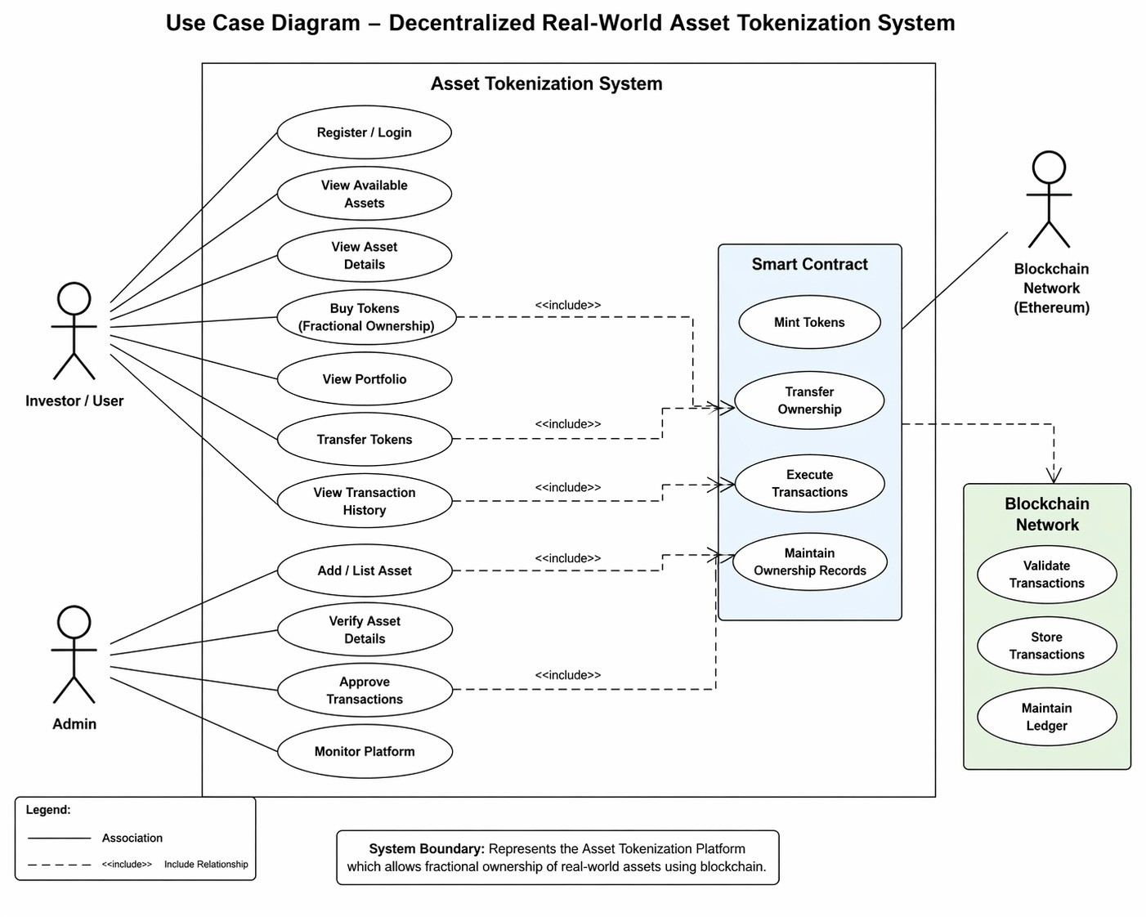
Fig 3.1: Use case diagram
Fig 3.1 shows the interaction between investors, admin, smart contracts, and the blockchain network in the Asset Tokenization System. Investors can register, view assets, buy tokens, transfer ownership, and check transaction history, while the admin manages assets and approves transactions. Smart contracts automate token minting, transaction execution, and ownership management. The blockchain network validates, stores, and maintains secure transaction records in the distributed ledger.

3.2.2 Sequence diagram
A sequence diagram shows object interactions arranged in time sequence. It depicts the objects and classes involved in the scenario and the sequence of messages exchanged between the objects needed to carry out the functionality of the scenario. The figure 3.2 depicts the sequence diagram for our project. It emphasizes the chronological order of messages exchanged, showing how processes collaborate to achieve a specific functionality. By mapping out the flow of communication between actors, objects, and systems, sequence diagrams provide clarity on the dynamic behavior of the application. In the context of block chain-based asset tokenization, such diagrams illustrate users, smart contracts and decentralized ledgers interact to complete transactions securely and transparently.
During trading, the investor requests to buy tokens, the system checks availability, processes payment, and updates ownership records. For compliance, the system logs transactions, sends them to the regulator, and raises alerts if suspicious activity is found. This simple flow highlights how actions move between users, services, and the system in a clear order. We can depict both sequential processing and concurrent processing of activities using an activity diagram. It illustrates the flow of activities within a system or process. It focuses on the sequence of actions, decision points, parallel operations, making it useful for understanding complex workflows. It depicts the objects and classes involved in the scenario and the sequence of messages exchanged between the objects needed to carry out the functionality of the scenario. A blockchain can securely record that someone owns a token, but laws in the real world do not recognize that token as proof of owning part of a physical asset. This creates a gap between digital ownership and legal ownership. It emphasizes the chronological order of messages exchanged, showing how processes collaborate to achieve a specific functionality

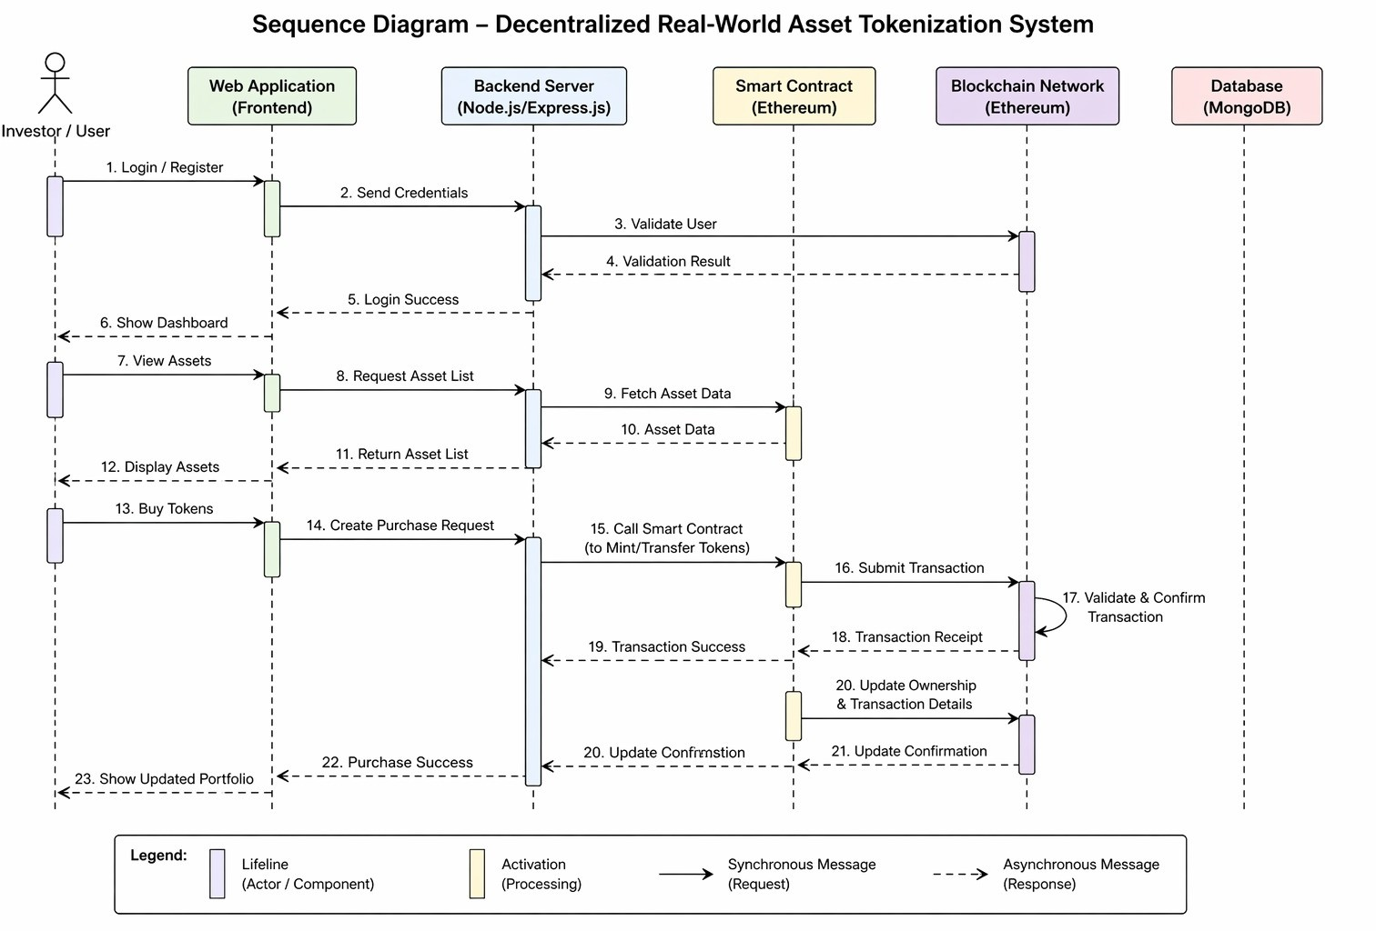
Fig 3.2: Sequence diagram
Fig 3.2 represents the sequence of interactions between the investor, frontend, backend server, smart contract, blockchain network, and database in the Asset Tokenization System. The process begins with user login and asset viewing, followed by sending purchase requests through the web application. The backend communicates with smart contracts to execute token minting or transfer transactions, which are validated and confirmed by the blockchain network. Finally, the system updates ownership details, stores transaction data in the database, and displays the updated portfolio to the user.

Activity diagram
An activity diagram is a behavioral diagram i.e. it depicts the behavior of a system. An activity diagram portrays the control flow from a start point to a finish point showing the various decision paths that exist while the activity is being executed. We can depict both sequential processing and concurrent processing of activities using an activity diagram. It illustrates the flow of activities within a system or process. By representing activities as nodes and transitions as arrows, the diagram provides a visual overview of how tasks progress from start to finish. In the context of block-chain based asset tokenization, activity diagrams can depict processes such as user registration, asset verification, token creation, and transaction execution. An activity diagram portrays the control flow from a start point to a finish point showing the various decision paths that exist while the activity is being executed. The continuously monitors intermediaries.
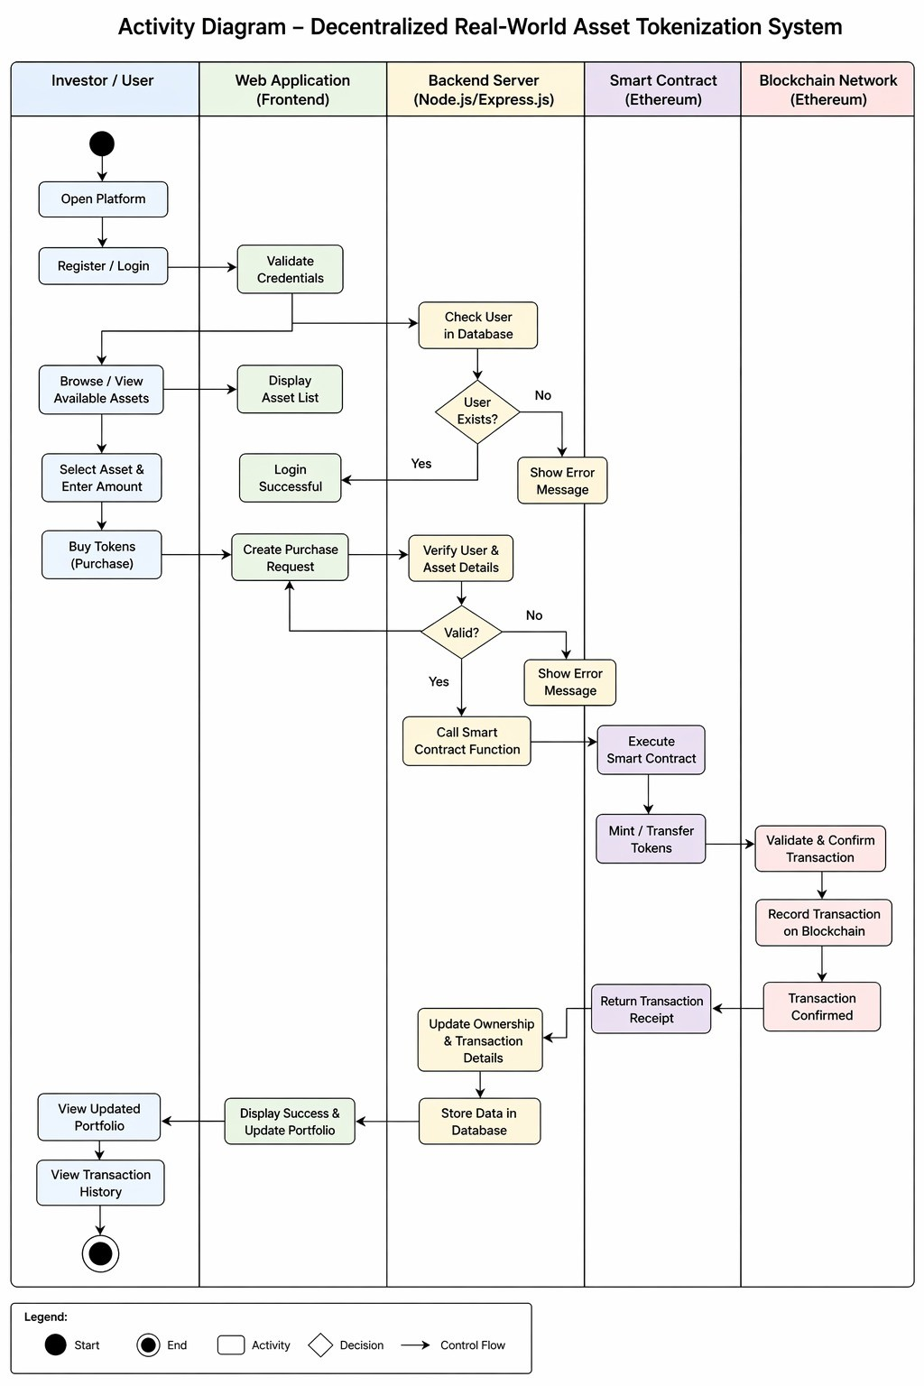
Fig 3.3: Activity diagram
Fig 3.3 illustrates the workflow of the Asset Tokenization System from user login to transaction completion. The investor browses assets, creates a purchase request, and the backend verifies user and asset details before calling the smart contract. The smart contract executes token minting or transfer operations, while the blockchain network validates and records the transaction securely. After confirmation, the system updates ownership details, stores transaction data, and displays the updated portfolio and transaction history to the user.

3.3 Software Requirements Specification

3.3.1 Functional Requirements:
i. User Registration and Authentication:
The system should allow users to create accounts and securely log-in.
ii. Asset Management:
Admin should be able to add, update, and manage asset listings.
iii. Tokenization Process:
The system should convert asset ownership into digital tokens using smart contracts.
iv. Transaction Handling:
Users should be able to safe purchase tokens and transfer ownership
v. Blockchain Integration:
All transactions must be recorded on the blockchain for transparency and immutability.
vi. User Dashboard:
Users should be able to view their owned assets and transaction history
3.3.2 Non-Functional Requirements
i. Performance:
The system should process transactions efficiently with minimal delay.
ii. Security:
The platform must ensure data protection, secure authentication, and safe transactions
using encryption and blockchain.
ii. Scalability:
The system should support a growing number of users and Transactions.
iv. Usability:
The interface should be simple, user-friendly, and easy to navigate.
v. Reliability:
The system should function consistently without failures.
vi. Maintainability:
The codebase should be structured to allow easy updates.

CHAPTER 4
PROJECT PLANNING

4.1 Project Planning and Scheduling

Selecting Domain:
This project is related to blockchain technology and financial systems. It focuses on asset tokenization, where real-world assets are converted into digital tokens and managed using a decentralized blockchain network.

Prepared Plan of Execution:
After identifying the domain and problem, a plan was prepared to develop a system that enables secure and efficient tokenization of assets.

Gathered Research Papers:
Relevant research papers, consultation reports, and technical documents related to blockchain and asset tokenization were studied. This helped in understanding the existing systems, their methodologies, and their drawbacks.

Designed Architecture:
Based on the study of research papers, a suitable system architecture was designed. The system consists of frontend, backend, and blockchain components, which work together to provide asset tokenization and transaction functionalities.

Determine Model Architecture:
The overall architecture and working model of the system were defined. The system includes modules such as asset listing, tokenization, transaction processing, and user management. These modules are developed and integrated step by step.

Development, Testing and Execution:
The development process includes designing smart contracts, developing frontend and backend components, and integrating them with the blockchain network. Testing is performed at each stage to ensure correct functionality and performance. Then, the ownership of that SPV is divided into shares, and these shares are represented as tokens on the blockchain.

Deriving Results:
After completing the implementation, the system is tested and evaluated. The results demonstrate the efficiency, security, and feasibility of the proposed asset tokenization platform. In your project, the main challenge is that blockchain by itself cannot legally represent ownership of real-world assets like land or property. A blockchain can securely record that someone owns a token, but laws in the real world do not recognize that token as proof of owning part of a physical asset. This creates a gap between digital ownership and legal ownership. If you directly sell tokens claiming they represent ownership of an asset, those claims are not enforceable in court. As a result, the system can be considered misleading or even illegal because it may violate property and securities laws.
To solve this problem, your project introduces an SPV (Special Purpose Vehicle), which is essentially a legally registered company or trust created specifically to hold the asset. Instead of linking tokens directly to the asset, the asset is first owned by the SPV. Then, the ownership of that SPV is divided into shares, and these shares are represented as tokens on the blockchain. This structure creates a valid legal connection because company shares are recognized under law. So when a user buys tokens, they are actually purchasing shares in the SPV, and since the SPV owns the asset, the user indirectly owns a portion of that asset.
This approach ensures that the system aligns with existing legal frameworks. The blockchain still provides transparency, security, and easy transfer of ownership, while the SPV provides legal recognition and protection. As a result, the project becomes both technologically efficient and legally valid. Without the SPV, the tokens would only exist digitally without any enforceable rights, but with the SPV, they gain real-world meaning and legitimacy.

CHAPTER 5
SYSTEM DESIGN

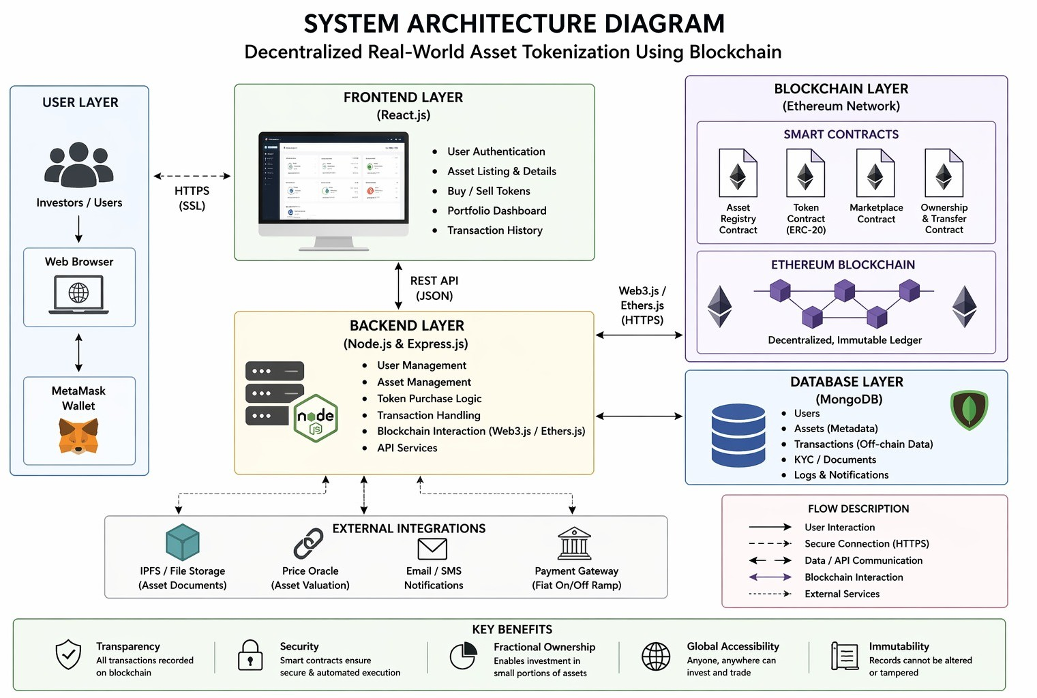
Architecture Diagram
Fig 5.1: Architecture Diagram
Fig 5.1 illustrates the overall architecture of the Asset Tokenization System, consisting of user, frontend, backend, blockchain, and database layers. The frontend developed using React.js provides features such as authentication, asset viewing, token purchase, portfolio management, and transaction history. The backend built with Node.js and Express.js handles business logic, API services, user management, and communication with blockchain smart contracts. The blockchain layer uses Ethereum smart contracts to manage asset registration, token transfer, ownership tracking, and secure transaction execution. MongoDB is used to store user data, asset metadata, transaction records, and KYC documents. The architecture price oracles for asset valuation, and payment gateways further also integrates external services such as IPFS storage, price oracles, email notifications, and payment gateways to enhance system functionality and security.
The architecture of the system consists of three main components:
• Frontend Application – Provides user interface for asset listing, token purchase, and transaction tracking.
• Backend Server – Handles API requests, user authentication, and communication between frontend and blockchain.
• Blockchain Network – Executes smart contracts and records transactions securely. The frontend interacts with the backend, which in turn communicates with the blockchain network to perform tokenization and transaction operations.
The system architecture for asset tokenization is designed as a multi-layered framework that integrates user interaction, application logic, blockchain technology, and data management. At the user layer, investors access the platform through a web interface and connect securely using digital wallets such as MetaMask. The frontend layer, developed using modern frameworks, provides functionalities like user authentication, asset listing, transaction tracking, and portfolio management. This layer communicates with the backend through REST APIs, where the backend handles core operations including user management, asset validation, transaction processing, and blockchain interaction using libraries like Web3.js or Ethers.js. The blockchain layer, built on the Ethereum network, executes smart contracts responsible for token creation, ownership transfer, and marketplace operations, ensuring transparency and immutability. Additionally, a database layer is used to store off-chain data such as user details, asset metadata, and transaction logs. External integrations like IPFS for file storage, price oracles for asset valuation, and payment gateways further enhance system functionality. Overall, this architecture ensures secure, decentralized, and efficient tokenization of real-world assets.
5.2 Component Design / Module Decomposition
The component diagram of the asset tokenization system illustrates the modular structure and interaction between key system components. The user interface, developed using React.js, handles all client-side operations such as user authentication, asset listing, token transactions, portfolio tracking, and profile management. This interface communicates securely with the backend server through HTTPS APIs. The backend, built with Node.js and Express.js, acts as the core processing unit, managing business logic, user authentication, asset management, transaction handling, and interaction with smart contracts. It also connects to the database (MongoDB), which stores off-chain data including user information, asset details, transaction records, KYC documents, and audit logs. The system integrates with blockchain components through Web3.js or Ethers.js, enabling communication with Ethereum-based smart contracts written in Solidity. These smart contracts handle critical operations such as asset registration, token creation (ERC-20), marketplace transactions, and ownership transfers. Additionally, the blockchain network ensures decentralized execution, immutable record-keeping, and secure transaction confirmation. Wallet integration, such as MetaMask, enables users to sign and authorize blockchain transactions. Overall, this component-based architecture ensures scalability, security, and efficient coordination between decentralized and centralized elements of the system. It also connects to the database (MongoDB), which stores off-chain data including user information, asset details, transaction records, KYC documents, and audit logs. The system integrates with blockchain components through Web3.js or Ethers.js, enabling communication with Ethereum-based smart contracts written in Solidity.

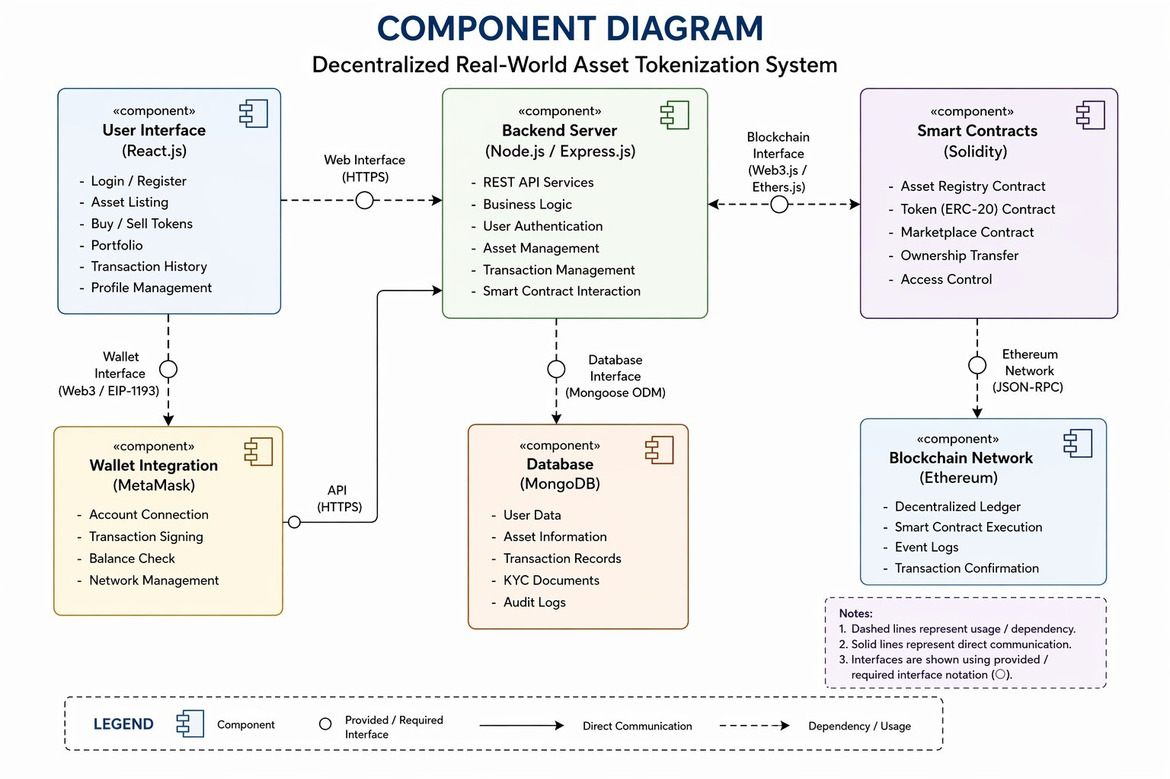
Fig. 5.2: Component Design
Fig 5.2 illustrates the component diagram of the Asset Tokenization System and shows interaction between major system components. The user interface built with React.js communicates with the backend server through secure web APIs for authentication, asset management, and transaction processing. The backend interacts with smart contracts deployed on the Ethereum blockchain using Web3.js/Ethers.js to execute token-related operations securely. MongoDB stores user data, asset information, transaction records, and audit logs, while MetaMask enables wallet connection and transaction signing for blockchain interactions. The diagram also highlights integration between blockchain and web technologies for secure and transparent asset tokenization.
The system is divided into the following modules:
• User Module: Handles user registration, login, and authentication.
• Asset Management Module: Allows admin to add and manage asset details.
• Tokenization Module: Converts real-world assets into digital tokens using smart contracts.
• Transaction Module: Manages token purchase, transfer, and transaction validation.
• Blockchain Module: Handles execution of smart contracts and storage of transaction records.
Together, these modules work in an integrated manner to provide transparency, security, and smooth functionality of the platform. The Interface Design of the Asset Tokenization System is developed to provide smooth and efficient interaction between users, administrators, and the blockchain network. Proper security measures are integrated to ensure safe communication and data handling. The interface design enhances usability, transparency, and overall user experience within the platform. The Admin Interface provides functionalities for managing asset listings, verifying asset information, monitoring transactions, and controlling overall system operations.

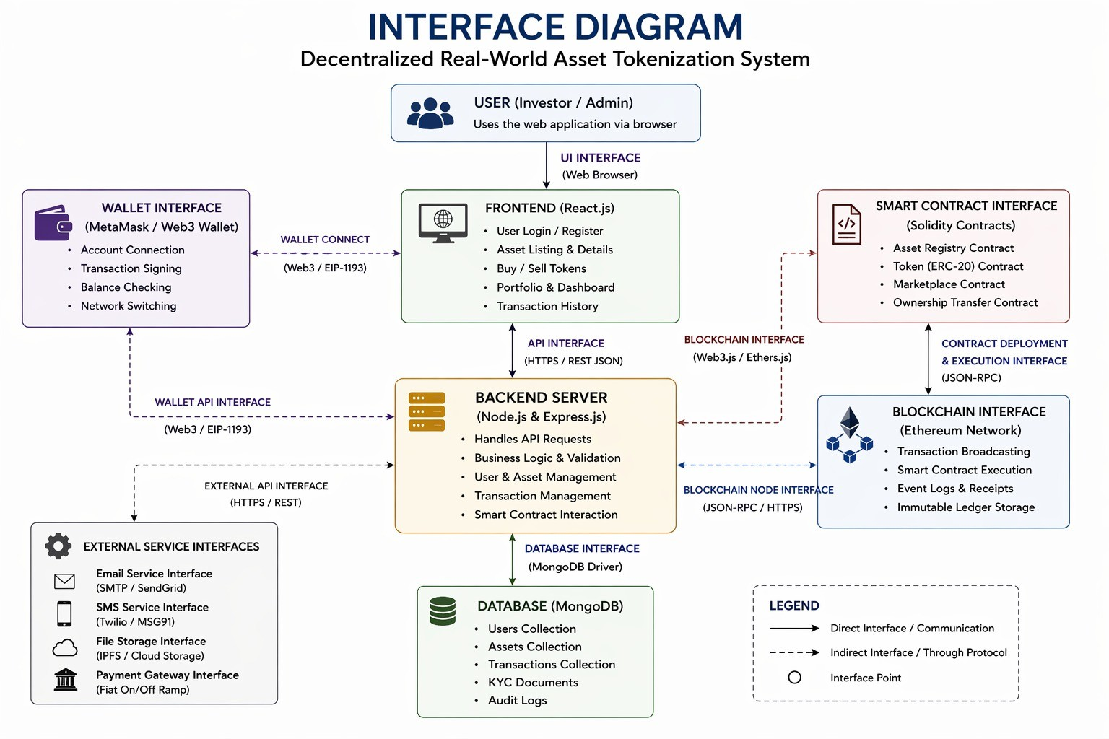
5.3 Interface Design
Fig 5.3: Interface Diagram
Fig 5.3 illustrates the interface architecture of the Asset Tokenization System and the communication between the frontend, backend, blockchain, and database components. The React.js frontend allows users to manage assets, buy tokens, and view portfolios through a web interface. The Node.js and Express.js backend handles API requests, business logic, and interaction with Ethereum smart contracts. MongoDB stores system data, while MetaMask and external services support wallet connectivity, notifications, and payment integration.
The system consists of user-friendly interfaces for interaction:
• User Interface: Allows users to view assets, purchase tokens, and track ownership.
• Admin Interface: Enables admin to manage asset listings and system operations.
• Blockchain Interface: Facilitates communication between backend and blockchain network for executing smart contracts.
The Interface Design of the Asset Tokenization System is developed to provide smooth and efficient interaction between users, administrators, and the blockchain network. The User Interface allows investors and users to register, log in, view available assets, purchase tokens, and monitor their ownership details through a simple dashboard. The Admin Interface provides functionalities for managing asset listings, verifying asset information, monitoring transactions, and controlling overall system operations. The Blockchain Interface acts as a communication layer between the backend server and the blockchain network for executing smart contracts and validating transactions securely. All interfaces are designed with a user-friendly layout to improve accessibility and navigation. Proper security measures are integrated to ensure safe communication and data handling.

5.4 Data Structure Design
The following data structures are used in the project:
Table 5.1: Few data structures used in project
Data Structure | Description
JSON | Used for storing and exchanging data between frontend and backend
Arrays | Used to store lists of assets and transactions
Objects | Used to represent user and asset details
Blockchain-Ledger | Stores transaction records in a secure and immutable format
The Table 5.1 describes various data structures to manage and store information efficiently. JSON is used for data exchange between the frontend and backend through APIs. Arrays are used to store collections such as assets, transactions, and user portfolios. Objects help represent structured data like user details and asset information. The blockchain ledger securely stores transaction records in an immutable and decentralized manner, ensuring transparency and security throughout the system.

5.5 Algorithm Design
An algorithm is a sequence of steps used to solve a problem. The system consists of the following algorithms:

5.5.1 Asset Tokenization Algorithm
Step 1: Admin adds asset details into the system.
Step 2: Smart contract is created for the asset.
Step 3: Asset value is divided into tokens.
Step 4: Tokens are generated and stored on blockchain.
Step 5: Tokens are made available for purchase. Hash Collection
Step 6: Tokens representing fractional ownership are generated.
Step 7: Asset tokens are made available for purchase in the marketplace.

5.5.2 Token Purchase Algorithm
Step 1: User logs into the system.
Step 2: User selects an asset.
Step 3: User enters number of tokens to purchase.
Step 4: Request is sent to smart contract.
Step 5: Blockchain validates transaction.
Step6: Tokens are transferred to user wallet

5.5.3 Transaction Validation Algorithm

Step 1: Transaction request is initiated.
Step 2: Smart contract verifies user details.
Step 3: Blockchain network validates transaction.
Step 4: Transaction is recorded in ledger.
Step 5: Confirmation is sent to user.
5.5.4 User Authentication Algorithm
Step 1: User enters login credentials.
Step 2: Backend verifies credentials from database.
Step 3: If valid, access is granted.
Step 4: If invalid, error message is displayed.
CHAPTER 6
CONCLUSION, APPLICATIONS AND FUTURE
WORK

6.1 Conclusion
The rapid advancement of digital technologies has significantly transformed traditional financial systems, paving the way for innovative solutions such as asset tokenization. This project, titled “Asset Tokenization: Decentralized Platform for Real-World Asset Tokenization Using Blockchain”, successfully demonstrates the feasibility and effectiveness of integrating blockchain technology with modern web-based applications to address the limitations of conventional asset management systems.
The primary objective of this project was to design and develop a decentralized platform that enables the conversion of real-world assets into digital tokens, thereby facilitating fractional ownership, enhancing liquidity, and improving accessibility for investors. The system effectively eliminates the dependency on intermediaries by leveraging smart contracts and distributed ledger technology, ensuring secure, transparent, and tamper-proof transactions.
The implementation of the system using technologies such as React.js, Node.js, MongoDB, and Ethereum blockchain provides a robust and scalable solution. The developed platform offers an intuitive user interface for asset browsing, token purchasing, and portfolio management, thereby enhancing user experience and usability. The successful execution of transactions and proper management of ownership records demonstrate the reliability and correctness of the system.
Furthermore, the project highlights the potential of blockchain technology in revolutionizing financial markets by reducing operational inefficiencies, minimizing transaction costs, and enabling real-time settlement. The concept of tokenization not only democratizes investment opportunities but also introduces a new paradigm for asset ownership and management in the digital era.
Despite its successful implementation, the system also acknowledges certain limitations such as regulatory constraints, security challenges, and dependency on blockchain infrastructure. However, these limitations can be addressed with further research and technological advancements.
In conclusion, the proposed system serves as a significant step towards modernizing traditional financial ecosystems. It demonstrates how asset tokenization can bridge the gap between physical assets and digital platforms, thereby creating a more inclusive, efficient, and transparent investment environment.

6.2 Applications
The asset tokenization platform has wide-ranging applications across various domains due to its ability to digitize and decentralize asset ownership.
1. Real Estate Investment: Enables fractional ownership of high-value properties, allowing multiple investors to participate with lower capital.
2. Financial Markets: Facilitates trading of tokenized securities, bonds, and other financial instruments.
3. Commodity Trading: Allows tokenization of commodities such as gold, silver, and oil for easier trading and investment.
4. Supply Chain Management: Improves transparency and traceability of goods through tokenized assets.
5. Intellectual Property Rights: Enables ownership and trading of digital assets such as patents, copyrights, and media content.
6. Crowdfunding Platforms: Provides a decentralized mechanism for raising funds through tokenized assets.
These applications demonstrate the versatility and adaptability of tokenization across multiple industries.

6.3 Limitations of The System
Although the proposed asset tokenization system demonstrates significant advantages over traditional asset management approaches, it is subject to certain limitations that need to be considered. The current system is developed as a prototype and is deployed on a test environment rather than a live blockchain network. As a result, real-time financial transactions and actual asset ownership validations are not fully implemented. This limits the system’s applicability in real-world scenarios without further enhancements.
Another limitation is related to regulatory and legal compliance. Asset tokenization involves complex legal frameworks that vary across different countries. The current system does not incorporate comprehensive regulatory compliance mechanisms such as Know Your Customer (KYC), Anti-Money Laundering (AML), and legal ownership verification, which are essential for real-world deployment.
The system also depends on blockchain infrastructure, which may introduce challenges such as network latency, transaction fees (gas fees), and scalability issues. In high-demand scenarios, blockchain networks may experience congestion, leading to delays in transaction processing.
Security is another critical concern. Although blockchain provides a secure environment, vulnerabilities may still exist in smart contracts or application layers. The current implementation does not include advanced security measures such as formal smart contract auditing or multi-signature authentication.
Additionally, the platform currently supports a limited set of asset types, primarily focusing on real estate-based tokenization. It does not yet support a wide range of asset classes such as equities, bonds, or digital collectibles.
Finally, the user interface and experience, although functional, can be further improved to enhance usability and accessibility for non-technical users. Integration with mobile platforms and advanced analytics features is also not included in the current version.

Future Scope of The Project
The future scope of asset tokenization is vast and promising, with significant potential for growth and innovation. Several enhancements and advancements can be incorporated to further improve the system:
1. Integration with Real Blockchain Networks: Deployment on mainnet environments for real-time transactions and practical usage.
2. Enhanced Security Mechanisms: Implementation of advanced cryptographic techniques and multi-factor authentication for improved security.
3. Regulatory Compliance Integration: Incorporation of legal frameworks and compliance mechanisms to ensure adherence to global financial regulations.
4. Multi-Asset Support: Expansion of the platform to support various asset classes such as stocks, bonds, and digital collectibles.
5. AI and Data Analytics Integration: Use of artificial intelligence for predictive analysis and investment recommendations.
6. Cross-Platform Accessibility: Development of mobile applications to enhance accessibility and user engagement.
7. Scalability Improvements: Adoption of advanced blockchain solutions such as Layer-2 scaling for handling large volumes of transactions.

COURSE OUTCOMES (CO) and CO-PO MAPPING
Course Outcomes (COs)
Table A1 : Course Outcomes
CO No. | Statement
CO1 | To develop student’s knowledge for solving technical problems
CO2 | To provide an opportunity to learn about new ideas and concepts
CO3 | To improve written and verbal communication skills.
CO4 | To Analyze, Design and Evaluate Engineering System
CO5 | To Develop the working products model or prototypes and applications with ethics
CO6 | To provide an opportunity to work in team

Table: A1 presents the Course Outcomes achieved during the development of the project. The project enhanced students’ technical knowledge and problem-solving skills through practical implementation of modern technologies. It provided practical exposure to blockchain technology, smart contracts, and full-stack web development concepts. Students learned to analyze system requirements and design suitable software solutions based on user needs. The development process improved programming, testing, debugging, and system integration abilities. Students gained knowledge about database management, API handling, and secure transaction processing.
Strength of CO Mapping to PO/PSOs with Justification:
Table A2 : CO-PO-PSO Mapping Matrix
COs | PO1 | PO2 | PO3 | PO4 | PO5 | PO6 | PO7 | PO8 | PO9 | PO10 | PO11 | PSO1 | PSO2
CO1 | 3 | 2 | - | - | 3 | - | - | - | - | - | - | 3 | 2
CO2 | 2 | 3 | 2 | 2 | - | - | - | - | - | - | - | 2 | 3
CO3 | 2 | 2 | 3 | 2 | 2 | - | - | 1 | - | - | - | 3 | 3
CO4 | 2 | 3 | 2 | 3 | 3 | - | - | 1 | - | - | - | 2 | 3
CO5 | 2 | 2 | 3 | 2 | 2 | - | - | 3 | 1 | - | - | 3 | 2
CO6 | - | - | - | - | - | - | - | 1 | 3 | 3 | 2 | - | -
Average | 1.8 | 2.3 | 2.0 | 1.8 | 1.8 | - | - | 0.8 | 0.7 | 0.5 | 0.3 | 2.1 | 2.5
Table: A2 shows the mapping between Course Outcomes (COs), Program Outcomes (POs), and Program Specific Outcomes (PSOs). The matrix represents how effectively each course outcome contributes toward achieving the overall program objectives and learning goals. It helps in evaluating the relationship between the knowledge gained through the project and the expected academic outcomes of the engineering program. A value of 3 represents high correlation, 2 represents medium correlation, and 1 represents low correlation between COs and POs/PSOs. It also demonstrates the ability of students to analyze requirements, design suitable solutions, and develop a functional working prototype successfully. The mapping clearly indicates that the project strongly supports technical knowledge, analytical thinking, problem-solving abilities, system design, software development, and implementation skills. The project also contributes significantly toward improving programming knowledge, testing methodologies, debugging techniques, and system integration capabilities. Students gained practical exposure to blockchain technology, smart contracts, database management, and full-stack web development through the implementation of the project. The matrix further highlights the contribution of the project toward enhancing teamwork, communication skills, leadership qualities, and collaborative learning among team members. Professional ethics, responsibility, and understanding of secure digital transaction systems were also addressed during project development. The mapping values indicate that the project encourages innovation, creativity, and application of engineering concepts in solving real-world problems. It also demonstrates the ability of students to analyze requirements, design suitable solutions, and develop a functional working prototype successfully. Professional ethics, responsibility, and understanding of secure digital transaction systems were also addressed during project development. The average mapping values show that the project maintains a strong alignment with the required academic standards and program objectives. Overall, the CO-PO-PSO mapping matrix confirms that the project effectively fulfills the intended educational outcomes and contributes toward the overall professional development of students.
Correlation Levels:
1-Low
2-Medium
3-High
Program Outcomes (POs):
PO1 – Engineering Knowledge
PO2 – Problem Analysis
PO3 – Design/Development of Solutions
PO4 – Investigation of Complex Problems
PO5 – Modern Tool Usage
PO6 – Engineer and Society
PO7 – Environment & Sustainability
PO8 – Ethics
PO9 – Individual & Team Work
PO10 – Communication
PO11 – Project Management & Finance
Table A3 : Justification for CO-PO-PSO Mapping
CO | PO/PSO | Justification
CO1 | PO1, PO5, PSO1 | Applies engineering knowledge, blockchain tools, MongoDB, React.js and Ethereum technologies for solving asset management problems.
CO2 | PO2,PO4,PSO2 | Analysis traditional system inefficiencies and evaluates blockchain-based decentralized solutions.
CO3 | PO3,PO5,PSO1,  PSO2 | Designs and develops a complete blockchain-based asset tokenization platform using modern software engineering practices.
CO4 | PO2,PO4,PSO2 | Evaluates security, transaction transparency, scalability and system performance using blockchain architecture.
CO5 | PO3,PO5,PO8,  PSO1 | Develops a secure and ethical decentralized application ensuring transparency and proper handling of user transactions.
CO6 | PO9,PO10,PO11 | Demonstrates teamwork, communication, project coordination and management during project development and documentation.

Table A3 illustrates the Course Outcomes (COs) and CO-PO Mapping, which describe how the Asset Tokenization project contributes toward achieving engineering, technical, and professional learning objectives. The project enhances students’ technical knowledge through the implementation of blockchain technology, smart contracts, React.js, Node.js, Express.js, and MongoDB. It improves analytical thinking, logical reasoning, and problem-solving abilities by evaluating decentralized systems, secure transaction mechanisms, and digital asset management processes. The project also strengthens software design, development, testing, debugging, and implementation capabilities using modern engineering tools and technologies. Students gained practical exposure to frontend and backend integration, API development, database management, blockchain interaction, and secure authentication systems during the project development process. The implementation of blockchain-based transaction management and smart contract execution ensured transparency, security, reliability, and ethical handling of digital transactions. The project further contributed toward improving teamwork, communication skills, technical documentation, presentation abilities, and collaborative learning among team members. It also encouraged innovation, creativity, and practical application of engineering concepts while developing a secure and scalable application prototype.
SDG – SUSTAINABLE DEVELOPMENT GOALS

SDG No. | Sustainable Development Goal | Mapping with Project
SDG 8 | Decent Work and Economic Growth | The project promotes digital investment opportunities and improves financial accessibility through asset tokenization and fractional ownership.
SDG 9 | Industry, Innovation and Infrastructure | The system utilizes blockchain technology, smart contracts, and decentralized applications to support technological innovation and modern digital infrastructure.
SDG 10 | Reduced Inequalities | Fractional ownership allows small and medium investors to participate in high-value asset markets, reducing financial inequality.
SDG 11 | Sustainable Cities and Communities | Real estate tokenization can improve access to property investment and support transparent urban asset management systems.
SDG 16 | Peace, Justice and Strong Institutions | Blockchain technology ensures transparency, immutability, and secure transactions, reducing fraud and improving trust in financial systems.
SDG 17 | Partnerships for the Goals | The project supports integration between blockchain platforms, financial systems, and digital technologies for collaborative development.
Table A4 : Mapping with Sustainable Development Goals (SDGs)

Table: A4 illustrates The Asset Tokenization System supports the Sustainable Development Goals (SDGs) through financial inclusion and digital innovation. It contributes to SDG 8 by providing wider investment opportunities and supporting economic growth. The system uses blockchain technology to ensure secure and transparent financial transactions. It also supports SDG 9 by improving innovation and digital financial infrastructure. Through decentralized technology, the platform enhances transparency and efficiency in asset management.

SWOT – STRENGTHS, WEAKNESSES,
OPPORTUNITES, THREATS
SWOT Analysis of Asset Tokenization
Table A5 : SWOT Matrix
Category | Description
Strengths | - Decentralized and secure blockchain-based platform.  - Enables fractional ownership of assets.  - Improves transparency and reduces fraud.  - Reduces dependency on intermediaries.  - Faster and efficient transactions using smart contracts.
Weaknesses | - Regulatory and legal uncertainty regarding digital assets.  - Requires blockchain knowledge and technical expertise.  - High dependency on internet and network availability.  - Gas fees and scalability issues in blockchain networks.
Opportunities | - Growing adoption of blockchain and Web3 technologies.  - Expansion into real estate, commodities, and financial sectors.  - Increasing interest in decentralized finance (DeFi).  - Potential integration with global digital investment platforms.
Threats | - Cybersecurity threats and smart contract vulnerabilities.  - Rapidly changing government regulations.  - Market volatility in blockchain ecosystems.  - Competition from centralized financial platforms and emerging blockchain projects.

Table: A5 illustrates The SWOT analysis of the Asset Tokenization System provides an overview of the strengths, weaknesses, opportunities, and threats associated with the platform. The system uses blockchain technology to provide a decentralized, secure, and transparent environment for digital asset management. One of its major strengths is enabling fractional ownership, which allows multiple investors to own portions of high-value assets. Smart contracts help automate transactions and reduce dependency on intermediaries. The platform also improves transaction speed, transparency, and security. However, the system faces challenges such as legal and regulatory uncertainty regarding digital assets and blockchain operations. Technical complexity and the requirement of blockchain knowledge can also limit user adoption. Scalability issues and blockchain gas fees may affect system performance and transaction costs. The increasing adoption of blockchain, Web3, and decentralized finance creates strong growth opportunities for the platform.

ANNEXURE

ANNEXURE – A : Source Code Structure

The project is organized into multiple folders and modules to ensure modularity, scalability, and maintainability of the system. The folder structure helps developers manage frontend, backend, blockchain, and database components efficiently.

Project Folder Structure

Asset-Tokenization/

│

├── client/

│ ├── src/

│ │ ├── components/

│ │ ├── pages/

│ │ ├── services/

│ │ ├── context/

│ │ └── App.js

│ │

│ └── public/

│

├── server/

│ ├── controllers/

│ ├── middleware/

│ ├── models/

│ ├── routes/

│ ├── uploads/

│ ├── seed.js

│ ├── server.js

│ └── .env

│

├── blockchain/

│ ├── contracts/

│ │ └── PropertyToken.sol

│ ├── scripts/

│ └── hardhat.config.js

│

├── screenshots/

├── README.md

└── package.json

ANNEXURE – B : Database Schemas

1. User Schema

The user schema stores information related to investors and administrators.

Fields:

Name

Email

Password

Wallet Address

Wallet Balance

Role (Admin/User)

2. Asset Schema

The asset schema stores details related to tokenized real-world assets.

Fields:

Asset Name

Description

Category

Total Value

Total Tokens

Available Tokens

Price Per Token

Property Address

Location

Annual Yield

Smart Contract Address

3. Ownership Schema

This schema maintains ownership records of purchased tokens.

Fields:

User ID

Asset ID

Number of Tokens Owned

Ownership Percentage

4. Transaction Schema

Stores all token purchase and transfer transactions.

Fields:

User Information

Asset Information

Token Quantity

Transaction Amount

Blockchain Transaction Hash

Transaction Status

ANNEXURE – C : APIs Used in the Project

Authentication APIs
API | Method | Purpose
/api/auth/register | POST | User registration
/api/auth/login | POST | User login

Asset APIs
API | Method | Purpose
/api/assets | GET | Fetch all assets
/api/assets/:id | GET | Fetch single asset
/api/assets/create | POST | Add new asset

Transaction APIs
API | Method | Purpose
/api/transactions/buy | POST | Buy asset tokens
/api/transactions/my | GET | View transaction history
/api/transactions/portfolio | GET | View owned assets

ANNEXURE – D : Smart Contract Overview

The smart contract is developed using Solidity and deployed on the Ethereum blockchain test network.

Functions Implemented

1. Token Minting

Creates digital tokens representing ownership of assets.

2. Ownership Transfer

Transfers token ownership from seller to buyer.

3. Transaction Validation

Ensures secure and transparent execution of token transactions.

4. Blockchain Recording

Records all transactions permanently on blockchain ledger.

ANNEXURE – E : Screenshots Description

1. Home Page

Displays introduction, statistics, and available tokenized properties.

2. Marketplace Page

Shows all listed assets with:

Asset image

Token price

Total value

APY

Availability

3. Asset Details Page

Displays:

Asset description

Price simulation chart

Token distribution chart

Buy token panel

4. Dashboard

Displays:

Wallet balance

Total investment

Asset ownership

Investment distribution chart

ANNEXURE – F : Sample Input and Output

Sample Input

User Login Credentials

Asset Selection

Number of Tokens to Purchase

Sample Output

Login Successful

Asset Details Displayed

Token Purchase Confirmation

Updated Dashboard Balance

Blockchain Transaction Hash Generated
Technology | Purpose
React.js | Frontend development
Node.js | Backend runtime
Express.js | API handling
MongoDB | Database storage
Ethereum | Blockchain platform
MetaMask | Wallet integration
Hardhat | Smart contract deployment
VS Code | Development environment
GitHub | Version control

ANNEXURE – G : Tools and Technologies Used

ANNEXURE – H : Future Enhancements

The following features can be added in future versions of the project:

Real Ethereum Mainnet Deployment

NFT-based Asset Ownership

AI-based Investment Recommendation

KYC and AML Verification

Multi-chain Blockchain Support

Mobile Application Development

Live Crypto Payment Gateway

Secondary Token Marketplace

DAO-based Governance System

Real-time Market Analytics Dashboard

Smart Contract Security Auditing

REFERENCES
[1] Agur, I., Villegas-Bauer, G., Mancini-Griffoli, T., Martinez Peria, M. S., and Tan, B., “Tokenization and Financial Market Inefficiencies”, International Monetary Fund (IMF), Fintech Note 2025/001, January 2025.
[2] International Financial Services Centres Authority (IFSCA), “Regulatory Approach towards Tokenization of Real-World Assets”, Consultation Paper, February 2025.
[3] Nishith Desai Associates, “Real Estate Tokenisation: Legal, Tax and Regulatory Considerations”, Research Report, March 2025.
[4] Soni, U., Fines, O., and Sun, J., “An Investment Perspective on Tokenization: A Primer on the Use of Distributed Ledger Technology”, CFA Institute Research Report, January 2025.
[5] Nakamoto, S., “Bitcoin: A Peer-to-Peer Electronic Cash System”, 2008.
[6] Antonopoulos, A. M., “Mastering Ethereum: Building Smart Contracts and DApps”, O’Reilly Media, 2018.
[7] Buterin, V., “Ethereum Whitepaper: A Next-Generation Smart Contract and Decentralized Application Platform”, 2014.
[8] Wood, G., “Ethereum: A Secure DecentralisedGeneralised Transaction Ledger”, Ethereum Project Yellow Paper, 2014.
[9] Crosby, M., et al., “Blockchain Technology: Beyond Bitcoin”, Applied Innovation Review, 2016.
[10] Swan, M., “Blockchain: Blueprint for a New Economy”, O’Reilly Media, 2015.
[11] Ethereum Official Website – https://ethereum.org
[12] Solidity Programming Language Documentation – https://soliditylang.org
[13] React.js Official Documentation – https://react.dev
[14] Node.js Official Documentation – https://nodejs.org
[15] MongoDB Official Website – https://www.mongodb.com
[16] MetaMask Wallet Documentation – https://metamask.io
[17] Hardhat Development Environment – https://hardhat.org
[18] Remix IDE for Smart Contracts – https://remix.ethereum.org
[19] Web3.js Library Documentation – https://web3js.readthedocs.io
[20] Ethers.js Library Documentation – https://docs.ethers.org
Online Tools and AI Assistance
[1] ChatGPT (OpenAI), used for structuring the report, generating explanations, refining academic content, and assisting in documentation of project modules.
[2] Claude AI (Anthropic), used for conceptual clarification, technical understanding of
blockchain systems, and enhancement of written explanations.
[3] Gemini AI (Google), used for supplementary research, validation of ideas, and gathering additional insights on tokenization and distributed ledger technology.
[4] Visual Studio Code, used as the primary development environment for project management.
[5] GitHub, used for version control, code storage, and collaboration during project development.

