
KES’s Rajarambapu Institute of Technology, Rajaramnagar.
An Empowered autonomous institute, affiliated to Shivaji University, Kolhapur
Department of Computer Science & Engineering
A. Y. 2025-26
Capstone Project Synopsis
Group Number | 01
Title of the project | GeoVisionAI: AI-Powered Geospatial Storytelling Platform
Project Guide Name | Dr. P. J. Kulkarni
Team Leader’s Name | Ketakee Sanjay Deshmukh
Project domain area | AI/ Machine Learning / NLP

Members
Sr. No. | Roll No. | Name | Email | Phone | Sign
1 | 2303012 | Omkar Ramesh Patil | 2303012@ritindia.edu | 9403842218
2 | 2303013 | Sanjana Vikas Patil | 2303013@ritindia.edu | 7420959769
3 | 2303017 | Ketakee Sanjay Deshmukh | 2303017@ritindia.edu | 9699192556
4 | 2303020 | Atharv Arun Jadhav | 2303020@ritindia.edu | 8055472672

Ms. J. A. Patil  Project Guide | Prof. P. N. Jadhav  Project Coordinator | Dr. S. S. Patil  HOD, CSE

1. Abstract
Geospatial data is increasing rapidly due to advancements in satellite systems, smart city infrastructure, remote sensing technologies, and environmental monitoring platforms. This growth has created vast amounts of spatial information that can provide valuable insights into urban development, environmental change, and resource management. However, existing Geographic Information System (GIS) platforms primarily focus on static 2D map-based visualization and often lack automated mechanisms for predictive analysis, contextual exploration, and narrative-based explanations. As a result, interpreting complex spatial patterns remains challenging for non-expert users such as students, planners, and decision-makers. Recent research in AI-driven geospatial storytelling has explored techniques such as automated cartography and satellite image presentation; however, many existing systems do not integrate structured machine learning analytics with interactive visual storytelling in a unified platform.
To address these limitations, this project implements GeoVisionAI, an AI-powered geospatial storytelling and visual analytics platform designed to transform complex spatial datasets into interactive and understandable narratives. The platform integrates structured geospatial data processing, spatial pattern detection, time-series forecasting, and natural language generation. In the latest implementation, the platform incorporates an interactive 3D Earth Globe viewer built with WebGL and Three.js for realistic planetary-scale spatial exploration, replacing flat static maps with continuous rotation and dynamic coordinate markers.
Additionally, the system features a dedicated Filter-Wise AI Story Studio, enabling users to generate multi-dimensional spatial narratives customized by geographic domain, analytical theme (e.g., climate change, urban expansion, deforestation), and analytical depth. To enhance user interaction and interpretability, the platform integrates a conversational GeoAI Assistant featuring sample query chips, real-time spatial query answering, and contextual explanations powered by high-speed Large Language Model (Groq LLM) inference.
The developed prototype demonstrates a modular full-stack architecture combining a responsive React.js frontend with robust backend API services for geospatial data processing. The outcome is a scalable and user-friendly web application that bridges the gap between complex geospatial data science and intuitive visual storytelling, effectively supporting data-driven decision-making in environmental monitoring, urban planning, and geographic education.

2. Introduction
Geospatial data plays a critical role in understanding environmental changes, urban development, climate monitoring, and population dynamics. With the rapid growth of satellite systems, smart city infrastructure, and environmental monitoring technologies, the volume of geospatial data has increased significantly. Traditional Geographic Information System (GIS) platforms primarily provide static map-based visualization of spatial information; however, interpreting complex spatial patterns often requires expert knowledge and experience, making it difficult for students, planners, and non-expert decision-makers to extract meaningful insights.
Recent advancements in artificial intelligence have introduced geospatial storytelling systems that aim to improve the presentation of spatial information through narrative visualization. Although these approaches enhance the visual communication of geospatial data, many existing systems mainly focus on layout generation or visual storytelling and lack predictive spatial modeling and structured machine learning-based analytics. Large Language Models (LLMs) are capable of generating text-based explanations, but they often lack structured spatial reasoning and analytical capabilities. Similarly, creative AI frameworks designed for satellite storytelling primarily focus on image reconstruction and visual enhancement rather than structured geospatial analysis and predictive modeling.
To address these limitations, the proposed platform, GeoVisionAI, integrates machine learning-based spatial pattern detection, time-series forecasting, and natural language narrative generation within a unified, interactive web system. The implemented platform advances beyond flat maps by incorporating an interactive WebGL/Three.js-powered 3D Earth Globe for dynamic planetary exploration, a dedicated Filter-Wise AI Story Studio for customized thematic narratives across diverse regions, and a conversational GeoAI Assistant powered by high-speed Groq LLM inference to deliver instant spatial explanations. By uniting predictive analytics, automated natural language generation, and immersive 3D visualization, GeoVisionAI transforms complex geospatial data into intuitive, predictive, and actionable visual stories.

3. Objectives
1. To design a structured geospatial data processing system for efficient spatial data analysis and preprocessing.
2. To develop machine learning models for spatial pattern detection and time-series forecasting of geospatial trends.
3. To generate automated natural language explanations from structured analytical outputs using Natural Language Processing (NLP) techniques.
4. To develop an interactive web-based visualization platform that presents predictive geospatial insights through narrative storytelling.

4. Problem Statement
Existing geospatial systems primarily provide static map-based visualizations without integrating predictive analytics, contextual spatial reasoning, and automated natural language explanations. While recent AI-based storytelling tools improve visual aesthetics, they lack structured machine learning-based spatial trend detection and time-series forecasting. Consequently, non-expert users, students, and urban planners struggle to interpret complex multi-dimensional spatial patterns, understand underlying environmental causes, and project future trends effectively. Therefore, there is a critical need to develop a unified AI-powered geospatial storytelling platform—GeoVisionAI—that integrates structured data processing, machine learning-driven forecasting, interactive 3D planetary exploration, and automated narrative generation to make spatial insights accessible, intuitive, and actionable.

5. Flowchart
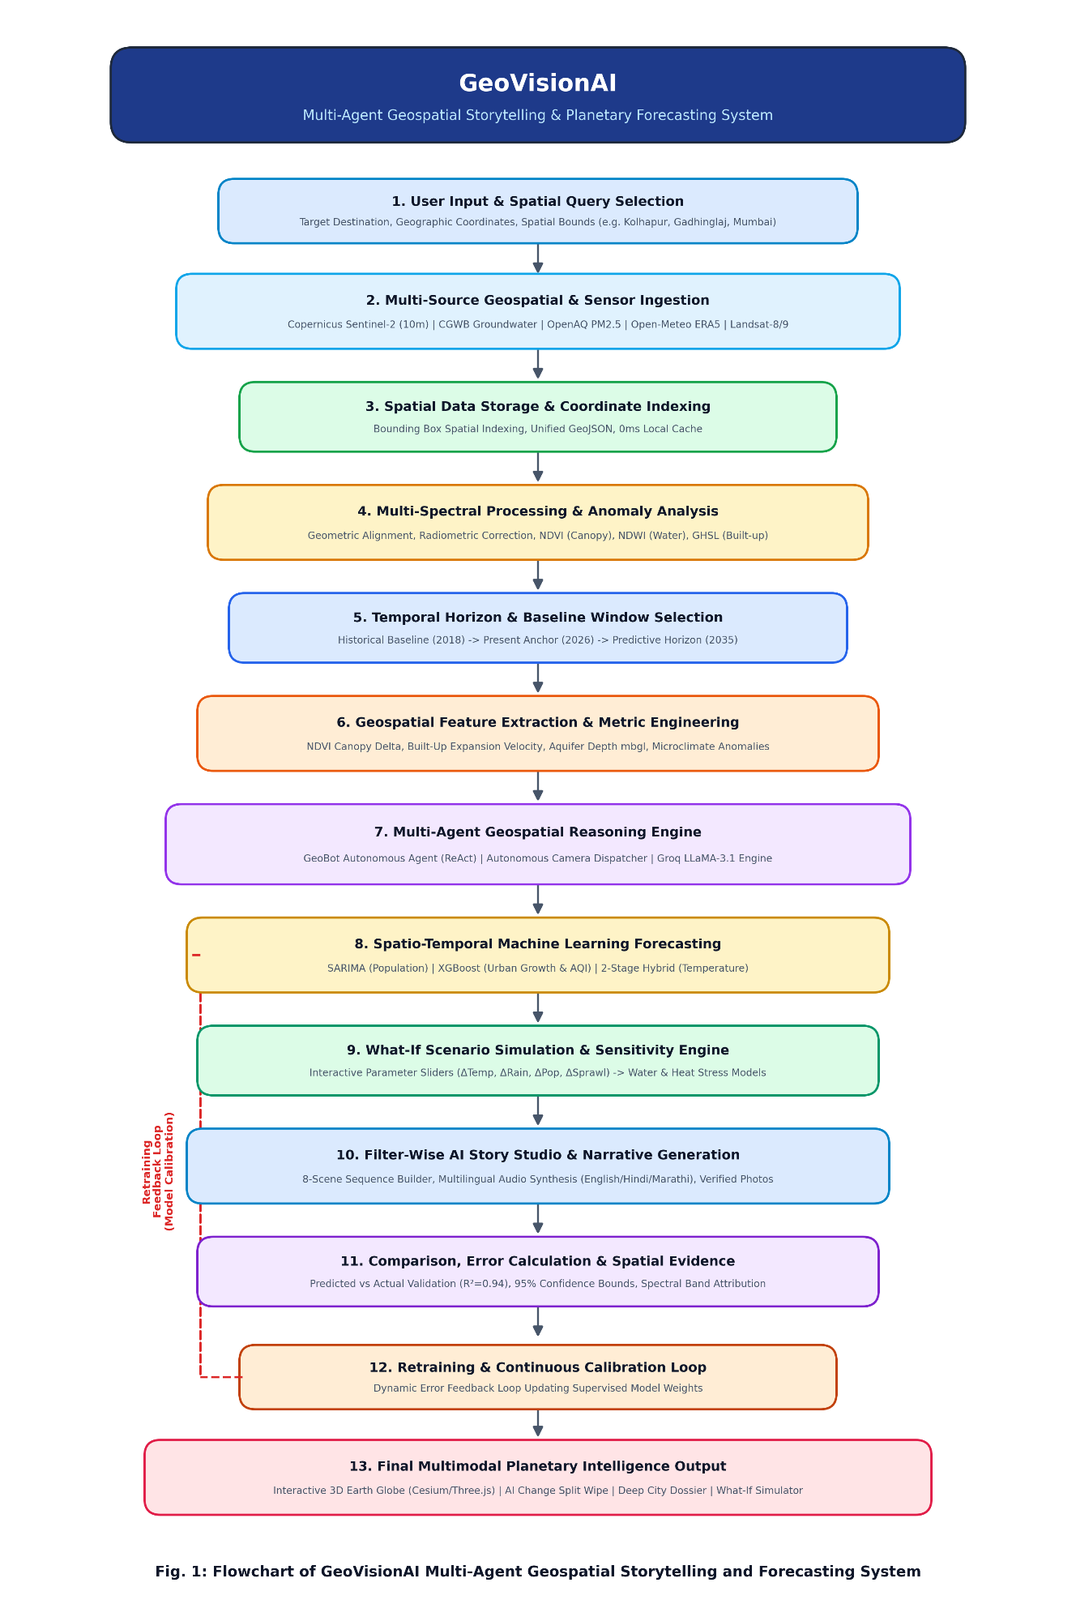

6. Methodology
The methodology of GeoVisionAI follows a systematic, modular pipeline designed to convert raw geospatial datasets into predictive, interactive visual stories. The process is divided into four sequential phases:
Phase 1: Geospatial Data Ingestion & Preprocessing
- Data Collection: Collects multi-source spatial data including satellite indicators, climate records, urban expansion indexes, and geographical boundary files (GeoJSON/Shapefiles).
- Data Cleaning & Standardization: Removes noise, handles missing geographical coordinates, and normalizes time-series attributes using Pandas and NumPy.
- Spatial Feature Extraction: Extracts key analytical features such as regional centroid coordinates, temporal variation rates, and environmental threshold values.
Phase 2: Machine Learning Analytics & Time-Series Forecasting
- Spatial Pattern Detection: Implements clustering algorithms (e.g., K-Means/DBSCAN) and regression analysis via Scikit-Learn to identify spatial anomalies, density hotspots, and regional correlations.
- Time-Series Trend Forecasting: Utilizes time-series predictive modeling to project future environmental and urban trends (such as temperature rises, urbanization rates, or vegetation changes) based on historical patterns.
- Analytical Summary Formulation: Packages the statistical findings and predictions into structured JSON formats for the language model.
Phase 3: Contextual AI Story Generation (LLM Pipeline)
- Prompt Engineering: Synthesizes the structured spatial metrics, historical context, and forecasted numbers into an optimized system prompt.
- Natural Language Generation: Leverages high-speed Large Language Model inference (Groq LLM / OpenAI API) to translate numerical analytics into structured narrative chapters:
- Executive Summary: Immediate high-level context of the location.
- Underlying Causes & Impact: Explainable environmental/urban factors.
- Future Projections: Plain-language interpretation of ML forecasts.
- Actionable Takeaways: Practical recommendations for planners and citizens.
Phase 4: Interactive 3D Visualization & User Interaction
- 3D Earth Globe Rendering: Built with WebGL and Three.js, rendering a continuous 3D planetary model with realistic atmospheric glow and dynamic location markers for global exploration.
- Filter-Wise Story Studio: Presents generated narratives through categorized interactive story cards, allowing users to filter by region, environmental theme, and analytical depth.
- Conversational GeoAI Assistant: Integrates an interactive 3D assistant with one-click quick-question chips for real-time spatial query answering and personalized guidance.
Core System Modules
- Data Preprocessing Module: Ingests, cleans, and standardizes multi-format geospatial datasets.
- ML Spatial & Forecasting Module: Executes pattern clustering and time-series predictive algorithms.
- AI Narrative Generation Module: Converts structured ML outputs into coherent, non-technical stories.
- Interactive 3D Visualization Module: Hosts the Three.js 3D Earth Globe and dynamic UI cards.
- Conversational Assistant Module: Delivers instant, interactive explanations via real-time LLM chat.

7. Implementation
1. User Input Module
- Accepts user inputs through multiple interaction channels:
  - Location selection on the interactive 3D Earth Globe (coordinates or country name).
  - Filter criteria in Story Studio (Region, Theme, Narrative Depth).
  - Direct questions typed or selected from prompt chips in the GeoAI Assistant.
2. Geospatial Data Collection Module
- Collects multi-source spatial data including satellite environmental indices, urban growth metrics, and climate time-series.
- Ingests geographic boundary files (GeoJSON/Shapefiles) and tabular data.
- Stores and organizes datasets for fast downstream access.
3. Data Preprocessing & Cleaning Module
- Cleans raw geospatial datasets by handling missing coordinate entries and removing anomalies.
- Normalizes time-series values across disparate scales using Pandas and NumPy.
- Validates geometric bounds and coordinate reference systems (CRS).
4. Spatial Feature Engineering Module
- Computes analytical spatial features:
  - Moving averages and rate of change over temporal windows.
  - Spatial density and distance-to-cluster metrics.
  - Environmental threshold flags (e.g., severe drought index, heat stress levels).
5. Machine Learning & Forecasting Module
- Implements Scikit-learn clustering algorithms to detect regional spatial clusters and hotspots.
- Applies time-series forecasting models to project future spatial trajectories (predicting short-term and multi-year environmental/urban trends).
- Generates a structured JSON statistical summary containing numerical projections.
6. AI Story Generation Module (Groq LLM)
- Takes the structured analytical summary and dynamically constructs contextual prompts.
- Leverages high-speed Groq LLM inference to automatically generate a 4-part narrative:
  - Executive Overview
  - Environmental & Spatial Causes
  - Predictive Forecast Breakdown
  - Practical Takeaways
7. Interactive 3D Earth Globe Module (Earth3DViewer.jsx)
- Implements a WebGL and Three.js 3D spherical planetary viewer.
- Renders realistic Earth textures, normal bump mapping, and atmospheric glow.
- Dynamically plots spherical coordinates (x, y, z) as interactive 3D location pins.
8. Filter-Wise Story Studio Module (StoryPage.jsx)
- Hosts the dedicated storytelling interface.
- Organizes stories by user-selected filters (e.g., Climate, Urbanization, Ecological Risk).
- Displays structured narrative chapters, key metrics badges, and historical timeline indicators.
9. Conversational GeoAI Assistant Module (GeoAIAssistant.jsx)
- Renders a floating 3D assistant mascot on the client interface.
- Provides 7 one-click sample question chips for rapid spatial querying.
- Delivers real-time streaming conversational answers explaining complex geographic phenomena.
10. Database & Caching Module (MongoDB)
- Stores generated stories, spatial features, and forecasted metrics.
- Caches previously requested regional stories for instant loading without redundant API calls.
11. Final Output Delivery
- Combines visual 3D planetary rendering, categorized narrative cards, and conversational explanations into a unified, responsive React dashboard.
Implementation Flow
User Input (3D Globe / Filters / AI Chat)
↓
Geospatial Data Collection
↓
Data Preprocessing & Cleaning
↓
Spatial Feature Engineering
↓
Machine Learning & Forecasting Model
↓
AI Story Generation Module (Groq LLM)
↓
Interactive 3D Earth Globe & Story Studio
↓
Conversational GeoAI Assistant
↓
Database Storage & Caching
↓
Final Output

8. Conclusion
GeoVisionAI provides an AI-powered platform that integrates structured geospatial data processing, machine learning-based pattern detection, and time-series forecasting with automated narrative generation. By replacing static 2D maps with an interactive Three.js 3D Earth Globe, a Filter-Wise Story Studio, and a conversational GeoAI Assistant powered by Groq LLM, the system simplifies complex spatial analytics for non-expert users.
Overall, the platform bridges the gap between spatial data science and human comprehension, transforming raw environmental metrics into predictive, explainable, and visually captivating stories to support informed decision-making in urban planning, climate monitoring, and education.

9. Future Scope
- Real-Time Satellite Ingestion: Integrating live APIs (e.g., Sentinel, NASA Earthdata) for automated, continuous spatial data updates.
- Advanced Deep Learning Models: Incorporating Spatio-Temporal Transformers and Graph Neural Networks (GNNs) for higher forecasting accuracy.
- Multilingual & Voice Support: Adding local regional languages and automated voice narration for wider accessibility.
- Mobile & AR Integration: Extending the platform to mobile devices with Augmented Reality (AR) overlays for interactive field exploration.

