BASIC STRUCTURE OF A PC
A computer is an electronic device, operating under the control of instructions stored in its own memory unit that can accept data (input), process data arithmetically and logically, produce output from the processing, and save the results for future use (storage).
The most basic of all computers must have at least three parts:
- an input device – as simple as a keyboard
- a processing device – this is a microprocessor chip or a CPU
- an output device – as simple as a printer
The heart of every computer is the microprocessor chip (or integrated circuit) called the Central Processing Unit (CPU). The purpose of the microprocessor is to manipulate the data it receives by using a written set of instructions. Attached to the processor there must be at least one input device and one output device.
The input device accepts data from the operator, or the machine, using the computer and transmits it to the processing device.
The output device accepts the processed data from the processing device and presents it to the operator or machine in a usable form.
A computer has six basic functions:
- Storing whatever data is entered, so the data can be saved and used in future.
- Retrieving the stored data, this can then be used many times.
- Displaying the data you're working with on a screen or monitor, so you can see the actions that are taking place.
- Editing the data, allowing the user to change or alter data they are working on.
- Printing the data, allowing the user to obtain hard copy of the printed output.
- Sending and receiving data, allowing the user to transmit the information to another person anywhere in the world.

Hardware
The main component of any computer system is the hardware, that is, the parts of the computer that you can touch, including the:
- case (and the components inside the case)
- monitor
- keyboard
- mouse
- any other 'hard' devices attached to the system
The hardware heart of the computer is the microprocessor or CPU (Central Processing Unit). This silicon chip or integrated circuit is the part that does all the real work; this is the brains of the system.
Another very important hardware component is Random Access Memory (RAM). This is temporary storage space for the software currently being used and the data you are currently working with.
The six functions of the information processing cycle require specialised hardware devices:
- input devices
- output devices
- storage devices
- communication devices

Common input devices
The most common input device for a computer is the keyboard. Some other input devices include: the mouse, scanners, digital cameras and microphones.
Common output devices
The most common output devices for PCs are: monitors, printers, web cams and speakers.
In addition to input, processing, and output devices, most computers have several other important parts. One of the most important devices are storage devices - these hold data on a permanent basis.
Common storage devices
The most common storage devices are USB sticks, removable hard disk drives, floppy disks, CDs and DVDs.
Other storage devices include magnetic tape drives, zip drives, magneto optical devices, juke boxes and RAID arrays.
Common communication devices
Communication devices also help to share data with other computer systems, allowing connection to the internet and sharing of data across networks. The most common communication devices are wireless (such as Bluetooth and WiFi interfaces), modems and satellites.
Software
Software is the term used to refer to the programs which the computer needs to process data. A computer program is nothing more than a set of instructions that tell the computer what to do and how to do it.
The hardware is built to perform many different tasks; the software tells the hardware how to do each different task.

Types of Computers
Computers come in a variety of types designed for different purposes, with different capabilities and costs.

Microcomputers
A microcomputer is a computer that has a microprocessorchip as its CPU. They are often called personal computersbecause they are designed to be used by one person at a time. Personal computers are typically used at home, at school, or at a business. Popular uses for microcomputers include word processing, surfing the web, sending and receiving e-mail, spreadsheet calculations, database management, editing photographs, creating graphics, and playing music or games.
Personal computers come in two major varieties, desktop computers and laptop computers:
Desktop computers are larger and not meant to be portable. They usually sit in one place on a desk or table and are plugged into a wall outlet for power. The case of the computer holds themotherboard, drives, power supply, and expansion cards. This case may lay flat on the desk, or it may be a tower that stands vertically (on the desk or under it). The computer usually has a separate monitor (either a CRT or LCD) although some designs have a display built into the case. A separate keyboard and mouse allow the user to input data and commands. |  |  | 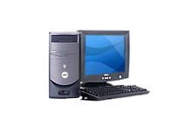  Desktop personal computer
Laptop or notebook computers are small and lightweight enough to be carried around with the user. They run on battery power, but can also be plugged into a wall outlet. They typically have a built-in LCD display that folds down to protect the display when the computer is carried around. They also feature a built-in keyboard and some kind of built-in pointing device(such as a touch pad).  While some laptops are less powerful than typical desktop machines, this is not true in all cases. Laptops, however, cost more than desktop units of equivalent processing power because the smaller components needed to build laptops are more expensive.  PDAs and Palmtop Computers |  |  | 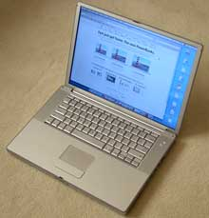  Laptop personal computer
A Personal Digital Assistant (PDA) is a handheld microcomputer that trades off power for small size and greater portability. They typically use a touch-sensitive LCD screen for both output and input (the user draws characters and presses icons on the screen with a stylus). PDAs communicate with desktop computers and with each other either by cable connection, infrared (IR) beam, or radio waves. PDAs are normally used to keep track of appointment calendars, to-do lists, address books, and for taking notes.  A palmtop or handheld PC is a very small microcomputer that also sacrifices power for small size and portability. These devices typically look more like a tiny laptop than a PDA, with a flip-up screen and small keyboard. They may use Windows CE or similar operating system for handheld devices.  Some PDAs and palmtops contain wireless networking or cell phone devices so that users can check e-mail or surf the web on the move.  Workstations/Servers |  |  | 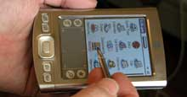  Personal Digital Assistant  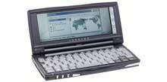  Palmtop computer
A workstation is a powerful, high-end microcomputer. They contain one or more microprocessor CPUs. They may be used by a single-user for applications requiring more power than a typical PC (rendering complex graphics, or performing intensive scientific calculations).  Alternately, workstation-class microcomputers may be used asserver computers that supply files to client computers over anetwork. This class of powerful microcomputers can also be used to handle the processing for many users simultaneously who are connected via terminals; in this respect, high-end workstations have essentially supplanted the role of minicomputers (see below).  Note! The term “workstation” also has an alternate meaning: In networking, any client computer connected to the network that accesses server resources may be called a workstation. Such a network client workstation could be a personal computer or even a “workstation” as defined at the top of this section. Note:Dumb terminals are not considered to be network workstations (client workstations on the network are capable of running programs independently of the server, but a terminal is not capable of independent processing).  There are classes of computers that are not microcomputers. These include supercomputers, mainframes, and minicomputers.  Minicomputers |  |  | 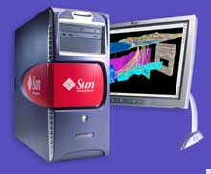  Workstation computer
A minicomputer is a multi-user computer that is less powerful than a mainframe. This class of computers became available in the 1960’s when large scale integrated circuits made it possible to build a computer much cheaper than the then existing mainframes (minicomputers cost around $100,000 instead of the $1,000,000 cost of a mainframe).
The niche previously filled by the minicomputer has been largely taken over by high-end microcomputer workstations serving multiple users (see above).

Mainframes
A mainframe computer is a large, powerful computer that handles the processing for many users simultaneously (up to several hundred users). The name mainframe originated after minicomputers appeared in the 1960’s to distinguish the larger systems from the smaller minicomputers.  Users connect to the mainframe using terminals and submit their tasks for processing by the mainframe. A terminal is a device that has a screen and keyboard for input and output, but it does not do its own processing (they are also called dumb terminals since they can’t process data on their own). The processing power of the mainframe is time-shared between all of the users. (Note that a personal computer may be used to “emulate” a dumb terminal to connect to a mainframe or minicomputer; you run a program on the PC that pretends to be a dumb terminal).  Mainframes typically cost several hundred thousand dollars. They are used in situations where a company wants the processing power and information storage in a centralized location. Mainframes are also now being used as high-capacityserver computers for networks with many client workstations.  Supercomputers |  |  | 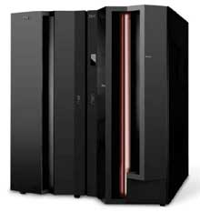  Mainframe computer (this IBM z-series computer is about 6 feet tall)
A supercomputer is a mainframe computer that has been optimized for speed and processing power. The most famous series of supercomputers were designed by the company founded and named after Seymour Cray. The Cray-1 was built in the 1976 and installed at Los Alamos National Laboratory. Supercomputers are used for extremely calculation-intensive tasks such simulating nuclear bomb detonations, aerodynamic flows, and global weather patterns. A supercomputer typically costs several million dollars.  Recently, some supercomputers have been constructed by connecting together large numbers of individual processing units (in some cases, these processing units are standard microcomputer hardware).  Please note: All of this talk of which computers are more powerful than others (i.e., mainframes are more powerful than minicomputers, which are more powerful than microcomputers) is relative for any particular moment in time. However, all classes of computers are becoming more powerful with time as technology improves. The microprocessor chip in a handheld calculator is more powerful than the ENIAC was, and your desktop computer has more processing power than the first supercomputers did.  Microprocessors Everywhere |  |  | 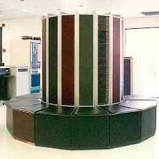  Supercomputer (this one is a Cray-2 from the 1980’s)
Computers are, in fact, all around you. Microprocessor chips are found in many electronic devices (in your iPod, in your DVD player, in your microwave, in your car, in your phone). These are special-purpose computers that run programs to control the equipment and optimize its performance

Operating System

Microsoft Windows is a series of operating systems produced by Microsoft.
Microsoft first introduced an operating environment named Windows on November 20, 1985 as an add-on to MS-DOS in response to the growing interest in graphical user interfaces (GUIs). Microsoft Windows came to dominate the world's personal computer market, overtaking Mac OS, which had been introduced in 1984. As of October 2009, Windows had approximately 91% of the market share of the client operating systems for usage on the Internet. The most recent client version of Windows is Windows 7; the most recent server version is Windows Server 2008 R2; the most recent mobile version is Windows Phone 7.
An operating system (OS) is software, consisting of programs and data, that runs on computers, manages computer hardware resources, and provides common services for execution of various application software. Operating system is the most important type of system software in a computer system. Without an operating system, a user cannot run an application program on their computer, unless the application program is self booting.
For hardware functions such as input and output and memory allocation, the operating system acts as an intermediary between application programs and the computer hardware,^{[1][2]} although the application code is usually executed directly by the hardware and will frequently call the OS or be interrupted by it. Operating systems are found on almost any device that contains a computer—from cellular phones and video game consoles to supercomputers and web servers.
Examples of popular modern operating systems are: BSD, Linux, Mac OS X, Microsoft Windows and UNIX

Computer data storage, often called storage or memory, refers to computer components andrecording media that retain digital data. Data storage is one of the core functions and fundamental components of computers

What is Partition?
Disk partitioning is the act of dividing a hard disk drive into multiple logical storage units referred to as partitions, to treat one physical disk drive as if it were multiple disks.

ROM or Read Only Memory, Computers almost always contain a small amount of read-only memory that holds instructions for starting up the computer. Unlike RAM, ROM cannot be written to. It is non-volatile which means once you turn off the computer the information is still there.

What is RAM?

RAM (Random Access Memory) is a temporary (Volatile) storage area utilized by the CPU. Before a program can be ran the program is loaded into the memory which allows the CPU direct access to the program.

What is Spyware
Spyware is a type of malware that can be installed on computers, and which collects small pieces of information about users without their knowledge. The presence of spyware is typically hidden from the user, and can be difficult to detect. Typically, spyware is secretly installed on the user's personal computer. Sometimes, however, spywares such as keyloggers are installed by the owner of a shared, corporate, orpublic computer on purpose in order to secretly monitor other users.
While the term spyware suggests software that secretly monitors the user's computing, the functions of spyware extend well beyond simple monitoring. Spyware programs can collect various types of personal information, such as Internet surfing habits and sites that have been visited, but can also interfere with user control of the computer in other ways, such as installing additional software and redirecting Web browser activity. Spyware is known to change computer settings, resulting in slow connection speeds, different home pages, and/or loss ofInternet connection or functionality of other programs. In an attempt to increase the understanding of spyware, a more formal classification of its included software types is provided by the term privacy-invasive software.

SOUND FORMAT

The WAVE Format
The WAVE (waveform) format is developed by IBM and Microsoft.
It is supported by all computers running Windows, and by all the most popular web browsers (except Google Chrome).
Sounds stored in the WAVE format have the extension .wav.

The MP3 Format (MPEG)
MP3 files are actually MPEG files. But the MPEG format was originally developed for video by the Moving Pictures Experts Group. We can say that MP3 files are the sound part of the MPEG video format.
MP3 is one of the most popular sound formats for music recording. The MP3 encoding system combines good compression (small files) with high quality. Expect all your future software systems to support it.
Sounds stored in the MP3 format have the extension .mp3, or .mpga (for MPG Audio).

What Format To Use?
The WAVE format is one of the most popular sound format on the Internet, and it is supported by all popular browsers. If you want recorded sound (music or speech) to be available to all your visitors, you should use the WAVE format.
The MP3 format is the new and upcoming format for recorded music. If your website is about recorded music, the MP3 format is the choice of the future.

Input Devices -- "How to tell it what to do"
- A keyboard and mouse are the standard way to interact with the computer. Other devices include joysticks and game pads used primarly for games.

Output Devices -- "How it shows you what it is doing"
- The monitor (the screen) is how the computer sends information back to you, whether it be surfing the web or writing a memo. A printer is also an output device.

Storage Devices -- "How it saves data and programs"
- Hard disk drives are an internal, higher capacity drive which also stores the operating system which runs when you power on the computer.
- "Floppy" disk drives allow you to save work on small disks and take the data with you.

Memory -- "How the processor stores and uses immediate data"
- When you use a program, the computer loads a portion of the program from the hard drive to the much faster memory (RAM). When you "save" your work or quit the program, the data gets written back to the hard drive.

Microprocessors -- "The brain of the computer"
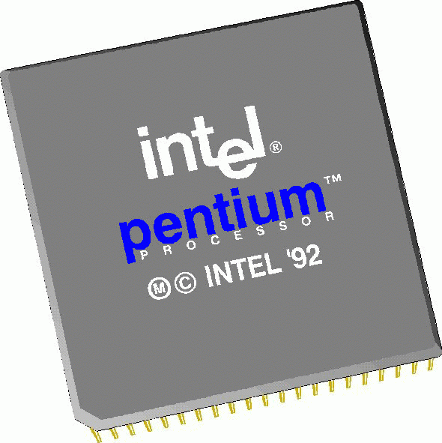- PCs primarily use microprocessors (sometimes called the chip) manufactured by Intel. The older Intel versions include the 386, 486 and now the Pentium line.
- Macintoshes use PowerPC processors by Motorola.
- Megahertz (MHz) is the internal processor speed in which computer instructions are performed. The MHz speed does not always indicate the power of the microprocessor. Newer processors can execute more instructions at the same or slower MHz. For example, an Intel 486 @100MHz is less powerful than a Pentium @75 MHz (but the MHz is "faster").
Hardware Accessories

Modems
- Modems allow you to communicate with other computers using a phone line. Modem speeds are in bits per second (14.4, 28.8 and 56 thousand bits per second are standard).

CD-ROM Drives
- A CD-ROM drive is a high capacity storage device which lets you read data from the disk, but not write data back. The speed of the drive (how fast the CD platter spins) is measured in multiples from the first generation drives. New drives are up to 24X (or 24 times the first drives), but while the CD spins faster, it is not really 24 times faster in actual output.

Printers
- There are different types of printers (laser, ink jet, dot matrix) with differing quality of output. They are measured in dpi (dots per inch) and ppm (pages per minute), the higher the better.

Scanners
- Scanners "digitize" printed material (like photos and graphics) and save it to a graphic file format (like .GIF or .JPG) for display on the computer.

Operating System Software
Operating system software provides a "user interface" for users to manage files, start programs, customize computer settings, and other tasks. The operating system also provides the fundamental core computer functionality for programmers.
Intel based PCs use Microsoft Windows as the operating system. Macintoshes use the Macintosh operating system.

Software Applications

Application software uses the operating system software and provides the real functionality of a computer. Applications include:
- Word Processing (MS Word, WordPerfect, Ami...)
- Spreadsheets (Lotus 123, MS Excel...)
- Database (DBase, Fox Pro, Oracle...)
- Presentation (MS PowerPoint, Persuasion...)
- Internet Browsers (Netscape Navigator, MS Internet Explorer)
- Games

Disk partition
Disk partitioning is the act of dividing a hard disk drive into multiple logical storage units referred to as partitions, to treat one physical disk drive as if it were multiple disks. Partitions are also termed "slices" for operating systems based on BSD,Solaris or GNU Hurd. A partition editor software program can be used to create, resize, delete, and manipulate these partitions on the hard disk.

