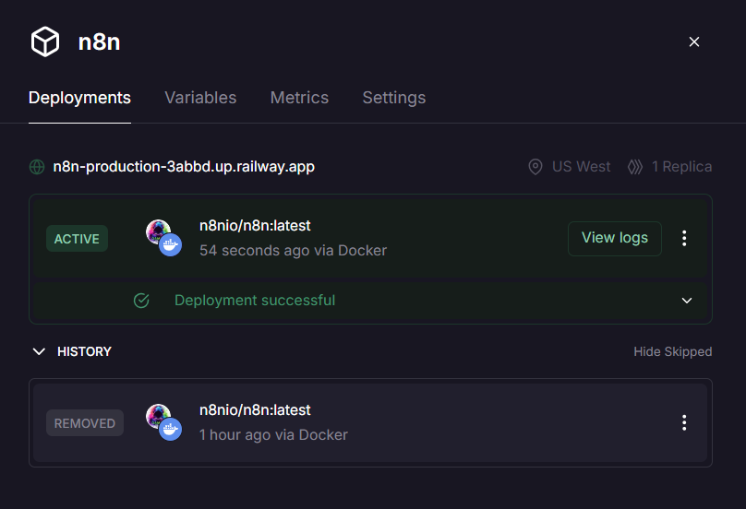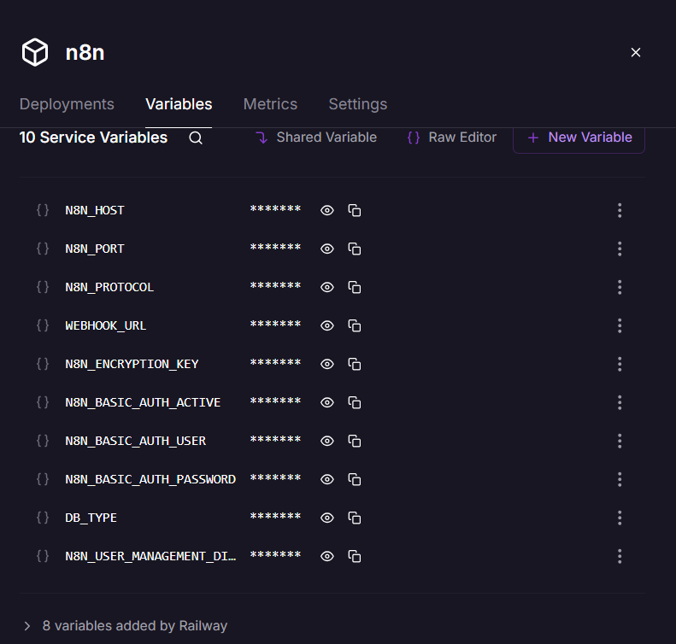
N8N_HOST=0.0.0.0
N8N_PORT=5678
N8N_PROTOCOL=https
WEBHOOK_URL=https://n8n-production-3abbd.up.railway.app

N8N_ENCRYPTION_KEY=8fK29xLqP4zNmA7vR2tYbU5wCsD9eH1m

N8N_BASIC_AUTH_ACTIVE=true
N8N_BASIC_AUTH_USER=admin
N8N_BASIC_AUTH_PASSWORD=admin123

DB_TYPE=sqlite
N8N_USER_MANAGEMENT_DISABLED=false

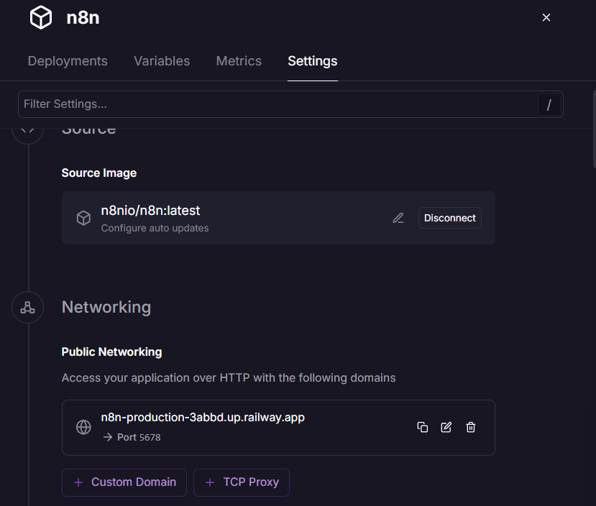
Go to settings and go to networking
Select Port
In:
Generate Service Domain
Choose:
5678 (MainThread)
NOT 5679.
Because n8n runs on port 5678.

Then click:
Generate Domain
Railway will generate:
https://something.up.railway.app

AFTER DOMAIN IS GENERATED
Go to:
Variables
Add/update:
WEBHOOK_URL=https://YOUR-DOMAIN.up.railway.app
Example:
WEBHOOK_URL=https://flowzint-ai-production.up.railway.app
Save variables.
Railway redeploys automatically.

