**SAVITRIBAI PHULE PUNE UNIVERSITY**



**DEPARTMENT OF COMPUTER ENGINEERING**

*SKN Sinhgad Institute of Technology and Science*

*A MINI PROJECT REPORT ON*

**“EXAM PORTAL”**

**Third year of Engineering (Computer Engineering)**

By

* OMKAR KANDALE *(T151044245)*
* MANU NAIR *(T151044268)*
* MANGESH BONDRE *(T151044212)*
* ANIKET BIRAJDAR *(T151044209)*

**Under The Guidance of**

*Prof. Akshita Chanchlani*



**SKN Sinhgad Institute of Technology and Science**

*DEPARTMENT OF COMPUTER ENGINEERING*

**CERTIFICATE**

This is to certify that “**Exam Portal**” embodies the original work done by *Omkar Kandale, Mangesh Bondre, Manu Nair, Aniket Birajdar* under the supervision of ***Prof. Akshita Chanchlani*** and it is submitted towards the partial fulfillment of the requirement of Third of Engineering Project.

Prof. Akshita Chanchlani Prof. G. M. Kadam Dr. M. S. Rohokale

[Internal Guide] [H.O.D] [Principal]

**Abstract**

Exam Portal system is software solution, which allows a particular company or institute to arrange, conduct and manage examinations.

Some of the problems faced by manual Examination Systems are delays in result processing, human errors, filtering of records are not easy. The chance of loss of records is high and also record searching is difficult. Maintenance of the system is also very difficult and takes lot of time and efforts.

We therefore, intent to provide a solution by developing a GUI based Java Application to conduct Exams in the institute which gives instant result to students.

**Acknowledgement**

It gives us great pleasure in presenting the preliminary project report on **“Exam Portal”**.

I would like to take this opportunity to thank my internal guide *Prof. Akshita Chanchlani* for giving me all the help and guidance I needed. I am really grateful to her for kind support. In particular I am indebted to *Prof. Akshita Chanchlani* who had a faith in this idea, believed in my ability, whispered the words of encouragement and made helpful suggestions from time to time. I would forever remain indebted to her.

Omkar Kandale

Manu Nair

Mangesh Bondre

Aniket Birajdar

(T.E. Computer Department)

**Contents**

Certificate 2

Abstract 3

Acknowledgement 4

1. Overview 6

2. Requirements 7

3. GUI and Screenshots 8

4. Database and Schema 13

5. Reference 15

8. Conclusion 16

1. **Overview**

**Application Development Plan**

The EXAM PORTAL has the four Modules. The system to conduct Exam in the form of multiple choice questions. In this Exam Portal, questions are based on Java and Relational DataBase Management System (MySQL).

* **Home Page :**

This is the beginning of the Exam Portal to navigate from Log In page and Registration Form.

* **Registration :**

In this section collects information/details from users and stores the Data in the Database (MySQL).

* **Log In :**

This section navigates towards the Exam section by validating and verifying the users PRN and password, which is stored in main database.

* **Exam :**

After Log In valid users can attend Exam. The Exam is in the form MCQ’s, user should select the appropriate answers and must attend all questions.

* **Result :**

After submitting the Exam valid answers are validated and the final score is displayed in the pop up window.

1. **Requirements**

Machine Requirements:

Operating System: Windows,Ubuntu.

Developing Exam portal includes the following requirements:

1. Eclipse IDE

Minimum required version Eclipse MARS.

1. windowBuilder for Swing Designer Application.
2. JDK 1.7 or above.
3. JRE 1.7 or above.
4. RDBMS (MySQL) for backend data manipulation.
5. **GUI and Screenshots**

Step 1 :-Home Page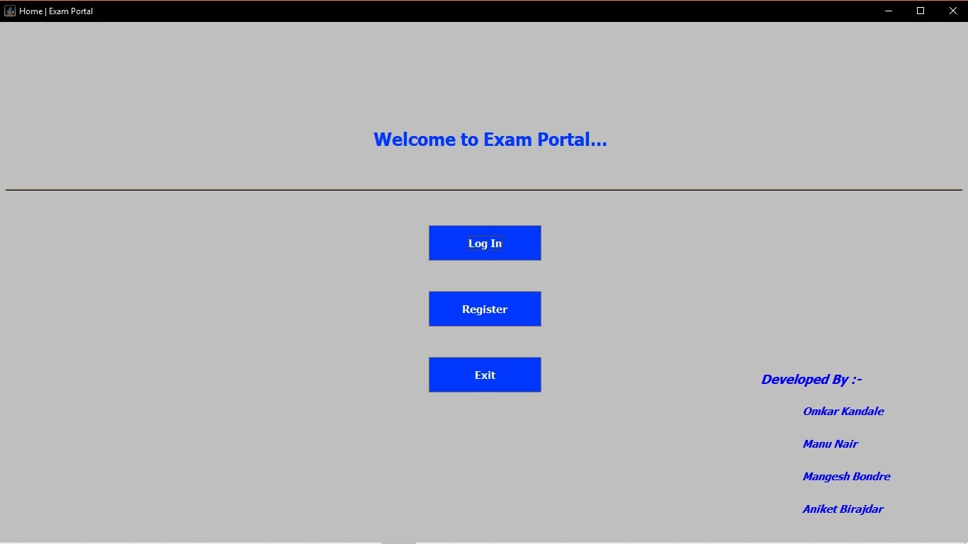

Step 2 (i):- Register Pages

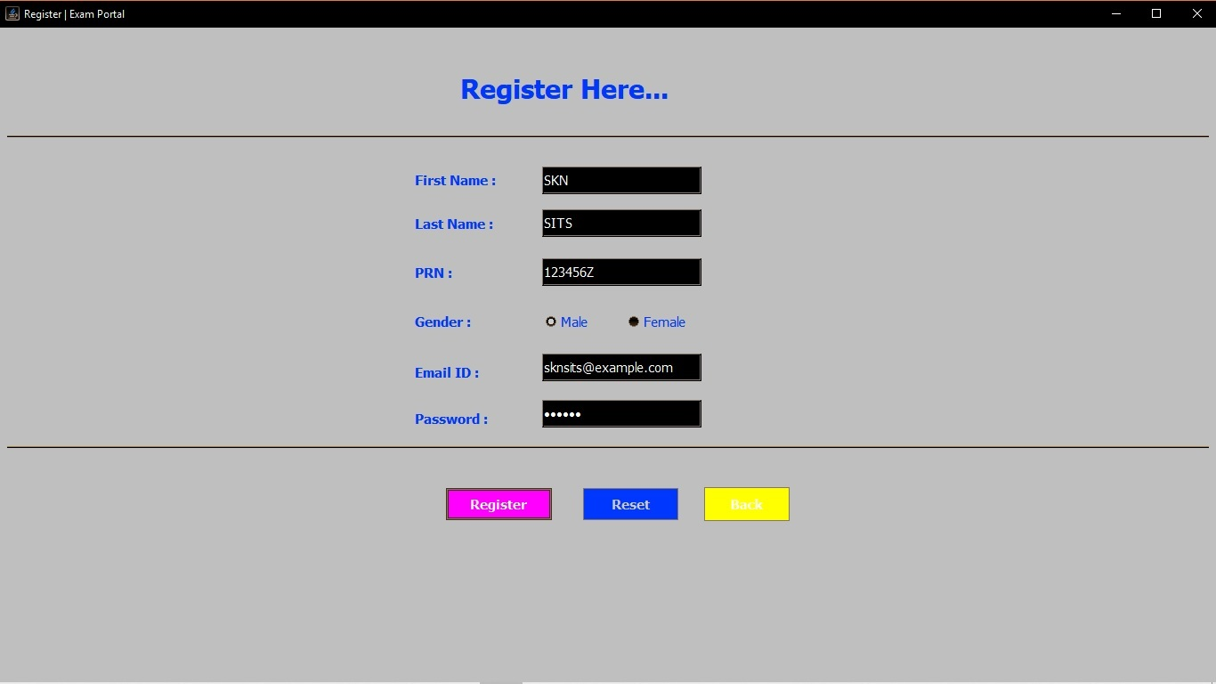

Step 2 (ii) :-

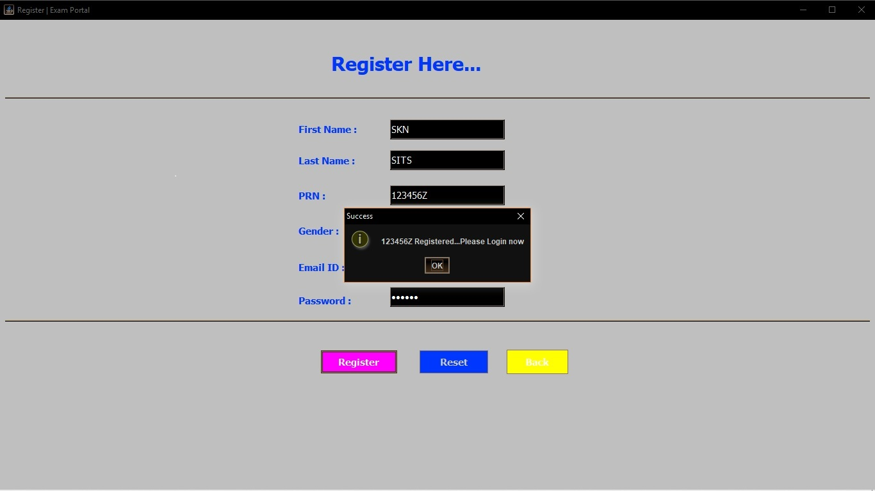

Step 3 (i) :- Log In Pages

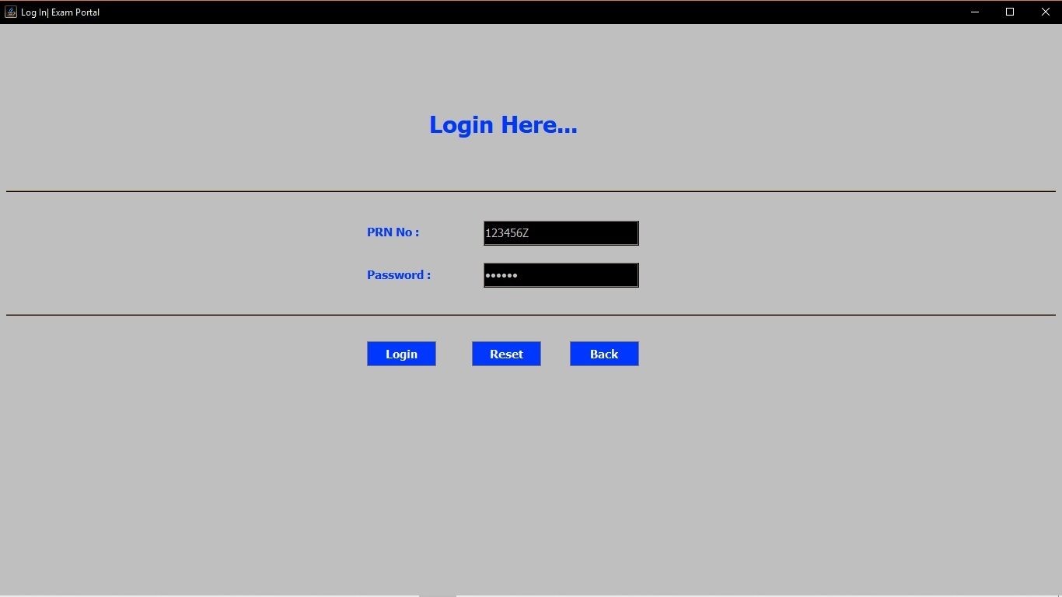

Step 3 (ii) :-

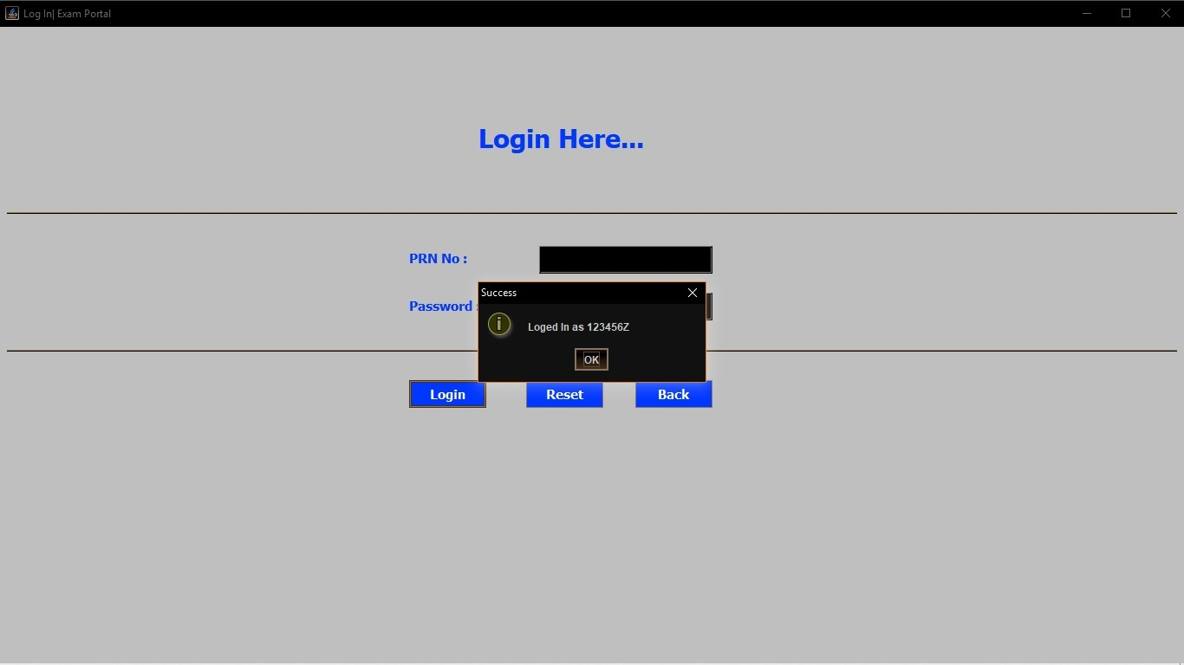

Step 3 (iii) :-

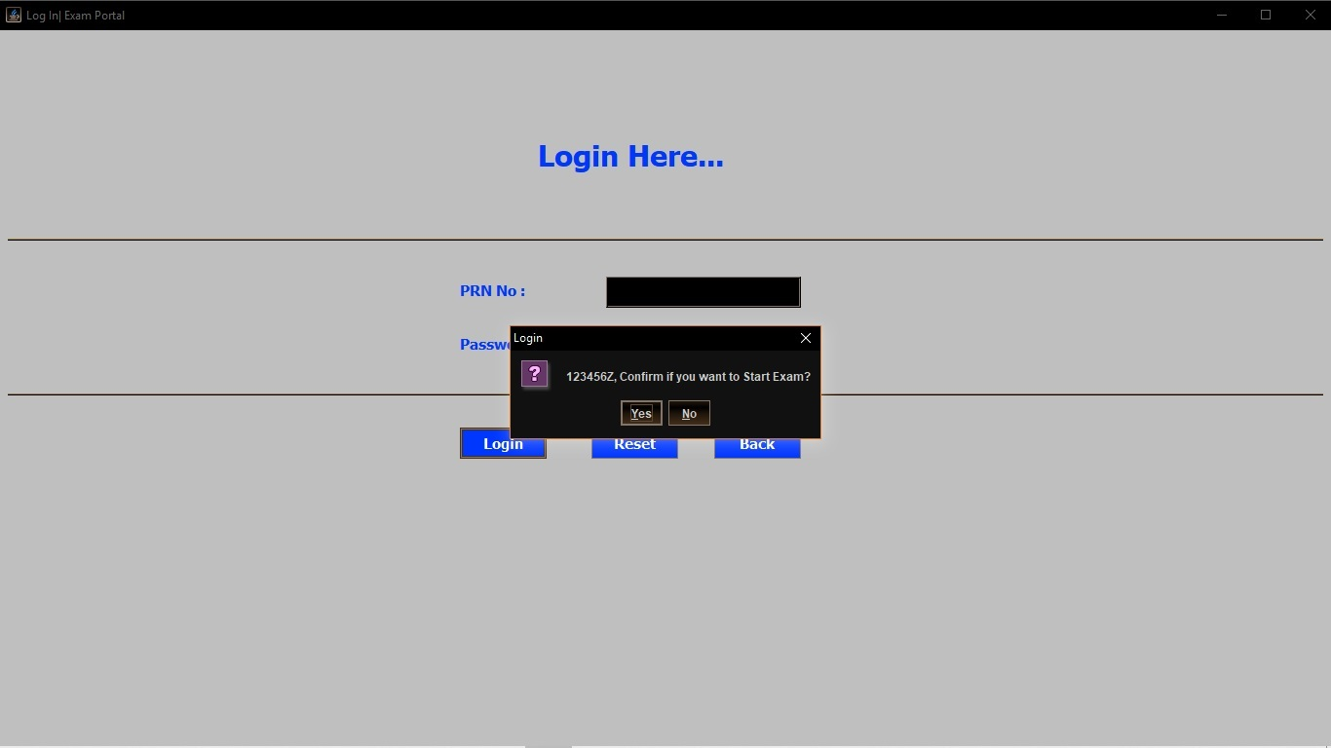

Step 4 (i) :- Exam Section

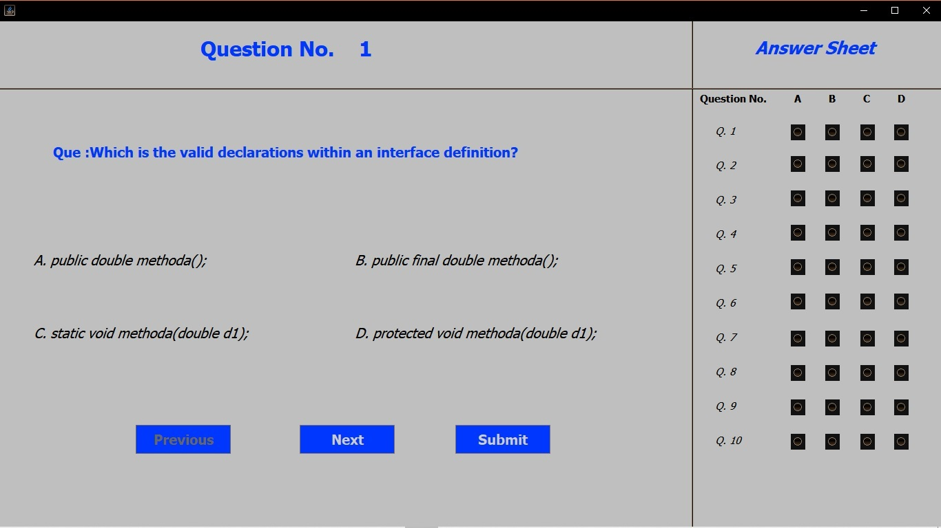

Step 4 (ii) :-

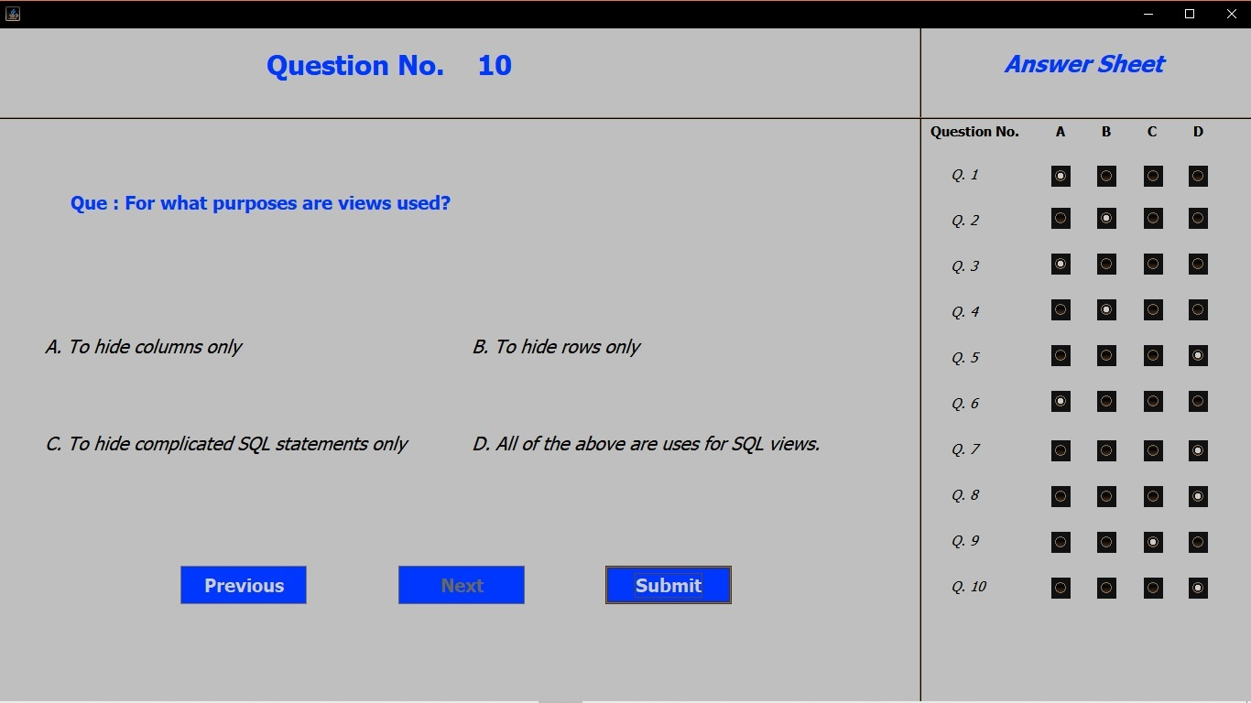

Step 5 (i) :-

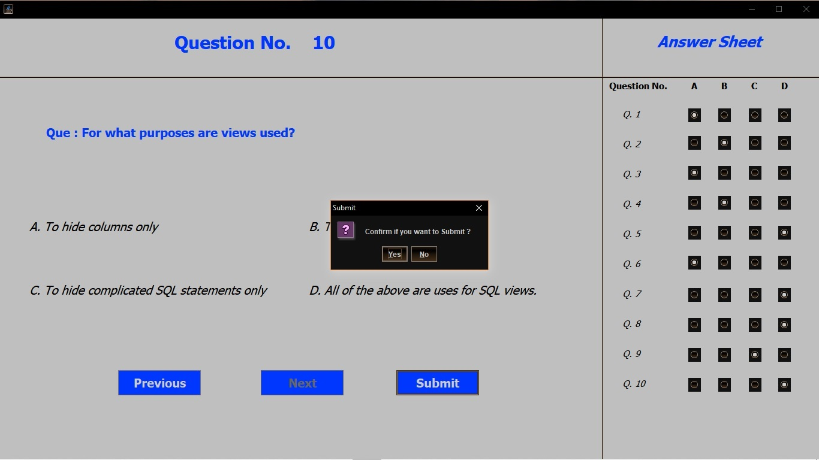

Step 5 (ii) :-

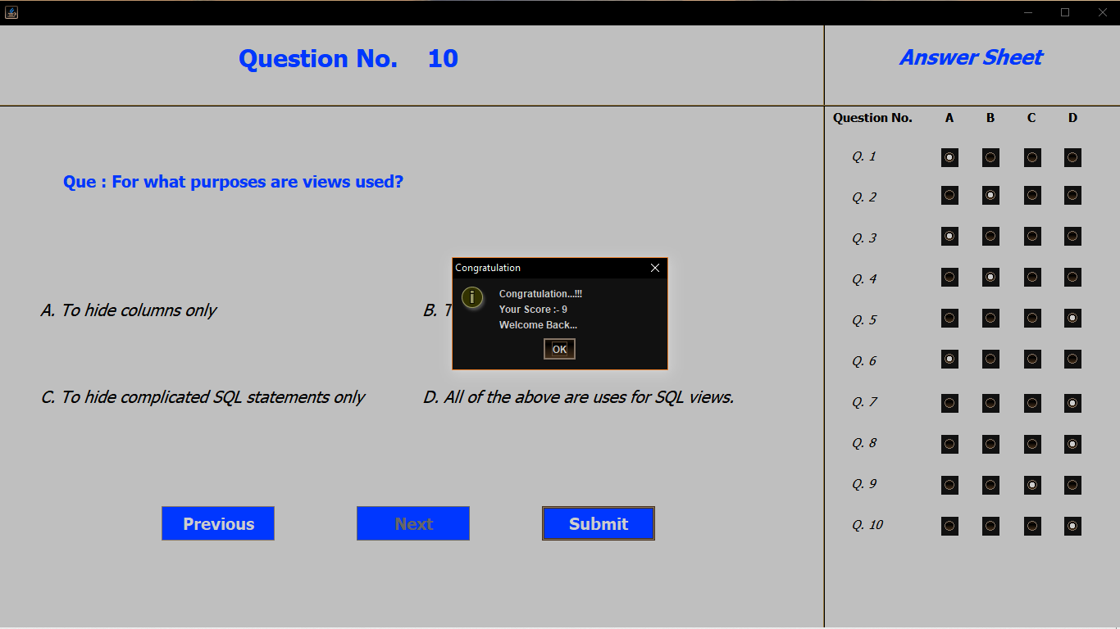

1. **Database and Schema**

* 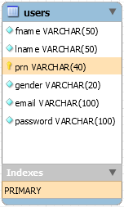**Create table of users information :**

CREATE TABLE IF NOT EXISTS `exam_portal`.`users` (

`fname` VARCHAR(50) NOT NULL,

`lname` VARCHAR(50) NOT NULL,

`prn` VARCHAR(40) NOT NULL,

`gender` VARCHAR(20) NOT NULL,

`email` VARCHAR(100) NOT NULL,

`password` VARCHAR(100) NOT NULL,

PRIMARY KEY (`prn`));

* **Creating table qa of Questions :**

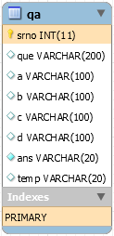 CREATE TABLE IF NOT EXISTS `exam_portal`.`qa` (

`srno` INT(11) NOT NULL,

`que` VARCHAR(200) NULL DEFAULT NULL,

`a` VARCHAR(100) NULL DEFAULT NULL,

`b` VARCHAR(100) NULL DEFAULT NULL,

`c` VARCHAR(100) NULL DEFAULT NULL,

`d` VARCHAR(100) NULL DEFAULT NULL,

`ans` VARCHAR(20) NOT NULL,

`temp` VARCHAR(20) NULL DEFAULT NULL,

PRIMARY KEY (`srno`));

Users Information Database :-

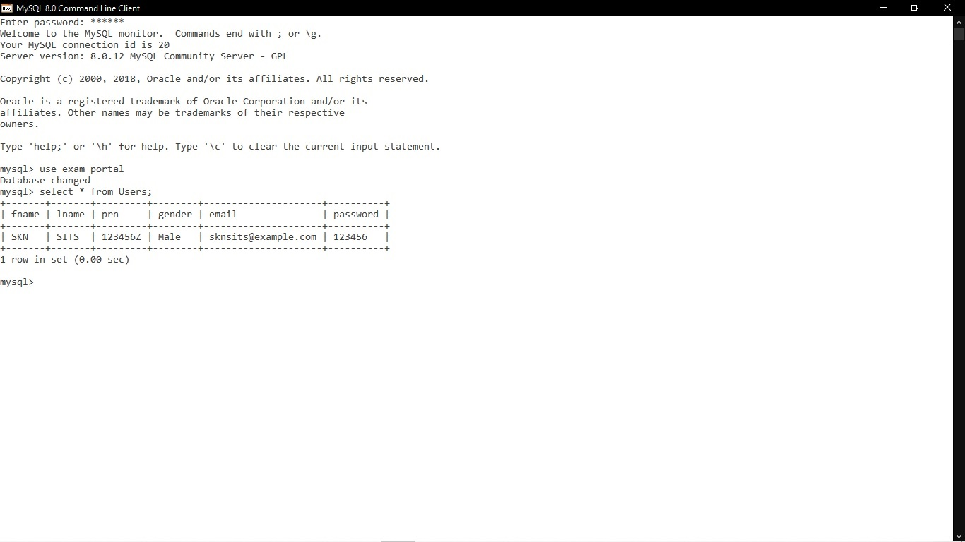

Question Answers Database :-

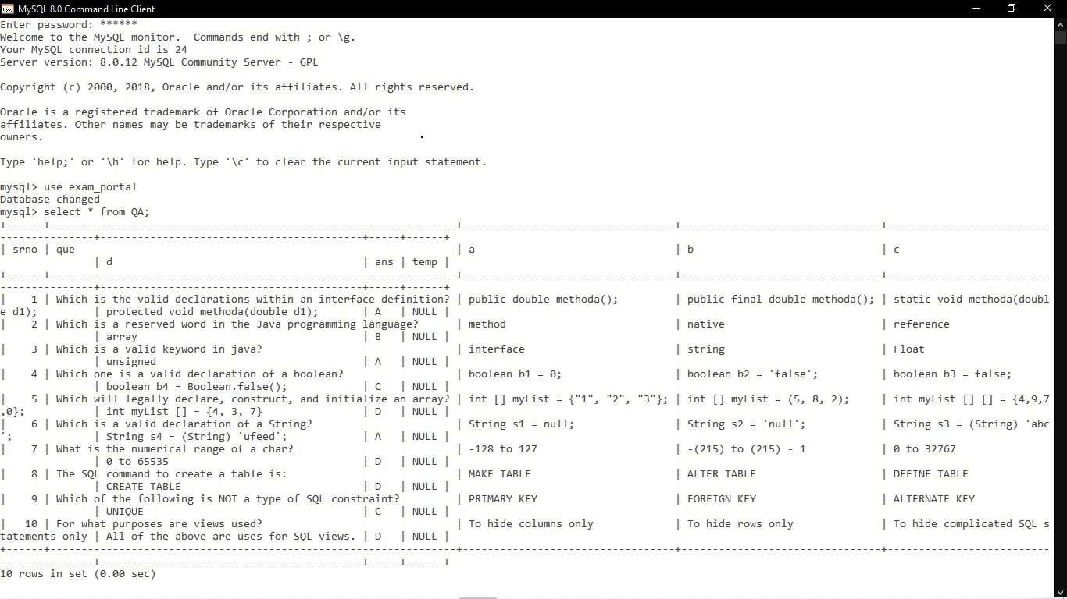

1. **References**

<https://www.wikipedia.org>

<http://www.google.com>

<https://stackoverflow.com>

<https://www.github.com>

<https://www.tutorialspoint.com>

<https://www.javatpoint.com>

1. **Conclusion**

Hence, we implemented a Java application using the Eclipse IDE. Also MySQL used in the backend to store user details and MCQ Questions.