1.

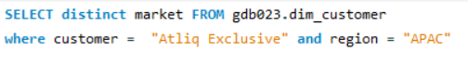

|  |
| --- |
| [India,Indonesia,Japan,Philiphines,South,Korea,Australia,Newzealand,Bangladesh] |
| 2.    3.      4. |
| 5. |
|  |
| 6.      7.      8.      9.      10. |
|  |
|  |
|  |
|  |
|  |
|  |
|  |
|  |