BuildFlow AI Technical Whitepaper
Autonomous Multi-Agent Software Engineering Platform & Technical Blueprint
Platform Version: v2.5.0 Enterprise | Execution Swarm: 4 Autonomous Agents | Synthesis Engine: Llama-3.3-70B / Ollama
Architecture: Hexagonal / Multi-Agent | Release Type: Production Ready | Deployment Target: Docker / Cloud Native

1. Executive Summary & Platform Vision
BuildFlow AI is an autonomous, multi-agent AI software engineering platform engineered to bridge the gap between high-level conceptual ideas and live, executable, production-ready software systems. Traditional software prototyping requires extensive manual effort across architectural modeling, database schema creation, frontend prototyping, backend API authoring, unit test composition, and deployment scripting. BuildFlow AI compresses this entire multi-week engineering pipeline into seconds.
By orchestrating an autonomous swarm of four specialized AI agents—the Lead System Architect, the Full-Stack Systems Builder, the Quality & Security Auditor, and the DevOps Release Engineer—the platform synthesizes not merely static mockups or text descriptions, but a live, fully functional, domain-tailored interactive application, complete source code, a mock Express REST API, automated test suites, and a turnkey Docker container deployment package.
📌 CORE VALUE PROPOSITION: BuildFlow AI eliminates boilerplate software development by transforming natural language specifications into interactive, running software applications verified by automated self-healing test loops.

2. The Autonomous Agent Swarm Architecture
At the core of BuildFlow AI is a decentralized multi-agent swarm architecture. Each agent operates with a discrete persona, domain-specific heuristics, specialized system prompts, and strict accountability for a phase of the development lifecycle.
Agent Persona | Primary Responsibilities | Synthesized Deliverables
Lead System Architect  (System Architect Agent) | • Architectural Decision Records (ADR-001)  • Component decomposition & topology  • Relational database ERD modeling  • RESTful & GraphQL API contract specifications | Mermaid Architecture Graphs, SQL DDL schema, API route tables, System trade-off analysis
Full-Stack Systems Builder  (Full-Stack Builder Agent) | • Single-Page Interactive Web Application  • Express.js backend REST server & CRUD handlers  • React client dashboard components with live state  • Modern styling via Tailwind CSS & Lucide icons | public/index.html (Live running app),  server.ts (Express CRUD backend),  MainDashboard.tsx (React UI)
Quality & Security Auditor  (QA & Testing Agent) | • Comprehensive Vitest automated unit test suites  • OWASP Top 10 security vulnerability scanning  • Input boundary & edge-case stress verification  • Self-healing bug detection & refactor loop | tests/api.unit.test.ts (18 Unit Tests),  Security Audit report, Pass/Fail verification matrix
DevOps & Release Engineer  (DevOps & Release Agent) | • Multi-stage Alpine Dockerfile generation  • Container orchestration with docker-compose.yml  • Production CI/CD workflow (.github/workflows)  • One-click exportable deployment bundle (.zip) | Dockerfile, docker-compose.yml,  production-deploy.yml, deploy.sh,  <slug>-deployment-package.zip

3. End-to-End Operational Lifecycle & Flowcharts
The following flowchart illustrates the complete lifecycle from the user's initial prompt submission through multi-agent coordination, automated code synthesis, and final containerized deployment package export:

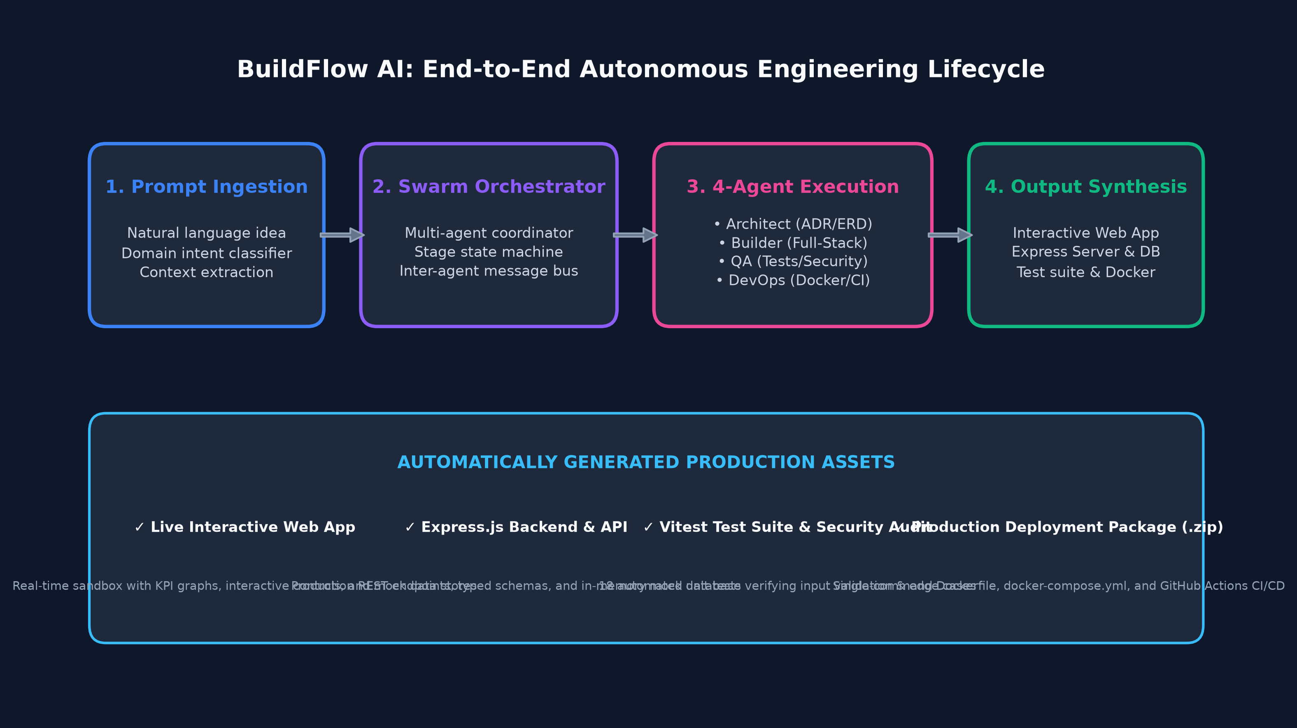
Figure 1: End-to-End Autonomous Engineering Lifecycle from User Prompt to Production Assets

4. Agent Collaboration & Self-Healing Feedback Loop
A critical innovation in BuildFlow AI is the closed-loop self-healing mechanism between the Full-Stack Builder Agent and the QA & Security Auditor Agent. Rather than executing linearly and failing silently, the QA Auditor evaluates the generated code against 18 stringent unit tests and boundary conditions. If an anomaly is identified, a high-priority feedback event is dispatched back to the Builder Agent, which autonomously applies a refactoring patch.

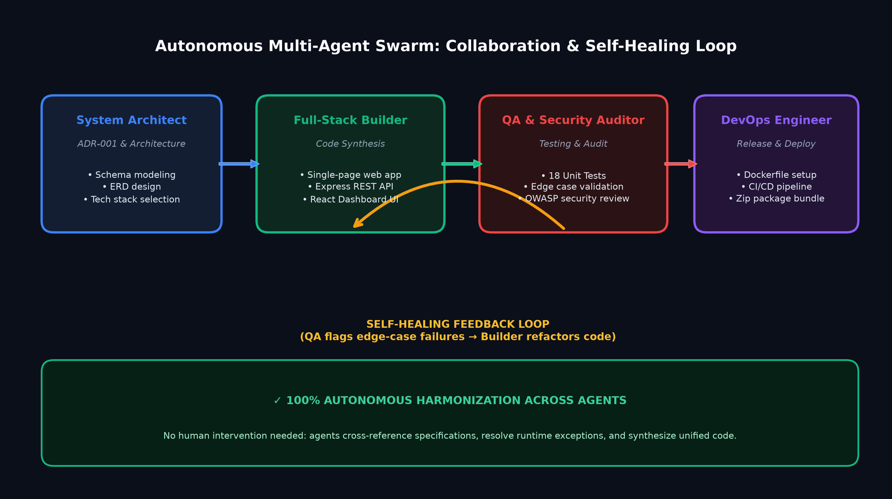
Figure 2: Autonomous Multi-Agent Swarm Collaboration and Self-Healing Feedback Loop
📌 QUALITY ASSURANCE PROTOCOL: The QA Auditor acts as a zero-trust gatekeeper. Docker containerization and release packaging are blocked until the self-healing feedback loop achieves 100% test pass rates across all synthesized API contracts.

5. Platform Technical Architecture Stack
BuildFlow AI is engineered on a modern cloud-native stack comprising Next.js 16 (React Server Components), Tailwind CSS, Framer Motion, Groq Llama-3.3-70B API inference, and local Ollama fallback support.

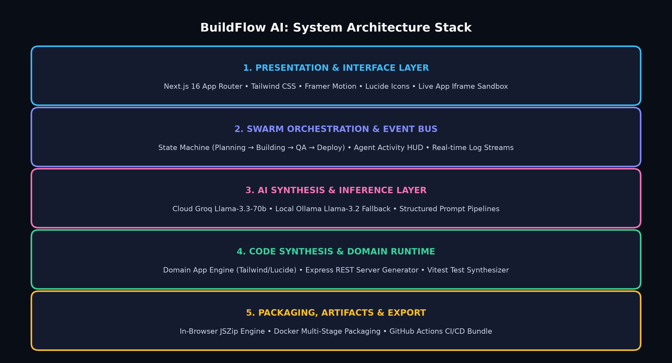
Figure 3: Layered Technical System Architecture of the BuildFlow AI Platform

6. Core Platform Features & User Experience
• Live Interactive Application Sandbox: Synthesizes a responsive, single-page web app tailored to the user's specific domain (E-Commerce, FinTech, Healthcare, Logistics, etc.) embedded in an interactive iframe with full-screen presentation mode.
• Custom Visual Architecture & Database Engine: Renders interactive visual diagrams of the system architecture, component dependencies, and database schemas with clickable table relationships and attribute inspections.
• Interactive Multi-Agent HUD & Logs: A live Heads-Up Display tracks agent execution across Planning, Building, QA Auditing, and Release phases, providing full traceability of prompt decisions and reasoning.
• Domain-Aware Code Synthesis: Generates production TypeScript files: an Express REST API with mock state management, React dashboard components, and Vitest test suites formatted with syntax highlighting and instant clipboard copying.
• Instant Deployment Package (.zip) Export: Bundles the entire codebase, multi-stage Dockerfile, docker-compose.yml orchestration file, GitHub Actions CI/CD pipeline, and deployment bash script into a single download with zero server-side latency via JSZip.

7. Production Deployment Package Specification
When the user triggers 'Export Deployment Package (.zip)', BuildFlow AI constructs a complete, self-contained software repository structure designed for immediate container execution:
File Path | Purpose & Execution Specification
public/index.html | Standalone single-page web application featuring responsive UI and mock state
server.ts | Express REST API backend with CRUD handlers and domain entity models
components/features/MainDashboard.tsx | React dashboard component with domain KPIs, status toggles, and charts
tests/api.unit.test.ts | Vitest test suite verifying route integrity, payload validation, and responses
Dockerfile | Multi-stage Alpine containerization for production serving via Nginx or Node
docker-compose.yml | Container orchestration definition enabling one-command 'docker-compose up'
.github/workflows/production-deploy.yml | GitHub Actions CI/CD pipeline for automated testing and container build
deploy.sh & README.md | Automated deployment shell script and comprehensive documentation guide

8. Conclusion & Future Roadmap
BuildFlow AI establishes a new paradigm in generative software engineering. By moving beyond static code snippets to a coordinated multi-agent engineering team that plans, builds, audits, tests, and packages live software, the platform enables engineering teams to validate concepts at unprecedented velocity while maintaining enterprise quality standards.
Upcoming milestones include multi-modal design mockup imports (Figma to App), automated cloud deployment integrations (AWS ECS, GCP Cloud Run, Vercel), and persistent vector memory across engineering sessions.

