Assignment No. 4
Roll no 41239

Title: Design an interface prototype for the selected product / system.

Objectives:
1. To develop prototype of interface design system.
2. To involve the users in testing design ideas and get their feedback.
3. To test the effectiveness of interface design.

Theory:
What is Prototyping?
In the initial design phase, the proposed design undergoes frequent changes, it is not advisable to
even feasible to carry out evaluation with real users. An alternative way to collect feedback on
proposed design is to develop and evaluate prototypes.
The main purpose of prototyping is to involve the users in testing design ideas and get their feedback
in the early stage of development, thus to reduce the time and cost. It provides an efficient and
effective way to refine and optimize interfaces through discussion, exploration, testing and iterative
revision.

Why Use it?
1. Saves money - “Finding and fixing a software problem after delivery is 100 times more
expensive than finding and fixing it during the requirements and early design phases.”
2. Brings the design to life
3. Clarifies requirements
4. Supports user involvement and feedback
1. As observers of demonstrations, and/or
2. Through hands-on testing, and/or
3. In extended field trials (beta testing)and/or
4. As co-designers
5. Identifies problems early - can be used to explore usability issues
6. Improves communication
7. Supports exploration of imagined use – the prototype does not have to be able to do
everything that the finished product does

Different types of Prototyping:
Prototyping can be divided into three groups
1. Low-fidelity prototyping,
2. Medium-fidelity prototyping and
3. High-fidelity prototyping
Low-fidelity prototyping:
Low-fidelity prototypes are quickly constructed to depict concepts, design alternatives, and screen
layouts, rather than to model the user interaction with a system. Low-fidelity prototypes provide
limited or no functionality. They are intended to demonstrate the general look and the feel of the
interface, but not the detail how the application operates.
• Sketches
Sketching techniques, a kind of visual brainstorming, can be useful for exploring all kinds of
design ideas. After producing initial sketches the best ideas can be further developed by
constructing cardboard representations of the design
• Storyboard
Storyboard is a graphical depiction of the outward appearance of the intended system without
accompanying system functionality. Storyboard provides snapshots of the interface at
particular points in the interaction so that the users can determine quickly if the design is
heading in the right direction.• PICTIVE
PICTIVE stands for Plastic Interface for Collaborative Technology Initiatives through Video
Exploration. It was developed at Bell Communications Research (Bellcore) in 1990 within the
context of participatory design.
PICTIVE insures that users have early exposure to the target implementation technology. The
PICTIVE technique provides a fine-grained, dynamic paper and pencil concretization mock-
up of what the system will eventually look like and how it will behave. The components are
literally made of colored plastic.
Medium-fidelity prototyping:
Medium-fidelity prototypes simulate or animate some but not all features of the intended system.
There are three approaches to limit prototype functionality.
• Horizontal prototyping
Horizontal prototyping reduces the level of functionality so that the result is a surface layer
that includes the entire user interface to a full-featured system without underlying
functionality.
• Vertical prototyping
Vertical prototyping cuts down on the number of features, so that the result is a narrow system
that includes in-depth functionality, buy only for a few selected features.
• Scenario
Scenario reduces both the number of features and the level of functionality. a user can use a
specific set of computer facilities to achieve a specific outcome under specified circumstances.
Scenarios can be easy and cheap to build.
Hi fidelity prototyping:
High-fidelity prototypes are fully interactive, simulating much of the functionality in the final
product. Users can operate on the prototype, or even perform some real tasks with it. High-
fidelity prototypes are not as quick and easy to create as low-fidelity prototypes, but they
faithfully represent the interface to be implemented in the product.

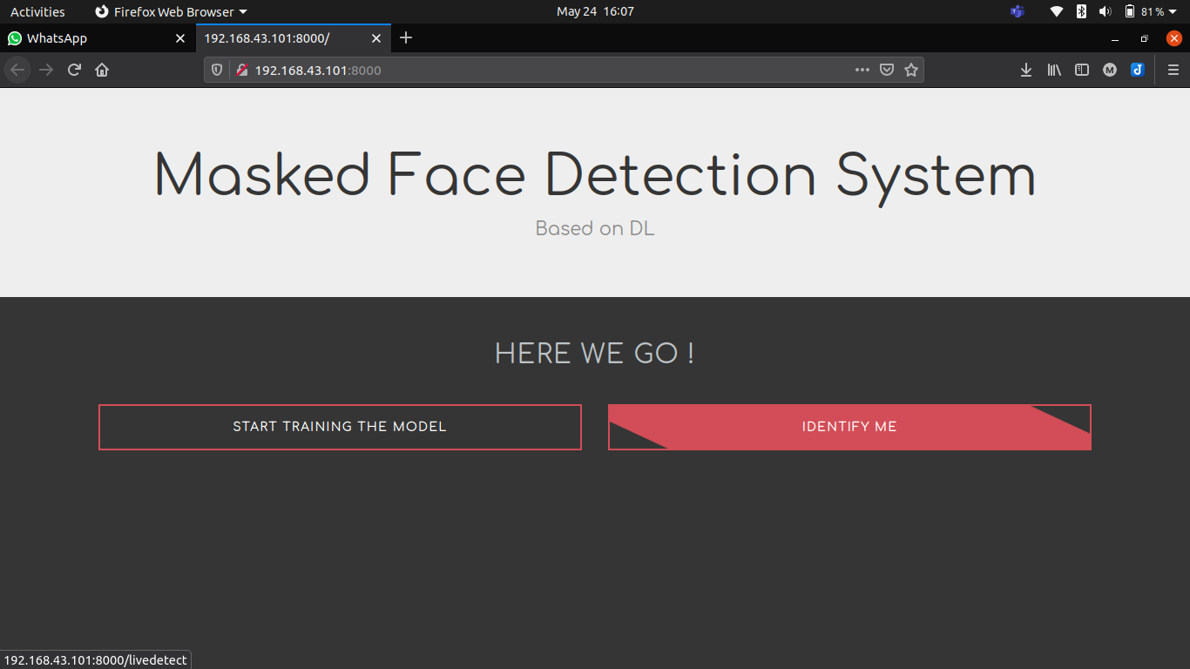
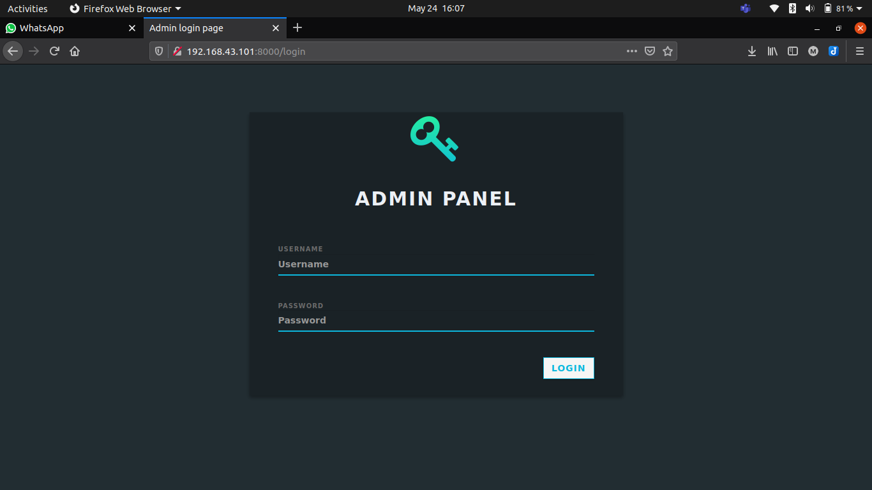

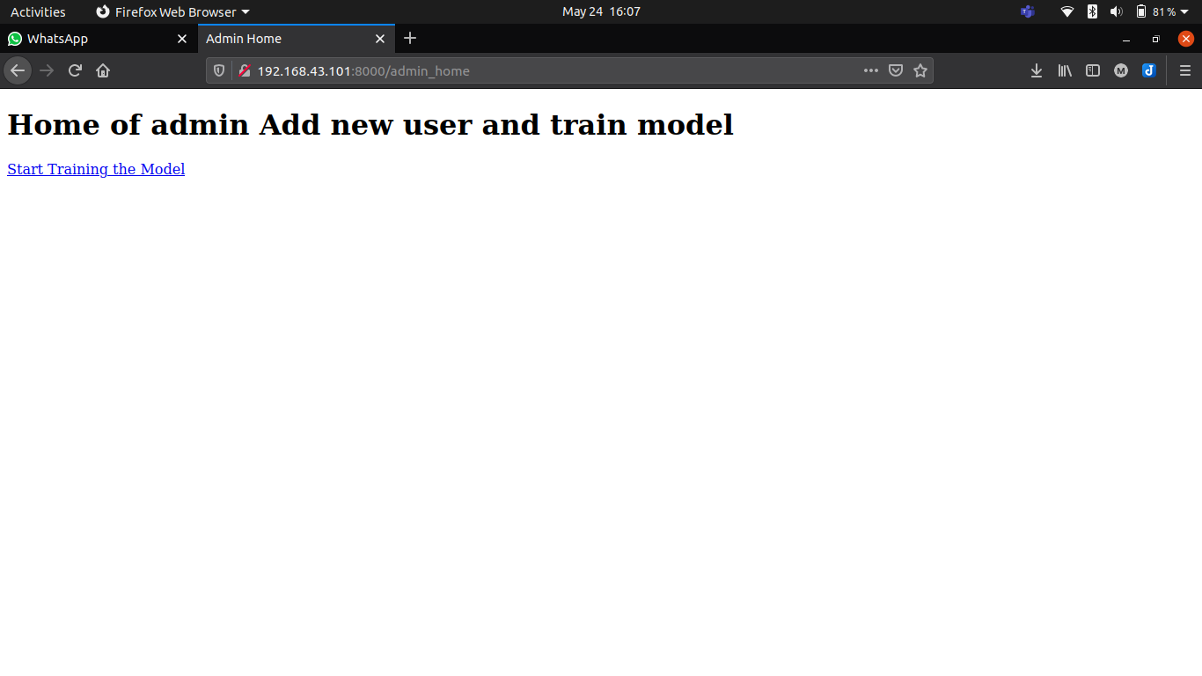

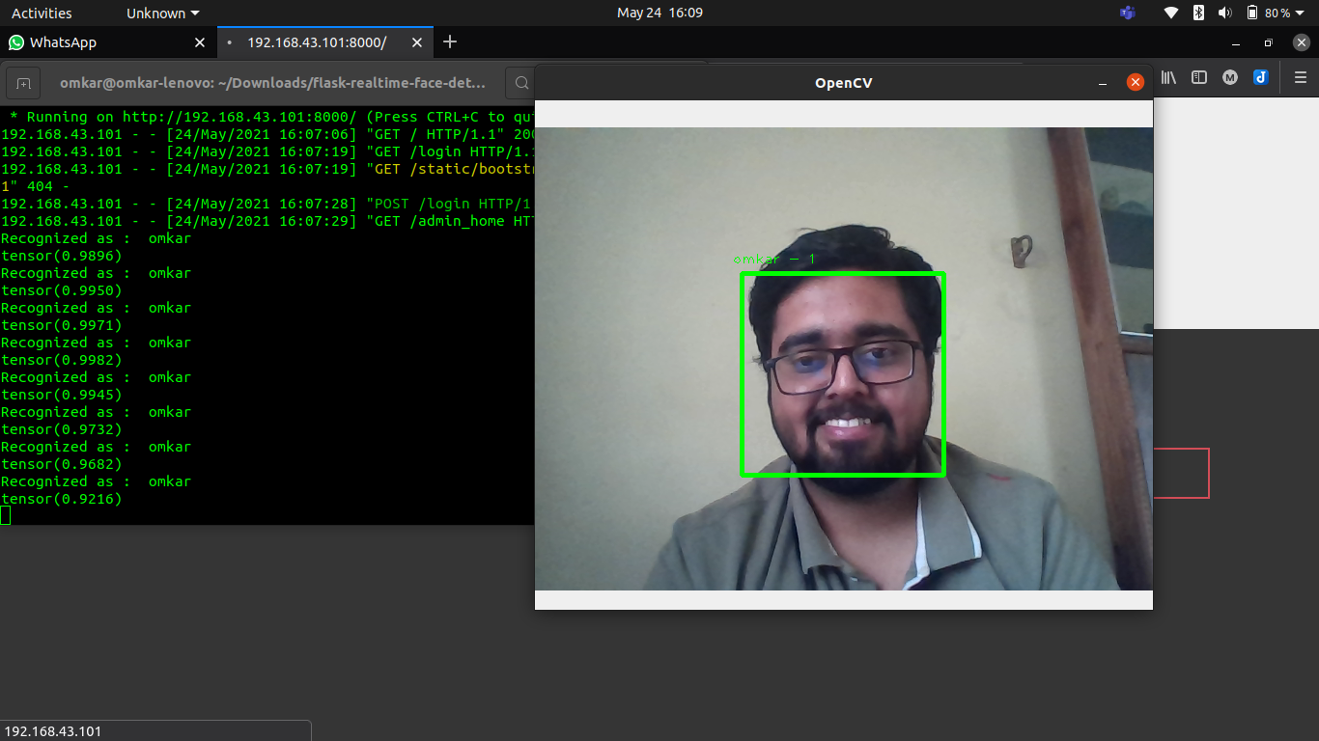

Conclusion:
Thus we have designed an interface prototype for selected system/product.

