Assignment No.5
Roll – 41239

Title: Evaluate an interface using usability evaluation technique.

Objectives:
1. To evaluate an interface using usability evaluation technique.
2. To test the effectiveness of interface design using usability evaluation technique.

Theory:
What is Usability?
Usability refers to the quality of a user's experience when interacting with products or systems,
including websites, software, devices, or applications. Usability is about effectiveness, efficiency and
the overall satisfaction of the user.
It is important to realize that usability is not a single, one-dimensional property of a product, system,
or user interface.
‘Usability’ is a combination of factors including:
• Intuitive design: a nearly effortless understanding of the architecture and navigation of the site
• Ease of learning: how fast a user who has never seen the user interface before can accomplish
basic tasks
• Efficiency of use: How fast an experienced user can accomplish tasks
• Memorability: after visiting the site, if a user can remember enough to use it effectively in future
visits
•Error frequency and severity: how often users make errors while using the system, how serious
the errors are, and how users recover from the errors
•Subjective satisfaction: If the user likes using the system

What are the Evaluation Methods and When Should I Implement Them?
The key to developing highly usable sites is employing user-centered design. The expression, “test
early and often”, is particularly appropriate when it comes to usability testing. As part of UCD you
can and should test as early as possible in the process and the variety of methods available allow you to assist in the development of content, Information architecture, visual design, interaction design and
general user satisfaction.

Opportunities for testing include:
• Baseline usability testing on an existing site
• Focus groups, surveys or interviews to establish user goals
• Card Sort testing to assist with IA development
• Wireframe testing to evaluate navigation
• First click testing to make sure your users go down the right path
• Usability testing to gauge the user interaction end-to-end and
• Satisfaction surveys to see how the site fares in the real world.

Any one or a combination of these tests will radically improve the usability of your site, system or
application.

Working with Data from Testing:
Usability evaluations can capture two types of data: qualitative data and quantitative
data. Quantitative data notes what actually happened. Qualitative data describes what participants
thought or said.
Once you have gathered your data, use it to:
1. Evaluate the usability of your website
2. Recommend improvements
3. Implement the recommendations4. Re-test the site to measure the effectiveness of your changes.

Usability Evaluation Methods:
The purpose of evaluation can be to improve the usability of the product as part of
design/development (formative evaluation), or to assess the extent to which usability objectives have
been achieved (summative evaluation).
1. Usability Inspection Method:
This section describes methods that can be used by experienced practitioners to assess usability issues.
While these methods do not involve users directly, they can provide some useful insights. However, the
goal is to use them to supplement, not replace, direct user involvement in testing designs and systems.
The ISO standard for user-centered design (ISO, 2009) defines five key activities in the project,
as Figure given below shows, starting with the requirement to plan for user-centered design and
usability, and then proceeding through an iterative cycle of activities including evaluation (ISO,
2010).

2. Usability Testing with Users:
Usability testing involves observing users while they perform tasks with a hardware or software
system. The product may be a paper sketch, a wireframe, a storyboard, a display mock-up, a product in development, a working prototype, or a completed product. Usability testing can also be conducted on competitive products to understand their strengths and weaknesses. A usability test can be a formative evaluation, which is conducted early in the design process to find problems improve the product, or summative evaluation, conducted to validate the design against specific goals.

Result :

Running Usability Tests:
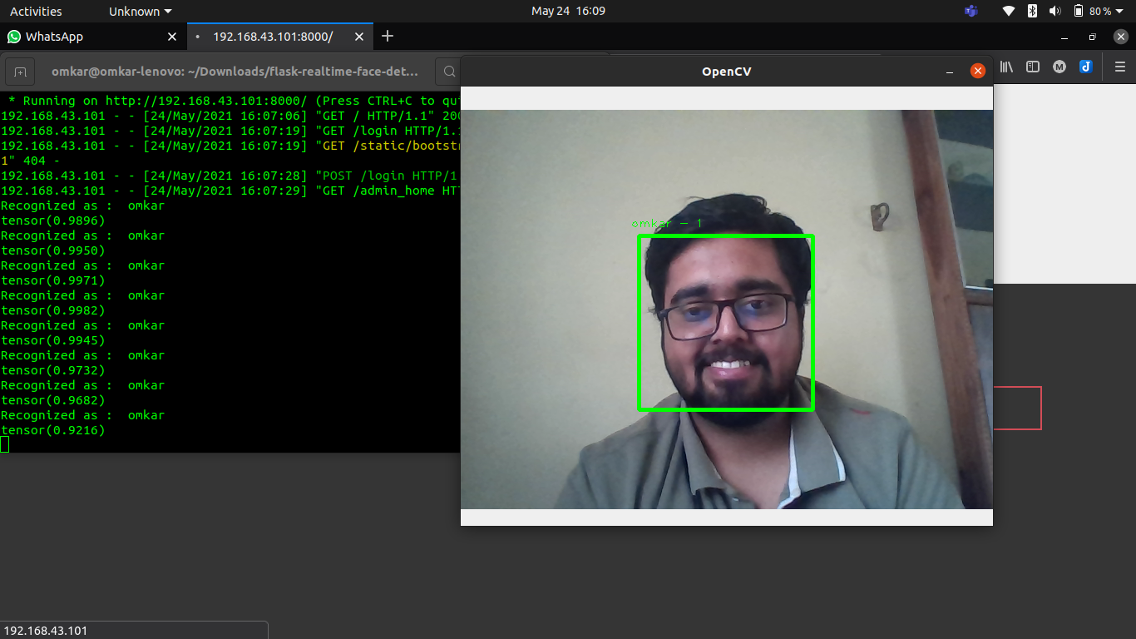
Correctly labels the user

Running a Test & First Click Testing :
Only one click required to get the desired result.

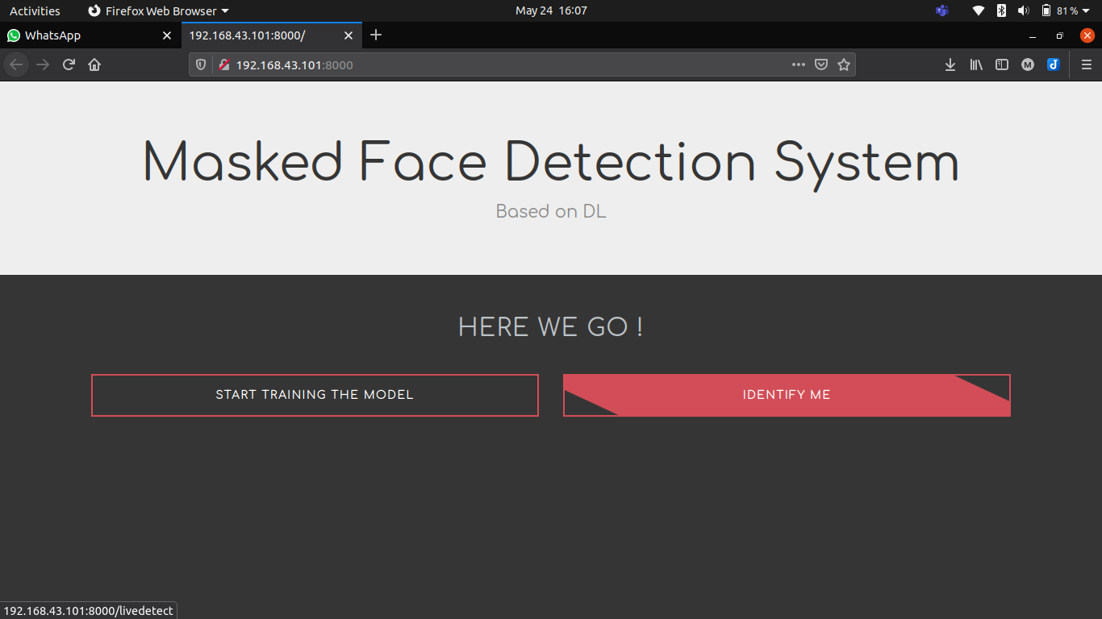

Conclusion: Thus we have studied different usability evaluation methods and hoe to evaluate an
interface using usability evaluation technique.

