Identify specialized users and related facilities for a selected product / system and make necessary suggestions for its improved accessibility design.

PROBLEM STATEMENT -

Face Recognition System Web App for a Organization which provides facility for recognizing the faces,facility for attendence marking of employees.The web app uses the camera module and if it is not available a camera should be installed.The interaction takes place through GUI where user can select different options.
There can be cases where the user is disabled(Blind,Cannot used hand for using GUI) these are the specialized users in our case.So they are given another interface like Control Panel with Braille and also Speech recognition has to be done.This can be used for security system, video conference, and human-computer interaction.

IDENTIFY USERS -

1) Employee
2) System Admin
3) Head of Department

USE CASES -
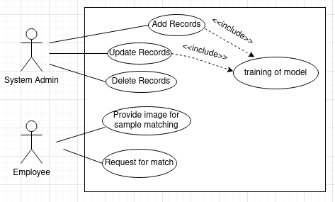

Specialized users -

1) Blind Person
Facility – Control Panel with Braille

