|  |
| --- |
| Lockedme.com  (Application Screenshots) |

Version History:

|  |  |
| --- | --- |
| Author | Òmkar Milind Londhe |
| Purpose | Screenshots of Application |
| Date | 08/14/2021 |
| Version | 1.0 |

**Table of Contents**

1. **Folder containing Files…………………………………………………………………………………………………………3**
2. **Main Menus………………………………………………………………………………………………………………………..4**
3. **Display all Files……………………………………………………………………………………………………………………5**
4. **Add new File…………………………………………………………………………………………………………………….…5**
5. **Added file and its content…………………………………………………………………………………………………..6**
6. **Delete a file………………………………………………………………………………………………………………………..6**
7. **Search a file………………………………………………………………………………………………………………………..8**
8. **Exit from application…………………………………………………………………………………………………………..9**

# Folder containing files

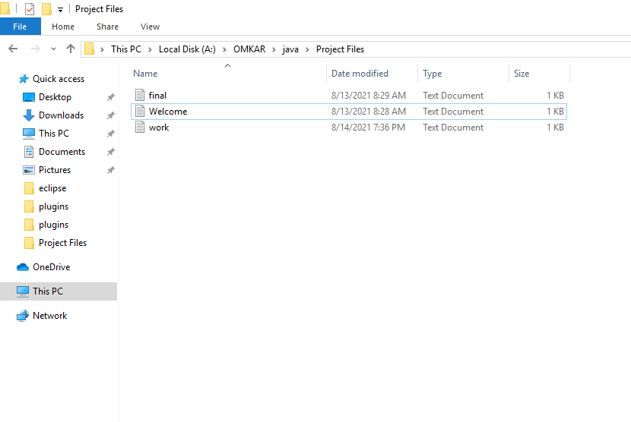

# Main Menus

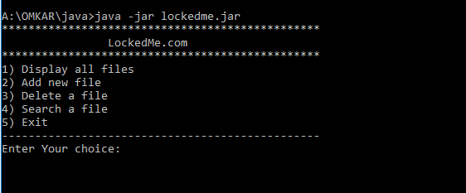

# Display All Files

# Add new File

# Added file and its contents:

# Delete a file

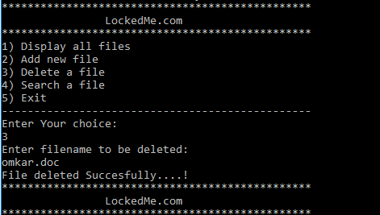

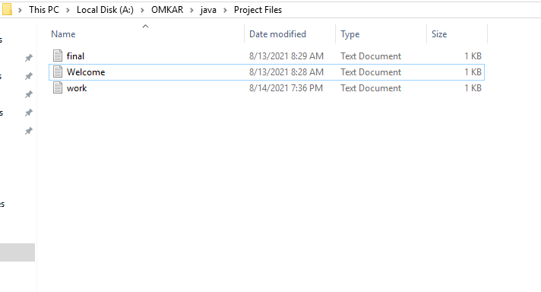

# Search a file

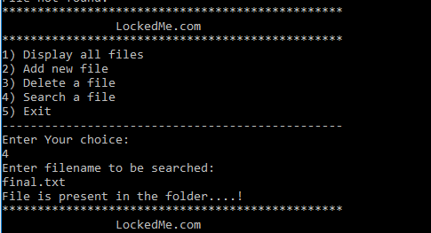

# 8.Exit from application