BCM Door Functionality Validation Report

Test Execution Summary
Total Test Cases : 11
Passed Test Cases : 5
Failed Test Cases : 6
Pass Percentage : 45.45%
Fail Percentage : 54.55%

Pass / Fail Pie Chart
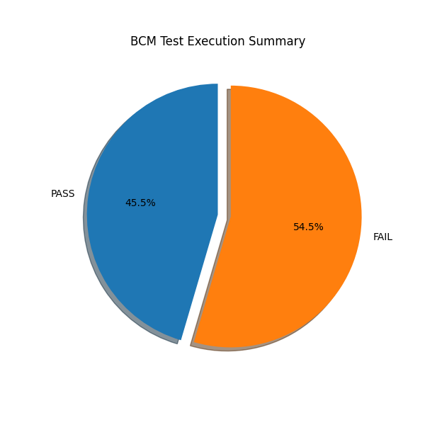

Detailed Test Results
TC_ID | Description | Expected | Actual | Status | Remarks
TC01 | Lock door using key fob | Door Locked | Door Unlocked | Fail | Driver Door Open, Rear Left Door Open, Boot Door Open, Lock Failed
TC02 | Unlock door using key fob | Door Unlocked | Door Unlocked | Pass | Driver Door Open, Unlock Successful
TC03 | Verify unlock is allowed at low speed value<10 | Door Locked | Door Unlocked | Fail | Unlock Allowed
TC04 | Verify unlock is blocked above speed limit>10 | Door Unlocked | Door Unlocked | Pass | Rear Right Door Open, Unlock Allowed
TC05 | Verify unlock at boundary value 60 km/h | Door Locked | Door Unlocked | Fail | Driver Door Open, Rear Left Door Open, Unlock Allowed
TC06 | Verify auto-lock activates above 20 km/h | Door Locked | Door Locked | Pass | Auto Lock Activated
TC07 | Verify auto-lock does not activate below threshold(20) | Door Unlocked | Door Unlocked | Pass | Rear Right Door Open, Speed Below Auto Lock Threshold
TC08 | Verify lock command when driver door is open | Door Locked | Door Unlocked | Fail | Driver Door Open, Lock Failed
TC09 | Verify central lock request | Door Locked | Door Unlocked | Fail | Rear Right Door Open, Central Lock Failed
TC10 | Verify central unlock request | Door Unlocked | Door Unlocked | Pass | Unlock Allowed
TC11 | Verify lock request when boot door open | Door Locked | Door Unlocked | Fail | Boot Door Open, Lock Failed

Failed Test Cases
TC01 : Driver Door Open, Rear Left Door Open, Boot Door Open, Lock Failed
TC03 : Unlock Allowed
TC05 : Driver Door Open, Rear Left Door Open, Unlock Allowed
TC08 : Driver Door Open, Lock Failed
TC09 : Rear Right Door Open, Central Lock Failed
TC11 : Boot Door Open, Lock Failed

Conclusion
A total of 11 test cases were executed.
5 test cases passed.
6 test cases failed.
Pass Percentage : 45.45%

