ASSIGNMENT NO. 3(a)
Name: Aman Shaikh
PRN:12420191
Class: TY-CSE(AIML)-B
Batch: B3
Title: - 3a) Write the client server programs using TCP Berkeley socket primitives for wired /wireless network for following
a. to say Hello to Each other
b. File transfer
Aim: - 1. To understand the concept of client–server communication using TCP.
2. To learn the use of Berkeley socket API (socket, bind, listen, accept, connect, send, receive).
Theory: -
Socket Programming:
A socket is an endpoint for sending or receiving data across a computer network. Berkeley sockets provide a programming interface for network communication.
TCP (Transmission Control Protocol):
- TCP is a connection-oriented, reliable transport protocol.
- It ensures data delivery with acknowledgment, sequencing, and error checking.
- Suitable for applications like file transfer, web browsing, and chat systems.
Client–Server Model:
- Server: Listens for incoming client requests on a specific port.
- Client: Initiates connection to the server using server IP and port.
- Once a connection is established, they can exchange data bidirectionally.
Basic TCP Socket Primitives:
- socket() → Create a socket.
- bind() → Bind socket to an IP address and port.
- listen() → Server waits for client requests.
- accept() → Server accepts a client connection.
- connect() → Client requests connection to server.
- send() / recv() → Data transfer between client and server.
- close() → Close the connection.
Program:-
  - Say hello to each other

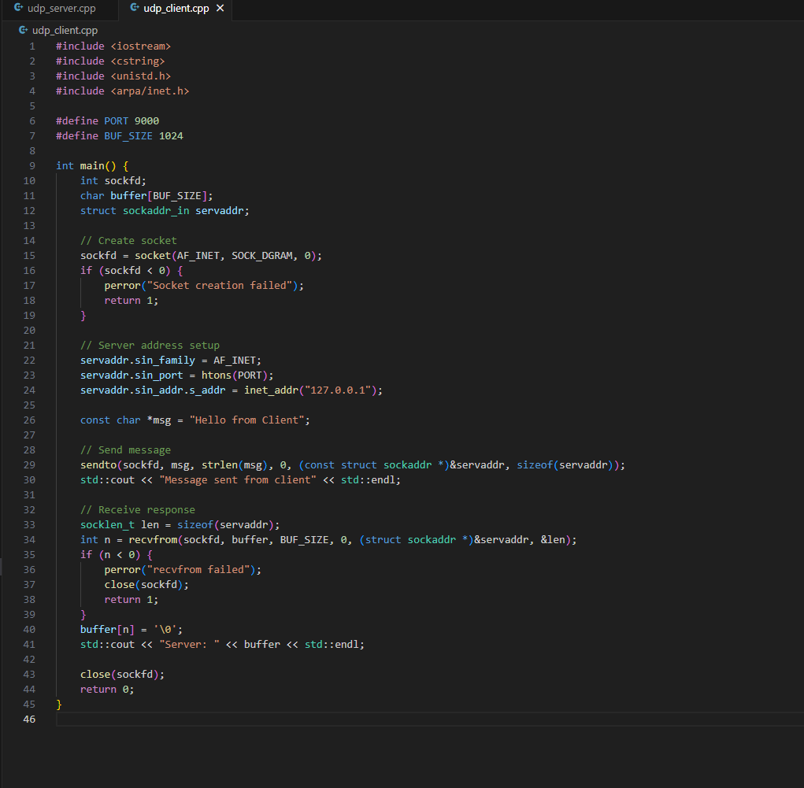
- udp_client.cpp

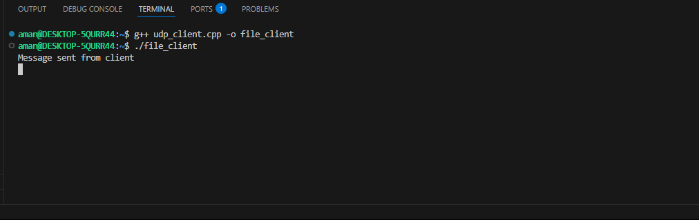
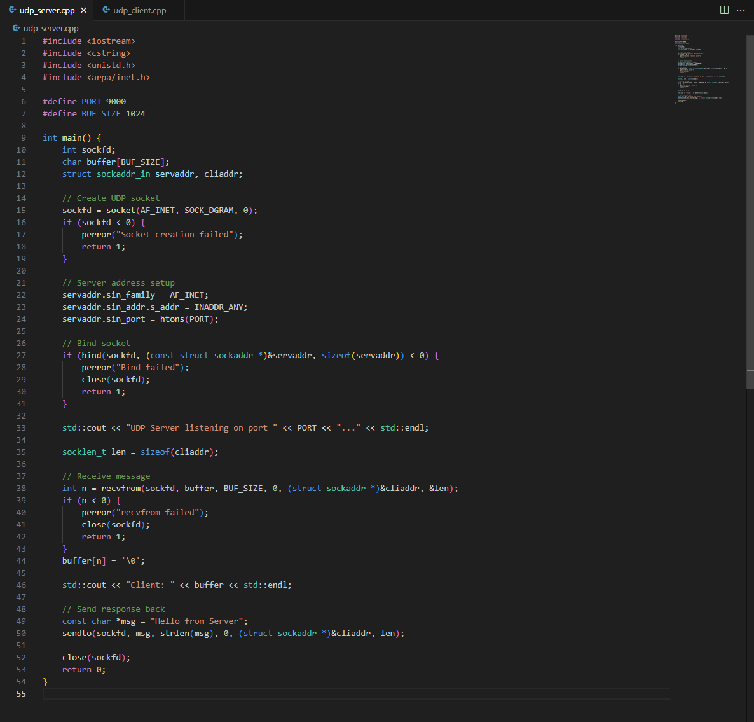
- udp_server.cpp

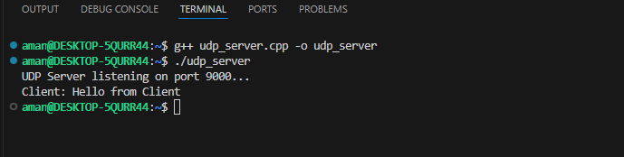
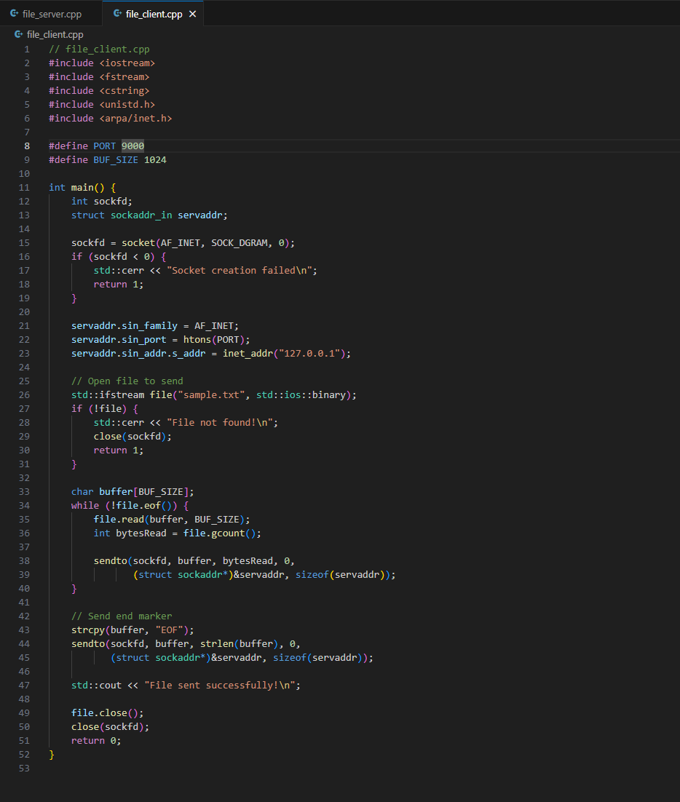
  - File Transfer (file_client.cpp)
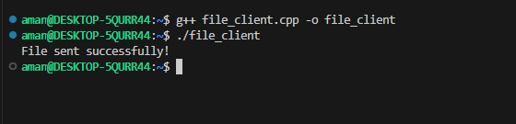

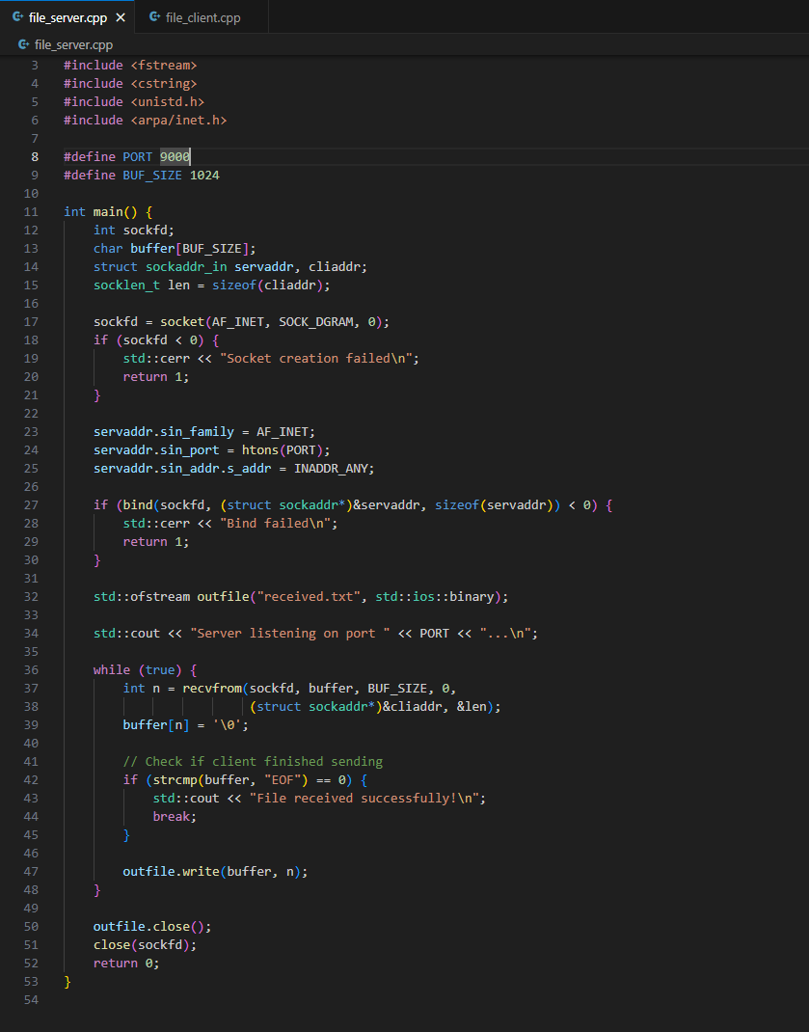
file_server.cpp
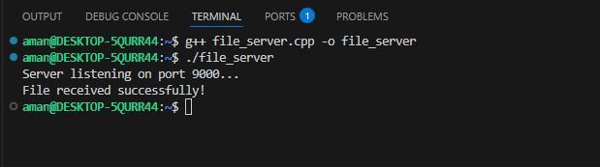

Conclusion:-
From this practical, we successfully implemented client–server communication using TCP Berkeley socket primitives. The simple Hello message exchange demonstrated how a connection-oriented communication works, while the file transfer program highlighted the reliability of TCP in transmitting data without loss or duplication. This experiment helped us understand the working of the client–server model, TCP socket functions, and their applications in real-world wired and wireless networking.

