+

A
Project Report
On

“TRAVELS MANAGEMENT SYSTEM”
Submitted To

BHARATI VIDYAPEETH (DEEMED TO BE UNIVERSITY),
PUNE
In the partial fulfillment for requirement of the degree

BACHELOR of Computer Application
(BCA-II Sem-IV 2023-24)

Submitted By
Mr.Omkar B. Bhandalkar
Mr.Ganesh K. Yadav
Mr.Vishal R. Shinde

Under the guidance of

Dr. A.R. Mujawar
Through The

INSTITUTE OF MANAGEMENT AND RURAL DEVELOPMENT ADMINISTRATION, SANGLI



Bharati Vidyapeeth Deemed University
Institute of Management & Rural Development Administration, Sangli-416416

CERTIFICATE

This is certified that a Project Report titled “Travels Management System” Submitted By Omkar Bhandalkar, Ganesh Yadav and Vishal Shinde BCA Sem-IV in partial fulfillment for requirement of the degree of ‘Bachelor of Computer Application’ submitted to Bharati Vidyapeeth Deemed University, Pune has been completed under my guidance.

To the best of my knowledge and belief matter presented by them is original in nature and has not been copied down from any sources.

Place: Sangli
Date:

Dr. A.R.Mujawar Dr. R. S. Pujari Prof. Dr. P. P. Jamsandekar
(Guide) HoD – Computer Applications (Director)

Examiner :

Declaration

TO,

THE DIRECTOR;
BVDU IMRDA, Sangli.

Respected sir,

We the undersigned hereby declare that the Project report entitled,
“TRAVELS MANAGEMENT SYSTEM” written and submitted under the guidance of Dr. A.R. Mujawar is our Original Work. The Empirical findings in this report are based on information collected by us. We have not copied from any report submitted to BVDU IMRDA, Sangli. We understand any such copying is such liable in a punishment in a way that the university authority demits this.

PLACE: Sangli
DATE:

Mr. Omkar Bhandalkar
Mr. Ganesh Yadav
Mr. Vishal Shinde

Acknowledgement

We take this opportunity to express our deep sense of obligation to the Bharati Vidyapeeth Deemed University, Pune. The Institute of Management and Rural Development Administration Sangli.
We express our sincere thanks to the Director Dr. P. P. Jamsandekar for giving us an opportunity to undertaking this Project work. We our deepest gratitude towards respective guide Dr. A.R. Mujawar
And all of our faculty members for their valuable guidance and motivation during the completion of the Project Report.
Finally We very much thankful to everyone who helped us a lot in the completion of this Report to the great extent.
Thanking you all.

Place: Sangli.
Date:-

Mr.Omkar Bhandalkar
Mr.Ganesh Yadav
Mr.Vishal Shinde

Index
(For database projects like library, dairy, bank, etc.)

Index
(For simple processing of array, pyramid or mathematical operations)

Sr. No. | Title | Page No.
1 | Introduction to Project
2 | Existing System
3 | Proposed System
4 | Objectives
5 | System Requirement
6 | Site Map
7 | Input Design
8 | Code
9 | Advantages
10 | Limitations
11 | Conclusion
12 | Bibliography

INTRODUCTION

The Travel Management System is window based application. The main purpose of travel management system is to provide a convenient way for a passenger to book Travels for travel purposes. This application provides access to lucrative travel deals and offers and gives pricing information for each of them. The main purpose of travels management system is to provide a best facility and travelling services for a passenger to book Travels ticket for trip purpose. We have developed travels management system to provide a search platform find their travel places according to their choices.
This is instead of to provide the best traveling services to the passengers. We have expanded travel administration strategy to provide an exploration platform where a tourist can find their trip spots according to their choices. The admin can select any of the three choices available, which includes travel, food and accommodation facilities. Details of different types of travels which includes tours like family tours, couple tours, general tours, date and time of departure and the fair of the tours etc are maintained.

EXISTING SYSTEM

In the existing system, each task is carried out manually and processing is also a tedious job. In previous system travelers were maintaining time table details manually in pen and paper, which was time taking costly. The travelers is not able to achieve its need in time and also the results may not accurate. In the existing system, all the records are not kept perfectly because all the work is done manually, so keeping up to date details of the timings of bookings, seat availability for booking is not done. Amount of the overall trips are kept in documents and the calculations done are manually which made lead to huge mistakes. Thus, the existing system is very time consuming and being manual work sometimes lead to a great loss as well. Because of the manual maintenance there are number of difficulties and drawbacks exist in the system. Some of them are:

PROPOSED SYSTEM

The proposed system is designed to be more efficient than the manual system. It invokes all base tasks than are now carried out manually, such as the forms transactions and reports which is added advantage. The proposed system is completely computer-based application. Thousands of records can searched and displayed without taking any significant time. The proposed system is to develop a fully functional window Website, to provide efficient and time consuming system for travellers and service provider related with the travel business, providing registration, ticket booking and other facilities. This system also gives related information like which places are travel attractions, cities and provinces. Passenger can also book Travles through our travel management system.

- Simplifies the manual work.
- It minimizes the documentation related work.
- Provides up to date information.
- Friendly Environment by providing warning messages.
- Travelers details can be provided.
- Booking confirmation notification.
- Gives accurate information.

Objectives:

1. Website Branding: The code aims to establish the brand identity of TravelIndia.com by including the company name in the title tag and displaying the logo prominently in the header section.

2. Navigation: It provides easy navigation for users through a menu bar located in the header, allowing users to access different sections of the website such as Home, Offers, Gallery, About Us, and Contact.

3. Content Presentation: The code organizes content into sections such as Offers, Gallery, About Us, and Contact, making it easier for users to find relevant information about travel destinations and services offered by TravelIndia.com.

4. Visual Appeal: It incorporates images and styling to enhance the visual appeal of the website, making it more attractive and engaging for visitors.

5. User Engagement: The inclusion of interactive elements like the "Book Now" buttons and smooth scrolling functionality aims to increase user engagement and encourage visitors to take action, such as booking a tour or contacting the agency.

6. Information Accessibility: The code ensures that essential information such as contact details and booking forms are easily accessible to users, facilitating communication and interaction with the agency.

System Requirement

Sr. No. | Name of resource / Material | Specifications | Qty | Remarks
1. | Computer system with broad specifications | Ryzen 5000 SERIES  Ram – 2Gb | 1
2. | Software | Windows 11 | 1

Site map:

TRAVELS MANAGEMENT SYSTEM

Home

Contact Us
About Us
Gallery
Offer
Booking

Display

SYSTEM DESIGN
HTML CODE :

<!DOCTYPE html>
<html>
<head>
<meta charset="utf-8">
<meta name="viewport" content="width=device-width, initial-scale=1">
<link rel="stylesheet" type="text/css" href="Traveller.css">
<title>Best Online Travel Page in India | TravelIndia.com</title>
</head>
<body>
<div id="home"></div>
<header id="header">
<div id="logo"><img src="logo.png"></div>
<ul>
<li><a href="Index.html" class="active">Home</a></li>
<li><a href="#offer">Offers</a></li>
<li><a href="#gallery">Gallery</a></li>
<li><a href="#about_us">About Us</a></li>
<li><a href="#contact">Contact</a></li>
</ul>
</header>
<section>
<h2 id="text"><span>A New Journey Is</span><br>Waiting</h2>
<img src="bird1.png" id="bird1">
<img src="bird2.png" id="bird2">
<img src="forest.png" id="forest">
<img src="rocks.png" id="rocks">
<img src="water.png" id="water">
</section>
<div id="offer">
<div class="sec">
<h2>We have the best tours</h2>
<div id="scroll">
<div id="agra"><img src="agra.jpg"><h1>Agra<span>Days - 3<br>Rs. 14500.00</span></h1><a id="book" href="booking_page.html">Book Now</a></div>
<div id="goa"><img src="goa.jpg"><h1>Goa<span>Days - 7<br>Rs. 15500.00</span></h1><a id="book" href="booking_page.html">Book Now</a></div>
<div id="jaipur"><img src="jaipur.jpg"><h1>Jaipur<span>Days - 4<br>Rs. 17000.00</span></h1><a id="book" href="booking_page.html">Book Now</a></div>
<div id="manali"><img src="manali.jpg"><h1>Manali<span>Days - 5<br>Rs. 13500.00</span></h1><a id="book" href="booking_page.html">Book Now</a></div>
<div id="mumbai"><img src="mumbai.jpg"><h1>Mumbai<span>Days - 5<br>Rs. 10500.00</span></h1><a id="book" href="booking_page.html">Book Now</a></div>
</div>
</div>
</div>
<button onclick="topFunction()" id="srl_up" title="Go to top">Scroll Up</button>
<div id="spcl_offer">
<div class="maldives_head"><h1>maldives deluxe package</h1></div>
<div id="maldives">
<p>
Luxurious stay in comfortable, aesthetically designed and fully sanitized villas with the mesmerizing view to the beach and the ocean
A Green Tax of 6 USD per person (per night) is directly payable at the resort.The Gala Dinner cost of USD 50 to USD 100 per person is not included in the package. It’s directly payable at the property and is applicable on the night of 24th and31st December. Liquor is not allowed at Maafushi Island<br>
<span>Days - 5<br>Rs. 120599.00</span><br><br>
<a id="book" href="booking_page.html">Book Now</a>
</p>
</div>
</div>
<div id="gallery">
<hr>
<div class="galry_head"><h3>Gallery</h3></div><hr>
<div class="slidebox">
<div class="slideshow-container">
<div class="mySlides fade">
<img src="switzerland.jpg">
</div>
<div class="mySlides fade">
<img src="santa_monica.jpg">

</div>
<div class="mySlides fade">
<img src="agra2.jpg">
</div>
</div>
<br>
<div style="text-align:center">
<span class="dot"></span>
<span class="dot"></span>
<span class="dot"></span>
</div>
</div>

<div id="glry_view">
<div class="disp_container">
<table>
<tr>
<td><img src="gallery_1.jpg"></td>
<td><img src="gallery_2.jpg"></td>
<td rowspan="2"><img src="italy.jpg"></td>
</tr>
<tr>
<td><img src="gallery_3.jpg"></td>
<td><img src="gallery_4.jpg"></td>
</tr>
<tr>
<td><img src="gallery_5.jpg"></td>
<td colspan="2"><img src="manali.jpg"></td>
</tr>
</table>
</div>
</div>
</div>
<div id="about_us">
<hr>
<div class="abt_head"><h3>About Us</h3></div><hr>
<div class="abt_content">
<div class="abt_img"><img src="intro.png"></div>
<div class="abt_info">
<h3>We Have The Best Tours</h3>
<p>
Interesting and Intriguing, India offers incredible holiday experiences through its cultural, topography, and wildlife diversity. With these amazing and unique experiences, this south Asian country conveniently finds its way into the world tourism map as one of the finest destinations for a holistic vacation.
</p><br>
<p>
India establishes its identity as the country of architectural masterpieces, making it an ideal travel destination to plan a heritage tour in the world. While Taj Mahal makes for the major draw on an India tour, there are a plethora of monuments and edifices in every India travel guide displaying the fine architecture and grandiose of different eras in the country.
</p><br>
<p>
Through our exceptionally curated occasion bundles, we need to take you on an adventure where you personally enjoy the stunning magnificence of America and far-off terrains. We need you to observe sensational scenes that are a long way past your creative ability.Our online visa administrations are exceptional and make the bulky procedure of booking visas a cake stroll for clients. We likewise give exceptional visa, forex, and travel protection and outside settlement administrations for understudies voyaging abroad for study.
</p><br>

</div>
</div>
<h2>Plan The Perfect Holiday...</h2>
</div>
<div id="contact">
<hr>
<div class="cnt_head"><h3>Contact</h3></div><hr>
<div class="cnt_content">
<div class="cnt_form">
<form>
<label for="fname">First Name</label>
<input type="text" id="fname" name="firstname" placeholder="Your name..">
<label for="lname">Last Name</label>
<input type="text" id="lname" name="lastname" placeholder="Your last name..">
<label for="country">Country</label>
<select id="country" name="country">
<option value="australia">Australia</option>
<option value="canada">Canada</option>
<option value="usa">USA</option>
</select>
<label for="subject">Subject</label>
<textarea id="subject" name="subject" placeholder="Write something.." style="height:170px"></textarea>
<input type="submit" value="Submit">
</form>
</div>
<div class="cnt_info">
<div class="call"><img src="phone.png">TollFree Number<br></div>
<div class="info"><span>1800 123 5555<br>Available Monday to Saturday 10 AM - 7 PM</span>
</div><br>
<div class="mail"><img src="mail.webp">Customer Email ID<br></div>
<div class="info"><span>customercare@travelindia.com</span>
</div><br>
<div class="adrs"><img src="location.png">Office<br></div>
<div class="info"><span>Travel India Private Limited<br>
Plot No -29 , 3rd & 4th Floor Dynamic House, Maruti Industrial Complex Sector 18,
Mumbai</span>
</div><br>
</div>
</div>
<div>
<marquee>Made within <img src="heart.png"> India. All rights reserved ©2022</marquee>
</div>
</div>

</body>
<script type="text/javascript" src="Traveller.js"></script>
</html>

CSS CODE :

@import url('https://fonts.googleapis.com/css2?family=Poppins&display=swap');
@import url('https://fonts.googleapis.com/css2?family=Rancho&display=swap');
*{
margin: 0;
padding: 0;
box-sizing: border-box;
font-family: 'Poppins', sans-serif;
scroll-behavior: smooth;
}
body{
overflow-x: hidden;
background-color: #fff;
min-height: 600vh;
scroll-behavior: smooth;
}
#header{
position: relative;
top: 0;
left: 0;
width: 100%;
height: 80px;
background: linear-gradient(to bottom, rgba(0, 255, 255, 0.3), transparent);
padding: 30px 80px;
display: flex;
justify-content: space-between;
align-items: center;
}
#header #logo img{
margin-top: 80px;
width: 160px;
height: 120px;
}
#header ul{
display: flex;
justify-content: center;
align-items: center;
}
#header ul li{
list-style: none;
margin-left: 10px;
}
#header ul li a{
text-decoration: none;
padding: 6px 15px;
color: #094b65;
border-radius: 20px;
}
#header ul li a:hover, #header ul li a.active{
background-color: #094b65;
color: #fff;
}
section{
position: relative;
width: 100%;
height: 90vh;
display: flex;
justify-content: center;
align-items: center;
}
section::before{
content: '';
position: absolute;
bottom: 0;
left: 0;
width: 100%;
height: 100px;
background: linear-gradient(to top, #094b65, transparent);
z-index: 10;
}
section img{
position: absolute;
top: 0;
left: 0;
width: 100%;
height: 100%;
object-fit: cover;
pointer-events: none;
}
section #text{
position: absolute;
color: #094b65;
font-size: 70px;
text-align: center;
line-height: 40px;
font-family: 'Rancho', cursive;
letter-spacing: 15px;
transform: translateY(-80px);
}
section #text span{
font-size: 30px;
letter-spacing: 2px;
font-weight: 400;
}
#Explor_bnt{
position: fixed;
text-decoration: none;
display: inline-block;
padding: 8px 30px;
color: #000;
font-weight: bold;
background-color: #2f80ed;
font-size: 20px;
font-weight: 500px;
border-radius: 40px;
letter-spacing: 2px;
transform: translateY(90px);
}
#Explor_bnt:hover{
color: #FEFEFE;
background-color: #2F88C3;
}
#srl_up{
display: none;
position: fixed;
bottom: 20px;
right: 30px;
z-index: 99;
font-size: 18px;
border: none;
outline: none;
background-color: #000;
color: white;
cursor: pointer;
padding: 7px;
border-radius: 25px;
}
#srl_up:hover {
background-color: #555;
}
#offer{
width: 100%;
height: 560px;
}
.sec{
position: absolute;
padding: 50px 0px 0px 0px;
width: 100%;
background-color: #f8f8ff;
}
.sec::before{
content: '';
position: absolute;
top: 0;
left: 0;
width: 100%;
height: 100px;
background: linear-gradient(to bottom, #094b65, transparent);
z-index: 10;
}
.sec #scroll{
display: flex;
padding: 10px 0px 20px 0px;
overflow-y: hidden;
overflow-x: scroll;
scroll-behavior: smooth;
}
.sec h2{
color: #000;
font-size: 30px;
text-align: center;
letter-spacing: 2px;
}
.sec img{
position: relative;
padding: 20px;
height: 300px;
width: 400px;

}
.sec #scroll h1{
display: flex;
margin-top: -20px;
margin-left: 30px;
justify-content: space-between;
align-items: center;
letter-spacing: 2px;
}
.sec #scroll span{
text-align: right;
margin-right: 30px;
margin-bottom: 20px;
font-size: 14px;
}
.sec #scroll #book{
margin-left: 140px;

}
#book{
background: linear-gradient(to right, #667eea, #2bb673, #ed6ea0, #8E37D7);
box-shadow: 0 4px 15px 0 rgba(116, 79, 168, 0.75);
text-decoration: none;
padding: 8px 25px;
font-size: large;
text-align: center;
border: none;
color: #fff;
border-radius: 50px;
background-size: 300% 100%;
moz-transition: all .4s ease-in-out;
-o-transition: all .4s ease-in-out;
-webkit-transition: all .4s ease-in-out;
transition: all .4s ease-in-out;
}
#book:hover{
background-position: 100% 0;
font-style: italic;
moz-transition: all .4s ease-in-out;
-o-transition: all .4s ease-in-out;
-webkit-transition: all .4s ease-in-out;
transition: all .4s ease-in-out;
}
#spcl_offer{
position: relative;
width: 100%;
height: 750px;
background-image: url('pics/maldives.jpg');
background-size: 100% 100%;
background-attachment: fixed;
}
#spcl_offer .maldives_head{
position: relative;
top: 150px;
margin-left: 28%;

text-align: center;
}
#spcl_offer h1{
font-family: georgia;
width: 60%;
padding: 10px;
border: 3px solid black;
border-radius: 10px;
}
#spcl_offer #maldives{
position: relative;
top: 250px;
line-height: 25px;
padding: 40px;
margin-left: 50px;
margin-right: 50px;
background-image: radial-gradient(circle, rgba(0, 0, 0, 0.5)70%, transparent);
color: #fff;
text-align: center;
}
#gallery{
position: relative;
width: 100%;
height: 1560px;
overflow: hidden;
}
#gallery .galry_head{
position: relative;
margin-left: 80px;
background: linear-gradient(to right, greenyellow 30%, transparent);
margin-top: 25px;
margin-bottom: 15px;

}
#gallery .galry_head h3{
font-family: georgia;
font-size: 25px;
width: 200px;
padding: 10px;
border: 3px solid black;
}
#gallery .slidebox{
height: 600px;
background-color: #E1AECE;
}
#gallery .slideshow-container {
max-width: 70%;
position: relative;
margin: auto;
}
#gallery .slideshow-container img{
width: 100%;
margin-top: 20px;
height: 550px;
border: 2px solid black;
border-radius: 20px;
}
.dot {
display: none;
}
.active {
background-color: #717171;
}
.fade {
animation-name: fade;
animation-duration: 2s;
}
@keyframes fade {
from {opacity: .4}
to {opacity: 1}
}
#glry_view{
position: relative;
padding: 20px;
background-color: #759E9A;
height: 900px;
width: 100%;
}
#glry_view .disp_container{
position: relative;
padding: 20px;
height: 800px;
display: inline-block;
margin-left: 20%;
width: 60%;
background-color: whitesmoke;
border: 2px solid black;
}
#glry_view .disp_container table{
text-align: center;
}
#glry_view .disp_container img{
max-width: 500px;
max-height: 500px;
padding: 10px;
}
#glry_view .disp_container img:hover {
-ms-transform: scale(1.1);
-webkit-transform: scale(1.1);
transform: scale(1.1);
}
#about_us{
position: relative;
width: 100%;
height: 700px;
overflow: hidden;
}
#about_us .abt_head{
position: relative;
margin-left: 80px;
background: linear-gradient(to right, greenyellow 30%, transparent);
margin-top: 25px;
margin-bottom: 15px;
}
#about_us .abt_head h3{
font-family: georgia;
font-size: 25px;
width: 200px;
padding: 10px;
border: 3px solid black;
}
#about_us .abt_content{
display: flex;
margin-left: 50px;
margin-right: 50px;
}
#about_us .abt_content img{
width: 500px;
height: 500px;
border-bottom: 3px solid blueviolet;
}
#about_us .abt_content .abt_info{
padding: 15px;
border-left: 3px solid blueviolet;
border-bottom: 3px solid blueviolet;
text-align: justify;
line-height: 25px;
}
#about_us .abt_content .abt_info h3{
font-size: 25px;
font-variant: small-caps;
}
hr{
height: 5px;
background-color: #26A4C4;
}
#about_us h2{
margin-top: 15px;
margin-left: 100px;
font-family: georgia;
width: 400px;
color: #228CDE;
background: linear-gradient(to top, #A2BCD0, transparent );
padding: 10px;
border-bottom: 3px solid black;
border-radius: 10px;
text-align: center;
}
#contact{
position: relative;
width: 100%;
height: 780px;
overflow: hidden;
}
#contact .cnt_head{
position: relative;
margin-left: 80px;
background: linear-gradient(to right, greenyellow 30%, transparent);
margin-top: 25px;
margin-bottom: 15px;
}
#contact .cnt_head h3{
font-family: georgia;
font-size: 25px;
width: 200px;
padding: 10px;
border: 3px solid black;
}
#contact .cnt_content{
width: 100%;
background-image: url('pics/contact.jpg');
color: #fff;
overflow: hidden;
display: flex;
}
#contact .cnt_content .cnt_form{
width: 50%;
padding: 50px;
}
input[type=text], select, textarea {
width: 100%;
padding: 12px;
border: 1px solid #ccc;
margin-top: 6px;
margin-bottom: 16px;
resize: vertical;
}
input[type=submit] {
background-color: #04AA6D;
width: 100%;
color: white;
padding: 12px 20px;
border: none;
cursor: pointer;
}
input[type=submit]:hover {
background-color: #45a049;
}
#contact .cnt_content .cnt_info{
width: 50%;
padding: 50px;
background-color: rgba(0, 0, 0, 0.7);
}
#contact .cnt_content .cnt_info img{
height: 50px;
width: 50px;
margin-right: 30px;
margin-bottom: 10px;

}
#contact .cnt_content .cnt_info .call, .mail, .adrs{
display: flex;

}
#contact .cnt_content .cnt_info .info{
border-bottom: 1px solid white;
}
#contact marquee{
font-size: 15px;
font-family: sans-serif;
background-color: #404345;
color: #fff;
padding: 5px;
}
#contact marquee img{
height: 20px;
width: 20px;
}

JS CODE:

let text = document.getElementById('text');
let bird1 = document.getElementById('bird1');
let bird2 = document.getElementById('bird2');
let forest = document.getElementById('forest');
let explor_bnt = document.getElementById('Explor_bnt');
let rocks = document.getElementById('rocks');
let water = document.getElementById('water');
let header = document.getElementById('header');

window.addEventListener('scroll',function () {
let value = window.scrollY;
text.style.top = 50 + value * -0.4 + '%';
bird1.style.top = value * -1.5 + 'px';
bird1.style.left = value * 2 + 'px';
bird2.style.top = value * -1.5 + 'px';
bird2.style.left = value * -5 + 'px';
explor_bnt.style.marginTop = value * 1.5 + 'px';
rocks.style.top = value * -0.12 + 'px';
forest.style.top = value * 0.25 + 'px';
header.style.top = value * 0.5 + 'px';
})

let slideIndex = 0;
showSlides();

function showSlides() {
let i;
let slides = document.getElementsByClassName("mySlides");
let dots = document.getElementsByClassName("dot");
for (i = 0; i < slides.length; i++) {
slides[i].style.display = "none";
}
slideIndex++;
if (slideIndex > slides.length) {slideIndex = 1}
for (i = 0; i < dots.length; i++) {
dots[i].className = dots[i].className.replace(" active", "");
}
slides[slideIndex-1].style.display = "block";
dots[slideIndex-1].className += " active";
setTimeout(showSlides, 2500); // Change image every 2.5 seconds
}

var mybutton = document.getElementById("srl_up");

// When the user scrolls down 20px from the top of the document, show the button
window.onscroll = function() {scrollFunction()};

function scrollFunction() {
if (document.body.scrollTop > 20 || document.documentElement.scrollTop > 20) {
mybutton.style.display = "block";
} else {
mybutton.style.display = "none";
}
}

// When the user clicks on the button, scroll to the top of the document
function topFunction() {
document.body.scrollTop = 0;
document.documentElement.scrollTop = 0;
}

Limitations:

- Accessibility: The code lacks accessibility features such as alt text for images, ARIA roles, and keyboard navigation, making it less usable for people with disabilities.
- Responsive Design: The code doesn't seem to prioritize responsive design, which could result in poor user experience on different devices and screen sizes.
- SEO: There's limited or no implementation of SEO best practices like meta tags, structured data, and semantic HTML, which can impact search engine visibility and ranking.
- Code Organization: The code could be more organized, with separate files for CSS and JavaScript, and possibly modularized code for better maintenance and readability.
- Repetitive IDs: Multiple elements have the same IDs, violating the HTML specification. IDs should be unique within a document

Advantages:

- Clean Markup: The HTML structure is relatively clean and straightforward, making it easy to understand and modify.
- Visually Appealing: The page appears to have a visually appealing design with images and styling that can attract users.
- Interactive Elements: The inclusion of JavaScript allows for interactive elements like smooth scrolling to sections when clicking on links, enhancing user experience.
- Book Now Functionality: The "Book Now" buttons trigger a smooth scroll to the contact section, facilitating user engagement and conversion.
- Content Organization: The page is divided into sections (e.g., Home, Offers, Gallery, About Us, Contact) for better organization and navigation.
- Use of Semantic Elements: Semantic HTML elements like <header>, <section>, <h2>, <p>, <ul>, and <li> are used appropriately, improving code semantics and SEO.

HOME PAGE :
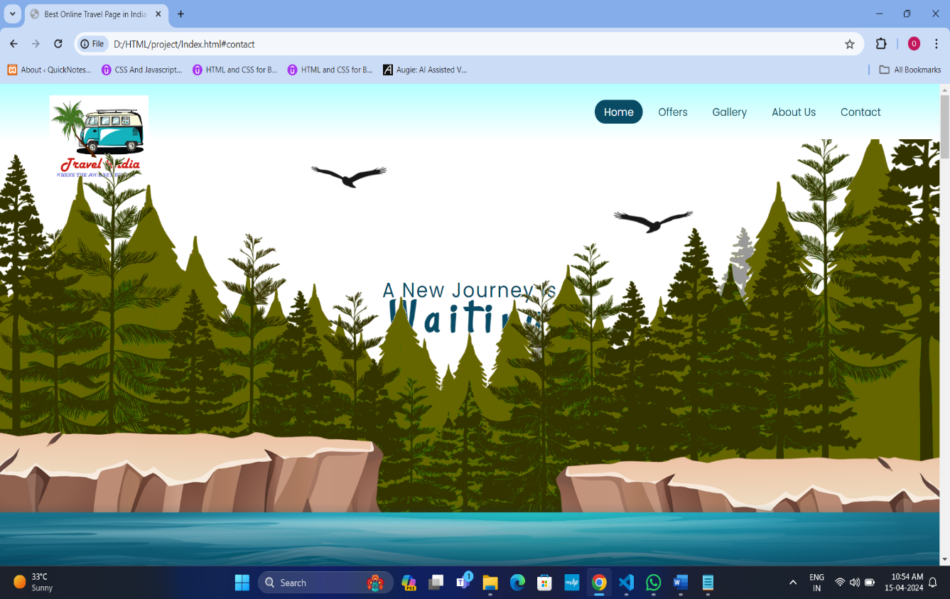

Booking Page :

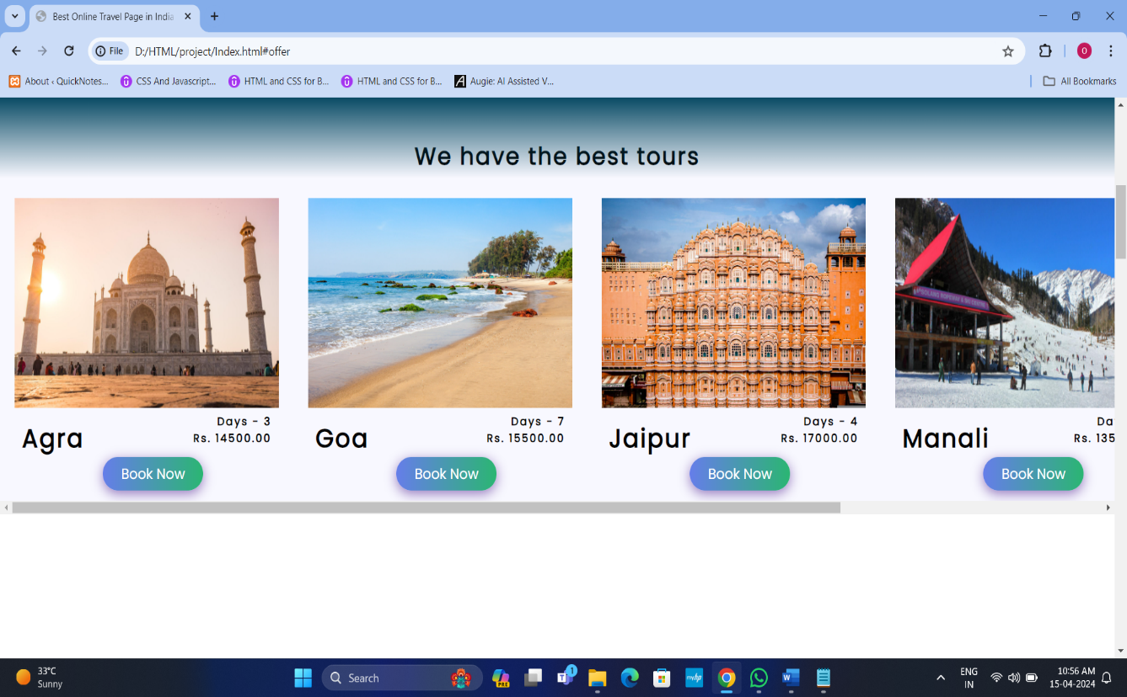
Gallery :

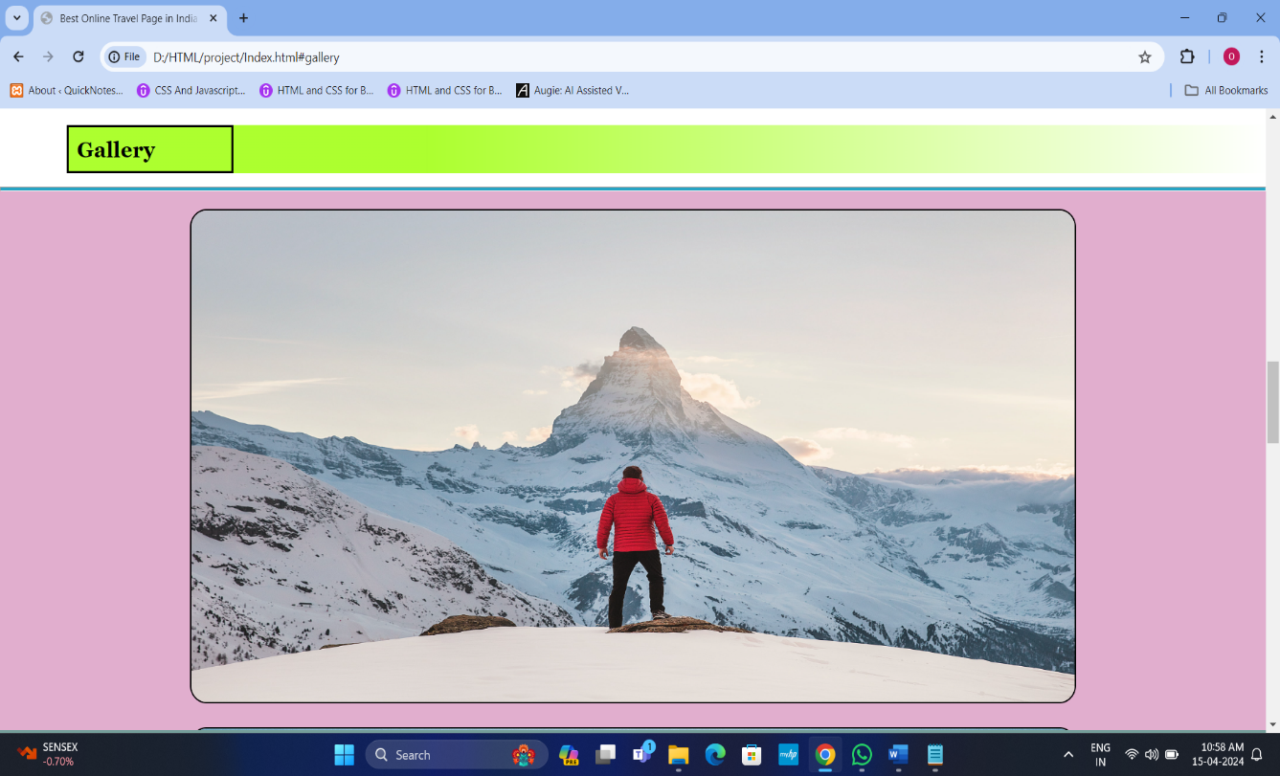
About Us :

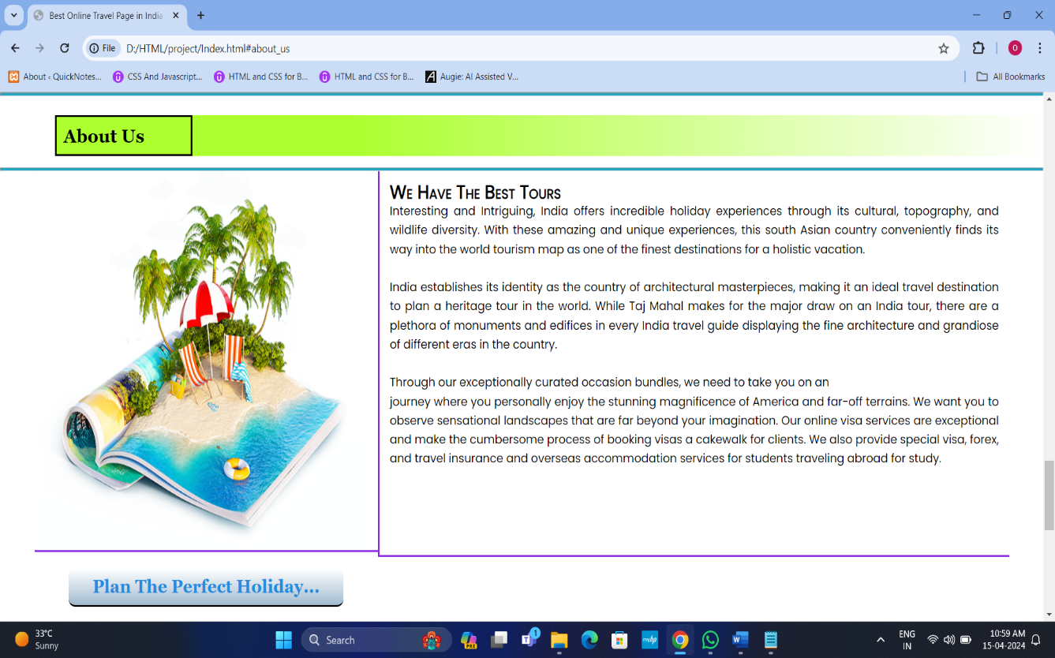
Contact Us:
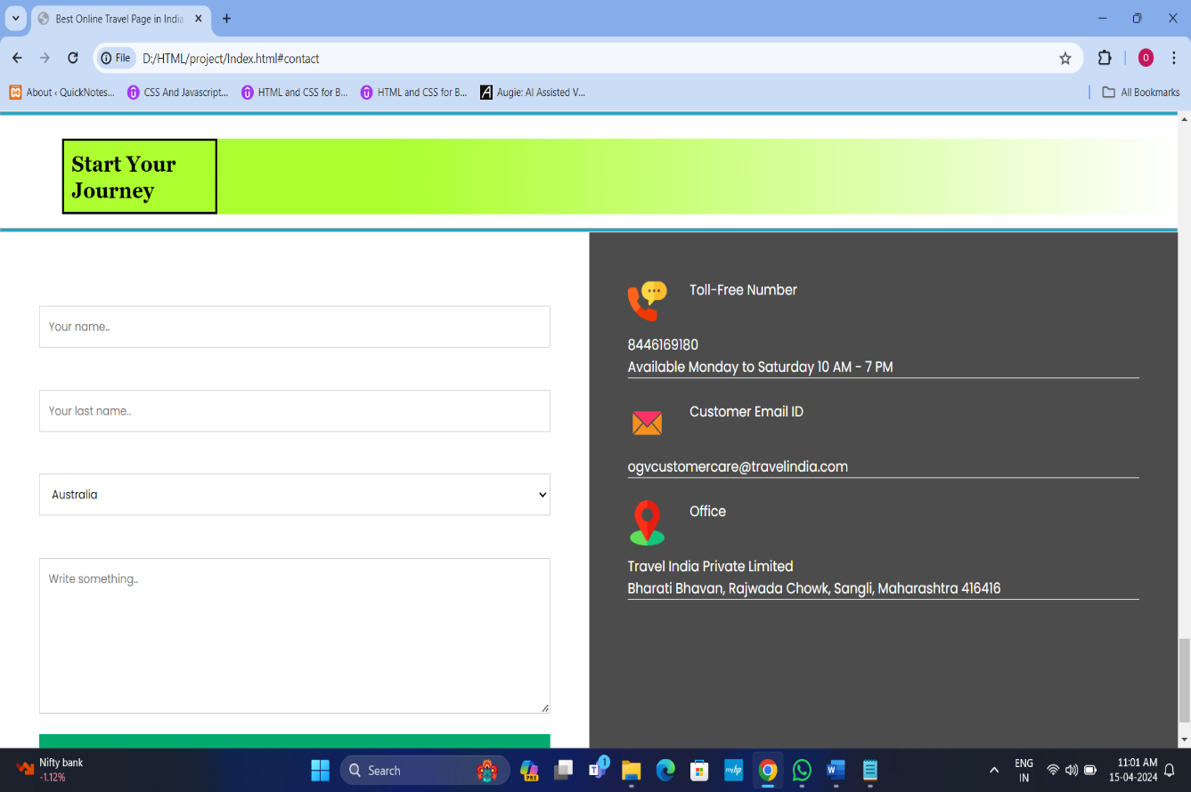
Booking Page :

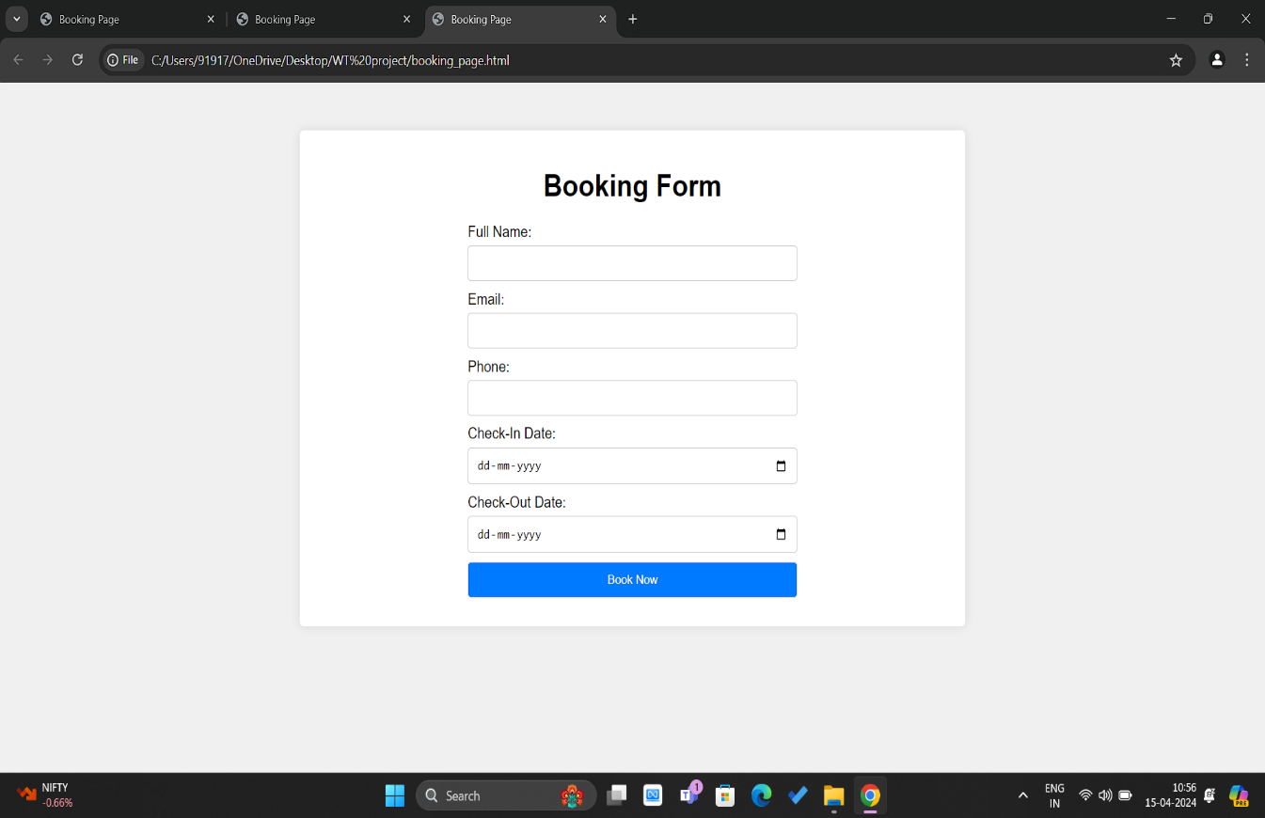

CONCLUSION

The travel management project has proven to be a pivotal tool in streamlining travel processes, enhancing efficiency, and ensuring cost-effectiveness within our organization. By implementing robust systems for booking, expense tracking, and itinerary management, we have significantly reduced administrative burdens and minimized potential errors.
Moreover, the project has facilitated better compliance with travel policies and regulations, ultimately leading to improved control and oversight. Moving forward, continued optimization and integration of innovative technologies will be crucial in maintaining our competitive edge and further enhancing the travel experience for all stakeholders involved.

BOOK & REFERENCES

- www.travelmanagementsystem.com
- https://youtu.be/ON_jkM0ZB0E
- www.google.com
- https://www.academia.edu

