**Pre requisites** : Visual Studio 2019, Dot Net Framework 4.8

**Steps To Execute** : Execute the FrozenLakeAIProblem.exe by double clicking on it

**Src :** Source Code is in Src folder

**Steps** :

1. Agent is iterating through the matrix
2. To improve Rationality, agent is skipping the **Key, and** whenever **Key** is found, it tries with other possible movement and move accordingly
3. For every step, 1 battery point is reduced so at the end total battery point is calculated

**Output Explanation :**

1. If Agent has next field value as “Null” then he will move to next field

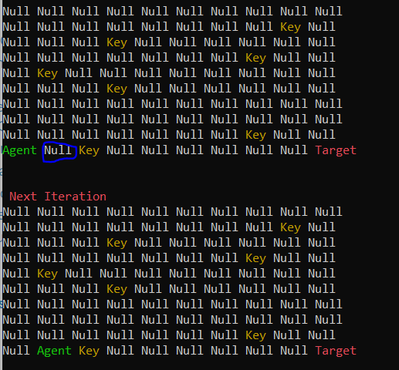

1. If agent find next field value as Key then he will look for other possible movement steps and try to skip the Key

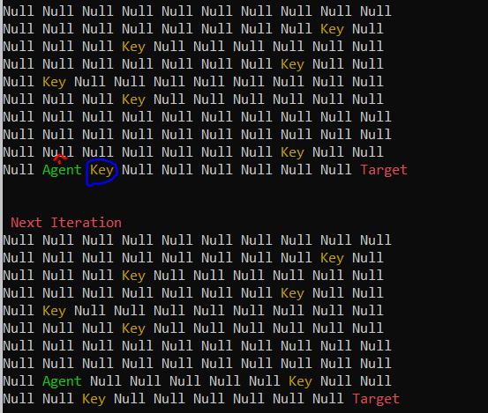

1. If agent finds next field as Key and there are multiple options are available for movement then agent takes the path which is near to target on the basis of horizontal and vertical coordinates 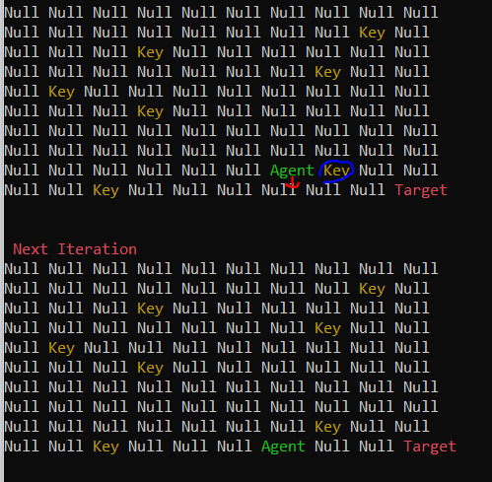
2. By following the algorithm, Agent will reach to the destination

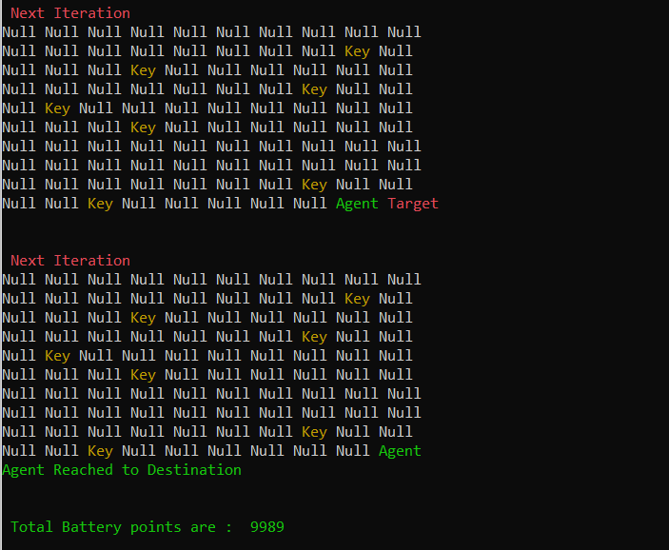

1. For each iteration 1 battery point is reduced from the total 10000 battery points and agent never override the Key hence agent saves 100 battery points.