Roll no.:20CSE1021

**Object Oriented Programing: Major Java language Project**

Roll no:20CSE1021

Name : Omkar Anil Borker

Project Name: Chatbot using Java GUI and swing

Description : This project is developed using java api and gui development packages.This project focuses around using the objects and methods of swing package(gui) and awt package to create a gui which can take commands and give suitable output as programmed.

The main functionalities are:

1)”hi” command

2)Telling the date and time (current)

3)Giving program age(the runtime of the program during which command is invoked)

4)Telling a random joke based on the pregiven jokes

5)Display a given picture from file

Given below the main menu gui:

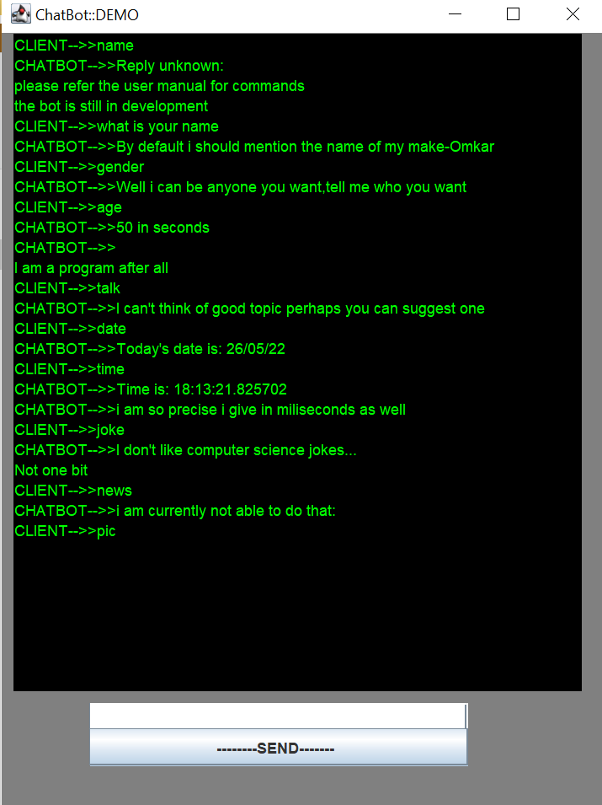

**How to run:**

1)Open command prompt

2)Go to the directory of project file.(cd _filepath_)

3)compile the source code using command

javac chatbotdemo.java

4)this will result in class files generated. Use the command given below (chatbotdemo contains main method).

java chatbotdemo

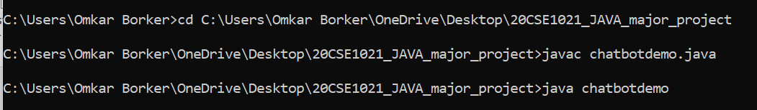

5)Please refer command handbook to get complete details of usable commands.