**Store management system in C Language**

Name : Omkar Anil Borker

Project Name: Department Store Management System

Description : This project is made using simple terminal GUI using library windows.h and with the knowledge of Unicode characters . The project offers the basic functions provided by a basic management system. The way data of item is stored is by name, item code, item quantity and price of the item.

The functionalities are:

1)Bill calculation.

2)Adding goods record/editing the existing record.

3)Search for goods record.

4)Deleting of goods record.

Below is the photo of main menu-

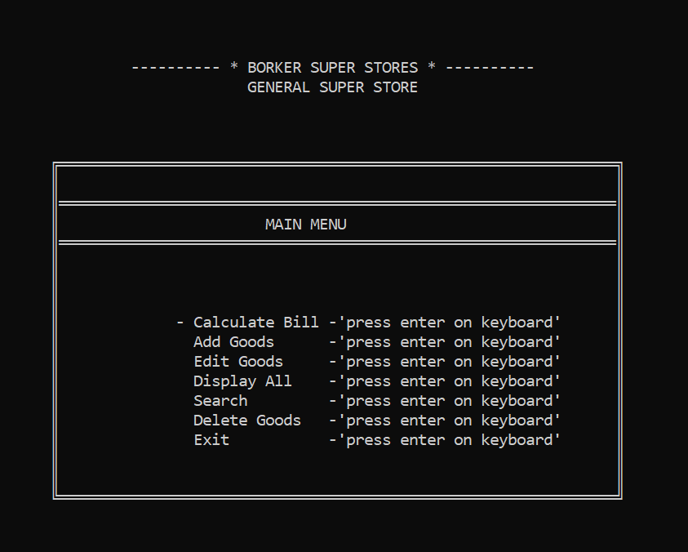

**How to Run:**

1)Open command prompt

2)Go to the directory of project file.(cd _filepath_)

3)compile the source code using command

gcc main.c

4)run the program using command

main.exe

5)Use the commands provided by the program