./

Report on – GkQuiz

Course Code: <CODE>



Report by: Omkar Chitragar

Ps no. : 99007640

Module : C-programming on multiple platforms

|  |  |  |  |  |  |
| --- | --- | --- | --- | --- | --- |
| **Ver. Rel. No.** | **Release Date** | **Prepared. By** | **Reviewed By** | **Approved By** | **Remarks/Revision Details** |
| 1 | 12/02/2022 | Omkar Chitragar |  |  |  |

**Document History**

# Table of Contents

* Description.
* Requirements.
* SWOT analysis.
* 4W’s and 1H.
* Architecture.
* Test plan.
* Test plan output.

# Description

## **GkQuiz:**

This quiz is designed to test the general knowledge of the user and help the user with an knowledge update. The user can take up the quiz by entering their credentials. Depending upon the user's score in the quiz, the user is provided with good/average/poor general knowledge as a result. User can end the quiz with end option and restart the quiz with restart option.

# Features of the project:

* User can enter the username in order to participate in the quiz.
* User can attempt the quiz and view the result.
* User can end the quiz.
* User can restarts the quiz.

**How each features is implemented:**

* Prints the statement asking the credentials such as name of the user for the participation in the quiz.
* Displays the multiple choice general knowledge questions to the user.
* Takes input as right/wrong answer from the user.
* Displays result upon completion of the quiz.
* Provides user with end option to end the quiz.
* Provides user with restart option to restart the quiz.

# Requirements

## High Level Requirements

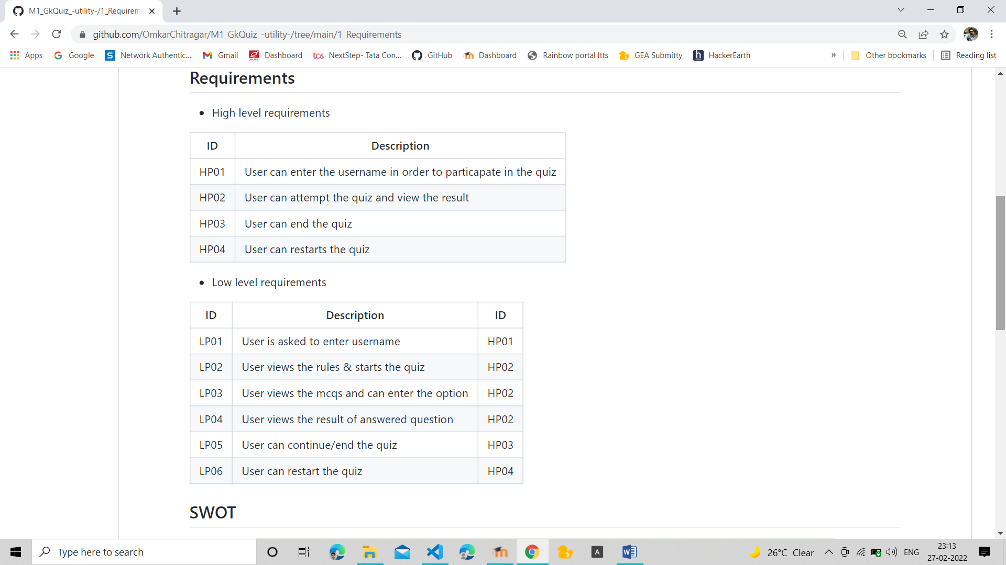

## Low Level Requirements

## 

## **SWOT analysis**

[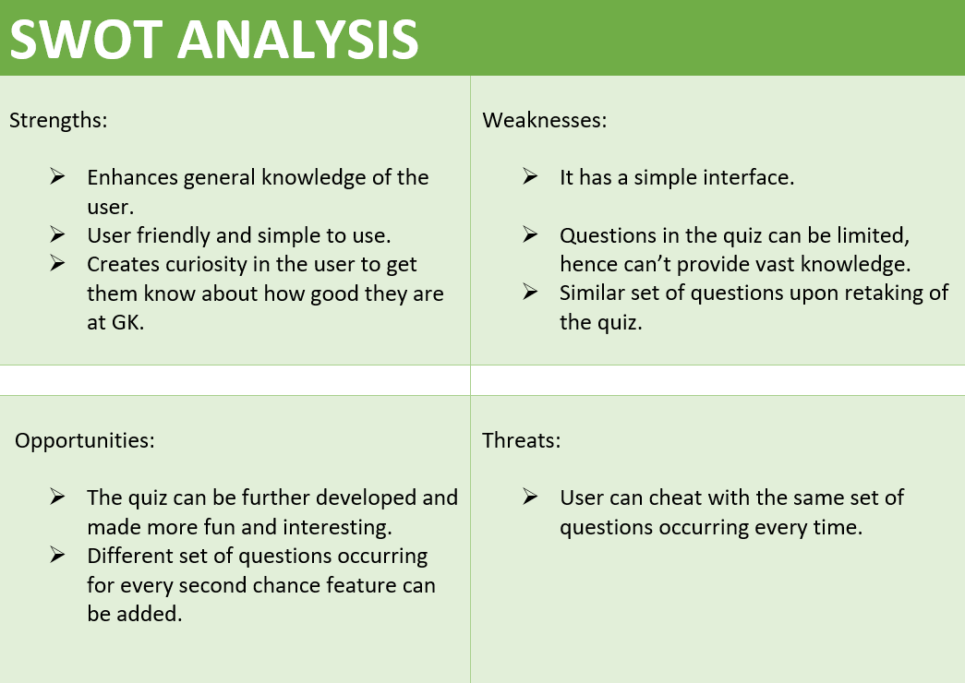](https://user-images.githubusercontent.com/42509490/153286605-2b3fae1f-2164-4568-a48f-b2b75c0bda07.png)

## **4W's & 1H**

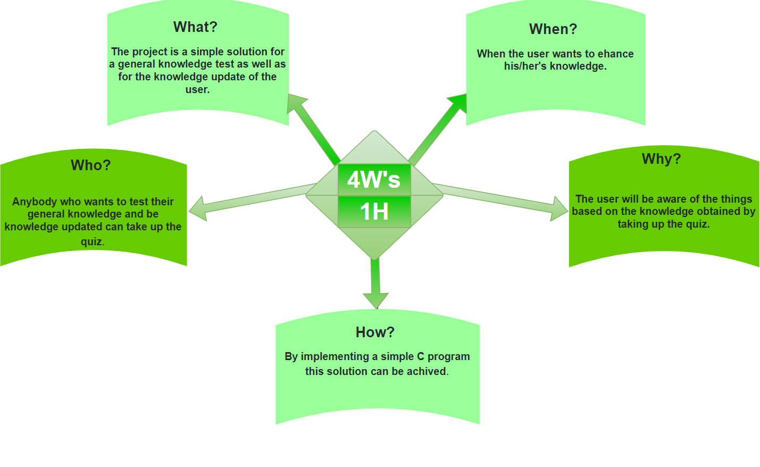

# Architecture

## **Structural diagram: Black box**

[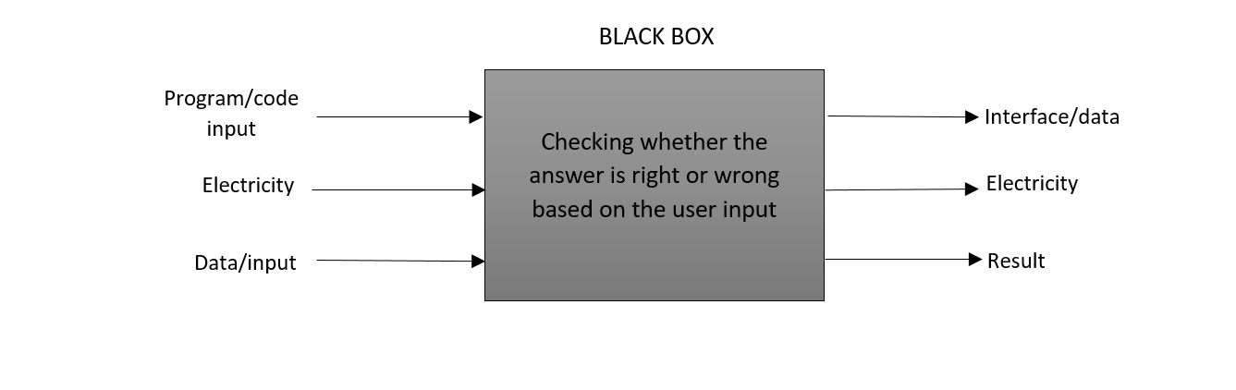](https://user-images.githubusercontent.com/42509490/153348755-d2583dae-5560-4f6e-b13c-ab75afec00ac.png)

## **Functional diagram:**

[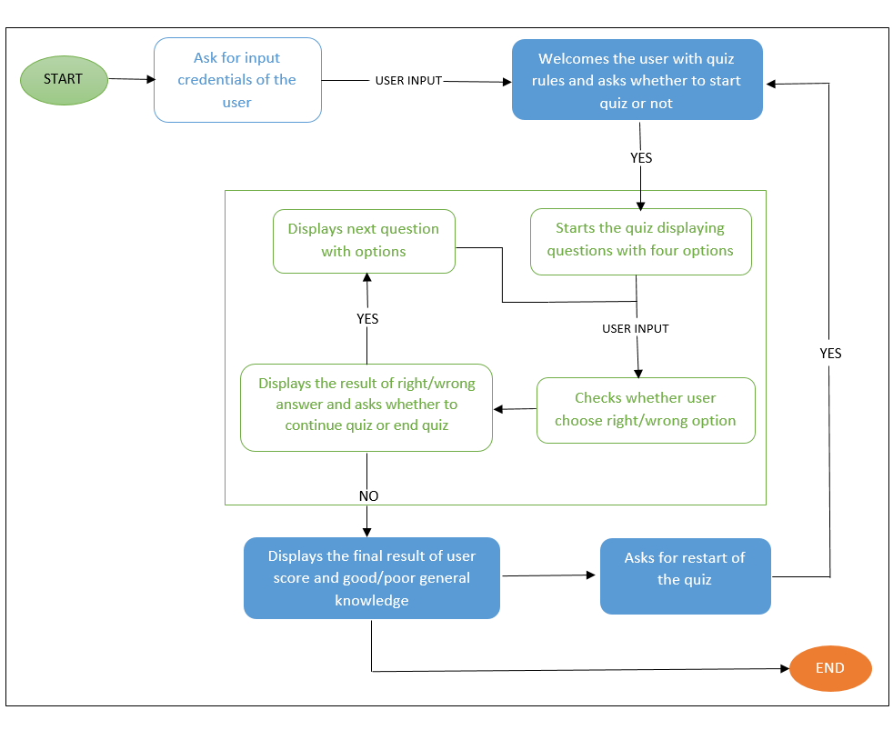](https://user-images.githubusercontent.com/42509490/153705708-c588a4fc-c9a4-4606-9036-84a72da7d91b.png)

## **Behavioral diagram: Flowcharts**

[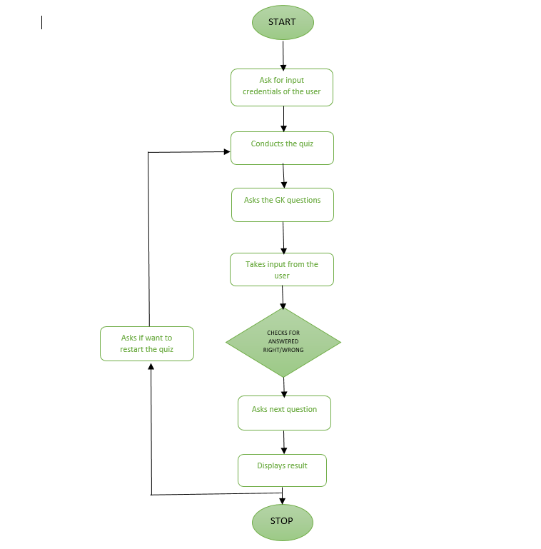](https://user-images.githubusercontent.com/42509490/153705620-98496a79-70c6-4291-aa63-8883d120d18f.png)

## **Usecase diagram:**

[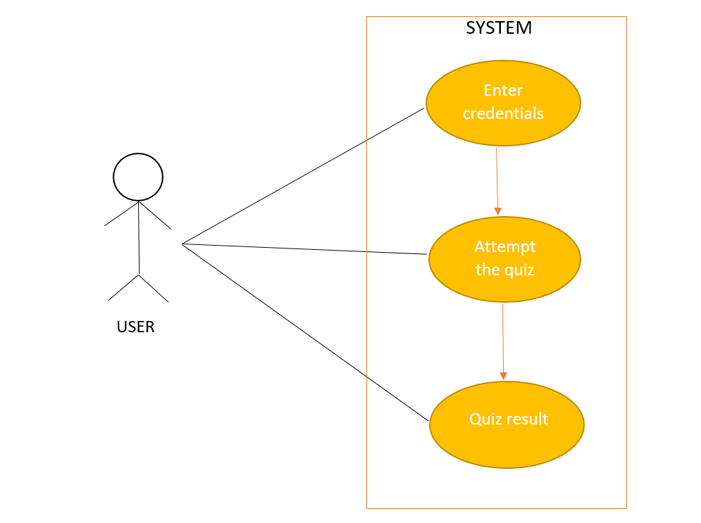](https://user-images.githubusercontent.com/42509490/153346897-d2576243-e63c-49e8-82ce-f44e833a7052.png)

# Implementation

* In C programming.

# Test Plan

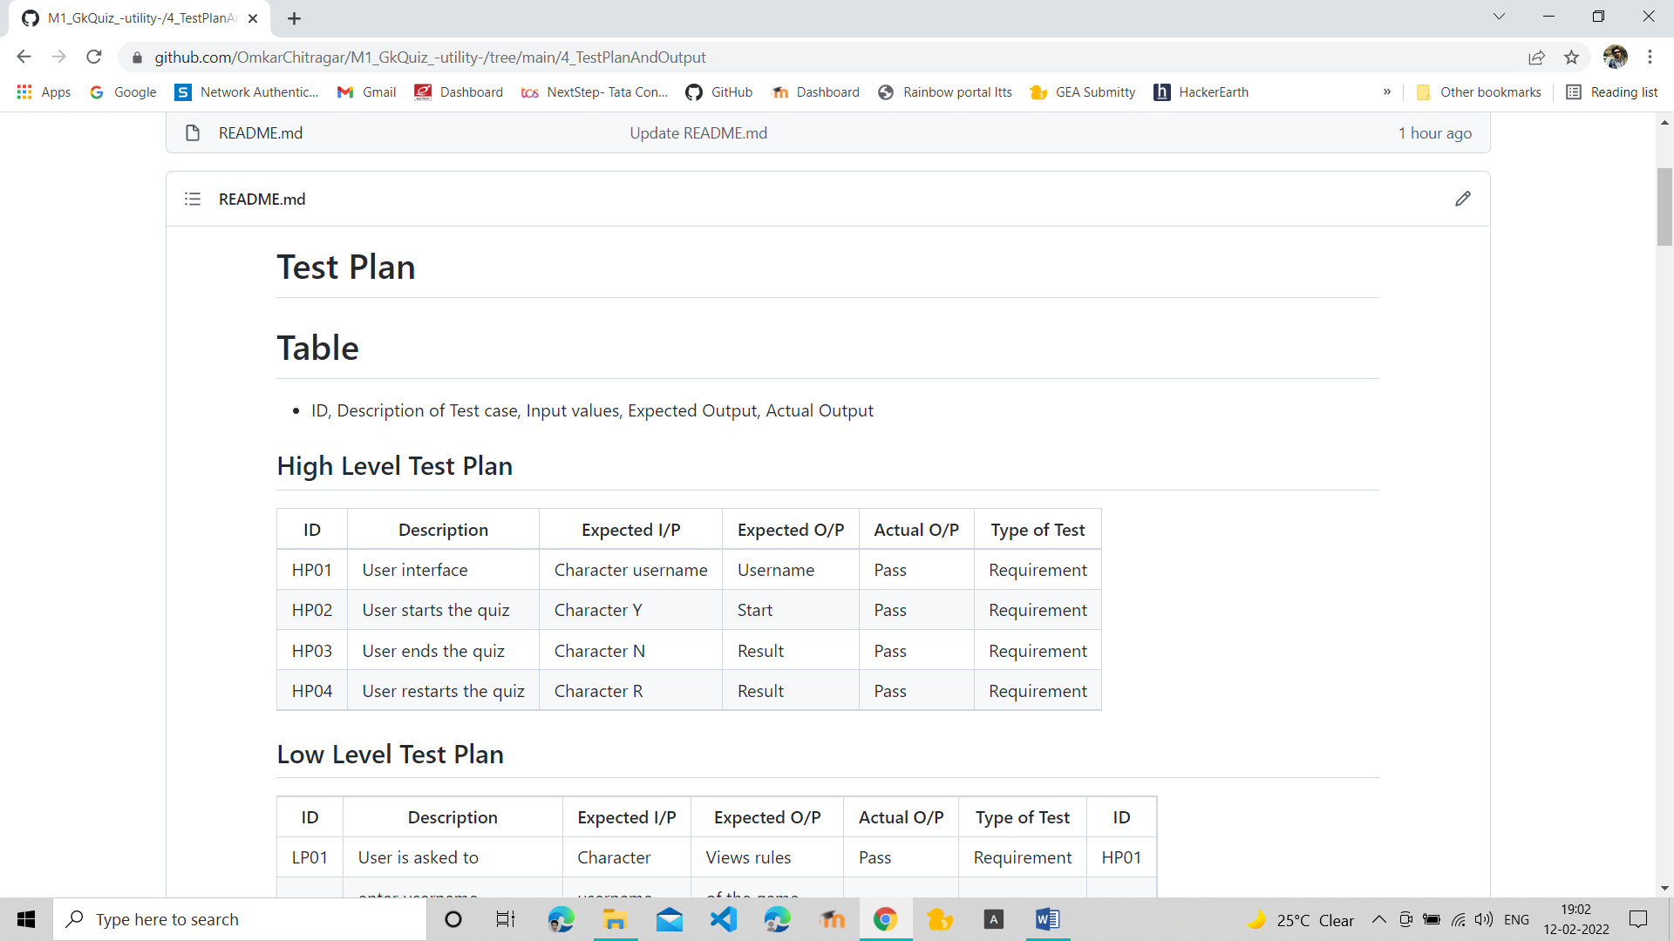

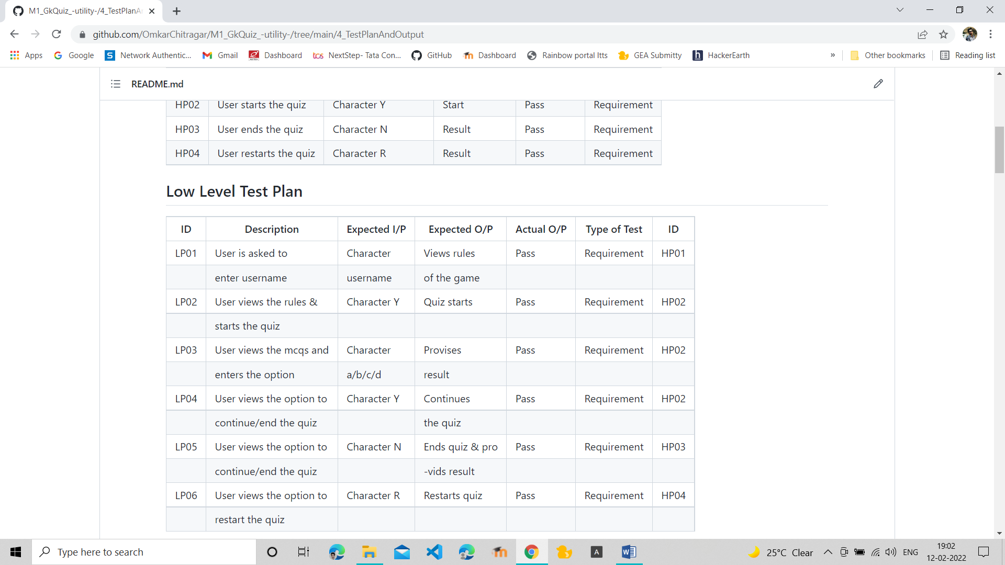

## **Test Plan Outputs**

* **Interface Output:**

[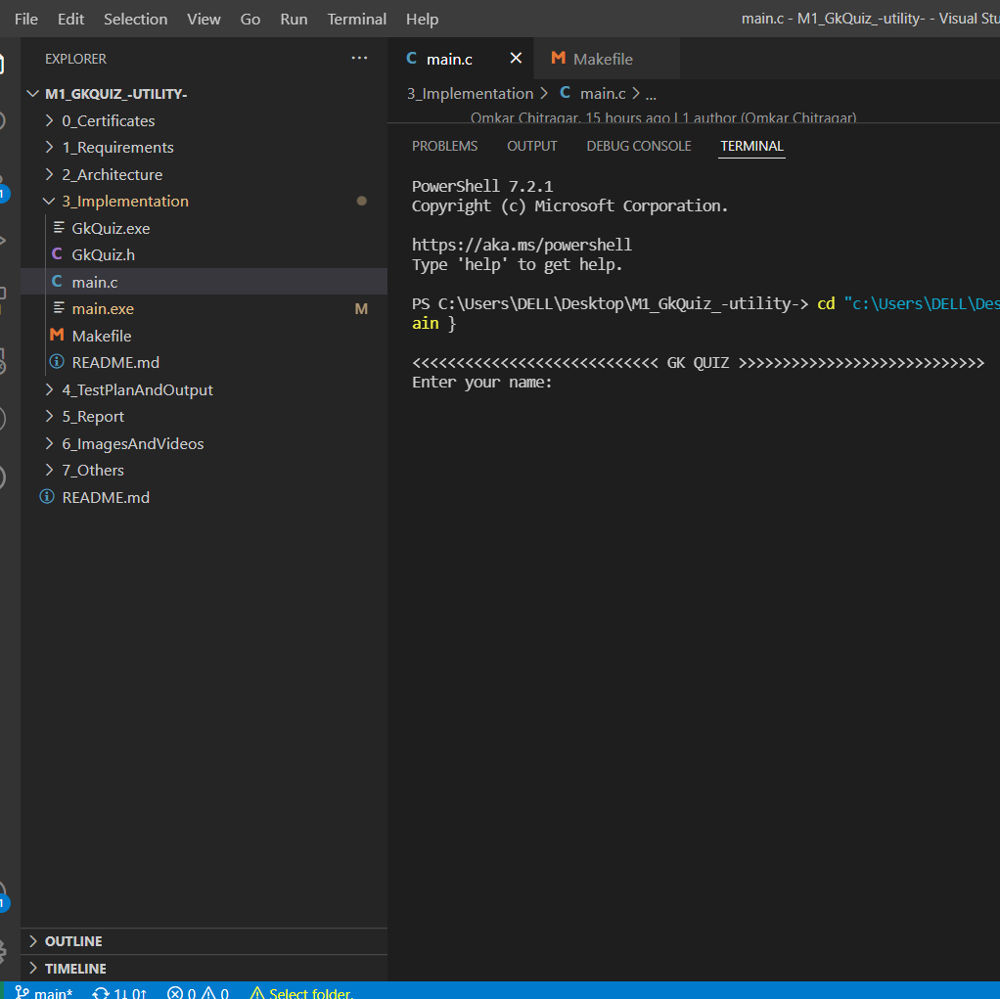](https://user-images.githubusercontent.com/42509490/153711501-1200e7af-e79c-42ba-ad1b-cf8bf65bbffd.png)

* **User enters the username and starts the quiz:**

[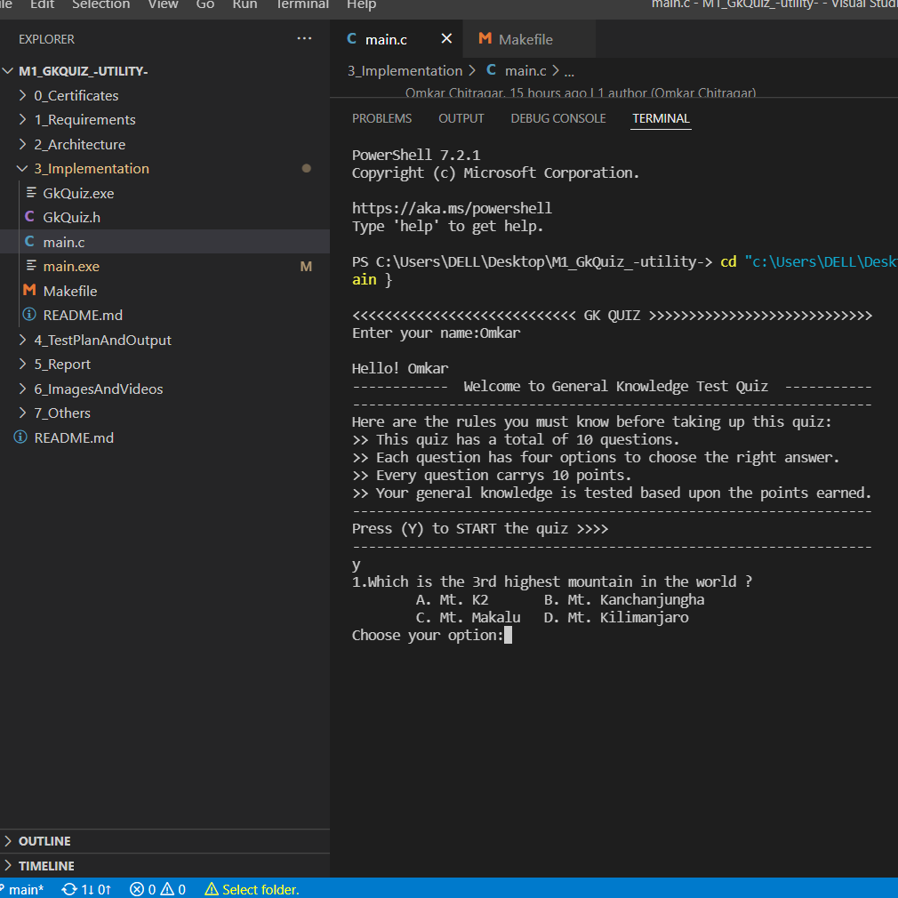](https://user-images.githubusercontent.com/42509490/153711526-3822287f-d92c-4935-84d9-d38d3ee92144.png)

* **User attempts the quiz entering option a/b/c/d and gets result output:**

[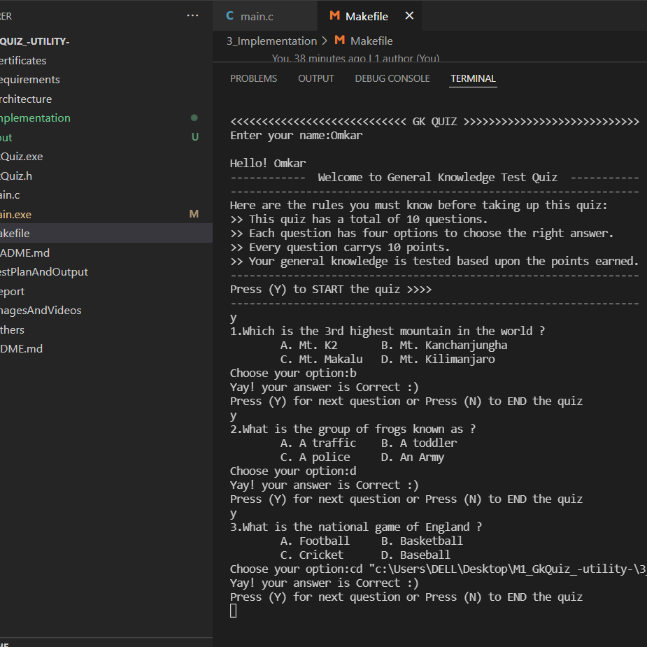](https://user-images.githubusercontent.com/42509490/153711675-f219ac6e-7480-4ca7-aaf3-cd604294dca3.png)

* **User ends by entering input ‘N’ the quiz:**

[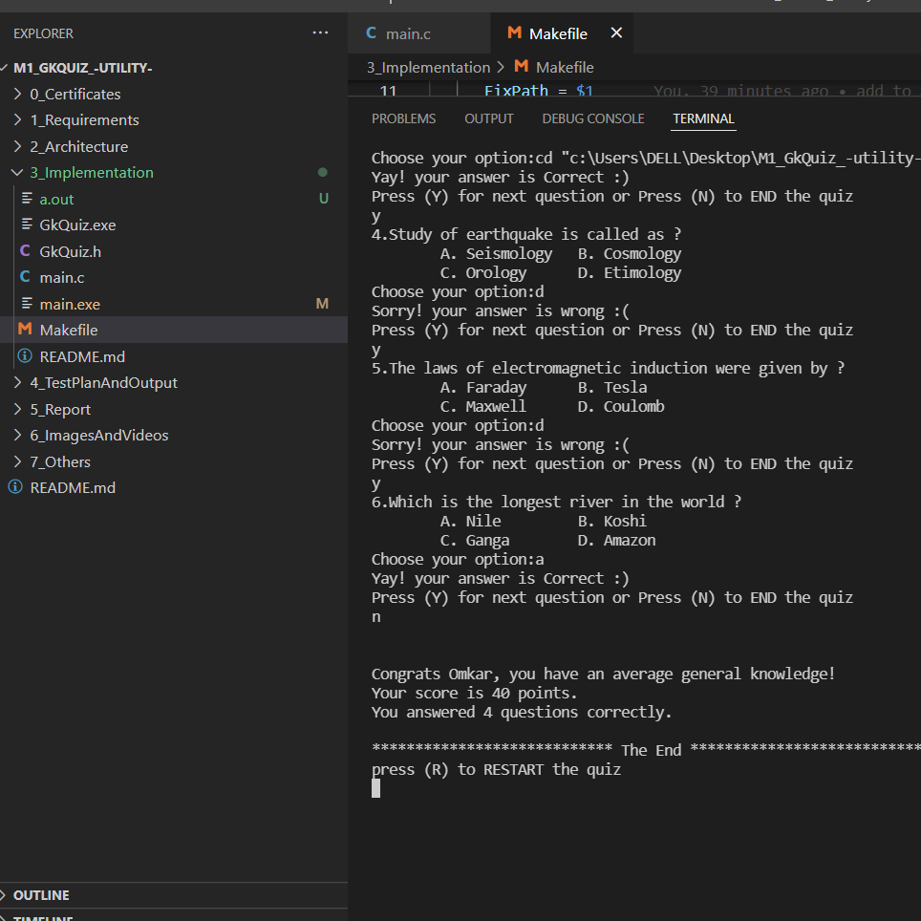](https://user-images.githubusercontent.com/42509490/153711721-de262028-2f0c-4931-a4ba-98d02c51c065.png)

* **User can restart the quiz by entering the input ‘R’ after the quiz ends :**

[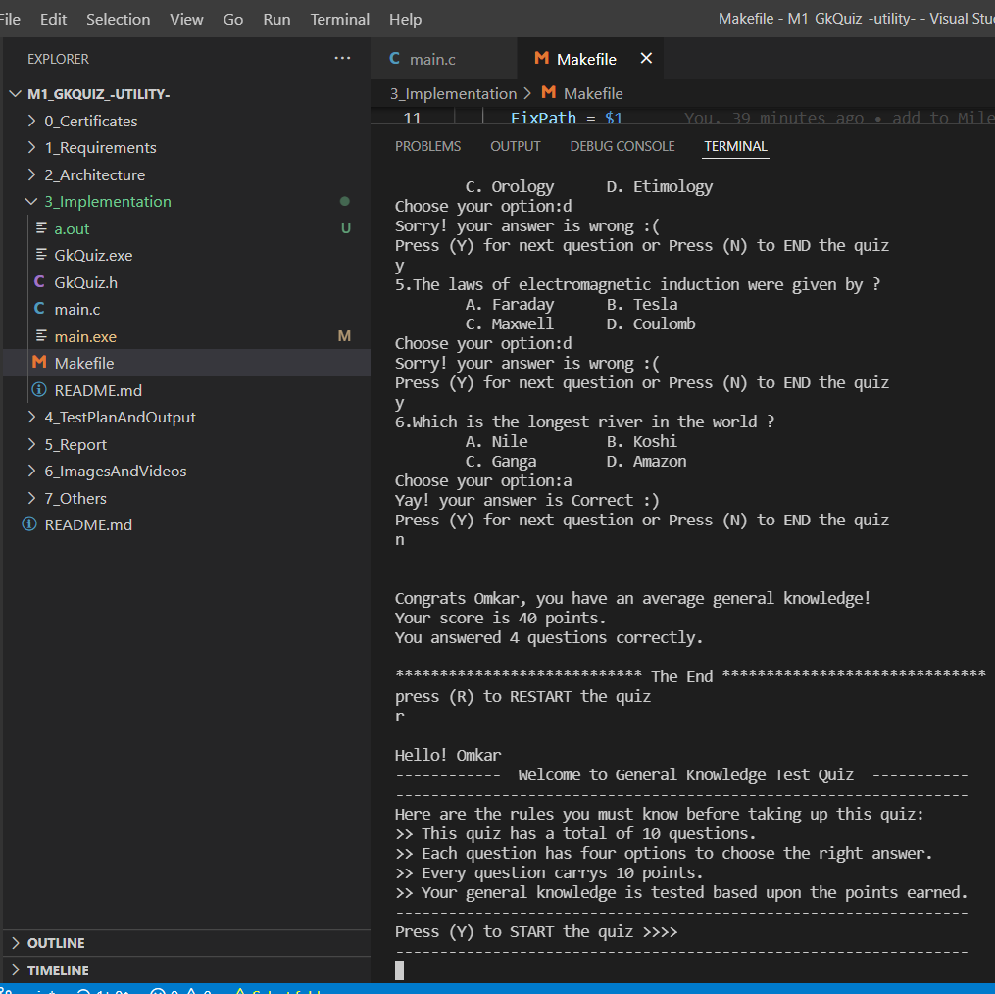](https://user-images.githubusercontent.com/42509490/153711745-34990b79-02fd-4357-b6f3-0815fa8f5b07.png)

THANK YOU!