# report on Automatic Water Pumping System with Overflow Control

Table of Contents

1. About Automatic Water Pumping System with Overflow Control
   1. Abstract
   2. Description
   3. Identifying features
   4. SWOT analysis
   5. 4W's and 1H

2. Requirements

2.1 High level requirements

2.2 Low level requirements

3. Component Details

4. Architecture

4.1 Black box

4.2 Behavioural diagram

4.3 Structural diagram

4.4 Best method followed

5. Test plan and output

5.1 High level test plan

5.2 Low level test plan

6. Application

## 1.1 Abstract

* In our daily life, we observe lots of wastage of natural resource such as water, one of the major area where the wastage of water is seen is overhead tanks at our homes. Whenever the water in the tank gets empty, we switch on the water pump to fill up the tank. Once the water in the tank fills up, it starts to overflow without any indication to us. In addition, we need to manually switch on/off the water pump in a timely manner. So in order to prevent the overflow of the tank and make the whole process of pumping up the water automated an Automatic Water Pumping System with Overflow and Water Level Indicator can be great solution.

## 1.2 Description

* This automated system has two water level sensor, which is to be attached at top x1 and bottom x1 surface of the water tank which detects the water level in the tank and switches on/off the water pump and also displays the water level.

## 1.3 Identifyng features

* It must detect the water level and display the water level.
* It must detect the low water-level and start the water-pump immediately with an indication.
* It must detect the high water-level and stop the water-pump immediately with an indication.

## 1.4 SWOT analysis

[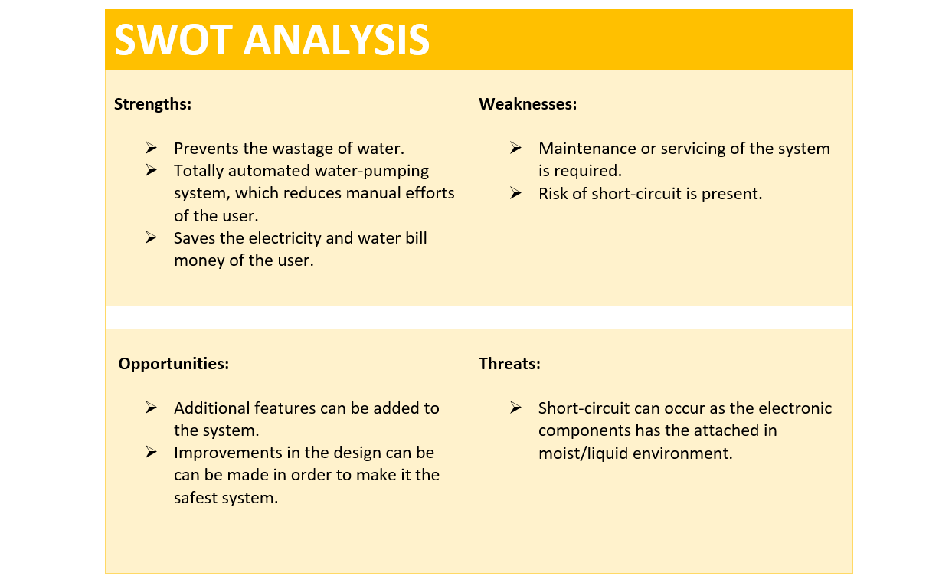](https://user-images.githubusercontent.com/42509490/155770217-7c11c6d5-c1c7-49fe-ad25-791606eb5779.png)

## 1.5 4W’s and 1H

* Why?

This system can be used by anyone who wants to save water as well as their money.

* What?

This system is an automatic water-pumping and water level indicator system which save a lot of manual efforts.

* When?

When the water level is low the water gets filled in the tank through water-pump and when the water gets filled fully in the tank, the water-pump offs.

* Where?

This system can be used at any place where the water storage tank is present.

* How?

The system controlled by atmega328 microcontroller and water level sensor which gives inputs to microcontroller, based on which the water-pump is controlled to fill the water tank.

# 2. Requirements

## 2.1 High Level Requirements

|  |
| --- |
|  |

## 2.2 Low Level Requirements

|  |
| --- |
|  |
|  |

# 3.Component detailes

| 4. Architecture |
| --- |
| 4.1 Black Box [Screenshot (228)](https://user-images.githubusercontent.com/42509490/155834819-0c1687c7-6275-4996-bb24-75e96938209d.png) 4.2 Behavioural Diagram/ Block Diagram [Screenshot (226)](https://user-images.githubusercontent.com/42509490/155833107-f9aa439e-6d0e-4d3d-b540-34d50e8ef612.png)  [Screenshot (226)](https://user-images.githubusercontent.com/42509490/155833107-f9aa439e-6d0e-4d3d-b540-34d50e8ef612.png) 4.3 Structural Diagram/ Flowchart [Screenshot (227)](https://user-images.githubusercontent.com/42509490/155833154-4395fcd1-1a22-4737-9e90-5f9fa67c6042.png) 4.4 Best method followed  * The best of the best diagrams are considered. * With the use of all the diagrams code will be built. * Low level and High level requirements are implemented.  5. Teat plan and output  * To be implemented.  5.1 High Level test plan  5.2 High Level Test plan |

# 6. Applications

* This system can be used in overhead water tanks in house.
* This system can be used in offices and industries.
* This system can be used in other liquid tanks such as oil, milk. .etc, other than water.