Tableau

By Group Id 1:
- Shubham Darak (33212)
- Omkar Deshpande (33213)
- Devesh Chandak (33214)
- Alrik Fernandes (33217)

1

What is tableau ?

- Tableau is an easy to use business intelligence software.
- It makes data visualization, data analytics, and reporting as easy as dragging and dropping.
- It is easy to learn.
- Anyone can learn to use Tableau without having a prior programming experience.
- Tableau can combine data from various data sources such as spreadsheets, databases, cloud data.

2
Why tableau ?

- Every organization needs to analyze their data for optimal decision making.
- Analyzing data has never been easier with traditional business intelligence tools.
- Tableau is very easy to learn. Even with no prior programming experience.
- It provides on various types of databases.
- It has interactive dashboard.
- Tableau is comparatively affordable.

3

How to install Tableau ?

- Go to https://www.tableau.com/academic/students, and register there (You will get a product key through mail ).
- Now, download tableau for desktop (download link will also be in mail).
- Double Click on the setup file and click next.
- Install tableau using the product key that you received through mail.
- Congratulations ! You have installed tableau.

4
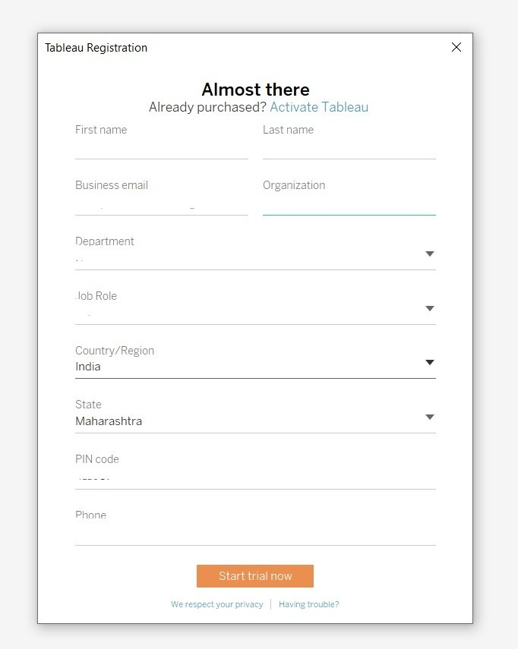

Installation step 1 -

  - Go to https://www.tableau.com/academic/stud ents
, and register there (You will get a product key through mail ).

5

Installation step 2 and 3 -

    - Now, download tableau for desktop (download link will also be in mail).
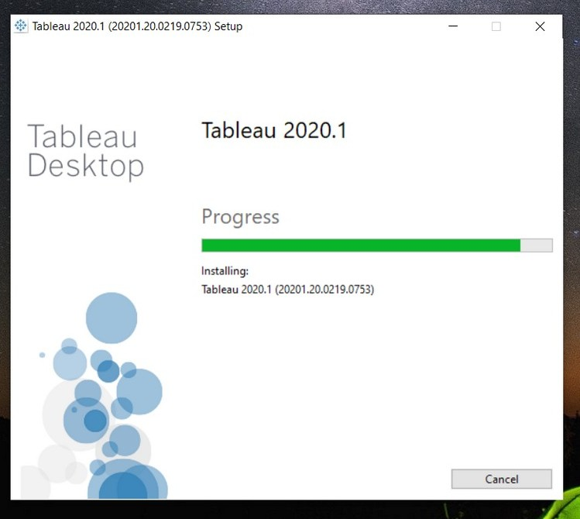

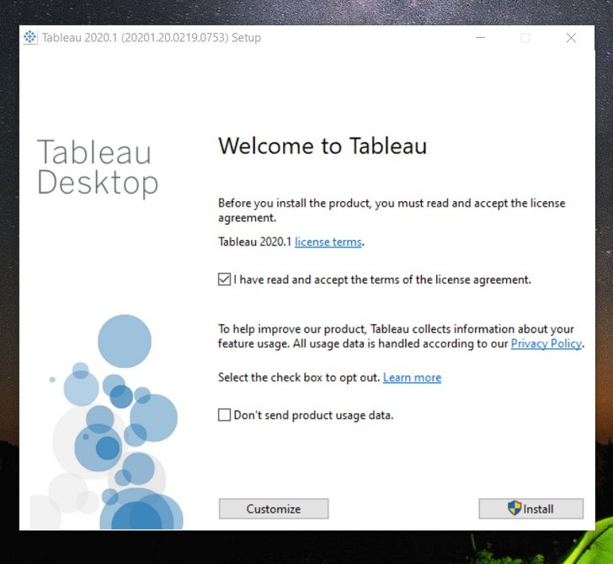

    - Double Click on the setup file and click next.

6

Installation step 4 -

- Install tableau using the product key that you received through mail.
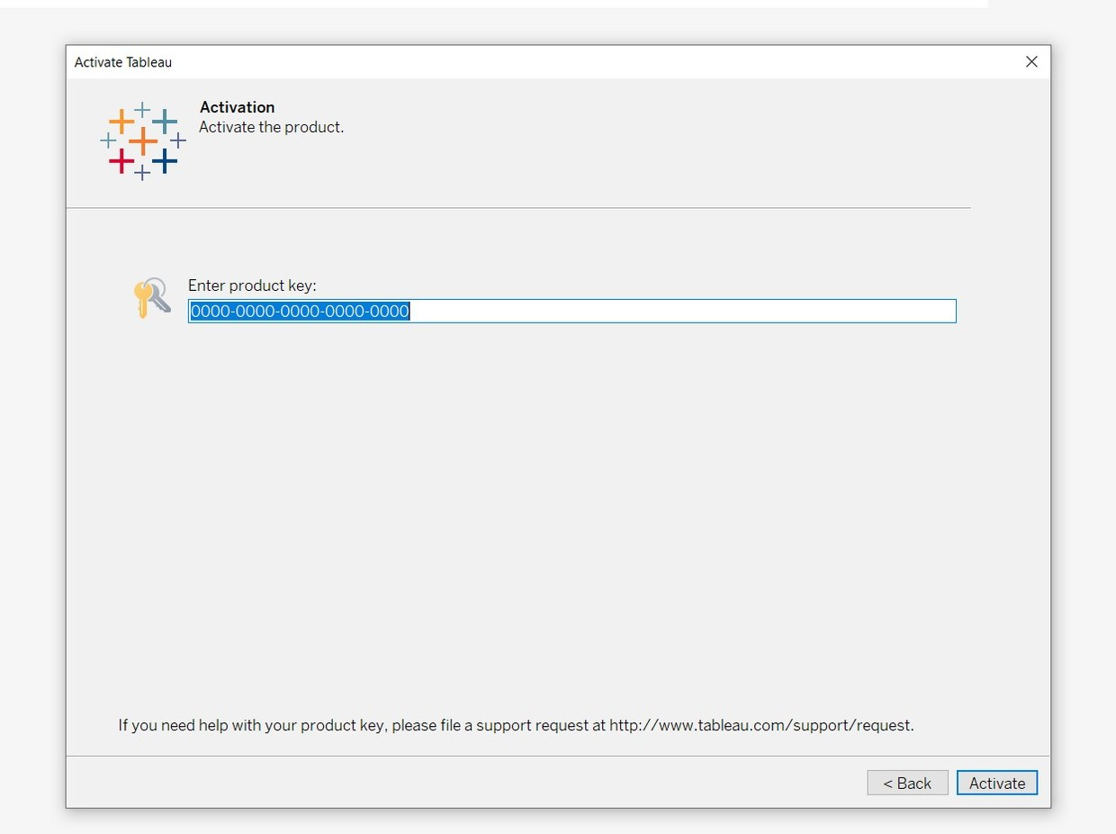

7

Installation step 5 -
- Congratulations ! You have installed tableau.
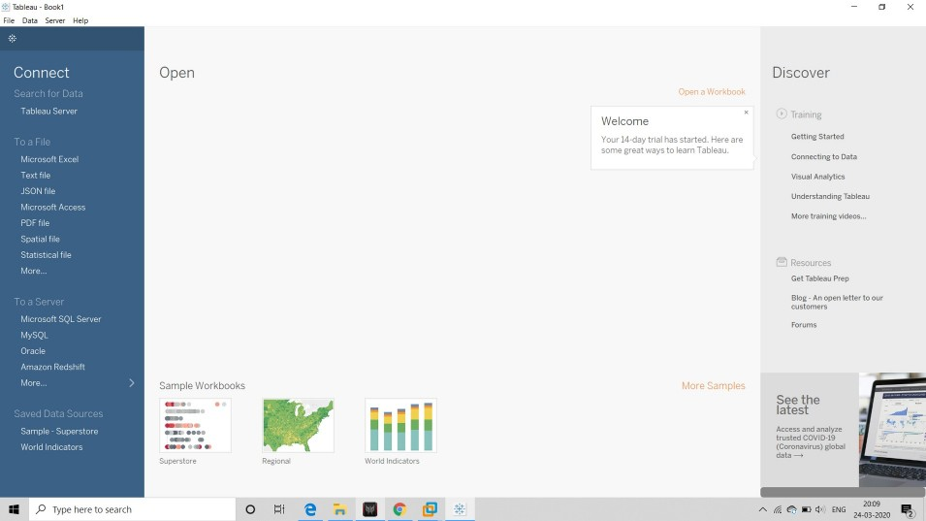

8

Connecting to your data in Tableau -
- Connecting to local Data -
  - Excel
  - Text File
  - Database Files
- Connecting to server ( Live Data ) -
  - Tableau server
  - MySQL
  - Hadoop
  - Hive
  - Oracle
  - PostgreSQL
  - SAP 9
Connecting to local data -

    - On the left hand side panel, in the “Local” section, select the type of file you want to import.
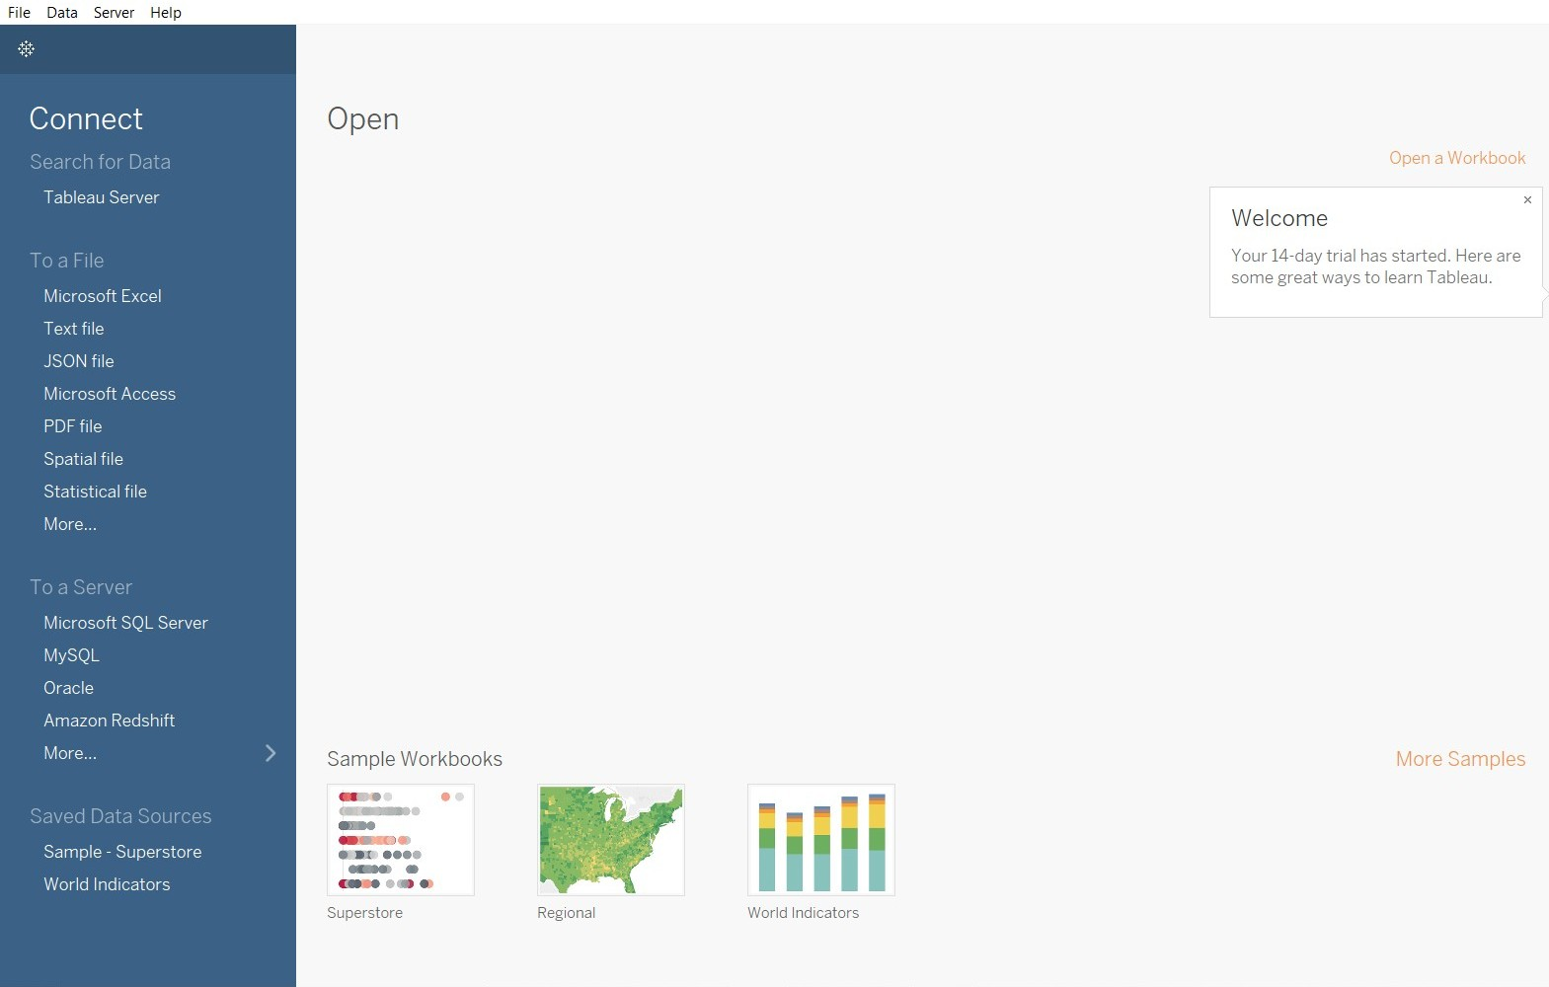

    - Now, browse the location of local database, select it and click “open”.

10

Connecting to Live data -

      - On the left hand side panel, in the “SERVER” section, select the type of configuration you want to connect to.

      - Now, tableau will ask for authentication for the server.
      - Complete the authentication step to connect to server.

11
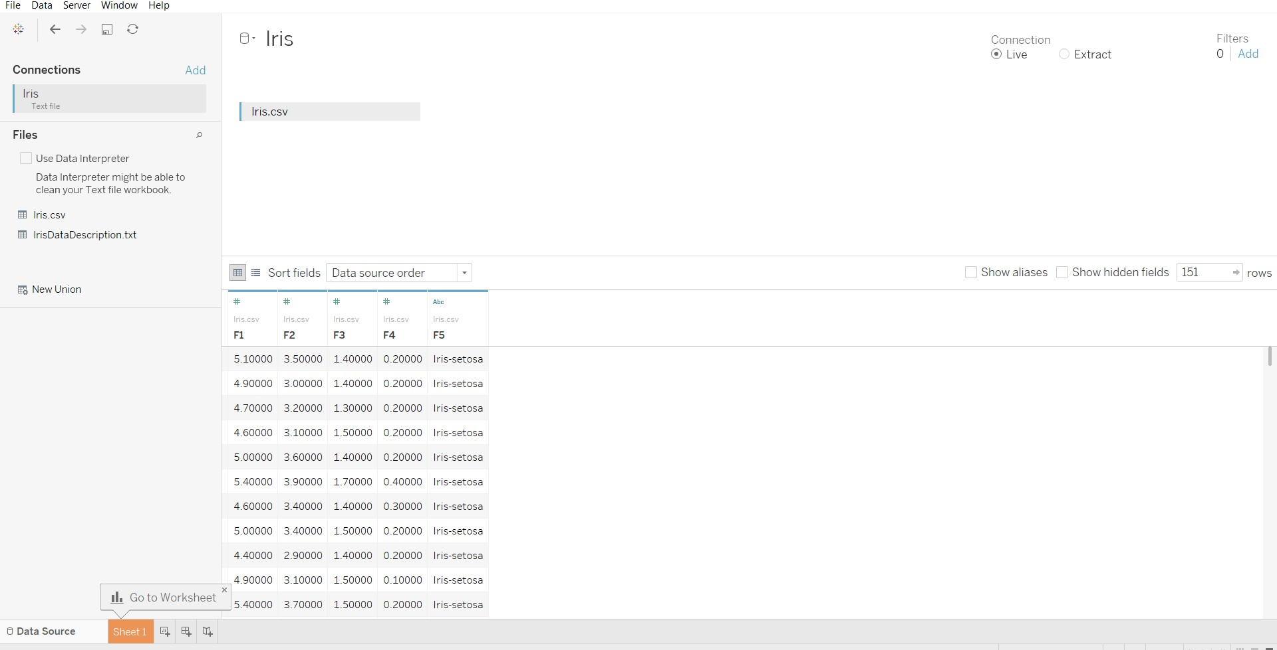

After connecting to database you will come to homepage -

12
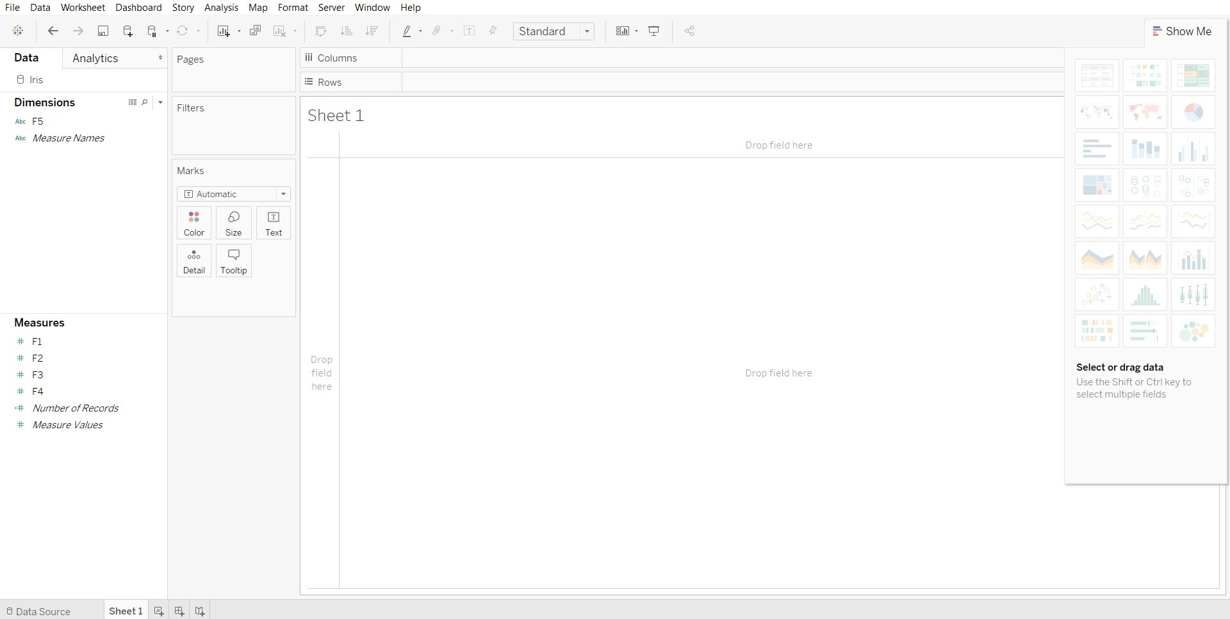

Start visualizing by clicking on “Sheet 1” at bottom

13

Creating charts -

- Now comes the fun part !
- You will have your attributes from your database on the left hand dashboard.
- And you can select type of graph from right hand side dashboard.
- Just drag your attributes from left and select type of graph from right.
- Enjoy …! Create your own Visualizations !

14
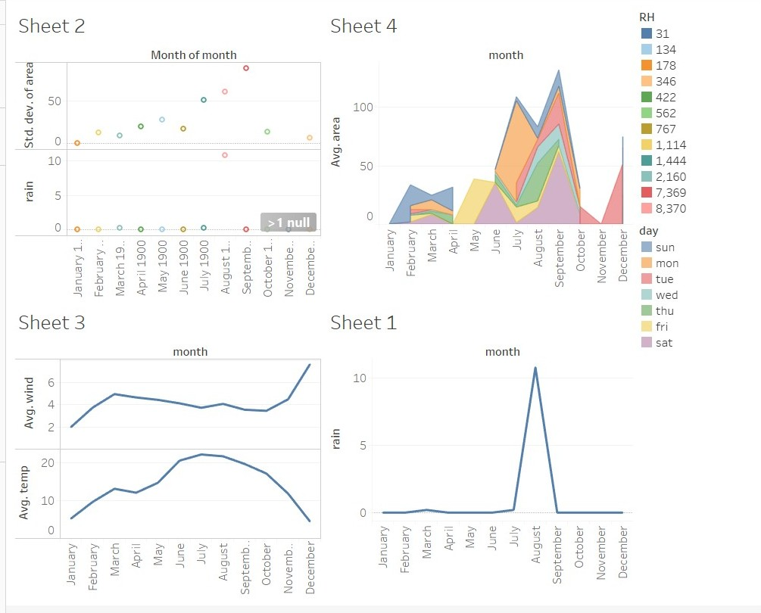
Creating Dashboards -

  - After you are done with your charts, you can show them at one place using Dashboards.

15
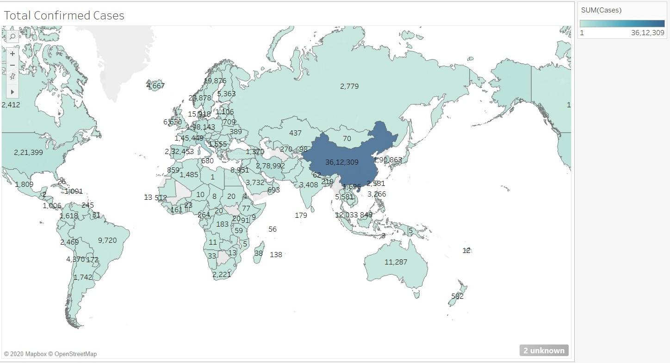

Example - COVID-19 live statistic visualization

16
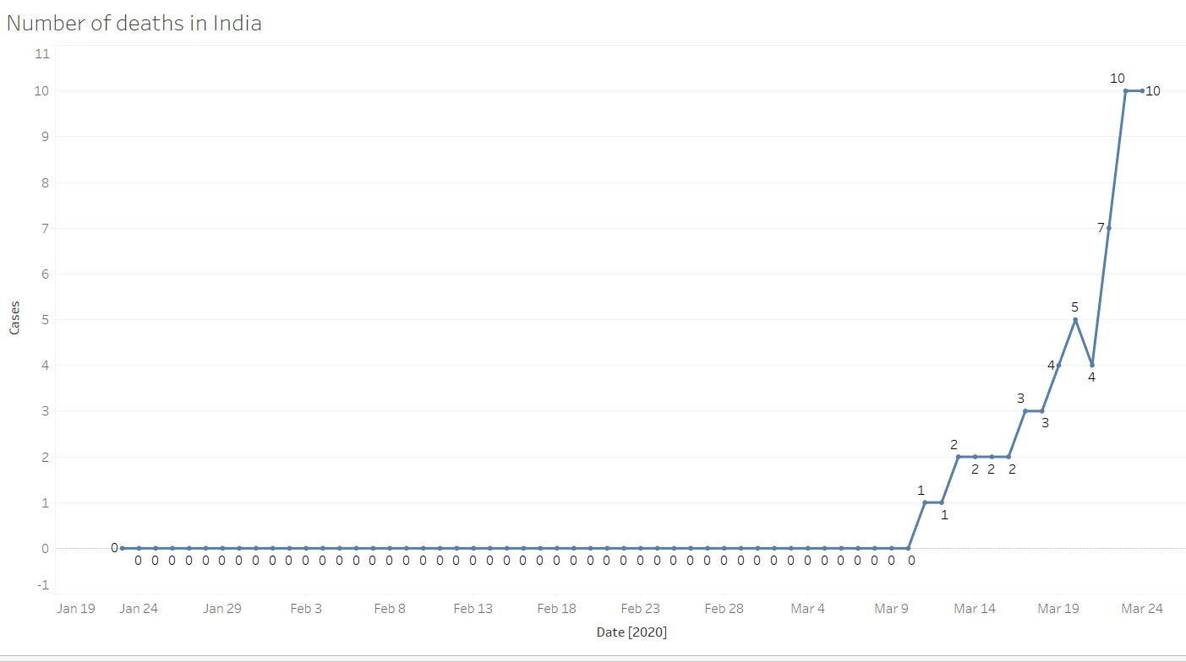

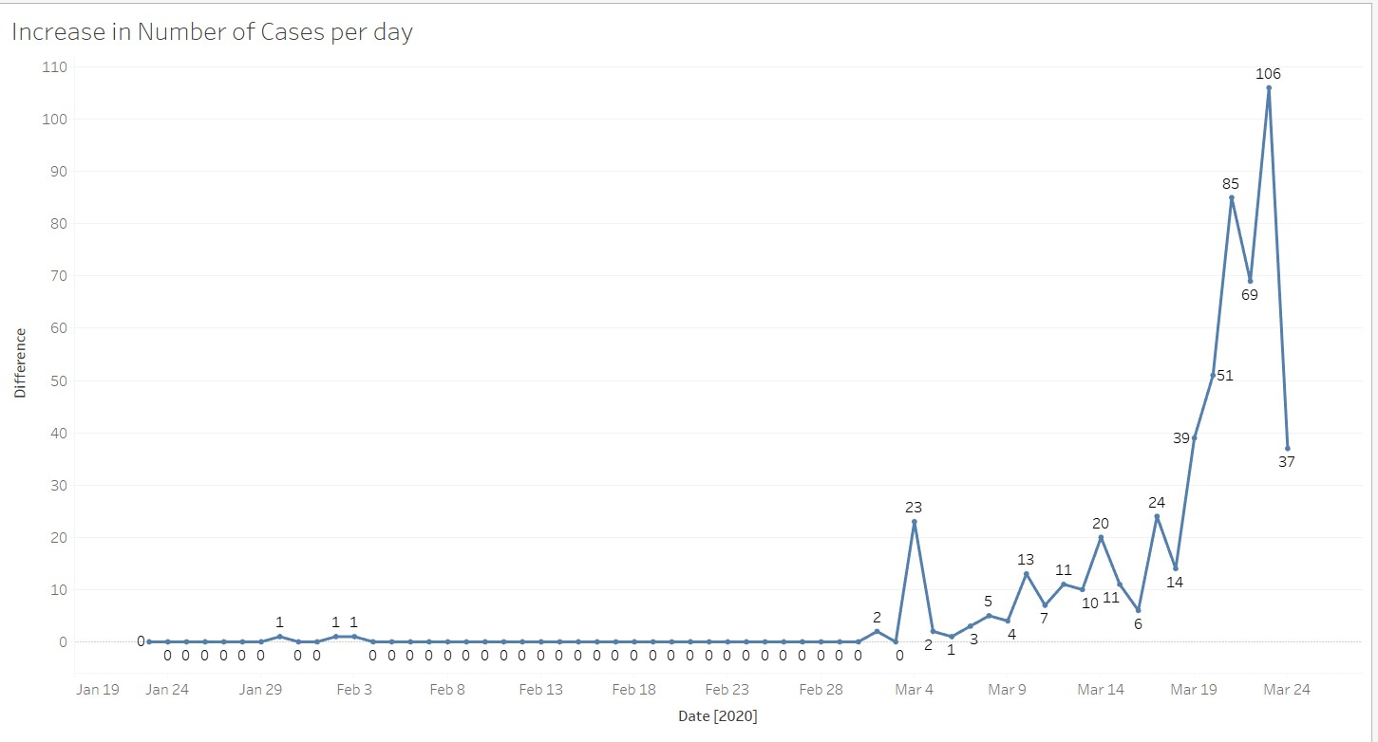

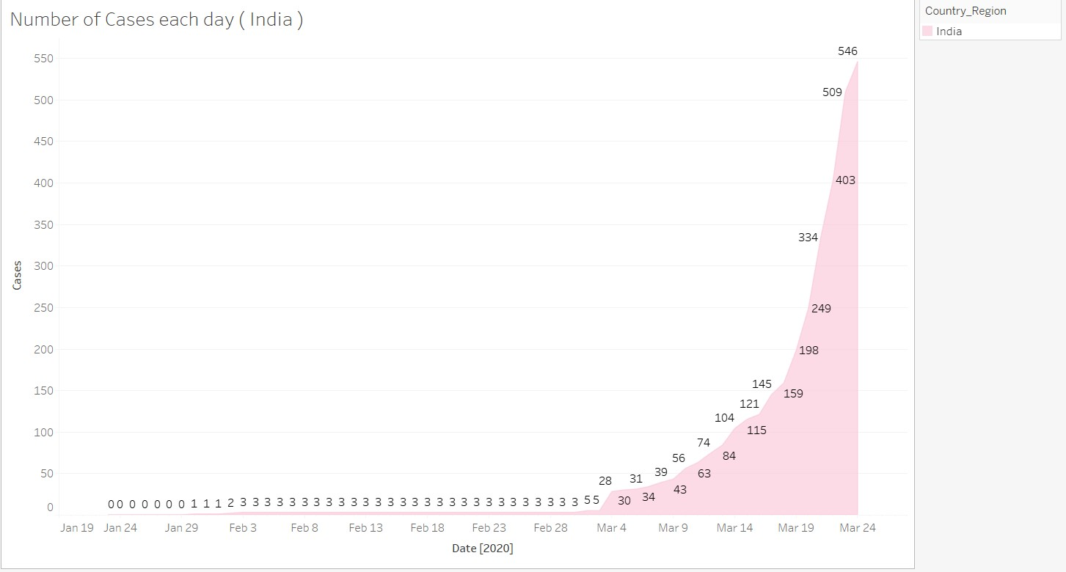

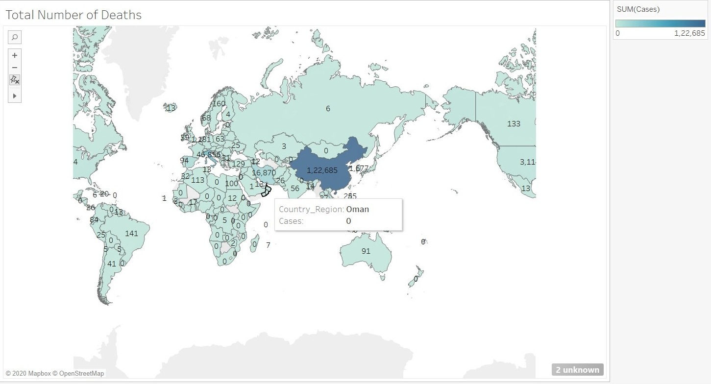

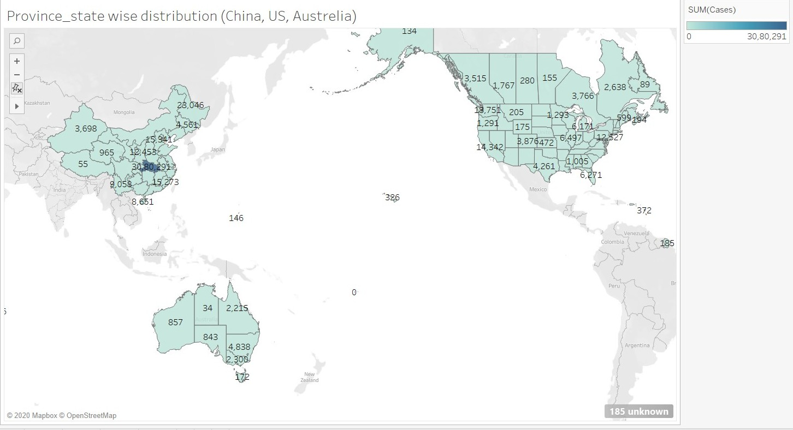

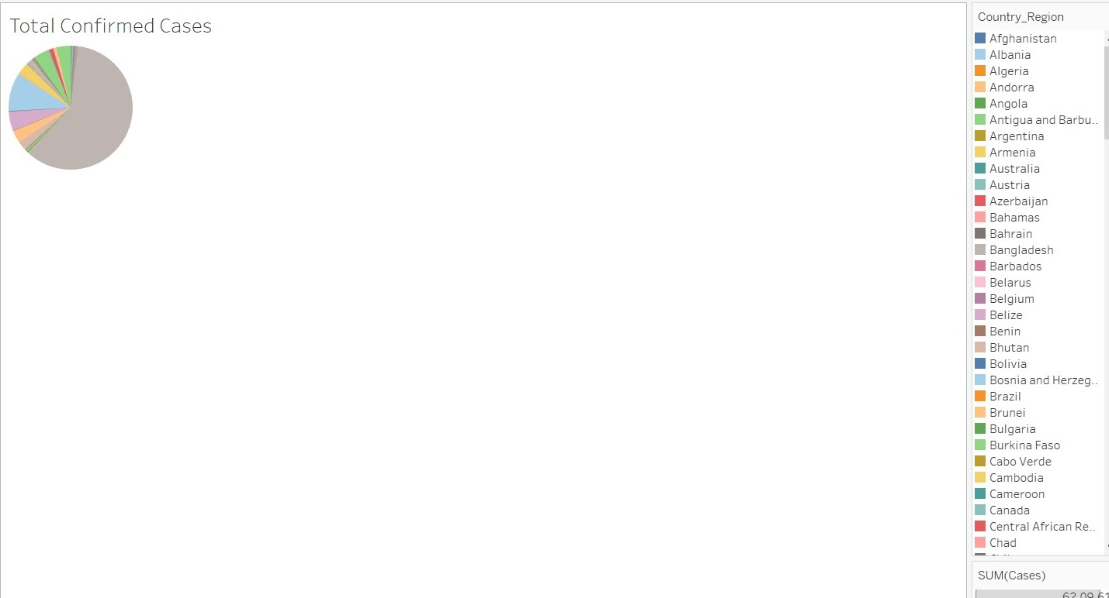

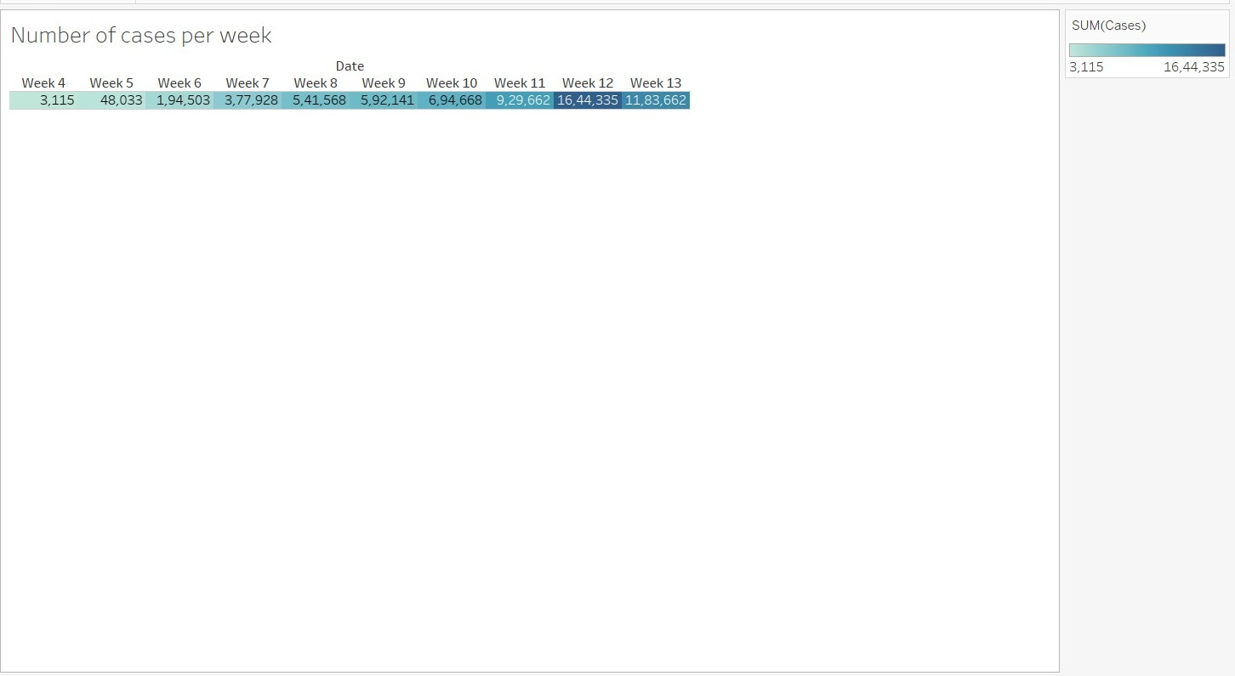

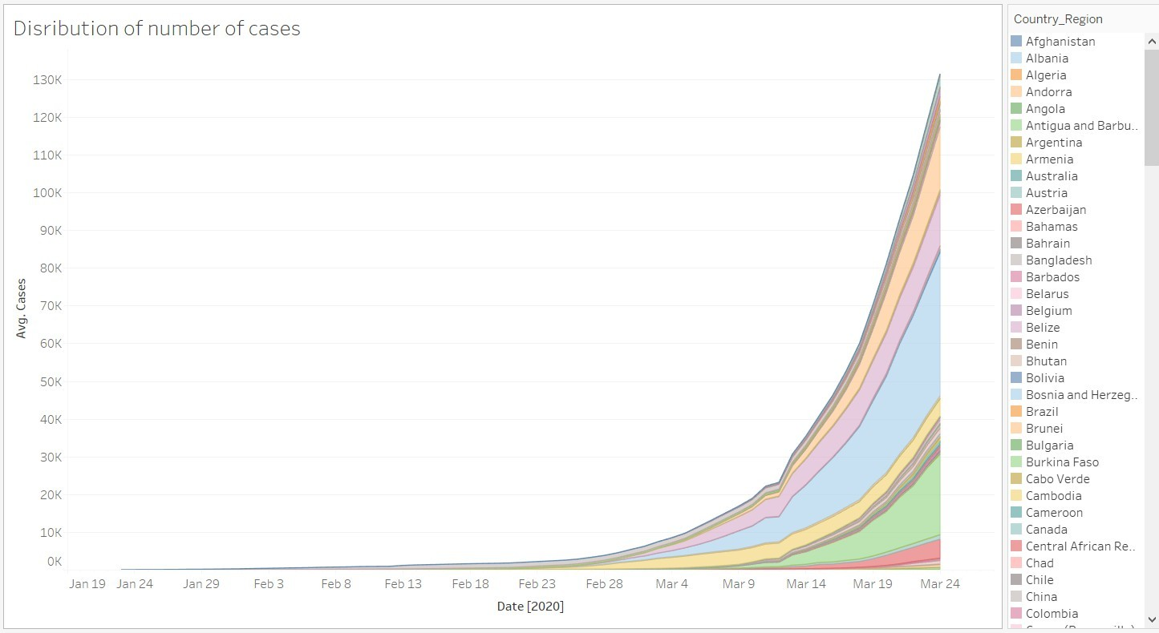

Advantages -

- Remarkable Visualization Capabilities
- Ease of Use and easy to learn
- Apart from its high visualization functionality, users rate its overall performance as robust and reliable
- Multiple Data Source Connections
- Thriving Community and Forum
- Mobile-Friendliness

17

Disadvantages -

- High Cost
- Inflexible Pricing
- Poor After-Sales Support
- Security Issues
- Poor BI Capabilities
- Poor Versioning
- Time- and Resource-Intensive Staff Training

18

Thank You !

19

