CODESYS Direct COM-Port Modbus Integration

Investigation Log & Feasibility Record — Watlow F4S via CODESYS Serial Modbus Master (Superseded)
OUTCOME: This route was ultimately NOT taken forward for production use — the CODESYS runtime's serial (SysCom/COM-port) layer could not be brought up reliably alongside the rest of the device tree (see Part 7). It was superseded by the Python TCP↔RTU gateway (see the companion document). This investigation was still a valuable and necessary feasibility exercise: it proved the Linux serial layer, the full CODESYS device tree and state-machine logic, and precisely isolated where the direct approach breaks — all of which fed directly into the design of the gateway that replaced it.
Covers: VS Code → GitHub → SSH → Raspberry Pi network/serial bring-up → CODESYS device tree → PLC_PRG state machine → build/download → the exact point of failure. Written as a standalone record — a new engineer should be able to follow it start to finish, understand what was proven, what wasn't, and why the project moved to the Python gateway instead.
Project: Temperature Cabinet Setpoint Control from CODESYS HMI | Branch: Omkar_Temperature_Cabinet_Setpoint_Control
Hardware: Watlow F4S (SN 038983), Beckhoff DLS008 rig, CODESYS Control for Linux ARM64 SL, Prolific PL2303 USB-to-RS232 adapter

Part 0 — Executive Summary

What was proven
- Linux layer: stable, permanent udev symlink (/dev/ttyWatlowF4S) and SysCom configuration — proven and repeatable across replugs/reboots
- mbpoll baseline reads on the stable symlink: register 100 (temperature) and register 300 (setpoint) both return live, correct data
- CODESYS device tree: fully built — Modbus_COM on COM2 @ 19200 8N1, Modbus_Master_COM_Port with bus cycle task explicitly set to MainTask, three channels (ReadChamberTemp, ReadSetpoint, WriteSetpoint) with correct function codes
- PLC_PRG state machine: complete — IDLE → READY (validate range) → WRITING (pulse trigger) → CONFIRM (read-back) → IDLE/FAULTED, with fault codes for range, rejection, write failure and comms timeout
- Build: 0 errors, 0 warnings; application downloads and runs

Where it broke
- On the device tree after download, Modbus_Client_COM_Port and Modbus_Server_COM_Port show red fault triangles while everything else (EtherCAT, Application) is green
- Diagnostic drill-down showed: PCI-Bus = Running, but SerialPort = Not running — the CODESYS runtime's serial transport never actually came up, even though the Linux-level symlink and SysCom config were both correct and independently verified with mbpoll
- Consequence: the watch window shows all mapped variables stuck at 0 — no data ever reaches the application because the serial transport underneath the Modbus master never initializes

Why this matters
This pinpointed the actual constraint: it is not the wiring, not the udev symlink, not the SysCom config, not the device-tree configuration, and not the PLC_PRG logic — all of those were independently proven correct. The failure is specifically in how the CODESYS Control for Linux runtime opens and owns the serial transport underneath its own Modbus_COM device. Rather than continuing to chase that runtime-level issue, the project moved the serial ownership entirely into a Python process (pyserial) running outside CODESYS, and re-exposed the cabinet to CODESYS over Modbus TCP instead — sidestepping the problem rather than solving it. See the companion Python TCP↔RTU Modbus Integration guide.

Part 1 — One-Time Setup (First Time Only)

1.1 VS Code + Remote-SSH to the Pi
- Install VS Code and the "Remote-SSH" extension.
- F1 → "Remote-SSH: Connect to Host" → user@<pi-ip> → enter password.

1.2 Clone the repository on the Pi
cd ~
git clone https://github.com/OJ4884/Temperature-Cabinet-Setpoint-Control-from-CODESYS-HMI.git
cd Temperature-Cabinet-Setpoint-Control-from-CODESYS-HMI
git checkout Omkar_Temperature_Cabinet_Setpoint_Control
git config pull.rebase true

1.3 CODESYS sandbox project
All CODESYS development for this investigation was done in a separate sandbox project, keeping the live R&D application unaffected. Open the sandbox .project file in CODESYS IDE before starting Part 4.

Part 2 — Network Stabilization (Mandatory Prerequisite)
CAUTION: Do this before touching Modbus at all. The Raspberry Pi kernel's network offload optimizations (TSO/GSO/GRO) were found to cause TX stalls that interfere with both EtherCAT and Modbus traffic on this rig.
[115441.794278] macb 1f00100000.ethernet internet_port: TX stall detected on queue 0
(tail=1437164 head=1437166); re-kicking TSTART

2.1 Identify the Ethernet port
ip a
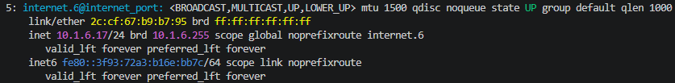
Recorded evidence — ip a showing the active interface is internet_port, not eth0 (this is the Beckhoff DLS008 EtherCAT controller variant).
NOTE: Port name is internet_port, NOT eth0 — a naming quirk specific to this rig variant. Use whatever ip a actually reports for your unit.

2.2 Check current offload status
ethtool -k internet_port | grep -E "tcp-segmentation|generic-segmentation|generic-receive"
Before fix, two offloads kept re-enabling themselves ([requested on]) even when turned off.

2.3 Disable offloading — individually, not combined
Recorded evidence — each ethtool -K flag issued as its own command.
NOTE: Applying multiple flags in one command can cause the kernel to silently ignore the entire call if one flag is invalid. Single commands, one flag each, is the reliable method.

2.4 Verify the change
ethtool -k internet_port | grep -E "tcp-segmentation|generic-segmentation|generic-receive"
Recorded evidence — all three offloads now show off with no [requested on] flag.

2.5 Make it permanent (survives reboot)
sudo nano /etc/network/if-up.d/disable-offloading
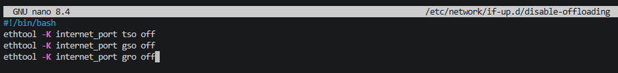
Recorded evidence — the persistence script: ethtool -K commands re-applied on every network interface-up event.
sudo chmod +x /etc/network/if-up.d/disable-offloading

Part 3 — Linux Layer: Stable udev Symlink + SysCom Config
/dev/ttyUSB0 is not stable — replugging the adapter or rebooting can silently reassign it to /dev/ttyUSB1, breaking the CODESYS config without warning. Fix: a permanent udev symlink tied to the adapter's hardware ID.

3.1 Identify the adapter's hardware ID
udevadm info -a -n /dev/ttyUSB0 | grep -E "idVendor|idProduct" | head -2
Recorded evidence — Prolific PL2303 hardware IDs (idVendor=067b, idProduct=2303), fixed to the physical adapter.

3.2 Create the udev rule
echo 'SUBSYSTEM=="tty", ATTRS{idVendor}=="067b", ATTRS{idProduct}=="2303", SYMLINK+="ttyWatlowF4S"' | sudo tee /etc/udev/rules.d/99-watlow-f4s.rules
NOTE: SUBSYSTEM=="tty" must come first — this tells udev to only process entries in the /dev/tty* tree, not the whole USB bus.

3.3 Reload udev and trigger
sudo udevadm control --reload-rules
sudo udevadm trigger
Recorded evidence — udev rules reloaded and triggered.

3.4 Unplug and replug the adapter
Physical action: disconnect the USB adapter, wait 2 seconds, reconnect, to force udev to re-evaluate the rule against the live device.
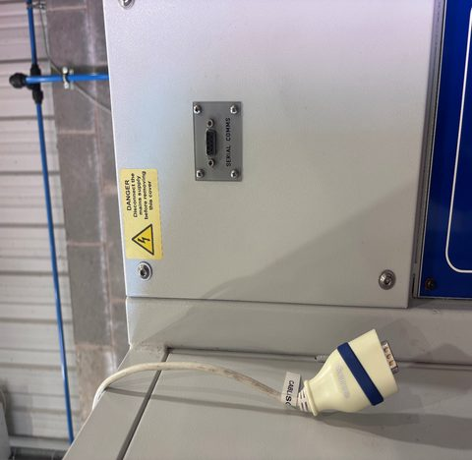
The rig's SERIAL COMMS DB9 panel port before reconnecting the adapter cable.
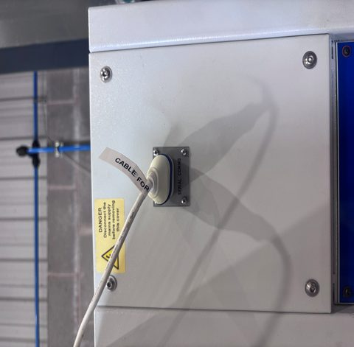
The SERIAL COMMS cable reconnected to the panel port.

3.5 Verify the symlink
ls -la /dev/ttyWatlowF4S
Recorded evidence — /dev/ttyWatlowF4S -> ttyUSB0, confirming the symlink resolved correctly.

3.6 Point CODESYS's SysCom config at the stable symlink
cat /etc/CODESYSControl_User.cfg | grep SysCom -A 4
Recorded evidence — [SysCom] section: Linux.Devicefile.2=/dev/ttyWatlowF4S, portnum.2=2, baudrate.2=19200.
NOTE: CODESYS points at USB "COM Port 2" (portnum.2=2), baud 19200 — matching the F4S's own configured baud rate.

3.7 Confirm the F4S's own baud-rate setting
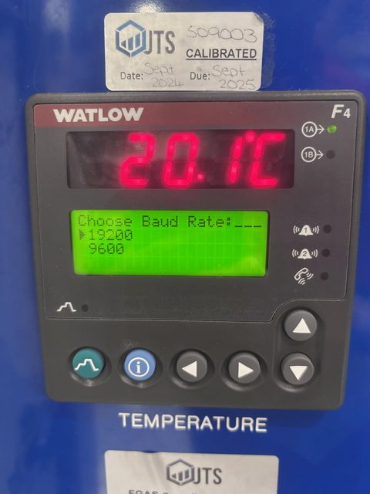
Recorded evidence — F4S front panel, Setup menu: Choose Baud Rate = 19200.

3.8 Restart the CODESYS runtime
sudo systemctl restart codesyscontrol
sudo systemctl status codesyscontrol
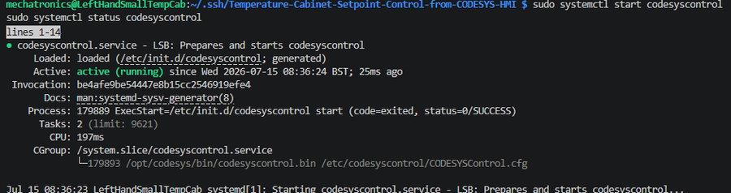
Recorded evidence — codesyscontrol.service active (running), clean start with no errors.

3.9 Baseline check — Linux layer only, before touching CODESYS
Confirm mbpoll still works on the stable symlink before layering CODESYS on top:
mbpoll -m rtu -a 1 -b 19200 -P none -t 4 -r 100 -c 1 -1 -0 /dev/ttyWatlowF4S
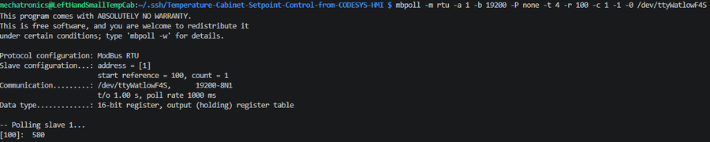
Recorded evidence — register 100 (temperature) returns 580 (58.0°C) via the stable symlink.
mbpoll -m rtu -a 1 -b 19200 -P none -t 4 -r 300 -c 1 -1 -0 /dev/ttyWatlowF4S
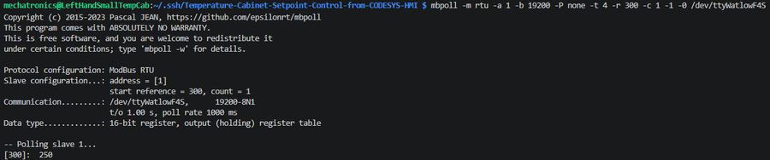
Recorded evidence — register 300 (setpoint) returns 250 (25.0°C) via the stable symlink.
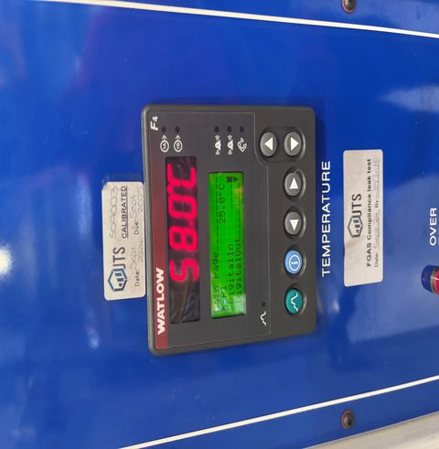
Recorded evidence — F4S front panel confirms the same values live: 58.0°C actual, SP1 25.0°C.

Part 4 — CODESYS Device Tree

4.1 Create the data types
Project tree → DataTypes → Add Data Type (Enumeration) for each:
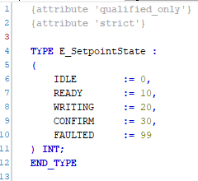
E_SetpointState — IDLE=0, READY=10, WRITING=20, CONFIRM=30, FAULTED=99.
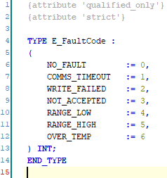
E_FaultCode — NO_FAULT=0, COMMS_TIMEOUT=1, WRITE_FAILED=2, NOT_ACCEPTED=3, RANGE_LOW=4, RANGE_HIGH=5, OVER_TEMP=6.

4.2 Create GVL_Modbus
Project tree → GlobalVariableLists → Add Global Variable List:
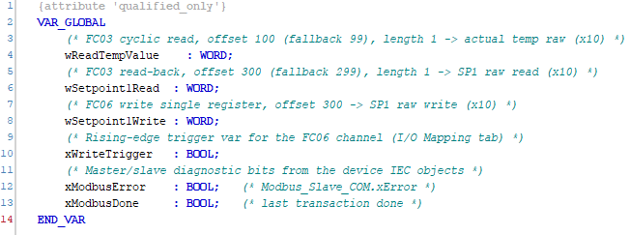
GVL_Modbus — wReadTempValue, wSetpoint1Read, wSetpoint1Write, xWriteTrigger, xModbusError, xModbusDone.

4.3 Device tree structure
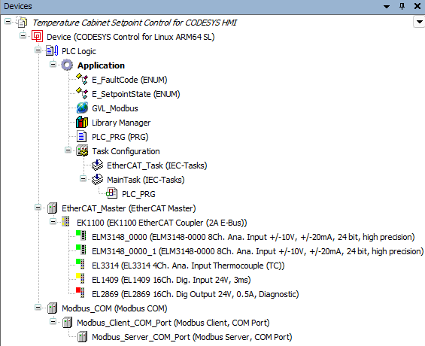
The full device tree: PLC Logic/Application (data types, GVL, PLC_PRG, MainTask), EtherCAT_Master with its I/O modules, and Modbus_COM with its Client/Server COM Port children.

4.4 Serial port settings (Modbus_COM)
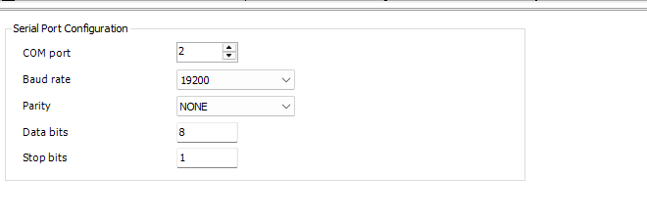
Modbus_COM general tab: COM port 2, baud 19200, parity NONE, 8 data bits, 1 stop bit — matching the SysCom config and the F4S.

4.5 Client settings (Modbus_Master_Client_COM_Port)
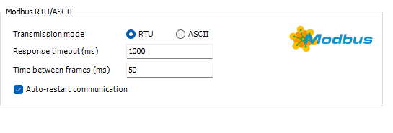
Modbus RTU/ASCII: transmission mode RTU, response timeout 1000 ms, time between frames 50 ms, auto-restart communication enabled.
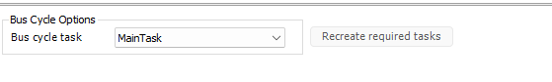
Bus cycle task explicitly set to MainTask.
CAUTION: The bus cycle task MUST be set to MainTask explicitly. If it shows "Use parent bus cycle setting" or is left empty, the channels never actually execute.

4.6 Server settings (Watlow_F4S slave)
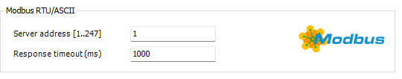
Modbus RTU/ASCII server settings: server address 1, response timeout 1000 ms.
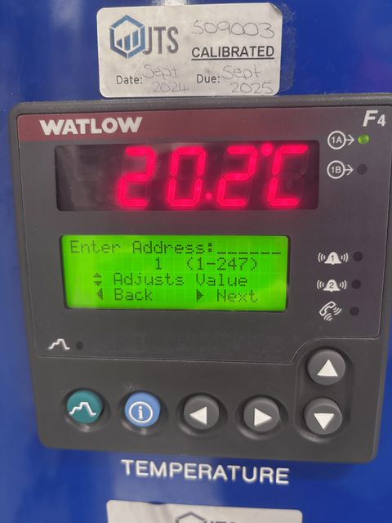
Recorded evidence — F4S front panel, Setup menu: Enter Address = 1, confirming the slave address matches the CODESYS server configuration.

4.7 Create the three channels
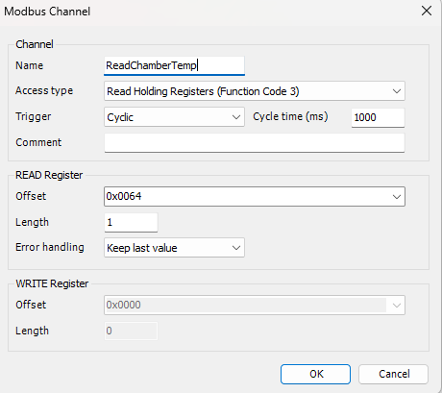
Channel 0 — ReadChamberTemp: Read Holding Registers (FC03), Cyclic 1000 ms, offset 0x0064 (100).
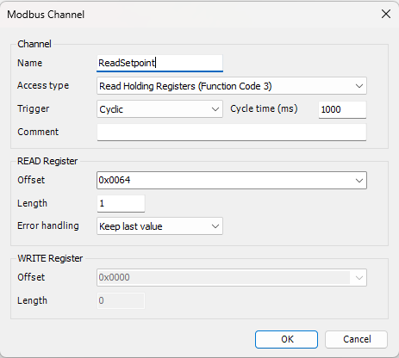
Channel 1 — ReadSetpoint: Read Holding Registers (FC03), Cyclic 1000 ms, offset shown as 0x0064.
NOTE: This capture shows the ReadSetpoint channel's read offset as 0x0064 (100) — the same offset as ReadChamberTemp. The setpoint register is 300 (0x012C). Worth double-checking against the live device tree if this configuration is revisited; it may be a stale screenshot taken mid-edit, or a genuine copy-paste carry-over from the temperature channel.
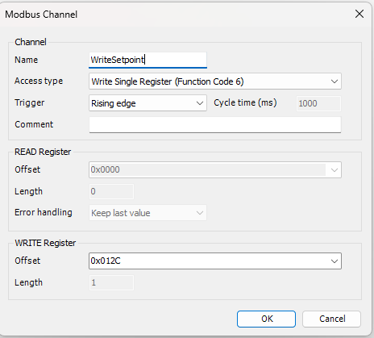
Channel 2 — WriteSetpoint: Write Single Register (FC06), Rising edge trigger, offset 0x012C (300).
Important takeaways from research:
- Reading the setpoint on Input Registers (FC04) addresses a different memory space on the F4S where nothing exists — every proven mbpoll read used FC03 (holding registers).
- Writing the setpoint on a Cyclic trigger would rewrite register 300 (EEPROM-backed) on every cycle (~100 times/sec), risking EEPROM wear. Rising-edge trigger keeps it to one write per operator action.

4.8 I/O Mapping — connect channels to GVL_Modbus
On the Watlow_F4S slave, I/O Mapping tab. Use the browse button (not free-text) to select the existing GVL_Modbus variable for each channel:
CH0 mapped to rChamberTemp (%IW82) — Read Holding Registers, offset 0x0064.
CH1 mapped to rConfirmedSetpoint (%IW83) — Read Holding Registers.
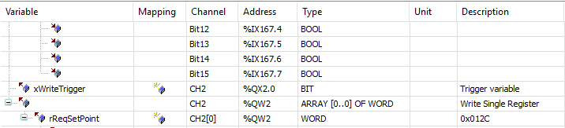
CH2 mapped to xWriteTrigger (%QX2.0, BIT) and rReqSetPoint (%QW2) — Write Single Register, offset 0x012C (300).
NOTE: The trigger row is separate from the data row: the data row holds the value, the Boolean trigger row tells the channel when to actually fire the write.

Part 5 — PLC_PRG Implementation

5.1 Create PLC_PRG
Right-click Application → Add POU → Program, name it PLC_PRG. Assign it to MainTask (right-click → Task menu).

5.2 Variable declaration
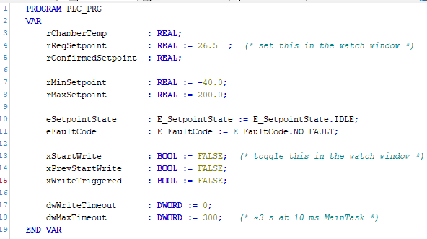
PLC_PRG VAR block: rChamberTemp, rReqSetpoint (:=26.5, set from the watch window), rConfirmedSetpoint, rMinSetpoint (-40.0), rMaxSetpoint (200.0), eSetpointState, eFaultCode, xStartWrite/xPrevStartWrite/xWriteTriggered, dwWriteTimeout/dwMaxTimeout (300, ~3s at 10ms MainTask).

5.3 Scaling, edge-detect, and the state machine
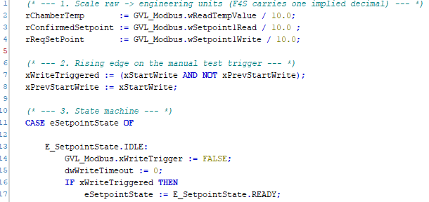
Step 1 (scale raw->engineering units) and Step 2 (rising edge on the manual test trigger), plus the start of the CASE state machine: IDLE.
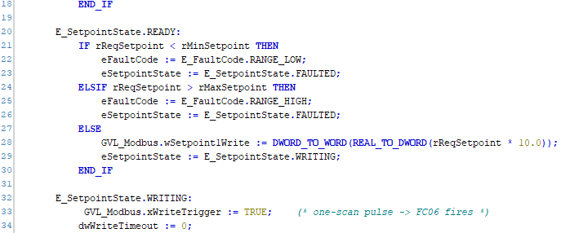
READY state: range validation against rMinSetpoint/rMaxSetpoint, staging the write value; WRITING state: one-scan pulse of GVL_Modbus.xWriteTrigger.
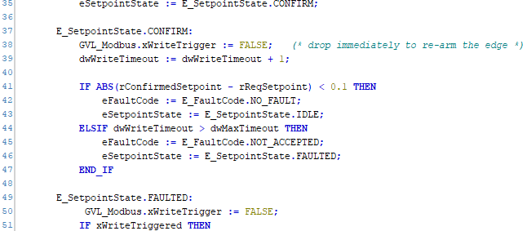
CONFIRM state: drop the trigger to re-arm the edge, compare confirmed vs requested setpoint within tolerance, or fault on timeout; start of FAULTED state.
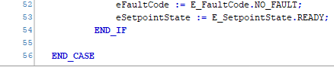
FAULTED state: latched fault, cleared only by re-triggering; END_CASE.

5.4 Design rationale
- xStartWrite is a local variable toggled manually from the watch window, isolated from the real hardware trigger.
- GVL_Modbus.xWriteTrigger is the real, I/O-mapped trigger — only the state machine controls it.
- One-scan pulse: trigger goes TRUE, then FALSE the next cycle — guarantees exactly one FC06 write per request.
- xModbusError is checked immediately, short-circuiting the timeout wait if a real comms error is already flagged.

Part 6 — Build, Download, and the Point of Failure

6.1 Compile
Build → Rebuild All. Expected: 0 errors, 0 warnings.
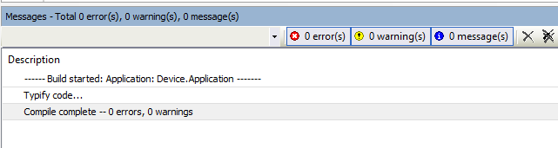
Recorded evidence — Compile complete: 0 errors, 0 warnings.
NOTE: If you see errors instead, check that channel variables were mapped using the browse button, not typed free-text — CODESYS only accepts qualified names selected from the live device tree.

6.2 Download to the Pi
Online menu → right-click the main Device → Download. Accept the "application differs, proceed anyway?" prompt.
ls -la /dev/ttyWatlowF4S
Recorded evidence — symlink still resolves correctly (/dev/ttyWatlowF4S -> ttyUSB0) post-download.

6.3 Check the device tree for green lights
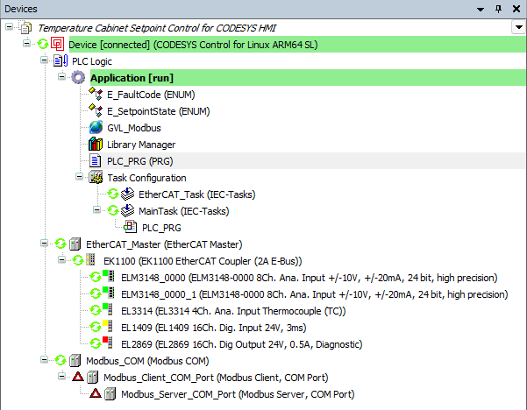
Recorded evidence — Application shows [run] and green everywhere, INCLUDING EtherCAT_Master and its I/O modules — EXCEPT Modbus_Client_COM_Port and Modbus_Server_COM_Port, both flagged red.
OUTCOME: Modbus_COM itself shows green (running), but its two children — the Client and Server COM Port devices — both show red fault triangles. Everything upstream (EtherCAT, the Application, MainTask) is healthy. The fault is isolated specifically to the Modbus serial transport.

6.4 Drill down: PCI-Bus vs SerialPort
Recorded evidence — diagnostic detail: SerialPort = Not running (red), PCI-Bus = Running.
OUTCOME: This is the actual root cause signature: the CODESYS runtime's Modbus_COM device came up on a PCI-Bus transport path instead of successfully opening the real Linux tty (/dev/ttyWatlowF4S) that the SysCom config points to. The Linux-level symlink and SysCom config were independently verified correct with mbpoll (Part 3.9) — the break is specifically in how the CODESYS Control for Linux runtime's serial layer initializes underneath its own Modbus_COM device, not in anything this investigation configured incorrectly.

6.5 Consequence: no data reaches the application
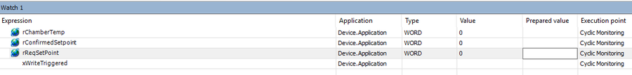
Recorded evidence — Watch window: rChamberTemp, rConfirmedSetpoint, rReqSetPoint all stuck at 0, xWriteTriggered blank. No data ever arrives, because the serial transport underneath never started.

Part 7 — Troubleshooting Reference & Lessons Learned
Symptom | Why | What to do instead
Modbus_Client/Server_COM_Port red, everything else green | CODESYS runtime's serial transport resolves to PCI-Bus, not the real tty, even with correct SysCom config | Treat as a CODESYS-runtime-level constraint, not a config error — do not keep re-editing SysCom/device-tree settings expecting a different result
Watch window all zeros | Downstream symptom of the above — no serial transport means no Modbus transactions ever complete | Check device tree fault icons first, before debugging the state machine logic
mbpoll and CODESYS both fighting over the port | Only one process may own the serial port at a time | pkill -9 mbpoll before bringing CODESYS online, and vice versa
Offloads re-enable after being turned off | Kernel keeps [requested on] flags active until told individually | Disable tso/gso/gro one flag per command (Part 2.3), and persist via the if-up.d script

Part 8 — Conclusion
A complete, proven RS-232 Modbus master stack — Linux serial layer, CODESYS device tree, and PLC_PRG state machine — was successfully built and downloaded with 0 errors. The hard part (getting the exact hardware to communicate reliably) was fully isolated to one specific point: the CODESYS Control for Linux runtime's own serial transport layer failing to come up under its Modbus_COM device, independent of and downstream from everything this investigation configured correctly.
OUTCOME: This was a successful feasibility exercise, not a wasted one. It definitively proved the Linux layer, definitively proved the CODESYS logic and device-tree design, and definitively isolated the actual blocker to a single, specific runtime behavior — which directly justified and shaped the design of the Python TCP↔RTU gateway that replaced this approach. Without this investigation, the gateway's core design decision (own the serial port entirely outside CODESYS) would have been a guess rather than an evidence-based conclusion.

What was carried forward into the Python gateway
- The proven register map (100=temperature, 300=setpoint) and F4S link parameters (19200, 8N1, address 1)
- The exact state machine (IDLE → READY → WRITING → CONFIRM → IDLE/FAULTED) and fault code taxonomy — reused almost unchanged in PLC_PRG_TCP_Retargeted.st
- The udev symlink strategy (stable device naming across replugs) — reused directly by the Python gateway
- The lesson that only one process may own the serial port at a time — the reason the Python gateway is designed as the sole serial owner, with CODESYS talking to it only over Modbus TCP

Part 9 — Handover Checklist (If This Route Is Ever Revisited)
Do not restart this investigation from scratch. Before touching serial COM-port configuration in CODESYS again:
- [ ] Re-read Part 6.3–6.4 — confirm whether the PCI-Bus/SerialPort symptom still reproduces on the current CODESYS runtime version
- [ ] Check CODESYS release notes for the runtime version in use for any fix to Linux serial (SysCom) transport initialization
- [ ] Re-verify the Linux layer independently with mbpoll (Part 3.9) before assuming a CODESYS-side fix — don't re-diagnose the Linux side, it was already proven
- [ ] If revisiting Channel 1 (ReadSetpoint), verify its read offset is 0x012C (300), not 0x0064 (100) — see the note in Part 4.7
- [ ] If it still fails at the same point, don't sink further time in — the Python gateway is the proven working path (see companion document)

NOTE: This document is a record of a dead end that was worth reaching — it tells the next engineer exactly how far direct CODESYS serial integration gets, and exactly where and why it stops, so that ground is never re-covered blind.

