Linux Modbus RTU Integration

Complete End-to-End Guide & POC Test Record — Raspberry Pi to Watlow F4S Temperature Controller
OUTCOME: This was a successful proof of concept and is the foundation everything else builds on. Register 100 (temperature) and register 300 (setpoint) both read correctly, a write-then-read-back test confirmed the F4S accepts a new setpoint over Modbus RTU, and the front panel visually confirmed the change. This proven RTU link was later reused twice: first as the transport CODESYS attempted to drive directly over its own COM-port device (see the companion CODESYS investigation log — that attempt was not carried forward), and then as the exact protocol the Python TCP↔RTU gateway wraps (see the companion Python integration guide — that one was carried forward and is the adopted solution).
Covers: VS Code → GitHub → SSH → Raspberry Pi → serial bring-up → Modbus RTU read/write proof of concept, with real terminal captures and F4S front-panel photos from the bench test on the DLS008 rig. Written as a standalone handover document — a new engineer with no prior context should be able to follow it start to finish, including recovery when the USB adapter is unplugged and re-plugged.
Project: Temperature Cabinet Setpoint Control from CODESYS HMI | Branch: Omkar_Temperature_Cabinet_Setpoint_Control
Hardware: Watlow F4S (SN 038983), Prolific PL2303-class USB-to-RS232 adapter, Raspberry Pi (Debian Trixie), DLS008 rig

Part 0 — What Is Modbus RTU? (Concepts First)
Modbus RTU is a simple industrial communication protocol — a standard "language" for talking to devices over a serial cable. Instead of inventing a custom command format, both sides use Modbus's predefined commands so any device (F4S, other controllers, software) speaks the same way.

Register
A numbered storage slot inside the F4S, like a spreadsheet cell. Each register holds one number (0–65535). We care about two:
- Register 100 = actual chamber temperature, read-only (the sensor measurement)
- Register 300 = the setpoint (target temperature) — readable AND writable

Function Code (FC)
- FC03 = "read holding registers" — ask the F4S what's in register 100 or 300
- FC06 = "write single register" — tell the F4S to set register 300 to a new value

Baud Rate, Parity, Data Bits, Stop Bits
Serial port configuration that both sender and receiver must match exactly, or they won't understand each other:
- Baud rate (19200) = 19200 symbols per second
- 8N1 = 8 data bits, No parity, 1 stop bit

Slave Address
The F4S has an address (default 1) — like a house number, for when multiple Modbus devices share one cable. With just one F4S, it's always address 1.

0-Based vs 1-Based Addressing
The Modbus PDU (the actual frame on the wire) uses 0-based addressing. mbpoll normally uses 1-based (human-friendly), so the -0 flag tells it to use 0-based PDU addressing to match the F4S's internal numbering — a real gotcha found during testing.

Part 1 — One-Time Setup (First Time Only)
Do this once per laptop / new engineer. If VS Code Remote-SSH already works against the Pi, skip to Part 2.

1.1 Install VS Code and the Remote-SSH extension
- Install Visual Studio Code on your laptop.
- Install the "Remote - SSH" extension from the Extensions marketplace.

1.2 Get SSH access to the Raspberry Pi
- Confirm the Pi's IP address on the network.
- In VS Code: F1 → "Remote-SSH: Connect to Host" → enter user@<pi-ip>.
- Enter the SSH password when prompted; VS Code installs its remote server component on first connect.
- Bottom-left corner of VS Code shows "SSH: <pi-ip>" once connected.

1.3 Clone the repository on the Pi
cd ~
git clone https://github.com/OJ4884/Temperature-Cabinet-Setpoint-Control-from-CODESYS-HMI.git
cd Temperature-Cabinet-Setpoint-Control-from-CODESYS-HMI
git checkout Omkar_Temperature_Cabinet_Setpoint_Control

1.4 Configure git for rebase-based pulls
git config pull.rebase true
git config --global user.name "Your Name"
git config --global user.email "you@example.com"

Part 2 — Hardware Setup (Before Any Commands)

Step 2A: Plug in the USB-to-RS232 adapter
Plug the Prolific PL2303-based USB adapter into a free USB port on the Raspberry Pi (on the DLS008 rig, the vacant Raspberry Pi port). Do not yet plug in the serial (DB9) connector — verify the adapter first.

Step 2B: Verify the adapter is recognized
dmesg | tail -n 20
Look for a line confirming the adapter attached:
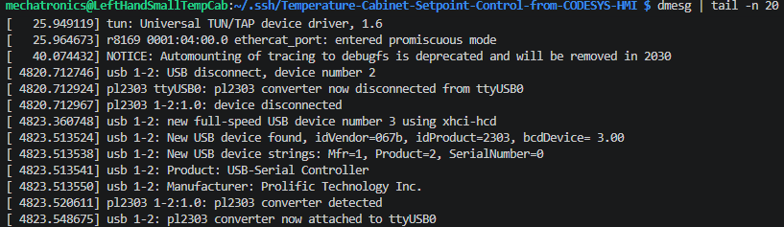
Recorded evidence — dmesg confirming "pl2303 converter now attached to ttyUSB0" after re-plugging the adapter.
This means the adapter appeared as /dev/ttyUSB0 — a device file the OS exposes for you to use.
NOTE: If the adapter is ever unplugged and re-plugged, or the Pi reboots, the kernel may assign a different number (e.g. /dev/ttyUSB1). Always run dmesg | tail after any replug to confirm which device file it landed on.

Step 2C: Plug in the DB9 adapter and check permissions
Plug the 9-pin D-SUB DB9 adapter into the vacant serial comms port, then check who is allowed to use it:
ls -la /dev/ttyUSB0
Recorded evidence — /dev/ttyUSB0 owned by root:dialout, mode crw-rw----.
Only root and members of the dialout group can use it. If your user isn't in dialout, add yourself:
sudo usermod -a -G dialout $USER
Log out and back in (or reboot) for the group change to take effect. Verify:
groups
Recorded evidence — groups output confirming dialout membership.

Step 2D: Physically wire the serial cable
The F4S has a terminal block on its back panel. Wire the DB9 connector as follows:
DB9 Pin | Colour (ADR-001 standard) | F4S Terminal | Purpose
3 (TXD) | White | 14 (Tx) | Transmit data FROM Pi TO F4S
2 (RXD) | Red | 15 (Rx) | Receive data FROM F4S TO Pi
5 (GND) | Black | 16 (GND) | Ground / Reference

CAUTION: TX (white) goes to terminal 14, RX (red) goes to terminal 15. Swapping these stops everything — this was a real bug found during testing.
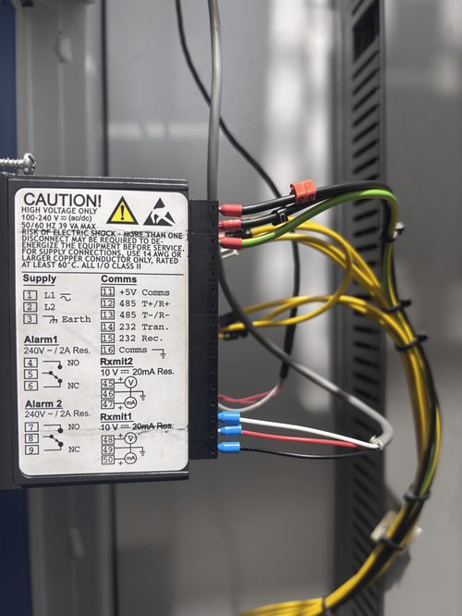
Recorded evidence — actual F4S rear terminal block wiring on the DLS008 rig (comms terminals 14/15/16 landed, supply and alarm terminals also visible).
Tighten the terminal-block screws firmly. Loose wires = intermittent timeouts.

Part 3 — Install and Verify mbpoll (The Modbus Testing Tool)
mbpoll is a command-line tool for sending Modbus commands from the terminal — think of it as a "Modbus telephone": pick it up, dial the F4S, ask it questions.

Step 3A: Install mbpoll
sudo apt-get update
sudo apt-get install mbpoll
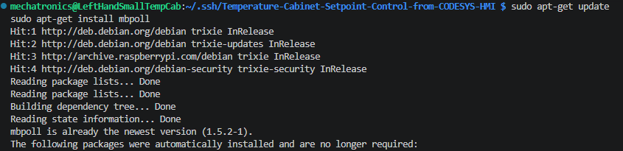
Recorded evidence — mbpoll already installed and up to date on the rig's Pi.
Verify installation:
which mbpoll
Recorded evidence — which mbpoll resolves to /usr/bin/mbpoll.

Step 3B: Understand the command structure
mbpoll -m rtu -a 1 -b 19200 -P none [action flags] /dev/ttyUSB0 [write value, if any]

Flags explained:
Flag | What It Does | Our Value | Why
-m rtu | Selects RTU protocol style | rtu | F4S uses RTU, not ASCII or TCP
-a 1 | Which device on the cable | 1 | F4S default address is 1
-b 19200 | Baud rate | 19200 | Confirmed on F4S: Setup → Communications → Baud Rate
-P none | Parity | none | F4S uses 8N1 (no parity) — critical fix from earlier testing
-t 4 | Register type | 4 | Holding registers

For reads (FC03), add:
Flag | Meaning | Our Value | Why
-r 100 / -r 300 | Register address | 100 or 300 | 100=temperature, 300=setpoint
-c 1 | Count | 1 | Read just 1 register
-1 | Poll once | — | Poll once and exit
-0 | 0-based addressing | — | Match F4S's internal (PDU) numbering

For writes (FC06), omit -c and -1, and append the value:
mbpoll -m rtu -a 1 -b 19200 -P none -t 4 -r 300 -0 /dev/ttyUSB0 265

Part 4 — First Test: Read the Actual Temperature (Register 100)
Ask the F4S "what temperature do you measure right now?" It should reply with the same value shown on its front-panel display.

Step 4A: Run the read command
mbpoll -m rtu -a 1 -b 19200 -P none -t 4 -r 100 -c 1 -1 -0 /dev/ttyUSB0

Expected output pattern (register value ×10, divide by 10 for °C):
-- Polling slave 1...
[100]: 249 # e.g. 249 -> 24.9°C

Step 4B: Compare against the front panel
The top red digits on the F4S front panel show the live measured temperature — compare it to the register-100 read to confirm the read link works:
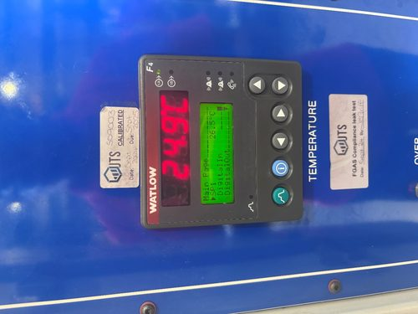
Recorded evidence — F4S front panel, live temperature 24.9°C, matching a register 100 read on the bench.

Step 4C: If it times out instead
Read output (holding) register failed: Connection timed out
Check in order: parity (mbpoll must show 8N1, not 8E1), permissions (dialout group), physical wiring (white=14, red=15, black=16), and F4S power/run-mode.

Part 5 — Second Test: Read the Static Setpoint (Register 300)
The setpoint is the target temperature for the cabinet. Register 300 holds this value and can be both read AND written.

Step 5A: Read the current setpoint
mbpoll -m rtu -a 1 -b 19200 -P none -t 4 -r 300 -c 1 -1 -0 /dev/ttyUSB0
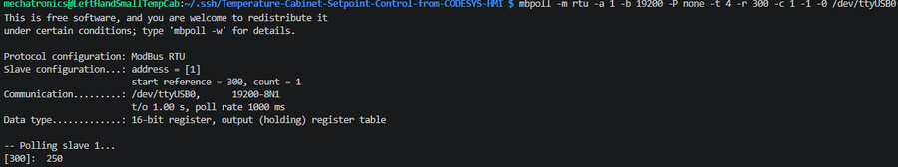
Recorded evidence — register 300 read returns 250 (25.0°C) before the write test.

Step 5B: Interpret and cross-check against the front panel
250 in raw form = 25.0°C. The "SP1" label on the front panel should show the same value:
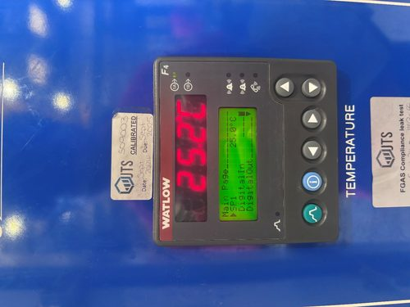
Recorded evidence — F4S front panel showing SP1 = 25.0°C and live temperature 25.2°C, confirming the register 300 read of 250.

Part 6 — The Critical Write Test (Register 300)
CAUTION: The F4S ONLY accepts setpoint writes while it is on the MAIN RUN PAGE. In the setpoint-adjustment screen, writes are acknowledged but silently rejected (no error, value just doesn't change). In the Setup menu, writes are rejected outright. Before writing, visually confirm the front panel is showing the main run screen — press ESCAPE/EXIT repeatedly if unsure.

Step 6A: Decide what to write
For this test: 26.5°C. In raw register form: 26.5 × 10 = 265.

Step 6B: Run the write command
mbpoll -m rtu -a 1 -b 19200 -P none -t 4 -r 300 -0 /dev/ttyUSB0 265
Notice: no -c 1, no -1 — the value 265 is just appended.
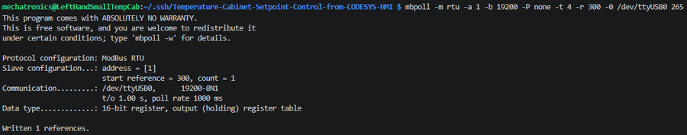
Recorded evidence — write executed, mbpoll reports "Written 1 references."

Step 6C: Interpret the result
"Written 1 references" means mbpoll sent the write and got an acknowledgement. Acknowledgement is NOT the same as acceptance — the F4S heard the command but may still have rejected it internally.

Step 6D: Confirm the write actually worked (read-back)
This step is critical. Immediately read register 300 again:
mbpoll -m rtu -a 1 -b 19200 -P none -t 4 -r 300 -c 1 -1 -0 /dev/ttyUSB0
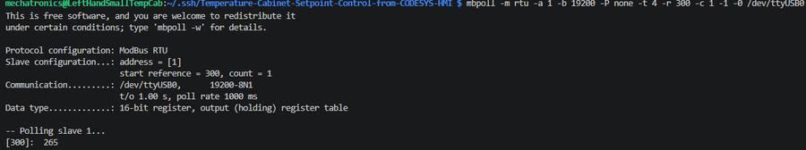
Recorded evidence — read-back confirms register 300 now holds 265 (26.5°C).
Scenario | Output | Meaning | What to do
Write succeeded | Read-back matches (265) | F4S accepted the value; front panel updates within seconds | Success — watch the F4S ramp toward 26.5°C
Write rejected silently | Read-back unchanged (250) | F4S acknowledged the frame but rejected the value | Exit any F4S menus to main page, retry
Communication lost | Connection timed out | Cable unplugged, adapter disconnected, or F4S off mid-write | Check physical connections, restart F4S, retry

What a communications timeout looks like (for reference):
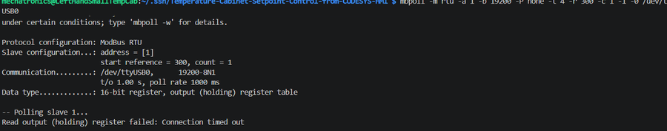
Reference capture — "Read output (holding) register failed: Connection timed out", the signature of a lost link (unplugged adapter, dead cable, or powered-off F4S).

Step 6E: Verify visually on the F4S

Recorded evidence — F4S front panel after the write: SP1 = 26.5°C, actual temperature 24.9°C and ramping toward the new setpoint.
NOTE: SP1 now shows 26.5°C and the actual temperature display ramps toward it — the F4S's own closed-loop PID is doing the work; this Pi link only sets the target.

Part 7 — Diagnostic Script (write-setpoint.sh)
Rather than typing commands by hand each time, use the provided script:
./scripts/write-setpoint.sh 26.5
This automates: read current setpoint → skip write if unchanged → validate range (0–200°C, matching the CODESYS logic bounds at the time) → convert to raw (×10) → send FC06 write → read back and confirm → report SUCCESS or FAILURE.
Example success:
$ ./scripts/write-setpoint.sh 28.0
Reading current setpoint (register 300)...
Current setpoint: 26.5C (raw 265)
Writing new setpoint: 28.0C (raw 280) to register 300...
Written 1 references.
CONFIRMED: setpoint now reads 28.0C (raw 280)
Example failure:
$ ./scripts/write-setpoint.sh 28.0
...
WARNING: read-back (265) does not match written value (280).
F4S may be in profile/ramp mode (SP1 owned by an active profile) --
confirm the front panel is in static/manual setpoint mode and retry.

Part 8 — Troubleshooting Reference
Symptom | Most Likely Cause | Fix
Read (Reg 100/300): Timeout | Parity mismatch, permissions, or wiring | Add -P none; confirm dialout group; re-check TX/RX/GND wiring
Read succeeds but off by one | 0-based vs 1-based addressing | Always use the -0 flag
Read shows stale value | Normal cold-start settle, or cable issue | Wait 10s and re-read; check cable if it never moves
Write "succeeds" but read-back unchanged | F4S in menu/edit mode (most common) | Press ESCAPE to main run page, retry
Write: Timeout | Cable unplugged or comms lost mid-write | Check dmesg for adapter disconnect; reseat cable
Read-back differs from written value | F4S rejected the value (range, profile active) | Check 0–200°C range; confirm F4S not in profile/ramp

Part 9 — Conclusion and Handover to the Python Gateway
Once you have successfully: read register 100 (temperature) multiple times, read register 300 (setpoint) multiple times, written register 300 and confirmed with read-back, and watched the F4S ramp toward the new setpoint on the display — the Linux/hardware layer is proven. The Modbus RTU link is fully functional. This is a successful Modbus proof of concept.
OUTCOME: Successful. Every read, write, and confirmation test in this document passed on real hardware, with terminal captures and front-panel photos as evidence (Parts 4–6). Direct CODESYS-to-serial-COM-port communication was later found to be the weaker link in the chain (see the companion CODESYS investigation log — that route was not carried forward). The proven mbpoll/RTU sequence documented here became the basis for the Python gateway instead (see the companion Python TCP↔RTU Modbus Integration guide — that route was carried forward and is the adopted solution), which now owns the serial port exclusively and re-exposes the cabinet to CODESYS over Modbus TCP.
Quick Reference — Command Summary
# Read actual temperature
mbpoll -m rtu -a 1 -b 19200 -P none -t 4 -r 100 -c 1 -1 -0 /dev/ttyUSB0

# Read setpoint
mbpoll -m rtu -a 1 -b 19200 -P none -t 4 -r 300 -c 1 -1 -0 /dev/ttyUSB0

# Write setpoint (example: 26.5C = raw 265)
mbpoll -m rtu -a 1 -b 19200 -P none -t 4 -r 300 -0 /dev/ttyUSB0 265

# Read back to confirm
mbpoll -m rtu -a 1 -b 19200 -P none -t 4 -r 300 -c 1 -1 -0 /dev/ttyUSB0

# Or use the script
./scripts/write-setpoint.sh 26.5

Part 10 — Handover Checklist
Give this to a new engineer taking over the bench test. Work top to bottom; do not skip ahead.
- [ ] VS Code Remote-SSH connects to the Pi (Part 1.1–1.2)
- [ ] Repo cloned, on branch Omkar_Temperature_Cabinet_Setpoint_Control (Part 1.3–1.4)
- [ ] USB-to-RS232 adapter recognized in dmesg, /dev/ttyUSB0 present (Part 2A–2B)
- [ ] Your user is in the dialout group (Part 2C)
- [ ] DB9 wiring landed correctly: white→14, red→15, black→16 (Part 2D)
- [ ] mbpoll installed and resolvable (Part 3A)
- [ ] Register 100 (temperature) read matches the F4S front panel (Part 4)
- [ ] Register 300 (setpoint) read matches SP1 on the front panel (Part 5)
- [ ] Write-then-read-back test confirms a new setpoint is accepted (Part 6)
- [ ] F4S front panel visually confirms the written setpoint and ramps toward it
- [ ] Know the Part 8 troubleshooting table before leaving the rig unattended

NOTE: If every box above is checked, the RTU link is proven end-to-end and safe to hand over or build on. This is the same proven link the Python TCP↔RTU gateway wraps — see the companion Python integration guide for the next stage (CODESYS via Modbus TCP).

