Ritesh Jaiswal 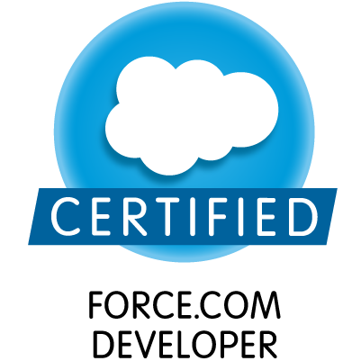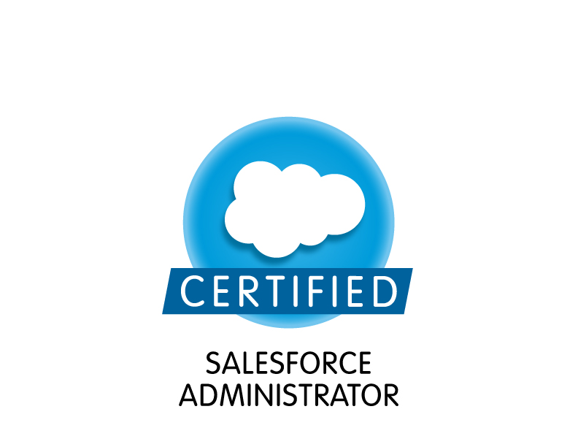
Mobile: 09015054668 / 9711249417
Tel no: 05952331118

E-Mail:ritesh4all2011@gmail.com
Seeking career enhancing assignments in the domain of Software developing with a growth oriented organisation

SNAPSHOT

- Worked as an Associate Consultant (Salesforce) in HCL Technologies Noida.
- Having more than 3.8 year experience in IT Industry.
- Certified Salesforce Administrator 201
- Certified Salesforce Developer 401
- Certified Salesforce Developer (Dev 1 / 501)
- Amcat Qualified with major skills needed in current scenario.
- Among Top Ranker in NIIT National IT Aptitude Test.
- Developing a generalised code efficient for both mobile and other.
- Certified for various languages under HRD Ministry (GOI).
- GATE 2012 Qualified in 1 Attempt (90 Percentile).
- Among Top Ranker in All India Cyber Olympiad.
- Understands the principles and best practices of Salesforce data modelling interface design, code development and testing, and can apply these principles in real-world development environments.
- Is capable of defining appropriate solutions to meet specific business challenges/process requirements to extend/customize the platform by applying their knowledge of declarative and programmatic features of the Force.com platform.
- Competent developing Apex code that will scale to large data sets, has a good understanding of platform behaviours, limits and performance considerations
- Can build custom user interfaces to display and interact with Salesforce data using the Lightning component framework, advanced Visualforce, and moderate JavaScript.
- Competent tuning Visualforce pages and understands performance implications of the controller design.
- Understands and applies best practices for general web and Salesforce-specific security concerns.
- Can design and implement complex sharing model using declarative and programmatic methods
- Can design and implement a test plan that ensures adequate quality (e.g., code coverage, application behaviours, scalability, environment independence, security) across application components.
- Can deploy custom applications, has a broad understanding of the Force.com development lifecycle, and understands all deployment tools and knows when to apply each tool.
- Understands and uses Apex SOAP and REST web services, and how to callout from Apex using SOAP and REST.
- Understands and uses asynchronous programming – batchable, schedulable, @future, etc.
- Understand and applies appropriate techniques for error and exception handling in various programmatic contexts
- Proven knowledge and experience with Agile methodologies Enterprise integration and software development patterns
- Ease working on complex projects
- Ability to think and design things that scale from a single box, to on premise solutions
- Clear interface design and integration with multiple other component to achieve optimum reuse.
- Understanding Customer Requirement, business process and need. Facilitate technical implementation of those requirement,
- Translating business requirement into technical specifications.
- Coordinate Deployment with specific module test execution
- Implementation of Service Oriented Architecture (SOA) with specialisation in API formatting.
- Strong customer interaction skills and ability to understand and document customer needs from a business solutions perspective.
- Let the customer know additional options that can be added with proper UX for better interaction.
- Feature mapping to technical solution to the requirements from non-technical business users.
- Provide technical expertise in identifying, evaluating, and developing effective procedures and systems requirements that meet business requirements.
- Interaction with foreign as well as Indian clients with client meeting, requirement gathering to project implementation.
- Experience in business logic, implementation,3-party API Integration, leading team with best method to develop a secure and efficient product.
- Strong behavioural knowledge of Telecom Domain with Flexible Coding Architecture.
- CERTIFICATION OF EXCELLENCE from ATFP program (Ministry of IT) at ABV –IIITM, Gwalior under various technologies like Android ,Java ,cloud computing etc. (AUGUST-OCTOBER,2012)
- Worked under IBM project based training on PRODUCT MANAGEMENT SYSTEM.
- Strong foundation of UI/UX, SDLC, UML AND ALGORITHMS.
- Strong foundation in testing methodologies with developing best test cases.

EDUCATION
Bachelor of Technology (CSE) | 76.2% (honours) | GBTU (SDCET,GHAZIABAD)
CLASS XII | 76% | CBSE (ST. PAULS)
CLASS X | 82% | CBSE (ST. PAULS)

Certifications

Exam | Date | Result
Salesforce Certified Administrator (SP15) | 26 May 2015 | Pass
Salesforce Certified Force.com Developer (SP15) | 11 June 2015 | Pass
Salesforce Certified Administrator - Summer '15 Release Exam | 02 July 2015 Etc/UTC | Pass
Salesforce Certified Force.com Developer - Summer '15 Release Exam | 02 July 2015 Etc/UTC | Pass
Salesforce Certified Administrator - Winter '16 Release Exam | 03 December 2015 Etc/UTC | Pass
Salesforce Certified Force.com Developer - Winter '16 Release Exam | 03 December 2015 Etc/UTC | Pass
Salesforce Certified Platform App Builder - Transition Exam (WI16) | 11 March 2016 | Pass
Salesforce Certified Platform Developer I (WI16) | 22 March 2016 | Pass
Salesforce Certified Platform App Builder - Spring '16 Release Exam | 08 April 2016 Etc/UTC | Pass
Salesforce Certified Platform Developer I - Spring '16 Release Exam | 11 April 2016 Etc/UTC | Pass
Salesforce Certified Administrator - Spring '16 Release Exam | 13 April 2016 Etc/UTC | Pass
IBM RAD Certified | 2011 | Pass
ABV –IIT Certified | 2012 | Pass

TECHNICAL KNOWLEDGE

- Language and Specification : APEX, C#, WCF and Web Services
XML, XSL, ASP.NET, ADO.NET, SOAP, REST
Entity-Framework, JSON, Visualforce

- Basic Modules Knowledge : Lightning Development , CRM Basic, HTML5, UI Customization, Mobile
Basic API, Desk.com + SFDC, Lightening Experience, Lightning Connect
(Basic/Intermediate) Email Services. Email2Case, Manage/Unmanaged Package
- Process Automation : Visual Workflows , Lightning Process Builder , Flows
- Basic Configuration : Basic Knowledge of Formulae’s , Data Security , SOQL/SOSL
: Deployment, asynchronous apex (Batch Job), Communities Basic, Data
Management (Import/Export Data), Lightening Connect, Identity Basics,
Report/Dashboard, Validations
- Programming Concept : OOPS and SOA implementation
- API Integration : SOAP/REST Facebook,Oauth, Paypal, Cashu, google API’s
: And many other.
- Business /Documentation : Class/Model Diagram, Integration Documentation
- Database : MSSQL,MYSQL,Stored-Procedure,PL/SQL,LINQ,SOQL
- ,trigger,indexing,profiler,transaction(ACID),views
- Modelling Language/other Batch , Workflow, Process Diagram,Salesfoece functionalities UML
- Scripting Languages : JavaScript, VisalForce, JQuery and parsing structure.
- Basic knowledge : JAVA, Oracle 10G and SVN
- Tools/Framework : Net beans, and Visual Studio 2013
- Utilities : Testing, Internet, Email including the latest technology
- Designing : Fluid UI ,Wire framing , Axure

INDUSTRIAL EXPERIENCE
1. Organisation : HCL Technologies
Position : Working as Associate Consultant.
2. Organisation : AdvaitamTech Sol. Pvt. Ltd. (A TSN Inc.)
Position : Worked as a Product Developer.
2. Organisation : Velocity Sol. Pvt. Ltd.
Position : Worked as a Product Developer.

Internship/Training EXPERIENCE
1. Organisation : Valid Page, Greater Noida
Position : Internship of 2 months worked under the project E-Coordinator.
2. Organisation : IBM
Position : Internship of 2 months worked under the project PMS and studying the RAD.
3. Organisation : ABV-IIITM, Gwalior
Position : Trained for latest technology with Project Development.

INDUSTRIAL PROJECTS

S.No. | Organisation | Project Name | Technology Used | Time Period | Role
1 | AdvaitamTech / TSN | Mbuzzz LM | Salesforce | 4 months | Developer
Description:
From creating database to developing the product with an adaptive an efficient methodology dealing with all the things which can make a product categorisation and description best.

2 | AdvaitamTech / TSN | RMS | Salesforce | 10 month | Developer with requirement elicitation and team leading
Description:
Working on the dot net integration as well as implementing the SOA architecture. Implementing the Trigget and visualforce Pages as required.

3 | ADVAITAMTECH TECHNOLOGIES (A Telservnet Inc (TSN)) | Mbuzzz.co.uk & admin.mbuzzz.co.uk | ASP.NET, MS SQL, nhibernate, API and Webservices | 4 month | Client Interacting ,developing and maintaining
Description:
From creating database to developing the product with an adaptive an efficient methodology dealing with all the things. Integrating PayPal and cashu as payment gateway and logging in via face book ,Google and other third party’s api is there. Customer can purchase a plan with proper denomination and can make his profile.
Customer can also recharge, check cdr,refer a friend, get bonous,redeem voucher, enable and disable pin.

Admin panel controls the front panel completely with full report and addition or deletion.

4 | ADVAITAMTECH TECHNOLOGIES (A Telservnet Inc (TSN)) | inetvoiz.com || admin.inetvoiz.com | ASP.NET, MS SQL, nhibernate, API and Webservices | 3 month | Client Interacting ,developing and maintaining
Description:
From creating database to developing the product with an adaptive an efficient methodology dealing with all the things. Integrating PayPal and cashu as payment gateway and logging in via face book ,Google and other third party’s api is there. Customer can purchase a plan with proper denomination and can make his profile.
Customer can also recharge, check cdr,refer a friend, get bonous,redeem voucher, enable and disable pin.

5 | ADVAITAMTECH TECHNOLOGIES (A Telservnet Inc (TSN)) | hbuzzz.com | mobile affiliates | ASP.NET, MS SQL, nhibernate, API and Webservices | 2 month | Client Interacting ,developing and maintaining
Description:
From creating database to developing the product with an adaptive an efficient methodology dealing with all the things.
Customer can order the variety of healthy foods they want
6 | ADVAITAMTECH TECHNOLOGIES (A Telservnet Inc (TSN)) | CDR Websites | ASP.NET, MS SQL, nhibernate, API and Webservices | 2 day | Client Interacting ,developing and maintaining
Description:
A small module based websites in a bundles where customer can recharge and do various other functionality.
7 | ADVAITAMTECH TECHNOLOGIES (A Telservnet Inc (TSN)) | NimbuzzGulf | ASP.NET, MS SQL, nhibernate, API and Webservices | 1 month | Client Interacting ,developing and maintaining
Description:
From creating database to developing the product with an adaptive an efficient methodology dealing with all the things. Integrating PayPal and cashu as payment gateway and logging in via face book ,Google and other third party’s api is there. Customer can purchase a plan with proper denomination and can make his profile.
Customer can also recharge, check cdr,refer a friend, get bonous,redeem voucher, enable and disable pin.

Admin panel controls the front panel completely with full report and addition or deletion.
8 | ADVAITAMTECH TECHNOLOGIES (A Telservnet Inc (TSN)) | PinDispatcher | ASP.NET, MS SQL, nhibernate, API and Webservices | 2 month | Client Interacting ,developing and maintaining
Description:
A project with various role in it and assigning and checking pins and report according to it with automatic invoice generation.
9 | ADVAITAMTECH TECHNOLOGIES (A Telservnet Inc (TSN)) | Reseller TSN | ASP.NET, MS SQL, nhibernate, API and Webservices | 2 month | Client Interacting ,developing and maintaining
Description:
Functionalities like customer rate check ,updating funds , recharge , PayPal integration , maintaining profile,checkingCDR and various other things.
10 | ADVAITAMTECH TECHNOLOGIES (A Telservnet Inc (TSN)) | Emenu/E Jwellery | ASP.NET, MS SQL, EntityFramework/LINQ, API and Webservices | 6 month | Client Interacting ,developing and maintaining
Description:
Functionalities like adding and updating items with proper report order of items ,purchase and printout at the same time from android devices.
11 | ADVAITAMTECH TECHNOLOGIES (A Telservnet Inc (TSN)) | Nimbuzz Recharge | ASP.NET, MY SQL, EntityFramework/LINQ, API and Webservices | 1 month | Client Interacting ,developing and maintaining
Description:
From creating database to developing the product with an adaptive an efficient methodology dealing with all the things. Integrating PayPal and cashu as payment gateway and logging in via face book ,Google and other third party’s api is there. Customer can purchase a plan with proper denomination and can make his profile.
Customer can also recharge, check cdr,refer a friend, get bonous,redeem voucher, enable and disable pin.

Admin panel controls the front panel completely with full report and addition or deletion.
12 | ADVAITAMTECH TECHNOLOGIES (A Telservnet Inc (TSN)) | EWallet | ASP.NET, MY SQL, EntityFramework/LINQ, API and Webservices | working | Developing and requirement gathering
Description:
Requirement Gathering in process.
13 | ADVAITAMTECH TECHNOLOGIES (A Telservnet Inc (TSN)) | RMS | ASP.NET, MY SQL, EntityFramework/LINQ, API and Webservices | working | Developing
Description:
Requirement Gathering creating companies agents, creating resellers and groups, uploading rate sheet and implementing it on defined time, changing and updating rates, implementing defined cost, effective cdr reports having different profile according to usage.
14 | ADVAITAMTECH TECHNOLOGIES (A Telservnet Inc (TSN)) | Ecommerce Site | ASP.NET, MY SQL, EntityFramework/LINQ, API and Webservices | working | Client interaction and developing
Description:
Requirement Gathering in process.
15 | Velocity Software Solutions Pvt Ltd | UNICEF-IEC (Website Development) | CakePHP,MySql, JQuery,HTML, CSS, JS | 3 months | Developer and design integrator

ACHIEVEMENTS:

- AMCAT Qualified.
- GATE 2012 Qualified with 90 percentile.
- Amongst top in NIIT National IT Aptitude test.
- Got 75 rank in all India Cyber Olympiad.
- Participated in Maths Marathon(Limca Book of World Records)
- Finalist of AIMA NATIONAL MANAGEMNT QUIZ
- Winner of college and district level debate, GD and GK competition.
- Blogger with a fair hit ratio http://consultantriteshjaiswal-sfdc.blogspot.in/
- A good reputation on Salesforce stackexchange (more than 700)

I hereby declare that all the above information is true and correct to best of my knowledge.
DATE: RITESH JAISWAL

