<http://githowto.com/rebasing>

Step to learn Git ----

Q-1- How to push code in master branch?

Git status ---

Git add . ----

Git commit –m “your message” ---

Git push origin master ----(where master means your branch name)

Git log --- it show history of commited file means who and when commite the code.

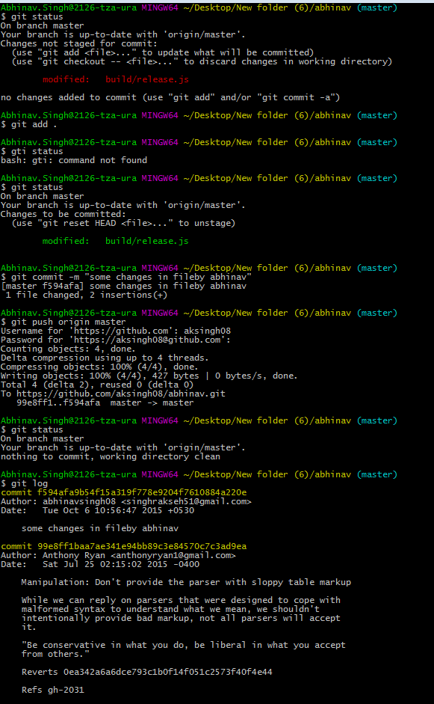

Q-2- How to create branch in Git repository and push code in new branch?

**Git branch – > it return list of all branch name**

Git checkout –b nitinbranch ----- (where nitinbranch is your new branch name)

Gti push origin nitinbranch

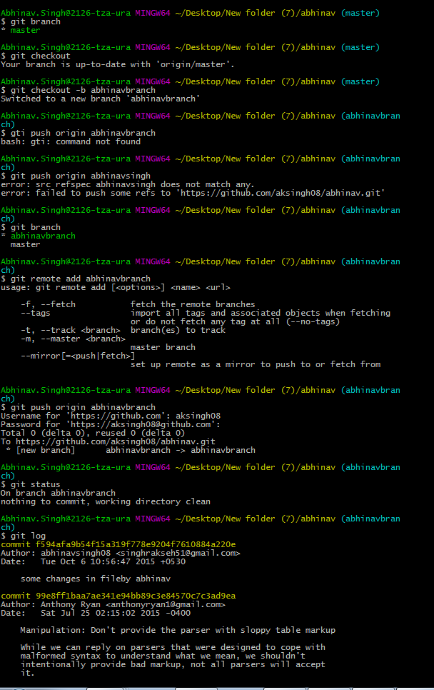

Q-3- How to add remote for new branch?

Git remote add nitinbranch (where nitinbranch is your new branch name)

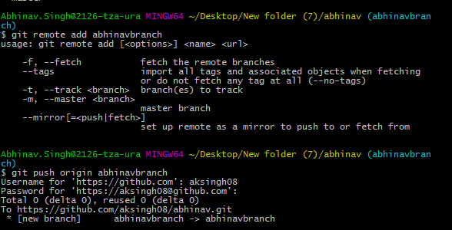

Q-4- How to merge our branch code into master branch?

Git checkout master – move into master branch

Git merge nitinbranch --- now merge code from nitinbranch to master

Git push origin master --- now push code into master branch

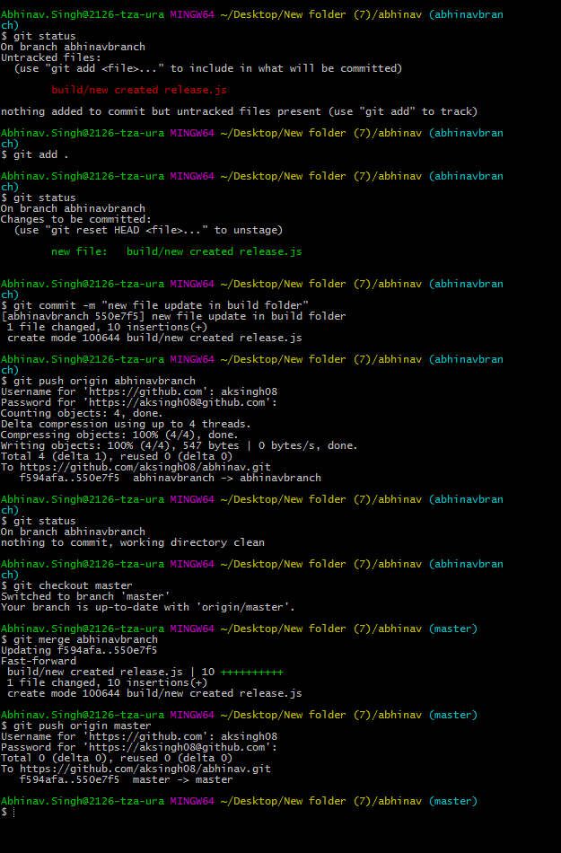

Q-5- How to revert our changes from local branch?

<http://boonconic.com/revert-back-to-a-commit-even-after-you-have-pushed-your-code-to-remote/>

Sometimes we end up pushing some commits to remote repository, just realising that it was the wrong branch or any other reason.

The way to fix this is 3 fold.

* First we need to reset to a commit that we want.
* Next we need to checkout to the right branch and save our changes.
* Lastly we need to rebase our branch to the commit that we want.
* **1. Resetting**

First let's "git log" and find the commit that we want to go back to.

$ git log

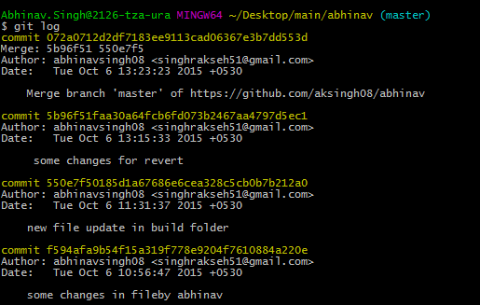

git reset without the --hard option resets the commit history, but not the files. With the --hard option the files in working tree are also reset.

git reset --hard d1ce3ef1ba5de7071997e1afc33efc14923794c8

git reset --hard c35a22cc875ca76d73ea84ad29f1e0490677a91f

Once you choose the commit you want to go back to, we will reset our branch to the that specific commit by-

$git reset 4c23aa9bbb41140eb4fdb91cc1e1ae78572d707

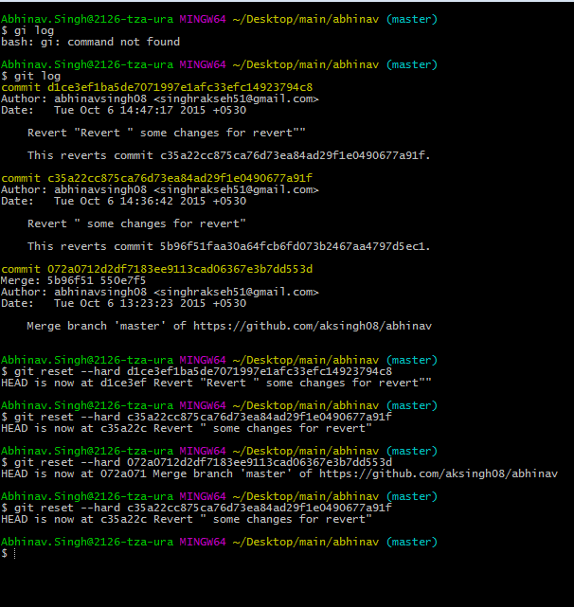

When you reset your branch to the commit of you choice, any future commits will be undone and moved to the working directory

Q-6- How to revert our code from main branch when we merge code in this from my local branch?

Q-7-If there are some changes in main branch and some changes in my local branch and if we want to merge our local branch code into main branch then how is it possible?

Q-8- How to delete our branch from repository?

Q-9- If we want to push some changes into branch. And many developer working on same branch. SO first we have to push code into same branch, take pull from that branch so that other changes which is done by other developer can pull into my local branch and after that push our changes into that branch.

For that we have to run following code –

Git pull --- git pull is method to get code from main branch to our local branch.

git pull will pull down from a remote whatever you ask (so, whatever trunk you’re asking for) and instantly merge it into the branch you’re in when you make the request. Pull is a high-level request that runs ‘fetch’ then a ‘merge’ by default.

Git push origin master –

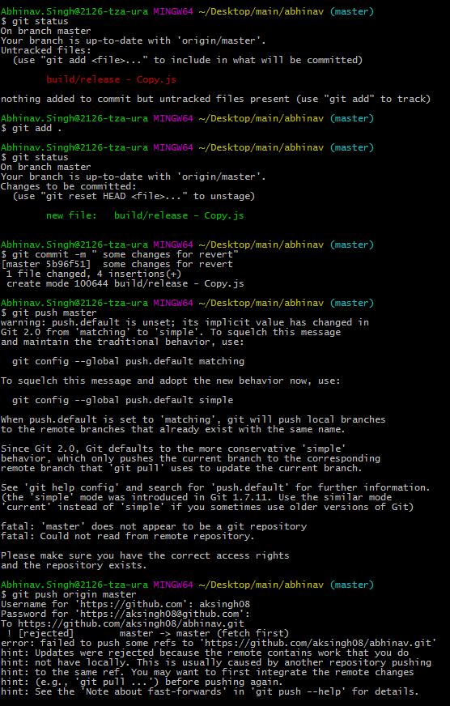

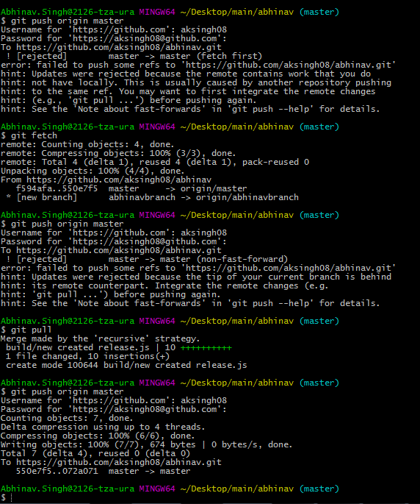

Q-10- How can we merge the remote “master” branch into the local “localBranch”.

git checkout localBranch

git pull origin master

git branch

master

* localBranch

The above will merge the remote “master” branch into the local “localBranch”.

Q-11- How can we make clone from particular branch?