BUG REPORT.
Project Name: SOVIO
Total Bug Founded: 11
Created By: Omkar Khatik
Bug 1:
Description: If browser is in dark mode, the message of verification is not visible, means it is not user-friendly.
Steps to Reproduce:
1. Open the browser
2. Navigate to sign up page
3. Enter email and click continue
4. Message is displayed.
priority: High
severity: minor
screenshot:
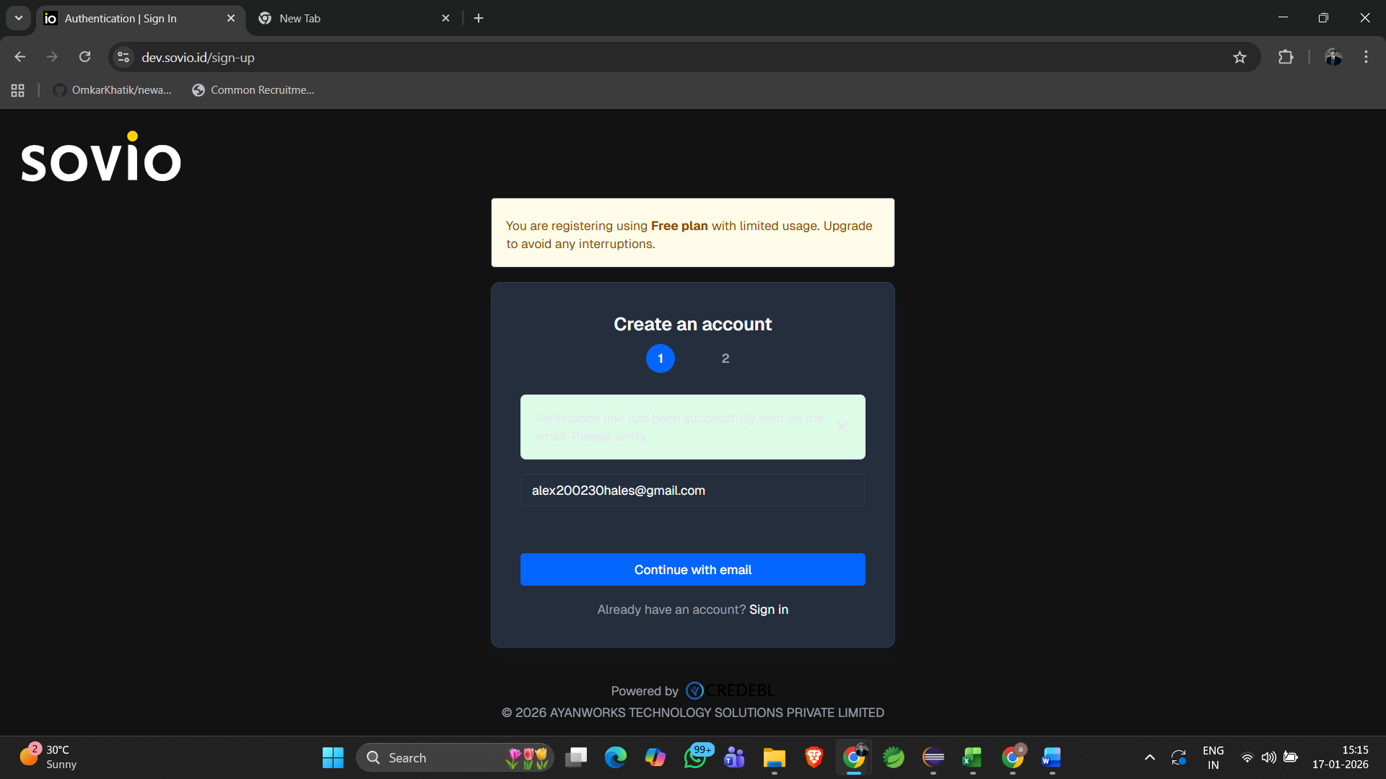

Bug 2:
Description: While clicking on passkey, the popup of create passkey renders lates on the UI, means it takes too much time to pop up.
Steps to reproduce:
1. Open the browser
2. Complete step 1 for account creation
3. Fill all the details and click on passkey
4. Click on create button.
severity: Critical
priority: High
Bug3:
Description: Without FirstName and LastName, User can be able to create Passkey, but it should only pop up when user’s FirstName and LastName is filled.
Step to reproduce:
1. Open the browser
2. Complete the step1 and enter into the create account page
3. Click on passkey
4. Without passing data in First and last name field, click on create account
5. Pop up of Create passkey window is displayed
severity: High
priority: High
screenshot:
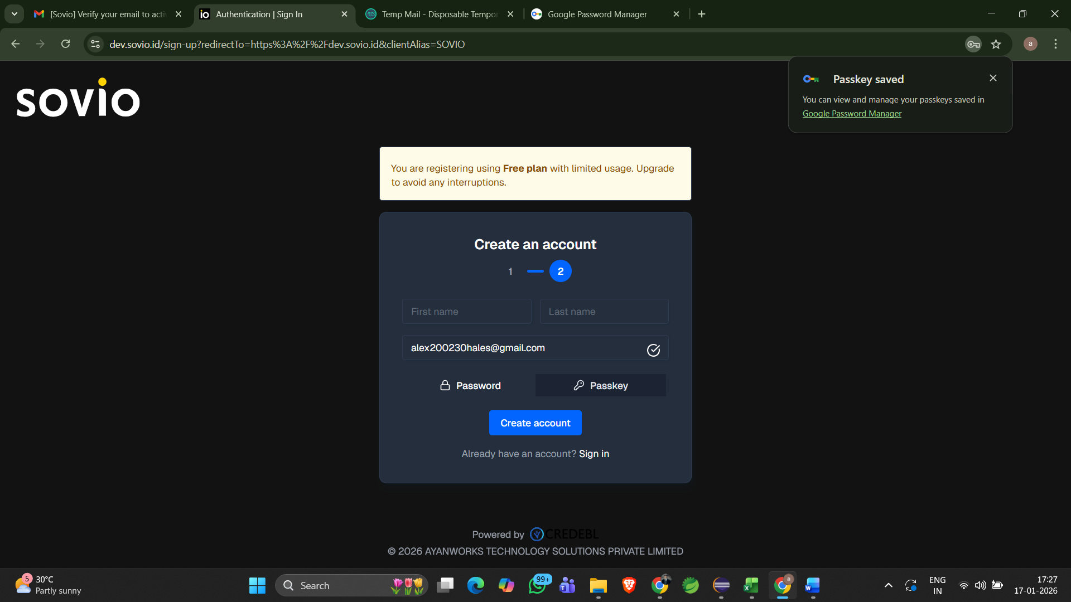

Bug4:
Description:
After creating passkey while registering, it is showing Passkey Registration failed. But it should display Successfully registration.
Steps to Reproduce:
1. Open the browser
2. Complete the step1 and enter into the create account page
3. Click on passkey, Fill all the details and click on create account
4. Pop up comes of create passkey, choose android, turn on Bluetooth and the scan the QR by the respective mobile and give permission do verification.
5. After that, one message pop up of passkey saved.
6. But Passkey Registration failed is displayed.
Severity: High
priority: High
Screenshot:
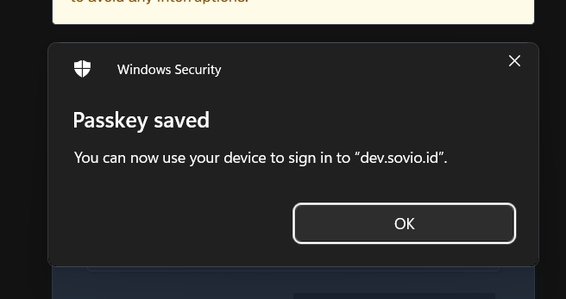
ss: bug4.1
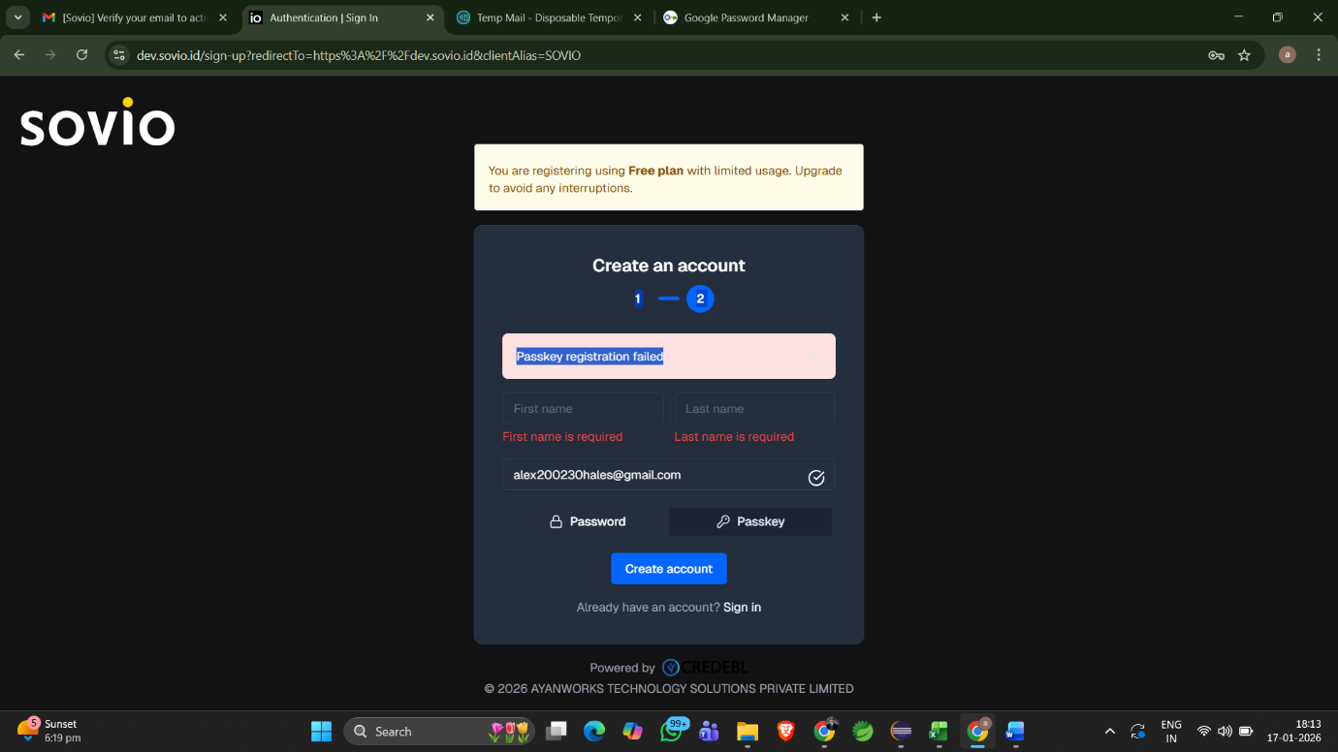ss: bug4.2

Bug5:
Description:
The verification link is one time link, which means if user deletes the mail of verification at inbox. And try to click again for registration the application is saying already sent it is not sending fresh generated verification link.
Step to Reproduce:
1. Open the browser.
2. Navigate on create an account page
3. Enter mail and click continue with email.
4. Then this message is displayed “The verification link has already been sent to your email address”.
5. Then go to inbox of Gmail and delete the mail.
6. return to the application and again click on continue, with same email address
7. You will get same message of sent but You will not get any verification link mail.
severity: Critical
Priority: High
Screenshot:
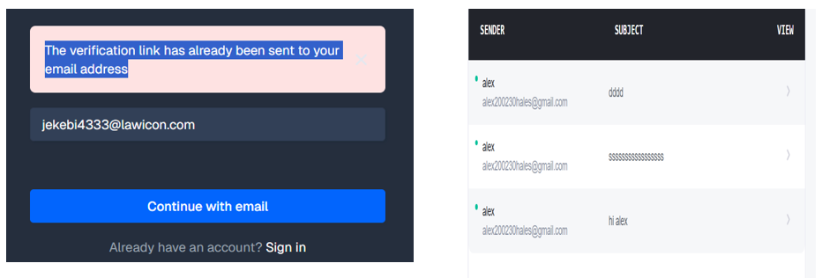

Bug6:
Description:
the password toggle icon is not working as excepted
steps to reproduce:
1. Open the browser
2. Navigate to sign in page
3. Enter password and click on password toggle icon.
severity: minor
priority: Medium
screenshot:
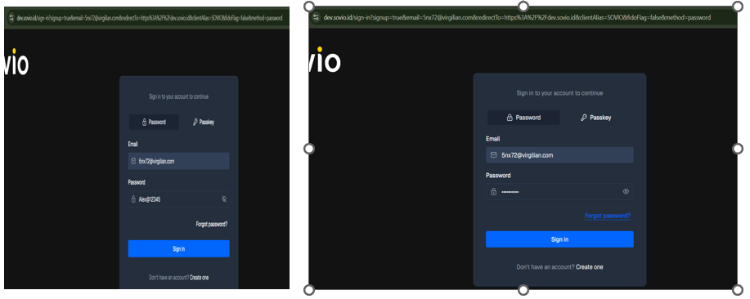
Bug7:
Description:
Sometimes with the passkey it can register and login, but sometimes it only loads but no pop-up message or not navigating to dashboard.
Steps to reproduce:
1. Open the browser
2. register with passkey
3. After that, try to login using passkey
4. The continue with passkey button will load but no further message or navigation.
severity: Blocker
priority: High
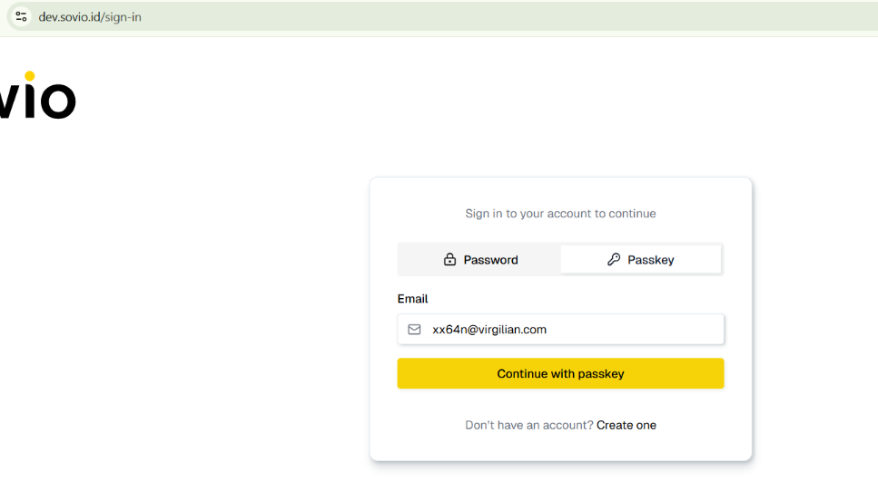
Bug8:
Description:
with unregistered mail, if I try to login using passkey, nothing happens no error message or not any suggestion or pop up.
Step to Reproduce:
1. Open the Browser
2. Navigate to sign in page
3. Click on passkey and enter unregistered email
4. Click continue.
priority: High
severity: Major
Screenshot:

Bug9:
Description: Not compatible with many devices, means alignment problem
SS:
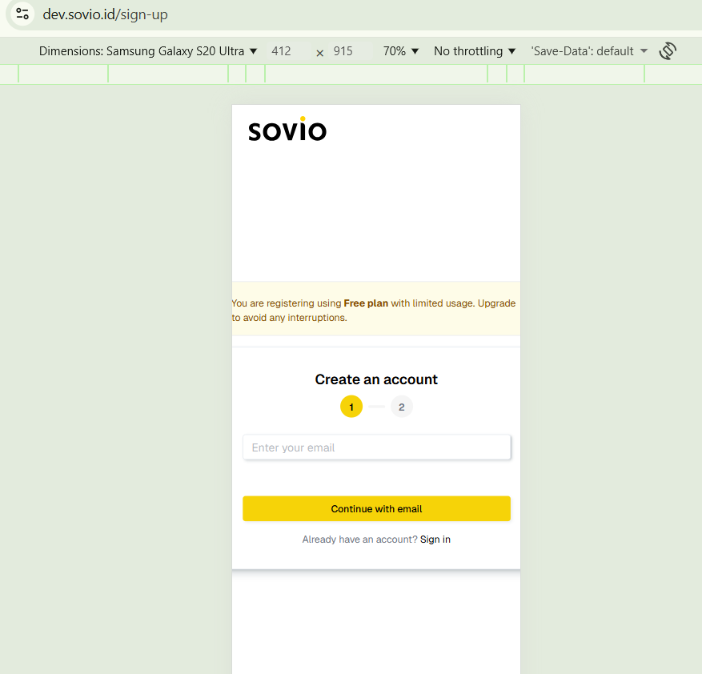
Bug10:
Description:
The mail alignment is not proper, and Company logo is not loaded most of the time.
Priority: low
severity: minor
SS:
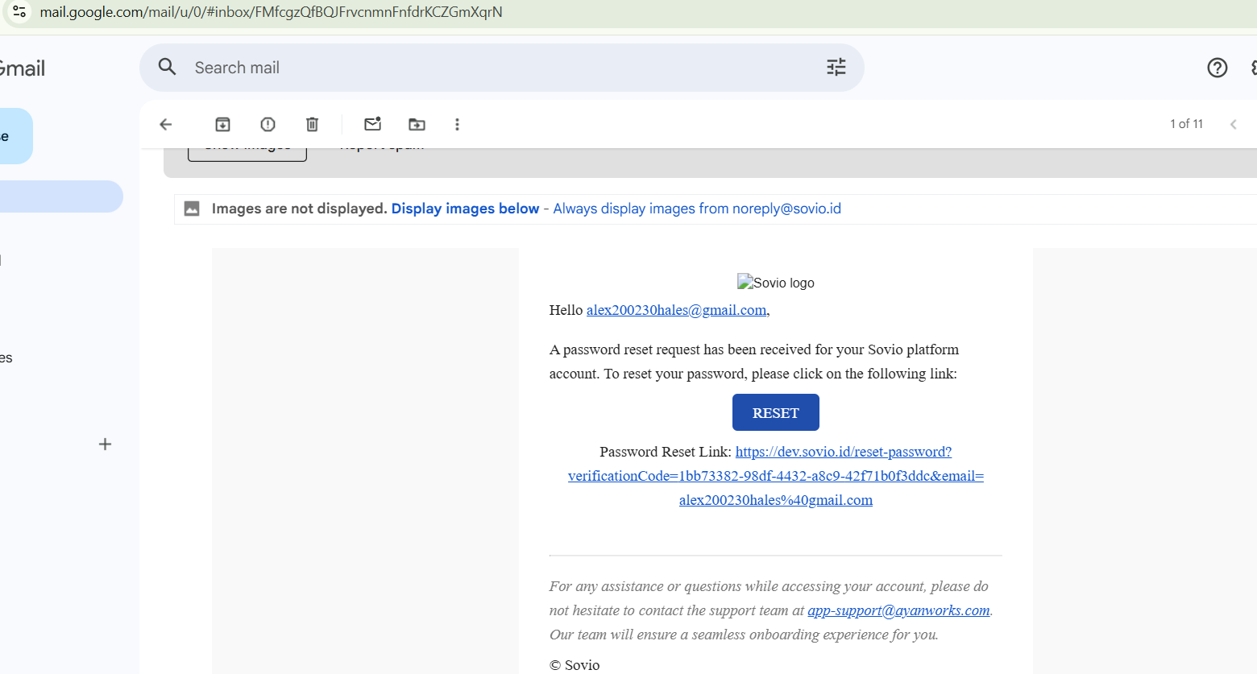
Bug11:
Description:
While clicking on forget password, link is sent but while clicking on the link it is navigating to dashboard. [Sometimes it is resetting password and sometimes after resetting password also it is not signing to dashboard]
Steps to Reproduce:
1. Enter registered email address and click on Forget password
2. Click on reset button in the mail.
priority: High
Severity: major
I had done Screen Recording for this…
link: https://drive.google.com/file/d/12F2mPMNETISZVvfizWD1IexsXHGB5_Y4/view?usp=drivesdk

