Software Requirement Specification (SRS) for

Online Car Rental Portal

Team: Omkar Kolge

Manish Jaiswal

---------------------------------------------------------------------------------------------------------------

# Introduction

### 1.1 Purpose:

This document is meant to delineate the features of online car rental Portal, so as to serve as a guide to the developers on one hand and software validation document for the prospective client on the other.

It is a system design especially for large, premium and small car rental business. The car rental system provides complete functionality of listing and booking car. In this system, Tourism and Travelling facilities also provide.

### 1.2 Scope:

This system allows the Customer can easily get the car whenever they need to on the rent with use of this system.

### 1.3 Definitions:

CRS- Car Rental System

SRS- Software Requirement Specification

GUI- Graphical User Interface

**1.4 Overview:**

It is a system design especially for large, premium and small car rental business. The car rental system provides complete functionality of listing and booking car. In this system, Tourism and Travelling facilities also provide.

This proposed system can be used by any naïve users and it does not require any educational level, experience or technical expertise in computer field but it will be of good use if user has the good knowledge of how to operate a computer.

**EXISTING SYSTEM**

* An existing system can provide manually paper work.
* The user has to go in the office where user can get the car on rent and book their car.
* In the existing system you cannot provide feedback of the user to the admin online.

**NEED FOR NEW SYSTEM**

* The new system is totally computerized system.
* A new system provides features like time efficiency to show car details, user profiles and whatever the customer will give the feedback to the admin.
* This system provides tourism and travelling facilities.
* An inquiry is easily done by user in the system.
* It is the most software application for managing online car rental business.

**2.Overall Description**:

The Car Rental System application enables admin to add a car, manage booking car and rent and also view feedback and enquiry, User to view information of available car, booking car, easily get the car on rent and also give feedback and can enquiry. Also, the developer is designing an online car rental site to manage the cars in the portal and also help customers to book them online without visiting the center physically. The online car rental system will use the internet as the solemethod for booking cars on rent for customer.

**2.1 Product Perspective**:

This product aimed toward a person who don’t want to visit the center as he might don’t get time for that or might not interested in visiting there and dealing with lot of formalities

**2.2 Product Functions**:

In car Renatal System THREE ROLE :

1. Admin

. Login

. Edit Profile

. Car Availability

. Payment History

. Feedback and Rating List

2. Employee

.Sign Up

. Login

. Edit Profile

. Add Car

. Car Availability

. Remove Car

. Payment History

. User Booking List

3. User

. Sign Up

. Login

. Edit Profile

. Car Availability

. Book Car

. Manage Booking

. Feedback and Rating

Car Rental System should support this use case:

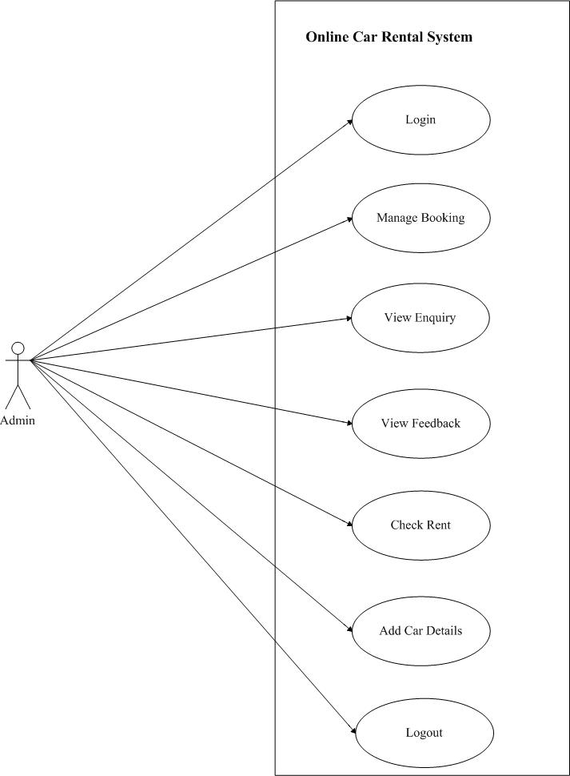**Use Case Diagrams** : A Use case is a description of set of sequence of actions. Graphically it is rendered as an ellipse with solid line including only its name. Use case diagram is a behavioral diagram that shows a set of use cases and actors and their relationship. It is an association between the use cases and actors. An actor represents a real-world object. Primary Actor - Sender, Secondary- Actor Receiver.

**Use case diagram for admin**

**Use Case diagram for User**

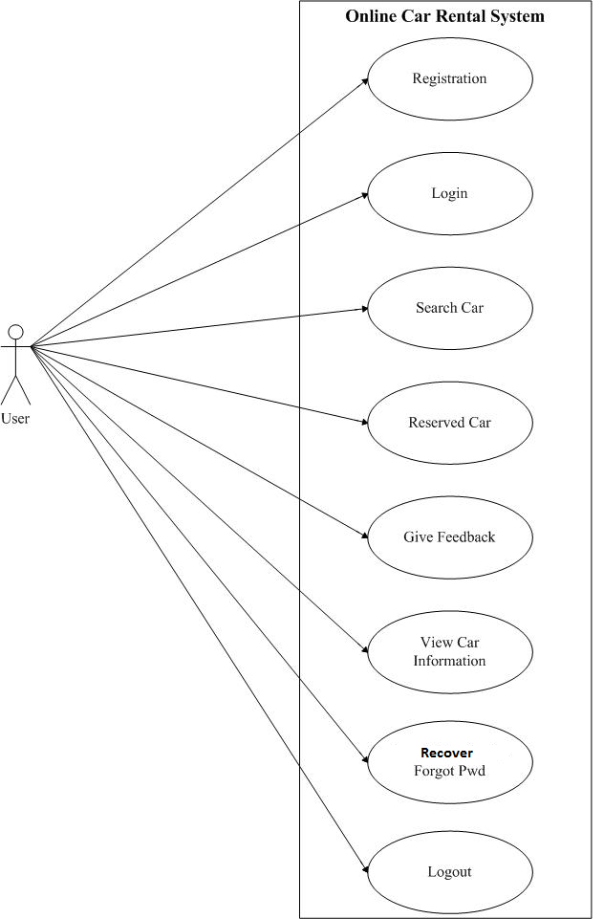

**Use Case diagram for Employee**

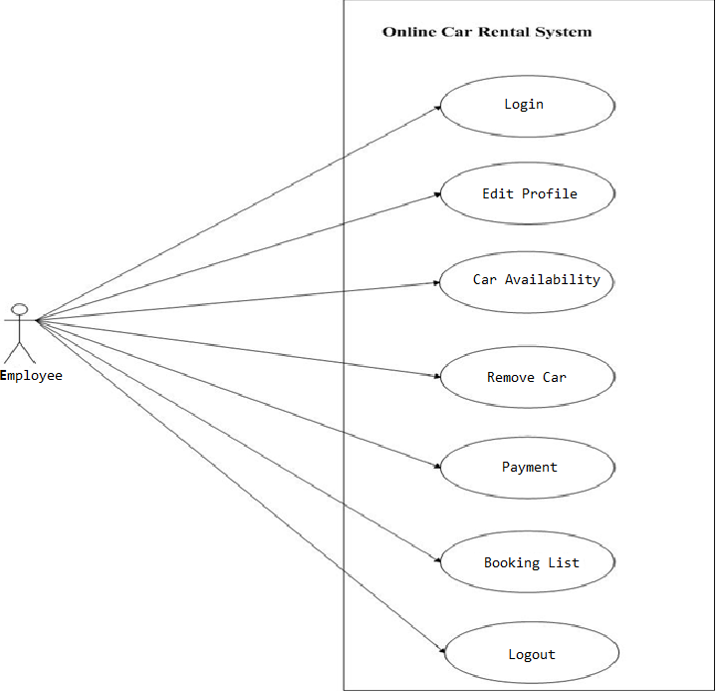

**2.3 User Characeristics**:

User should be familiar with the terms like login,register etc.

**2.4 Principle Actors**:

2 Principle Actors are Customer and Administrator.

**3. Specific Requirements**:

3.1 **FUNCTIONAL SPECIFICATION**

User Specification

**Admin:**

Admin can add a car, manage booking car and rent and also view feedback and enquiry.

**User:**

User can view information of available car, booking car, easily get the car on rent and also give feedback and can enquiry.

**MODULE SPECIFICATION**

**User**

**•View Available Cars:**

The user can view Available cars and user can book for that car.

**•Booking Car:**

The user can view Available cars and user can book for that car.

**•Easily Get the Car on rent:**

The Customer can easily get the car whenever they need to on the rent with use of this system.

**•Give Feedback:**

The customer will give the feedback to the admin.

**•Enquiry:**

The inquiry can easily do by user.

**Admin**

**Dashboard:**

In this section admin can view the overview of the carrental (Like total vehicles, total booking, brands enquiry)

**Vehicle Brand:**

Admin can create/edit/delete vehicle brands

**Vehicles:**

The Admin can add the car so that The user can see the available cars and book the car.

Admin can also edit and delete the cars.

**Bookings:**

Admin can manage the bookings (confirm and cancel the booking)

**Manage testimonials:**

Admin can manage the testimonials (Active and Inactive the testimonials).

**Manage Contact us query:**

Admin can manage Contact us query.

**View Feedback:**

The admin easily view the feedbacks and solve the query.

**Registered users:**

Admin can view the registered users.

**Manage pages:**

Admin can update the pages data information.

**Contact info:**

Admin can update the contact info.

**3.2 Non-Functional Requirements**:

Following Non-Functional Requirements will be there in the insurance to the internet:

Various other Non-Functional Requirements are:

➢ Security

Secure access to consumer’s confidential data

Registered Customer will allowed to book car.

Admin will be to access system through authentication process.

System will automatically log of user after some time due to

inactiveness.

Sensitive data will be always encrypted across communcation.

User proper firewall to protect servers from out sided cyber or velnerable

attacks.

➢ Reliability

The system will backup business data on regular basis and recover in

short time duration to keep system operational

➢ Availability

24X7 availability

Better component design to get better performance at peak time.

➢ Maintainability

A Commercial database software will be used to maintain System data Persistence.

A readymade Web Server will be installed to host online CRS(Web Site) to management server capabilities.

➢ Portability

PDA: Portable Device Application

System will provide portable User Interface ( HTML, CSS, JS) through users will be able to access CRS portal.

System can be deployed to single server, multi server, to any OS, Cloud

➢ Extensibility

➢ Reusability

➢ Compatibility

➢ Resource Utilization

**3.3 Performance Requirements**:

In order to maintain an acceptable speed at maximum number of uploads allowed from a particular customer as any number of users can access to the system at any time. Also the connections to the servers will be based on the attributes of the user like his location and server will be working 24X7 times.

**3.4 Technical Issues**:

This system will work on client-server architecture. It will require an internet server and which will be able to run PHP application. The system should support some commonly used browser such as IE,mozzila firefox,chrome etc.