ASSIGNMENT NO : 1

**Q1 Create the following users, groups, and group memberships:**

• A group named sysadmin.

• A user natasha who belongs to sysadmin as a secondary group.

• A user harry who also belongs to sysadmin as a secondary group.

• A user sarah who does not have access to an interactive shell on the system, and who is not a member of sysadmin.

• natasha, sarah and harry should all have the password of "thuctive".

Process :

I make group sysadmin and add two users harry and natasha to it ,

After that I make user sarah in another shell (/sbin/nologin) and after that this

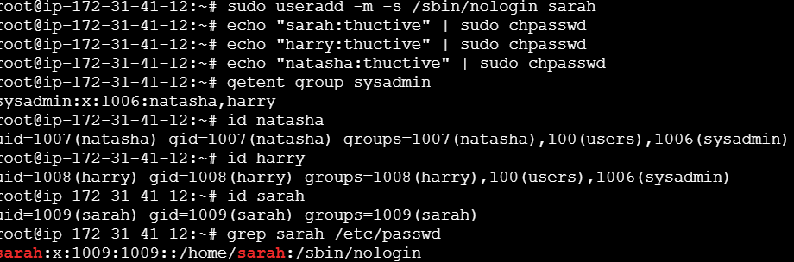

**\*\* Q2 Create a collaborative directory /common/admin with the following characteristics:\*\***

• Group ownership of /common/admin is sysadmin.

• The directory should be readable, writable, and accessible to members of sysadmin, but not to any other user.

• (It is understood that root has access to all files and directories on the system.)

• Files created in /common/admin automatically have group ownership set to the sysadmin

Full process of this :

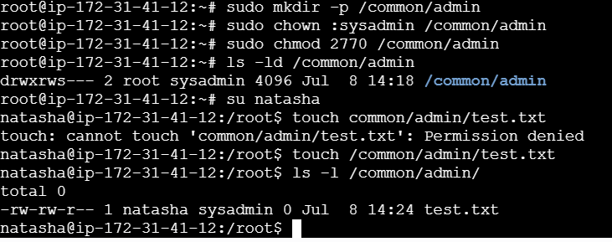

**Q3 Copy the file /etc/fstab to /var/tmp. Configure the permissions of/var/tmp/fstab so that:**

• The file /var/tmp/fstab is owned by the root user.

• The file /var/tmp/fstab belong to the group root.

• The file /var/tmp/fstab should not be executable by anyone.

• The user natasha is able to read and write /var/tmp/fstab.

• The user harry can neither write nor read /var/tmp/fstab.

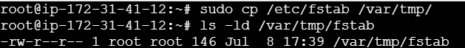

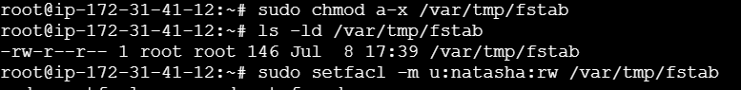

If you don’t have acl then install it by







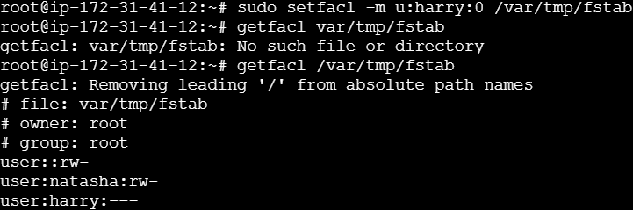

**Q4 You are a system administrator, and your task is to schedule a cron job that backs up a directory (/home/student/projects/) to another location (/home/student/backup/) every day at 2:30 AM. The backup should be done using the cp command.**

What command would you add to the crontab file to achieve this?

How would you edit the crontab for the current user to add this job?





**Q5 You need to set up a cron job that clears the system log file (/var/log/myapp.log) every Sunday at midnight. Instead of deleting the file, you should rename it with a timestamp and create a new empty log file.**

Tasks: Write the cron job command to achieve this.

Explain what each part of the cron job does.

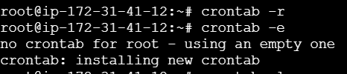

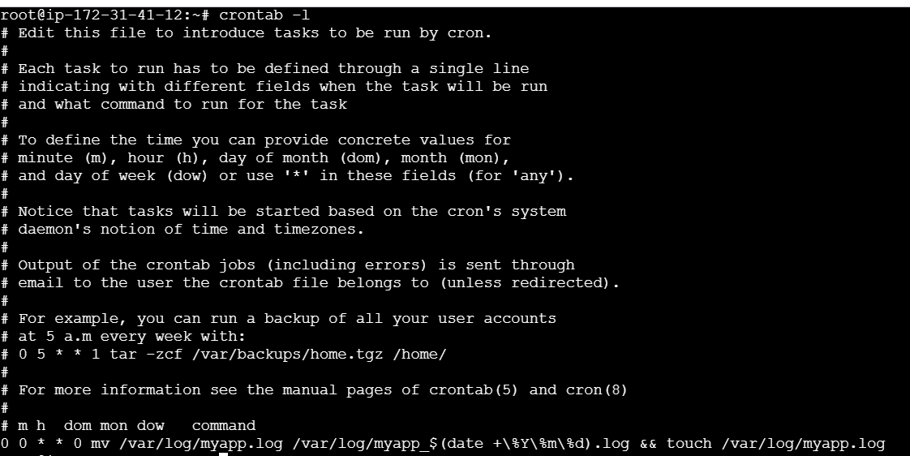

**Q6 Custom Script Execution**

You wrote a script (/home/student/cleanup.sh) that removes temporary files older than 7 days from /tmp. You want to schedule this script to run every Monday, Wednesday, and Friday at 3:15 AM.

Tasks: What would the crontab entry look like?

How can you ensure the script runs with the correct permissions?

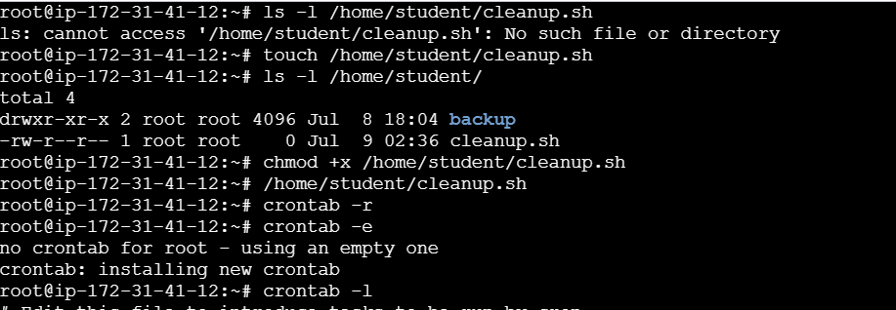



**Q7 Configure a job for user natasha that runs daily at 23:14 local time and execute "Hiya"**

