Software Requirements Specification

**Revision History**

|  |  |  |  |  |
| --- | --- | --- | --- | --- |
| **Date** | **Description** | **Author** | **Approver** | **Comments** |
| 27-10-2019 | New features added | Omkar Metri | Maanvi Nunna |  |
|  |  |  |  |  |
|  |  |  |  |  |

**Table of Contents**

**Revision History** **2**

**1. Introduction** **4**

1.1 Purpose and Intended Audience 4

1.2 Scope 4

1.3 Definitions, Acronyms, and Abbreviations 5

**2. General Description** **5**

2.1 Product Perspective 5

2.2 Product Features 6

2.3 User Characteristics 7

2.4 Operating Environment 8

2.5 Constraints 8

2.6 Assumptions and Dependencies 8

2.7 Documentation 9

**3. Specific Requirements** **9**

3.1 Functional Requirements 9

3.2 Non-Functional Requirements 11

4 External Interface Requirements 12

4.1 User Interfaces 12

4.2 Hardware and Software in terms of how they would interact or how they would be executed 12

4.2.1 Software Interfaces 12

4.2.2 Hardware Interfaces 12

4.2.3 Communication Interfaces 12

**5 Appendix A: Glossary** **12**

# 1. Introduction

## 1.1 Purpose and Intended Audience

The Conference Management System is an online website which provides information regarding the conferences and journals happening all over the world along with the courses offered by various universities. The details of the conference, recommendations, subscription alerts, analytics and technology news feed will be made available to users through the website.

This platform provides a unique service to tech enthusiasts which includes people from different segments of the society such as IT professionals, people enrolled in educational courses, people working for the academia in CS-oriented fields, hobbyist software developers and others. These set of user segments are the target customers for the product.

## 1.2 Scope

ConfHub is a conference management system that works as an aggregator service, listing out all the details about conferences occurring across the globe with many additional features like giving information regarding the courses offered by the universities, analytics and tech news. The existing conference management systems though look like they have most of the features mentioned already, ConfHub’s effort is to get all the features into one place and give the users a very refreshing and seamless experience. ConfHub also provides an added advantage to the organizers where we remove the hassle of manual entry and make it automated, a functionality that is not offered by the existing systems.

There are many services that make us stand out from the existing systems : conference listing, recommendations based on H-index of the conferences, option of subscriptions and a news feed for participant experience enhancement. Finally, devising our market strategy and financial projection, the team aims to make ConfHub a very easy to use and rich graphical interface where users can access the information in a very organized manner.

**What ConfHub is not?**

It is not another website among the hundred other existing ones where the details about the conference is explicitly added by the conference manager. Though it is an aggregator service, the goal of the product is not monetary. ConfHub would be willing to accept donations to publicize a specific conference more than the others, but this is not the only thing the product offers.

## 1.3 Definitions, Acronyms, and Abbreviations

|  |  |
| --- | --- |
| **Acronym/Abbreviations** | **Definitions** |
| DB | Database |
| CMS | Conference Management System |
| SDK | Software Development Kit |
| CS-oriented | Computer Science - oriented |
| AWS | Amazon Web Services |

# 2. General Description

ConfHub is a conference management system that lists out all the details about the conferences, hackathons happening around the world with additional features like giving information regarding the courses offered by the universities, analytics and tech news, thus providing a very intuitive experience. The system is expected to evolve over a period of 1.5-2 months, ultimately allowing a hassle free web based system which users can completely rely on for the things related to conferences.

## 2.1 Product Perspective

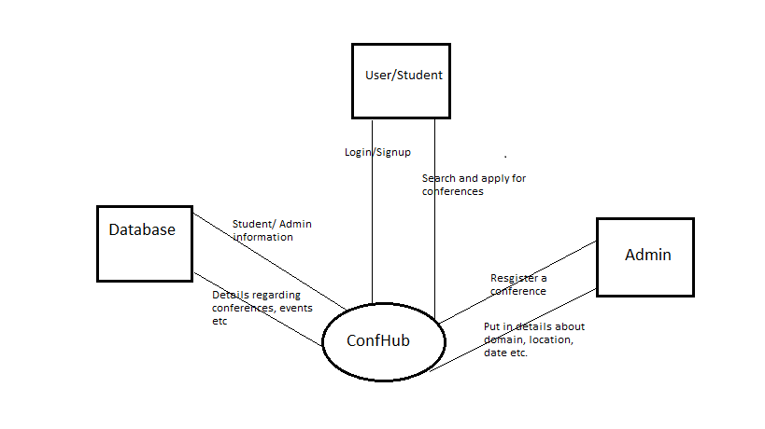

## 2.2 Product Features

|  |  |
| --- | --- |
| **S.No** | **Feature** |
| 1 | Information about the conference which includes name, deadline, conference date, organizer, organizer email-id, website, about the conference, location and country. |
| 2 | Hierarchy structure for the computer science domain |
| 3 | Courses offered by the universities across the globe |
| 4 | Filtering based on location, date and domain along with the aggregation of these filters |
| 5 | Subscription alerts → Mail notification to the registered users well before the deadline along with information of the conference |
| 6 | Tech news feed which gives out information regarding the current technology |
| 7 | Analytics → Recommending based on H-index of the conferences |

## 

## 2.3 User Characteristics

|  |  |
| --- | --- |
| **User** | **Characteristics** |
| Client | * The client is the user who is willing to retrieve associated information. They will have to login or create an account upon which they would be able to see the respective content. * Have access to conference heatmap. * Have access to conference location based on relevant topic. * Access to reviews on conferences * Access to training programs * Give reviews on events |
| System administrator | * Collect Feedback and report * Verify genuinity of uploaded entries * Validate entries * Delete unethical users with inappropriate behavior/Maintain ethical content |
| Employee | * Improve and implement features from user feedback * Maintain website * Handle security aspects of the website |
| Accounting department member | Responsible for subscription handling, payroll activities |
| Third parties | Advertisements in provided platform |

## 2.4 Operating Environment

|  |  |
| --- | --- |
| **OE-1:** | Client/server system |
| **OE-2:** | System shall operate in newest versions of all web browsers |
| **OE-3:** | There should be no constraint on users being able to access the system at a given time. |
| **OE-4:** | Data generated by periodic scraping from multiple websites is stored in SQLite database. User Details also stored in SQLite Database. |
| **OE-5:** | Deploying the application on an AWS instance |
| **OE-6:** | Web Framework used: Flask (Python-based) |
| **OE-7:** | Front-end frameworks and styling frameworks include: HTML, CSS, JS, Flask |

## 2.5 Constraints

|  |  |
| --- | --- |
| **CO-1:** | All data shall be stored on the cloud AWS . |
| **CO-2:** | User interface shall be composed using Django or flask. |

## 

## 2.6 Assumptions and Dependencies

|  |  |
| --- | --- |
| **AS-1:** | No more than 500 MB of data should be stored on cloud AWS. |
| **AS-2:** | Only 5 million pages can view in a month. |
| **AS-3:** | User should have an email account with which they can login. |
| **AS-4:** | Javascript should be enabled by the user in Web browser. |
| **DE-1:** | Google app engine is a Platform as a Service (PaaS) product that provides Web app developers and enterprises with access to google’s scalable hosting. |
| **DE-2:** | Jquery UI is a curated set of user interface interactions, effects, widgets, and themes built on top of the jquery JavaScript Library.  Jquery is a JavaScript library designed to simplify HTML DOM tree traversal and manipulation, as well as event handling, CSS animation, and Ajax. |

## 2.7 Documentation

None as of now.

# 3. Specific Requirements

## 3.1 Functional Requirements

|  |  |  |  |
| --- | --- | --- | --- |
| **FR ID** | **Feature** | **Description** | **Priority**  **(importance)** |
| FR-1 | SignUp | User details and creating an account | ***** |
| FR-2 | Login | User authentication | ***** |
| FR-3 | ConfHub & Higher Studies management | Information of the conferences and high studies programs happening across the globe and filtering of the conferences based on location, date and domain | ***** |
| FR-4 | Recommendations | Based on user profile, history and location | *** |
| FR-5 | Mail Subscription | receive event alerts and information | ** |
| FR-6 | Tech News Feed | Short description about the current technology and redirection links | ** |

Note: More the number of stars, higher the priority.

**FR-1: Signup**

* Stimulus
  + User enters the mandatory details
  + first-name, last-name, email-id, contact number, age, profession, interested domains, location and password are the mandatory details
* Response
  + Validation of the details
  + Verify the mail and contact number
  + Create an account

**FR-2: Login**

* Stimulus
  + User enters email-id and password
* Response
  + Authentication and user session

**FR-3: ConfHub & Higher Studies management**

* Stimulus
  + Display of the conference information and higher studies
  + Filtering based on domain, location and date
  + Hierarchy of the domains, i.e., computer science
* Response
  + Information based on the filter option or display the conference information based on date

**FR-4: Recommendations**

* Stimulus
  + Based on H-index of the conference
* Response
  + Display of information on the side tab

**FR-5: Mail Subscription**

* Stimulus
  + User subscribed for the event alerts
* Response
  + Mark the user for mail subscription and send alerts on weekly basis

**FR-6: Tech News Feed**

* Short description about the current trends in the research domain and redirection links

## 3.2 Non-Functional Requirements

|  |  |  |  |
| --- | --- | --- | --- |
| **NFR ID** | **Feature** | **Description** | **Priority**  **(importance)** |
| NFR-1 | Security | Security from unauthorized access to system | ***** |
| NFR-2 | Performance | > 99% of requests should be served within one second | ***** |
| NFR-3 | Availability | System should have less than 0.1% downtime | ***** |
| NFR-4 | Scalability | Should be possible to scale up and down without any significant changes in the system implementation | *** |
| NFR-5 | Modularity | Should be possible to plug in a module and integrate it in a new part with no implementation changes | ** |

Note: More the number of stars, higher the priority.

**NFR-1: Security**

System should be safe from unauthorized and unauthenticated access and guard against common security vulnerabilities such as SQL injection, XSRF attack, XSS attack and others.

**NFR-2: Performance**

Both the front-end and the back-end of the system should be performant. On the front-end, no user action should take more than 100ms for response from the UI thread. On the back-end 99% of the requests must be served within one second. The daemon tasks running in the background must not take up more than 50% of the CPU and RAM resources.

**NFR-3: Availability**

System must be available at least 99.9% of the total time. Any updates in the back-end application should not lead to more than three seconds of server downtime.

**NFR-4: Scalability**

It must be possible to launch more number of instances of the application as well as to reduce the number of instances without affecting data integrity and system behaviour, and without requiring any changes in the implementation at the run time.

**NFR-5: Modularity**

System should be organized in a highly modular structure to allow component reuse. For this purpose, it should be possible to use the individual modules in different contexts without any dependency issues. The modules must encapsulate all their requirements with them.

## 4 External Interface Requirements

### 4.1 User Interfaces

**UI-1:** Web application shall permit complete navigation and item selection using the keyboard alone, in addition to using a mouse and keyboard combinations.

**UI-2:** Web application will be user responsive, i.e., compatible with all the browsers and different screen sizes (PC, tablets, mobile phone).

### 4.2 Hardware and Software in terms of how they would interact or how they would be executed

### 4.2.1 Software Interfaces

**SI-1:** Cronjob system shall scrape the data periodically on weekly/monthly basis

SI-1.1: The system scrapes the data from the sources and stores to the DB

SI-1.2: Upon completion, the system will display the information to the user.

**SI-2:** Database: The system shall communicate with database through a programmatic interface for the following operations:

SI-2.1: To manage the conference and higher studies program data

SI-2.2: To allow an administrator to approve for the DB update

SI-2.3: Data backup and restore

**SI-3**: Front-end client interface of the system will be built using HTML, CSS, JS, AJAX which will be user friendly and attractive

### 4.2.2 Hardware Interfaces

**HI-1:** Server for hosting and cronjob

### 4.2.3 Communication Interfaces

**CI-1:** The system shall send an email message to confirm and verify the user during registration

**CI-2:** The system shall send a notification to inform the users regarding the conference details

**CI-3:** The system shall send a message to the contact number before the start of the event (30 minutes prior)

# 5 Appendix A: Glossary

No glossary terms available at this time.