LAPTOP RECOMMENDATION SYSTEM
Technical Documentation
AI-Powered Full-Stack Application
Version 1.0 | 3/21/2026

Table of Contents
This document covers:
- Executive Summary
- System Architecture
- Technology Stack
- System Components
- Database Design
- API Specifications
- Workflow & Data Flow
- Recommendation Algorithm
- Deployment & Operations
- Security Considerations

1. Executive Summary

1.1 Project Overview
The Laptop Recommendation System is an AI-powered full-stack web application designed to help users find the perfect laptop based on their specific requirements. The system employs a conversational AI chatbot that intelligently gathers user preferences across 10 key features and recommends the top 3 matching laptops from a curated database using a sophisticated scoring algorithm.

1.2 Key Features
- Conversational AI-driven requirement gathering using Groq's LLaMA 3.1 model
- 10-parameter laptop evaluation system (GPU, CPU, RAM, Storage, Display, etc.)
- Intelligent scoring algorithm (0-9 scale) with budget filtering
- Real-time interactive chat interface with visual laptop cards
- RESTful API architecture for scalability
- MongoDB-backed persistent storage with AI-generated feature classifications

1.3 Business Value
- Reduces decision fatigue for laptop buyers through guided, intelligent recommendations
- Improves customer satisfaction with personalized, data-driven suggestions
- Scalable architecture supporting thousands of concurrent users
- Flexible feature system adaptable to new laptop models and market trends

2. System Architecture

2.1 High-Level Architecture
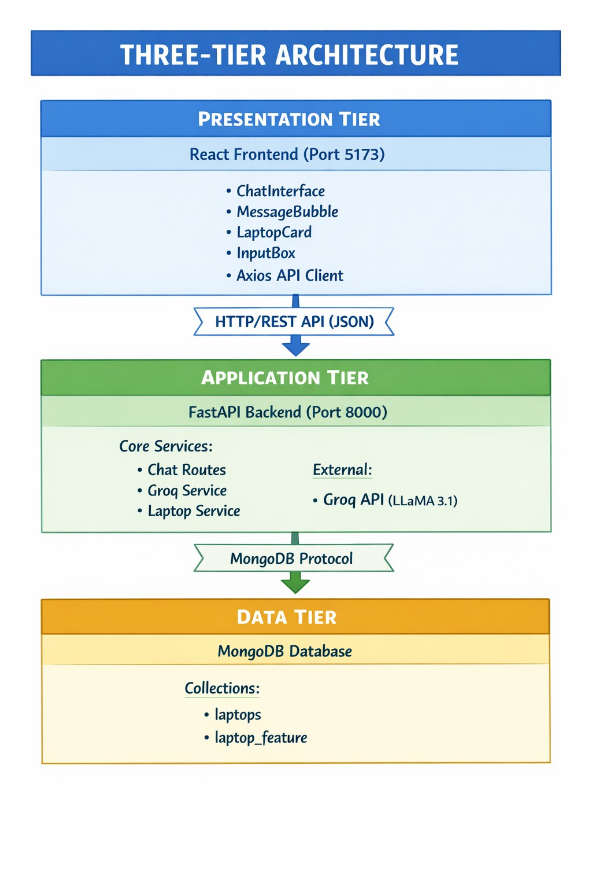

2.2 Component Interaction
The system components interact through well-defined interfaces:
Component | Communicates With | Protocol/Format
React Frontend | FastAPI Backend | HTTP/REST (JSON)
FastAPI Backend | Groq AI API | HTTPS/REST (JSON)
FastAPI Backend | MongoDB | MongoDB Wire Protocol

3. Technology Stack

Layer | Technology | Purpose & Version
Frontend | React 18 | UI framework for building interactive components
 | Vite 5.x | Fast build tool with HMR (Hot Module Replacement)
 | Tailwind CSS 3.4.1 | Utility-first CSS framework for rapid UI development
 | Axios | Promise-based HTTP client for API communication
 | Lucide React | Icon library for UI elements
Backend | Python 3.10+ | Core programming language
 | FastAPI 0.109.0 | Modern async web framework with automatic API documentation
 | Uvicorn 0.27.0 | ASGI server for running FastAPI applications
 | Pydantic 2.5.3 | Data validation and settings management
AI/LLM | Groq SDK 0.11.0 | Python SDK for Groq AI API integration
 | LLaMA 3.1 8B | Language model for conversational AI (llama-3.1-8b-instant)
Database | MongoDB | NoSQL document database for laptop catalog storage
 | Motor 3.3.2 | Async MongoDB driver for Python
 | PyMongo 4.6.1 | Sync MongoDB driver for data seeding scripts

4. System Components

4.1 Backend Components

4.1.1 Configuration Layer (config.py)
Manages environment-specific configuration using Pydantic Settings:
- Loads variables from .env file
- Validates configuration at startup
- Provides centralized access to MongoDB URL, Groq API key, and server settings
- Type-safe configuration with automatic validation

4.1.2 Database Layer (database.py)
MongoDB connection management with async support:
- AsyncIOMotorClient for asynchronous database operations
- Connection pooling for efficient resource utilization
- Health check functionality with ping command
- Graceful connection lifecycle management (startup/shutdown)

4.1.3 API Routes (routes/chat.py)
RESTful endpoints for chat interaction:
Endpoint | Method | Purpose
/api/chat/session | POST | Create new chat session, initialize conversation, return greeting
/api/chat/message | POST | Process user message, check intent, generate response with recommendations
/api/chat/session/{id} | GET | Retrieve session data including conversation history

4.1.4 Groq Service (services/groq_service.py)
AI chatbot orchestration service:
- initialize_conversation() - Creates system prompt with 10-feature instructions
- get_chat_completion() - Sends conversation to Groq API, receives AI response
- intent_confirmation_layer() - Validates if bot collected all 10 user requirements
- dictionary_present() - Extracts structured user profile from natural language response

4.1.5 Laptop Service (services/laptop_service.py)
Recommendation engine with scoring algorithm:
- get_all_laptops() - Fetches laptop catalog from MongoDB
- compare_laptops_with_user() - Core scoring algorithm (detailed in Section 8)
- extract_dictionary_from_string() - Parses user requirements using regex and AST

5. Database Design

5.1 MongoDB Collections

5.1.1 laptops Collection
Primary collection storing laptop product information and AI-generated feature classifications:
{ "_id": ObjectId("..."), "brand": "Dell", "model_name": "Inspiron 15 3000", "price": 45000, "cpu_manufacturer": "Intel", "core": "Core i5", "clock_speed": "2.4 GHz", "ram_size": "16GB DDR4", "storage_type": "512GB NVMe SSD", "display_type": "LED", "display_size": "15.6 inches", "graphics_processor": "NVIDIA GeForce MX350", "screen_resolution": "1920x1080 Full HD", "os": "Windows 11", "laptop_weight": "1.85 kg", "special_features": "Backlit Keyboard, Fingerprint Reader", "warranty": "1 Year Onsite", "average_battery_life": "8 hours", "description": "Powerful laptop for everyday computing...", "laptop_feature": { "gpu intensity": "medium", "processing speed": "medium", "ram capacity": "medium", "storage capacity": "medium", "storage type": "high", "display quality": "medium", "display size": "medium", "portability": "medium", "battery life": "high" } }

5.2 Feature Classification System
Each laptop has a laptop_feature object with 9 AI-generated classifications (low/medium/high). These are generated by analyzing the laptop's specifications using the Groq AI model:
Feature | Classification Criteria
GPU Intensity | low: Integrated (Intel UHD/Iris) | medium: Mid-range dedicated (GTX 1050-1650, MX series) | high: High-end (RTX, GTX 1660+)
Processing Speed | low: i3/Ryzen 3/Celeron | medium: i5/Ryzen 5 | high: i7+/Ryzen 7+/Xeon
RAM Capacity | low: ≤8GB | medium: 12-16GB | high: ≥24GB
Storage Capacity | low: <512GB | medium: 512GB-1TB | high: >1TB
Storage Type | low: HDD | medium: SATA SSD | high: NVMe/PCIe SSD
Display Quality | low: <Full HD (1366x768) | medium: Full HD (1920x1080) | high: 2K/4K/Retina/OLED
Display Size | low: <14" | medium: 14-15.6" | high: >15.6"
Portability | low: <1.5kg (ultraportable) | medium: 1.5-2.5kg | high: >2.5kg (desktop replacement)
Battery Life | low: <6 hours | medium: 6-10 hours | high: >10 hours

7. Workflow & Data Flow

7.1 End-to-End User Journey
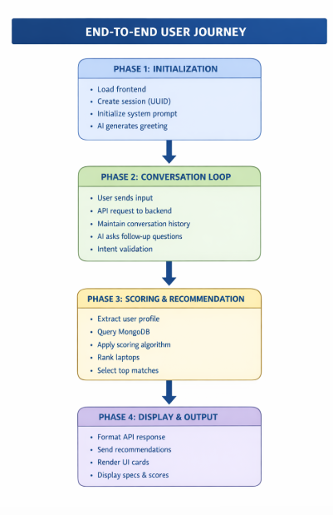

8. Recommendation Algorithm

8.1 Scoring Methodology
The recommendation engine uses a binary matching algorithm with numeric mapping:

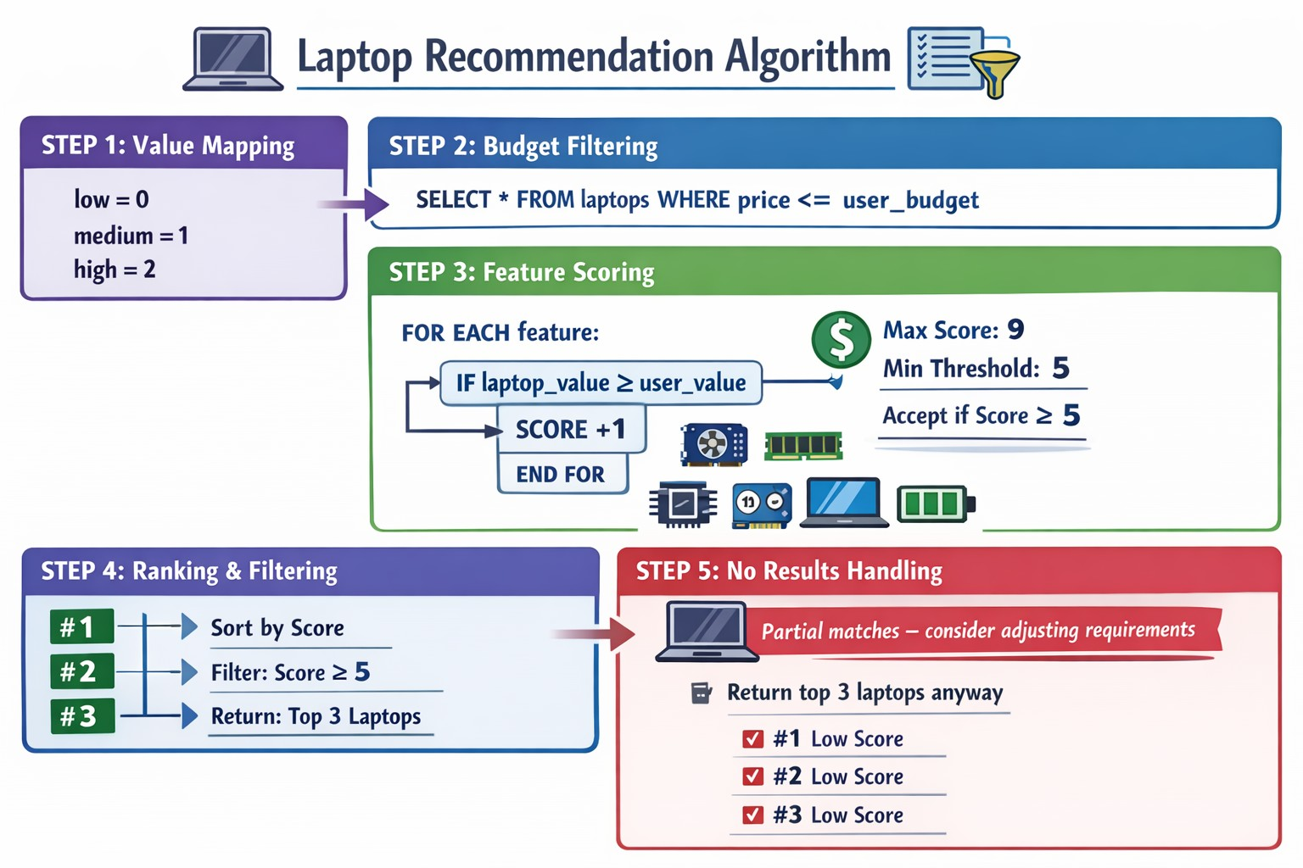

8.2 Example Calculation
Feature | User Need | Laptop A | Match? | Points
GPU Intensity | high (2) | high (2) | ✓ Yes | +1
Processing Speed | high (2) | medium (1) | ✗ No | +0
RAM Capacity | high (2) | high (2) | ✓ Yes | +1
... | ... | ... | ... | ...
FINAL SCORE |  |  |  | 7/9
Result: Laptop A scores 7/9 (78% match) - Qualifies for top recommendations

9. Deployment & Operations

9.1 Local Development Setup
# Backend Setup
cd backend python -m venv venv venv\Scripts\activate # Windows source venv/bin/activate # Mac/Linux pip install -r requirements.txt # Configure .env file MONGODB_URL=mongodb://localhost:27017 DATABASE_NAME=laptop_recommendation_db GROQ_API_KEY=your_api_key_here HOST=0.0.0.0 PORT=8000 # Seed database (one-time) python seed_data.py python generate_laptop_features.py # Start server uvicorn app.main:app --reload --host 0.0.0.0 --port 8000
# Frontend Setup
cd frontend npm install npm run dev # Access at http://localhost:5173

9.2 Production Deployment Considerations

9.2.1 Backend Deployment
- Use Gunicorn with Uvicorn workers for production ASGI server
- Configure environment-specific settings (staging, production)
- Implement CORS whitelist with specific frontend domains
- Use MongoDB Atlas for managed database hosting
- Implement API rate limiting to prevent abuse
- Use Redis for session storage instead of in-memory

9.2.2 Frontend Deployment
- Build optimized production bundle: npm run build
- Deploy to CDN (Vercel, Netlify, AWS S3 + CloudFront)
- Configure environment variables for API endpoint
- Enable HTTPS/SSL for secure communication
- Implement CDN caching for static assets

10. Security Considerations

10.1 API Security
- CORS configuration restricts API access to whitelisted domains
- Input validation using Pydantic schemas prevents injection attacks
- Content moderation placeholder for filtering inappropriate user input
- Session IDs use UUID4 for cryptographic randomness
- Environment variables protect sensitive credentials (API keys, DB URLs)

10.2 Data Protection
- MongoDB connection uses authentication and encrypted connections (Atlas)
- Session data stored temporarily; no persistent user tracking
- Groq API calls include user data only for recommendation context
- No personally identifiable information (PII) collected or stored

10.3 Recommended Enhancements
- Implement rate limiting per IP address to prevent API abuse
- Add request/response logging for audit trails
- Use HTTPS/TLS for all production endpoints
- Implement API key authentication for backend access
- Add CSRF protection for state-changing operations
- Regular security audits and dependency updates

11. Conclusion & Future Enhancements

11.1 Project Summary
The Laptop Recommendation System successfully demonstrates a modern full-stack architecture combining AI-driven conversational interfaces with intelligent scoring algorithms. The system provides users with personalized laptop recommendations through an intuitive chat experience, backed by robust backend services and scalable database design.

11.2 Key Achievements
- Integrated Groq's LLaMA 3.1 model for natural language understanding
- Developed 10-parameter evaluation system for comprehensive laptop assessment
- Implemented AI-powered feature classification for automated catalog management
- Created responsive, user-friendly React interface with real-time updates
- Built scalable RESTful API architecture ready for production deployment

11.3 Future Enhancement Roadmap
Feature | Description | Priority
User Authentication | Add user accounts to save search history and preferences | High
Price Tracking | Monitor price changes and alert users of deals | Medium
Comparison Tool | Side-by-side comparison of multiple laptops | High
Review Integration | Aggregate user reviews from multiple sources | Medium
Multi-language Support | Internationalization for global user base | Low
Mobile App | Native iOS/Android applications using React Native | Medium
Voice Interface | Voice-based interaction using speech recognition | Low
Analytics Dashboard | Admin portal for monitoring user preferences and trends | High

─────────────────────────────────────────────────────────────
END OF TECHNICAL DOCUMENTATION
For questions or support, please contact the development team.

