A
SYNOPSIS REPORT
ON

Lok Seva Mitra

Submitted in partial fulfillment of the requirements for the degree of Bachelor of Engineering in “Information Technology”

By:

Sr.No | Name | ID No.
1 | Anand Dane | VU4F2223094
2 | Swaroop Sawant | VU4F2223100
3 | Prathamesh Thakare | VU4F2223103
4 | Omkar Patil | VU4F2223108
Under the Guidance Of
Prof. Ankur Chavan

Department of Information Technology
Vasantdada Patil Pratishthan's College of Engineering & Visual Arts
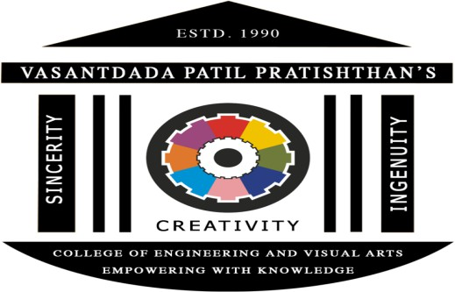

Vasantdada Patil Educational Complex, Eastern Express Highway, Near Everard Nagar, Sion- Chunabhatti, Mumbai – 400022.

UNIVERSITY OF MUMBAI
Academic Year: 2025-26

CERTIFICATE
This is to certify that the project entitled “LokSeva Mitra” is a bonafide work of “Omkar Patil (VU4F2223108), Prathamesh Thakare (VU4F2223103), Anand Dane (VU4F2223094), Swaroop Sawant (VU4F2223100)” submitted to the University of Mumbai in partial fulfillment of the requirement for the award of the degree of “Bachelor of Engineering” in “Information Technology”.

Project Guide
Prof. Ankur Chavan

Dr. PRADIP MANE | Dr. ALAM N. SHAIKH
Head of Department | Principal

Project Report Approval for B. E.

This project report entitled “LokSeva Mitra” by Omkar Patil (VU4F2223108), Prathamesh Thakare (VU4F2223103) , Anand Dane (VU4F2223094), Swaroop Sawant (VU4F2223100) is approved for the degree of “Bachelor of Engineering” in “Information Technology”.

Examiners

1.

2.

Date:

Place: Mumbai - 22

ABSTRACT

Government schemes in India, vital for providing financial aid and welfare benefits, especially to farmers and the economically weaker, suffer from inaccessibility and complexity. Information is scattered across various official portals, often presented in dense, legalistic language, and rarely available in regional languages. This fragmentation and lack of clarity on eligibility, documentation, and application procedures prevent a significant portion of intended beneficiaries, like farmers, from utilizing the support systems designed for them, consequently diminishing the overall impact of these crucial policies.
LokSeva Mitra is a solution designed to overcome this information barrier. This multilingual AI assistant employs a Retrieval-Augmented Generation (RAG) approach, combining generative AI (using Gemini Pro) with accurate information retrieval (using FAISS for vector search) to deliver clear and contextually relevant answers. The system processes unstructured data from government PDFs into structured formats, extracting key details like scheme name, eligibility, and benefits. Its unique strength is handling queries in languages like Marathi and English, providing simplified, jargon-free responses in the user's preferred language. By making complex government schemes easy to find and comprehend, LokSeva Mitra promotes inclusivity, transparency and accessibility, empowering citizens, reducing reliance on intermediaries, and ensuring that policy benefits effectively reach the people they are intended for.

TABLE OF CONTENTS

Chapter 1. Introduction
1.1 Introduction
1.2 Aim and Objectives
1.3 Motivation for the Work
1.4 Scope of the Project
Chapter 2. Survey and Problem Specification
2.1 Existing System
  - Need of New System
2.3 Problem Definition
Chapter 3. Design and Implementation
3.1 Proposed System
3.2 Software Architectural Design
3.3 Algorithms / Flowchart
Chapter 4. Conclusion
Chapter 5. References

List of figures
Sr.No | Name of the figure | Page no.
1
2
3

List of Tables
Sr.no. | Name of the table | Page no.
1
2
3

CHAPTER 1

Introduction
1.1 Introduction:
Accessing government schemes is often a challenging task for citizens, as the information is scattered across multiple websites, presented in technical language, and frequently unavailable in regional languages. This creates significant barriers, particularly for farmers and rural communities, who may find it difficult to understand eligibility criteria, application procedures, and benefits. To address these challenges, Lok Seva Mitra is designed as a multilingual conversational AI assistant that consolidates scheme information, simplifies complex details, and provides clear, understandable guidance to users. Specifically targeted at farmers in Maharashtra, the system ensures that important government schemes are easily accessible, understandable, and actionable, thereby promoting inclusivity, transparency, and better utilization of welfare programs.

1.2 Aim:
The primary aim of this project is to design and develop an intelligent system that can efficiently extract government scheme information from multiple sources, convert and organize this unstructured data into a well-defined JSON format, and facilitate seamless retrieval of relevant details through FAISS-based vector search. Furthermore, the system aims to integrate Gemini Pro for accurate, context-aware, and human-like query answering, ensuring that users receive precise, easy-to-understand, and actionable responses.

Objectives:

To provide multilingual support so that information is accessible to users in their preferred language.

To simplify complex eligibility criteria into clear, easy-to-understand explanations for farmers and citizens.

To implement a cost-free Retrieval-Augmented Generation (RAG) approach for delivering reliable and real-time responses without dependency on expensive solutions.

1.3 Motivation:
Farmers and rural citizens frequently miss out on the benefits of government schemes due to the inaccessibility of information, which is often fragmented, technical, and not available in their native languages. This lack of clarity can result in low adoption of welfare programs and prevent citizens from fully utilizing resources meant to support them. To address this gap, a conversational AI assistant that communicates in the user’s preferred language can play a crucial role by providing accurate, easy-to-understand, and timely guidance. By simplifying the process of discovering and understanding government schemes, such a system has the potential to significantly improve awareness, accessibility, and adoption of welfare initiatives among farmers. Issues faced in searching for appropriate CV.

1.4 Scope:
The current implementation of the system is initially focused on 5–10 government schemes for farmers in Maharashtra, delivered through a command-line interface (CLI) prototype to demonstrate functionality. The system is designed to provide structured scheme information, multilingual support, and eligibility guidance within this limited scope. In the future, the project can be expanded to include a web-based or WhatsApp chatbot interface, integration with additional states and user domains, and automated updates to ensure that the latest scheme information is always available. This scalability ensures that the system can grow into a comprehensive platform for improving citizen access to government welfare programs across India.

CHAPTER 2

Survey and Problem Specification

2.1 Existing System
At present, citizens access information about government schemes through a variety of methods, including multiple official government portals, downloadable PDFs, and manual searches. These approaches are often complex, fragmented, and time-consuming, making it difficult for users to find accurate and up-to-date information. Moreover, the content is frequently available only in a limited set of languages such as English, Hindi, or Marathi, which poses a significant barrier for farmers and rural communities who may be more comfortable with regional languages. As a result, citizens face challenges in understanding eligibility criteria, application procedures, and benefits, leading to low adoption rates of welfare programs and missed opportunities for support.

2.2 Need of New System:
Citizens, particularly farmers and rural communities, often face significant difficulties in accessing information about government schemes due to the fragmented, technical, and language-limited nature of existing resources. There is a clear need for a simple, unified, and multilingual interface that allows users to quickly find relevant scheme information without navigating multiple portals or interpreting complex documents. An AI-based conversational assistant can address these challenges by providing instant, accurate, and easy-to-understand responses in the user’s preferred language. Such a system would not only reduce the manual effort required to search for and comprehend scheme details but also improve awareness, adoption, and utilization of government welfare programs, ensuring that citizens can benefit fully from the resources available to them.

2.3 Problem Definition:
The primary problem addressed by this project is the difficulty citizens face in accessing and understanding government scheme information, which is often unstructured, fragmented, and available in technical language across multiple sources. The goal is to design an AI-powered system capable of automatically extracting structured knowledge from these unstructured documents, organizing the information in a standardized format, and providing simplified, multilingual responses to user queries. By doing so, the system will enable citizens, particularly farmers and rural users, to easily find relevant scheme details, understand eligibility criteria, and take informed actions without being hindered by language barriers or the complexity of official documenta

CHAPTER 3

Design and Implementation
3.1 Proposed System:
The LokSeva Mitra system is designed with a two-phase pipeline that ensures government scheme information is extracted, structured, and delivered to citizens in a simple, conversational format. In the first phase – Data Extraction, unstructured content from official scheme documents, such as government PDFs and portals, is processed, cleaned, and transformed into a standardized JSON format. This structured representation captures key details including scheme name, eligibility conditions, benefits, and application process, making the data easier to search, index, and reuse. By converting scattered and complex documents into a consistent machine-readable format, the system establishes a reliable knowledge base that forms the backbone of the solution. This phase eliminates the difficulties caused by fragmented, text-heavy documents and prepares the information for efficient retrieval.
The second phase – Conversational AI focuses on enabling citizens to interact with this knowledge base in a natural and accessible manner. The system employs a Retrieval-Augmented Generation (RAG) model that combines the power of FAISS for vector-based semantic search with Gemini Pro for generating accurate, context-aware, and multilingual responses. When a user queries the system, FAISS retrieves the most relevant scheme data, and Gemini Pro formulates a clear explanation in the user’s preferred language. This ensures that even complex eligibility criteria and procedural details are presented in an understandable way. By merging structured data with advanced AI-driven conversational capabilities, LokSeva Mitra provides fast and accurate information access while enhancing inclusivity through multilingual support. Its scalable design allows future expansion to more schemes, integration with platforms such as web or WhatsApp chatbots, and automatic updates of scheme information, making it a comprehensive solution for bridging the gap between government resources and citizens.
3.2 Software Architectural Design

Design

3.2.1
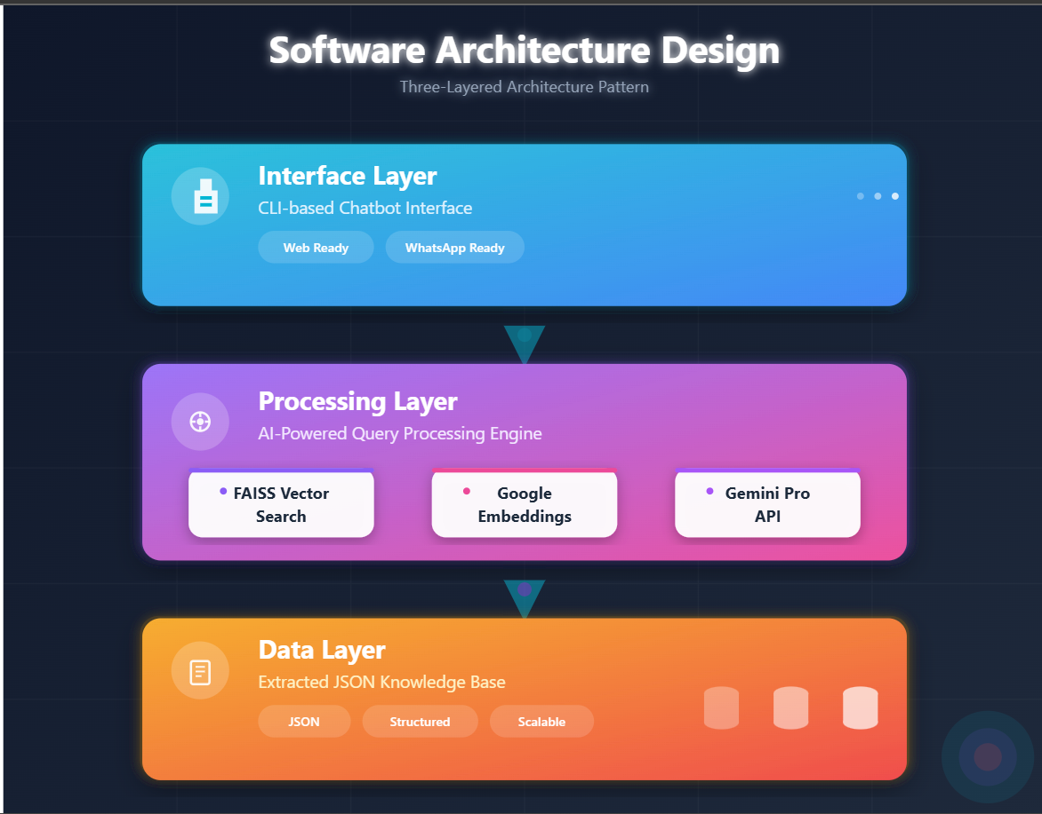

.

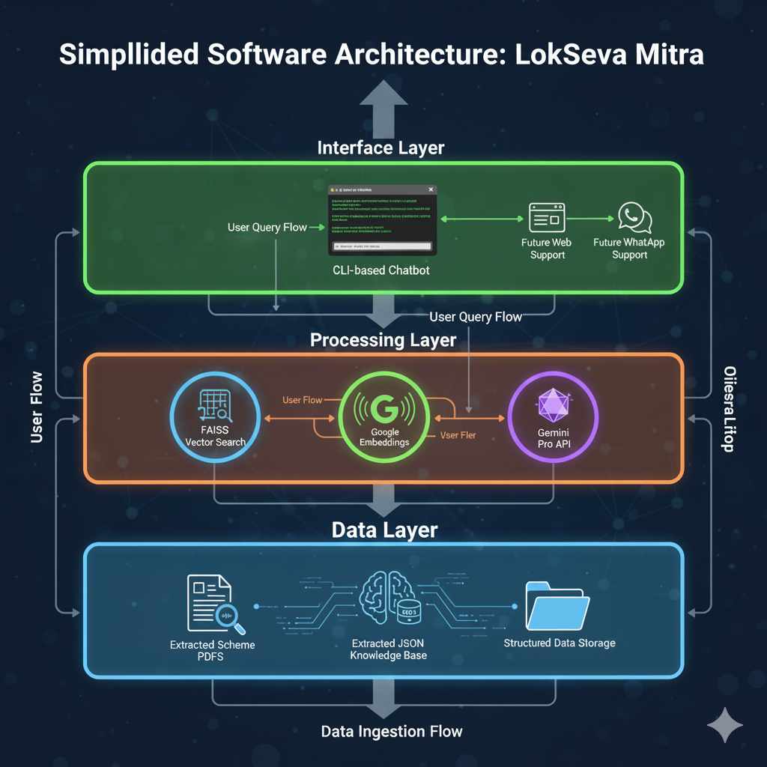

Figure 3.2.1 Usecase Diagram

3.3 Algorithms / Flowchart

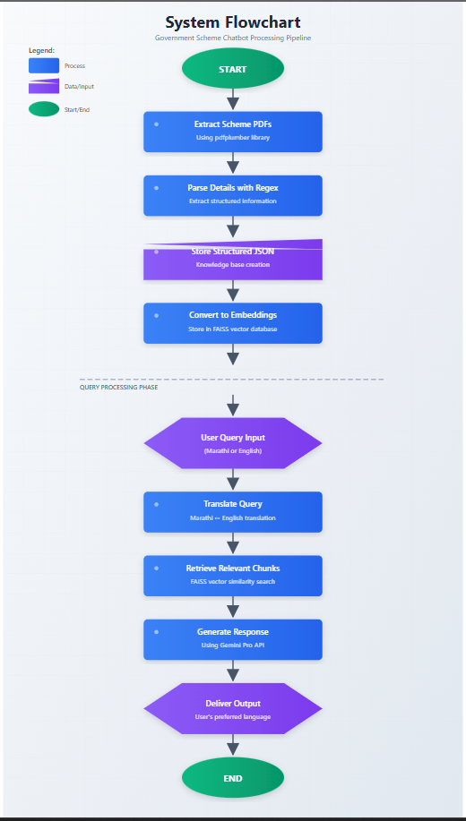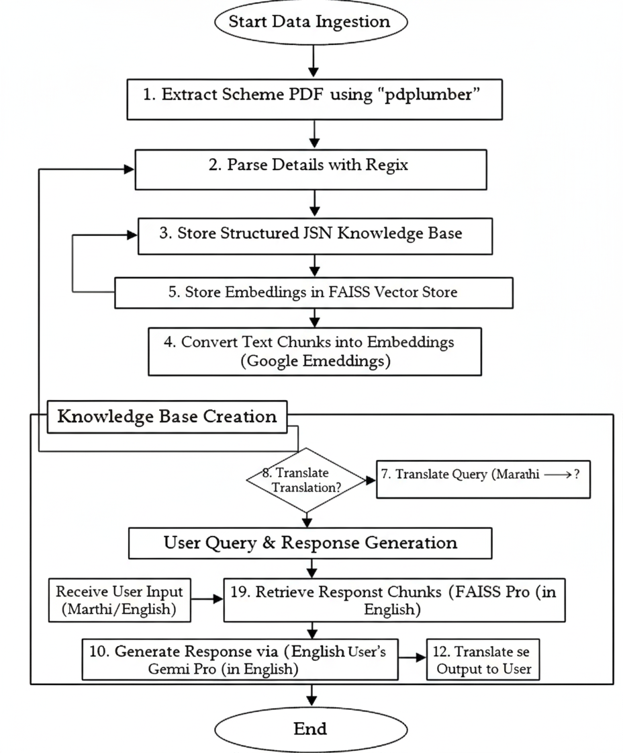

CHAPTER 4

CONCLUSION

Lok Seva Mitra effectively addresses the persistent challenges faced by citizens, especially farmers, in accessing, understanding, and utilizing government schemes. By providing a multilingual AI assistant, the system bridges the gap between complex, unstructured official documents and the end-users, presenting information in a simplified, clear, and actionable manner. This approach not only enhances accessibility but also empowers farmers to make informed decisions, complete applications accurately, and fully benefit from the welfare programs available to them. The project showcases the practical and impactful application of artificial intelligence in addressing real-world social challenges, demonstrating how technology can drive tangible grassroots benefits. In addition, the scalable architecture of the system, combined with its multilingual capabilities, allows for future expansion to include a wider range of government schemes, support for additional states, and integration into various user platforms such as web interfaces and messaging applications. By improving awareness, accessibility, and user engagement, LokSeva Mitra has the potential to contribute significantly to social inclusion and equitable access to government resources, making it a valuable tool for both citizens and policymakers..

CHAPTER5

References

- Google Generative AI Documentation – https://ai.google.dev
- FAISS: Facebook AI Similarity Search – https://github.com/facebookresearch/faiss
- pdfplumber Documentation – https://github.com/jsvine/pdfplumber
- Googletrans Python Library – https://py-googletrans.readthedocs.io/

