Name: Omkar Patil ID: VU4F2223108
Experiment 6
Aim: Analyze network performance for quality-of-service parameters such as throughput, latency etc.

Using trace file, trace.awk script is implemented to calculate throughput and latency. We refer the trace file generated in experiment 5 as an input for the awk script.

Code:

script.awk

BEGIN {
ftime = 0;
stime = 0;
flag = 0;
fsize = 0;
th = 0;
latency = 0;
}

{
if ($1 == "r" && $4 == 3) {
fsize += $6;
if (flag == 0) {
stime = $2;
flag = 1;
}
ftime = $2;
}
}

END {
latency = ftime - stime;
th = (fsize * 8) / latency;
printf("\n Latency: %f\n", latency);
printf("\n Throughput: %f\n\n", th);
}

trace_file.txt

r 1 10.5.6.7 3 100 1234
r 2 10.5.6.8 3 150 1235
r 3 10.5.6.9 3 200 1236
r 4 10.5.6.10 3 250 1237
r 5 10.5.6.11 3 300 1238

Output:
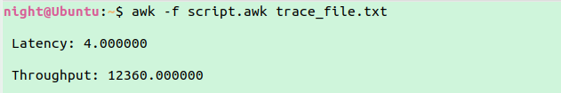

Conclusion: Hence, we have successfully implemented the analyze network performance for quality-of-service parameters such as throughput, latency etc.

