#include<stdio.h>

#include<stdlib.h>

int curId = 1;

char status[7][10] = {" Invalid "," General "," Ladies ","Handicap"," Senior ","  VIP  "};

struct personInQueue{

    char name[20];

    // Weightages: VIP=5, Senior =4, Handicap=3, Ladies=2, General =1

    int weightage, regId;

    struct personInQueue \*next;

}\*first;

struct personInQueue\* askForDetails(){

    struct personInQueue \*newEntry = (struct personInQueue\*) malloc(sizeof(struct personInQueue));

    newEntry->next = NULL;

    newEntry->regId=curId++;

    printf("Enter your name: ");

    scanf("%s",&newEntry->name);

    printf("From the following: 1.General \t 2.Ladies\t 3.Handicap\t 4.Senior\t 5.VIP\n");

    printf("Choose your status: ");

    scanf("%d",&newEntry->weightage);

    if(newEntry->weightage > 5 || newEntry->weightage < 1)

        newEntry->weightage = 0;

    return newEntry;

}

void queuePerson(struct personInQueue \*new){

    if(first==NULL){

        first = new;

        printf("Succesfully queued at first and only pos\n");

        return;

    }

    if(first->weightage < new->weightage){

        new->next = first;

        first = new;

        printf("Succesfully queued at first pos\n");

        return;

    }

    struct personInQueue \*check = first;

    struct personInQueue \*prev = first;

    while( (check!=NULL && check->weightage >= new->weightage ) ){

        //printf("Going behind of %s",check->name);

        prev = check;

        check = check->next;

    }

    new->next = prev->next;

    prev->next = new;

    printf("Succesfully queued\n");

}

void display(){

    struct personInQueue \*traverse = first;

    printf("Queue of reservation priority wise: \n");

    while (traverse!=NULL){

        printf(".-----------------------.\n");

        printf("|    %s (%s)\t|\n",traverse->name,status[traverse->weightage]);

        printf("'-----------------------'\n");

        traverse = traverse->next;

    }

    printf("End\n");

}

int main(){

    int choice, el;

    while (1){

        printf("Do you want to reserve ticket for any person? Yes: 1  /  No: 0\n");

        //printf("2. DeQueue \n");

        printf("Answer: ");

        scanf("%d",&choice);

        if(choice)

            queuePerson(askForDetails());

        else

            break;

    }

    display();

    return 0;

}

void display(){

    struct personInQueue \*traverse = first;

    printf("Queue of reservation priority wise: \n");

    while (traverse!=NULL){

        printf(".-----------------------.\n");

        printf("|    %s (%s)\t|\n",traverse->name,status[traverse->weightage]);

        printf("'-----------------------'\n");

        traverse = traverse->next;

    }

    printf("End\n");

}

int main(){

    int choice, el;

    while (1){

     printf("Do you want to reserve ticket for any person? Yes: 1  /  No: 0\n");        printf("Answer: ");

        scanf("%d",&choice);

        if(choice)

            queuePerson(askForDetails());

        else

            break;

    }

    display();

    return 0;

}

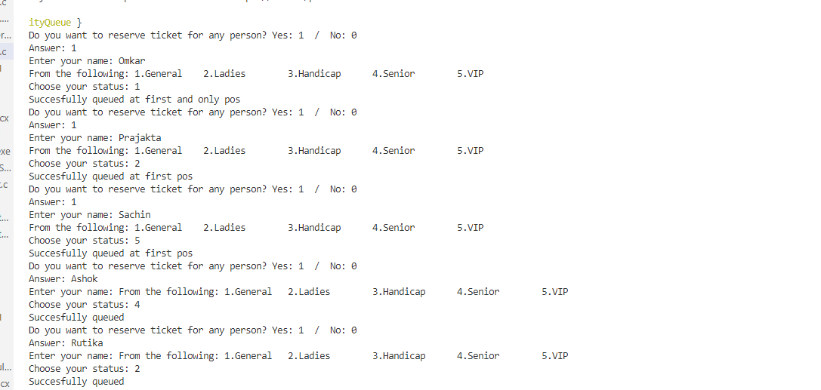

Output :

