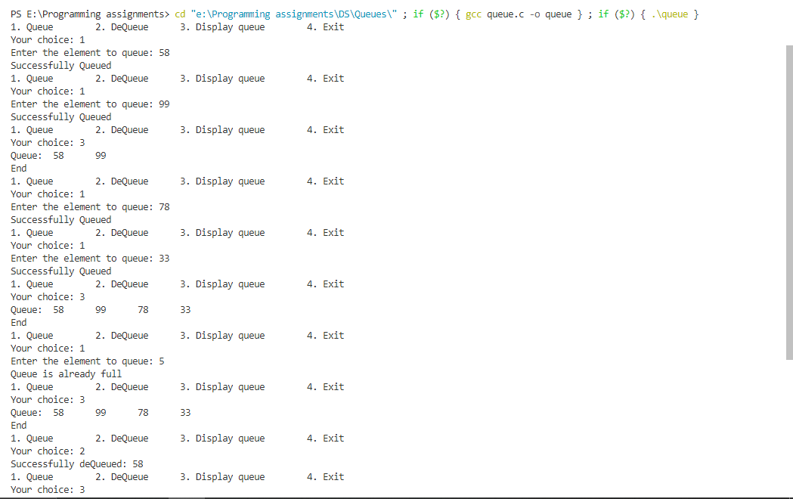

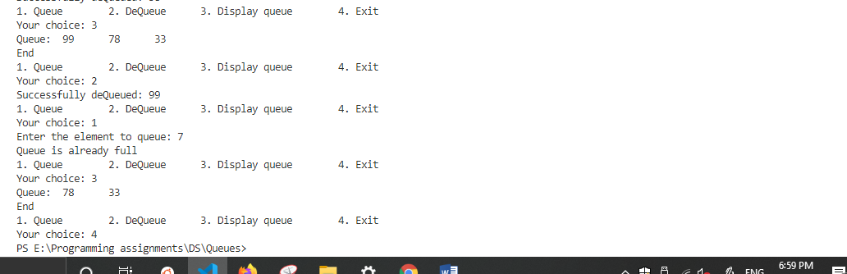

Queue

Queue

int main()

{

    int choice, el;

    while (1){

        printf("1. Queue\t");

        printf("2. DeQueue\t");

        printf("3. Display queue \t");

        printf("4. Exit \n");

        printf("Your choice: ");

        scanf("%d",&choice);

        switch (choice)

        {

        case 1:

            printf("Enter the element to queue: ");

            scanf("%d",&el);

            queueEl(el);

            break;

        case 2:

            dequeue();

            break;

        case 3:

            display();

            break;

        case 4:

            return 1;

            break;

        default:

            printf("Invalid choice opted! \n");

            break;

        }

    }

    return 0;

}

#include<stdio.h>

#define size 4

int queue[size];

int front = -1, rear = -1;

void queueEl(int element)

{

    if(rear==size-1 || front>rear)

        printf("Queue is already full\n");

    else if(front==-1 && rear==-1){

            front++;

            rear++;

            queue[rear] = element;

           printf("Successfully Queued\n");

        }

        else{

            rear++;

            queue[rear]=element;

           printf("Successfully Queued\n");

         }

}

void dequeue()

{

    if(( front==-1 && rear==-1 ) || front>rear)

        printf("There are no elements in the queue to dequeue\n");

    else{

        printf("Successfully deQueued: %d\n", queue[front]);

        front++;

    }

}

void display()

{

    if(( front==-1 && rear==-1 ) || front>rear)

        printf("Empty queue\n");

    else{

        int traverse = front;

        printf("Queue:\t");

        while (traverse<=rear){

            printf("%d\t",queue[traverse]);

            traverse++;

        }

        printf("\nEnd\n");

    }

}

Queue

Circular Queue

#include<stdio.h>

#define size 4

int queue[size];

int front = -1, rear = -1;

void queueEl(int element){

    if( (rear==size-1 && front==0) || (rear==front-1) )

        printf("Queue is already full\n");

    else if(front==-1 && rear==-1){

                front++;

                rear++;

                queue[rear] = element;

            printf("Successfully Queued\n");

        }

        else if(rear == size-1){

                rear = 0;

                queue[rear] = element;

            }

            else{

                rear++;

                queue[rear] = element;

            }

}

void dequeue(){

    int del;

    if(( front==-1 && rear==-1 ) )

        printf("There are no elements in the queue to dequeue\n");

    else{

        if(front==rear){

            del = queue[front];

            front = -1;

            rear = -1;

        }

        else if(front==size-1){

            del = queue[front];

            front=0;

        }

        else{

            del=queue[front];

            front++;

        }

        printf("Successfully deQueued: %d\n", del);

    }

}

void display(){

    int traverse;

    if(( front==-1 && rear==-1 ))

        printf("Empty queue\n");

            traverse = front;

            printf("Queue:\t");

            for(int i=front; i<=rear; i++)

                printf("%d\t",queue[i]);

        }

        else{

            printf("Queue:\t");

            for(int i=front; i<size; i++)

                printf("%d\t",queue[i]);

            for(int i=0; i<=rear; i++)

                printf("%d\t",queue[i]);

        }

        printf("\nEnd\n");

}

/\*int noOfEl(){

    int count = 0;

    int traverse = front;

    while(traverse != rear+1){

        count++;

        if(traverse == size-1)

            traverse = 0;

        else

            traverse++;

    }

    return count;

}\*/

int main(){

    int choice, el;

    while (1){

        printf("1. Queue\t");

        printf("2. DeQueue\t");

        printf("3. Display queue\t");

        printf("4. Exit\n");

        //printf("5. No of elements \n");

        printf("Your choice: ");

        scanf("%d",&choice);

        switch (choice)

        {

        case 1:

            printf("Enter the element to queue: ");

            scanf("%d",&el);

            queueEl(el);

            break;

        case 2:

            dequeue();

            break;

        case 3:

            display();

            break;

        case 4:

            return 1;

            break;

        case 5:

            //printf("No of elements: %d\n",noOfEl());

            break;

        default:

            printf("Invalid choice opted! \n");

            break;

        }

    }

    return 0;

}

    else if(front<=rear){

            traverse = front;

            printf("Queue:\t");

            for(int i=front; i<=rear; i++)

                printf("%d\t",queue[i]);

        }

        else{

            printf("Queue:\t");

            for(int i=front; i<size; i++)

                printf("%d\t",queue[i]);

            for(int i=0; i<=rear; i++)

                printf("%d\t",queue[i]);

        }

        printf("\nEnd\n");

}

int main(){

    int choice, el;

    while (1){

        printf("1. Queue\t");

        printf("2. DeQueue\t");

        printf("3. Display queue\t");

        printf("4. Exit\n");

        printf("Your choice: ");

        scanf("%d",&choice);

        switch (choice){

        case 1:

            printf("Enter the element to queue: ");

            scanf("%d",&el);

            queueEl(el);

            break;

        case 2:

            dequeue();

            break;

        case 3:

            display();

            break;

        case 4:

            return 1;

            break;

        default:

            printf("Invalid choice opted! \n");

            break;

        }

    }

    return 0;

}

Circular Queue

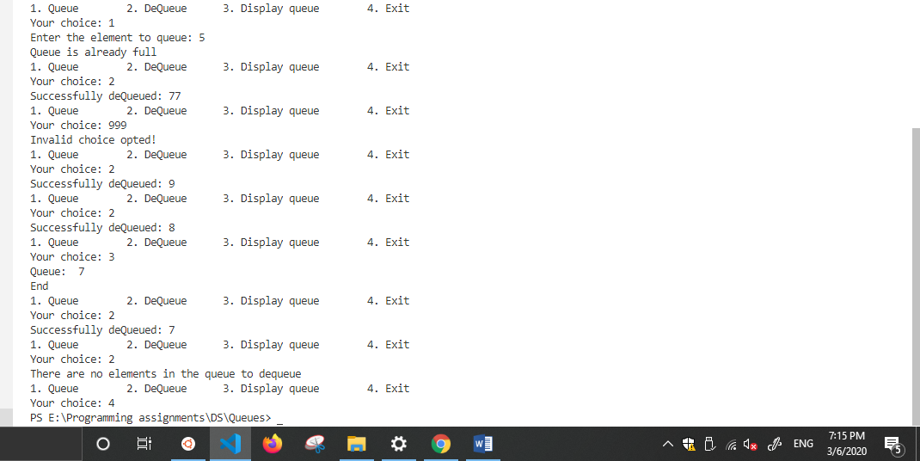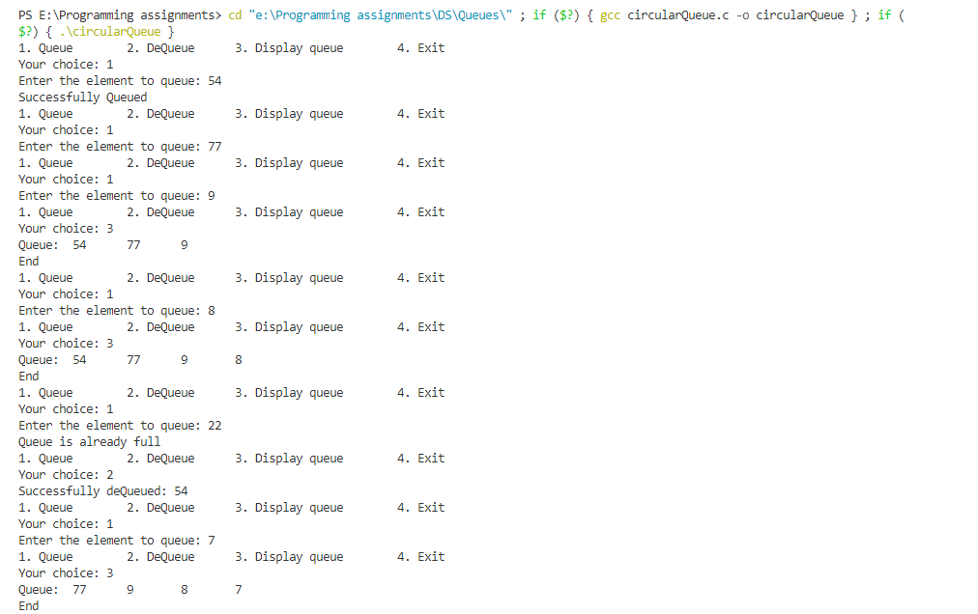

Circular Queue