PIZZA SALES SQL QUERIES
A. KPI’s
1. Total Revenue
SELECT SUM(total_price) AS Total_Revenue FROM pizza_sales;
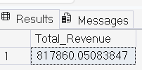
2. Average Order Value
SELECT (SUM(total_price)/ COUNT(DISTINCT order_id)) AS Avg_order_Value FROM; pizza_sales;
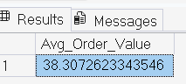
3. Total Pizzas Sold
SELECT SUM(quantity) AS Total_pizza_sold FROM pizza_sales;
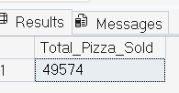
4. Total Orders
SELECT COUNT(DISTINCT order_id) AS Total_Orders FROM pizza_sales;
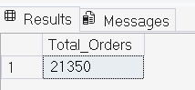
5. Average Pizzas Per Order
SELECT CAST(CAST(SUM(quantity) AS DECIMAL(10,2)) /
CAST(COUNT(DISTINCT order_id) AS DECIMAL(10,2)) AS DECIMAL(10,2))
AS Avg_Pizzas_per_order
FROM pizza_sales;
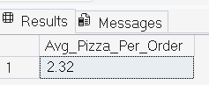

B. Daily Trend for Total Orders
SELECT DATENAME(DW, order_date) AS order_day,
COUNT(DISTINCTorder_id)AS total_orders
FROM pizza_sales
GROUP BY DATENAME(DW, order_date);
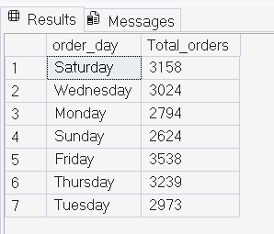

C. Monthly Trend for Orders
select DATENAME(MONTH, order_date) as Month_Name, COUNT(DISTINCT order_id) as Total_Orders
from pizza_sales
GROUP BY DATENAME(MONTH, order_date);
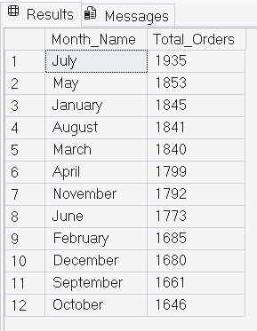

D. % of Sales by Pizza Category
SELECT pizza_category, CAST(SUM(total_price) AS DECIMAL(10,2)) as total_revenue,
CAST(SUM(total_price) * 100 / (SELECT SUM(total_price) from pizza_sales) AS DECIMAL(10,2)) AS PCT
FROM pizza_sales
GROUP BY pizza_category;
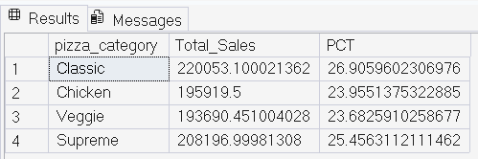
E. % of Sales by Pizza Size
SELECT pizza_size, CAST(SUM(total_price) AS DECIMAL(10,2)) as total_revenue,
CAST(SUM(total_price) * 100 / (SELECT SUM(total_price) from pizza_sales) AS DECIMAL(10,2)) AS PCT
FROM pizza_sales
GROUP BY pizza_size
ORDER BY pizza_size;
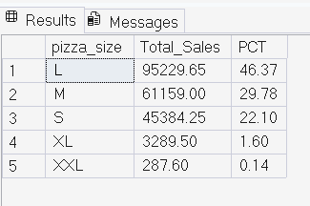
F. Top 5 Pizzas by Revenue
SELECT Top 5 pizza_name, SUM(total_price) AS Total_Revenue
FROM pizza_sales
GROUP BY pizza_name
ORDER BY Total_Revenue DESC;
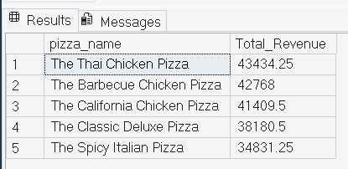
G. Bottom 5 Pizzas by Revenue
SELECT Top 5 pizza_name, SUM(total_price) AS Total_Revenue
FROM pizza_sales
GROUP BY pizza_name
ORDER BY Total_Revenue ASC;
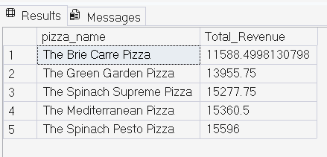

H. Top 5 Pizzas by Quantity
SELECT Top 5 pizza_name, SUM(quantity) AS Total_Pizza_Sold
FROM pizza_sales
GROUP BY pizza_name
ORDER BY Total_Pizza_Sold DESC;
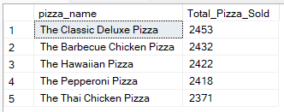

I. Bottom 5 Pizzas by Quantity
SELECT TOP 5 pizza_name, SUM(quantity) AS Total_Pizza_Sold FROM pizza_sales GROUP BY pizza_name ORDER BY Total_Pizza_Sold ASC ;
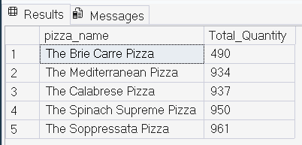
J. Bottom 5 Pizzas by Total Orders
SELECT Top 5 pizza_name, COUNT(DISTINCT order_id) AS Total_Orders
FROM pizza_sales
GROUP BY pizza_name
ORDER BY Total_Orders ASC;
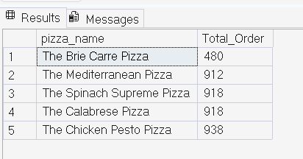
K. Top 5 Pizzas by Total Orders
SELECT Top 5 pizza_name, COUNT(DISTINCT order_id) AS Total_Orders
FROM pizza_sales
GROUP BY pizza_name
ORDER BY Total_Orders DESC;

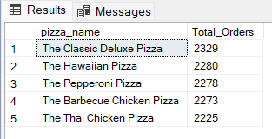
L. Total Pizzas Sold by Pizza Category
SELECT pizza_category, SUM(quantity) as Total_Quantity_Sold
FROM pizza_sales
WHERE MONTH(order_date) = 2
GROUP BY pizza_category
ORDER BY Total_Quantity_Sold DESC;
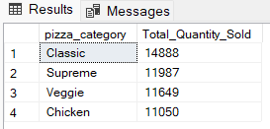
DAX FORMULAS USED IN POWER QUERY
1.Total Orders: The total number of order placed.
Total Orders = DISTINCTCOUNT(pizza_sales[order_id])

2. Total Revenue: The sum of all the total price of all pizza orders.
Total Revenue = SUM(pizza_sales[total_price] )

3. Average Order Value: The average amount spend per order, calculated by dividing the total revenue by the total number of orders.
Avg Order Value = [Total Revenue]/[Total Orders]

4. Total Pizza Sold: The sum of the quantity of all of the pizzas sold.
Total Pizza Sold = SUM(pizza_sales[quantity])

5. Average Pizzas Per Order: The average number of pizzas sold per order, Calculated by dividing the total number of pizzas sold by the number of orders.
Avg Pizzas Per Order = [Total Pizza Sold]/[Total Orders]

6.Order Day:
Order day = UPPER(LEFT(pizza_sales[Day Name], 3))

