**Normalization Assignment**

**Given Problem:**

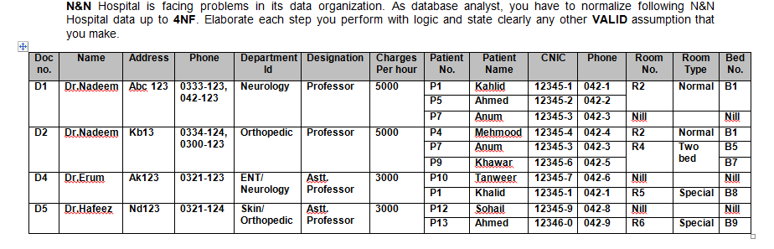

**Step 1: Converting to 1 NF, We Get**

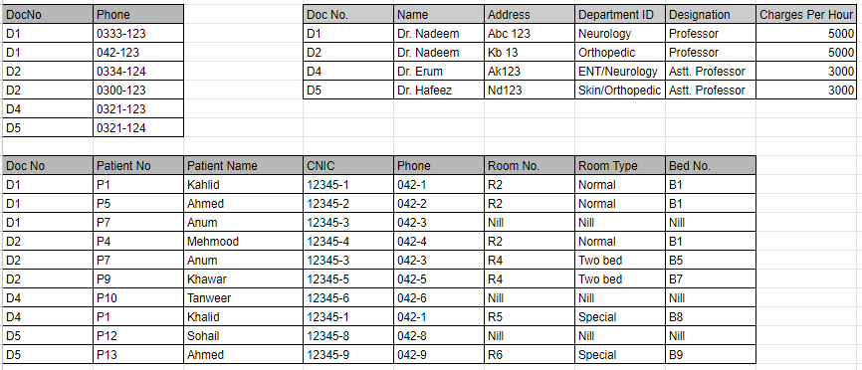

A new relation is created for Multi-valued attribute (Phone No.) since it is dependent on Dr No.

Patient is a multi-valued attribute. Thus another relation is created with atomic values.

**Step 2: Converting to 2NF, We Get**

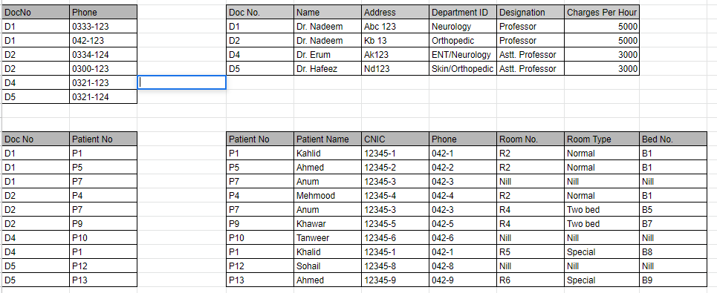

Relations having partial dependency are normalized by breaking it down in multiple relations.

Patient is dependent on Doctor. Room is dependent on the Patient & Doctor.

**Step 3: Converting to 3NF & then BCNF, We Get**

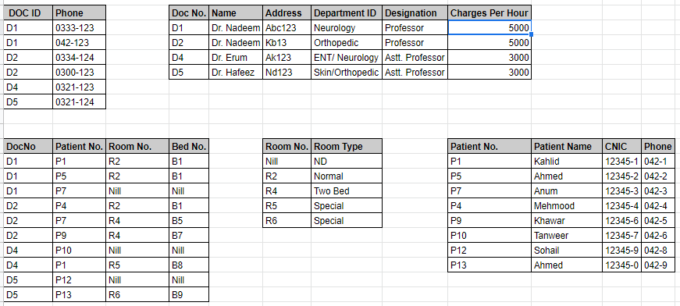

Decomposing Relations till every non-prime attribute of all relations (tables) is non-transitively dependent on every key of all derived tables and all candidate keys are part of the superkey.