Index
Sr.no | Date | Title | Signature
 |  | Equivalence Partitioning and Boundary value Analysis
 |  | - Calculate the body weight index
 |  | - Accept three numbers in the range of 1 to 300 and find the largest number among three numbers
 |  | - Accept three numbers in the range of 0 to 100 and arrange them in ascending order
 |  | Decision table and Cause Effect Graphing
 |  | - Test scenario of the insurance agency
 |  | - Test scenario of the different type of rail card
 |  | - Test Scenario of university examination application form
- Se |  | State Transition Testing
 |  | - Test scenario of the display devices in various modes
 |  | - Test scenario of the online shopping website
 |  | Use Case Testing
 |  | - User Registration form
 |  | - Online shopping cart
 |  | Loop Coverage, Call Coverage and Path Coverage
 |  | - Euclidean function code inspection
 |  | - Iteration function code inspection
 |  | Selenium IDE
 |  | - Create a test suite for facebook login page
 |  | - Create a registration form and create a test suite for the same.
 |  | - Create a test suite for the webpage which compares two numbers and gives the largest as the output.
 |  | Selenium Webdriver
 |  | - Retrieve and compare the title of the webpage
 |  | - Fill the registration form
 |  | - Compares two numbers and give the largest as the output.
 |  | Selenium Webdriver for counting the elements
 |  | - Count total number of elements on the webpage
 |  | - Count the total number of items in the combo/list/dropdown
 |  | - Count the number of checked and unchecked checkboxes/ radio buttons on the page
 |  | Use of jxl.jar file
 |  | - Update 10 records in excel sheet.
 |  | - Update 10 records in excel sheet. Include the header for each column. Also display the highest, lowest and average score

Practical 01
Aim: Equivalence Partitioning a Boundary value Analysis

Title: Black Box Testing – Equivalence Partitioning and Boundary value Analysis

Problem Statement:
When getting a person’s weight and height as input, the program prints the person’s body weight index. The weight is given in kilograms (as a real number, for instance: 82.0) and the height in meters (as a real number, for instance: 1.86). The body weight index equals weight divided by height squared: weight / (height * height). Design test cases for testing the program with the black-box strategy.

Source Code:

wt=float(input("Enter your weight in kilograms:"))
ht=float(input("Enter your height in meters"))
if ht<=0 or ht>4 or wt<=0 or wt>700:
print("Invalid input")
else:
index=w/(ht*ht)
print("Your BMI is " , index)

Solution:

Equivalence partitions (ht):
height ≤ 0 | 0.1 ≤ height ≤ 4 | height > =4.1
Invalid Partition | Valid Partition | Invalid Partition

Equivalence partitions (wt):
weight ≤ 0.0 | 1.0 ≤ weight ≤ 700.0 | weight ≥ 700.01
Invalid Partition | Valid Partition | Invalid Partition

Boundary Value Analysis (ht):
0 | 0.1 | 0.2
Invalid | Valid | Valid
3.99 | 4.0 | 4.1
Valid | Valid | Invalid

Boundary Value Analysis (wt):
0.0 | 1.0 | 2.0
Invalid | Valid | Valid
699.0 | 700.0 | 700.01
Valid | Valid | Invalid

Test Cases
Test case ID | Input: ht | Input: wt | Expected output | Remark
 | 1.7 | 95 | Your BMI is 32.871972318339104 | Pass
 | 2 | 700 | Your BMI is 175.0 | Pass
 | 3 | 237 | Your BMI is 26.33 | Pass
 | 2.2 | -159 | Invalid Input | Pass
 | 4 | 134 | Your BMI is 8.375 | Pass
 | -1.2 | 231 | Invalid Input | Pass
 | 7.4 | 430 | Invalid Input | Pass
 | 5.4 | 788 | Invalid Input | Pass
 | 3.4 | 800 | Invalid Input | Pass
 | 0 | 0 | Invalid Input | Pass

Conclusion: As the program specifications are given. With the given specifications, the above test cases are generated and seem to work well.

Title: Black Box Testing – Equivalence Partitioning and Boundary value Analysis

Problem Statement:
Design the test cases for Boundary Value analysis and equivalence partitioning of the following.
Consider a program for determining the largest amongst three numbers. Its input is a triple of integers and the numbers are in [1,300]. The possible outputs would be largest amongst three numbers or invalid input.

Source Code:

try:
a = int(input("Enter the first number (1-300): "))
if not (1 <= a <= 300):
print("Invalid Input")
else:
b = int(input("Enter the second number (1-300): "))
if not (1 <= b <= 300):
print("Invalid Input")
else:
c = int(input("Enter the third number (1-300): "))
if not (1 <= c <= 300):
print("Invalid Input")
else:
result = max(a, b, c)
print("The largest number is:", result)
except ValueError:
print("Please enter valid integers.")

Solution:

Let a, b, c be the variables that stores the three input values.
Equivalence partitions (a):
a<=0 | 1<=a<=300 | a>=301
Invalid Partition | Valid Partition | Invalid Partition

Equivalence partitions (b):
b<=0 | 1<=b<=300 | b>=301
Invalid Partition | Valid Partition | Invalid Partition

Equivalence partitions (c):
c<=0 | 1<=c<=300 | c>=301
Invalid Partition | Valid Partition | Invalid Partition

Boundary Value Analysis (a):
0 | 1 | 2
Invalid | Valid | Valid
299 | 300 | 301
Valid | Valid | Invalid

Boundary Value Analysis (b):
0 | 1 | 2
Invalid | Valid | Valid
299 | 300 | 301
Valid | Valid | Invalid

Boundary Value Analysis (c):
0 | 1 | 2
Invalid | Valid | Valid
299 | 300 | 301
Valid | Valid | Invalid

Test Cases
Test case ID | Input: a | Input: b | Input: c | Expected output | Remark
 | s | - | - | Error- Please enter valid integers. | Pass
 | 700 | - | - | Error- Invalid Input | Pass
 | 220 | 400 | - | Error-Invalid Input | Pass
 | 100 | 200 | 500 | Error-Invalid Input | Pass
 | 110 | 45 | 60 | The largest number is: 110 | Pass
 | 37 | 32 | 70 | The largest number is: 70 | Pass
 | 77 | 91 | 84 | The largest number is: 91 | Pass
 | 45 | r | - | Error- Please enter valid integers. | Pass
 | 87 | 63 | t | Error- Please enter valid integers. | Pass
 | 1 | 300 | 250 | The largest number is: 300 | Pass

Conclusion:
As the program specifications are given. With the given specifications, the above test cases are generated and seem to work well.

Title: Black Box Testing – Equivalence Partitioning and Boundary value Analysis

Problem Statement:
Design the test cases for Boundary Value analysis and equivalence partitioning of the following.
Consider a program that prompts the user to input three numbers (say x, y, z) and the data type for input parameters ensures that these will be integers greater than 0 and less than or equal to 100. The program should then output the numbers in ascending order.

Source Code:

while True:
n1=int(input("Enter First Number:"))
if 0 < n1 <=100:
break
else:
print("Number should be between range 1 to 100")

while True:
n2=int(input("Enter First Number:"))
if 0 < n2 <=100:
break
else:
print("Number should be between range 1 to 100")

while True:
n3=int(input("Enter First Number:"))
if 0 < n3 <=100:
break
else:
print("Number should be between range 1 to 100")

num=[n1,n2,n3]
num.sort()

print(num)

Solution:
Let x, y, z be the variables that stores the three input values.
Equivalence partitions (x):
x<=0 | 1<=x<=100 | x>=101
Invalid Partition | Valid Partition | Invalid Partition

Equivalence partitions (y):
y<=0 | 1<=y<=100 | y>=101
Invalid Partition | Valid Partition | Invalid Partition

Equivalence partitions (z):
z<=0 | 1<=z<=100 | z>=101
Invalid Partition | Valid Partition | Invalid Partition

Boundary Value Analysis (x):
0 | 1 | 2
Invalid | Valid | Valid
99 | 100 | 101
Valid | Valid | Invalid

Boundary Value Analysis (y):
0 | 1 | 2
Invalid | Valid | Valid
99 | 100 | 101
Valid | Valid | Invalid

Boundary Value Analysis (z):
0 | 1 | 2
Invalid | Valid | Valid
99 | 100 | 101
Valid | Valid | Invalid

Test Cases:
Test case ID | Input: x | Input: y | Input: z | Expected output | Remark
 | 78 | 15 | 17 | 15,17,78 | Pass
 | 12 | 32 | 45 | 12,32,45 | Pass
 | 0 | - | - | Error | Pass
 | 12 | 12 | 12 | 12,12,12 | Pass
 | 101.1 | - | - | Error | Pass
 | 169 | - | - | Error | Pass
 | 5 | 788 | - | Error | Pass
 | 56 | 23 | 99 | 23,56,99 | Pass
 | 11 | 10 | 12 | 10,11,12 | Pass
 | 54 | 66 | 49 | 49,54,66 | Pass

Conclusion:
As the program specifications are given. With the given specifications, the above test.

Practical no:02
Aim: Decision Table and Cause Effect Graphing

Title: Black Box Testing: Decision table and Cause Effect Graphing

Problem Statement: An insurance agency has the following norms fixed to provide premium for its policy holders:
- If age<=25 and no claim has been made, premium increase will be $50, else $25.
- If age <=25 and number of claims made is one, premium increase will be $100, else $50.
- If age <=25 and number of claims made is 2-4, premium increase will be $400, else $200.
- If one or more claims are made, send warning letter. If the number of claims made is 5 or more, cancel policy.
Draw the Decision table, cause effect graph and design test cases for Insurance renewal.

Source Code:

def determine_premium_and_policy_status(age, num_claims):
premium_increase = 0
warning_letter = False
cancel_policy = False

if age <= 25:
if num_claims == 0:
premium_increase = 50
elif num_claims == 1:
premium_increase = 100
warning_letter = True
elif 2 <= num_claims <= 4:
premium_increase = 400
warning_letter = True
elif num_claims >= 5:
warning_letter = True
cancel_policy = True
else:
if num_claims == 0:
premium_increase = 25
elif num_claims == 1:
premium_increase = 50
warning_letter = True
elif 2 <= num_claims <= 4:
premium_increase = 200
warning_letter = True
elif num_claims >= 5:
warning_letter = True
cancel_policy = True
return premium_increase, warning_letter, cancel_policy
def main():

age = int(input("Enter the age of the policyholder: "))
num_claims = int(input("Enter the number of claims made:"))

premium_increase, warning_letter, cancel_policy =determine_premium_and_policy_status(age, num_claims)

print(f"\nResults for Age = {age}, Claims = {num_claims}:")
print(f" Premium Increase: ${premium_increase}")
if warning_letter:
print(" Warning Letter: Sent")
if cancel_policy:
print(" Policy Status: Cancelled")
else:
print(" Policy Status: Active")

if __name__ == "__main__":

main()

Cause Effect Graph:
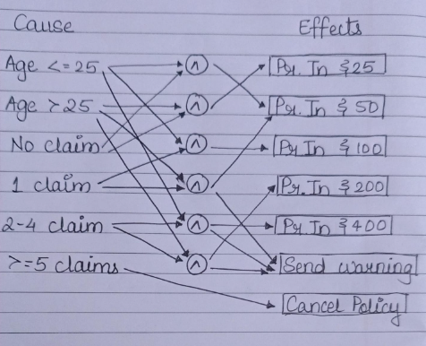

Decision Table:

Cause | 1 | 2 | 3 | 4 | 5 | 6 | 7 | 8
Age <= 25 | True | True | True | True | False | False | False | False
0 claim | True | - | - | - | True | - | - | -
1 claim | - | True | - | - | - | True | - | -
2-4 claims | - | - | True | - | - | - | True | -
5 or more claims | - | - | - | True | - | - | - | True
Effect
Premium increase by $ 25 | - | T | - | - | T | - | - | -
Premium increase by $ 50 | T | - | - | - | - | T | - | -
Premium increase by $ 100 | - | - | - | - | - | - | - | -
Premium increase by $ 200 | - | - | - | - | - | - | T | -
Premium increase by $ 400 | - | - | T | - | - | - | - | -
Send Warning Letter | - | T | T | T | - | T | T | T
Cancel Policy | - | - | - | T | - | - | - | T

Test cases:
Sr no | Age | No of Claim/s | Expected Output | Condition / cause met | Remarks
 | 27 | 0 | $50 | Yes | Pass
 | 30 | 1 | $100, Warning letter | Yes | Pass
 | 31 | 2 | $400, Warning Letter | Yes | Pass
 | 32 | 5 | $0, Warning Letter, Policy Cancelled | Yes | Pass
 | 64 | 0 | $25 | Yes | Pass
 | 34 | 1 | $50, Warning Letter | Yes | Pass
 | 25 | 3 | $200, Warning Letter | Yes | Pass
 | 27 | 5 | $0, Warning Letter, Policy Cancelled | Yes | Pass
 | 33 | 4 | $400, Warning letter | Yes | Pass
 | 55 | 7 | $0,Warning Letter, Policy Cancelled | Yes | Pass

Conclusion:
As the program specifications are given. With the given specifications, the above test cases are generated and seem to work well.

Title: Black Box Testing: Decision table and Cause Effect Graphing

Problem Statement: If you hold an 'over 60s' rail card, you get a 34% discount on whatever ticket you buy. If you are traveling with a child (under 16), you can get a 50% discount on any ticket if you hold a family rail card, otherwise you get a 10% discount. You can only hold one type of rail card. Draw a decision table and cause effect graph showing all the combinations of fare types and resulting discounts and derive test cases from the decision table.

Source Code:

def determine_discount(over_60_card, family_card, traveling_with_child):
if over_60_card and family card:
return "Error: You can only hold one type of rail card."
elif over_60_card:
return 34
elif family_card and traveling_with_child:
return 50
elif traveling_with_child:
return 10
else:
return 0

def main():

over_60_card = input("Do you have an 'Over 60s' rail card? (yes/no): ").strip().lower() == 'yes'
family_card = input("Do you have a family rail card? (yes/no): ").strip().lower() == 'yes'
traveling_with_child = input("Are you traveling with a child (under 16)? (yes/no): ").strip().lower() == 'yes'

discount = determine_discount(over_60_card, family_card, traveling_with_child)

if isinstance(discount, str):
print(discount)
elif discount > 0:
print(f"You are eligible for a {discount}% discount.")
else:
print("You are not eligible for any discount.")
if __name__ == "__main__":

main()

Cause Effect Graph:
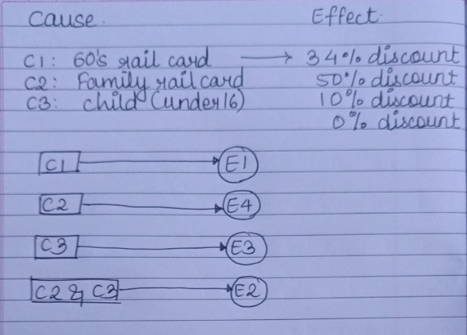

Decision Table:
Cause | 1 | 2 | 3 | 4 | 5 | 6 | 7 | 8
Over 60’s rail card | True | False | False | False | False | True | True | True
Family rail card | - | True | True | False | False | False | True | True
Travelling with child | - | True | False | True | False | True | True | False
Effects:
Discount (%) | 34% | 50% | 0% | 10% | 0% | 34% | 50%/X? | 34%/X/?

Conclusion:
As the program specifications are given. With the given specifications, the above test cases are generated and seem to work well.

Title: Black Box Testing: Decision table and Cause Effect Graphing

Problem Statement: The following instructions were taken from a University Examination Application Form. Examine and create a Decision Table to represent the University rules and thereby decide on the test cases to be designed.
- A candidate appearing for the exam should have a minimum 80% attendance
- Has attended 3 internal tests with an average of 10 or more marks or
- Has attended 2 internal tests with an average of 15 or more marks and
- Has taken up the external examination and scored more than 35 marks.
If the above conditions are fulfilled, then the student can be considered as pass in that subject

Source Code:

def determine_pass_status(attendance, internal_test_1,internal_test_2, internal_test_3, external_exam):

if attendance < 80:
return "Fail"
avg_test_1_3 = (internal_test_1 + internal_test_2 + internal_test_3) / 3
avg_test_2_3 = (internal_test_1 + internal_test_2) / 2
if avg_test_1_3 >= 10 or avg_test_2_3 >= 15:
if external_exam > 35:
return "Pass"
else:
return "Fail"
else:
return "Fail"
def main():
attendance = float(input("Enter attendance percentage:"))
internal_test_1 = float(input("Enter marks for Internal Test 1: "))
internal_test_2 = float(input("Enter marks for Internal Test 2: "))
internal_test_3 = float(input("Enter marks for Internal Test 3: "))
external_exam = float(input("Enter marks for External
Exam: "))
result = determine_pass_status(attendance,
internal_test_1, internal_test_2, internal_test_3, external_exam)
print(f"The student has: {result}")
if __name__ == "__main__":

main()

Cause Effect Graph:

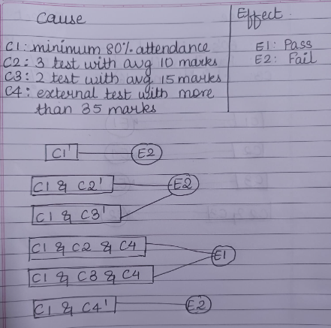
Decision Table:
Cause | 1 | 2 | 3 | 4 | 5 | 6 | 7 | 8
Attendance greater than 80% | False | True | True | True | True | True
Attended 3 internal tests with an average of 10 or more marks | - | False | True | True | False | False
Attended 2 internal tests with an average of 15 or more marks. | - | False | - | - | True | True
Cleared external exam and scored more than 35 marks | - | - | False | True | False | True
Effects:
Pass | - | - | - | T | - | T
Fail | T | T | T | - | T | -

Conclusion:
As the program specifications are given. With the given specifications, the above test cases are generated and seem to work well.

Practical no:03
Aim: State Transition Testing

Title: Black Box Testing: State Transition Testing

Problem Statement:

Draw the state transition diagram, possible transitions table, State table and write the test cases.
Specifications:
The software responds to input requests to change the display mode for a time displaydevice.
The display mode can be set to one of the four values: Two corresponding to displaying either time or date. The other two when altering either time or date.
Four possible input requests: Change mode (CM), Reset (R), Time Set (TS), Date Set (DS)
- Change Mode (CM): Activation of this shall cause the display mode to move between “Display Time (T)” and “Display Date (D)”
- Reset (R): If display mode is set to T or D, then a “reset” shall cause the display mode to be set to “Alter time (AT)” or “Alter Date (AD)” modes.
- Time Set (TS): Activation of this shall cause t he display mode to return to T from AT.
- Date Set (DS): Activation of this shall cause the display mode to return to D from AD.
Source Code:

class TimeDisplayDevice:
def __init__(self):
self.state = 'S1'
self.state_map = {
'S1': 'T',
'S2': 'D',
'S3': 'AT',
'S4': 'AD'
}

def change_mode(self):
if self.state == 'S1':
self.state = 'S2'
elif self.state == 'S2':
self.state = 'S1'
print(f"State: {self.state_map[self.state]}")

def reset(self):
if self.state == 'S1':
self.state = 'S3'
elif self.state == 'S2':
self.state = 'S4'
print(f"State: {self.state_map[self.state]}")

def time_set(self):
if self.state == 'S3':
self.state = 'S1'
print(f"State: {self.state_map[self.state]}")

def date_set(self):
if self.state == 'S4':
self.state = 'S2'
print(f"State: {self.state_map[self.state]}")

def handle_input(self, command):
if command == 'CM':
self.change_mode()
elif command == 'R':
self.reset()
elif command == 'TS':
self.time_set()
elif command == 'DS':
self.date_set()
else:
print("Invalid command")

def main():
device = TimeDisplayDevice()
print("Welcome to the Time Display Device")
print("Commands: CM (Change Mode), R (Reset), TS (Time Set), DS (Date Set), Q (Quit)")

while True:
command = input("Enter command: ").strip().upper()
if command == 'Q':
print("Exiting...")
break
device.handle_input(command)

if __name__ == "__main__":
main()

State Transition Diagram:
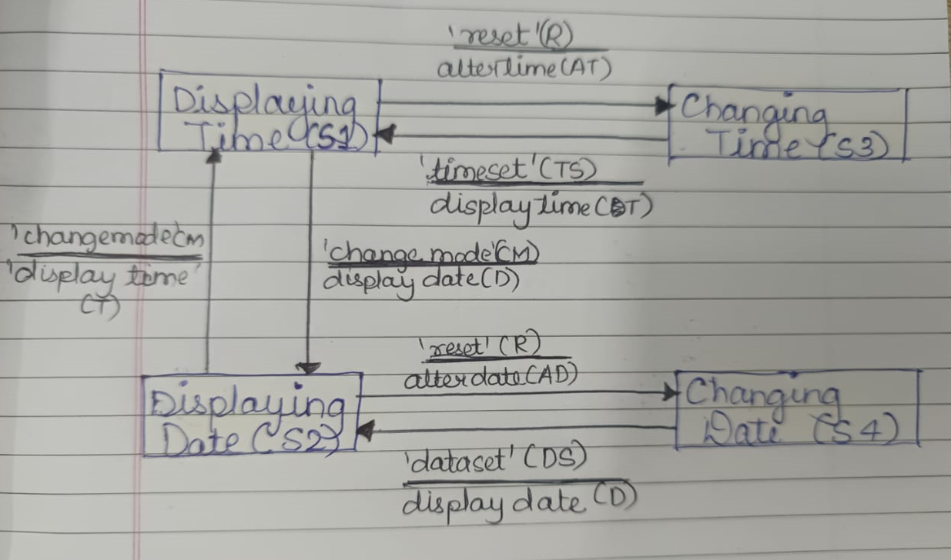

Solution:

0-Switch State Transition Table:
Test Case | 1 | 2 | 3 | 4 | 5 | 6
Start state | S1 | S1 | S2 | S2 | S3 | S4
Input | R | CM | CM | R | TS | DS
Exp output | AT | D | T | AD | T | D
Finish State | S3 | S2 | S1 | S4 | S1 | S2

1-Switch State Transition Table:
Test Case | 1 | 2 | 3 | 4 | 5 | 6 | 7 | 8 | 9 | 10
Start state | S1 | S2 | S1 | S2 | S1 | S4 | S2 | S3 | S3 | S4
Input | R | R | CM | CM | CM | DS | CM | TS | TS | DS
Exp Output | AT | AD | D | T | D | D | T | T | T | D
Next State | S3 | S4 | S2 | S1 | S2 | S2 | S1 | S1 | S1 | S2
Input | TS | DS | CM | CM | R | CM | R | CM | R | R
Exp Output | T | D | T | D | AD | T | AT | D | AT | AD
Finish State | S1 | S2 | S1 | S2 | S4 | S1 | S3 | S2 | S3 | S4

State Transition table:
 | CM | R | TS | DS
S1 | S2/D | S3/AT | S1/N | S1/N
S2 | S1/T | S4/AD | S2/N | S2/N
S3 | S3/N | S3/N | S1/T | S3/N
S4 | S4/N | S4/N | S4/N | S2/D

Test cases:
Test cases | 1 | 2 | 3 | 4 | 5 | 6 | 7 | 8 | 9 | 10 | 11 | 12 | 13 | 14 | 15 | 16
Start State | S1 | S1 | S1 | S1 | S2 | S2 | S2 | S2 | S3 | S3 | S3 | S3 | S4 | S4 | S4 | S4
Input | CM | R | TS | DS | CM | R | TS | DS | CM | R | TS | DS | CM | R | TS | DS
Expected Output | D | AT | N | N | T | AD | N | N | N | N | T | N | N | N | N | D
Finish State | S2 | S3 | S1 | S1 | S1 | S4 | S2 | S2 | S3 | S3 | S1 | S3 | S4 | S4 | S4 | S2

Conclusion:
As the program specifications are given. With the given specifications, the above test cases are generated and seem to work well.

Title: Black Box Testing: State Transition Testing

Problem Statement:
A website shopping basket starts out as empty. As purchases are selected, they are added to the shopping basket. Items can also be removed from the shopping basket. When the customer decides to check out, a summary of the items in the basket and the total cost are shown, for the customer to say whether this is OK or not. If the contents and price are OK, then you leave the summary display and go to the payment system. Otherwise you go back to shopping (so you can remove items if you want).
Source Code:

class ShoppingBasket:
def __init__(self):
self.state = 'empty'
self.basket = []
self.total_cost = 0

def add_item(self, item, price):
if self.state == 'empty' or self.state == 'shopping':
self.basket.append(item)
self.total_cost += price
self.state = 'shopping'
print(f"Added {item} to basket. Total cost: {self.total_cost}")
else:
print("Can't add items in the current state.")

def remove_item(self, item, price):
if self.state == 'shopping' and item in self.basket:
self.basket.remove(item)
self.total_cost -= price
print(f"Removed {item} from basket. Total cost: {self.total_cost}")
if not self.basket:
self.state = 'empty'
else:
print("Can't remove items in the current state or item not found.")

def checkout(self):
if self.state == 'shopping':
self.state = 'summary'
print(f"Checking out. Items in basket: {self.basket}. Total cost: {self.total_cost}")
else:
print("Can't checkout in the current state.")

def ok(self):
if self.state == 'summary':
self.state = 'payment'
print("Proceeding to payment system.")
else:
print("Can't proceed to payment in the current state.")

def not_ok(self):
if self.state == 'summary':
self.state = 'shopping'
print("Returning to shopping to modify basket.")
else:
print("Can't return to shopping in the current state.")

def generate_test_case():
basket = ShoppingBasket()
print("State Transition Test for Shopping Basket")

while True:
print("\nCurrent state:", basket.state)
print("Choose an option:")
print("1: Add item")
print("2: Remove item")
print("3: Checkout")
print("4: Confirm (OK)")
print("5: Not OK (return to shopping)")
print("6: Exit")

choice = input("Enter your choice (1-6): ")

if choice == '1':
item = input("Enter item name: ")
price = float(input("Enter item price: "))
basket.add_item(item, price)
elif choice == '2':
item = input("Enter item name to remove: ")
price = float(input("Enter item price: "))
basket.remove_item(item, price)
elif choice == '3':
basket.checkout()
elif choice == '4':
basket.ok()
elif choice == '5':
basket.not_ok()
elif choice == '6':
print("Exiting test case generation.")
break
else:
print("Invalid input, please try again.")
generate_test_case()

State Transition Diagram:

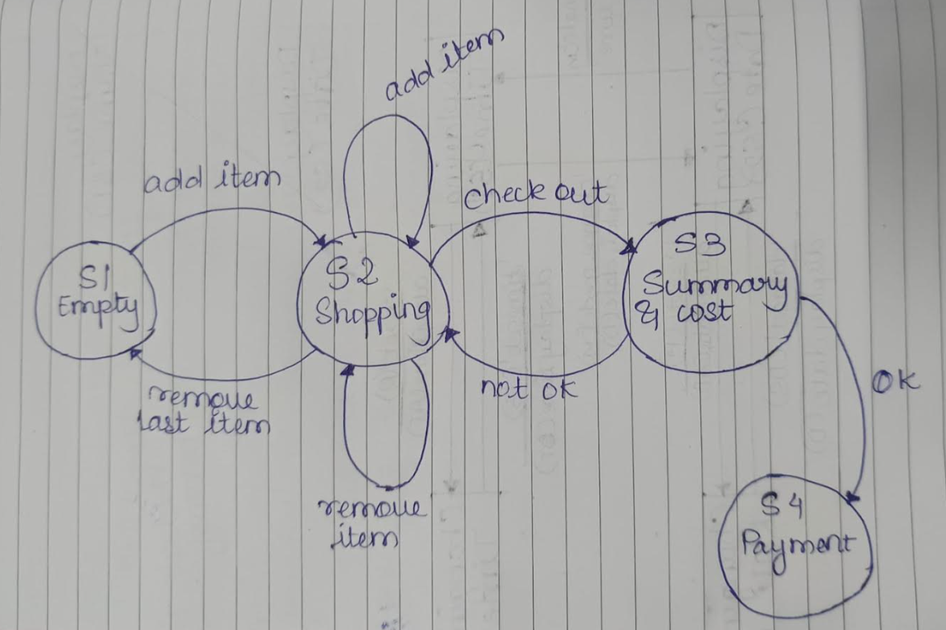State: empty, shopping, Summary, Payment

Events: Add items, Remove items, Remove last items, Checkout, ok, not ok

0-Switch State Transition Table:

Test Case | 1 | 2 | 3 | 4 | 5 | 6 | 7
Start state | S1 | S1 | S2 | S2 | S2 | S3 | S3
Input | Add Item | Checkout | Remove item | Remove Last Item | Checkout | Ok | Not Ok
Exp output | Items added | Invalid | Items removed | Basket Empty | Summary &Cost | Proceed to Payment | Return to shopping
Finish State | S2 | S1 | S2 | S1 | S3 | S4 | S2

1-Switch State Transition Table:
Test Case | 1 | 2 | 3 | 4 | 5 | 6 | 7 | 8 | 9 | 10
Start state | S1 | S2 | S2 | S2 | S3 | S3 | S1 | S1 | S3 | S1
Input | Add item | Checkout | Checkout | Remove last item | Not Ok | Not Ok | Add Item | Add Item | Not Ok | Add Item
Exp Output | Item Added | Summary & Cost | Summary &Cost | Basket Empty | Return to Shopping | Return to Shopping | Item Added | Item Added | Return Shopping | Item Added
Next State | S2 | S3 | S3 | S1 | S2 | S2 | S2 | S2 | S2 | S2
Input | Checkout | Ok | Not Ok | Add Item | Add item | Remove item | Remove Items | Remove Last Item | Remove Last Item | Add Item
Exp Output | Summary & Cost | Payment | Return to shopping | Item Added | Item Added | Item Removed | Items Removed | Basket Empty | Basket Empty | Items Added
Finish State | S3 | S4 | S2 | S2 | S2 | S2 | S2 | S1 | S1 | S2

State Transition Table:

 | Add items | Remove items | Remove last items | Checkout | OK | Not OK
S1 | S2 | S1/N | S1/N | S1/N | S1/N | S1/N
S2 | S2 | S2 | S1 | S3 | S2/N | S2/N
S3 | S3/N | S3/N | S3/N | S3/N | S4 | S2
S4 | S4/N | S4/N | S4/N | S4/N | S4/N | S4/N

Conclusion:
As the program specifications are given. With the given specifications, the above test cases are generated and seem to work well.

Practical no:04
Aim: Use Case Testing

Title: Black Box Testing: Use Case Testing

Problem Statement:
Construct the use case testing for the user registration scenario

Use Case Testing:
Use Case ID | UC-01
Title: | User Registration
Precondition: | The user is on the registration page of the application.
Main Scenario | Step | Description
 | 1 | Open Registration Page:  - The user navigates to the registration page.
 | 2 | Enter User Information:  - The user fills in the required fields:  - Username  - Email  - Password  - Confirm Password
 | 3 | Submit Registration Form  - The user clicks the "Register" button.
 | 4 | System Validations:  - The system checks if:  - The username is unique.  - The email format is valid.  - The password meets security criteria (e.g., length, complexity).  - The "Confirm Password" matches the "Password".
 | 5 | Successful Registration:  - If all validations pass, the user is registered, and a confirmation message is displayed.  - The system sends a confirmation email to the registered email address.
 | 6 | Redirect to Login Page:  - The user is redirected to the login page.
Extension / Alternate Flow | 1 | AF-01: Duplicate Username  - If the username already exists:  - The system displays an error message: "Username already taken."
AF-02: Invalid Email Format
- If the email format is invalid:
- The system displays an error message: "Please enter a valid email address."
AF-03: Password Complexity Failure
- If the password doesn’t meet criteria:
- The system displays an error message: "Password must be at least 8 characters long and contain a mix of letters and numbers."
AF-04: Password Mismatch
- If the password and confirm password fields do not match:
- The system displays an error message: "Passwords do not match."
Postconditions: |  | - If registration is successful, the user account is created and the user receives a confirmation email.  - If registration fails, no account is created, and the user is informed of the errors.

Testing Scenarios:
Test case | Input | Expected Output
Successful Registration | Unique username, valid email, strong password, matching confirmation. | User is registered successfully and receives a confirmation email.
Duplicate Username | Existing username, valid email, strong password. | Error message for duplicate username.
Invalid Email Format | Unique username, invalid email format, strong password. | Error message for invalid email.
Weak Password | Unique username, valid email, weak password. | Error message for weak password.
Password Mismatch | Unique username, valid email, password, and non-matching confirm password. | Error message for password mismatch.

Conclusion:
This scenario outlines a comprehensive use case for user registration, detailing the main flow, alternative flows, testing scenarios, and expected outcomes. It can be used to ensure that the registration feature functions correctly under various conditions.

Title: Black Box Testing: Use Case Testing

Problem Statement:
Construct the use case testing for the online shopping cart scenario

Use Case Testing:
Use Case ID | UC-02
Title: | Shopping Cart Functionality
Precondition: | The user is logged into their account and is on the product listing page.
Main Scenario  Actors: User (customer) | Step | Description
 | 1 | Browse Products:  - The user navigates through available products.
 | 2 | Add Product to Cart:  - The user selects a product and clicks the "Add to Cart" button:  - The system confirms the addition with a message (e.g., "Item added to your cart").
 | 3 | View Cart:  - The user clicks on the "Cart" icon to view their selected items.  - The system displays a list of items in the cart with details such as:  - Product name  - Quantity  - Price  - Total price
 | 4 | Update Cart:  - The user can change the quantity of an item or remove an item from the cart.  - The system updates the total price accordingly.
 | 5 | Apply Discount Code:  - The user enters a valid discount code in the designated field.  - The system validates the code and applies the discount to the total price.
 | 6 | Proceed to Checkout:  - The user clicks the "Checkout" button.
 | 7 | Complete Purchase:  - The user enters the required details and confirms the order.  - The system processes the payment and displays an order confirmation message.
Extension / Alternate Flow | 1 | AF-01: Item Not Available  - If an item is out of stock:  -The system displays an error message: "Item not available.
AF-02: Invalid Discount Code
- If the discount code is invalid
- The system displays an error message: "Invalid discount code."
AF-03: Exceeding Quantity Limit
- If the user exceeds the allowed quantity:
- The system displays: "Quantity limit exceeded."
Postconditions: |  | - If the purchase is successful, an order is created in the system, and the user receives a confirmation email.  - If the user cancels or fails to complete the purchase, no order is created.

Testing Scenarios:
Test case | Input | Expected Output
Successful Addition of Item to Cart | Product selection | Item added to the cart with confirmation message
View Cart Functionality | Click "View Cart" | Cart details with items, prices, and total displayed
Update Item Quantity in Cart | Change item quantity | Cart updated, total price reflects the changes
Remove Item from Cart | Remove an item from the cart | Item removed, and the total price is updated
Apply Valid Discount Code | Valid discount code | Discount applied, and total price reduced
Apply Invalid Discount Code | Invalid discount code | Error message displayed
Successful Checkout Process | Valid payment information | Purchase confirmed, order processed
Out of Stock Item Attempt | Out-of-stock item added | Error message displayed for unavailable item
Exceeding Quantity Limit | Quantity exceeding the limit | Error message displayed for quantity limit

Conclusion:
This detailed use case scenario outlines the complete shopping cart functionality, including the main flow, alternative flows, postconditions, and specific testing scenarios. This comprehensive approach ensures that all aspects of the shopping cart feature are thoroughly tested.

Practical no:05
Aim: Loop Coverage, Call Coverage and Path Coverage.

Title: White Box Testing: Loop Coverage, Call coverage and Path Coverage.

Problem Statement:
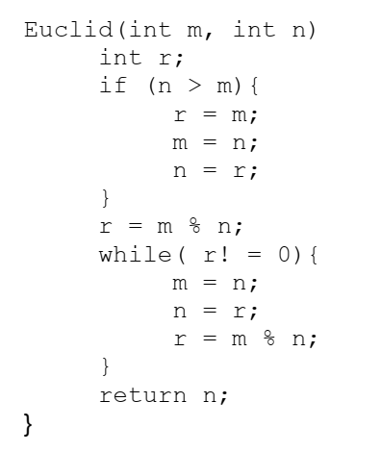
Step 1: Number the line of code

0Euclid(int m , int n){
1 int r;
2 if(n>m){
3 r=m;
4 m=n;
5 n=r;
6 }
7 r=m%n;
8 while(r!=0){
9 m=n;
10 n=r;
11 r=m%n;
12 }
13 return n;
14 }

Step 2: Flowchart
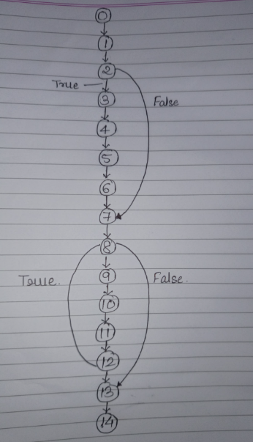

Step 3: Calculate the cyclomatic complexity
V(G) : Cyclomatic Complexity, E : No of Edges, N: No of Nodes, P : No of connected areas/ no of methods
V(G) = E – N + 2P
= 16 – 15 + 2
= 3
V(G) = No of predicates/Conditions + 1
Thus, the cyclomatic complexity is 3.

Step 4: Basis Test Path
Test Path B1: 0 1 2 7 8 13 14
2 : n>m ==> FALSE
8 : r!=0 ==> FALSE

Test Path B2: 0 1 2 3 4 5 6 7 8 13 14
2 : n>m ==> TRUE
8 : r!=0 ==> FALSE

Test Path B3: 0 1 2 3 4 5 6 7 8 9 10 11 12 8 13 14
2 : n>m ==> TRUE
8 : r!=0 ==> TRUE
8 : r!=0 ==> FALSE

Statement Coverage = Total no of statement executed/ Total number of statement
Statement Coverage for B1 = 7/15=0.46
Statement Coverage for B2 =11/15 = 0.73
Statement Coverage for B3 = 15/15 = 1
Overall Statement Coverage =
- B1: Executes lines: 0, 1, 2, 7, 8, 13, 14
- B2: Executes lines: 0, 1, 2, 3, 4, 5, 6, 7, 8, 13, 14
- B3: Executes lines: 0, 1, 2, 3, 4, 5, 6, 7, 8, 9, 10, 11, 12
The union of all unique statements executed is:
0, 1, 2, 3, 4, 5, 6, 7, 8, 9, 10, 11, 12, 13, 14
This gives us 15 unique lines of code executed.
Thus, the overall statement coverage is:
Overall Statement Coverage= 15/20 = 0.75 or 75%

Decision Coverage = no of decision outcomes executed/ total number of decision outcomes
No of Decision outcome = 4
node 2: n>m : True(B2, B3) / False (B1) ⇒ 2
node 8: r!=0 : True(B2, B3) / False (B1,B3) ⇒ 2

Total number of decision outcome = 2no of conditions
= 4
Decision Coverage for over all Code = 4/4 * 100 = 100%

100% decision coverage guarantees 100% statement coverage, but not the other way around!

Conclusion:
The control flow graph is drawn and the cyclomatic complexity is determined to be 3. Three basis paths are to be tested.

Title: White Box Testing: Loop Coverage, Call coverage and Path Coverage.

Problem Statement:
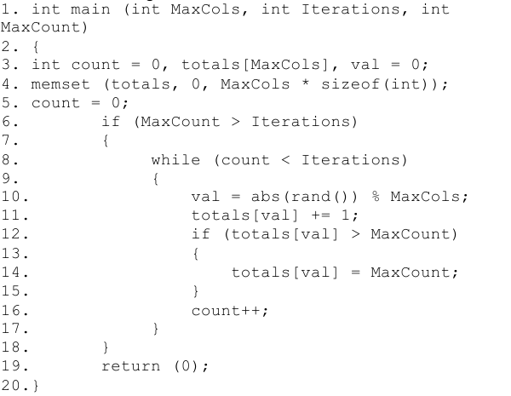

Step 1: Number the line of code

Step 2: Flowchart
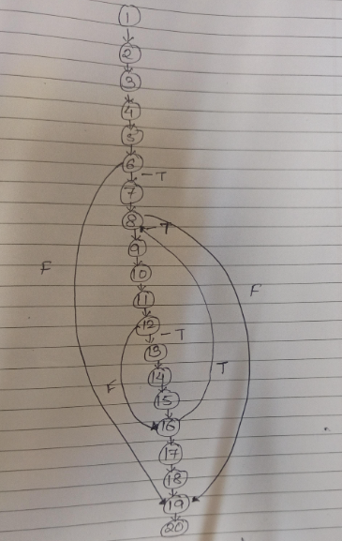

Step 3: Calculate the cyclomatic complexity
V(G) = E – N + 2P
=23-20+ 2*1
=3+2
=5
Thus , the cyclomatic complexity is 5.
Step 4: Basis Test Path
Test Path B1: 1 2 3 4 5 6 19 20
6 : if (MaxCount > Iterations) False

Test Path B2: 1 2 3 4 5 6 7 8 19 20
6 : if (MaxCount > Iterations) True
8 : while (count < Iterations) False

Test Path B3: 1 2 3 4 5 6 7 8 9 10 11 12 16 17 18 19 20
6 : if (MaxCount > Iterations) True
8 : while (count < Iterations) False
12 : if (totals[val] > MaxCount) False
8 : while (count < Iterations) False

Statement Coverage = Total no of statement executed/ Total number of statement
Statement Coverage for B1 = 8/20 =0.4 or 40%
Statement Coverage for B2 =10/20 = 0.5 or 50%
Statement Coverage for B3 = 17/20 = 0.85 or 85%
Overall Statement Coverage =
- B1: Executes lines: 1 2 3 4 5 6 19 20
- B2: Executes lines: 1 2 3 4 5 6 7 8 19 20
- B3: Executes lines: 1 2 3 4 5 6 7 8 9 10 11 12 16 17 18 19 20
The union of all unique statements executed is:
1, 2, 3, 4, 5, 6, 7, 8, 9, 10, 11, 12, 16, 17, 18, 19, 20
This gives us 18 unique lines of code executed.
Thus, the overall statement coverage is:
Overall Statement Coverage= Total unique statement executed/Total number of statement
=18/20 = 0.9 or 90%

Decision Coverage = no of decision outcomes executed/ total number of decision outcomes
No of Decision outcome = 3
- Node 6: if (MaxCount > Iterations)
- True (Test Paths B2, B3)
- False (Test Path B1)
- Node 8: while (count < Iterations)
- True (Test Path B3)
- False (Test Paths B1, B2, B3)
- Node 12: if (totals[val] > MaxCount)
- True (Not exercised in any path)
- False (Test Path B3)

Total number of decision outcome = 2no of conditions
= 6
Decision Coverage for overall Code = No. of decision outcomes executed/Total no. of decision outcomes
=5/6 * 100 = 83.3%

83.3% decision coverage guarantees 90% statement coverage!

Conclusion:
The control flow graph is drawn and the cyclomatic complexity is determined to be __5___. _3___ basis paths are to be tested.

Practical no:06
Aim: Selenium IDE

