INDEX
Sr. No | Title | Page No.
1 | Write a program for implementing Client Server communication model using TCP. | 03
2 | A client server based program using UDP to find the factorial of the entered number(also implement iterative server). | 07
3 | A program that finds the addition, subtraction, multiplication and division of the entered two numbers using RPC. | 11
4 | Implement UDP for sending broad cast sender and receiver using a multicast Socket. | 17
5 | a) Show the implementation of web services.  b) Implementing “Calculator” Web Service. | 21
6 | Implement Xen Server virtualization and manage with Xen Center. | 27
7 | Implement virtualization using VMWare ESXi Server and managing with vCenter | 41
8 | Implement Windows Hyper-V virtualization. | 69
9 | Develop Virtual machine using Microsoft Azure | 88

Practical 01
Aim: Write a program for implementing Client Server communication model using TCP.
Server-side Code
import java.io.*;
import java.net.*;
public class TCP_Server {
public static void main(String[] args) {
try {
System.out.println("Riya Thakur,32");
int port =5555 ;
ServerSocket ss=new ServerSocket (port);
System.out.println("Waiting for connection");
Socket s= ss.accept();
System.out.println("Connection is done...");

BufferedReader br = new BufferedReader(new InputStreamReader(s.getInputStream()));
int num = Integer.parseInt(br.readLine());
System.out.println("Request From client =" + num);
int f = 1;
for(int i=1;i<=num;i++)
{
f= f * i;
}
PrintWriter pw = new PrintWriter(new OutputStreamWriter(s.getOutputStream()));
pw.println(f);
pw.flush();
}
catch (Exception e)
{
System.out.println("Error : " + e);
}
}}
Server output:-
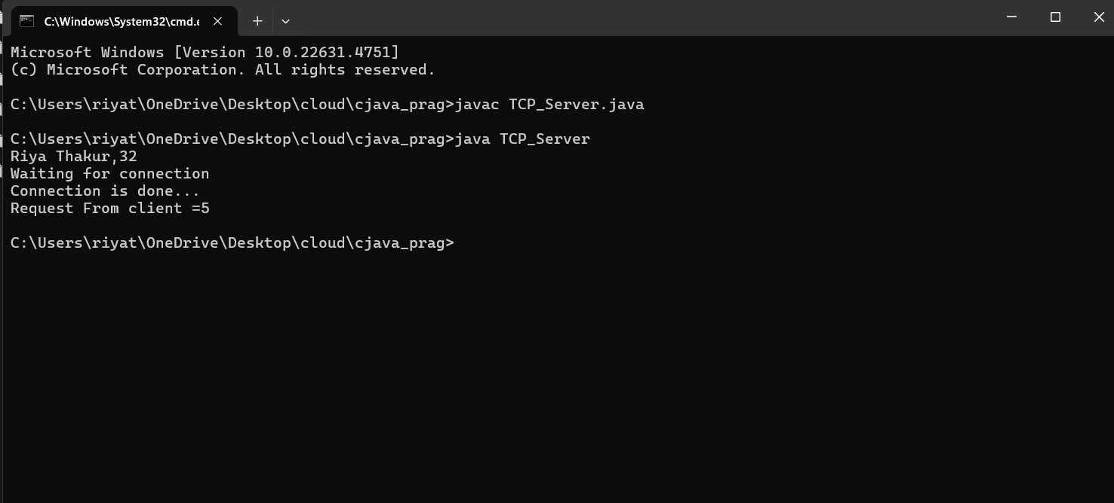

Client-Side Code
import java.io.*;
import java.net.*;
public class TCP_Client {
public static void main(String[] args) {
System.out.println("Riya Thakur ,32c");
try {
int port = 5555;
InetAddress addr = InetAddress.getLocalHost();
Socket s = new Socket(addr,port);
System.out.println("Connection is done ...");
BufferedReader br1 = new BufferedReader(new InputStreamReader(System.in));
System.out.println("Enter The Number :");
int num = Integer.parseInt(br1.readLine());
PrintWriter pw = new PrintWriter(new OutputStreamWriter(s.getOutputStream()));
pw.println(num);
pw.flush();
BufferedReader br2 = new BufferedReader(new InputStreamReader(s.getInputStream()));
int ans = Integer.parseInt(br2.readLine());
System.out.println("Response From Server =" + ans);
}
catch (Exception e)
{
System.out.println("Error : " + e);
}
}
}
Client output:

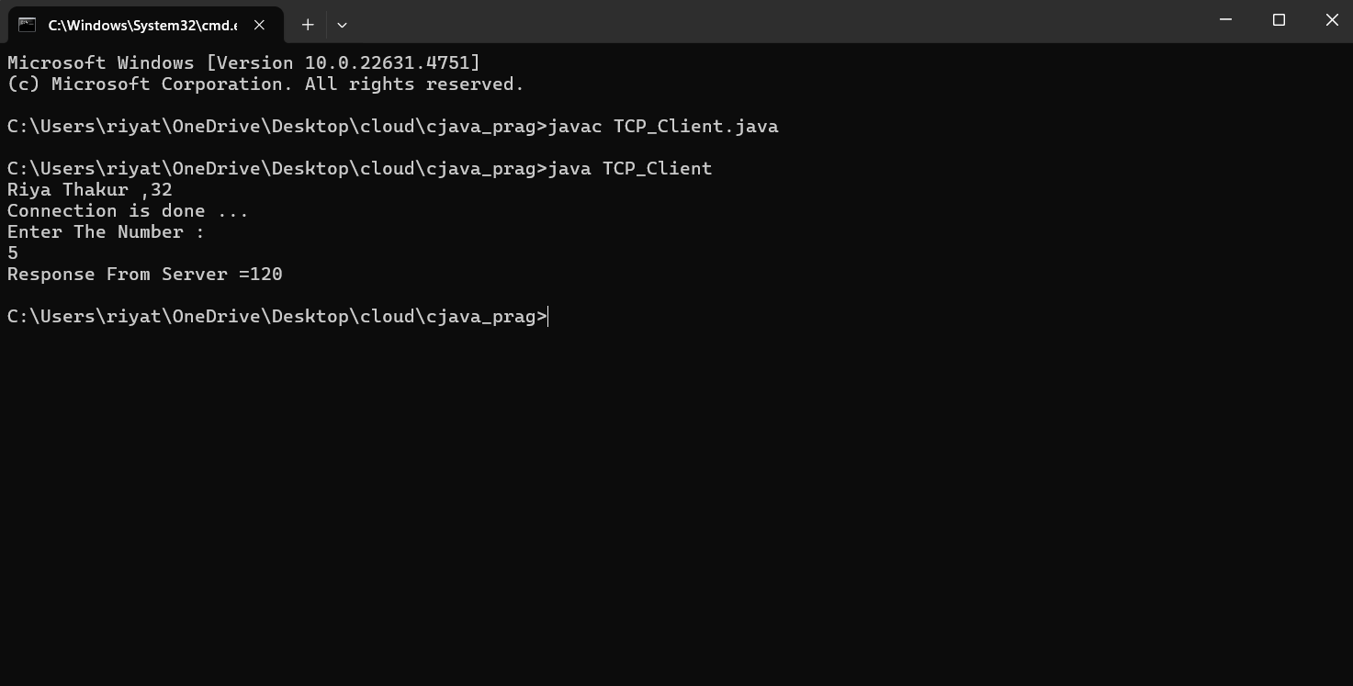

Practical 02
Aim: A client server based program using UDP to find the factorial of the entered number(also implement iterative server).

Server Side Code:
import java.io.*;
import java.net.*;
public class UDP_Factorial_server {

public static void main(String[] args) {
try
{
int port = 1234;
DatagramSocket ds = new DatagramSocket(port);
System.out.println("Waiting for Client ...");
while(true)
{
byte b[] = new byte[1024];
DatagramPacket dp1 = new DatagramPacket(b, b.length);
ds.receive(dp1);
String str = new String(dp1.getData(),0,dp1.getLength());
System.out.println("Request From Client="+str);
if(str.equals("end"))
{
System.exit(0);
}
int num = Integer.parseInt(str);
int f = 1;
for(int i=1;i<=num;i++)
{
f = f * i;
}
String res = "Factorial="+f;
byte b1[] = new byte[1024];
b1 = res.getBytes();
InetAddress addr1 = InetAddress.getByName(null);
DatagramPacket dp2 = new DatagramPacket(b1, b1.length,addr1,5678);
ds.send(dp2); }}
catch (Exception e)
{
System.out.println("Error=" + e);
}}}
Server Side Output:
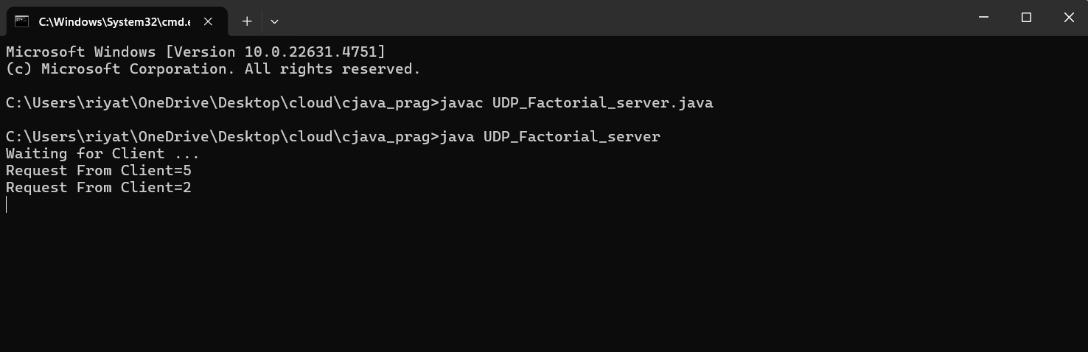

Client Side Code:
import java.io.*;
import java.net.*;
public class UDP_Factorial_Client {
public static void main(String[] args) {
try
{
int port = 5678;
DatagramSocket ds = new DatagramSocket(port);
while(true)
{
System.out.println("Enter The Number :");
BufferedReader br = new BufferedReader(new InputStreamReader(System.in));
String str = br.readLine();
byte b[] = new byte[1024];
b = str.getBytes();
InetAddress addr = InetAddress.getByName(null);
DatagramPacket dp1 = new DatagramPacket(b, b.length,addr,1234);
ds.send(dp1);
if(str.equals("end"))
{
System.exit(0);
}
byte b1[] = new byte[1024];
DatagramPacket dp2 = new DatagramPacket(b1, b1.length);
ds.receive(dp2);
String res = new String(dp2.getData(),0,dp2.getLength());
System.out.println("Response From Server : " +res);

} }
catch (Exception e)
{
System.out.println("Error=" + e);
}}}

Client Side Output:
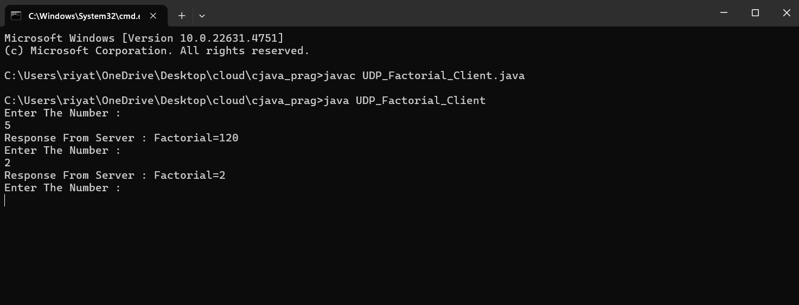

Practical 03
Aim: A program that finds the addition, subtraction, multiplication and division of the entered two numbers using RPC.

Server Side Code:
import java.io.*;
import java.net.*;
public class TCP_server {
public static void main(String[] args) {
System.out.println("RiyaThakur,Seat no:31011022032");
try
{
int port = 8888;
ServerSocket ss = new ServerSocket(port);
System.out.println("Waiting for Client ...");
Socket s = ss.accept();
System.out.println("Connection is done ...");
while(true)
{
BufferedReader br = new BufferedReader(new
InputStreamReader(s.getInputStream()));
int n1 = Integer.parseInt(br.readLine());
int n2 = Integer.parseInt(br.readLine());
String sign = br.readLine();
System.out.println("Data From Client :");
System.out.println("n1="+n1);
System.out.println("n2="+n2);
System.out.println("sign="+sign);
int ans = 0;
if(sign.equals("+"))
{
ans = n1 + n2;
}
else if(sign.equals("-"))
{
ans = n1 - n2;
}
else if(sign.equals("*"))
{
ans = n1 * n2;
}
else if(sign.equals("/"))
{
ans = n1 / n2;
}

else
{
ans = 0;
}
String res = "Answer ="+ans;
PrintWriter pw = new PrintWriter(new OutputStreamWriter(s.getOutputStream()));
pw.println(res);
pw.flush();
}
}
catch (Exception ex)
{
System.out.println("Error :" + ex);
}}}

Client Side Code:
import java.io.*;
import java.net.*;
public class TCP_client {
public static void main(String[] args)
{
System.out.println("RiyaThakur,Seat no:31011022032");
try
{
int port = 8888;
InetAddress addr = InetAddress.getByName(null);
System.out.println("IP-Address :" + addr);
Socket s = new Socket(addr, port);
System.out.println("Connection is done ...");
while(true)
{

BufferedReader br = new BufferedReader(new InputStreamReader(System.in ));
System.out.println("Enter The TWO Numbers :");
String str = br.readLine();
if(str.equals("end"))
{
System.exit(0);
}
int n1 = Integer.parseInt(str);
int n2 = Integer.parseInt(br.readLine());
System.out.println("Enter The Operation Sign(+,-,*,/)");
String sign = br.readLine();
PrintWriter pw = new PrintWriter(new OutputStreamWriter(s.getOutputStream()));
pw.println(n1);
pw.println(n2);
pw.println(sign);
pw.flush();
BufferedReader br1 = new BufferedReader(new
InputStreamReader(s.getInputStream()));
String res = br1.readLine();
System.out.println("REsponse From Server :"+res);
}}
catch(Exception ex)
{
System.out.println("Error :"+ex);
}}}

Server side output:
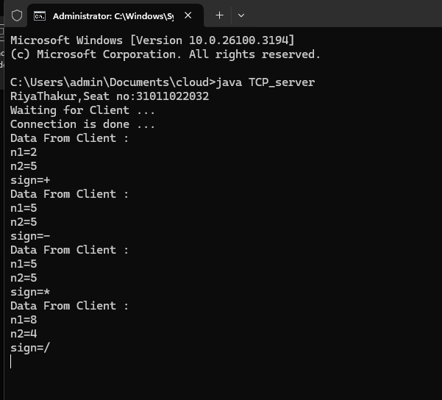

Client Side Output:
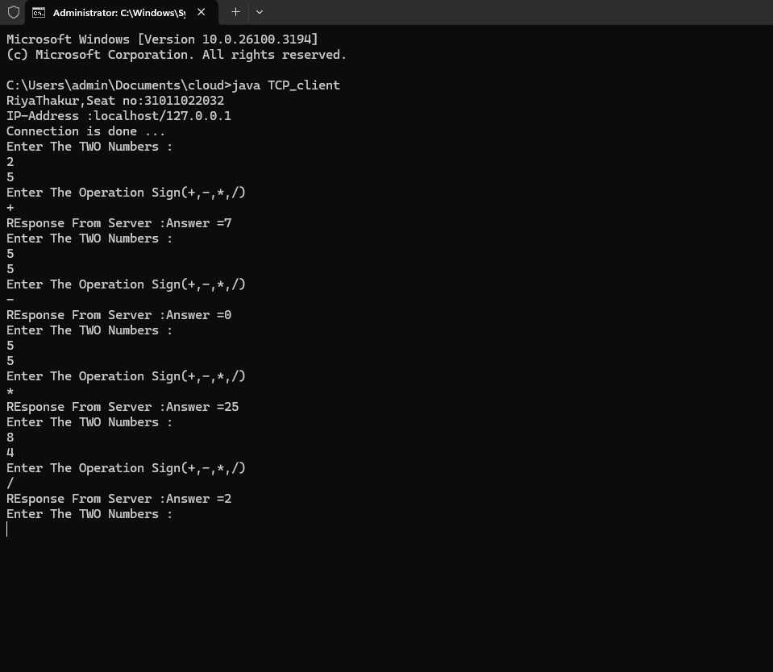
Practical 04
Aim: Implement UDP for sending broad cast sender and receiver using a multicast Socket.

Server Side Code:
import java.net.*;
import java.io.*;
public class Server1 {
public static final int PORT = 1234;
public static void main(String args[])throws Exception {
MulticastSocket socket;
DatagramPacket packet;
InetAddress address;
address = InetAddress.getByName("239.1.2.3");
socket = new MulticastSocket();
socket.joinGroup(address);
byte[] data = null;
for(;;)
{
Thread.sleep(10000); System.out.println("Sending ");
String str = ("This is Riya Calling ");
data= str.getBytes();
address = InetAddress.getByName(null);
packet = new DatagramPacket(data, str.length(),address,PORT);
socket.send(packet);
}
}}

Client side code :
import java.net.*;
import java.io.*;
public class Client1 {
public static final int PORT = 1234;
public static void main(String args[])throws Exception {
MulticastSocket socket;
DatagramPacket packet;
InetAddress address;
address = InetAddress.getByName("239.1.2.3");
socket = new MulticastSocket(PORT);
socket.joinGroup(address);
byte[] data = new byte[100];
packet = new DatagramPacket(data,data.length);
for(;;)
{
socket.receive(packet);
String str = new String(packet.getData());
System.out.println("Message received from "+ packet.getAddress() + "Message is : "+str);
}
}}

Server Side output :
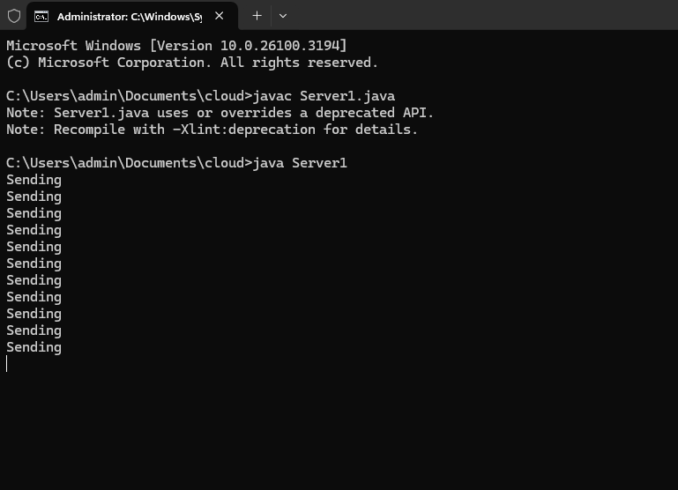
Client side output :
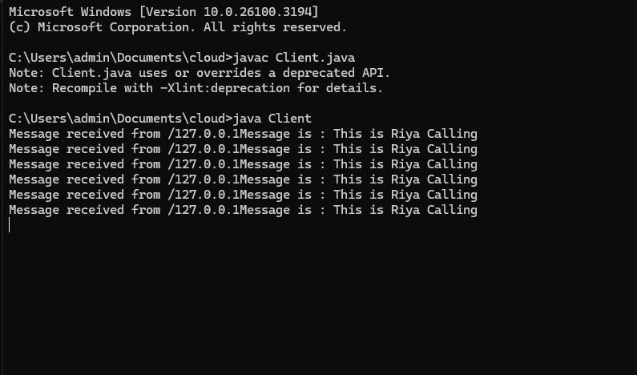

Practical 05
Aim:
a) Show the implementation of web services.
b) Implementing “Calculator” Web Service.

Step 1 : Go to file new project java web Web application.
Step 2 : Click on project name new Web Service allot a name Give package a name and click finish.
Step 3: Write Code then clean and build and deploy

Cal_s
package org.me;

import javax.jws.WebService;
import javax.jws.WebMethod;
import javax.jws.WebParam;
/**
*
* @author riyat
*/
@WebService(serviceName = "Cal_s")
public class Cal_s {

@WebMethod(operationName = "Addition")
public int add(@WebParam( name = "number1") int n1,@WebParam(name = "number2") int n2 ){

return n1+n2;
}
@WebMethod (operationName = "subtraction")
public int sub(@WebParam(name = "number1")int n1,@WebParam(name = "number2") int n2){
return n1-n2;
}
@WebMethod (operationName = "division")
public int div(@WebParam(name = "number1")int n1,@WebParam(name = "number2") int n2){
return n1/n2;
}
@WebMethod (operationName = "multiplication")
public int multi(@WebParam(name = "number1")int n1,@WebParam(name = "number2") int n2){
return n1*n2;
}
}

Step 4: Go to web service and right click on your service and test web service.
Output:
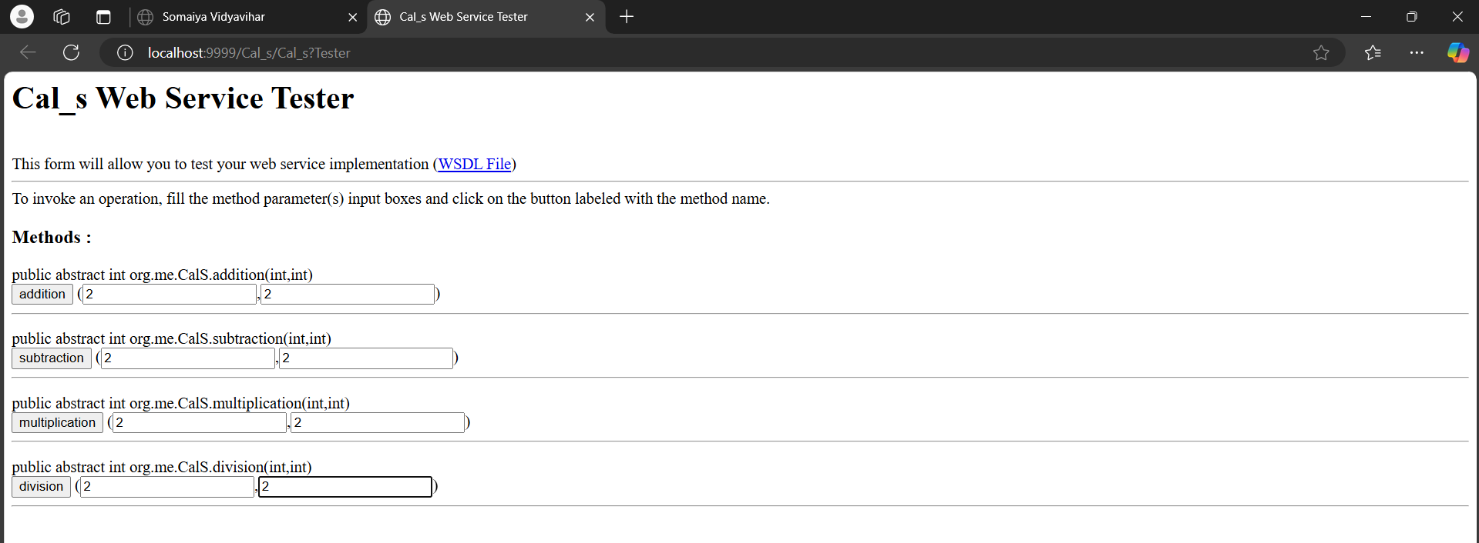
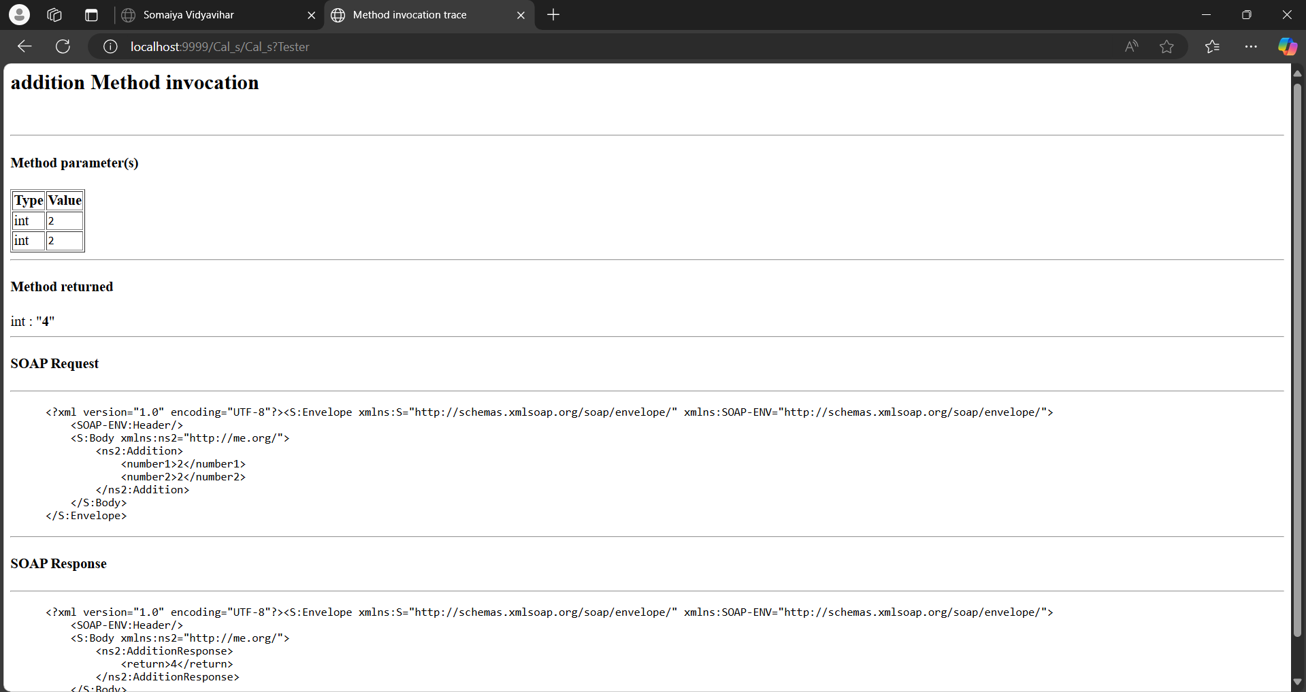
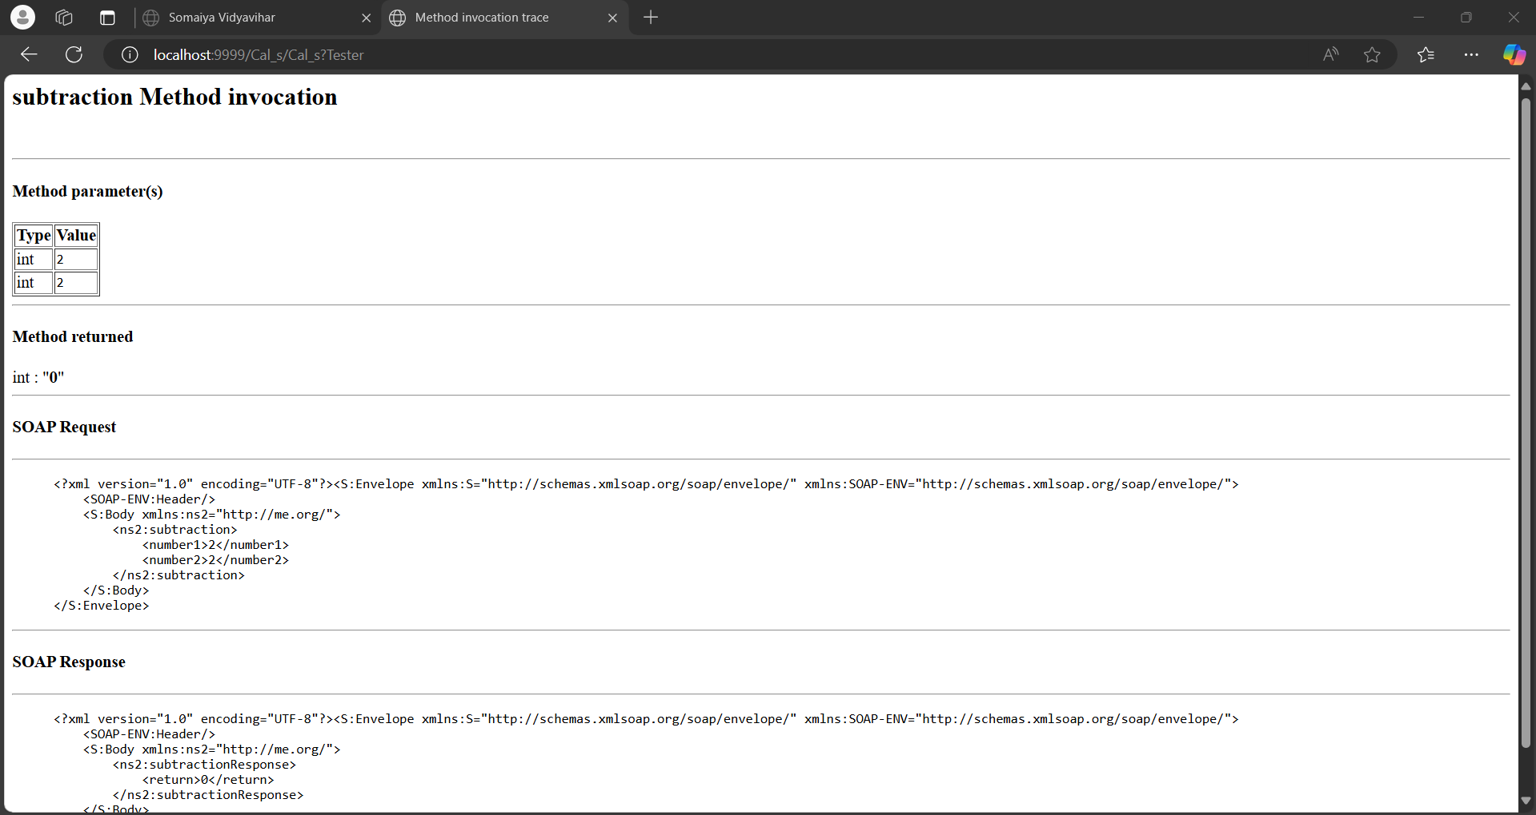
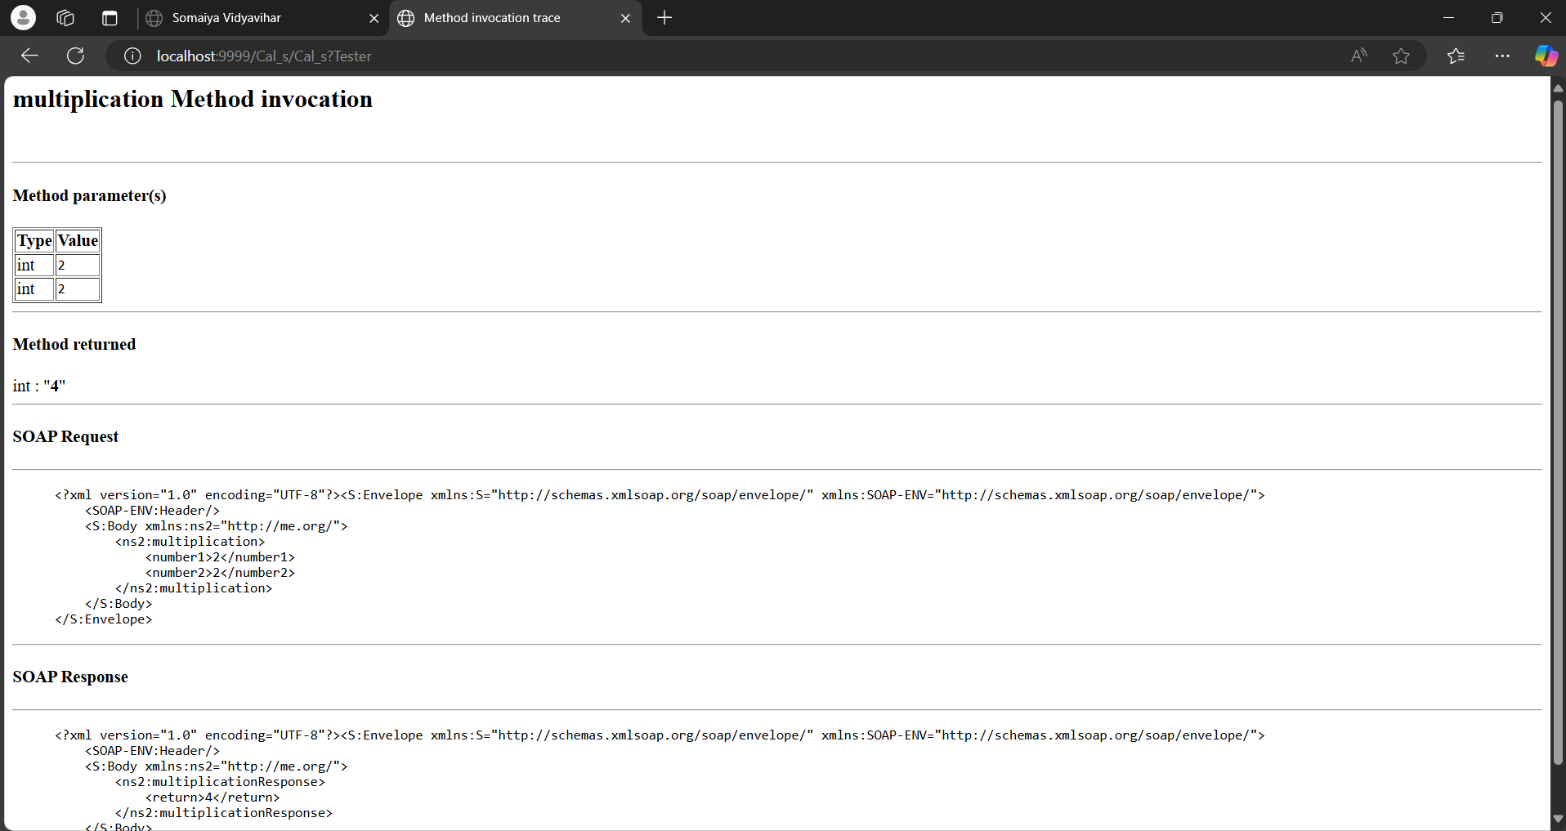
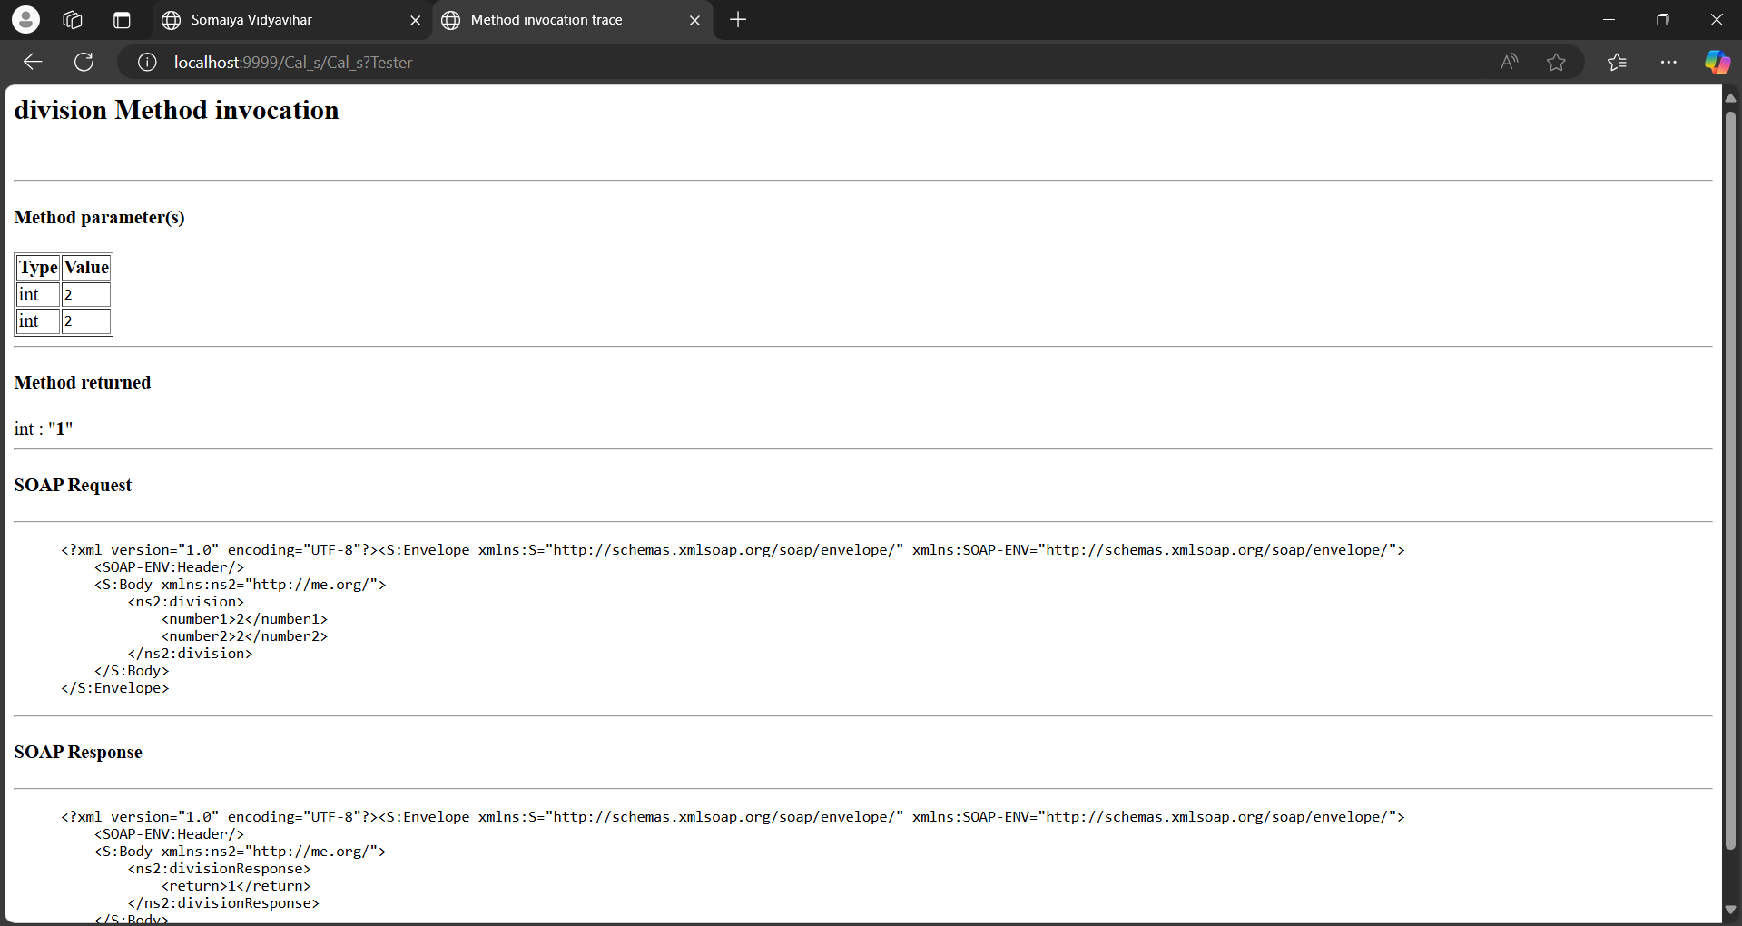

To create Client:
Step 1: Go to files new projectJavaJava ApplicationGive project name.
Step 2: Right click on your Project new Web Service Client In project , browse your Web service give a package name
Step 3: Write the code in the java file Write the code Clean and build Click on the project and run.
Client side Code:
Calculator_Client
package calculator_client;
import java.util.Scanner;

public class Calculator_Client {

public static void main(String[] args) {
Scanner sc = new Scanner (System.in);
System.out.println("Enter num1 :");
int num1 = sc.nextInt();
System.out.println("Enter num2 :");

int num2 = sc.nextInt();
org.me.CalS_Service service = new org.me.CalS_Service();
org.me.CalS port = service.getCalSPort();
System.out.println("Output in:" + port.addition(num1,num2));
System.out.println("Output in:" + port.subtraction(num1,num2));
System.out.println("Output in:" + port.division(num1,num2));
System.out.println("Output in:" + port.multiplication(num1,num2));
}
}
Output:
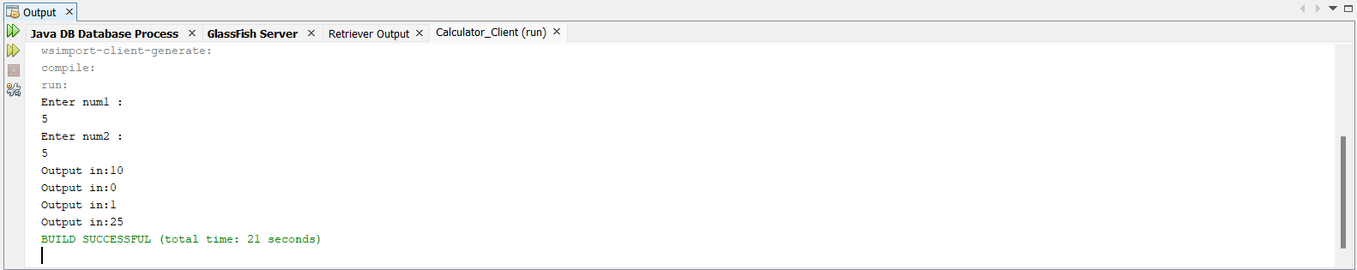

Practical 06
Aim: Implement Xen Server virtualization and manage with Xen Center
Steps:
Step 1: Go to Xenserver.com and download Xenserver8 -ISO
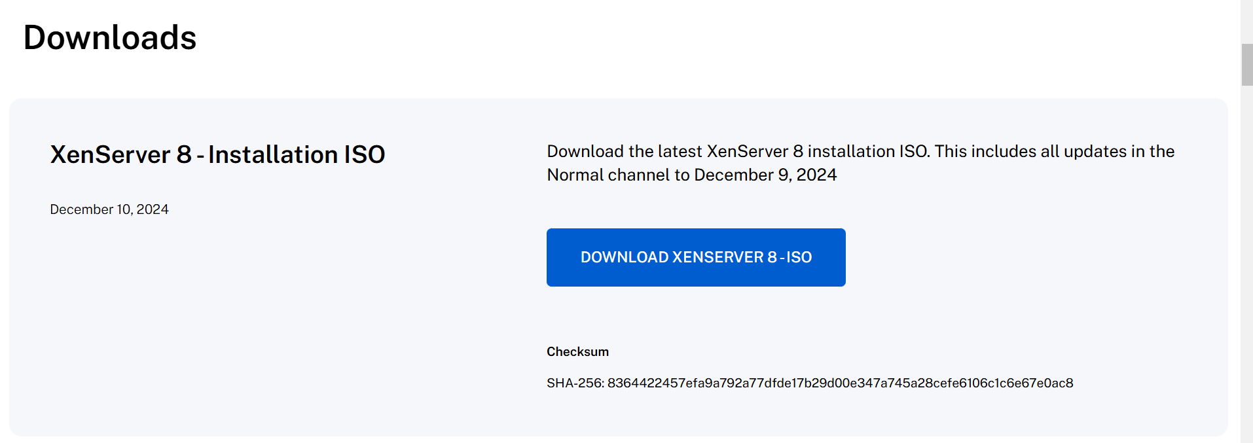
Step 2 : Now go to Oracle VM VirtualBox Manager and click New.
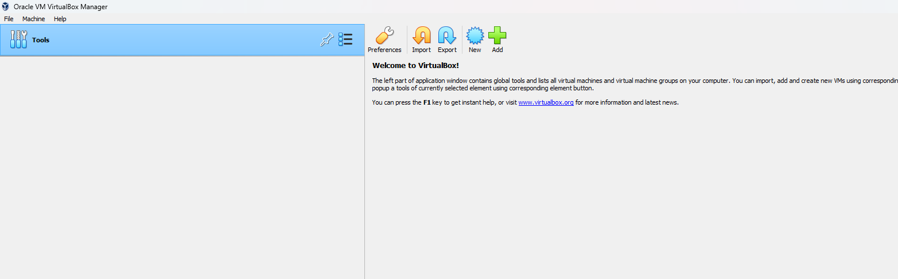

Step 3 : Fill name as Xen, Type as Linux and Version as Ubantu(64 bit) and click Next.
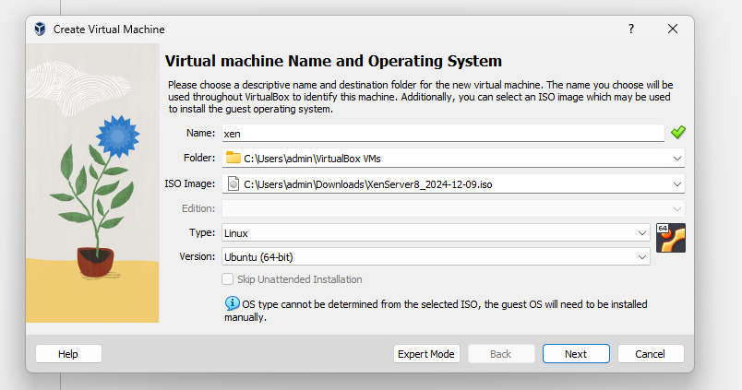

Step 4 : Adjust your base memory and processor.
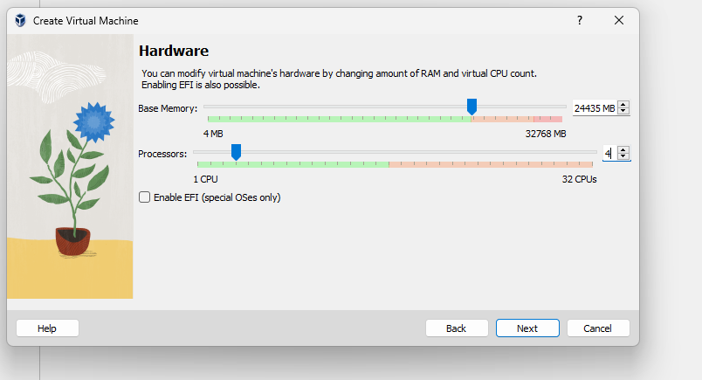
Step 5 : Adjust Virtual hard disk space and click next.
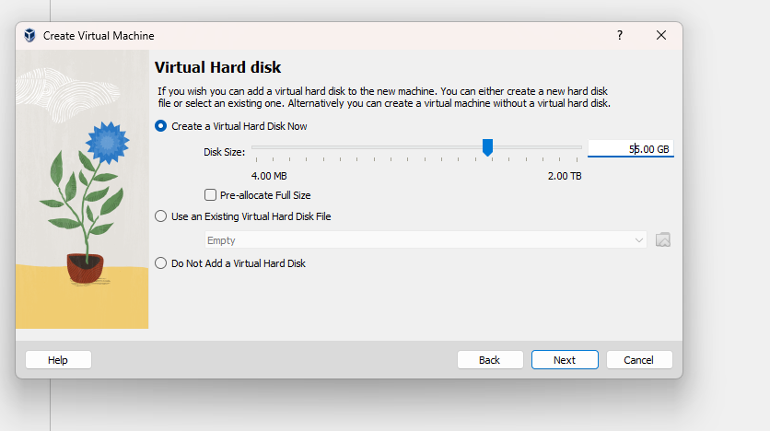

Step 6 : Select Back
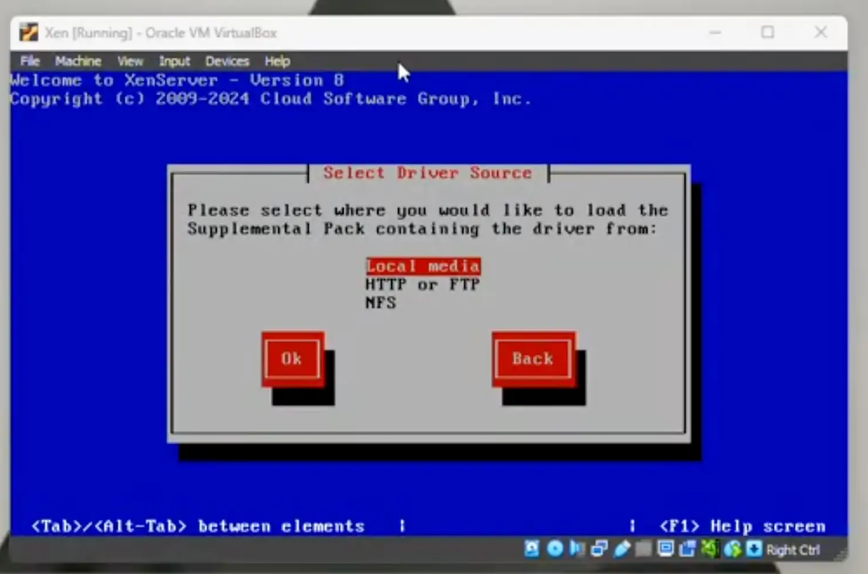
Step 7 : Click ok.
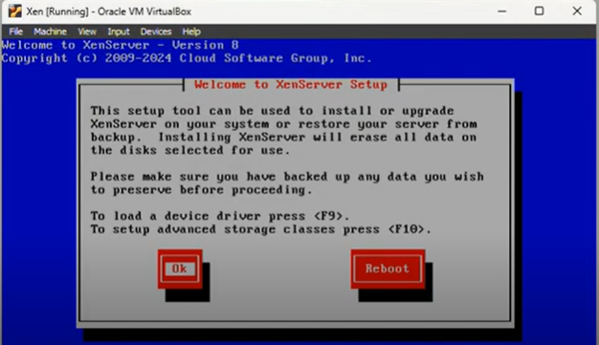

Step 8 : Click Accept
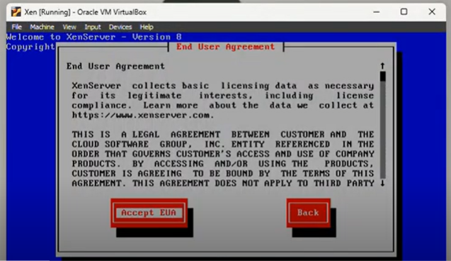
Step 9 : Click ok
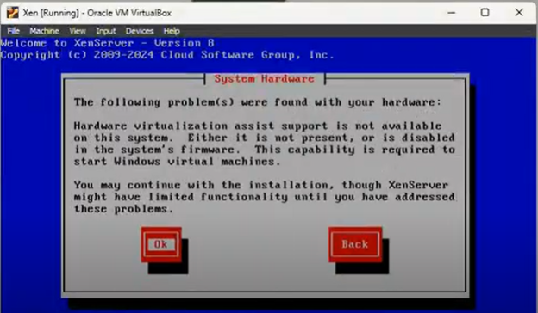
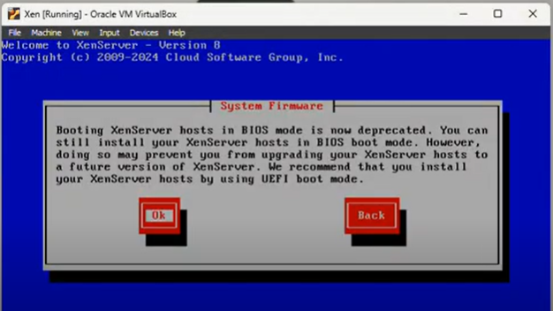

Step 10 : Click on space bar and then click ok
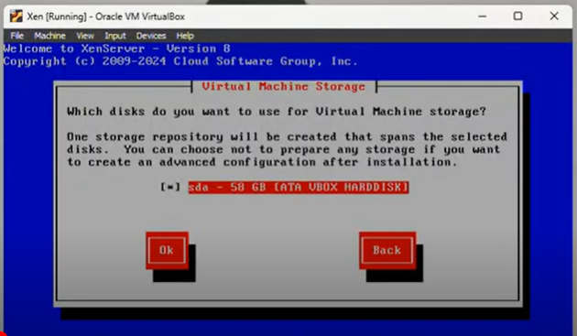
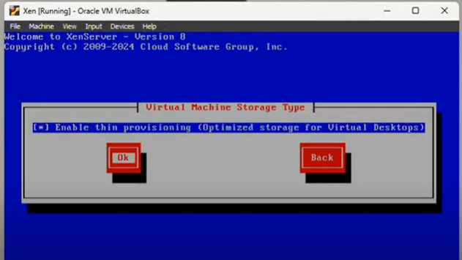
Step 11 : Select local media .
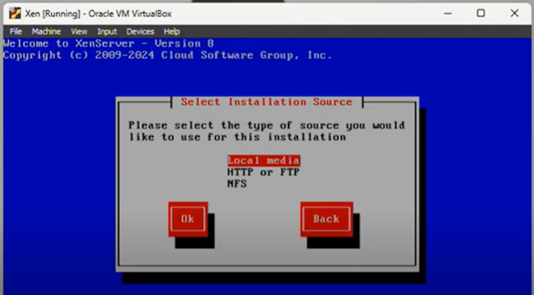

Step 12: Select skip verification
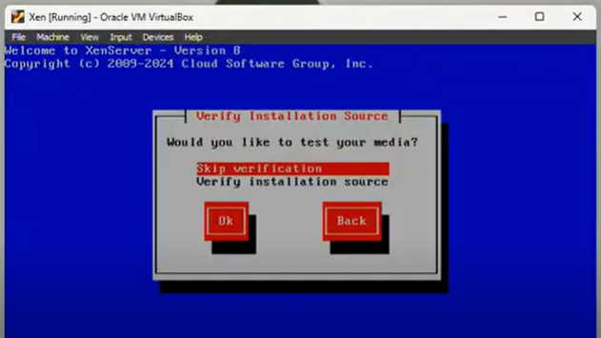
Step 13: Enter password and click ok.
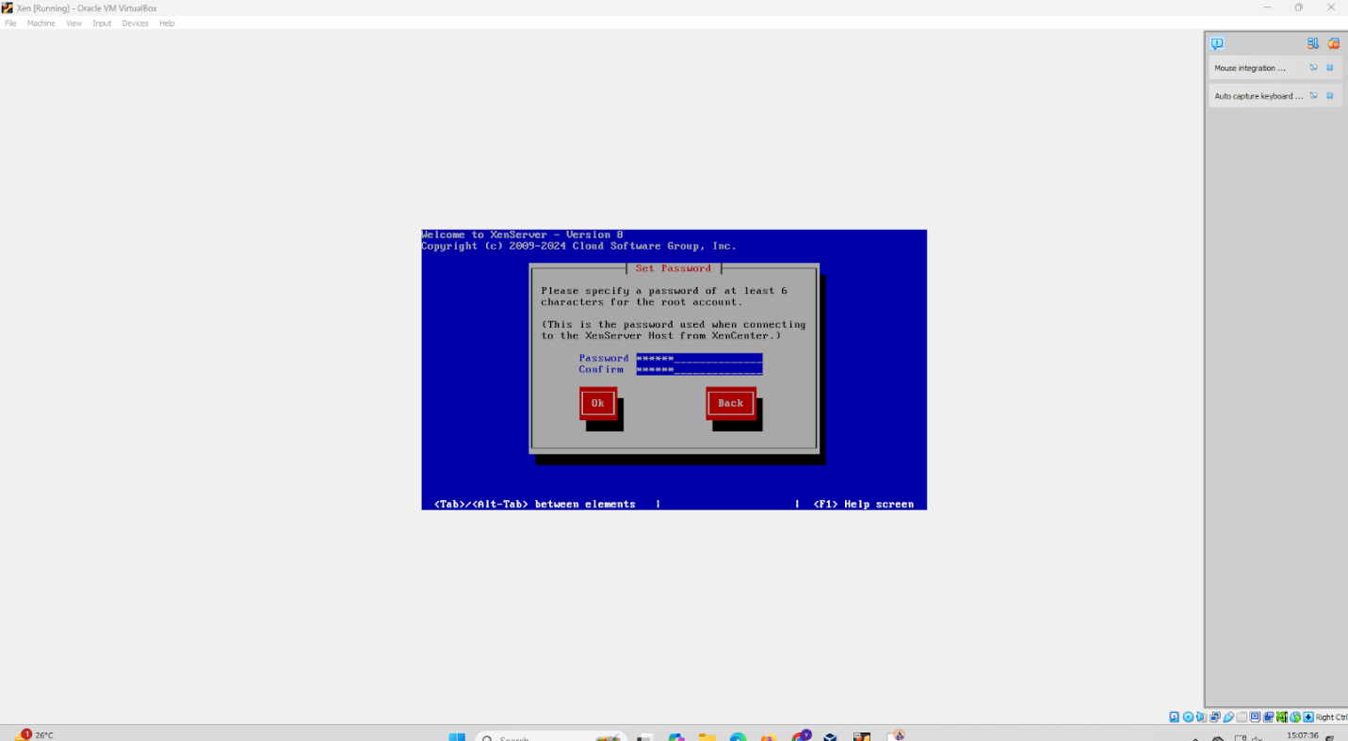

Step 14: Select automatic configuration and click ok
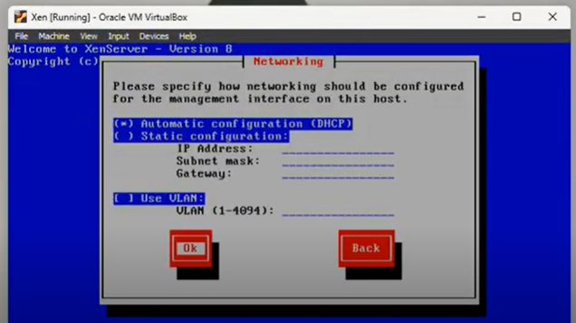
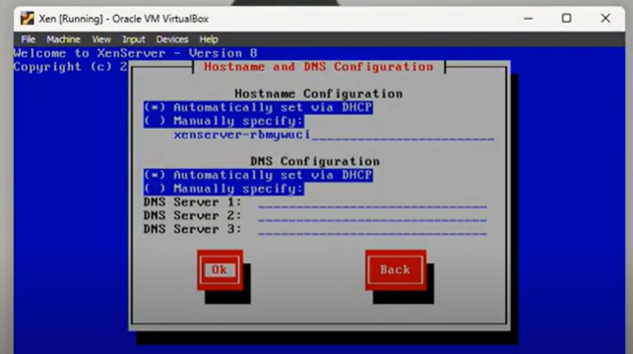
Step 15: Select Asia
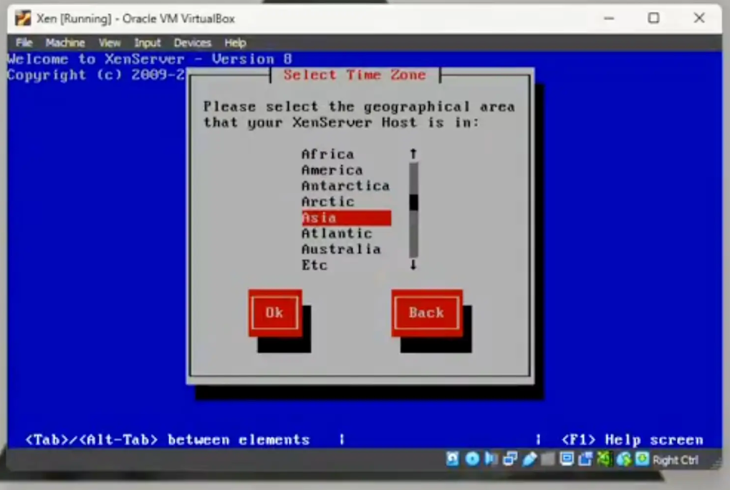
Step 16 : Select Kolkata
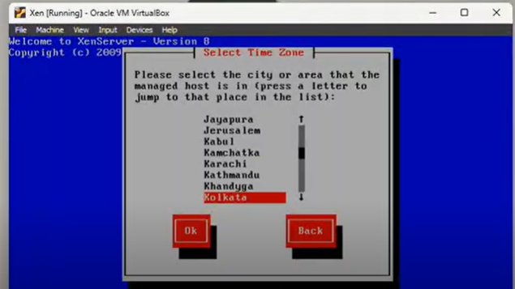
Step 17 : Select DHCP NTP
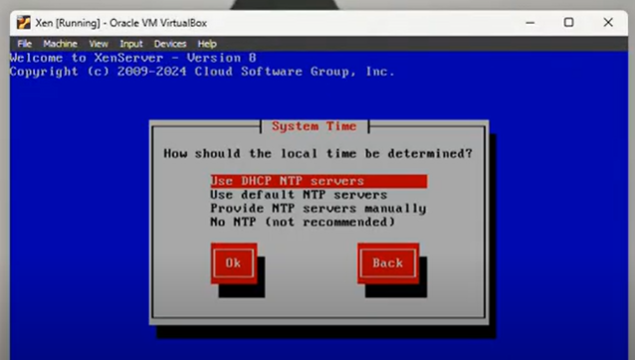
Step 18 : Click to install XenServer
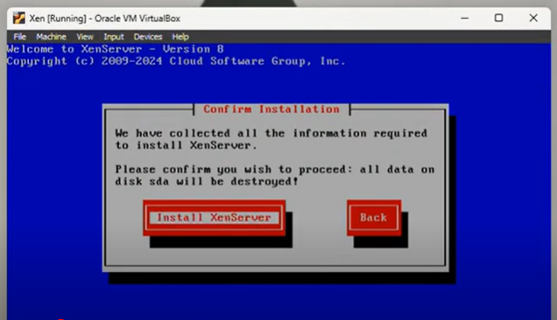
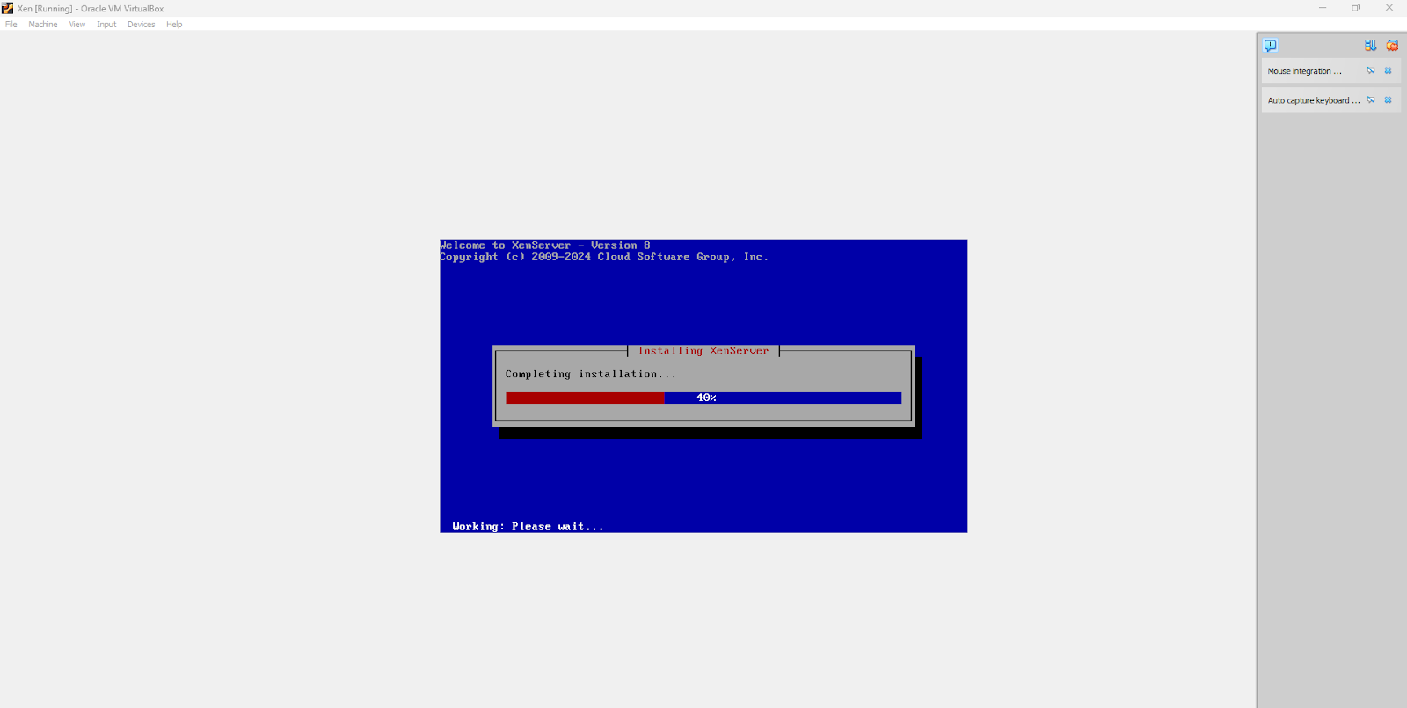
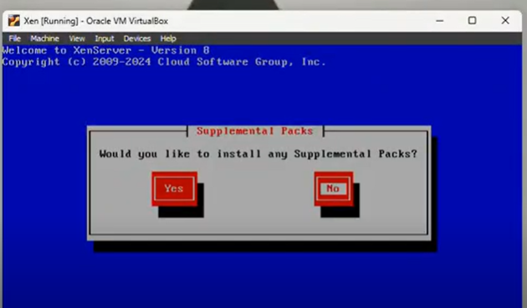
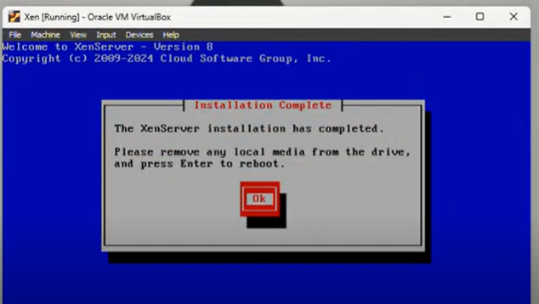
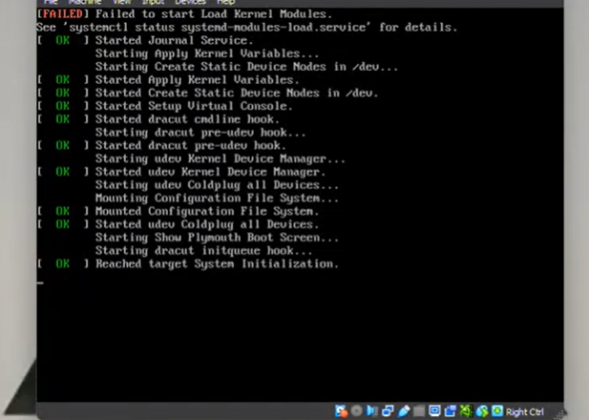
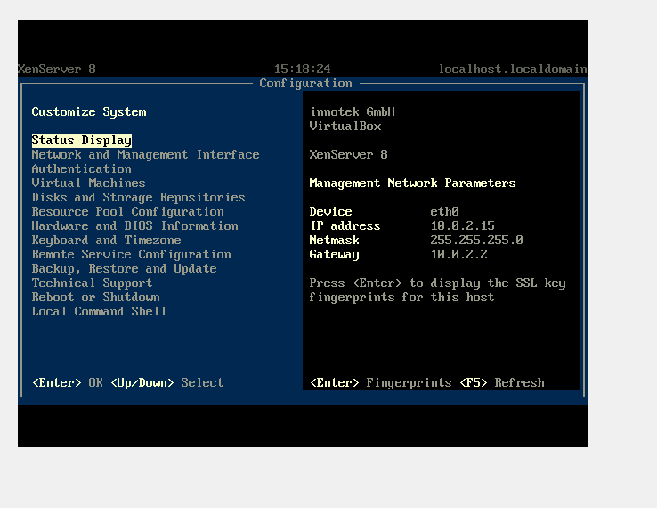

Practical 07
Aim: Implement virtualization using VMWare ESXi Server and managing with vCenter.
Steps:
Step 1: Open VM Workstation 16 Pro
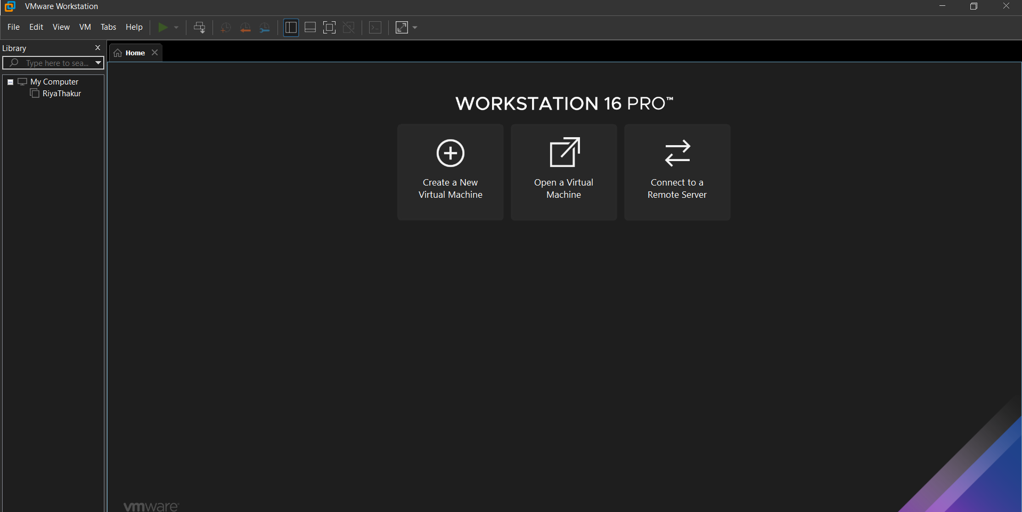
Step 2: Click Create new Virtual Machine and select custom and click next.
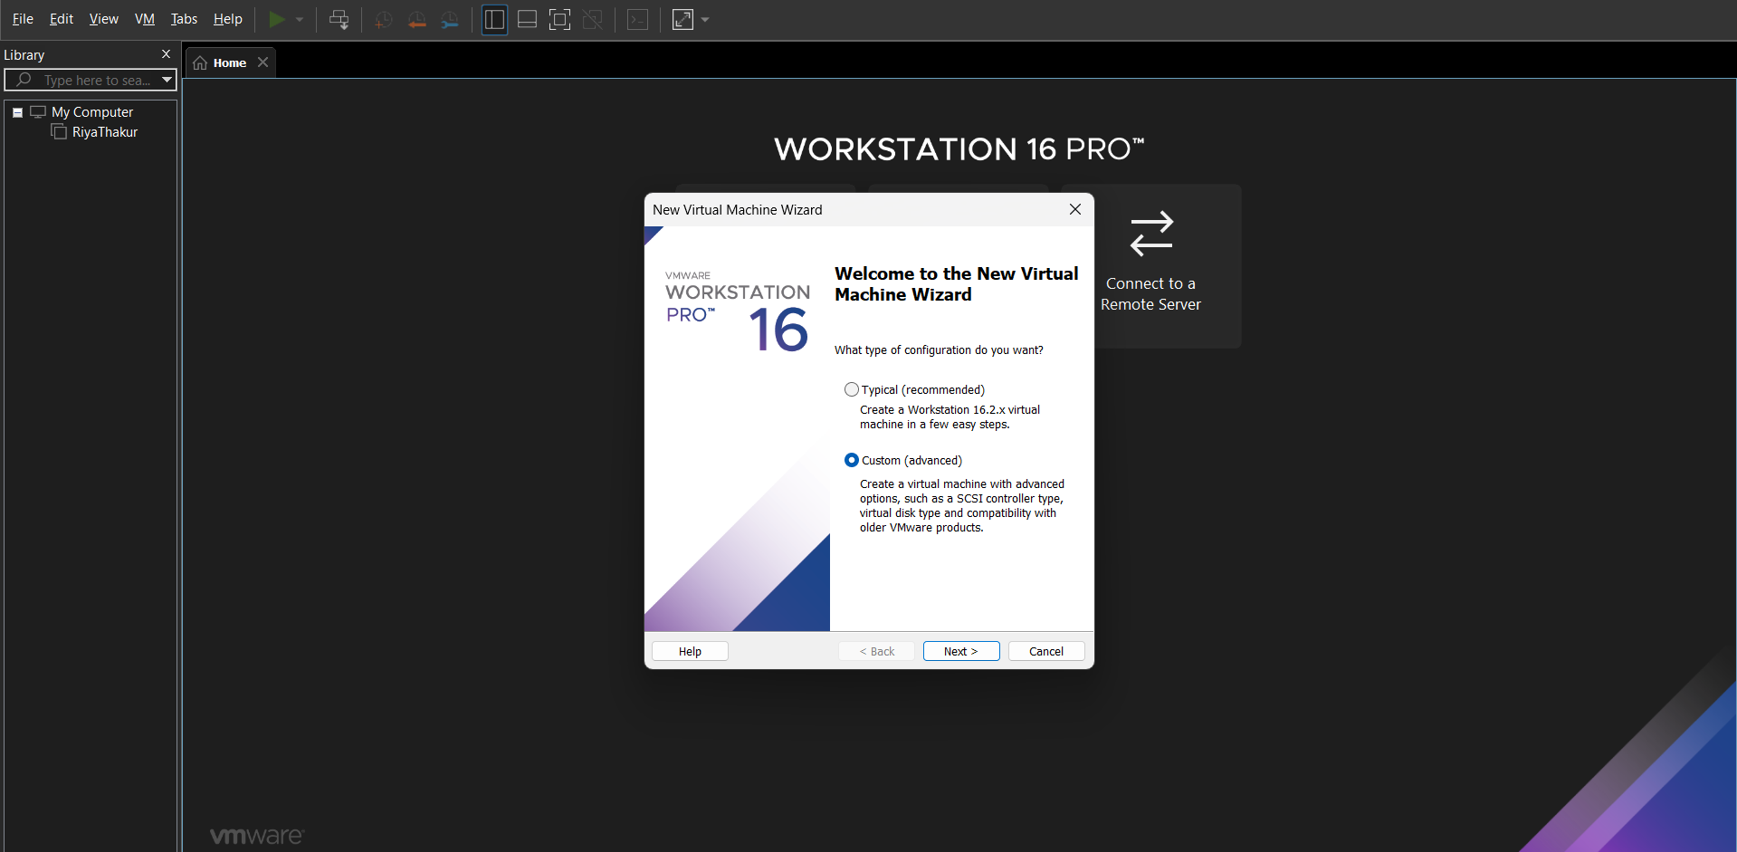

Step3: Select Workstation9.x and click next
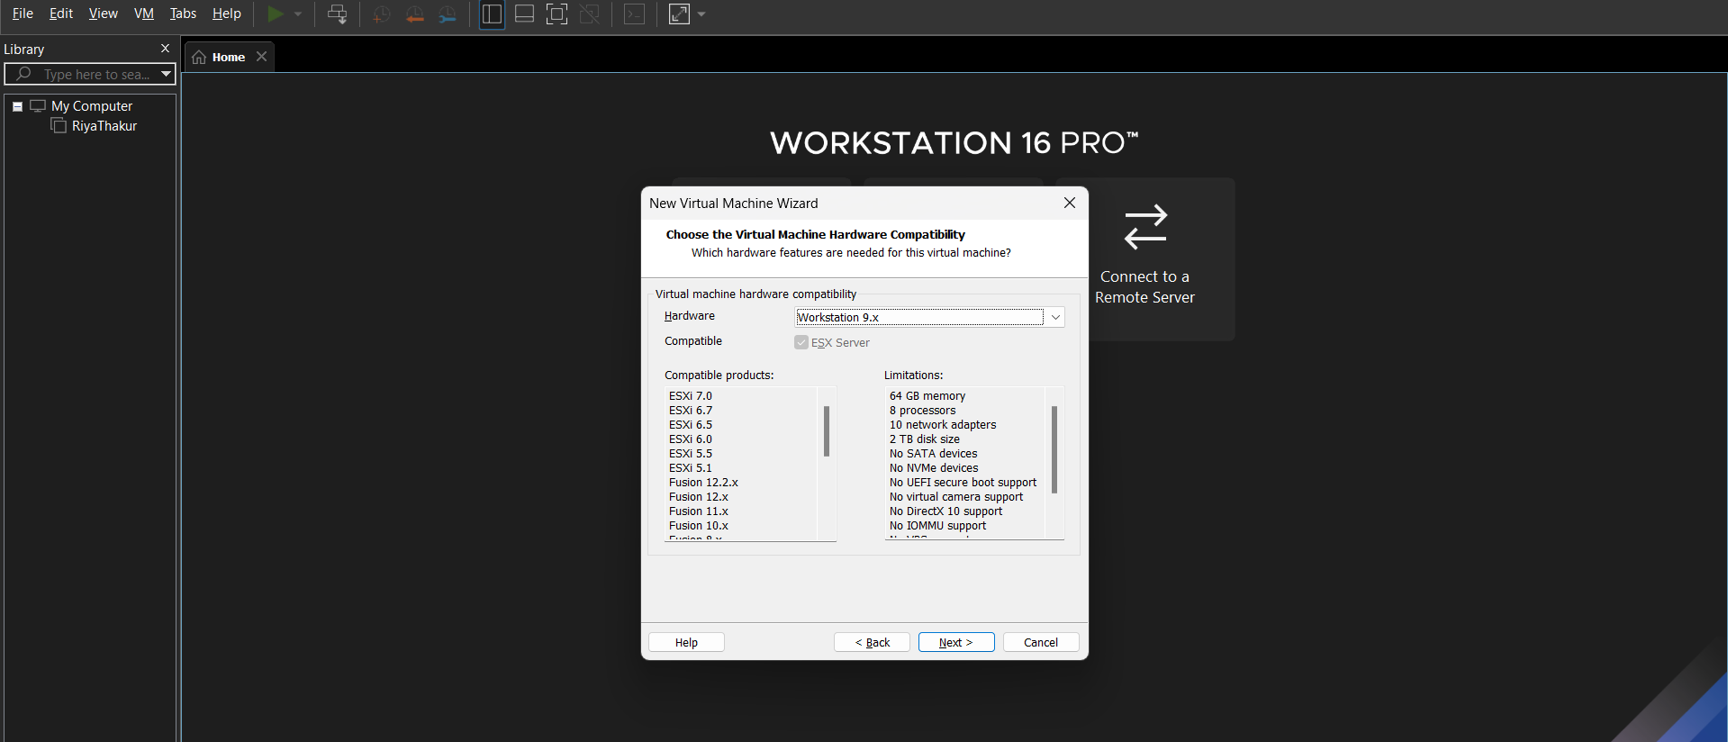
Step 4 : Browse ESXI.iso downloaded file , select it and click next
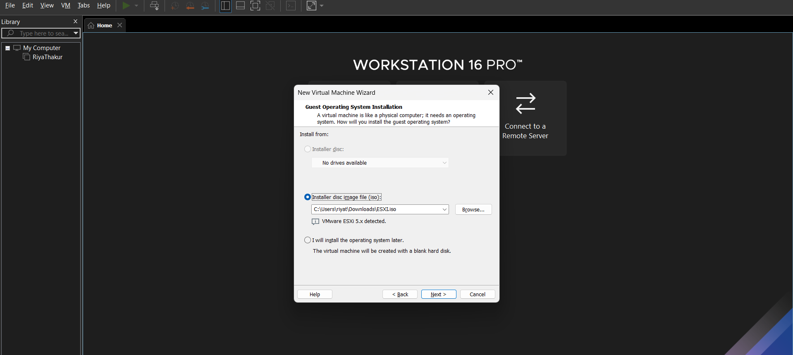

Step 5: Give your virtual machine a name and click next.

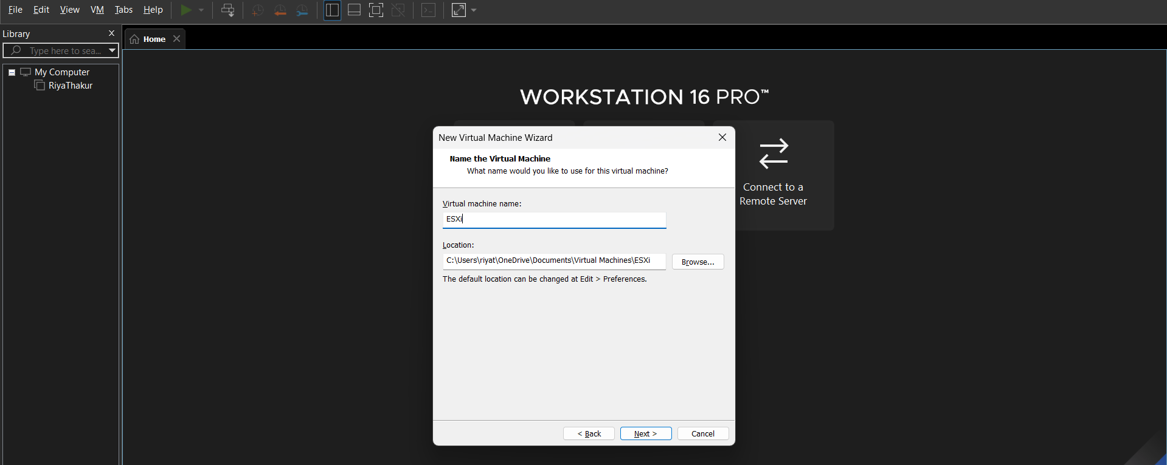
Step 6: Change Number of processor to 4 and Number of cores per processor to 2
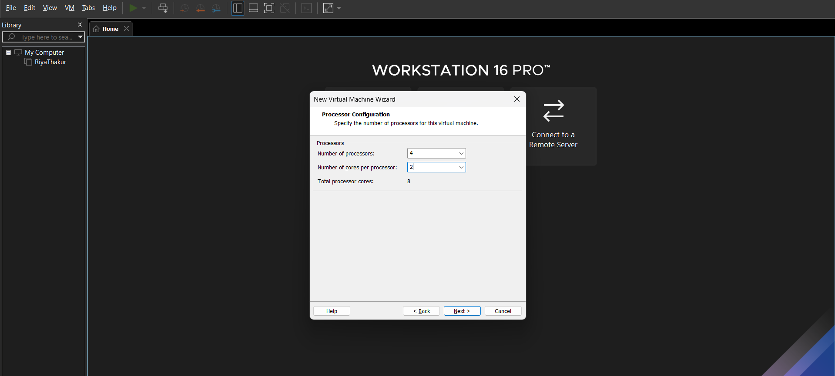

Step 7: Set memory for virtual machine as 18,000 Mb and click next.

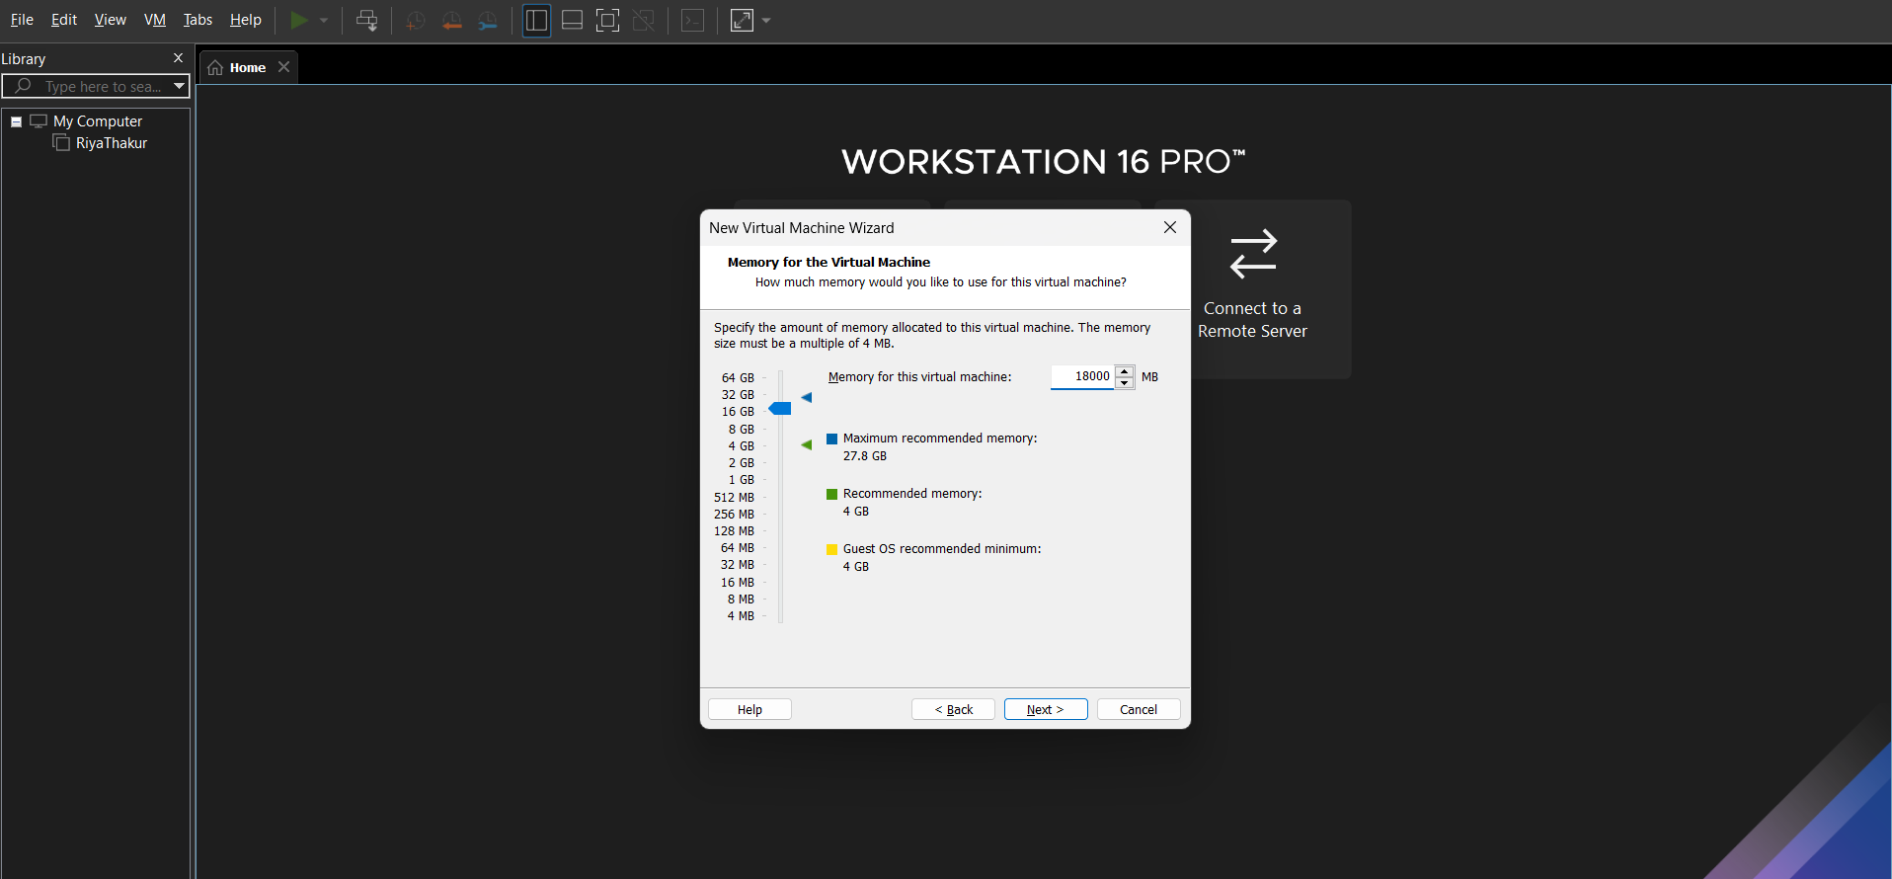
Step 8: Select Use bridged networking and click next
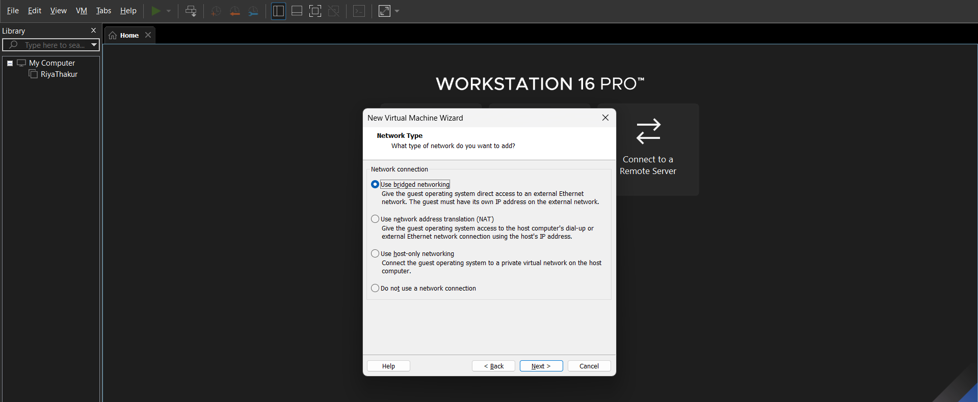
Step 9 : Select LSI Logic and click next.
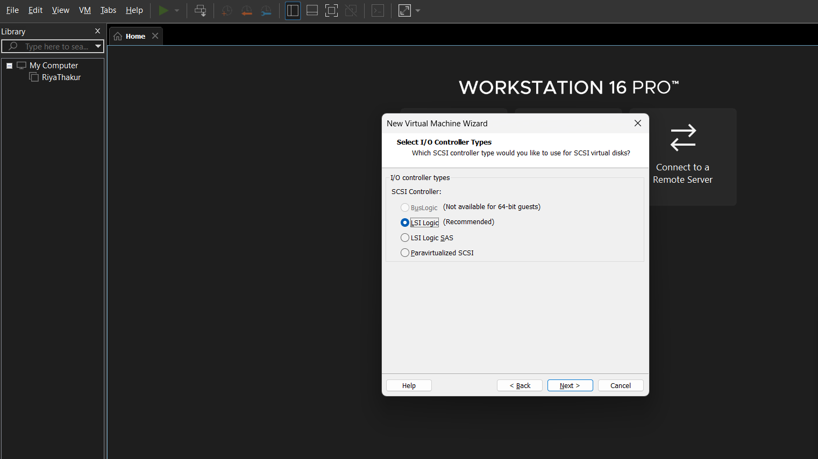
Step 10 : Select SCSI and click next
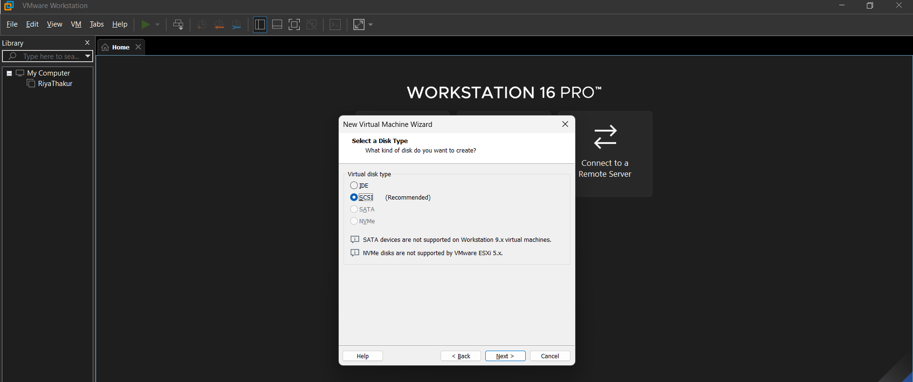
Step 11: Select create a new virtual disk and click next.
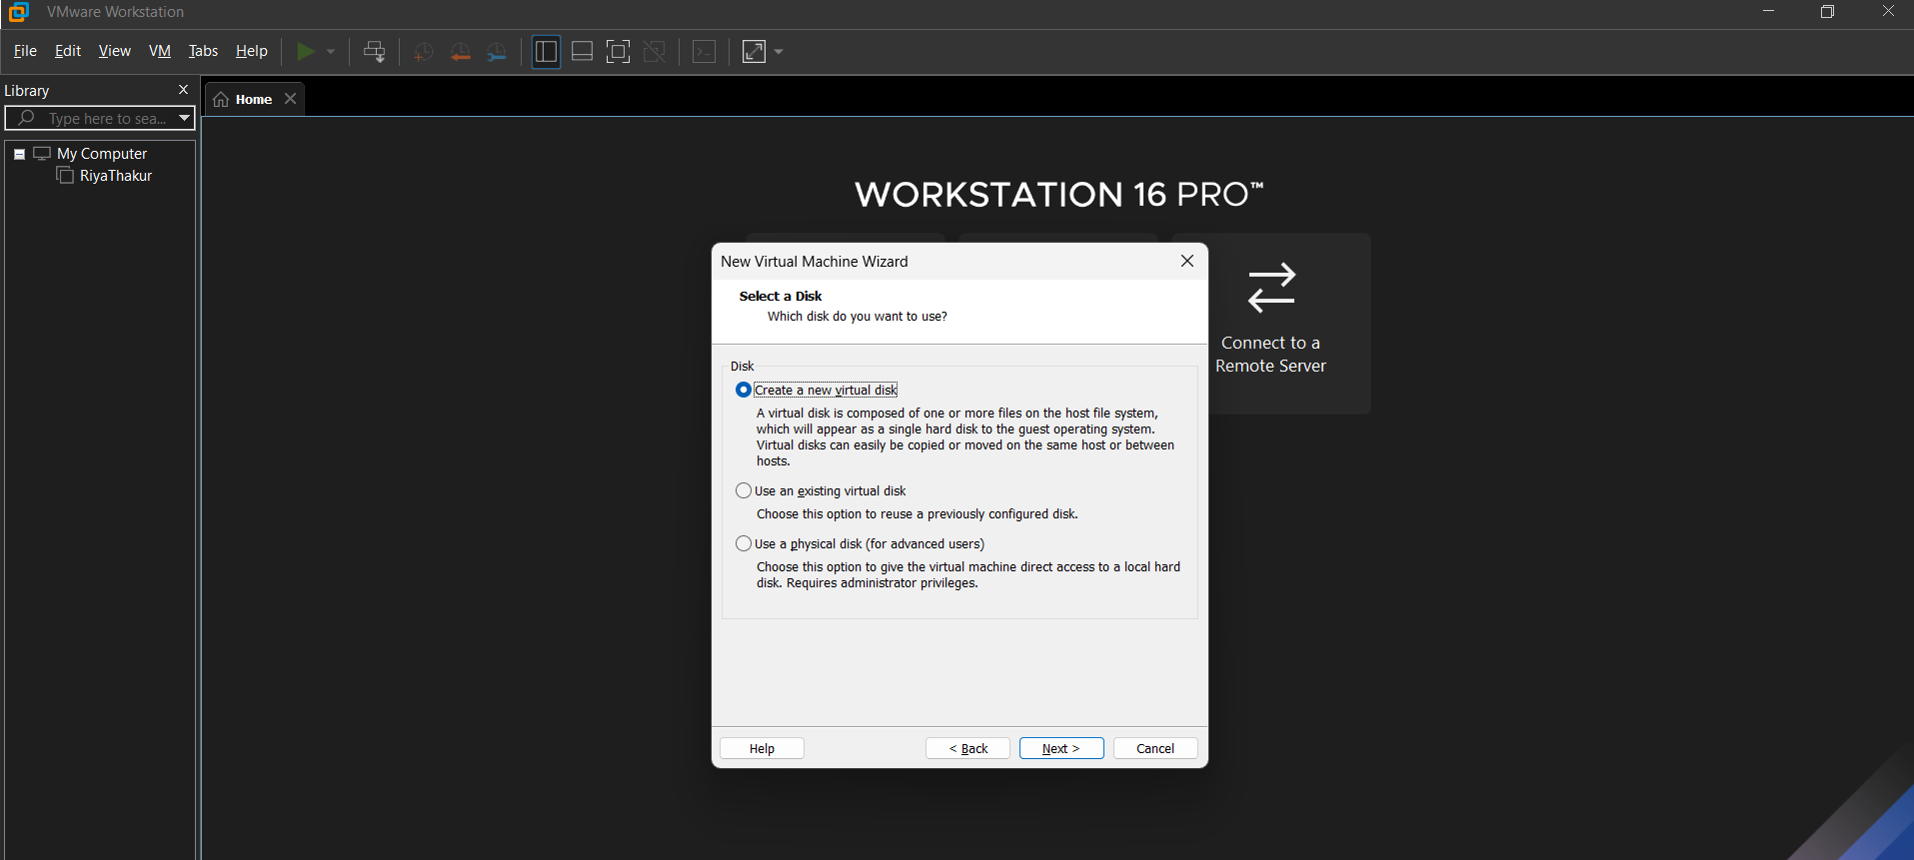
Step 12: Set maximum disk size and select store virtual disk as single file.

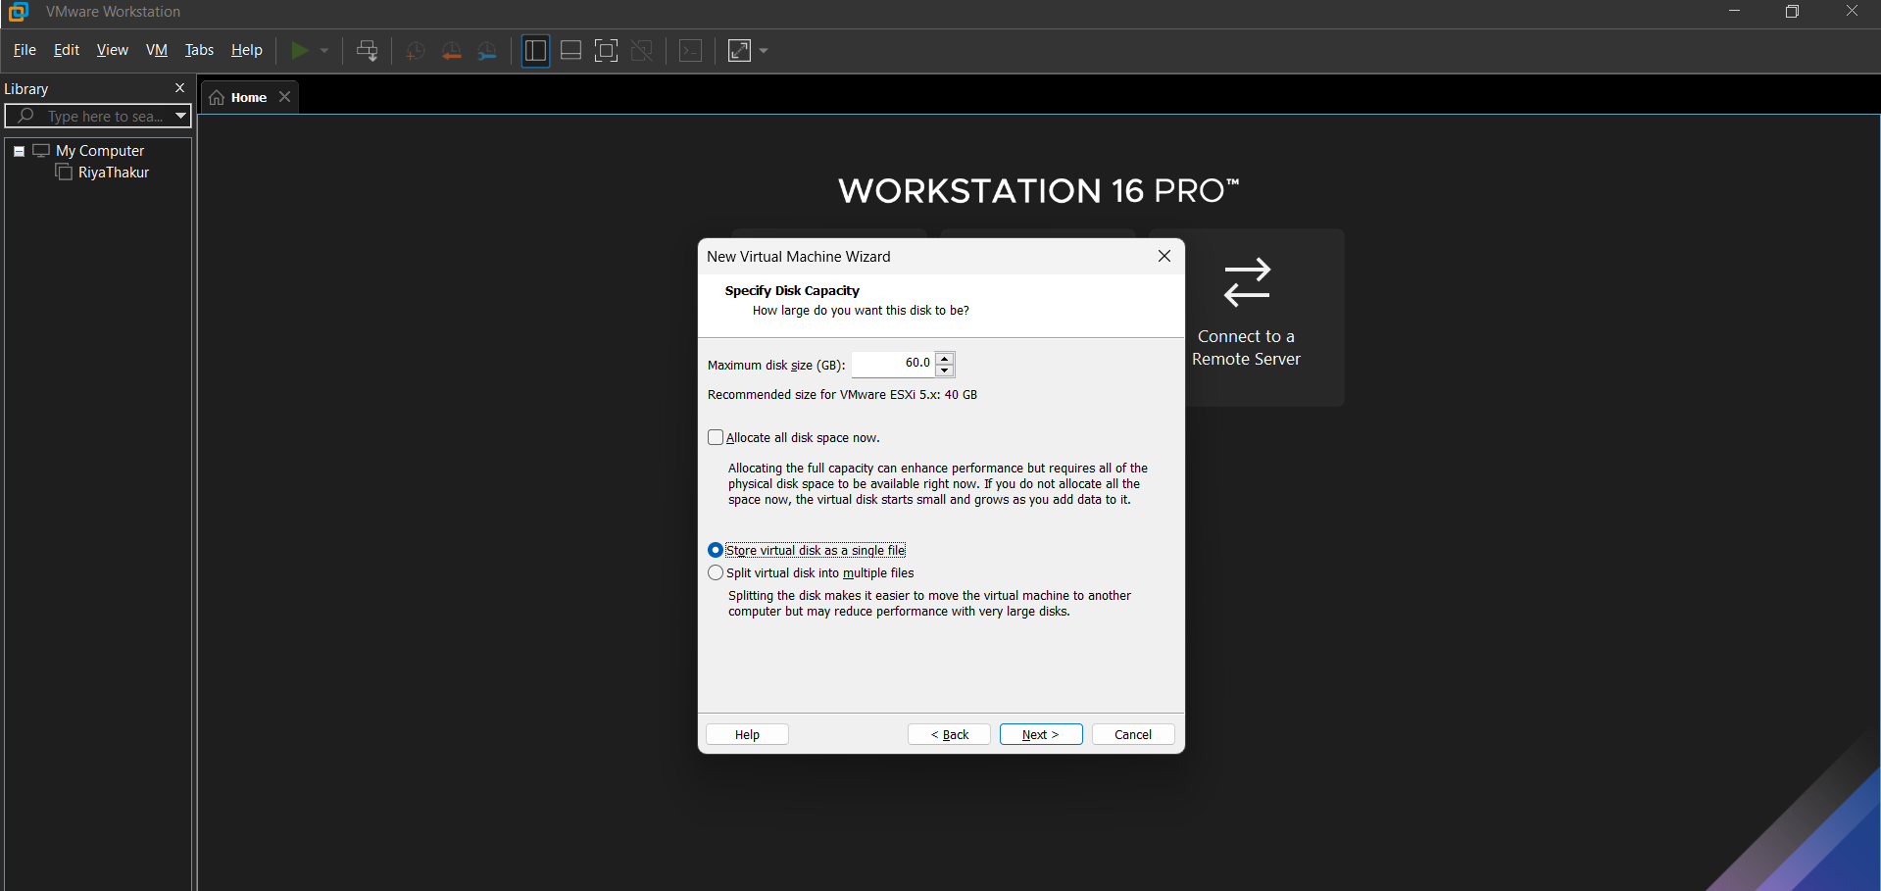
Step 13: Check the file name and click next.
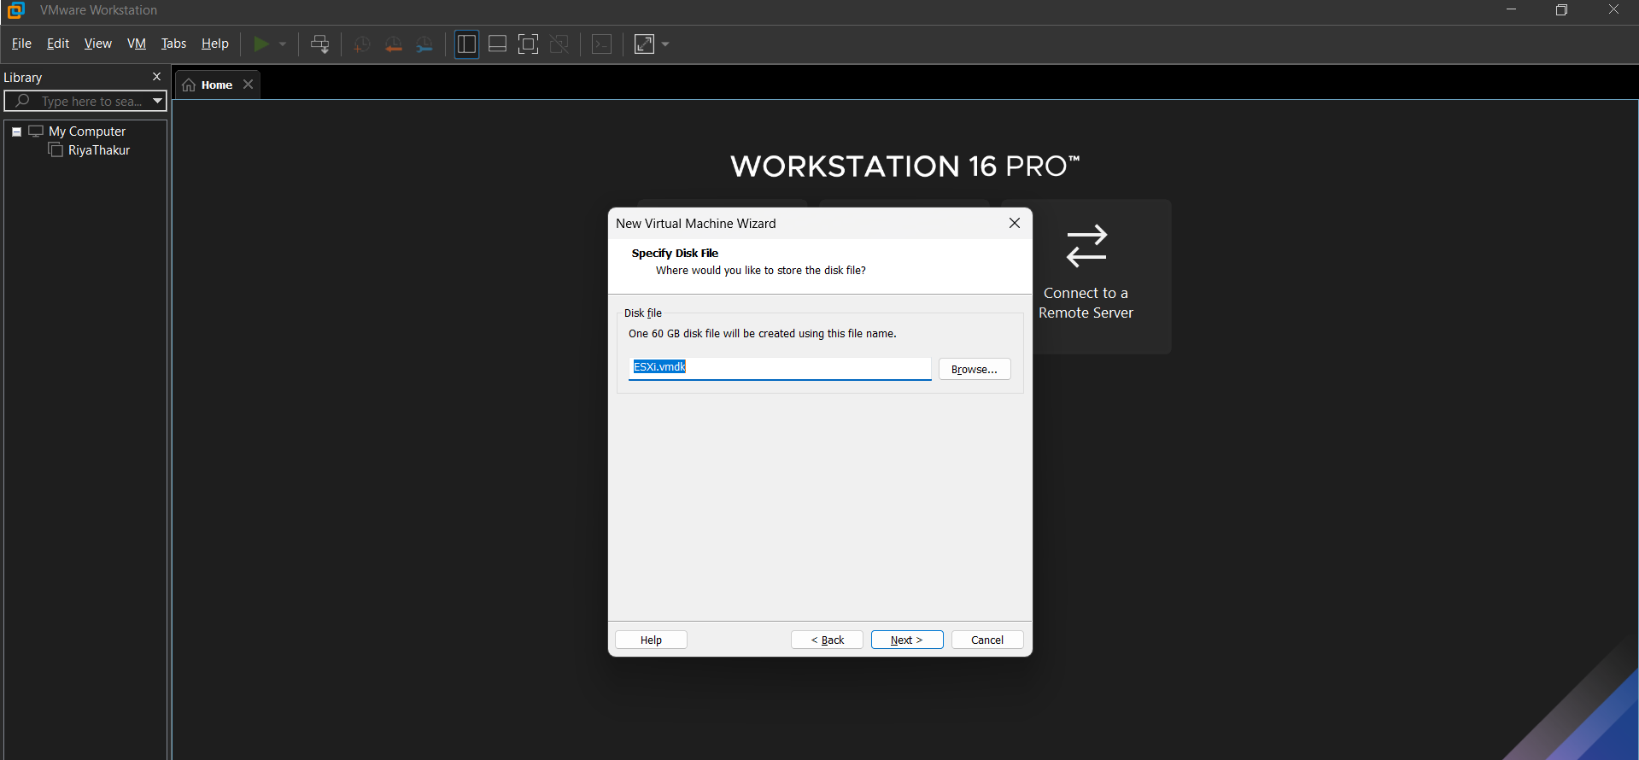
Step 14: Click customize hardware
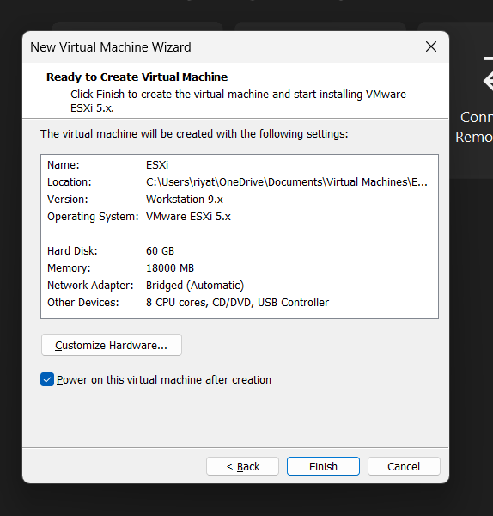
Step 15: Uncheck the Virtual Intel box
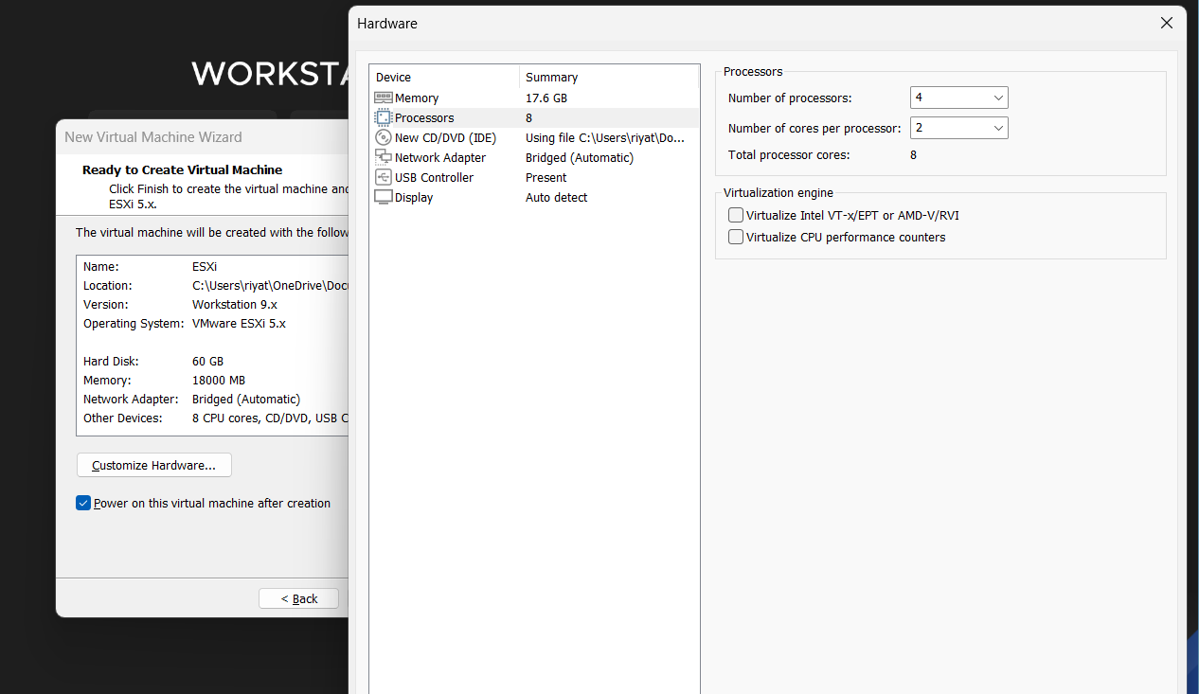
Step 16 : Start the virtual machine
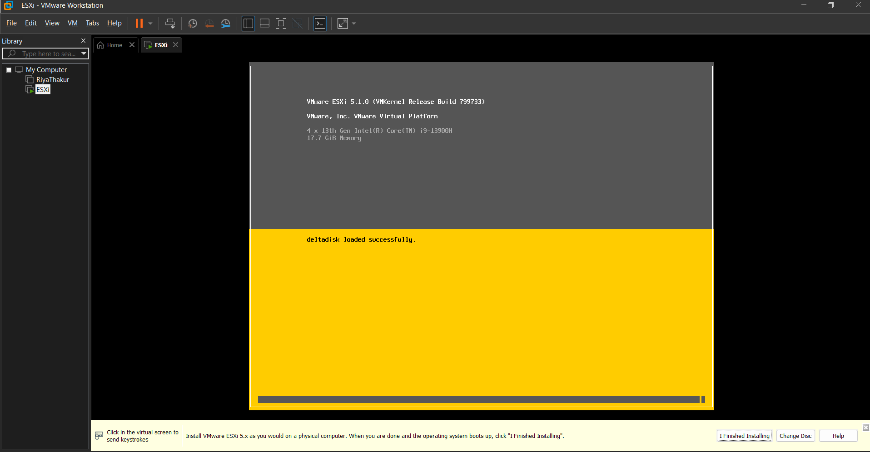
Step 17 : Now continue and accept.

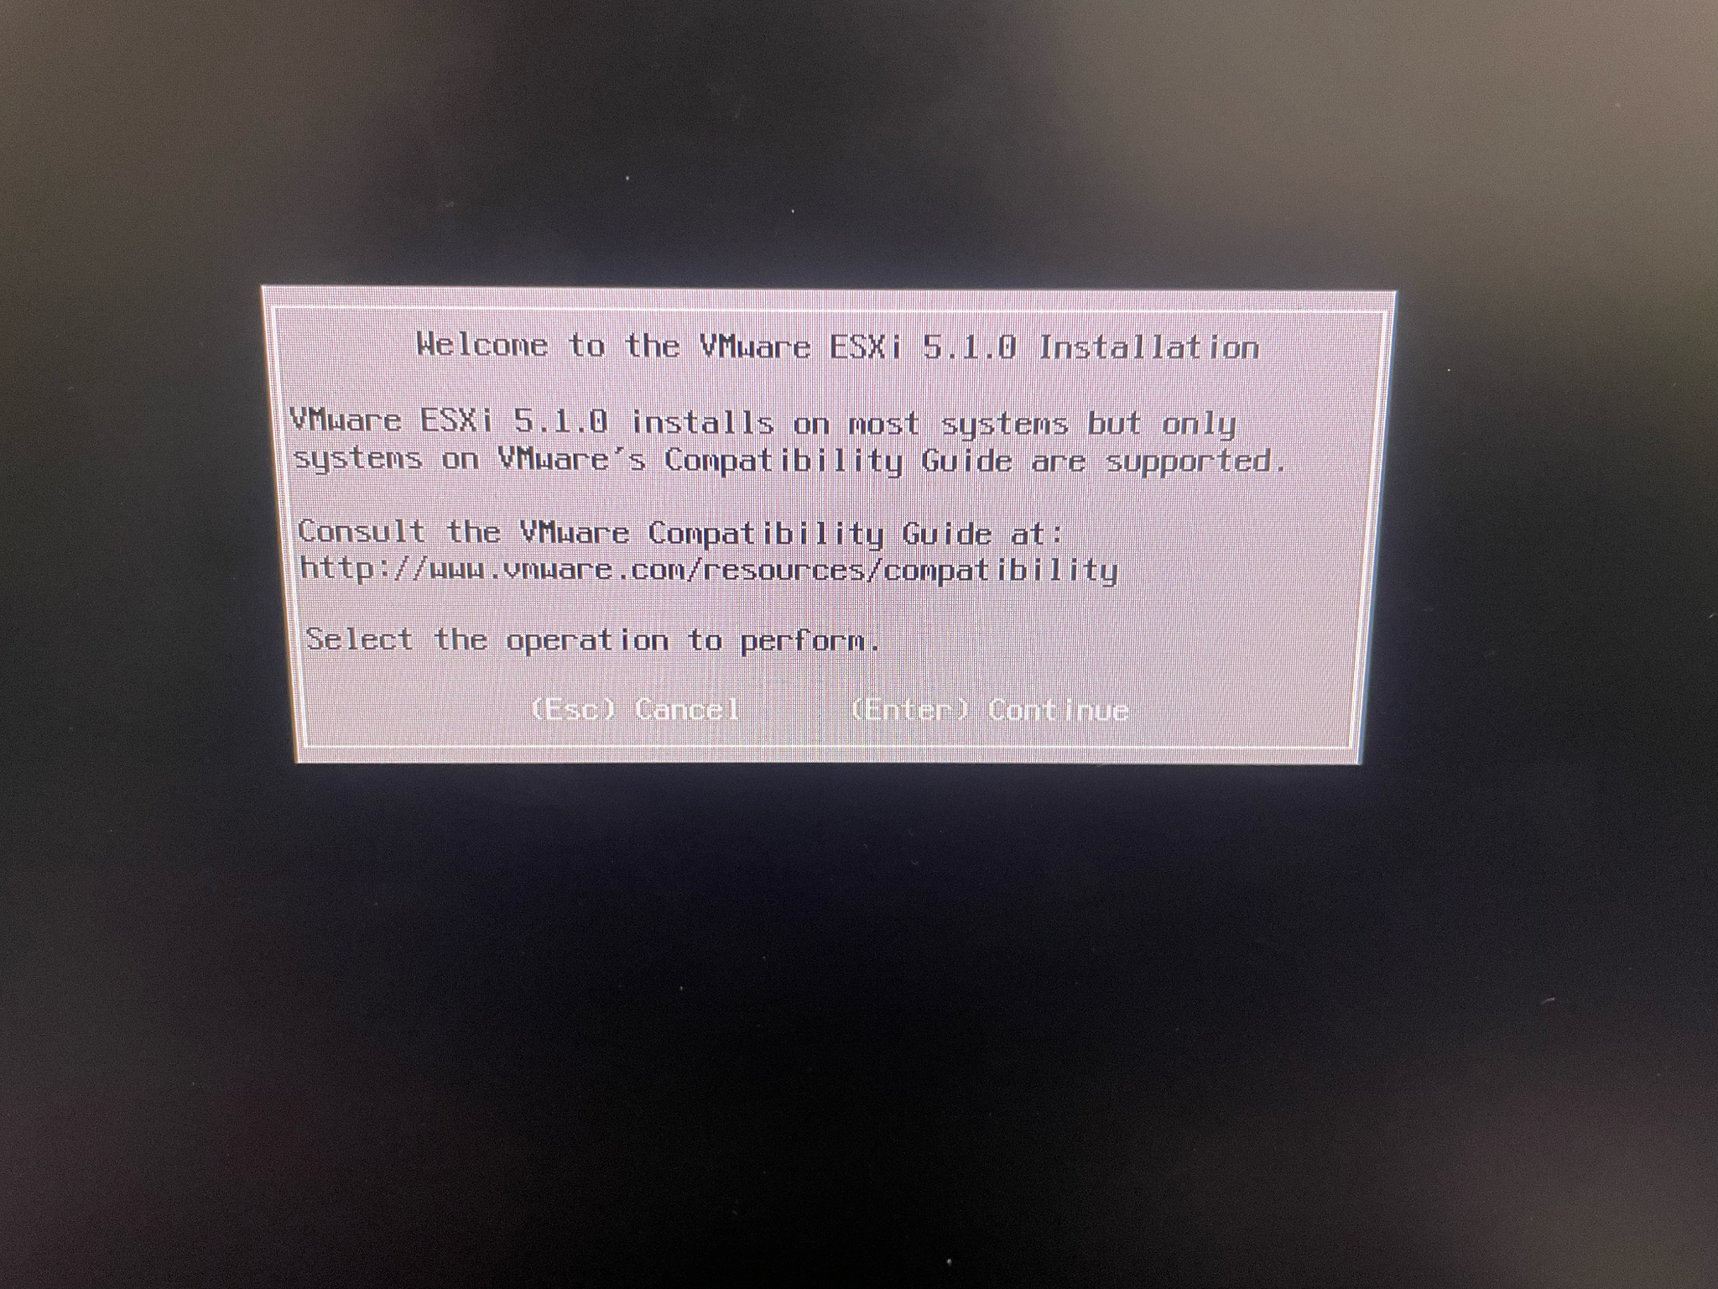
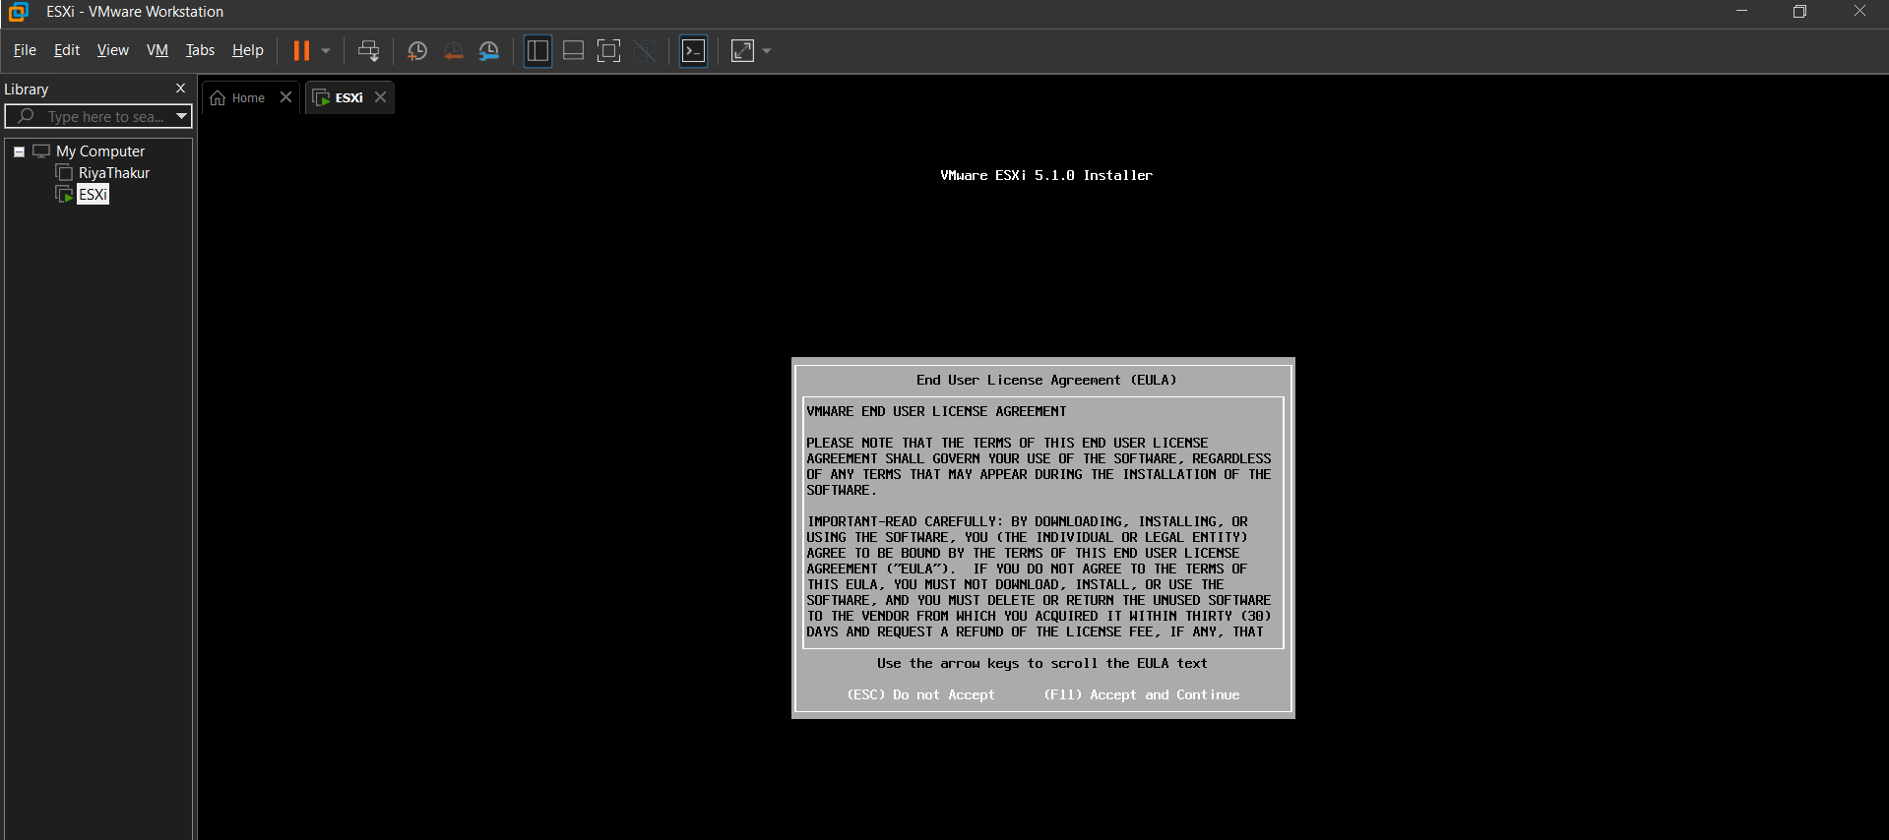
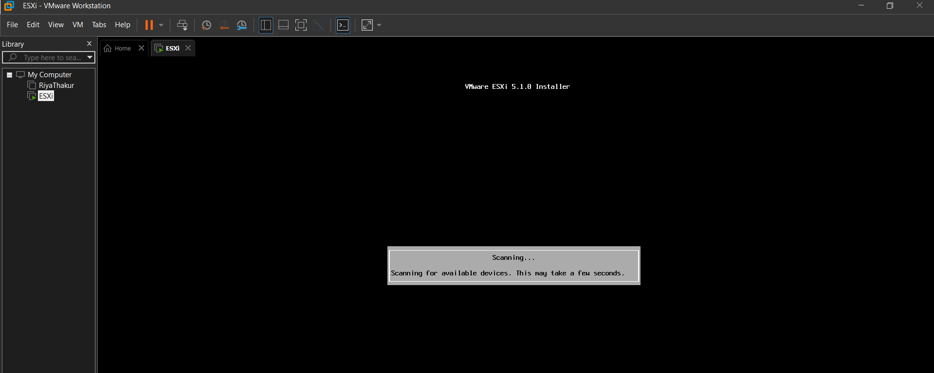

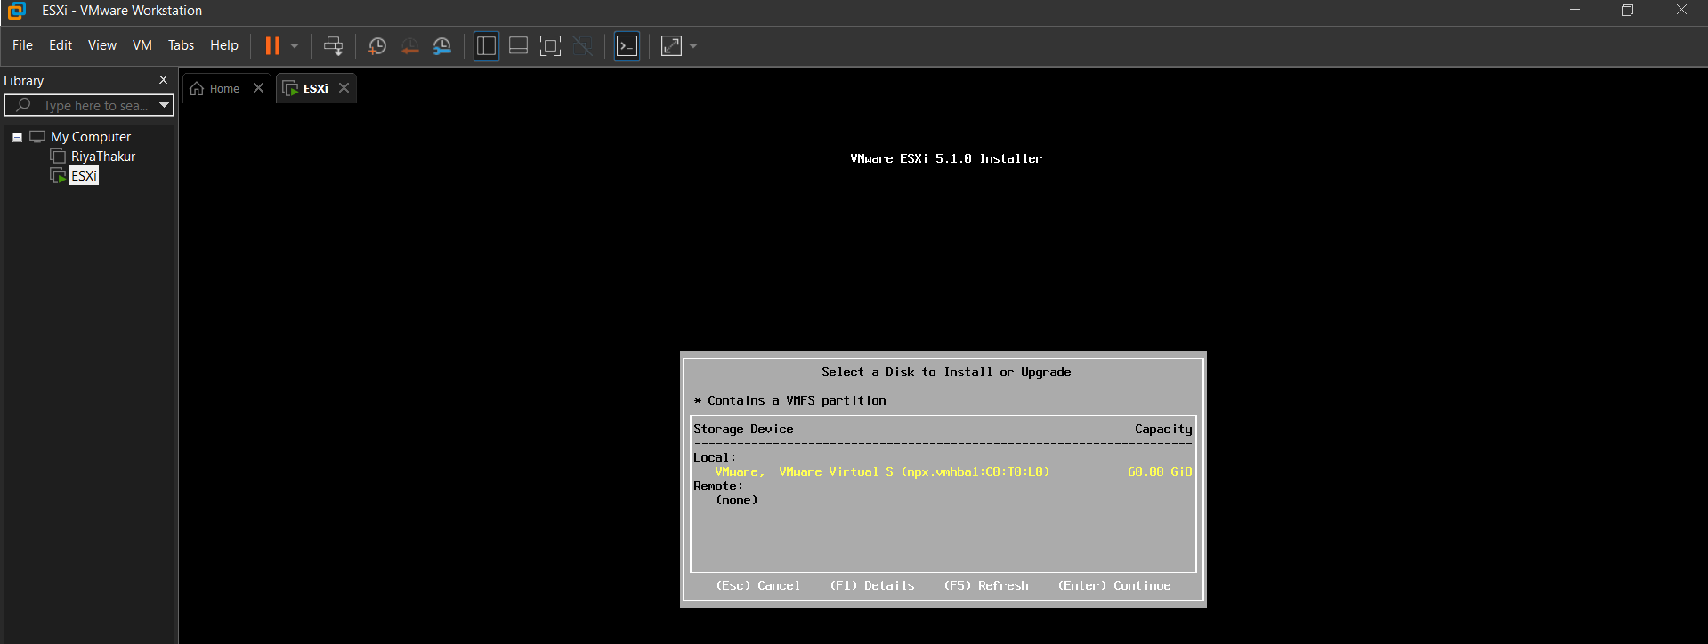
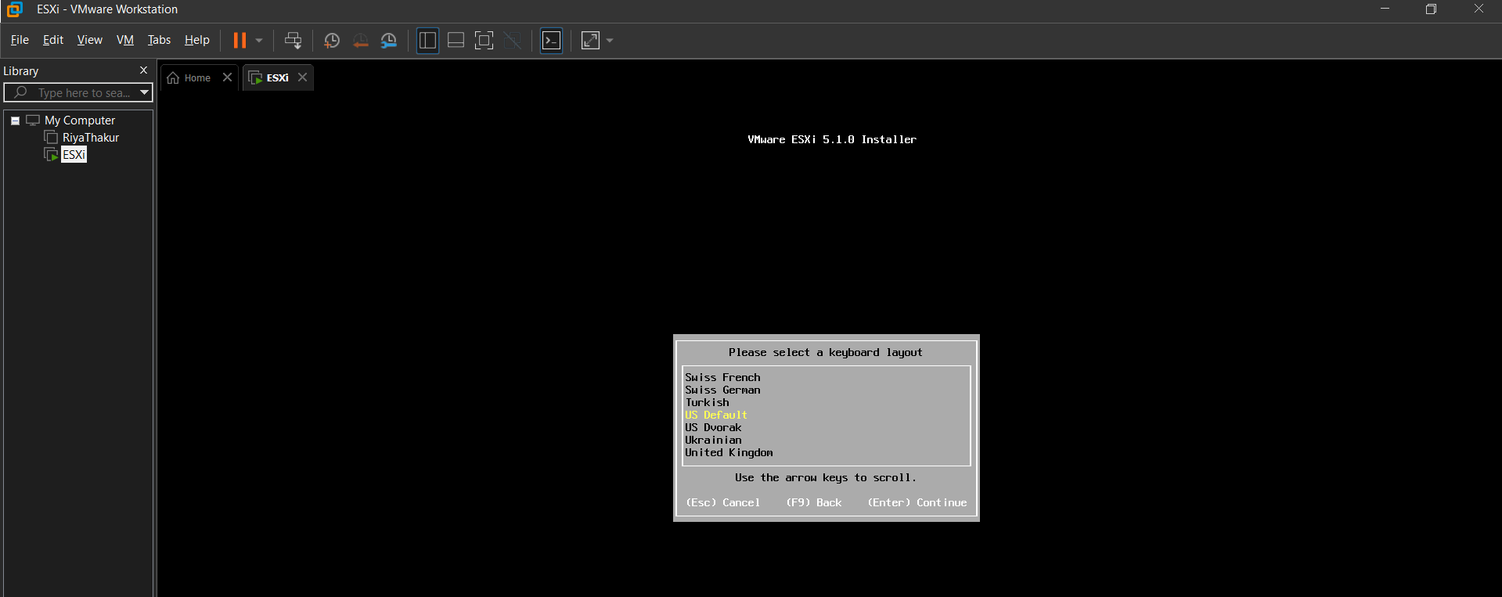
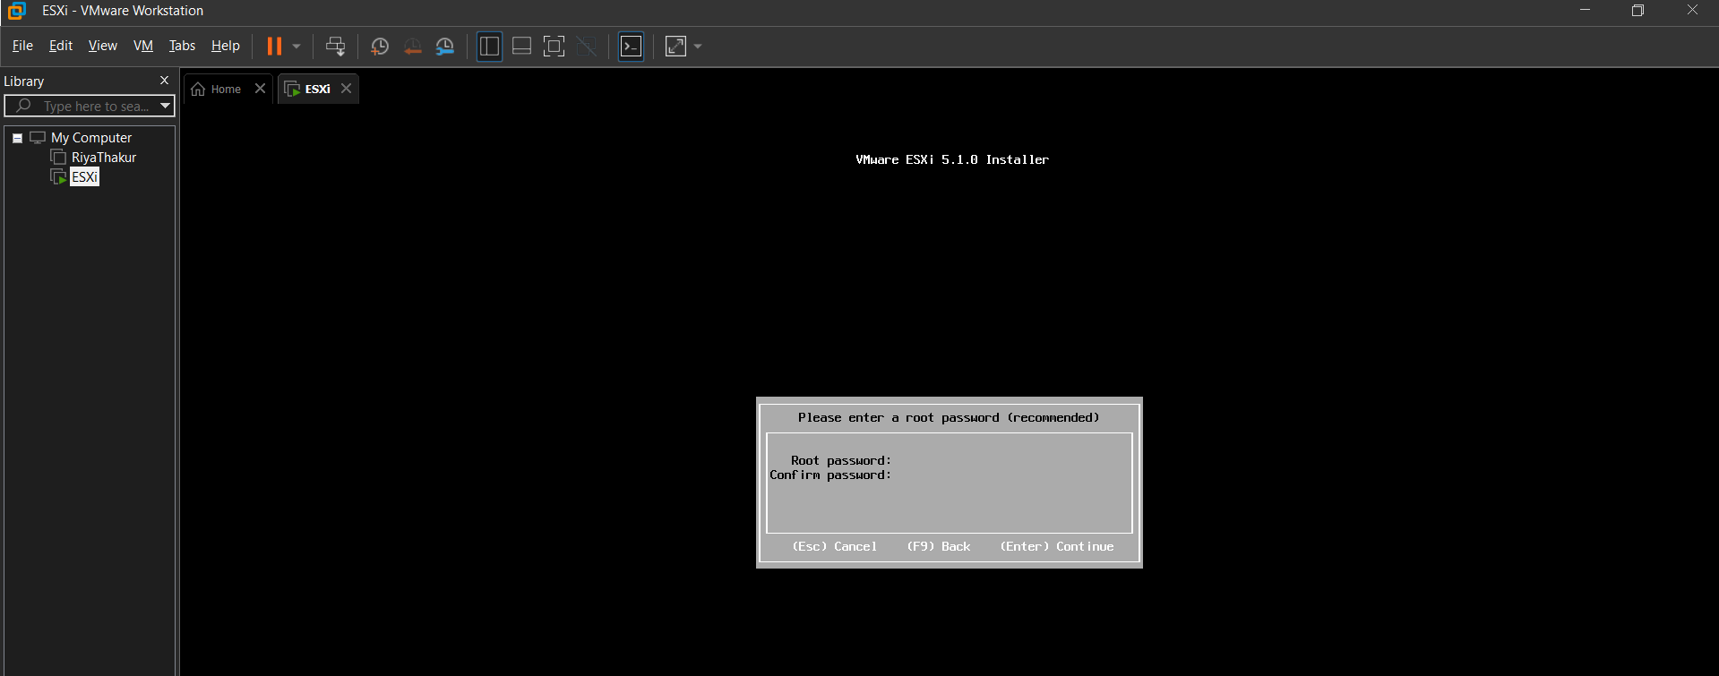
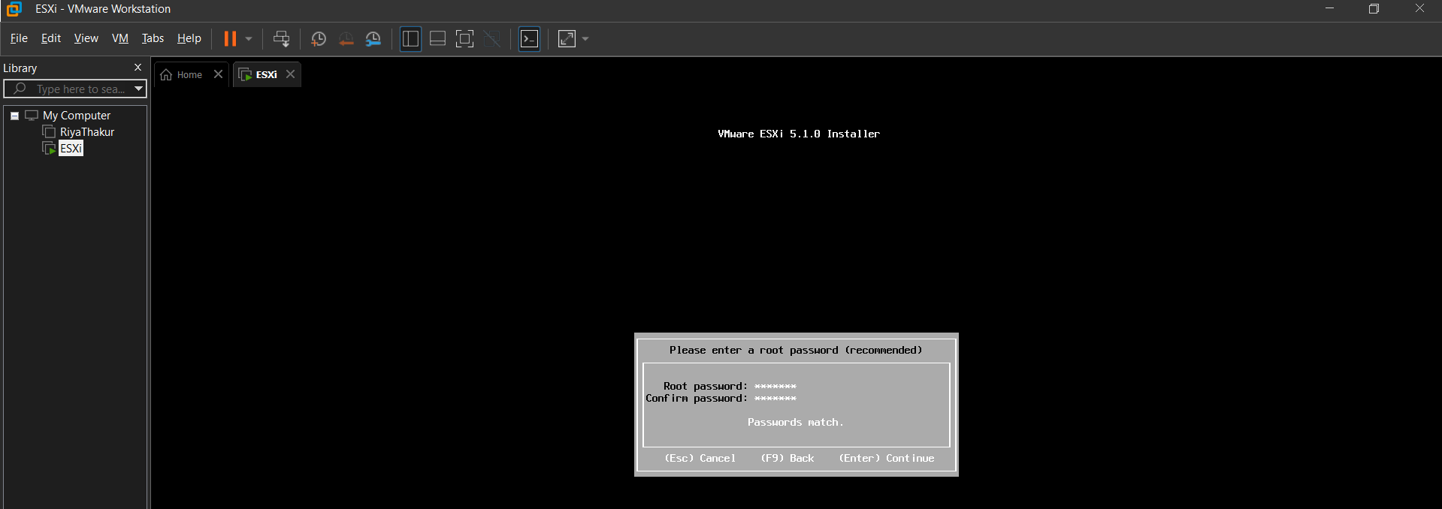
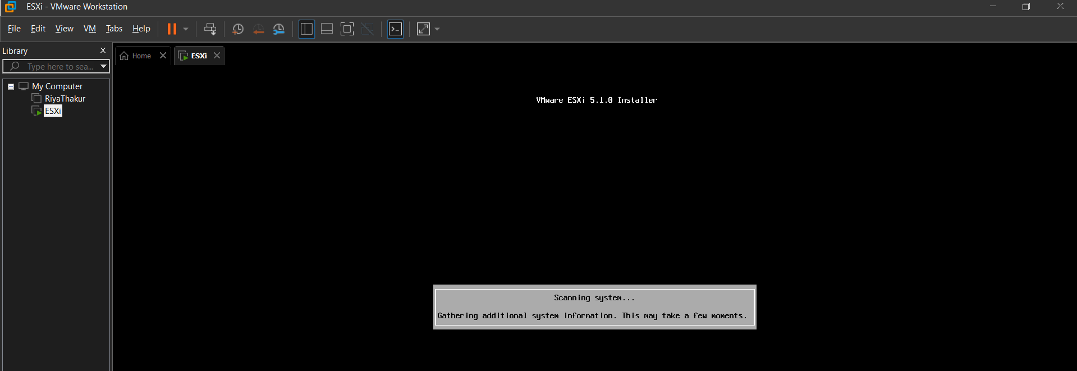

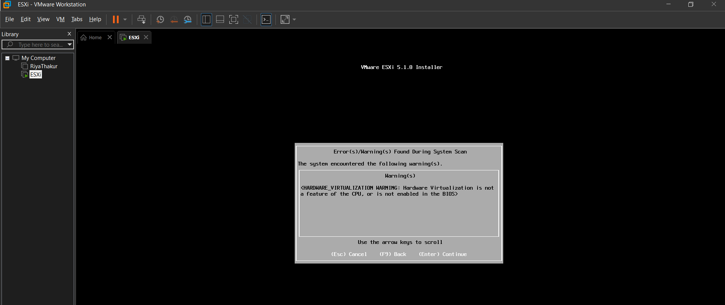
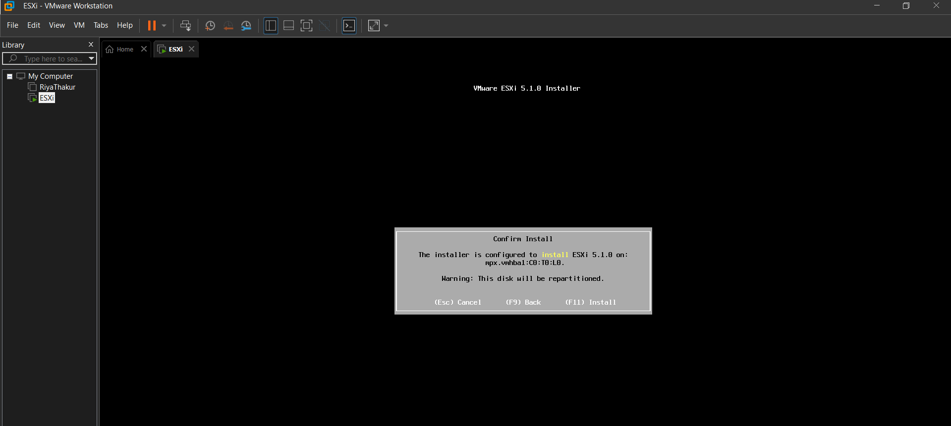

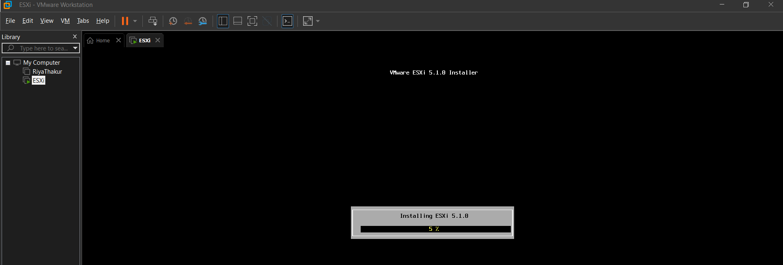
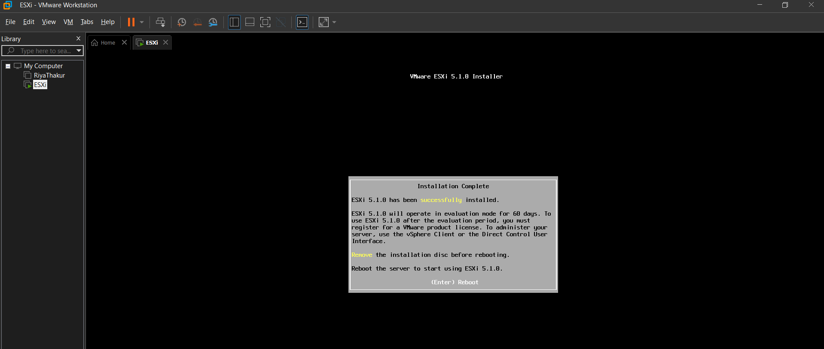
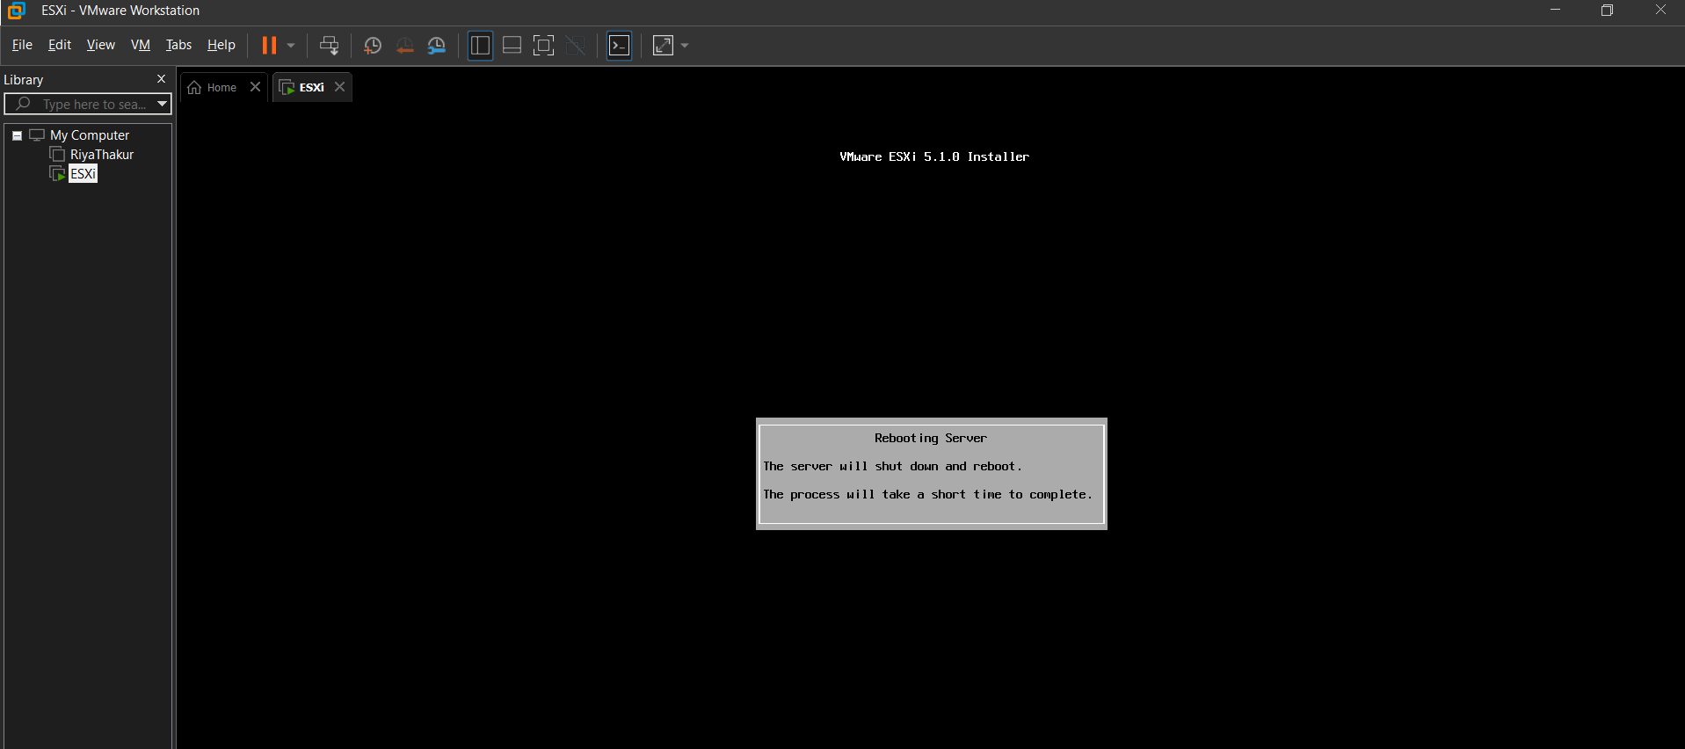
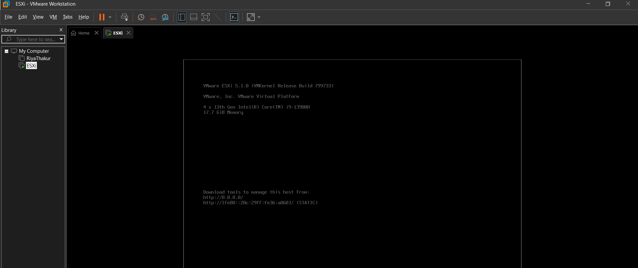
Step 17 : Set a password of 7 characters(1234567)
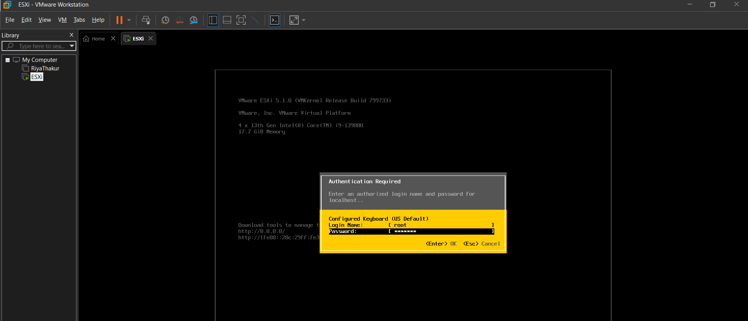
Step 18 : Check the IP address
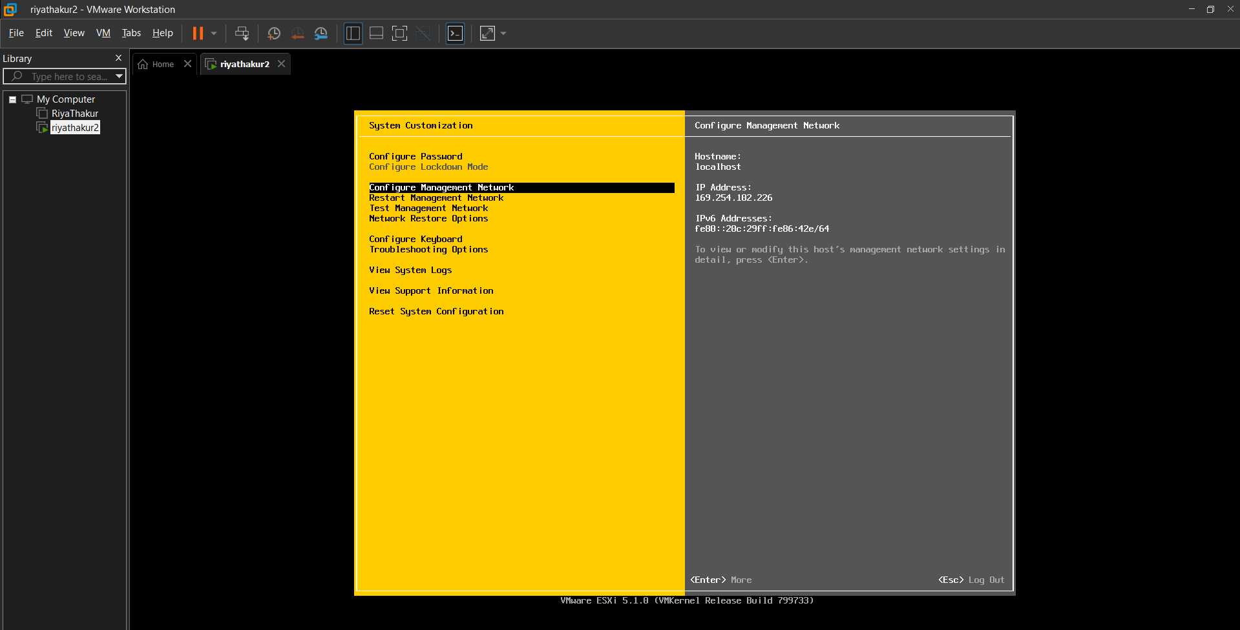
Step 19 : Open the VMware vSphere Client and try the IP address received along with the username and password previously set.
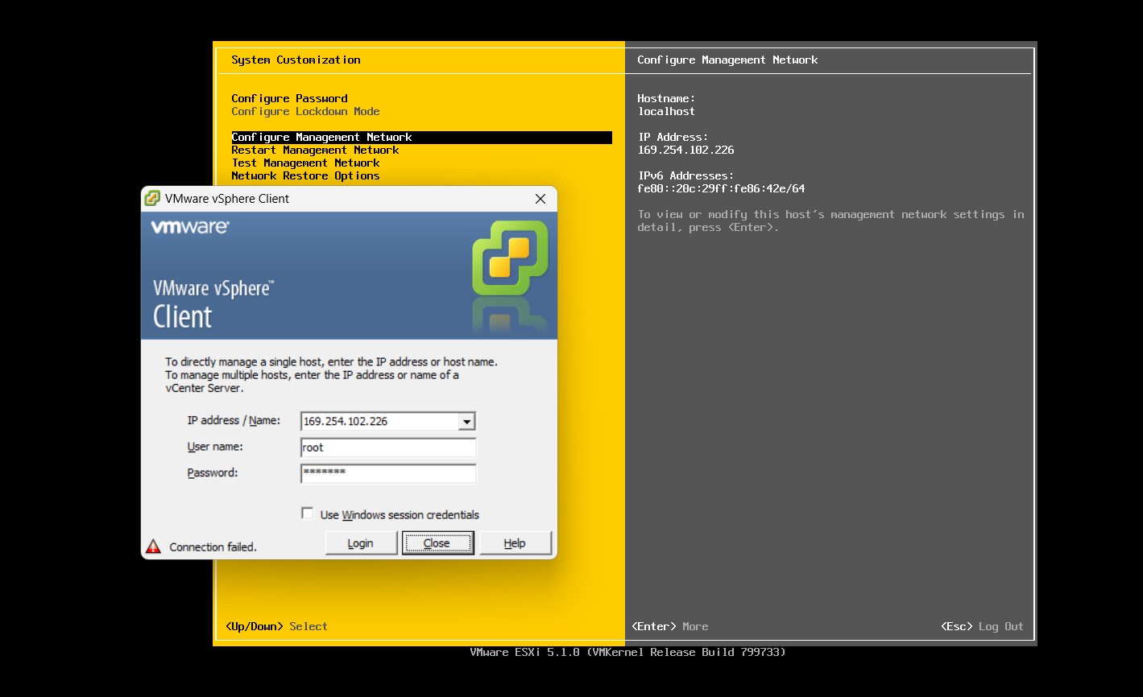
Step 20: Click Login
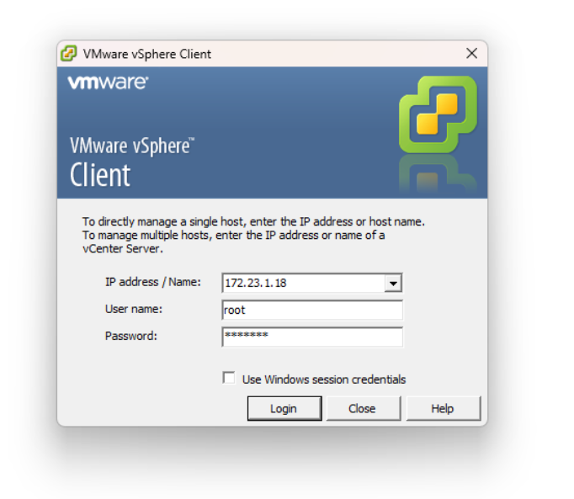
Step 21: Click ignore
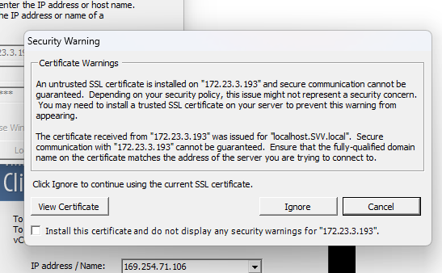
Step 22: Go to inventory
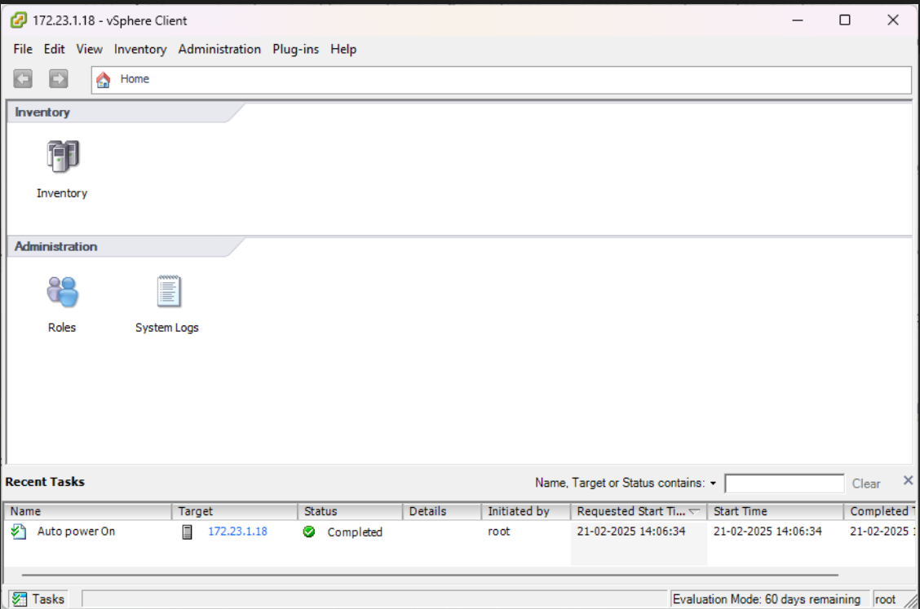

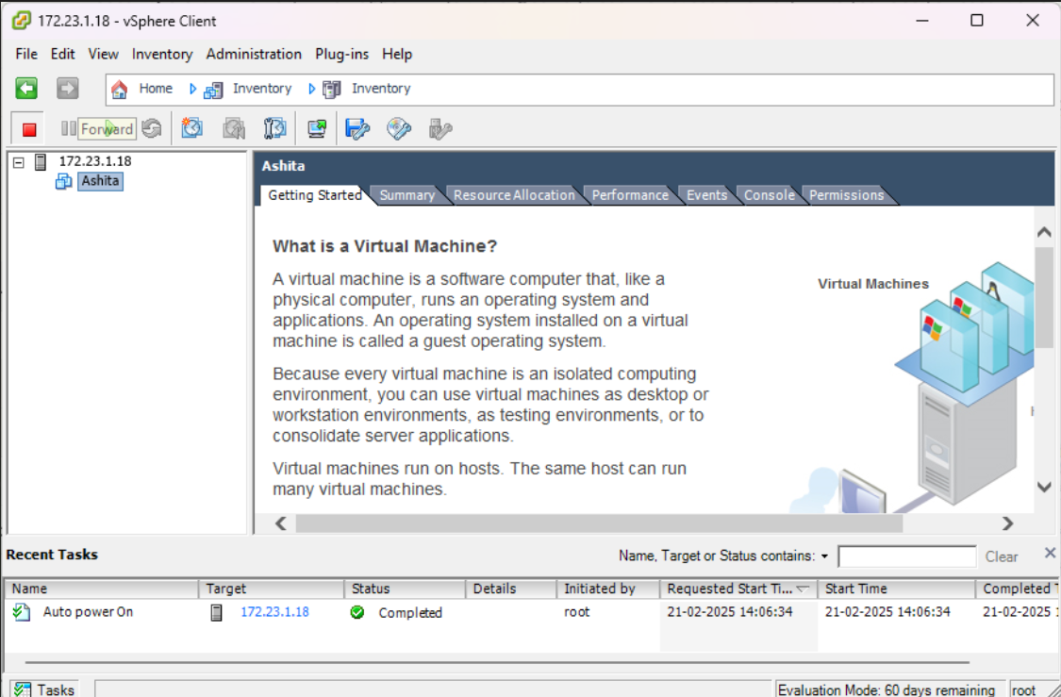
Step 23: Right click on the IP and select New Virtual Machine
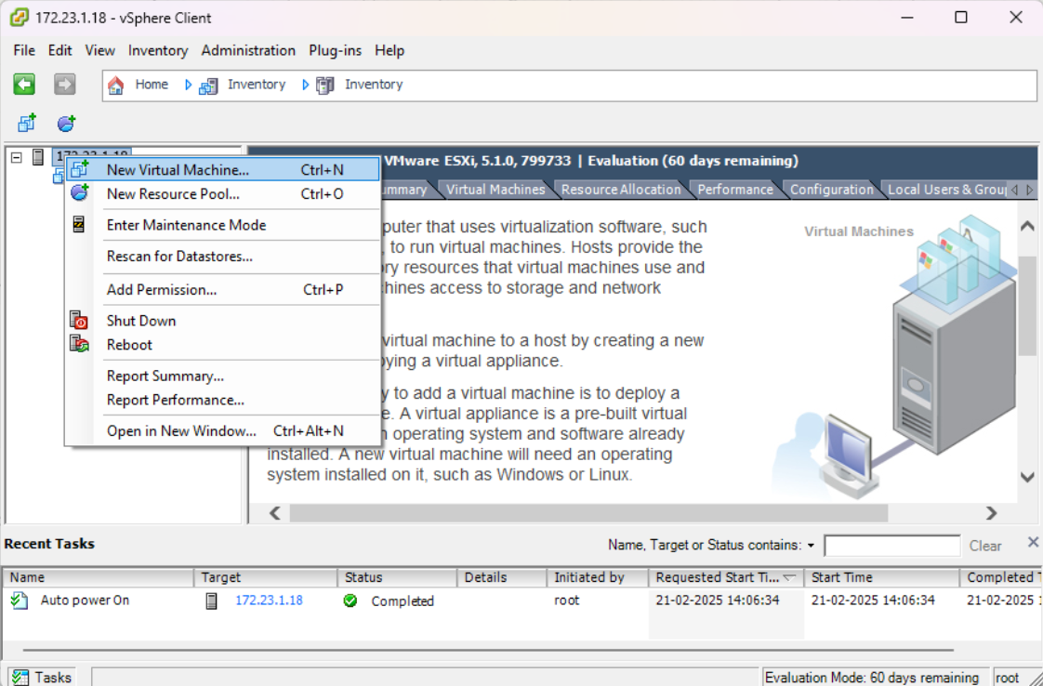
Step 24: Select the ‘Typical’ radio button
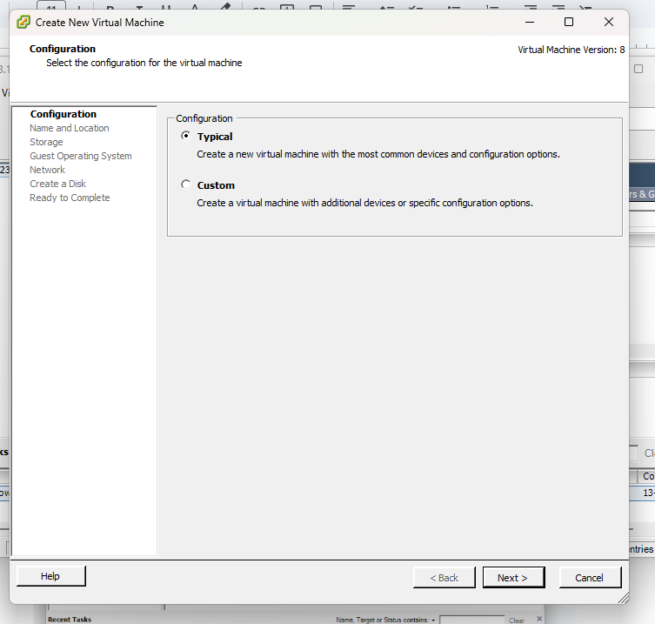
Step 25: Set a name for your Virtual machine.
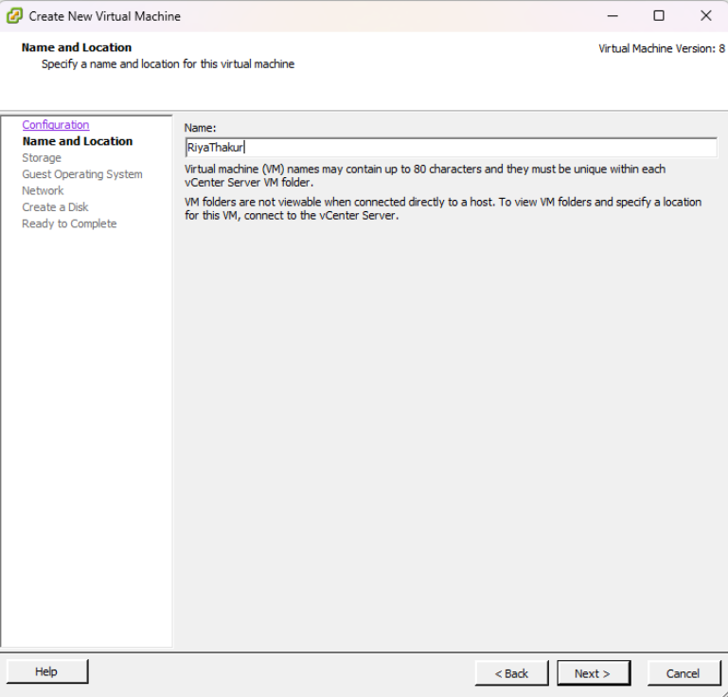
Step 26 : Set virtual disk size and select thick provision lazy zeroed

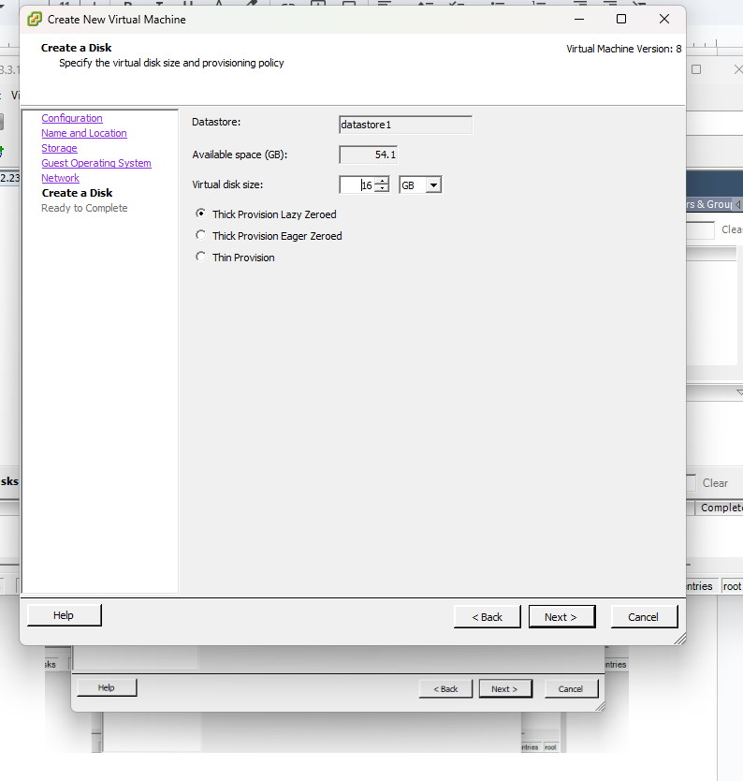
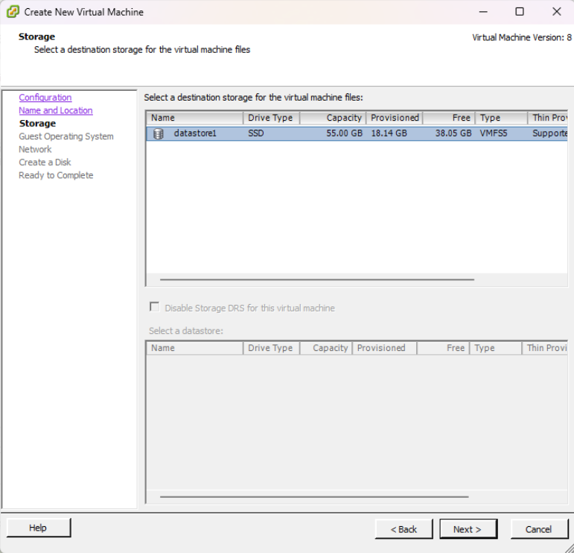
Step 27 : Select Linux and choose Red Hat Enterprise Linux 5(32-bit)

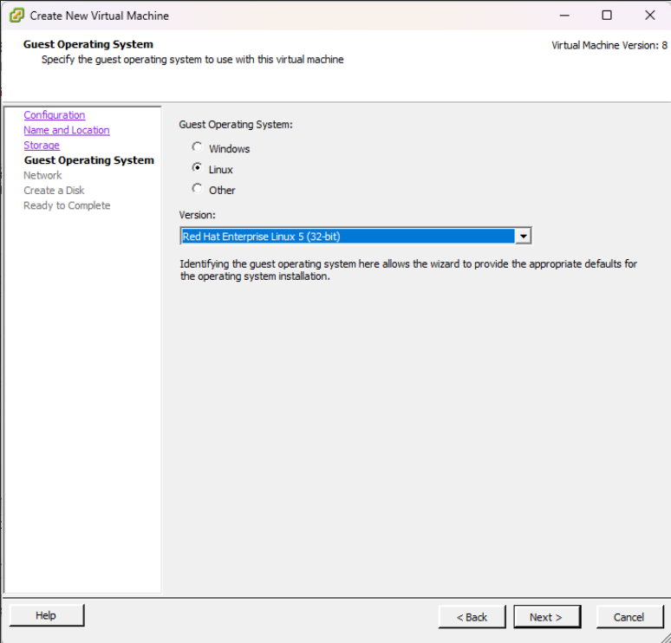
Step 28: Set the number of NIC connections.
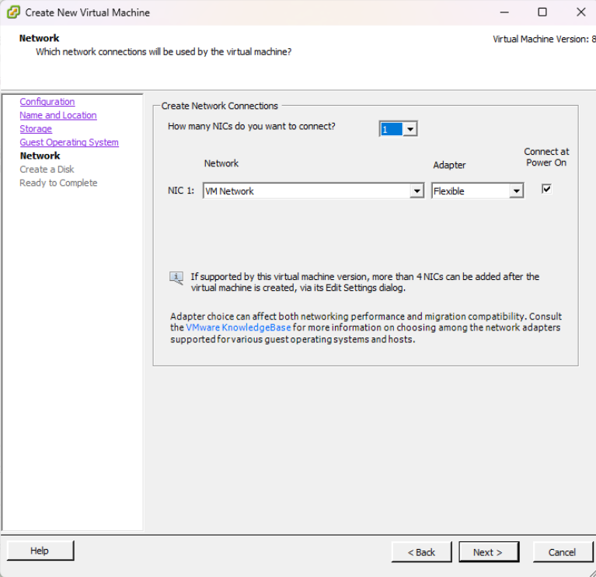
Step 29 : Check the details and click Finish

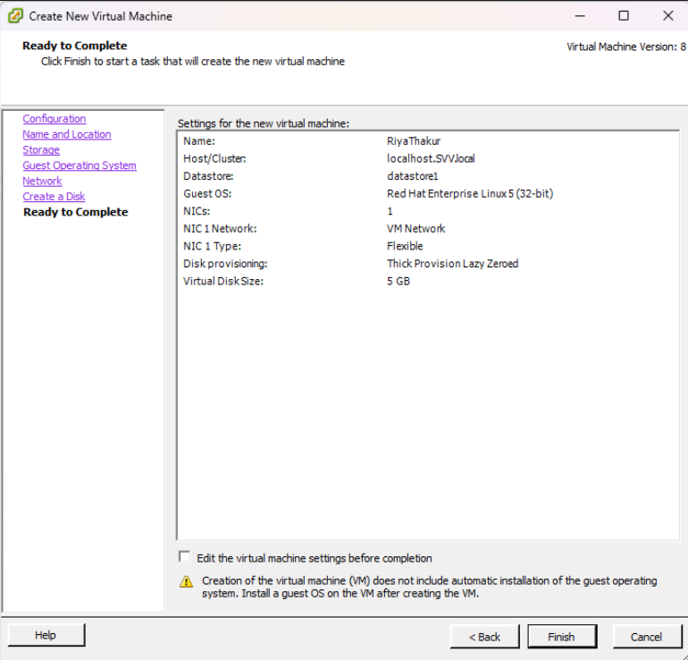
Step 30 : Check if you new virtual machine is created
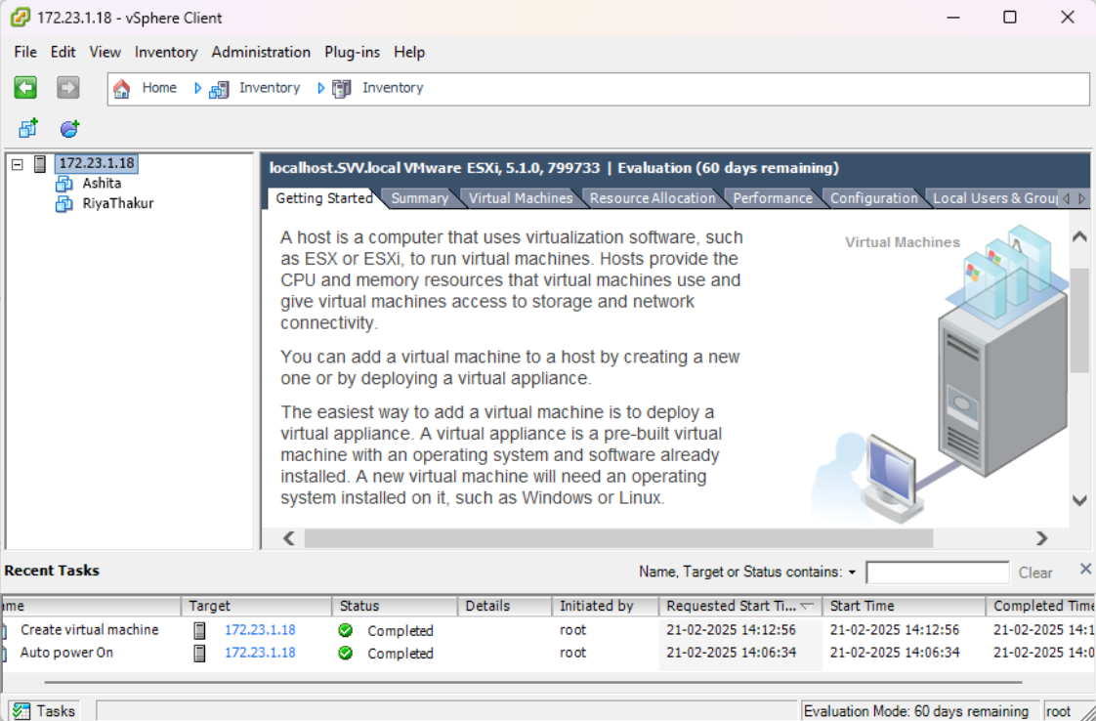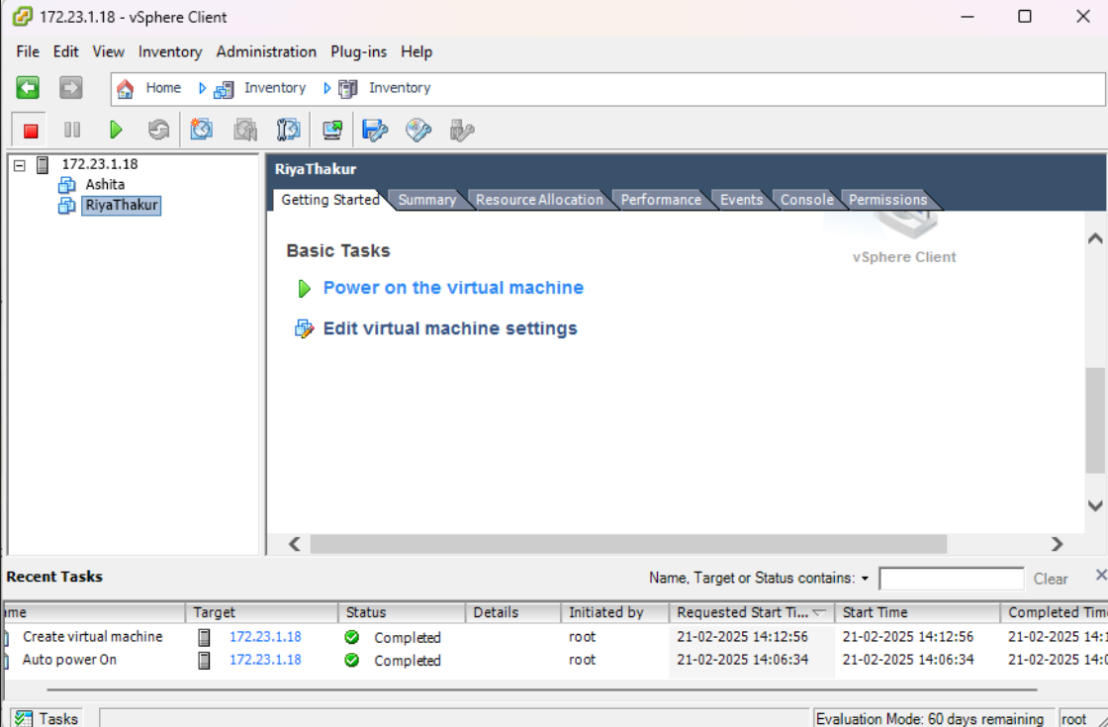

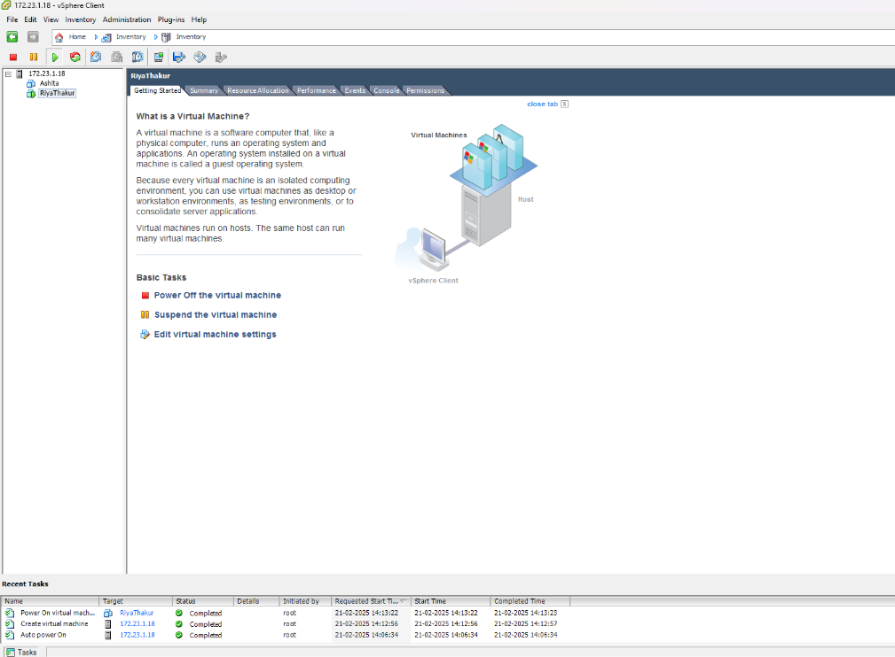

Practical 08
Aim: Implement Windows Hyper-V virtualization.
Steps:
Step 1: Go to windows and go to click features and select hyper v and click ok
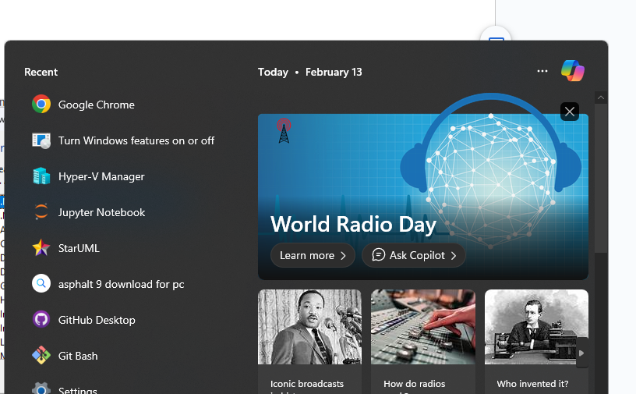
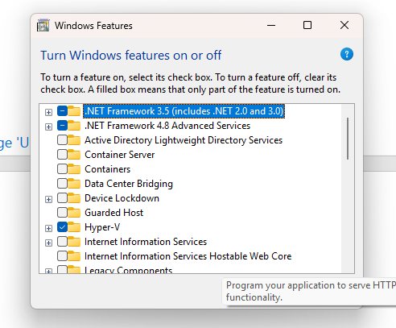
Step 2 : Go to hyper-v- manager

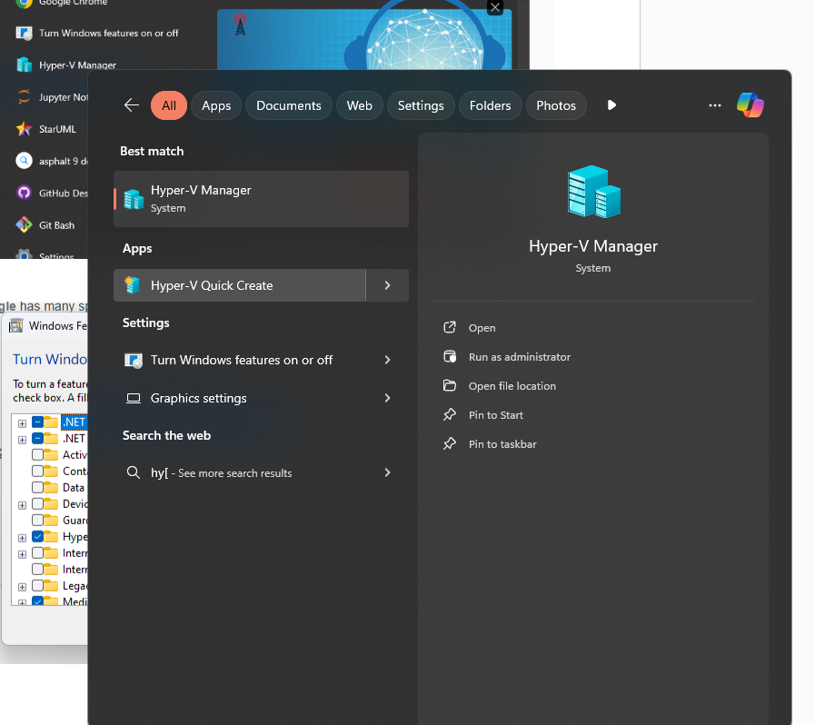

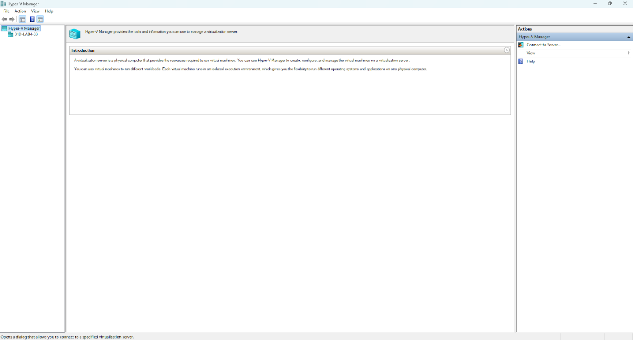

Step 3: Go to connect to server
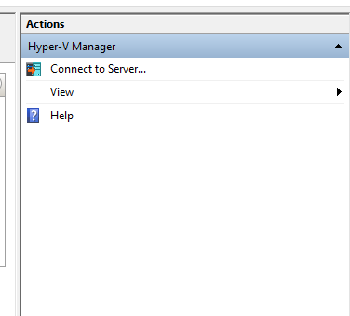

Step 4: Select local computer and ok
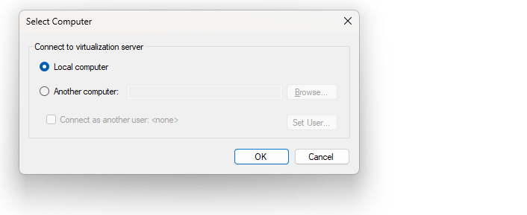
Step 5 : Select quick create
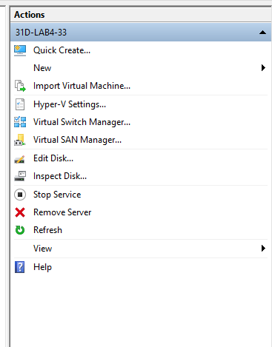

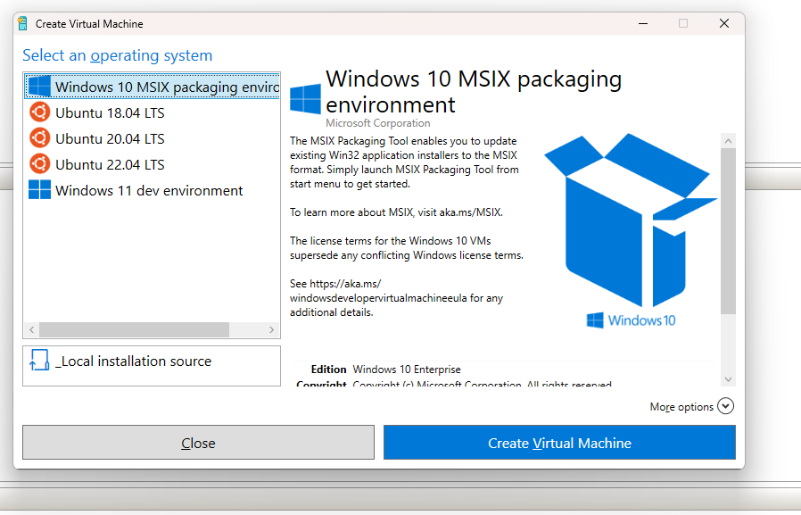
Step 6 :Select ubuntu 18.04 LTS and click on create virtual machine

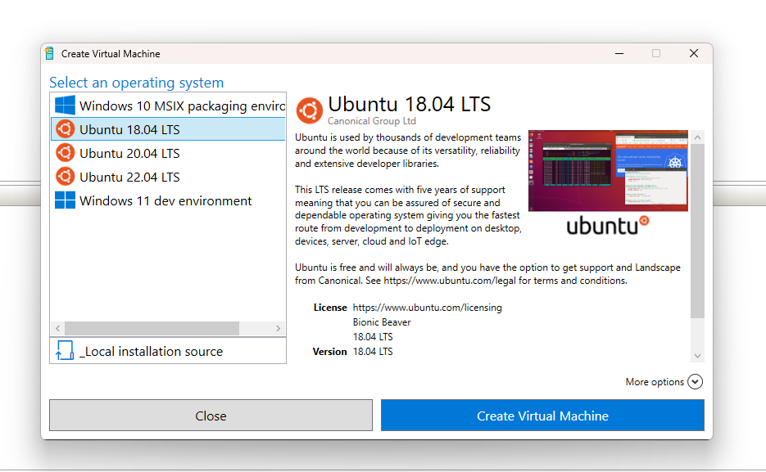

Step 7 :Click on Connect and CancelS
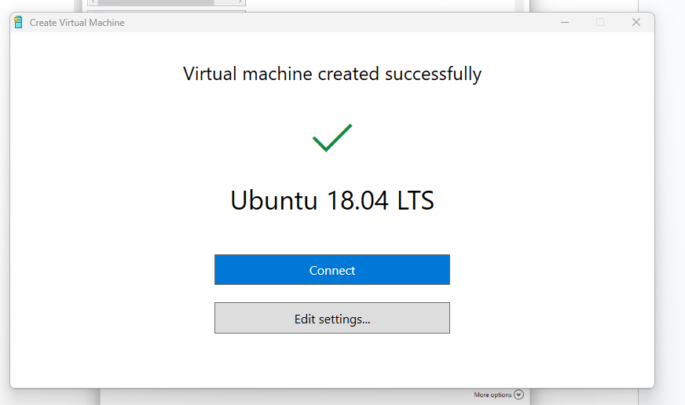
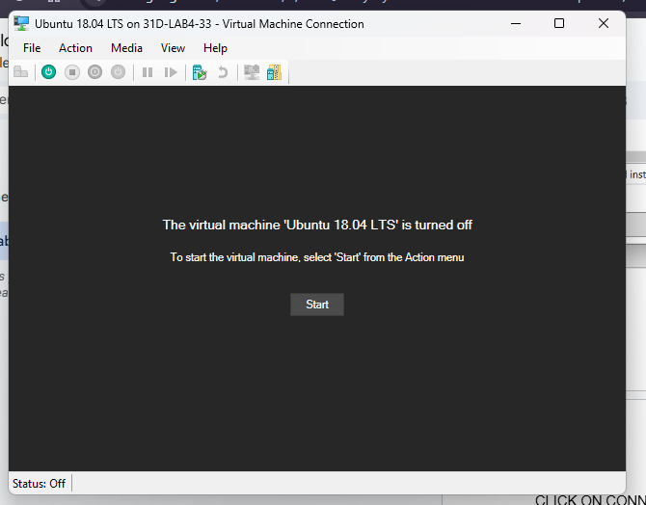
Step 8 : Click on Settings- Look at the memory and processor
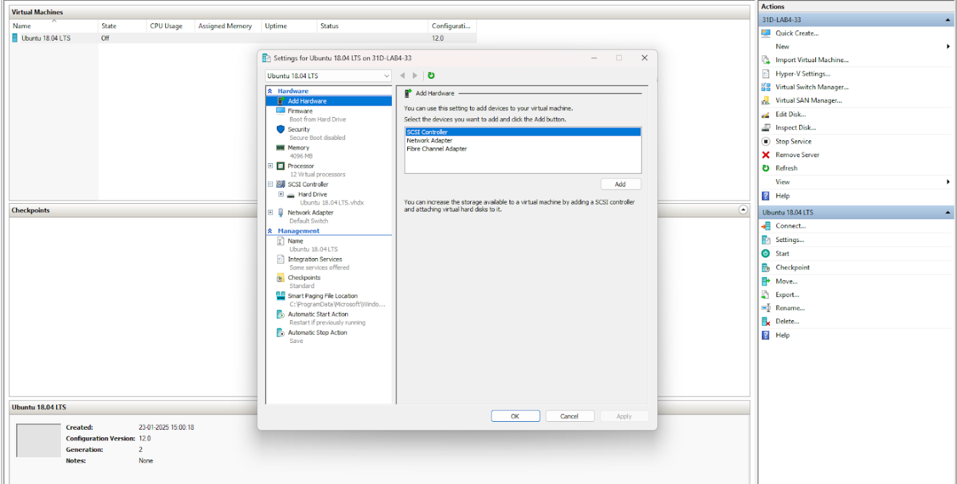
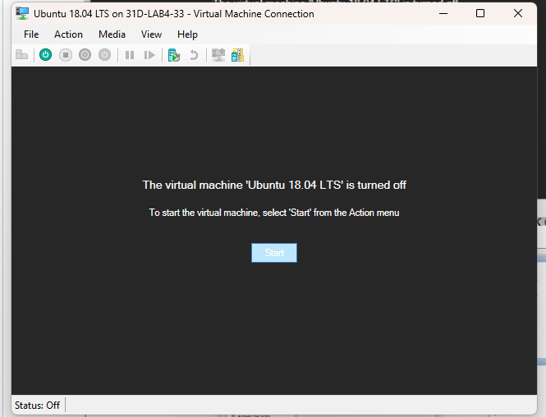
Step 9: Click on Start
Step 10 : Select the language
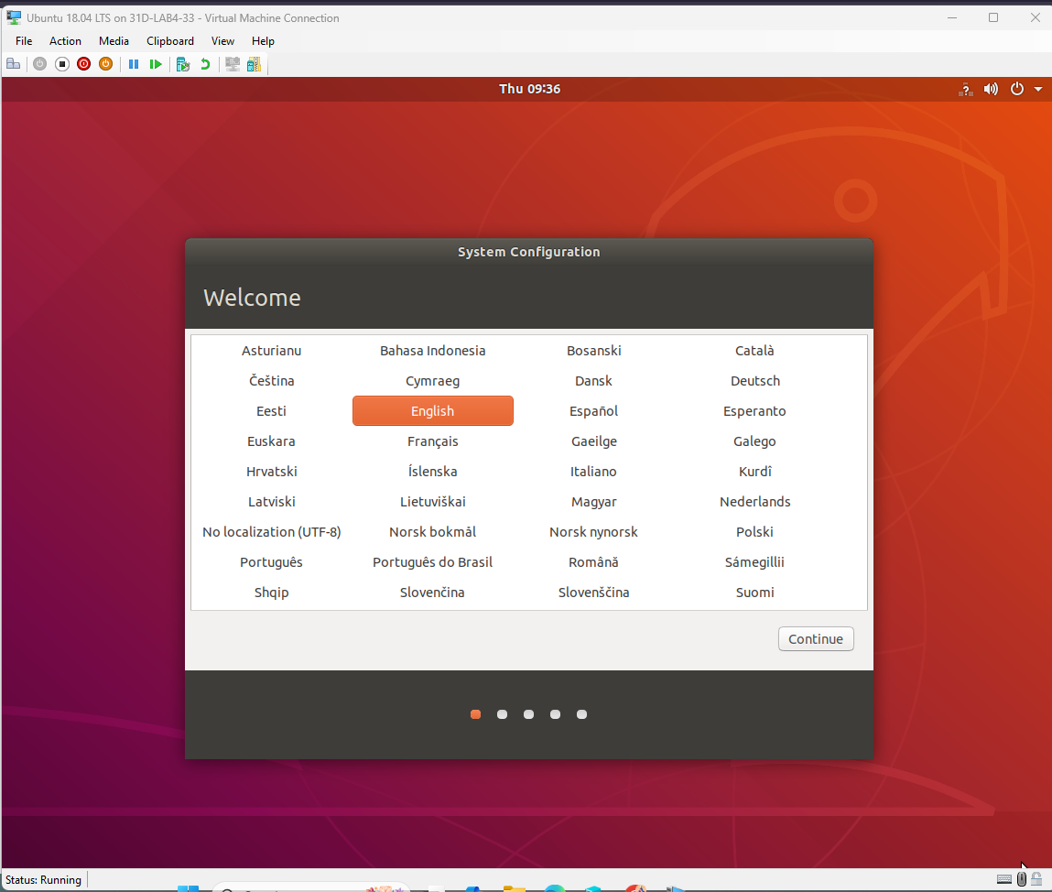
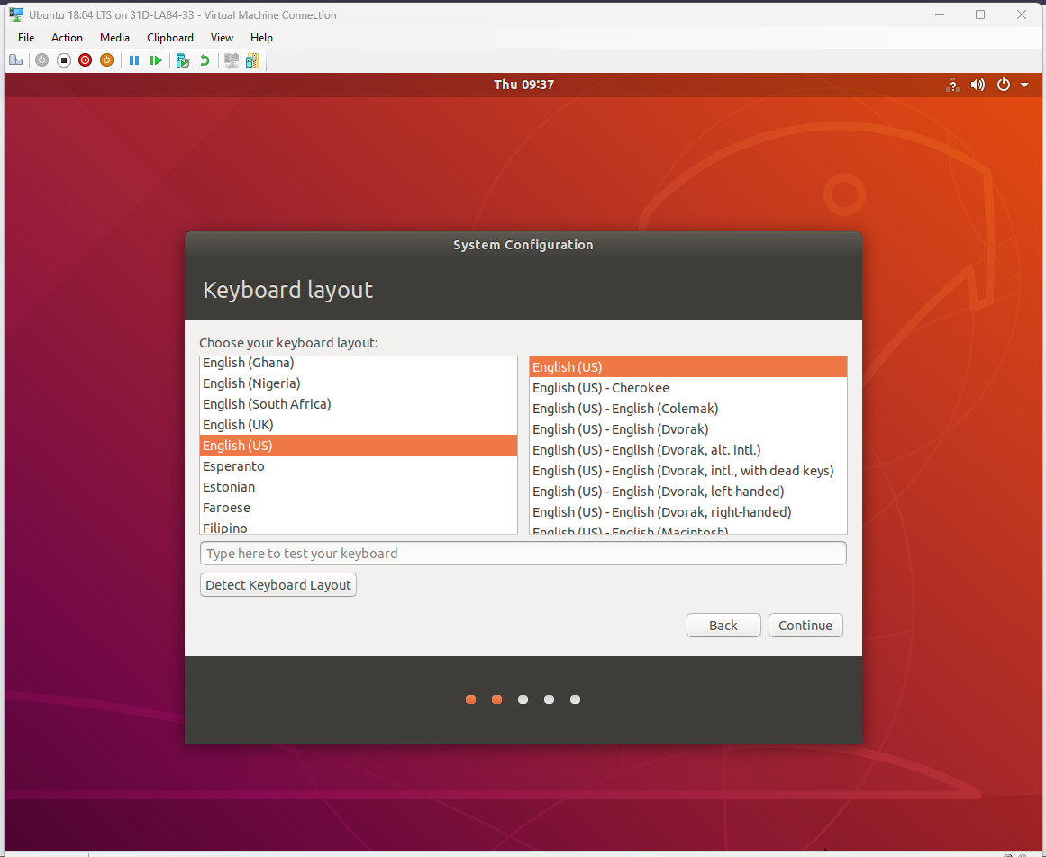

Step 11: Pin Kolkata and click Continue
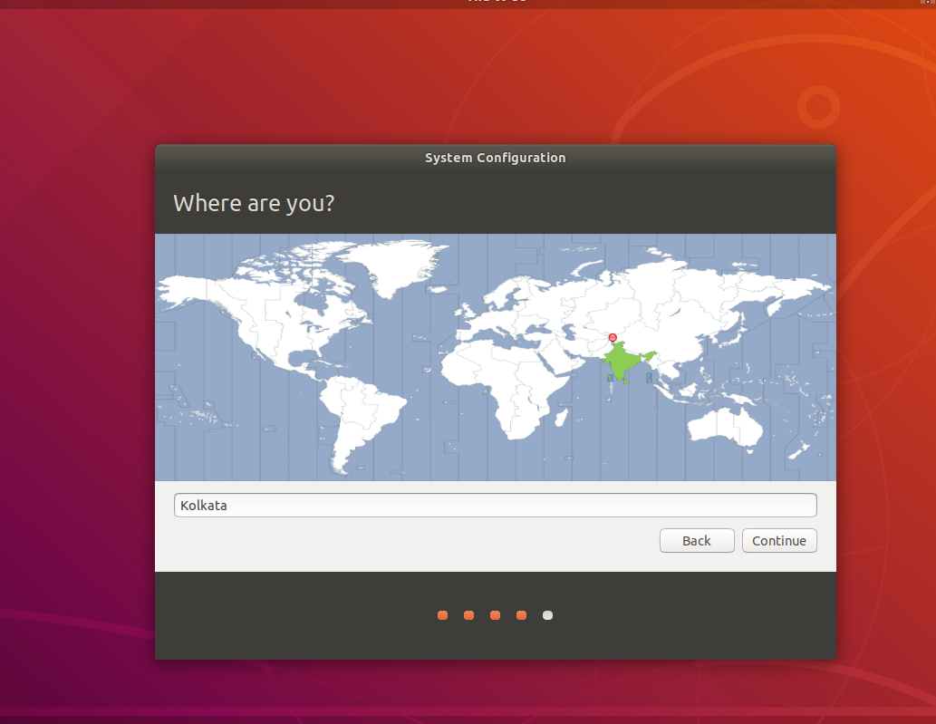
Step 12: Fill the required information.

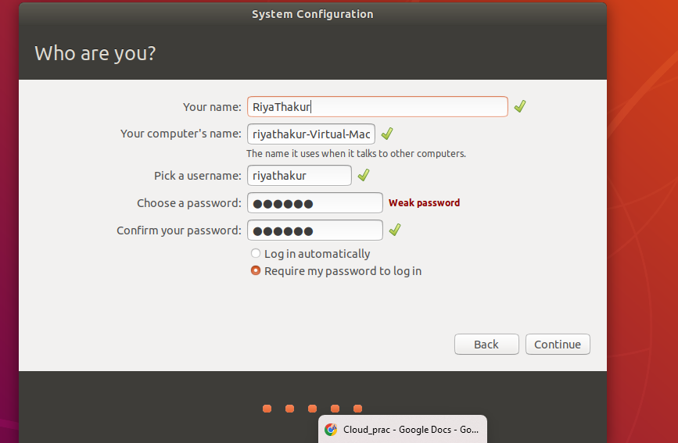

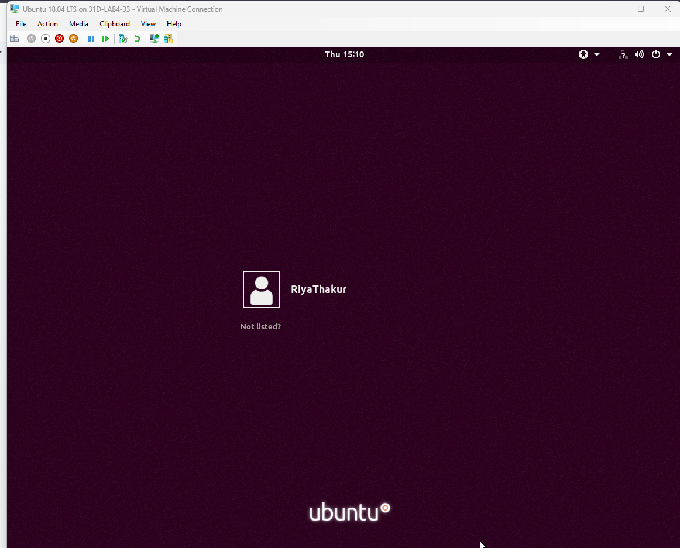
Step 13 : Now login using the appropriate password

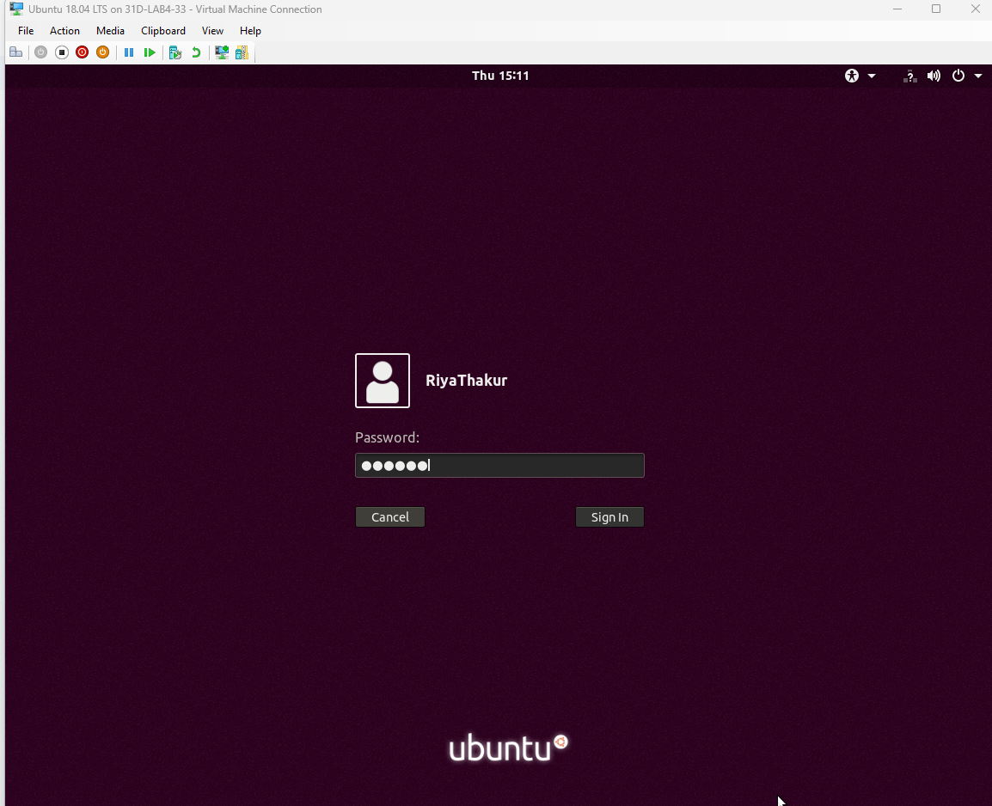

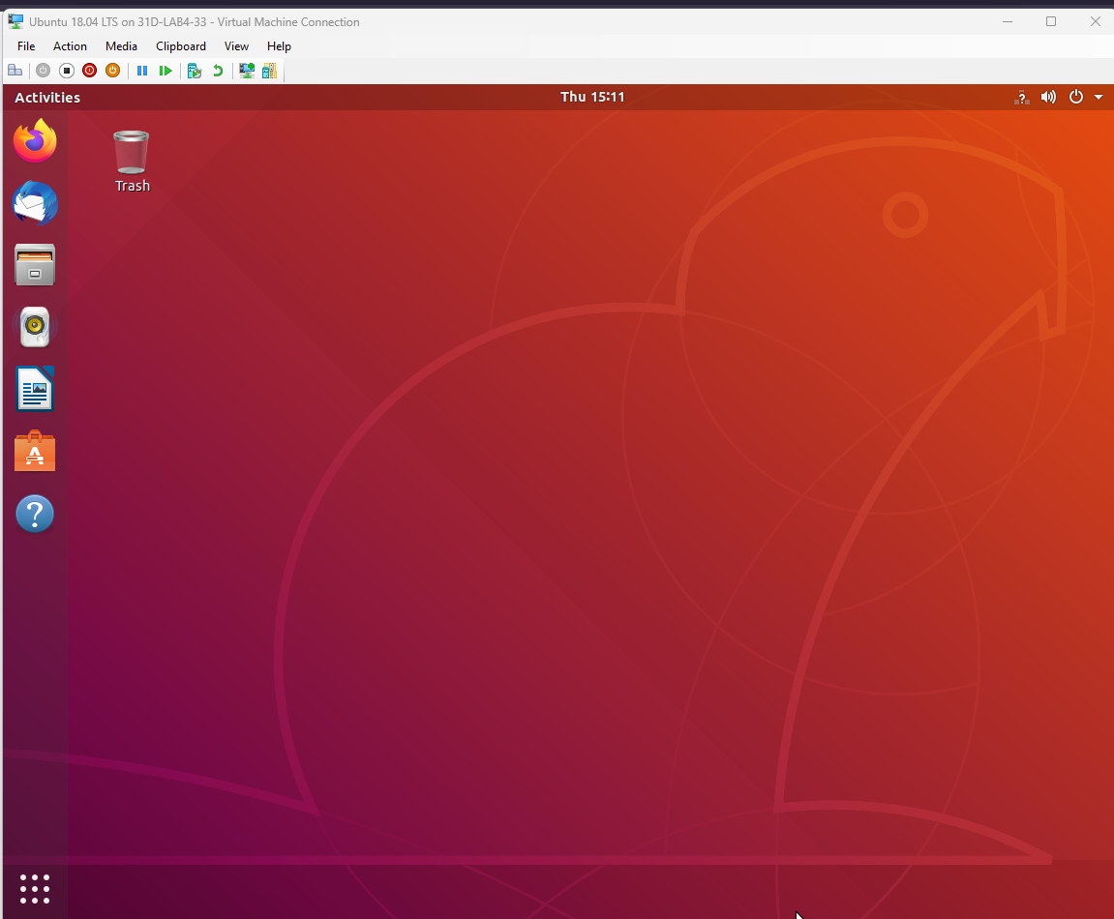
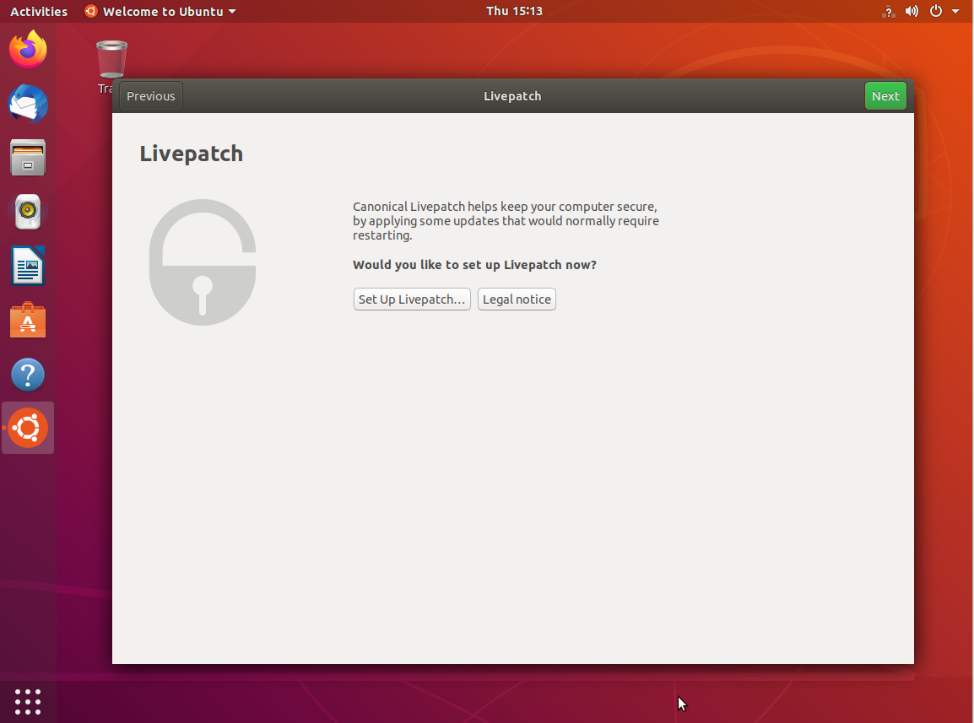
Step 14: Cancel and turnoff
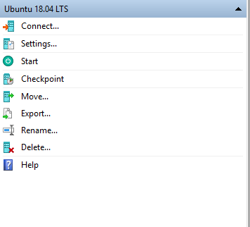
Step 15: Select Ubantu and delete
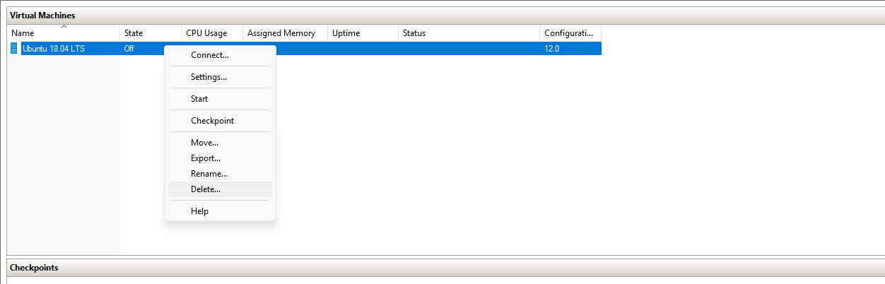
Step 16 : Go to features
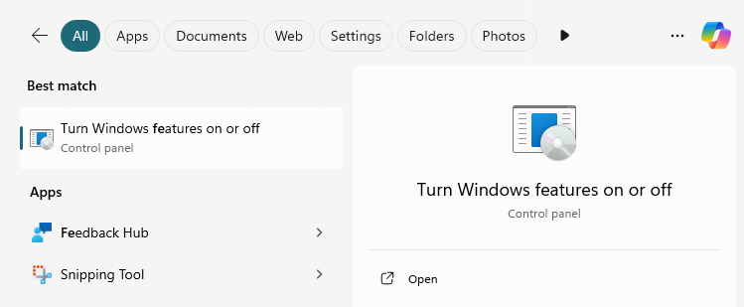

Step 17: Click on hyper v and deselect and click ok
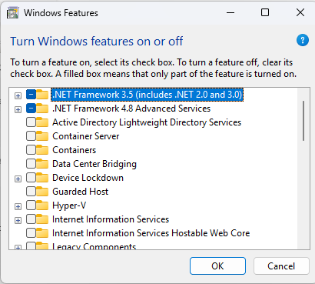

Practical 09
Aim: Develop Virtual machine using Microsoft Azure
Step1 : Go to your browser and search “azure for students” and click on the first link.
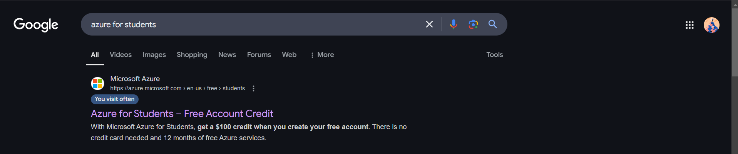
Step2: Now click on “Start Free”
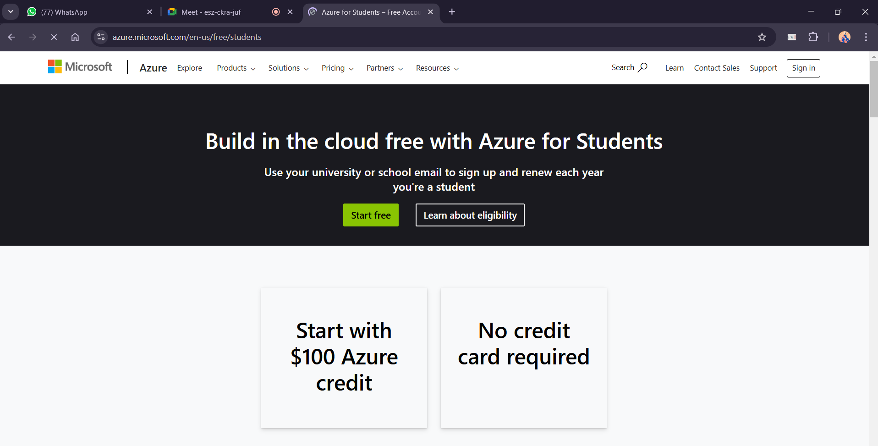
Step 3: Fill in the details and verify yourself
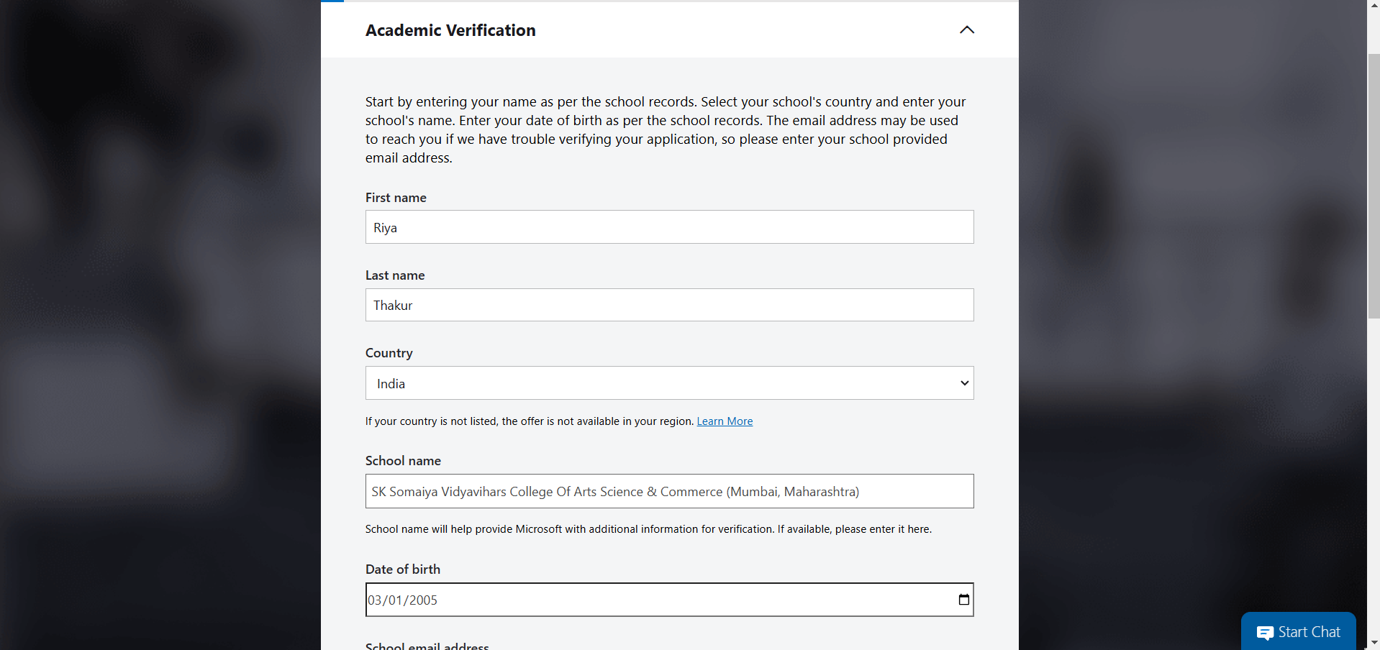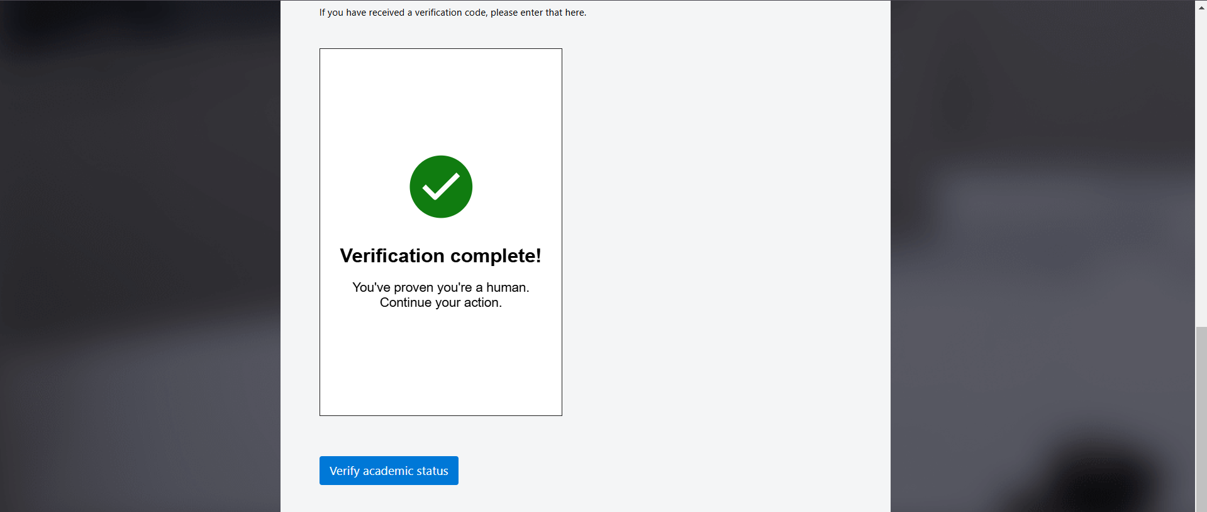

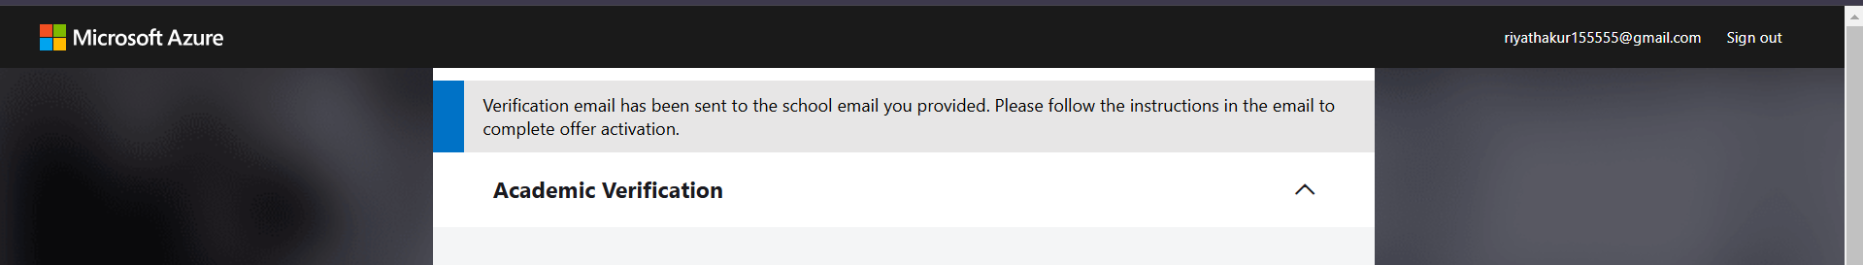
Step 4: Click on the verification link that is sent on your respective academic email address.
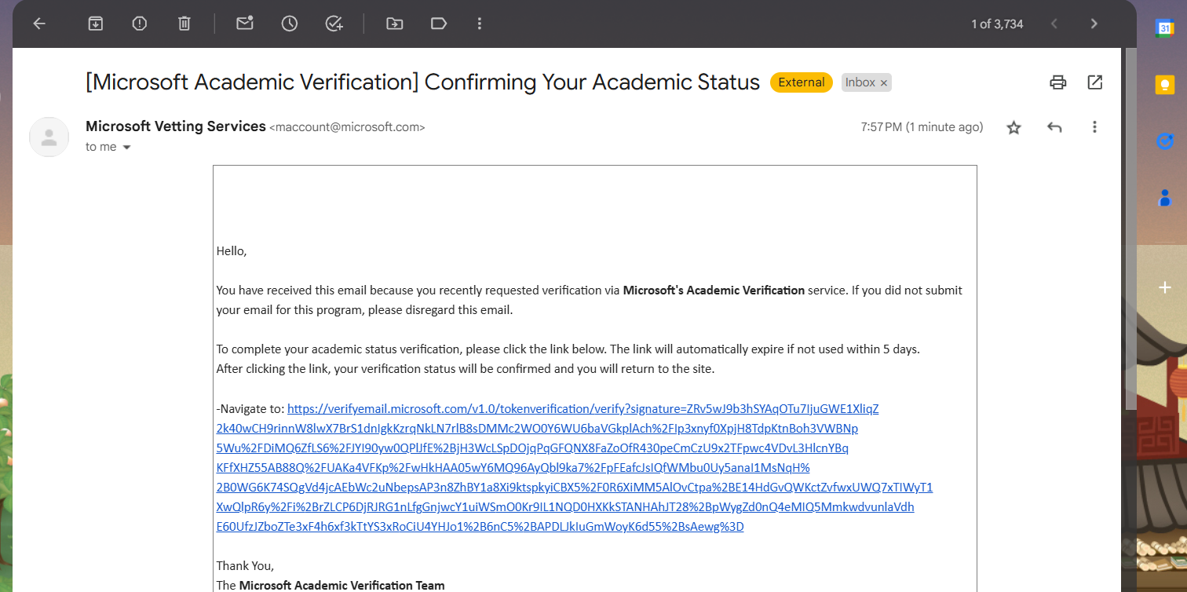
Step 5: Click on Verify.
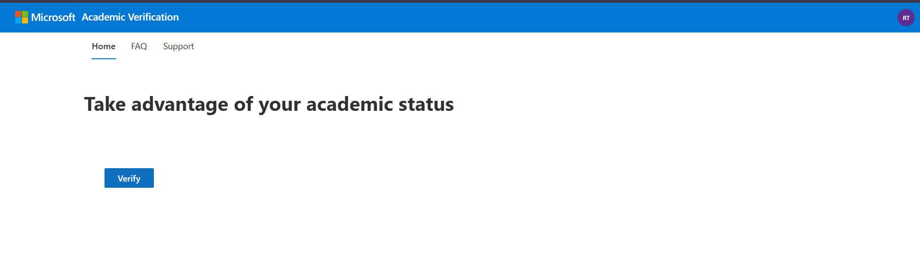
Step 6: Click on Continue
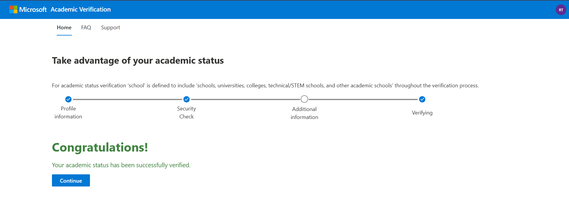
Step 7: Open new browser and again search “azure for students”
Step 8: Fill in the required details and click sign-in up
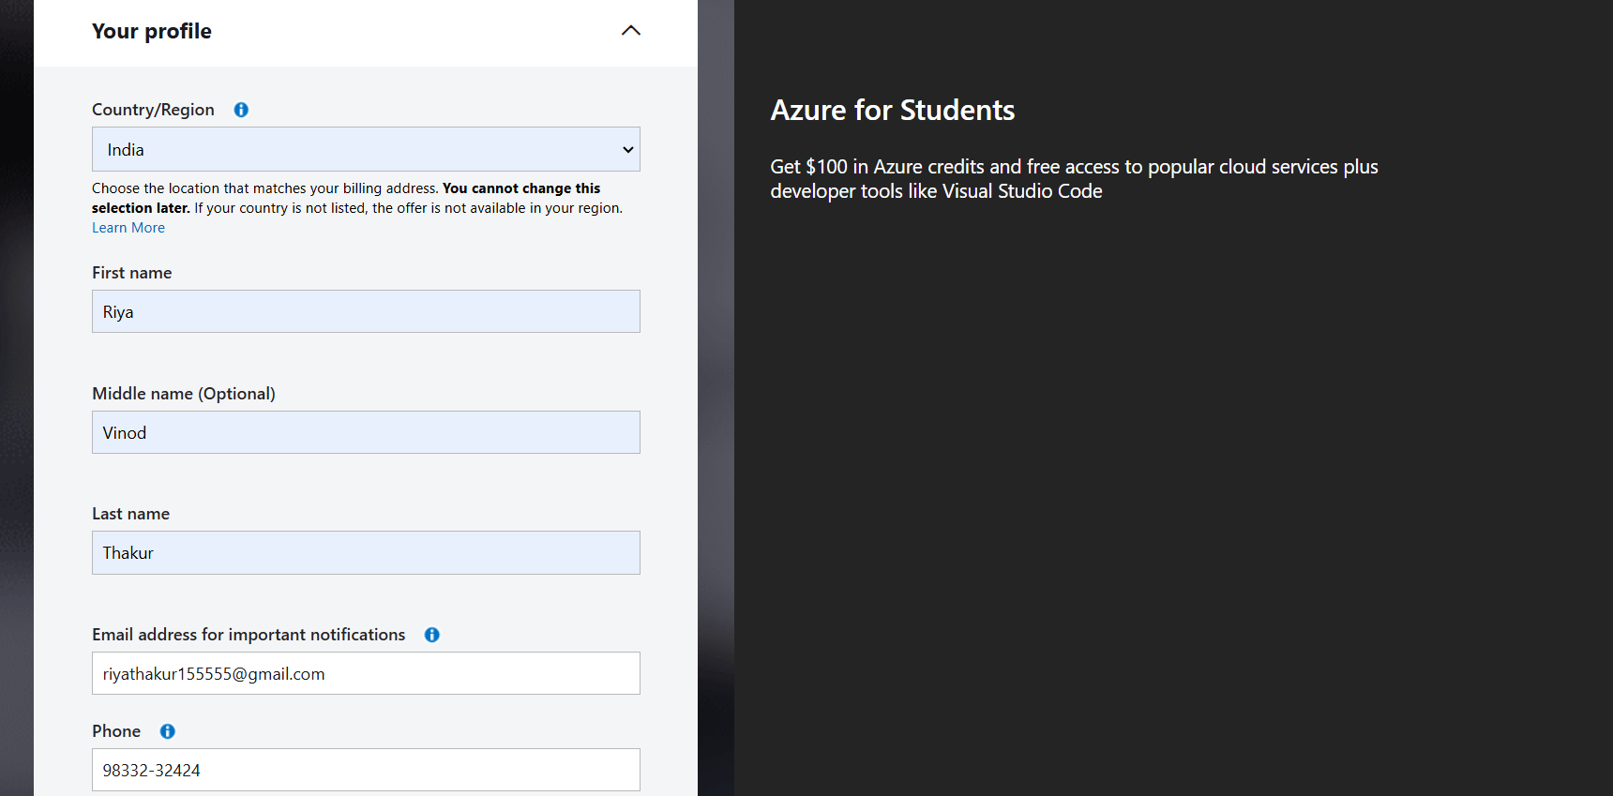
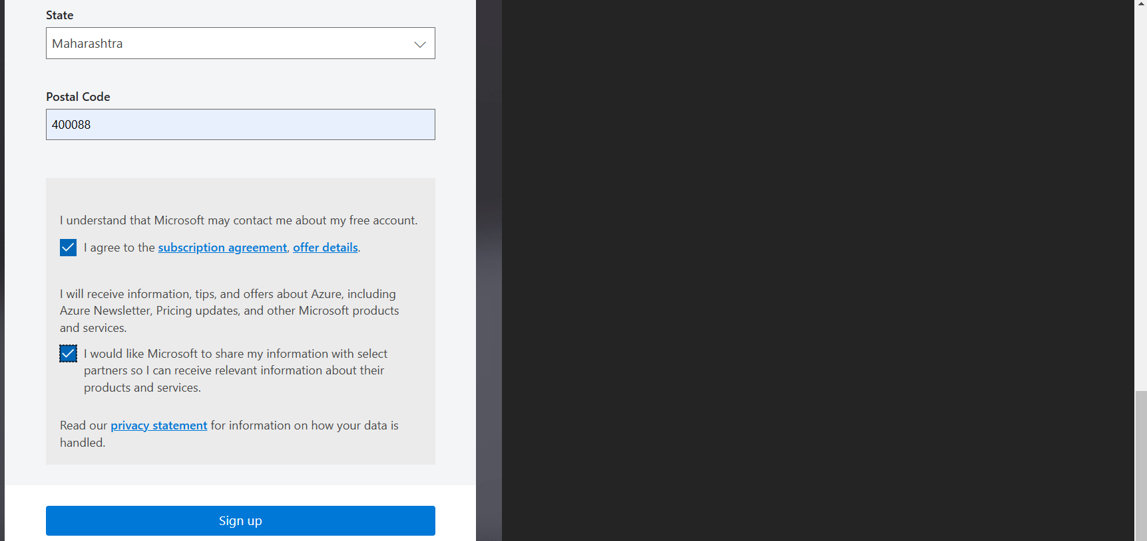

Step 9 : Check to see if $100 credits are available to you or not.
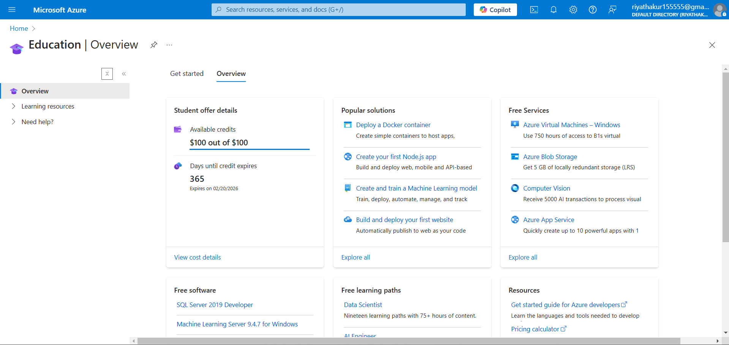
Step 10 : Go to home and hover over virtual machine
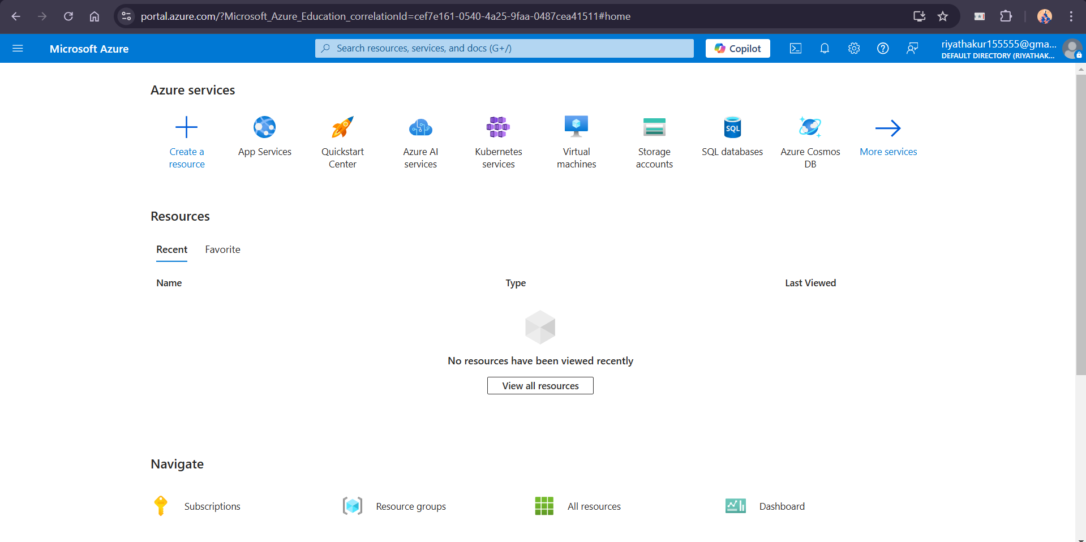
Step 11 : Hover over create and select azure virtual machine
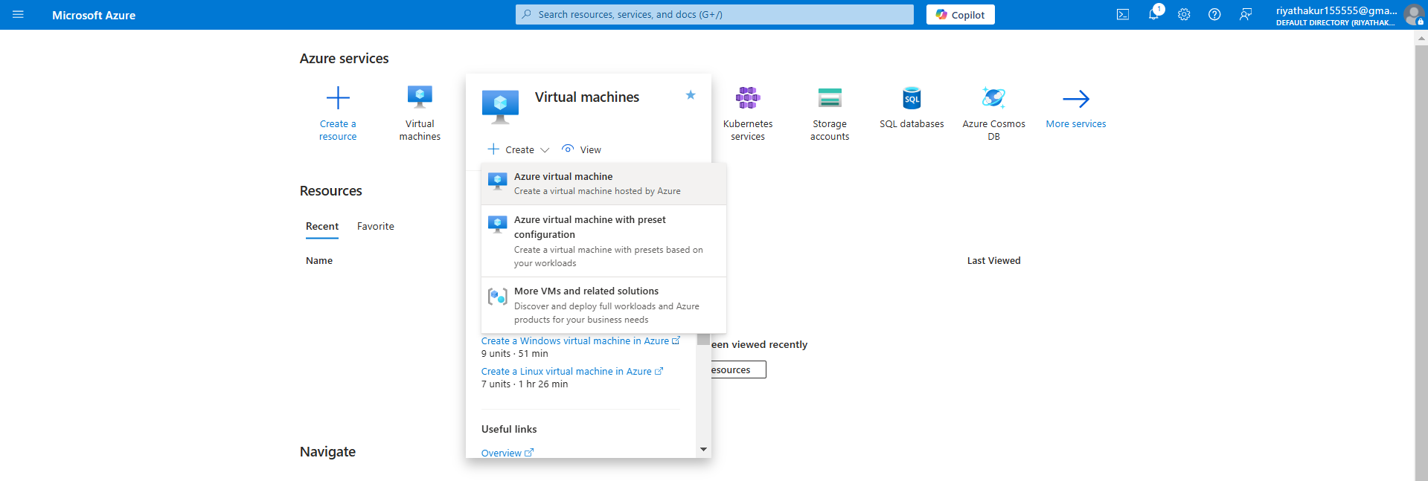
Step 12: In resource group – go to create new and give a name and click ok
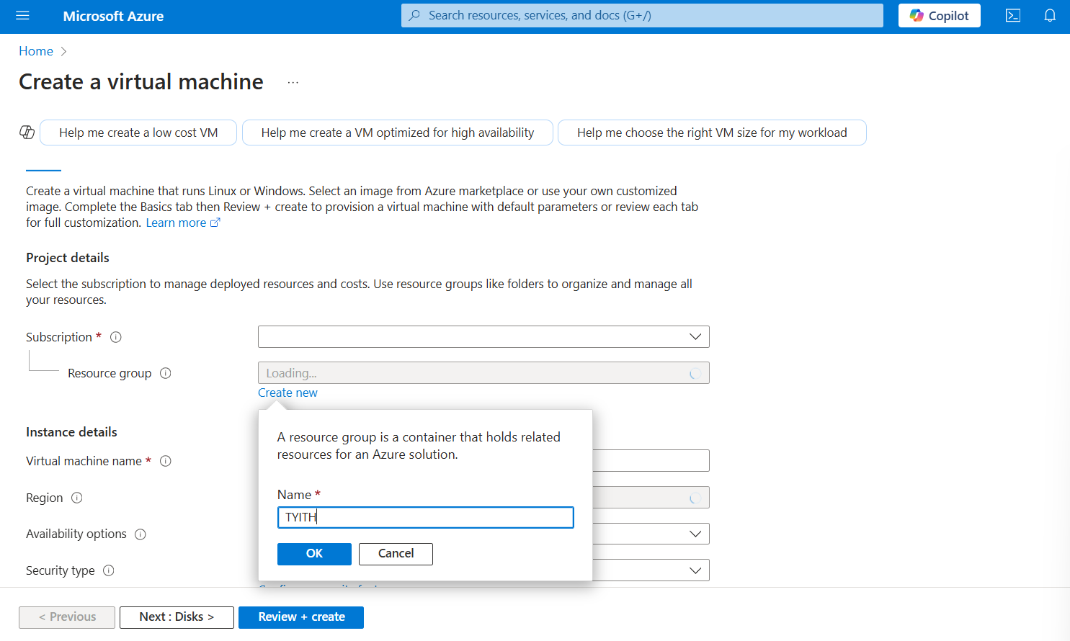
Step 13: Fill in the required details and click next until last page.
